**1 Develop GUI application to book a ticket and calculate a total number of booked tickets without using database.**

Public Class Form1

Private Sub Form1_Load(ByVal sender As System.Object, ByVal e As System.EventArgs) Handles MyBase.Load

rbWD.Checked = True

End Sub

Private Sub Calc_Click(ByVal sender As System.Object, ByVal e As System.EventArgs) Handles Calc.Click

Dim total As Double = 0

If rbWD.Checked = True Then

total += 50

ElseIf rbWE.Checked = True Then

total += 100

End If

If chkDance.Checked = True Then

total += 40

End If

If chkSing.Checked = True Then

total += 50

End If

If chkGame.Checked = True Then

total += 80

End If

If chkSport.Checked = True Then

total += 90

End If

total *= Convert.ToDouble(txtNooftickets.Text)

txtTotal.Text = total

End Sub

End Class

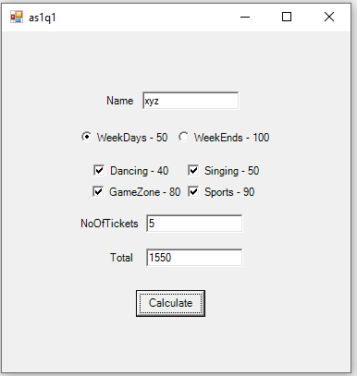

**2 Develop a Gmail Registration form and display the data on label.**

Public Class GmailReg

Private Sub btnReg_Click(ByVal sender As System.Object, ByVal e As System.EventArgs) Handles btnReg.Click

Dim gmail, pass As String

If txtGmail.Text = "" Then

MessageBox.Show("Please Enter Email Address...")

End If

If txtPass.Text = "" Then

MessageBox.Show("Please Enter Password...")

Else

If txtPass.Text.Length <= 5 Then

MessageBox.Show("Password Must be atleast 5 char long...")

Exit Sub

End If

End If

If txtGmail.Text = "" And txtPass.Text = "" Then

Else

gmail = vbCrLf & "Email :" & txtGmail.Text & vbCrLf

pass = "Password : " & txtPass.Text & vbCrLf

lblMsg.Text += gmail + pass

End If

End Sub

End Class

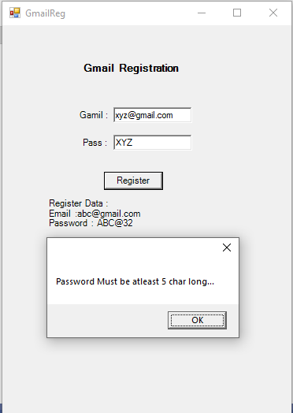

**3 Write a practical of Tic-Tac-Toe game.**

Public Class Form4

Private Sub Form1_Load(ByVal sender As System.Object, ByVal e As System.EventArgs) Handles MyBase.Load

lblname.Text = "Player1 : X"

End Sub

Private Sub btn1_Click(ByVal sender As System.Object, ByVal e As System.EventArgs) Handles btn1.Click, btn2.Click, btn3.Click, btn4.Click, btn5.Click, btn6.Click, btn7.Click, btn8.Click, btn9.Click

Dim btn1 As Button = sender

display(btn1)

End Sub

Private Sub display(ByVal btn As Button)

If btn.Text = "" Then

If lblname.Text = "Player1 : X" Then

btn.Text = "X"

lblname.Text = "Player2 : O"

Else

btn.Text = "O"

lblname.Text = "Player1 : X"

End If

End If

checkWinner()

End Sub

Private Sub checkWinner()

If (btn1.Text = btn2.Text And btn2.Text = btn3.Text And btn1.Text <> "" And btn2.Text <> "" And btn3.Text <> "") Or _

(btn4.Text = btn5.Text And btn5.Text = btn6.Text And btn4.Text <> "" And btn5.Text <> "" And btn6.Text <> "") Or _

(btn7.Text = btn8.Text And btn8.Text = btn9.Text And btn7.Text <> "" And btn8.Text <> "" And btn9.Text <> "") Or _

(btn1.Text = btn4.Text And btn4.Text = btn7.Text And btn1.Text <> "" And btn4.Text <> "" And btn7.Text <> "") Or _

(btn2.Text = btn5.Text And btn5.Text = btn8.Text And btn2.Text <> "" And btn5.Text <> "" And btn8.Text <> "") Or _

(btn3.Text = btn6.Text And btn6.Text = btn9.Text And btn3.Text <> "" And btn6.Text <> "" And btn9.Text <> "") Or _

(btn1.Text = btn5.Text And btn5.Text = btn9.Text And btn1.Text <> "" And btn5.Text <> "" And btn9.Text <> "") Or _

(btn3.Text = btn5.Text And btn5.Text = btn7.Text And btn3.Text <> "" And btn5.Text <> "" And btn7.Text <> "") Then

If lblname.Text = "Player1 : X" Then

MessageBox.Show("Player2 Is Winner ")

Else

MessageBox.Show("Player1 Is Winner ")

End If

clearControls()

ElseIf (btn1.Text <> "" And btn2.Text <> "" And btn3.Text <> "" And btn4.Text <> "" And btn5.Text <> "" And _

btn6.Text <> "" And btn7.Text <> "" And btn8.Text <> "" And btn9.Text <> "") Then

MessageBox.Show("Game Over NoBody Is Winner")

clearControls()

End If

End Sub

Private Sub clearControls()

btn1.Text = ""

btn2.Text = ""

btn3.Text = ""

btn4.Text = ""

btn5.Text = ""

btn6.Text = ""

btn7.Text = ""

btn8.Text = ""

btn9.Text = ""

lblname.Text = "Player1 : X"

End Sub

End Class

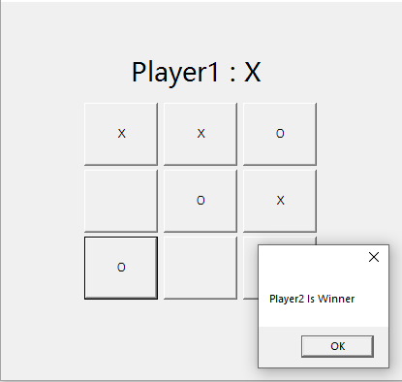

**4 Write a practical of option statements.**

Option Explicit On

Option Strict On

Option Infer Off

Public Class Form11

Private Sub btnExecute_Click(ByVal sender As System.Object, ByVal e As System.EventArgs) Handles btnExecute.Click

Dim num1 As Integer = 10

Dim num2 As Integer = 20

Dim result As Integer

result = num1 + num2

lblResult.Text = "Result: " & result.ToString()

End Sub

End Class

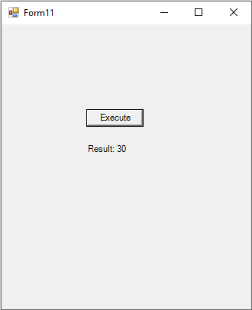

**5 Write a practical of Message box and Input box.**

Public Class Form6

Private Sub msgbox_Click(sender As Object, e As EventArgs) Handles msgbox.Click, msgbox.Click

MessageBox.Show("is visual basic awesome?", "the question",

MessageBoxButtons.YesNoCancel, MessageBoxIcon.Question, MessageBoxDefaultButton.Button2)

End Sub

Private Sub inputbox_Click(sender As Object, e As EventArgs) Handles inputbox.Click, inputbox.Click

Dim str As String

str = Interaction.InputBox("enter your name:", "Name", "Your Name", 100, 100)

Dim res As DialogResult

res = MessageBox.Show(str, "Your Name", MessageBoxButtons.OKCancel,

MessageBoxIcon.Information)

If res = Windows.Forms.DialogResult.OK Then

MessageBox.Show(str)

Else

MessageBox.Show("no value")

End If

End Sub

End Class

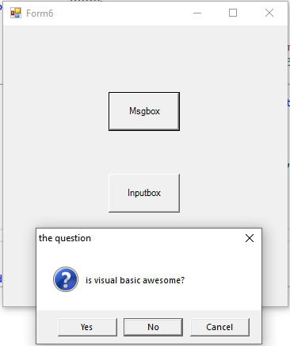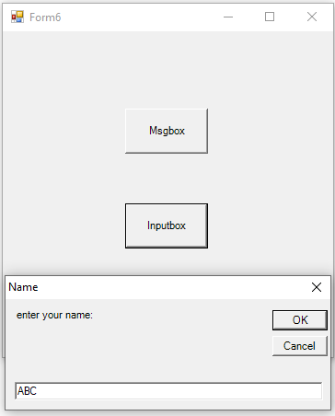

**6 Write practical enumeration.**

Public Class Form3

Enum filePermission

Create

Read = 20

Write

Delete = 40

End Enum

Private Sub Enumbtn_Click(ByVal sender As System.Object, ByVal e As System.EventArgs) Handles Enumbtn.Click

TextBox1.Text = filePermission.Create

TextBox2.Text = filePermission.Read

TextBox3.Text = filePermission.Write

TextBox4.Text = filePermission.Delete

End Sub

End Class

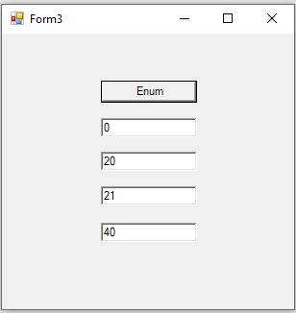

**7 Write a practical of string function.**

Public Class Form7

Private Sub ButtonConcat_Click(ByVal sender As Object, ByVal e As EventArgs) Handles ButtonConcat.Click

Dim str1 As String = TextBox1.Text

Dim str2 As String = TextBox2.Text

Dim result As String = str1 & " " & str2

Label1.Text = "Concatenated String: " & result

End Sub

Private Sub ButtonLength_Click(ByVal sender As Object, ByVal e As EventArgs) Handles ButtonLength.Click

Dim str As Double = TextBox1.Text.Length()

Label2.Text = "String Length: " & str

End Sub

Private Sub ButtonUpperCase_Click(ByVal sender As Object, ByVal e As EventArgs) Handles ButtonUpperCase.Click

Dim str1 As String = TextBox1.Text.ToUpper()

Label3.Text = "Upper Case: " & str1

End Sub

Private Sub ButtonLowerCase_Click(ByVal sender As Object, ByVal e As EventArgs) Handles ButtonLowerCase.Click

Dim str2 As String = TextBox1.Text.ToLower()

Label4.Text = "Lower Case: " & str2

End Sub

Private Sub ButtonTrim_Click(ByVal sender As Object, ByVal e As EventArgs) Handles ButtonTrim.Click

Dim str3 As String = TextBox1.Text.Trim()

Label5.Text = "Trimmed String: " & str3

End Sub

End Class

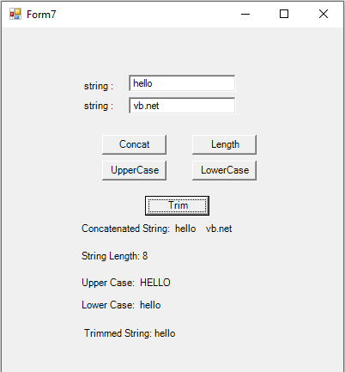

**8 Write a practical of mathematics function.**

Public Class Form8

Private Sub ButtonPower_Click(ByVal sender As Object, ByVal e As EventArgs) Handles ButtonPower.Click

Dim num1 As Double = Convert.ToDouble(TextBox1.Text)

Dim num2 As Double = Convert.ToDouble(TextBox2.Text)

Dim result As Double = Math.Pow(num1, num2)

LabelPower.Text = "Power: " & result

End Sub

Private Sub ButtonSqrt_Click(ByVal sender As Object, ByVal e As EventArgs) Handles ButtonSqrt.Click

Dim num As Double = Double.Parse(TextBox1.Text)

Dim result As Double = Math.Sqrt(num)

LabelSqrt.Text = "Square Root: " & result

End Sub

Private Sub ButtonSine_Click(ByVal sender As Object, ByVal e As EventArgs) Handles ButtonSine.Click

Dim angle As Double = Double.Parse(TextBox1.Text)

Dim result As Double = Math.Sin(angle)

LabelSine.Text = "Sine: " & result

End Sub

Private Sub ButtonCosine_Click(ByVal sender As Object, ByVal e As EventArgs) Handles ButtonCosine.Click

Dim angle As Double = Double.Parse(TextBox1.Text)

Dim result As Double = Math.Cos(angle)

LabelCosine.Text = "Cosine: " & result

End Sub

Private Sub ButtonTangent_Click(ByVal sender As Object, ByVal e As EventArgs) Handles ButtonTangent.Click

Dim angle As Double = Double.Parse(TextBox1.Text)

Dim result As Double = Math.Tan(angle)

LabelTangent.Text = "Tangent: " & result

End Sub

Private Sub ButtonLog_Click(ByVal sender As Object, ByVal e As EventArgs) Handles ButtonLog.Click

Dim num As Double = Double.Parse(TextBox1.Text)

Dim result As Double = Math.Log(num)

LabelLog.Text = "Logarithm: " & result

End Sub

End Class

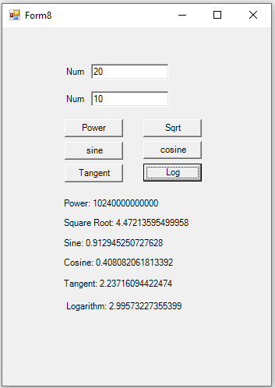

**9 Write a practical of data type conversion function.**

Public Class Form9

Private Sub Button1_Click(sender As Object, e As EventArgs) Handles Type_conv.Click

Dim DbVar As Double = 2.7182818284

Dim objVar As Object

objVar = CObj(DbVar)

MessageBox.Show("CObj=" & objVar.ToString)

DbVar = 125.5678

Dim byVar As Byte

byVar = CByte(DbVar)

MessageBox.Show("CByte=" & byVar.ToString)

DbVar = 123.45

MessageBox.Show("CInt=" & CInt(DbVar).ToString)

DbVar = 25.921987

MessageBox.Show("CSsng=" & CSng(DbVar).ToString)

Dim strVar As String = "Hello"

MessageBox.Show("CChar=" & CChar(strVar))

End Sub

End Class

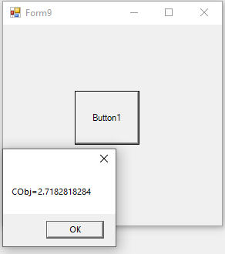 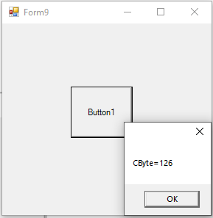 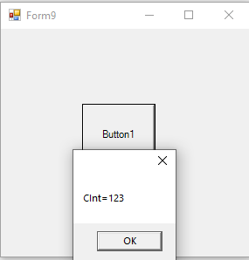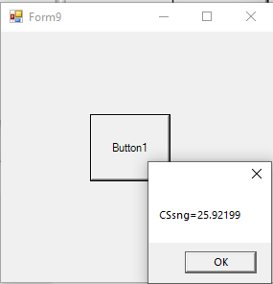 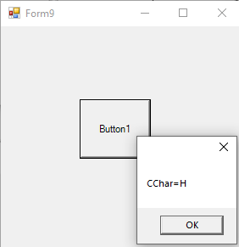

**10 Write a practical of data type checking function.**

Public Class Form10

Private Sub btnCheck_Click(ByVal sender As Object, ByVal e As EventArgs) Handles btnCheck.Click

Dim input As String = txtInput.Text

lblResult.Text = "Data Type: " & CheckDataType(input)

End Sub

Private Function CheckDataType(ByVal obj As Object) As String

Dim result As String = "Unknown"

If IsNumeric(obj) Then

If InStr(obj, ".") > 0 Then

result = "Double"

Else

result = "Integer"

End If

ElseIf TypeName(obj) = "Boolean" Then

result = "Boolean"

ElseIf TypeName(obj) = "Date" Then

result = "DateTime"

Else

result = "String"

End If

Return result

End Function

End Class

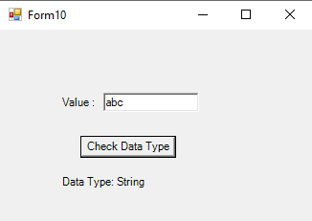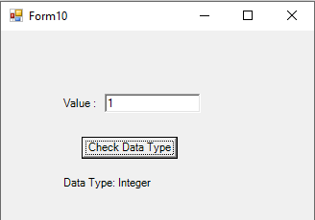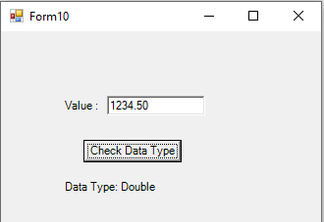

**11 Write a practical of keyboard and mouse event.**

Public Class Form15

Private Sub TextBox1_MouseEnter(sender As Object, e As EventArgs) Handles TextBox1.MouseEnter

MessageBox.Show("Event: MouseEnter on TextBox1")

End Sub

Private Sub TextBox2_MouseLeave(sender As Object, e As EventArgs) Handles TextBox2.MouseLeave

MessageBox.Show("Event: MouseLeave on TextBox2")

End Sub

Private Sub TextBox3_MouseLeave(sender As Object, e As EventArgs) Handles TextBox3.MouseLeave

MessageBox.Show("Event: MouseLeave on TextBox3")

End Sub

Private Sub TextBox4_MouseLeave(sender As Object, e As EventArgs) Handles TextBox4.MouseLeave

MessageBox.Show("Event: MouseLeave on TextBox4")

End Sub

Private Sub Button1_Click(sender As Object, e As EventArgs) Handles Button1.Click

MessageBox.Show("Event: Button Click")

End Sub

Private Sub TextBox1_KeyUp(sender As Object, e As KeyEventArgs) Handles TextBox1.KeyUp

MessageBox.Show("Event: KeyUp in TextBox1 - " & e.KeyCode.ToString())

' Allow only numeric input

If Not Char.IsDigit(ChrW(e.KeyValue)) AndAlso e.KeyCode <> Keys.Back Then

MessageBox.Show("Enter numbers only for Customer ID")

TextBox1.Text = ""

End If

End Sub

Private Sub TextBox_KeyDown(sender As Object, e As KeyEventArgs) Handles TextBox1.KeyDown, TextBox2.KeyDown, TextBox3.KeyDown, TextBox4.KeyDown

MessageBox.Show("Event: KeyDown in " & CType(sender, TextBox).Name & " - " & e.KeyCode.ToString())

End Sub

Private Sub TextBox_KeyPress(sender As Object, e As KeyPressEventArgs) Handles TextBox1.KeyPress, TextBox2.KeyPress, TextBox3.KeyPress, TextBox4.KeyPress

MessageBox.Show("Event: KeyPress in " & CType(sender, TextBox).Name & " - " & e.KeyChar.ToString())

End Sub

End Class

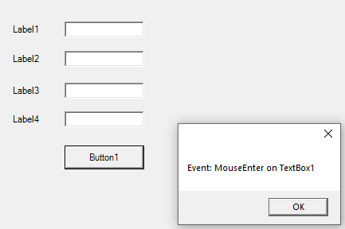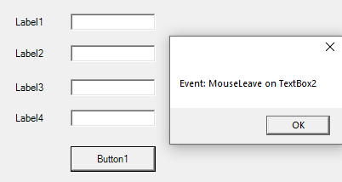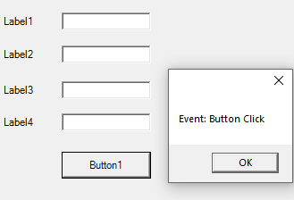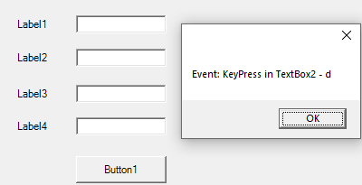

**12 Write a practical of exception handling (example structure and unstructured).**

Public Class Form12

Private Sub btnCalculate_Click(ByVal sender As Object, ByVal e As EventArgs) Handles btnCalc.Click

Try

Dim num As Integer = Convert.ToInt32(txtNum.Text)

Dim num2 As Integer = Convert.ToInt32(txtNum2.Text)

Dim result As Integer = num / num2

lblResult.Text = "Result: " & result.ToString()

Catch ex As DivideByZeroException

MessageBox.Show("Error: Division by zero is not allowed.", "Exception")

Catch ex As FormatException

MessageBox.Show("Error: Please enter valid numbers.", "Exception")

Catch ex As Exception

MessageBox.Show("An unexpected error occurred: " & ex.Message, "Exception")

Finally

txtNum.Clear()

txtNum2.Clear()

End Try

End Sub

End Class

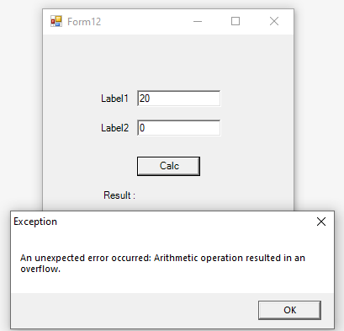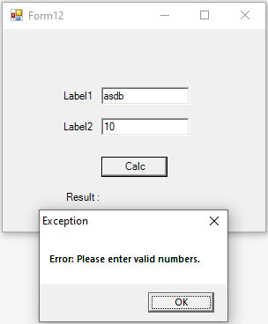

**13 Create VB.Net application to manage students’ data. Student_Master: (S_id, Class, Roll_no, S_name, Address, Phone, Email, Gender, CourseName) Perform following operations: a. Provide Insert, Update, Delete, Display facility. b. Display students’ information of the selected course.**

->Form1.vb

Imports System.Data.OleDb

Public Class Form1

Dim s1 As New Student

Dim cm As OleDbCommand

Dim ds As New DataSet

Dim gender As String = ""

Dim inc As Integer

Private Sub Form1_Load(sender As Object, e As EventArgs) Handles MyBase.Load

FillStudData()

End Sub

Private Sub FillStudData()

ds = s1.Display("select * from StudMast order by Rno")

DataGridView1.DataSource = ds.Tables(0)

End Sub

Private Sub btnInsert_Click(sender As Object, e As EventArgs) Handles btnInsert.Click

If rbMale.Checked Then

gender = "Male"

ElseIf rbFemale.Checked Then

gender = "Female"

End If

s1.IUD("insert into StudMast (Rno, SName, Phno, Address, Email, Gender, Course) values (" + txtRno.Text + ",'" +

txtName.Text + "','" + txtPhno.Text + "','" + txtAddr.Text + "','" + txtEmail.Text + "','" + gender +

"','" + cmCourse.Text + "')")

FillStudData()

ClearControls()

End Sub

Private Sub btnUpdate_Click(sender As Object, e As EventArgs) Handles btnUpdate.Click

If rbMale.Checked Then

gender = "Male"

ElseIf rbFemale.Checked Then

gender = "Female"

End If

s1.IUD("update StudMast set SName='" & txtName.Text & "', Address='" & txtAddr.Text & "', Phno='" & txtPhno.Text & "', Email='" & txtEmail.Text & "', Gender='" & gender & "', Course='" & cmCourse.Text & "' where SID=" & txtSID.Text)

FillStudData()

ClearControls()

End Sub

Private Sub btnDelete_Click(sender As Object, e As EventArgs) Handles btnDelete.Click

s1.IUD("delete from StudMast where SID=" + txtSID.Text)

FillStudData()

ClearControls()

End Sub

Private Sub btnExit_Click(sender As Object, e As EventArgs) Handles btnExit.Click

Me.Close()

End Sub

Private Sub btnFilter_Click(sender As Object, e As EventArgs) Handles btnFilter.Click

FilterData.Show()

End Sub

Private Sub DataGridView1_CellClick(sender As Object, ByVal e As DataGridViewCellEventArgs) Handles DataGridView1.CellClick

inc = e.RowIndex

txtSID.Text = DataGridView1.Rows(inc).Cells(0).Value

txtRno.Text = DataGridView1.Rows(inc).Cells(1).Value

txtName.Text = DataGridView1.Rows(inc).Cells(2).Value

txtPhno.Text = DataGridView1.Rows(inc).Cells(3).Value

txtAddr.Text = DataGridView1.Rows(inc).Cells(4).Value

txtEmail.Text = DataGridView1.Rows(inc).Cells(5).Value

gender = DataGridView1.Rows(inc).Cells(6).Value

If gender = "Male" Then

rbMale.Checked = True

ElseIf gender = "Female" Then

rbFemale.Checked = True

End If

cmCourse.Text = DataGridView1.Rows(inc).Cells(7).Value

End Sub

Private Sub ClearControls()

txtSID.Text = ""

txtRno.Text = ""

txtRno.Enabled = True

txtName.Text = ""

txtPhno.Text = ""

txtAddr.Text = ""

txtEmail.Text = ""

rbMale.Checked = False

rbFemale.Checked = False

cmCourse.Text = ""

End Sub

End Class

->Student.vb

Imports System.Data.OleDb

Public Class Student

Dim cn As New OleDbConnection("Provider=Microsoft.ACE.OLEDB.12.0;Data Source='C:\Users\windows 10\source\repos\StudMast\Database1.accdb'")

Dim cm As OleDbCommand

Dim da As OleDbDataAdapter

Dim ds As New DataSet

Public Sub IUD(ByVal str As String)

If cn.State = ConnectionState.Closed Then

cn.Open()

End If

cm = New OleDbCommand(str, cn)

cm.ExecuteNonQuery()

cn.Close()

End Sub

Public Function Display(ByVal str As String) As DataSet

da = New OleDbDataAdapter(str, cn)

ds.Tables.Clear()

da.Fill(ds)

Return ds

End Function

End Class

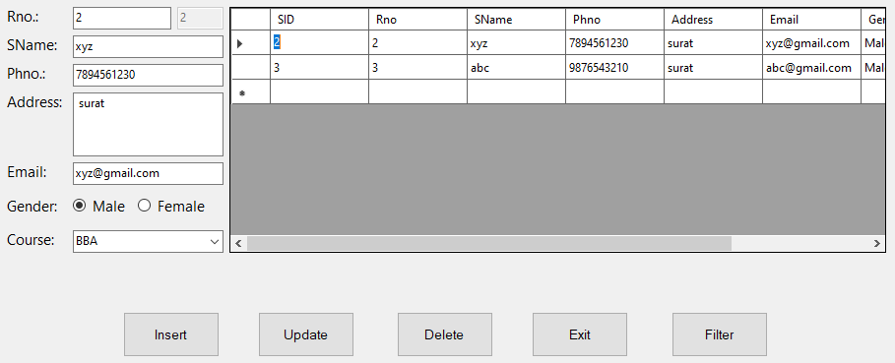

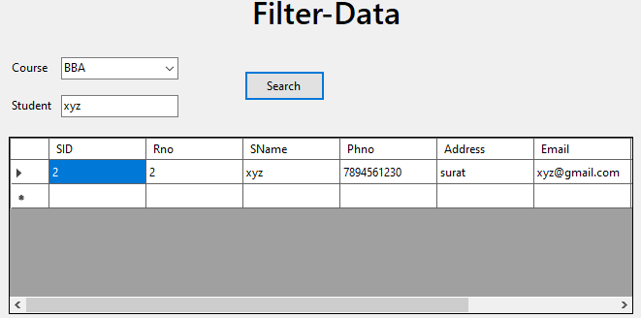

**14 Create VB.Net application for Library Project. Book_Issue: (Book_no, Book_name, Class, Roll_no, Issue_date, Return_date) Perform following operations: a. Provide Insert, Update, Delete and Display facility. b. Display all book details which are issued by a student with Issue_date and Return_date.**

Imports System.Data.OleDb

Public Class StudMast

Dim b As New Student

Dim ds As New DataSet

Dim inc As Integer

Private Sub Form2_Load(sender As Object, e As EventArgs) Handles MyBase.Load

FillBookData()

End Sub

Private Sub FillBookData()

ds = b.Display("SELECT * FROM Book_Issue ORDER BY Book_no")

DataGridView1.DataSource = ds.Tables(0)

End Sub

Private Sub btnInsert_Click(sender As Object, e As EventArgs) Handles btnInsert.Click

b.IUD("INSERT INTO Book_Issue(Book_no, Book_name, Class, Roll_no, Issue_date, Return_date) VALUES (" _

& txtBookNo.Text & ",'" & txtBookName.Text & "','" & txtClass.Text & "'," _

& txtRollNo.Text & ",'" & dtpIssueDate.Text & "','" & dtpReturnDate.Text & "')")

FillBookData()

ClearControls()

End Sub

Private Sub btnUpdate_Click(sender As Object, e As EventArgs) Handles btnUpdate.Click

b.IUD("UPDATE Book_Issue SET Book_name='" & txtBookName.Text & "', Class='" & txtClass.Text & "', " _

& "Roll_no=" & txtRollNo.Text & ", Issue_date='" & dtpIssueDate.Text & "', Return_date='" & dtpReturnDate.Text & "' " _

& "WHERE Book_no=" & txtBookNo.Text)

FillBookData()

End Sub

Private Sub btnDelete_Click(sender As Object, e As EventArgs) Handles btnDelete.Click

b.IUD("DELETE FROM Book_Issue WHERE Book_no=" & txtBookNo.Text)

FillBookData()

End Sub

Private Sub btnShowIssuedBooks_Click(sender As Object, e As EventArgs) Handles btnShowIssuedBooks.Click

ds = b.Display("SELECT * FROM Book_Issue WHERE Roll_no=" & txtRollNo.Text)

DataGridView1.DataSource = ds.Tables(0)

End Sub

Private Sub DataGridView1_CellClick(sender As Object, e As DataGridViewCellEventArgs) Handles DataGridView1.CellClick

inc = e.RowIndex

txtBookNo.Text = DataGridView1.Rows(inc).Cells(0).Value

txtBookName.Text = DataGridView1.Rows(inc).Cells(1).Value

txtClass.Text = DataGridView1.Rows(inc).Cells(2).Value

txtRollNo.Text = DataGridView1.Rows(inc).Cells(3).Value

dtpIssueDate.Text = DataGridView1.Rows(inc).Cells(4).Value

dtpReturnDate.Text = DataGridView1.Rows(inc).Cells(5).Value

End Sub

Private Sub ClearControls()

txtBookNo.Text = ""

txtBookName.Text = ""

txtClass.Text = ""

txtRollNo.Text = ""

dtpIssueDate.Value = DateTime.Now

dtpReturnDate.Value = DateTime.Now

End Sub

Private Sub btnExit_Click(sender As Object, e As EventArgs) Handles btnExit.Click

Me.Close()

End Sub

End Class

->Student.vb

Imports System.Data.OleDb

Public Class Student

Dim cn As New OleDbConnection("Provider=Microsoft.ACE.OLEDB.12.0;Data Source='C:\Users\windows 10\source\repos\StudentMaster\BookMast.accdb'")

Dim cm As OleDbCommand

Dim da As OleDbDataAdapter

Dim ds As New DataSet

Public Sub IUD(ByVal str As String)

If cn.State = ConnectionState.Closed Then

cn.Open()

End If

cm = New OleDbCommand(str, cn)

cm.ExecuteNonQuery()

cn.Close()

End Sub

Public Function Display(ByVal str As String) As DataSet

da = New OleDbDataAdapter(str, cn)

ds.Tables.Clear()

da.Fill(ds)

Return ds

End Function

End Class

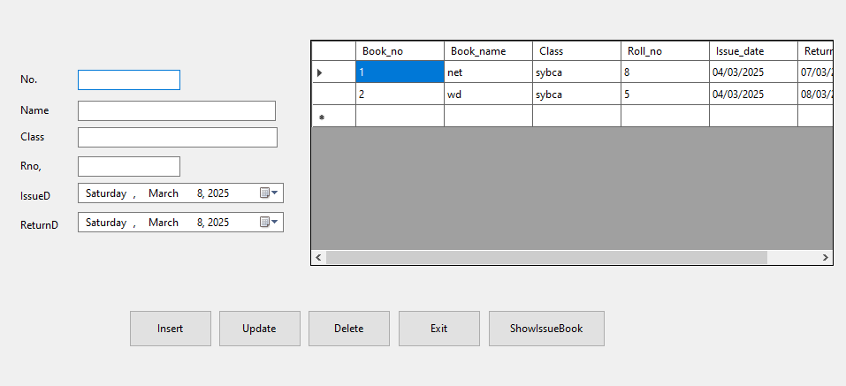

**15 Write a practical of ListBox, CheckedListBox, ComboBox.**

Public Class Form16

Private Sub Form1_Load(sender As Object, e As EventArgs) Handles MyBase.Load

cmbItems.Items.Add("Apple")

cmbItems.Items.Add("Banana")

cmbItems.Items.Add("Mango")

lstItems.Items.Add("Red")

lstItems.Items.Add("Blue")

lstItems.Items.Add("Green")

clbItems.Items.Add("Cricket")

clbItems.Items.Add("Football")

clbItems.Items.Add("Basketball")

End Sub

Private Sub btnAddListBox_Click(sender As Object, e As EventArgs) Handles btnAddListBox.Click

If txtItem.Text <> "" Then

lstItems.Items.Add(txtItem.Text)

txtItem.Clear()

Else

MessageBox.Show("Please enter an item!")

End If

End Sub

Private Sub btnRemoveListBox_Click(sender As Object, e As EventArgs) Handles btnRemoveListBox.Click

If lstItems.SelectedIndex <> -1 Then

lstItems.Items.RemoveAt(lstItems.SelectedIndex)

Else

MessageBox.Show("Select an item to remove!")

End If

End Sub

Private Sub btnShowListBox_Click(sender As Object, e As EventArgs) Handles btnShowListBox.Click

If lstItems.SelectedIndex <> -1 Then

lblSelectedItem.Text = "Selected: " & lstItems.SelectedItem.ToString()

Else

MessageBox.Show("Select an item!")

End If

End Sub

Private Sub btnShowCheckedItems_Click(sender As Object, e As EventArgs) Handles btnShowCheckedItems.Click

Dim selectedItems As String = ""

For Each item In clbItems.CheckedItems

selectedItems &= item.ToString() & vbCrLf

Next

If selectedItems = "" Then

MessageBox.Show("No items selected!")

Else

MessageBox.Show("Selected Items: " & vbCrLf & selectedItems)

End If

End Sub

Private Sub btnAddComboBox_Click(sender As Object, e As EventArgs) Handles btnAddComboBox.Click

If txtItem.Text <> "" Then

cmbItems.Items.Add(txtItem.Text)

txtItem.Clear()

Else

MessageBox.Show("Please enter an item!")

End If

End Sub

Private Sub btnRemoveComboBox_Click(sender As Object, e As EventArgs) Handles btnRemoveComboBox.Click

If cmbItems.SelectedIndex <> -1 Then

cmbItems.Items.RemoveAt(cmbItems.SelectedIndex)

Else

MessageBox.Show("Select an item to remove!")

End If

End Sub

Private Sub btnShowComboBox_Click(sender As Object, e As EventArgs) Handles btnShowComboBox.Click

If cmbItems.SelectedIndex <> -1 Then

lblSelectedItem.Text = "Selected: " & cmbItems.SelectedItem.ToString()

Else

MessageBox.Show("Select an item!")

End If

End Sub

End Class

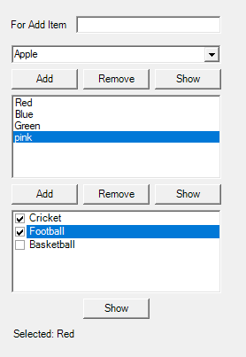

**16 Write a practical of PictureBox.**

Public Class Form17

Private Sub Form17_Load(sender As Object, e As EventArgs) Handles MyBase.Load

PictureBox1.SizeMode = PictureBoxSizeMode.StretchImage

End Sub

Private Sub btnLoadImage_Click(sender As Object, e As EventArgs) Handles btnLoadImage.Click

Dim openFileDialog As New OpenFileDialog()

openFileDialog.Filter = "Image Files|*.jpg;*.jpeg;*.png;*.bmp;*.gif"

If openFileDialog.ShowDialog() = DialogResult.OK Then

PictureBox1.Image = Image.FromFile(openFileDialog.FileName)

End If

End Sub

Private Sub btnClearImage_Click(sender As Object, e As EventArgs) Handles btnClearImage.Click

PictureBox1.Image = Nothing

End Sub

End Class



**17 Write a practical of RitchTextBox.**

Public Class Form18

Private Sub btnBold_Click(sender As Object, e As EventArgs) Handles btnBold.Click

RichTextBox1.SelectionFont = New Font(RichTextBox1.Font, FontStyle.Bold)

End Sub

Private Sub btnItalic_Click(sender As Object, e As EventArgs) Handles btnItalic.Click

RichTextBox1.SelectionFont = New Font(RichTextBox1.Font, FontStyle.Italic)

End Sub

Private Sub btnUnderline_Click(sender As Object, e As EventArgs) Handles btnUnderline.Click

RichTextBox1.SelectionFont = New Font(RichTextBox1.Font, FontStyle.Underline)

End Sub

Private Sub btnColor_Click(sender As Object, e As EventArgs) Handles btnColor.Click

Dim colorDialog As New ColorDialog()

If colorDialog.ShowDialog() = DialogResult.OK Then

RichTextBox1.SelectionColor = colorDialog.Color

End If

End Sub

Private Sub btnClear_Click(sender As Object, e As EventArgs) Handles btnClear.Click

RichTextBox1.Clear()

End Sub

End Class

