
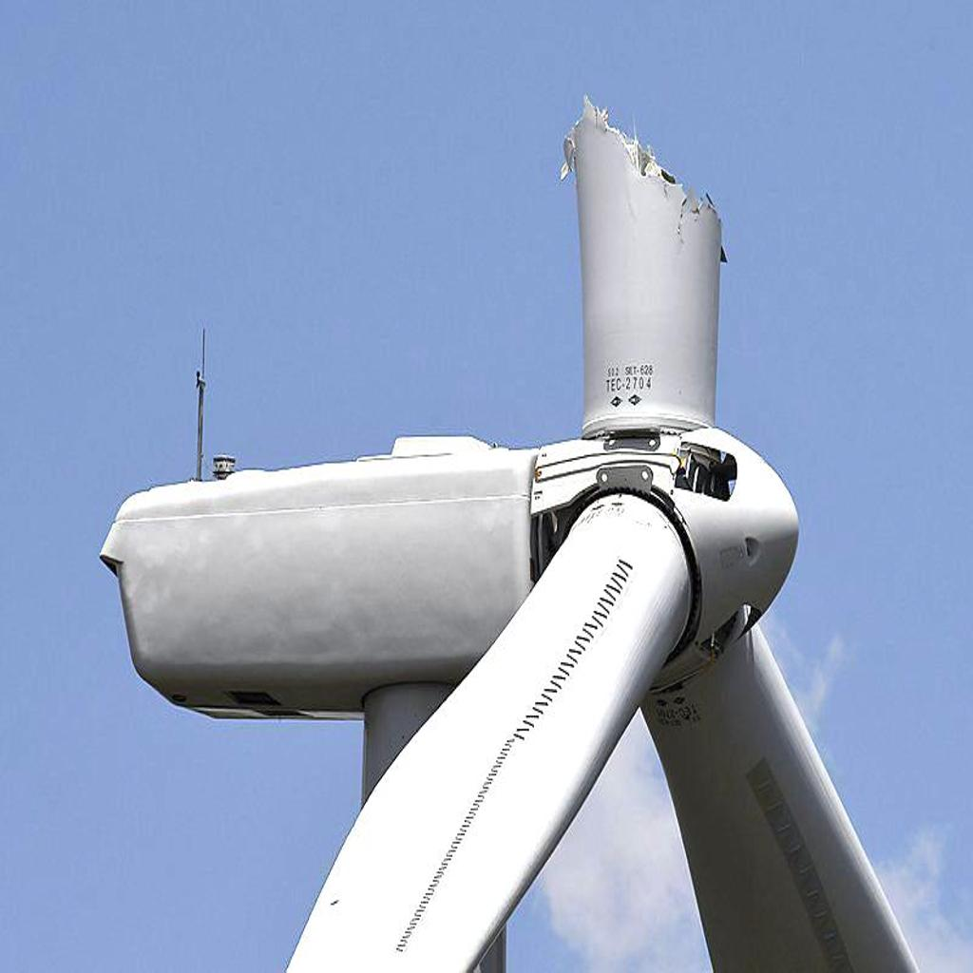
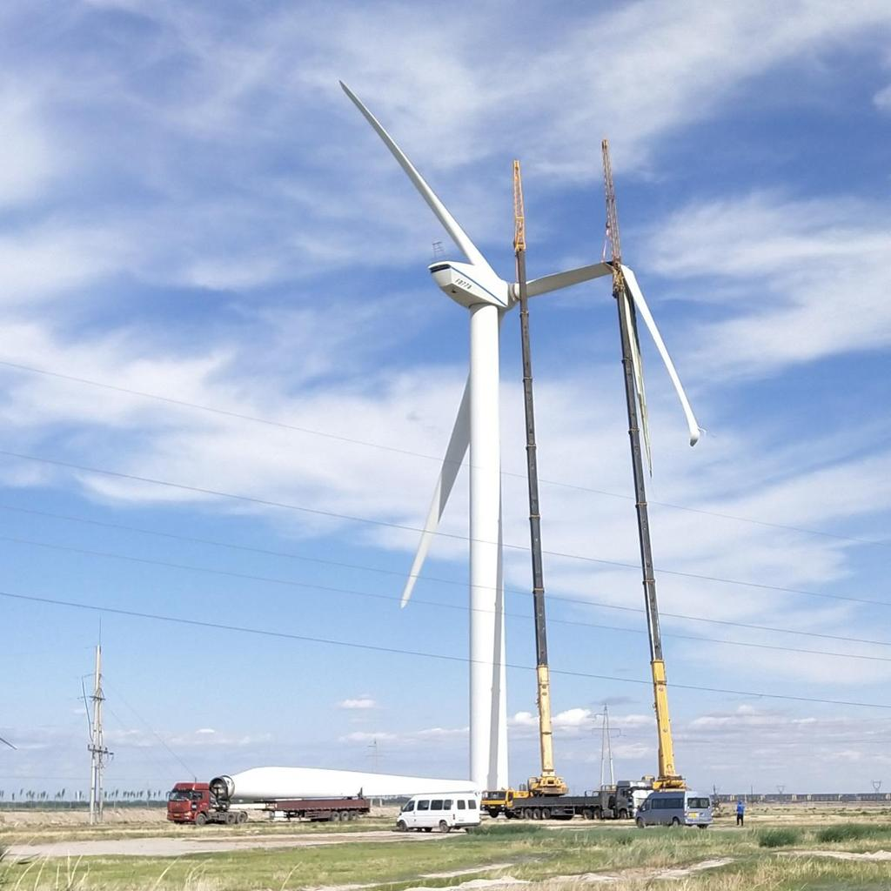
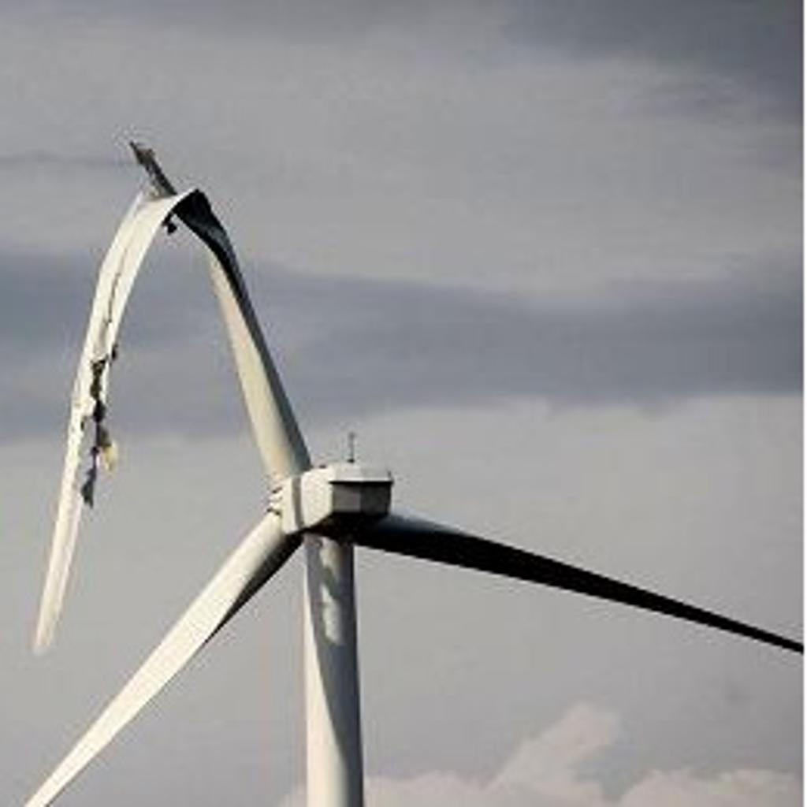

Machine Learning Report

Crop-Based Multi-Class Classification of Wind Turbine Blade Defects from Annotated UAV Images

Bhanu Shyam Steta (5475812)
M.Sc. Data Science (Student)
Institute of Geodesy and Photogrammetry (IGP)
Technische Universität Braunschweig, Germany
b.steta@tu-braunschweig.de
Abstract
Wind turbine blade inspection is an important maintenance task because undetected defects can reduce structural reliability and increase operational cost. In this project, we addressed wind turbine blade defect recognition as a crop-based six-class image-classification problem using annotated drone images. Rather than training a full object detector, we used the provided bounding-box annotations to extract defect crops and evaluated a leakage-safe classification pipeline under the official image-level train, validation, and test split. The dataset contains 1065 annotated source images and approximately 1584 defect instances across the classes craze, corrosion, surface_injure, thunderstrike, crack, and hide_craze. After duplicate-risk exclusion, all models were trained and evaluated on a strict modeling manifest containing 1580 crops.

We compared four completed model families: RGB HOG with Logistic Regression, RGB HOG with Linear SVM, RGB HOG with a multilayer perceptron, and a custom residual convolutional neural network trained directly on raw RGB crops. Validation macro-F1 was used as the primary model-selection criterion because the dataset is multiclass and imbalanced. The final results show a clear progression in representational strength. The best classical models achieved test macro-F1 scores of 0.7496 and 0.7605, the selected HOG-based MLP reached 0.7990, and the final residual CNN achieved the strongest overall performance with a test macro-F1 of 0.8560 and a test accuracy of 0.8613. These results indicate that learned spatial features from raw crops outperform handcrafted HOG-based baselines while remaining computationally practical for a compact end-to-end pipeline.

Keywords: wind turbine blade defects; crop classification; drone imagery; histogram of oriented gradients (HOG); logistic regression (LR); support vector machine (SVM); multilayer perceptron (MLP); residual convolutional neural network (res-CNN); leakage-safe evaluation

- Introduction

1.1 Industrial problem and motivation
Wind turbine blades are exposed to environmental and operational stress that can lead to visible surface defects requiring reliable inspection and maintenance [1]. As wind-energy systems scale further, inspection workflows that support faster and more consistent defect recognition become increasingly valuable [1, 2]. Drone-based imaging is therefore a relevant machine-learning application because it enables detailed visual inspection without requiring direct manual access to the full blade structure [2]. In this context, the present project investigates whether image-based methods can distinguish multiple blade-defect categories in a reliable and computationally manageable way, while preserving a leakage-safe evaluation setup.
1.2 Scope: crop classification instead of detection
Although the underlying dataset is detection-oriented and provides bounding-box annotations, this project deliberately narrows the task to crop-based multiclass classification. Instead of training a full detector, we use the provided annotation boxes to extract defect-centered image crops and predict the corresponding defect category [3, 4]. This scope reduction keeps the pipeline computationally manageable and methodologically clean. It is also appropriate for the dataset structure, since some source images contain multiple annotated defects and multiple classes, which would make full-image classification ambiguous [4].

1.3 Project goal and hypothesis
The main goal of this project is to develop a reproducible and leakage-safe pipeline for classifying cropped wind turbine blade defects into six categories: craze, corrosion, surface_injure, thunderstrike, crack, and hide_craze. To this end, we compare increasingly expressive model families under a shared evaluation protocol, starting from handcrafted-feature baselines and then moving to neural models. Our central hypothesis is that a compact convolutional neural network trained directly on raw RGB crops will outperform handcrafted-feature baselines in multiclass performance, particularly in terms of macro-F1. A secondary expectation is that a nonlinear classifier on top of RGB HOG descriptors will improve over linear HOG baselines, but remain limited by the representational ceiling of handcrafted features.

1.4 Report overview
The remainder of this report is organized as follows. Section 2 describes the dataset, preprocessing pipeline, and leakage-control steps. Section 3 presents the compared model families and the shared evaluation setup, including the classical RGB HOG baselines, the HOG-based multilayer perceptron, and the custom residual convolutional neural network. Section 4 reports and evaluates the final results, including class-wise behavior and error analysis, and discusses the main findings, limitations, and future work. Section 5 provides the overall conclusion.
2. Dataset and Preprocessing (Materials)

2.1 Dataset, task, and split
The dataset used in this project is a real wind turbine blade defect dataset composed of annotated blade-inspection images [3]. In its raw form, it contains 1065 source images, 1065 primary Pascal VOC XML annotation files, a provided image-level train/validation/test split, and a class-definition file. A second-annotator XML set is also available at full count, but the final modeling pipeline uses the primary annotation set as the label source. The six defect classes are craze, corrosion, surface_injure, thunderstrike, crack, and hide_craze. Although the original dataset is detection-oriented because the annotations are bounding boxes, this work reformulates it as a six-class crop-classification task by extracting defect-centered image crops. The official source-image split consists of 745 training images, 159 validation images, and 161 test images, and this split is preserved throughout the pipeline so that every crop inherits the partition of its original image.

2.2 Audit, leakage control, and crop generation
Before model training, we built a leakage-safe preprocessing pipeline that is summarized in Figure 1. The raw-data audit verified image/XML/split consistency, class definitions, auxiliary annotation files, bounding-box validity, duplicate-risk cases, and naming mismatches at the source-image stem level. At this level, the dataset inventory was complete, with 1065 source images, 1065 primary XML files, 1065 second-annotator XML files, and 1065 split entries. Because the internal XML filename field is not always consistent with the XML stem, image–annotation matching is performed by the safer stem-based rule rather than by trusting the filename metadata. The audit also performs explicit duplicate detection at the full-image level using SHA-256 hashes, revealing two exact duplicate image pairs, including one pair crossing the train/validation boundary. Crop extraction is then carried out deterministically from the audited annotations, producing one tight defect crop per annotated object while preserving the original source-image split. Visual overlay and crop sanity checks further confirm that the extracted regions are suitable for downstream classification.

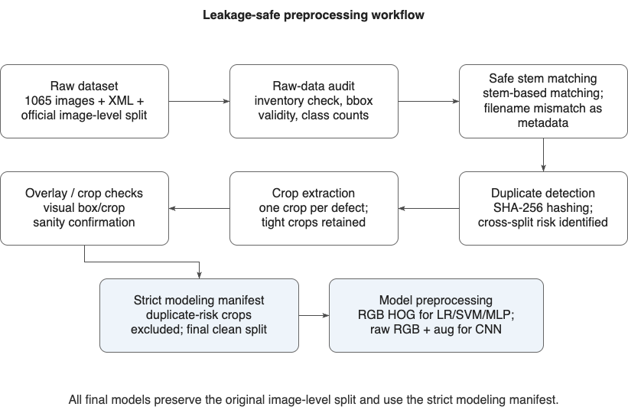
Figure 1. Leakage-safe preprocessing workflow. The raw dataset is first audited for inventory consistency, annotation validity, XML filename mismatches, and duplicate risk. Defect crops are then extracted, visually checked, and filtered into a strict modeling manifest, after which model-specific preprocessing is applied for handcrafted-feature and raw-image models.

2.3 Final preprocessing for the compared models
The final modeling pipeline does not use the raw crop manifest directly. Instead, all models are trained and evaluated on a strict modeling manifest in which all crops originating from exact-duplicate source images are excluded before fitting. After this filtering step, the final clean dataset contains 1580 crops, with 1097 training crops, 245 validation crops, and 238 test crops. All inputs are resized with preserved aspect ratio and padded to a square canvas. For the classical baselines and the HOG-based MLP, the processed crops are converted into RGB HOG descriptors, while the MLP branch additionally standardizes the resulting feature vectors using training-set statistics only. In contrast, the residual CNN is trained directly on raw RGB crops with light augmentation during training and deterministic normalization during validation and test evaluation. This shared strict-manifest foundation ensures that all compared model families remain directly comparable under the same leakage-safe preprocessing setup.

3. Methodology and Evaluation Setup
This section summarizes the compared model families and the shared evaluation setup used throughout the project. We studied a progression of increasingly expressive representations, starting from classical RGB HOG baselines, then moving to a HOG-based multilayer perceptron, and finally to a residual convolutional neural network trained directly on raw RGB crops. Despite these representational differences, all models were trained and evaluated under the same leakage-safe pipeline derived from the strict modeling manifest. Their selected final configurations are summarized in Table 1.

3.1 Model ladder and shared setup
The final comparison consists of four completed model families: RGB HOG with Logistic Regression, RGB HOG with Linear SVM, RGB HOG with a multilayer perceptron, and a residual CNN operating on raw RGB crops. All experiments use the same strict train/validation/test split inherited from the source-image partitions, so differences between models arise from representation and model capacity rather than from changes in data preparation. Validation macro-F1 was used as the primary model-selection metric throughout the project, while the test split was kept as the final unseen benchmark. This shared setup ensures that the comparison remains methodologically consistent across classical and neural approaches.

3.2 Classical baselines
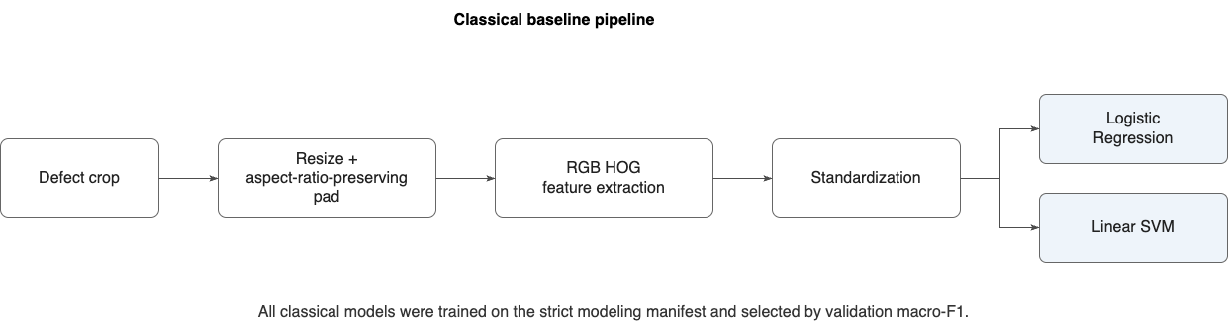
The classical phase uses RGB HOG as a shared handcrafted representation for both linear baselines. As shown in Figure 2, each defect crop is resized with preserved aspect ratio, converted into RGB HOG descriptors, standardized, and then classified by either Logistic Regression [7] or Linear SVM [8]. This design keeps the comparison controlled at the representation level: both models operate on the same feature family, while their behavior differs only through the classifier objective and regularization. HOG was chosen because it compactly captures local edge structure, contour geometry, and damage patterns that are visually relevant for blade-defect recognition [5], while the use of RGB HOG reflects the project’s finding that color information improves the handcrafted feature pipeline over grayscale variants [6].
Figure 2. Classical baseline pipeline. Each defect crop is resized with preserved aspect ratio, converted into RGB HOG descriptors, standardized, and then classified by either Logistic Regression or Linear SVM. All classical models were trained on the strict modeling manifest and selected by validation macro-F1.

3.3 HOG-based MLP
The next model in the ladder is a HOG-based multilayer perceptron (MLP), which extends the handcrafted-feature pipeline with nonlinear decision capacity [9]. As illustrated in Figure 3, defect crops are first resized and padded, converted into RGB HOG descriptors, standardized, and then passed through a shared six-class feedforward network with hidden layers 1024 → 512 → 256. The final retained MLP keeps the same strong RGB HOG representation established in the classical phase, so the comparison remains controlled at the feature level. An exploratory raw-image MLP was not retained, and the final selected model was the deeper validation-selected configuration rather than the widest explored variant. This makes the MLP a well-defined intermediate step between the linear HOG baselines and the raw-image residual CNN.
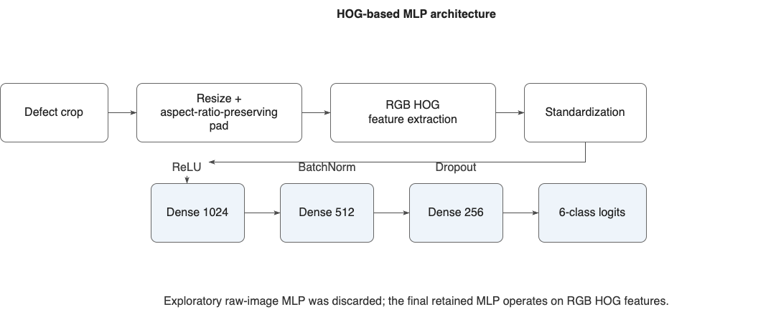
Figure 3. HOG-based MLP architecture. Defect crops are resized and padded, converted into RGB HOG descriptors, standardized, and then processed by a shared multilayer perceptron with three dense hidden layers. The final retained MLP extends the handcrafted-feature pipeline with nonlinear decision capacity.

Note: For HOG-based models, geometric augmentation must be used carefully, because operations such as rotation directly change local gradient orientations and therefore alter the HOG descriptor itself. As a result, strong rotations can reduce feature consistency unless such orientation changes are truly expected in the target data.

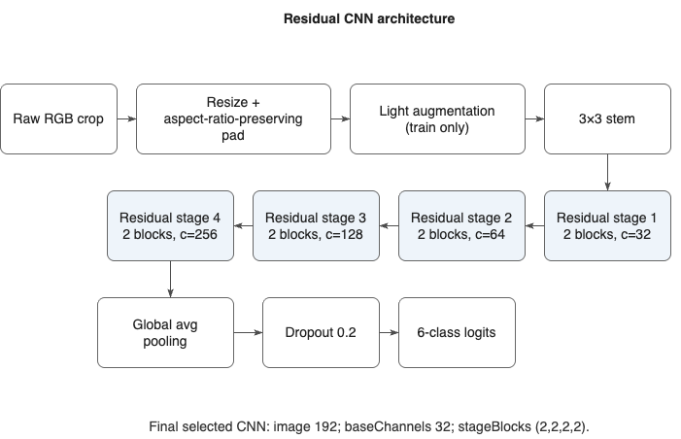
3.4 Residual CNN
Figure 4. Residual CNN architecture. Raw RGB defect crops are resized and padded, lightly augmented during training, and processed by a compact residual CNN with four stages of increasing channel width, followed by global average pooling, dropout, and a six-class output layer.

The final raw-image model is a compact residual convolutional neural network inspired by residual learning architectures [10]. As illustrated in Figure 4, raw RGB defect crops are resized with preserved aspect ratio, lightly augmented during training, and then processed by a convolutional stem followed by four residual stages of increasing channel width. The final selected configuration uses input size 192, base channel width 32, residual stage structure (2,2,2,2), and dropout 0.2 before the six-class output layer. This model forms the final step of the representation ladder, testing whether learned spatial features from raw crops can improve over the handcrafted RGB HOG pipeline while remaining computationally practical.

3.5 Selected configurations and model selection
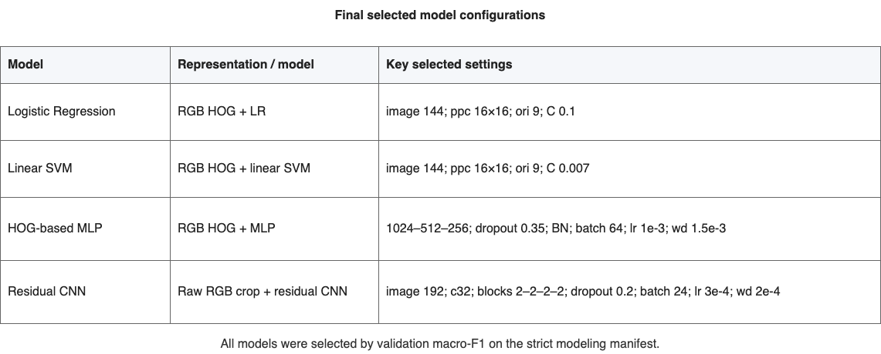
The final selected configurations of all four model families are summarized in Table 1. Across the project, model selection was performed consistently by validation macro-F1 on the strict modeling manifest, while the test split was reserved for the final unseen-data comparison. Under this rule, Logistic Regression is the validation-selected classical winner, the HOG-based MLP is the selected nonlinear handcrafted-feature model, and the residual CNN is the final raw-image deep model. Linear SVM is retained alongside these selected models because, despite ranking below Logistic Regression on validation macro-F1, it remained a strong classical comparator and achieved a slightly higher final test macro-F1.
Table 1. Final selected model configurations. All models were selected by validation macro-F1 on the strict modeling manifest.
4. Results and evaluation
This section reports the final comparison across all completed model families under the shared leakage-safe evaluation setup. Models were selected by validation macro-F1 on the strict modeling manifest, while final performance was reported on the held-out test split. We first summarize the overall ranking across models and then examine class-wise behavior and remaining error patterns.

4.1 Overall comparison
The final comparison shows a clear progression in performance from classical handcrafted-feature models to more expressive neural approaches. As summarized in Table 2 and Figure 5, the two RGB HOG classical baselines provide meaningful benchmarks, with test macro-F1 scores of 0.7496 for Logistic Regression and 0.7605 for Linear SVM. The HOG-based MLP improves this range substantially and reaches a test macro-F1 of 0.7990, indicating that nonlinear classification adds clear value on top of the handcrafted representation. The strongest overall result is achieved by the residual CNN, which reaches a test accuracy of 0.8613 and a test macro-F1 of 0.8560.
This ranking supports the central project hypothesis: learned spatial features from raw crops outperform handcrafted RGB HOG baselines while remaining computationally practical in a compact end-to-end pipeline.

4.2 Class-wise behavior and error analysis
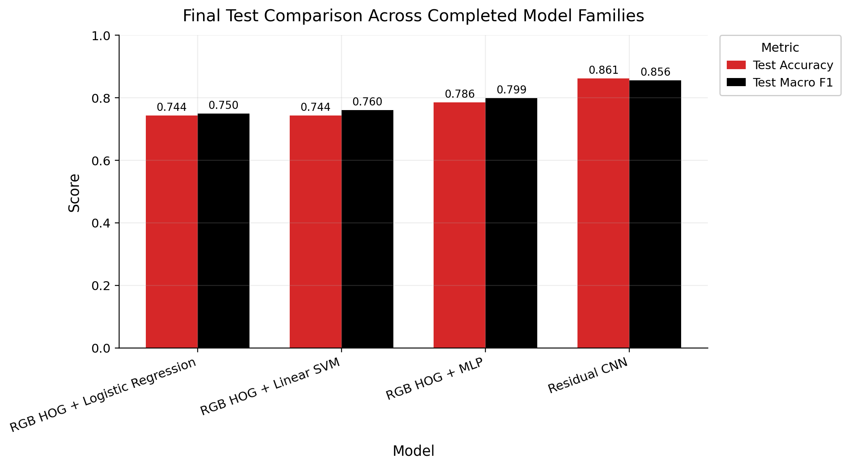
The class-wise F1 comparison in Figure 6 shows that the residual CNN is the strongest model overall, but the gain is not perfectly uniform across all classes. The CNN achieves the best broad class-level balance, which explains its strongest overall macro-F1, while the HOG-based MLP remains particularly competitive on classes such as thunderstrike. In contrast, the two classical RGB HOG baselines show weaker and less balanced class-wise performance. The most difficult cases are concentrated among visually similar surface-damage categories, especially corrosion and classes that overlap with broader surface texture or boundary damage. These error patterns indicate that increasing model capacity improves overall discrimination, but class confusion remains highest where visual differences are subtle and locally ambiguous.
Model \ Metric (%) | accuracy | macroPrecision | macroRecall | macroF1 | weightedF1
Residual CNN | 86.13 | 84.77 | 86.97 | 85.60 | 86.22
RGB HOG + MLP | 78.57 | 80.27 | 80.10 | 79.90 | 78.53
RGB HOG + Linear SVM | 74.37 | 76.47 | 75.82 | 76.05 | 74.30
RGB HOG + Logistic Regression | 74.37 | 75.01 | 75.02 | 74.96 | 74.31
Table 2. Final test-set performance comparison across all completed models.
Figure 5. Final test-set comparison across all completed models. The bar chart summarizes the two headline metrics used for high-level comparison: test accuracy and test macro-F1
4.3 Interpretation, limitations, and future work
The final comparison supports a clear representation ladder. The classical RGB HOG baselines provide meaningful leakage-safe reference points, but their performance indicates that handcrafted descriptors alone are limited in separating visually similar defect categories. The HOG-based MLP improves over both linear HOG baselines, showing that nonlinear classification adds real value even when the underlying representation remains handcrafted. The strongest overall performance is achieved by the residual CNN, suggesting that learned spatial features from raw defect crops are more effective than manually designed descriptors.
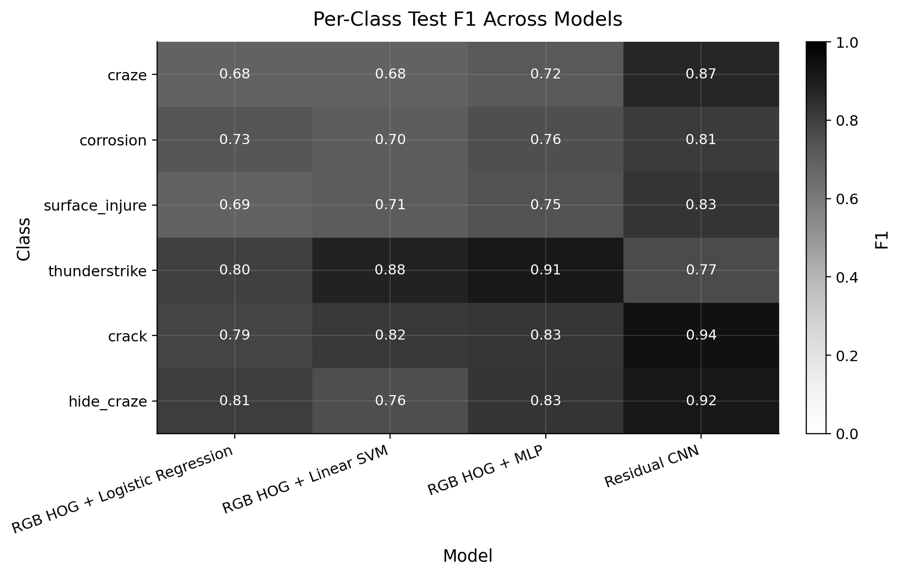
At the same time, the task is not fully solved. Class-wise confusion remains highest among visually similar surface-damage categories, especially around corrosion and related texture-like defects. In addition, the project is limited by its chosen scope, since it evaluates classification on trusted annotated crops rather than full end-to-end detection. A natural next step would therefore be to test stronger pretrained or transfer-learning models on the same strict modeling manifest and examine whether they improve the remaining difficult classes without weakening the clean evaluation setup.
Figure 6. Per-class test F1 across all completed models. The heatmap highlights class-wise performance differences, showing the overall strength of the residual CNN and the remaining difficult defect categories.
5. Conclusions
This project developed a reproducible and leakage-safe pipeline for crop-based six-class classification of wind turbine blade defects from annotated inspection images. Starting from a strict image-level split, the workflow combined raw-data auditing, safe stem-based image–annotation matching, duplicate-risk exclusion, deterministic crop generation, and a shared strict modeling manifest for all compared models. The final results show a consistent performance progression from classical RGB HOG baselines to a HOG-based MLP and finally to a compact residual CNN trained directly on raw RGB crops. Overall, the residual CNN achieved the strongest performance, indicating that learned spatial features provide the most effective representation for this defect-recognition task while remaining computationally practical within the scope of the project.
Use of AI-assisted tools
In preparing this report, Grammarly was used for grammar correction and correct rephrasing. ChatGPT was used as a supportive coding assistant, mainly for syntax help, debugging guidance, and error resolution in project. The project design, methodological decisions, implementation logic, model selection, experiments, and final evaluation remained the author’s own work.

References

[1] M. Memari, P. Shakya, M. Shekaramiz, A. C. Seibi, and M. A. S. Masoum, “Review on the advancements in wind turbine blade inspection: Integrating drone and deep learning technologies for enhanced defect detection,” IEEE Access, vol. 12, pp. 33236–33282, 2024, doi: 10.1109/ACCESS.2024.3371493.

[2] S.-J. Heo and W. S. Na, “Review of Drone-Based Technologies for Wind Turbine Blade Inspection,” Electronics, vol. 14, no. 2, Art. no. 227, 2025, doi: 10.3390/electronics14020227.

[3] L. Ji, J. Cheng, and S. Wu, “Multiclass Dataset for Intelligent Detection of Wind Turbine Blade Defects Using Drone Imagery,” Scientific Data, vol. 13, Art. no. 396, 2026, doi: 10.1038/s41597-026-06762-x.

[4] L. Ji, J. Cheng, and S. Wu, “Multiclass Dataset for Intelligent Detection of Wind Turbine Blade Defects Using Drone Imagery,” figshare, dataset, Mar. 18, 2026, doi: 10.6084/m9.figshare.30210175.

[5] N. Dalal and B. Triggs, “Histograms of Oriented Gradients for Human Detection,” in Proc. IEEE Computer Society Conference on Computer Vision and Pattern Recognition (CVPR), vol. 1, 2005, pp. 886–893, doi: 10.1109/CVPR.2005.177.

[6] K. E. A. van de Sande, T. Gevers, and C. G. M. Snoek, “Evaluating color descriptors for object and scene recognition,” IEEE Transactions on Pattern Analysis and Machine Intelligence, vol. 32, no. 9, pp. 1582–1596, Sep. 2010, doi: 10.1109/TPAMI.2009.154.

[7] C. M. Bishop, Pattern Recognition and Machine Learning. New York, NY, USA: Springer, 2006.

[8] C. Cortes and V. Vapnik, “Support-vector networks,” Machine Learning, vol. 20, no. 3, pp. 273–297, 1995, doi: 10.1007/BF00994018.

[9] D. E. Rumelhart, G. E. Hinton, and R. J. Williams, “Learning representations by back-propagating errors,” Nature, vol. 323, pp. 533–536, 1986, doi: 10.1038/323533a0.

[10] K. He, X. Zhang, S. Ren, and J. Sun, “Deep Residual Learning for Image Recognition,” in Proc. IEEE Conference on Computer Vision and Pattern Recognition (CVPR), 2016, pp. 770–778, doi: 10.1109/CVPR.2016.90.

