PRDA-01: Profit Analysis

NAME:- PRINCE RAJWAR
CERTIFIED DATA ANALYST
BATCH CODE:- 22-JUN-26-CDA

1. Project Objective
The objective of this project is to analyze the relationship between R&D Spend, Administration, Marketing Spend, State, and Profit. The project aims to identify factors associated with profitability, visualize business performance using Power BI, predict profit using regression analysis, and provide data-driven recommendations to the company.

2. Tools Used
- MySQL: Data exploration and SQL-based analysis.
- Microsoft Excel: Data analysis and regression modeling.
- Microsoft Power BI: Data visualization and dashboard creation.

3. Dataset Description
The dataset contains 50 records and the following five features:
Feature | Description
R&D Spend | Amount invested in research and development
Administration | Administrative expenses
Marketing Spend | Marketing-related expenditure
State | State associated with the business record
Profit | Profit earned

4. Regression Analysis
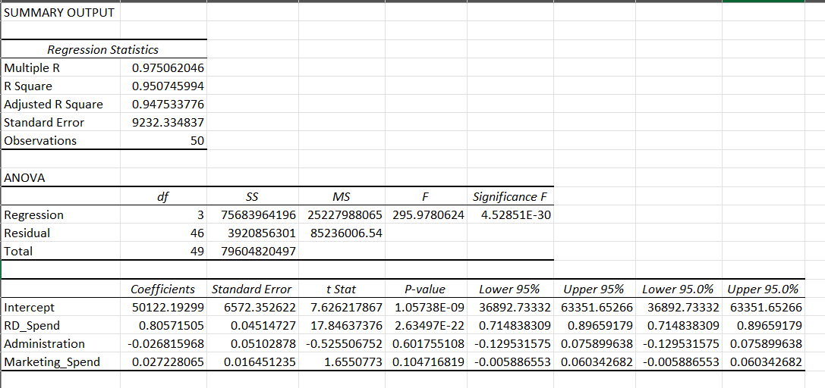
The regression model produced the following results:
Variable | Coefficient | P-value | Interpretation
RD_Spend | 0.8057 | 2.63497E-22 | Statistically significant
Administration | -0.0268 | 0.6018 | Not statistically significant
Marketing_Spend | 0.0272 | 0.1047 | Not statistically significant
The model's R-squared is 0.9507, meaning it explains approximately 95.07% of the variation in Profit in this dataset.
Insight: RD_Spend is a statistically significant predictor of Profit, while Administration and Marketing_Spend are not individually significant at the 5% level.
Recommendation: The company should evaluate the returns from R&D investment and investigate the efficiency of administrative and marketing expenditure before making budget decisions.
Note: Regression results indicate statistical relationships; they do not prove that increasing R&D spending will automatically cause profits to increase.

5. Profit Prediction
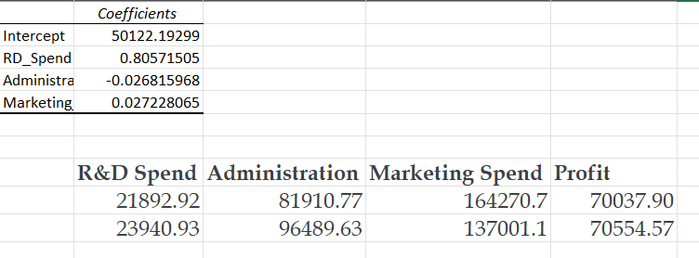
The regression equation is:
Predicted Profit = 50122.19299
+ 0.80571505 (RD Spend)
- 0.026815968 (Administration)
+ 0.027228065 (Marketing Spend)
The model can estimate expected profit for new spending combinations within a reasonable range of the training data. Predictions should be treated as estimates, not guaranteed outcomes.

6. Power BI Dashboard Insights
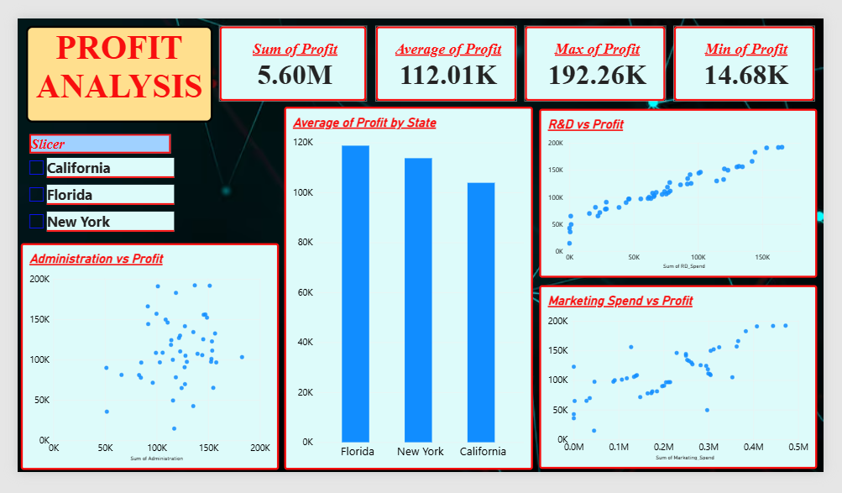
State-wise Profit Analysis
The average profit by state is:
State | Average Profit
Florida | 118,774.02
New York | 113,756.45
California | 103,905.18

Insight: Florida has the highest average profit among the three states, while California has the lowest.
Recommendation: The company should investigate differences in operating costs, customer demand, and business performance across states to understand why profitability varies.

7. Business Recommendations
Based on the analysis, the company should consider the following actions:
- Evaluate R&D investment: Review how R&D expenditure relates to profitability and identify projects that deliver strong returns.
- Compare state performance: Investigate why Florida has a higher average profit than California.
- Review administrative costs: Examine administrative expenses and identify potential operational inefficiencies without automatically cutting necessary spending.
- Measure marketing effectiveness: Track campaign costs, customer acquisition, and resulting revenue to assess marketing ROI.
- Monitor profitability: Use the Power BI dashboard regularly to track total profit, average profit, investment, and state-level performance.
- Validate future predictions: Compare predicted profit against actual results as new data becomes available.

8. Conclusion
This project analyzed startup profitability using MySQL, Excel, regression analysis, and Power BI. The dashboard provides a visual comparison of profitability and spending across the available records. Regression analysis identified R&D spending as a statistically significant predictor of profit, while the overall model explained approximately 95.07% of the variation in the dataset. The findings can help management investigate investment efficiency, compare state performance, and make more informed business decisions.

