NAME – Prince Dabgar

**Module -1: Understanding of Hardware and Its Components**

**Section 1 : Multiple Choice**

1. **Which of the following is NOT a component of the CPU?**
2. **ALU**
3. **RAM**
4. **CU**
5. **1 and 3 both**

**Ans: -** RAM

Reason: - RAM is not inside the CPU, it is used for storing data

ALU and CU are inside CPU and Help it work

1. **What is the function of RAM in a computer?**

**Ans:** - RAM is a temporary memory. It stores data for a short time while the computer is working and helps the CPU work faster. When the computer is turned off, the data is lost.

1. **Which of the following is a primary storage device?**
2. **HDD**
3. **SSD**
4. **SD card**
5. **1 and 2 both**

**Ans: None of this**

All options are secondary storage.

1. **What is the purpose of a GPU?**

**Ans: -** The purpose of a GPU is to process and render graphics and images.

**Section 2: True or False**

1. **True or False: The motherboard is the main circuit board of a computer where other components are attached**

**Ans: -** True

Reason: - The motherboard is the main board of the computer where parts like CPU, RAM, hard disk, and GPU are connected. It helps them work together. Without the motherboard, no part can work.

1. **True or False: A UPS (Uninterruptible Power Supply) is a hardware device that provides emergency power to a load when the input power source fails.**

**Ans: -** True

Reason: - A UPS (Uninterruptible Power Supply) is a hardware device that gives emergency backup power to a computer or other devices when the main electricity fails or goes out suddenly.

1. **True or False: An expansion card is a circuit board that enhances the functionality of a component.**

**Ans: -** True

Reason: - An expansion card is a circuit board that you insert into a computer to enhance or add new functions, like better graphics, sound, or network capability. Examples include graphics card, sound card, and Wi-Fi card.

**Section 3: Short Answer**

1. **Explain the difference between HDD and SSD.**

**Ans: -** 1. Full Form:

HDD: Hard Disk Drive

SSD: Solid State Drive

2. Speed:

HDD is slower in reading/writing data.

SSD is much faster in performance.

3. Parts:

HDD has moving parts (spinning disk).

SSD has no moving parts.

4. Durability:

HDD is less durable and can get damaged if dropped.

SSD is more durable and shock resistant.

5. Noise:

HDD makes noise during use.

SSD is silent.

6. Power Usage:

HDD uses more power.

SSD uses less power.

7. Cost:

HDD is cheaper.

SSD is more expensive.

8. Boot Time:

HDD takes longer to start the system.

SSD boots the system very quickly.

1. **Describe the function of BIOS in a computer system.**

**Ans: - BIOS (Basic Input/Output System) is a program on the computer's motherboard.**

* **Main Functions:**

**1. Starts the Computer:**

**When we turn on the PC, BIOS starts first and helps to load the operating system.**

**2. Checks Hardware:**

**BIOS checks if keyboard, RAM, hard disk, etc. are working properly.**

**3. Connects OS and Hardware:**

**It helps the operating system to talk to hardware parts.**

**4. System Settings:**

**We can use BIOS to change settings like date/time, boot order, etc.**

**10. List and briefly explain three input devices commonly used with computers.**

**Ans:** - 1. Keyboard: A keyboard is used to enter text, numbers, and commands into the computer. It includes keys like letters, numbers, and symbols.

2. Mouse: A mouse is a pointing device used to move the cursor, select items, and open files or folders by clicking.

3. Scanner: A scanner is used to convert physical documents or images into digital format so that they can be saved and used on the computer.

**Section 4: Practical Application**

11. **Identify and label the following components on a diagram of a motherboard:**

**● CPU**

**● RAM slots**

**● SATA connectors**

**● PCI-E slot**

**Ans:-**

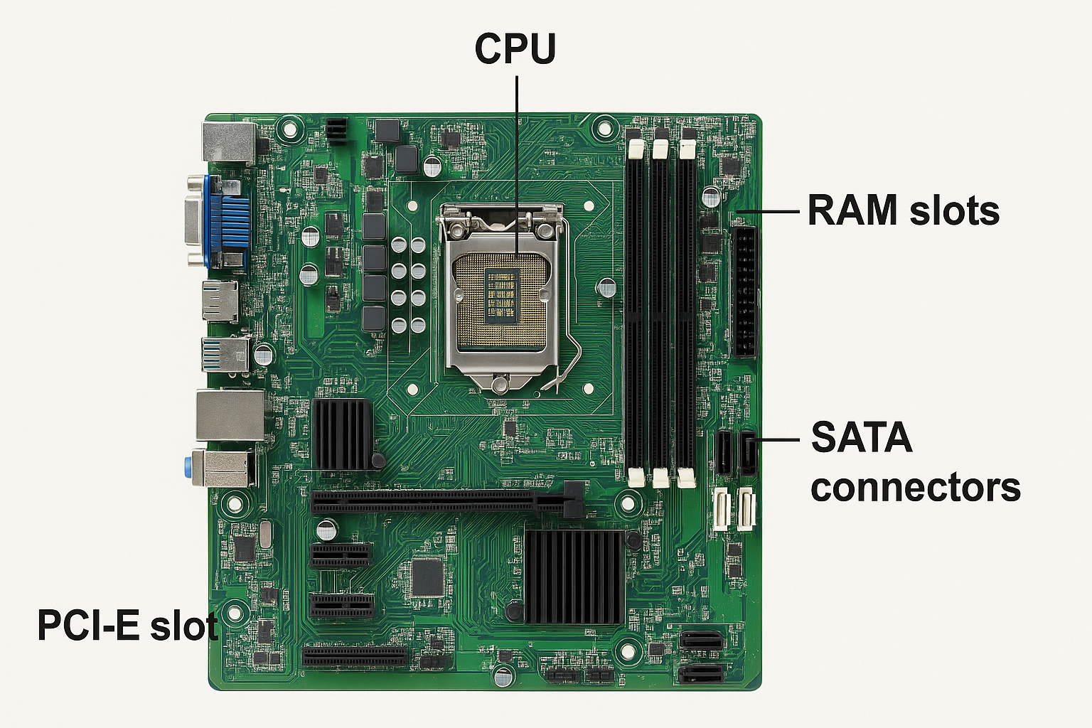

12. **Demonstrate how to install a RAM module into a computer**

**ANS:**

**Step 1: Power Off the Computer**

**Turn off the computer and unplug it from the power source for safety.**

**Step 2: Open the Case**

**Remove the side panel of the CPU cabinet using a screwdriver (if needed).**

**Step 3: Locate the RAM Slots**

**Find the RAM slots on the motherboard. They are long slots, usually next to the CPU.**

**Step 4: Align the RAM Module**

**Hold the RAM module carefully. Match the notch (cut) on the RAM with the slot to align it properly.**

**Step 5: Insert the RAM**

**Push the RAM module straight into the slot with firm pressure until the side clips lock it in place.**

**Step 6: Close the Case**

**Once RAM is installed, close the computer case and tighten the screws.**

**Step 7: Power On and Check**

**Plug in the computer and turn it on. Go to system settings to check if the RAM is detected.**

**Section 5: Essay**

**13. Discuss the importance of proper cooling mechanisms in a computer system. Include examples of cooling methods and their effectiveness.**

### Ans: - Cooling is very important in a computer system. When we use a computer, parts like CPU and GPU become hot. If they are not cooled properly, the system can slow down, stop working, or even get damaged. So, cooling helps the computer to run smoothly and safely.

### Importance of Cooling:

### 1.Keeps the system cool and safe.

### 2.Stops the computer from overheating.

### 3.Improves speed and performance.

### 4.Increases the life of computer parts.

### 5.Helps in gaming, video editing, and heavy work.

### Types of Cooling Methods:

### 1. Air Cooling (Fans):

### Fans blow hot air out and bring cool air in. Mostly used in normal computers.

### 2. Heat Sink:

### A metal piece that absorbs heat from the CPU and keeps it cool.

### 3. Liquid Cooling:

### Used in high-performance systems. It uses liquid to take away heat.

### 4. Thermal Paste:

### A special paste between CPU and heat sink to transfer heat better.

### 5. Laptop Cooling Pad:

### An extra fan pad used under laptops to keep them cool.

**14. Explain the concept of bus width and its significance in computer architecture**.

### Ans: - Concept of Bus Width and Its Significance in Computer Architecture

In a computer, data moves between different parts such as the CPU, memory, and input/output devices through pathways called **buses**. The **bus width** refers to the number of bits that can travel through these pathways at the same time.

For example, if a bus has a width of 8 bits, it can carry 8 bits of data in one go. If it is 32 bits wide, it can carry 32 bits at once. This means the wider the bus, the more data it can move in a single step.

The significance of bus width lies in its effect on the computer’s speed and performance. A wider bus can transfer more data at once, which makes the computer faster because it can send and receive large chunks of data quickly. On the other hand, a narrow bus moves less data at a time, which can slow down the system.

In computer architecture, bus width affects:

* **Data transfer rate:** Wider buses increase the amount of data transferred between components.
* **Processor performance:** The CPU can work faster if it can access more data at once.
* **Memory access:** Wider data buses allow the CPU to read or write larger amounts of data to memory efficiently.

Top of Form

Bottom of Form