**Machine Learning**

**Final Project**

Prince David Sanam

WSU ID: M339J323

Creating the Deep learning models that make up a committee and obtain the accuracies of each model and the average of the accuracies of three models will be the accuracy of the committee.

Step 1:

Import the necessary libraries which are to be used.

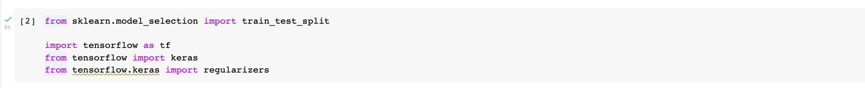

Step 2:

Importing the dataset,

Step 3:

Split the data set into train and validation sets,

Now as asked, we must create 3 individual models which makes a committee,

Step 4:

Let us create model 1,

Get the accuracy of the model,

Step 5:

Create model 2:

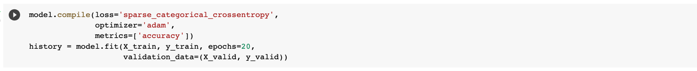

Calculate the accuracy,

Step 6:

Construct model 3:

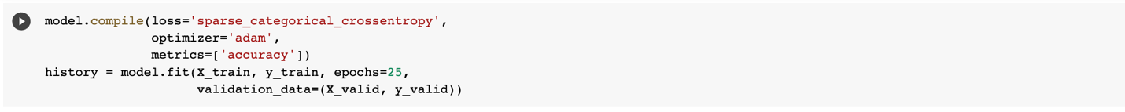

Let’s check the accuracy of the model,

Now we have created 3 models and obtained the accuracies of each model. We must get the accuracy of the committee and interpret the values.

Step 7:

Obtain the accuracy of the committee (Average accuracy),



**Analysis:**

We have created a committee that consists of three models. We have obtained the accuracies of each deep learning models names model1, model2 and model3 respectively.

The train accuracy, validation accuracy and test accuracy for each deep learning model is as follows,

Model1:

Train Acc: 89.85272645950317

Validation Acc: 88.55999708175659

Test Acc: 88.20000290870667

Model2:

Train Acc: 91.68363809585571

Validation Acc: 88.94000053405762

Test Acc: 88.63000273704529

Model3:

Train Acc: 95.55636644363403

Validation Acc: 88.27999830245972

Test Acc: 88.84000182151794

These three models make up the committee, so the total accuracy of the committee will be the average of the individual accuracies of the deep learning models. Now, the accuracy of the committee is as follows,

Accuracy = (testaccuracy_1 + testaccuracy_2 + testaccuracy_3)/3

= 0.8855666915575663

From the above values we can understand that the committee is 88.5% accurate