ASSIGNMENT

1. WPP to enter length and breadth of a rectangle and calculate area and perimeter of rectangle.

Ans:

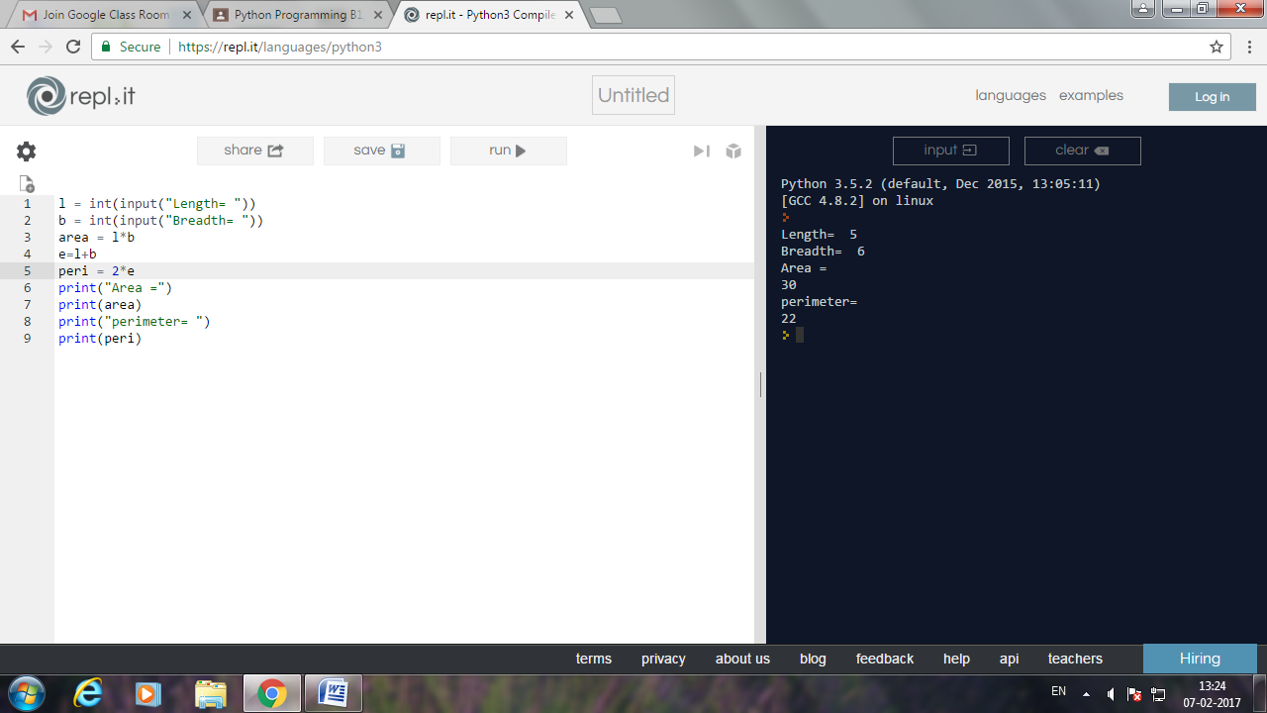

1. WPP to enter the radius of the circle and find area and circumference.

Ans:

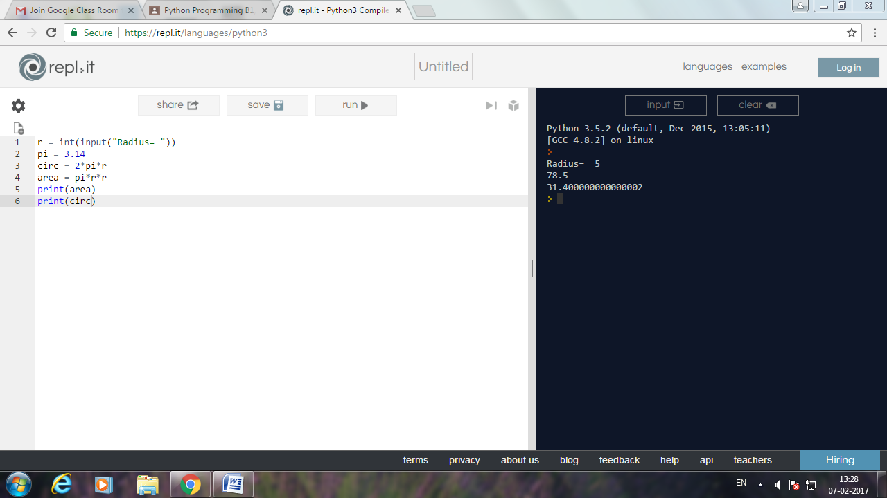

1. WPP to enter value in cm and convert it into meter and kilometer.

Ans:

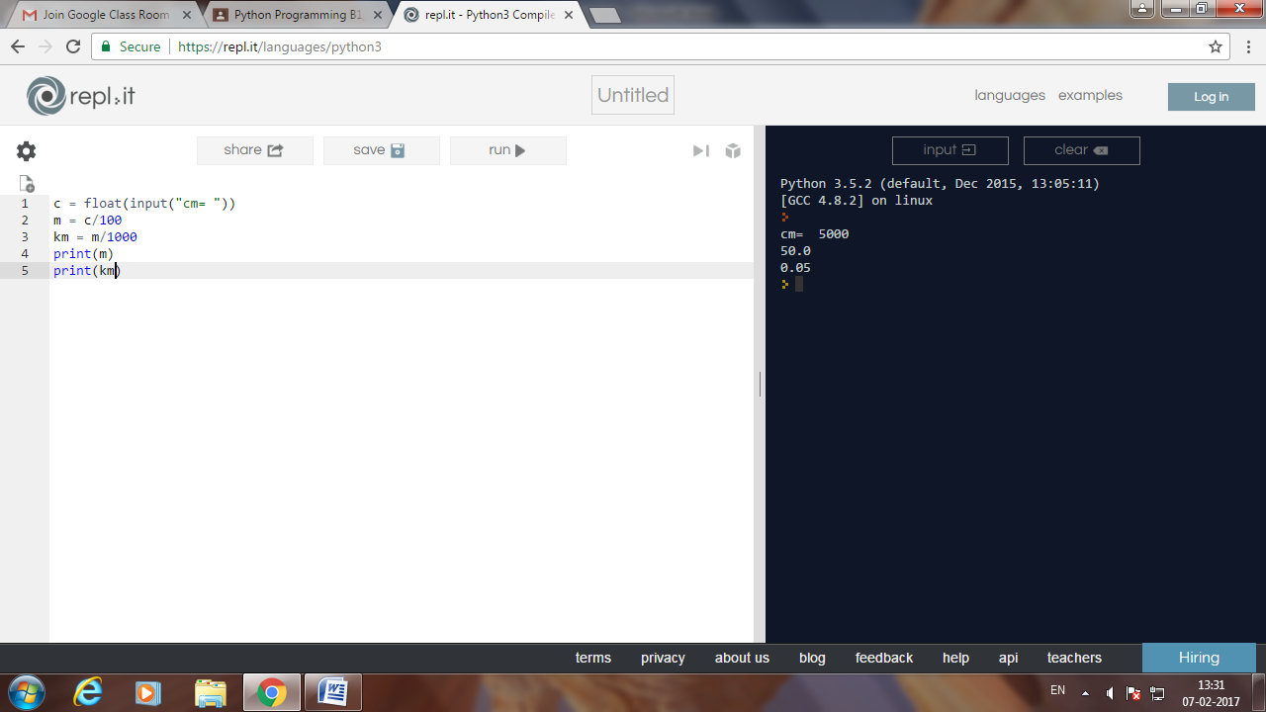

1. WPP to enter a value in Celsius and convert it into Fahrenheit.

Ans:

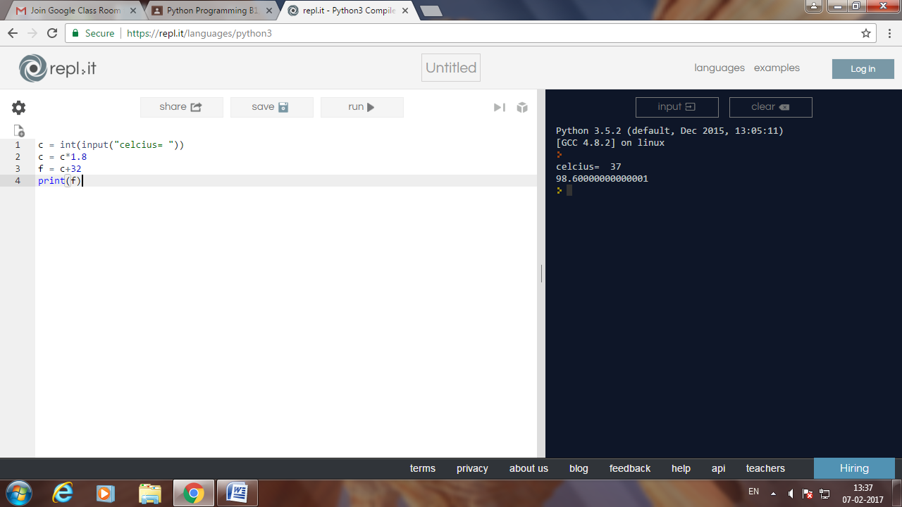

1. WPP to enter days and convert it into year, months and days.

Ans:

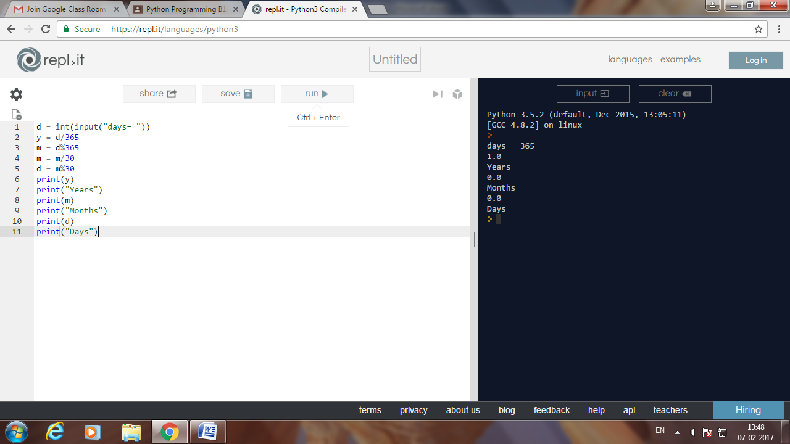

1. WPP to find power of any numbers in form of x^y where x and y are user input.\

Ans:

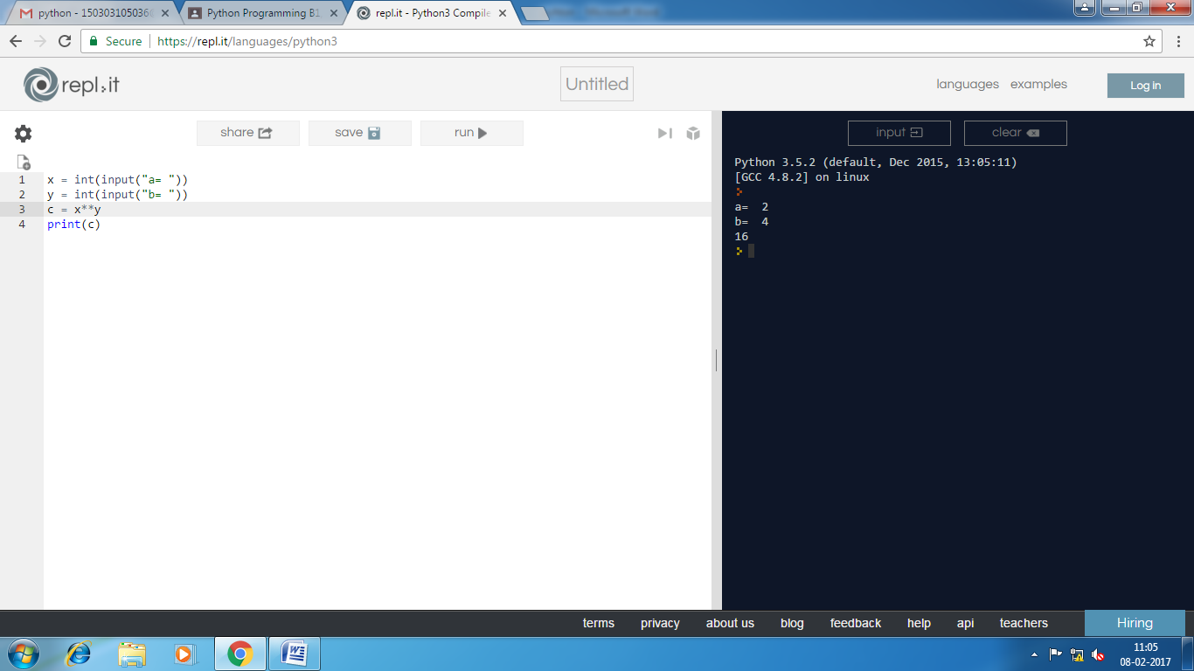

1. WPP to enter two angles using function thirdangle(angle1,angle2) to calculate the third angle.

Ans:

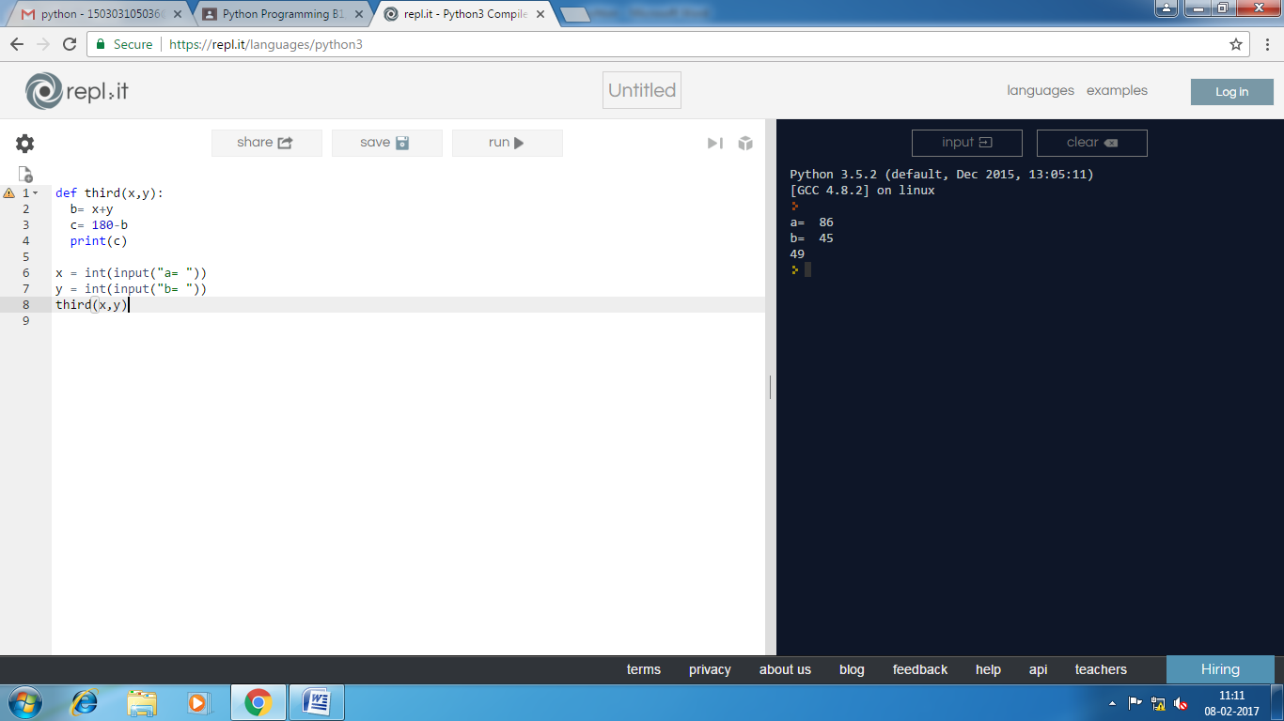

1. WPP to enter the base and height of a triangle and calculate area of the triangle.

Ans:

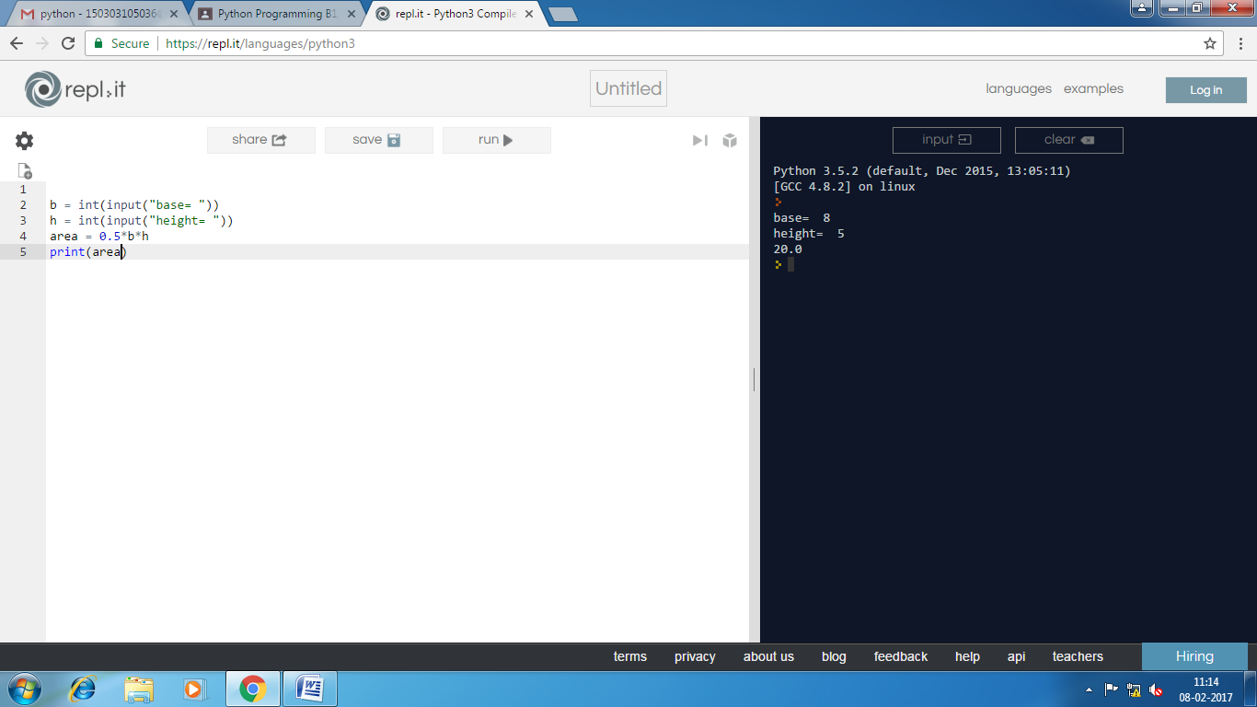

1. WPP to enter the marks of five subjects and find the mean of 5 subjects and calculate percentage. If percentage is less than 35 print fail else pass.

Ans:

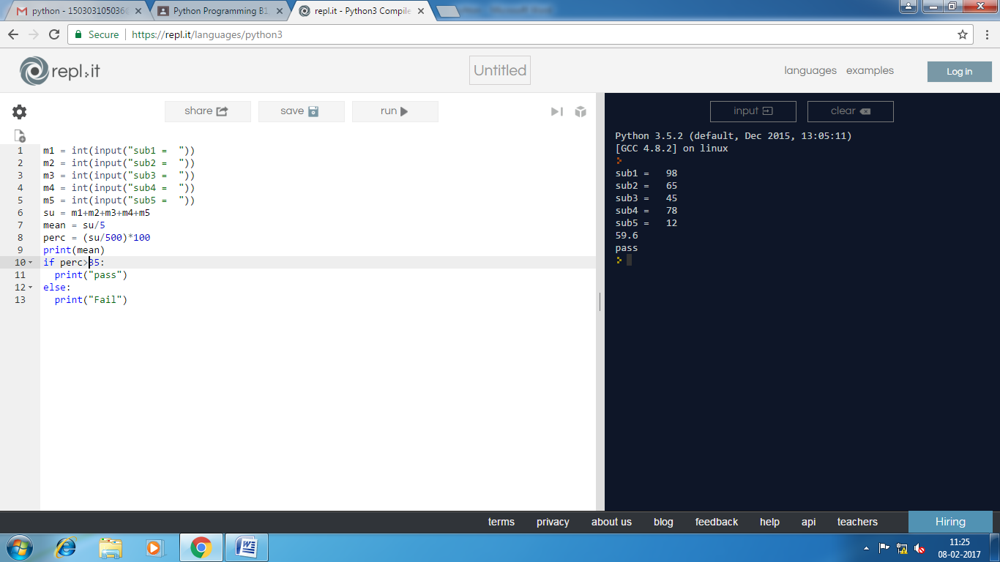

1. WPP to enter principal amount, time and interest rate. Create a simple_interest(principal,time,rate) function to calculate simple interest.

Ans: 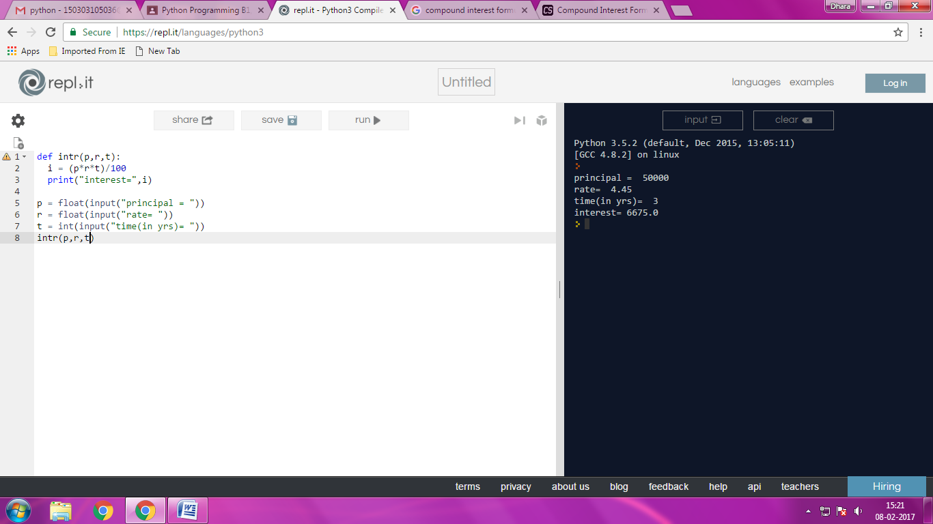

1. WPP to enter principal amount, time and interest rate. Create a simple_interest(principal,time,rate) function to calculate simple interest.

Ans:

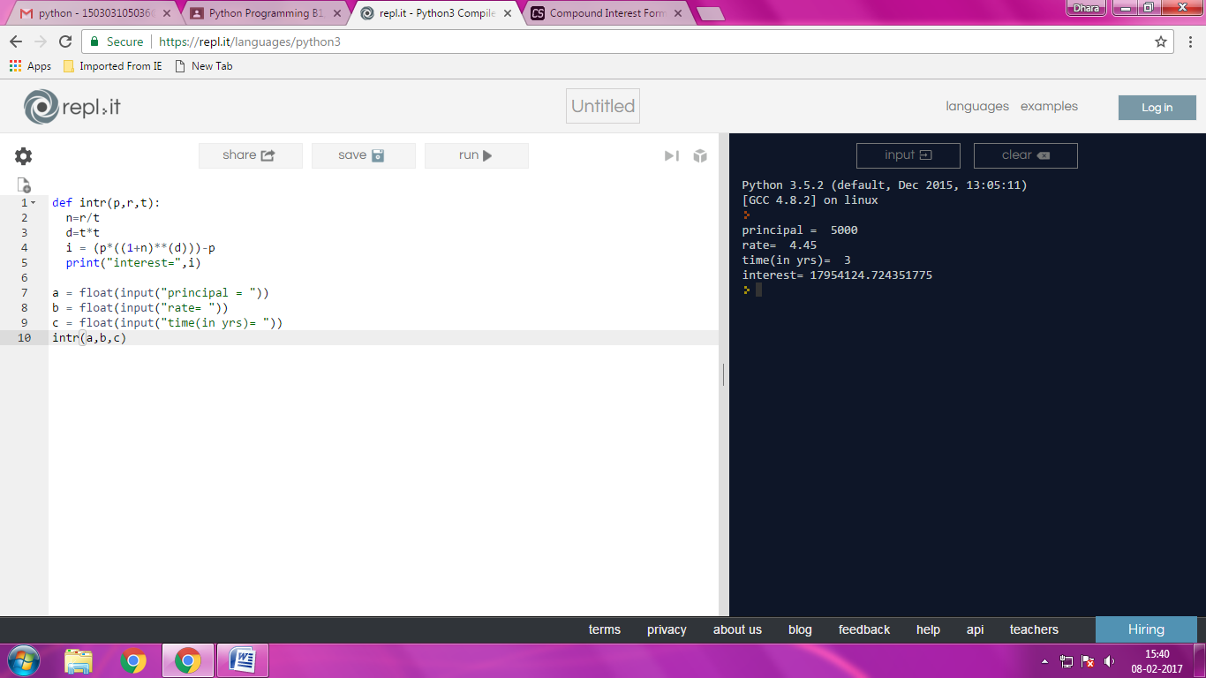

1. WPP that accepts an integer (n) and computes the value of n+nn+nnn.

Ans:

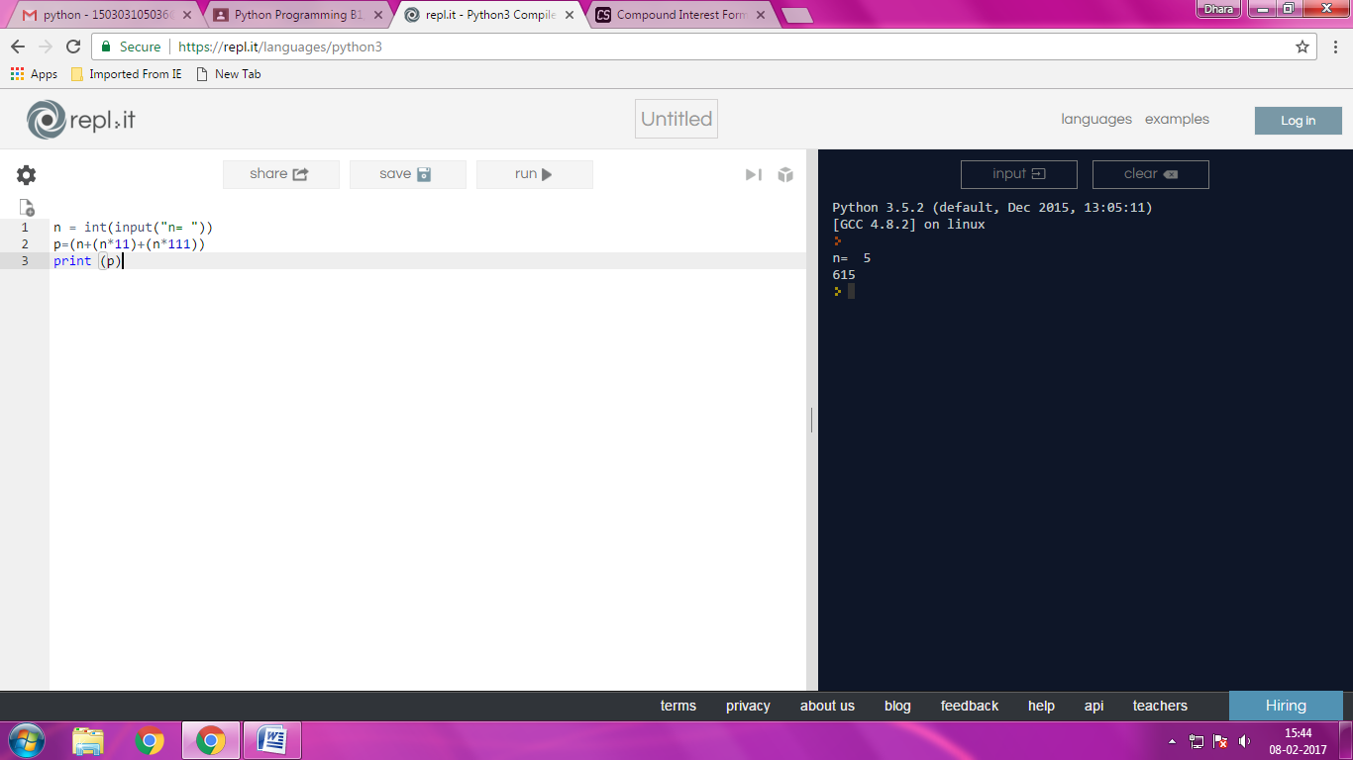

1. WPP to find whether a give number is even or odd and give an appropriate message to the user.

Ans:

