PHISHING EMAIL DETECTION
& AWARENESS REPORT
Real-World Email Threat Analysis
Prince Makwana
Future Interns — Cyber Security Internship | Task 2
September 2026

Executive Summary
This report analyzes two real phishing emails received in a live Gmail inbox, both using gambling/casino-themed prize scams to lure the recipient into clicking a verification link. Each email was examined for sender authenticity, domain legitimacy, and manipulation tactics, then classified by risk level with plain-language explanations and prevention guidance suitable for non-technical users.

Tools Used
- Gmail (source inbox — samples flagged by Gmail's own spam filter)
- Email header inspection (sender address, "mailed-by", "via" domain)
- Manual link/domain legitimacy review

Classification Summary
Email | Classification | Primary Technique
"You Received a Payment of $7,000.00 USD" | PHISHING | Sender-name spoofing + unrelated relay domain
"You have received 15.99$ ... Raging Bull Casino" | PHISHING | Brand-lookalike domain (fake LinkedIn subdomain) + urgency

Detailed Analysis

Email 1: "You Received a Payment of $7,000.00 USD"
Classification | PHISHING — High Confidence
Displayed Sender | Re:{prince.dheeraj.makwana} <prince.dheeraj.makwana@iuzaynhwullgw.us>
Relay / "via" Domain | trump-usa.wqxj.transmissini.info
Subject Lure | Fake $7,000 payment / casino jackpot notification
Spam Status | Automatically flagged as Spam by Gmail
Indicators Identified
- Sender-name spoofing: the email is crafted to display the recipient's own name in the "From" field, a manipulation tactic to appear self-referential and trustworthy.
- The actual sending domain (iuzaynhwullgw.us, relayed via trump-usa.wqxj.transmissini.info) is a random, unrelated string with no connection to any legitimate payment or casino service.
- Urgency and reward-based manipulation: large dollar figure ($7,000) designed to trigger excitement and reduce careful judgment.
- Multiple "Verify*" links and a "CONFIRM & CLAIM NOW" button — classic credential/data harvesting call-to-action.
- Gmail's own spam filter independently flagged this message before any manual review.
Business/Personal Impact
If the "Verify" or "Claim" links were clicked, the victim would likely be directed to a fake form requesting personal details, banking information, or an upfront "processing fee" — a well-known advance-fee fraud pattern. Providing any information here could lead to identity theft or direct financial loss.
Evidence Screenshots
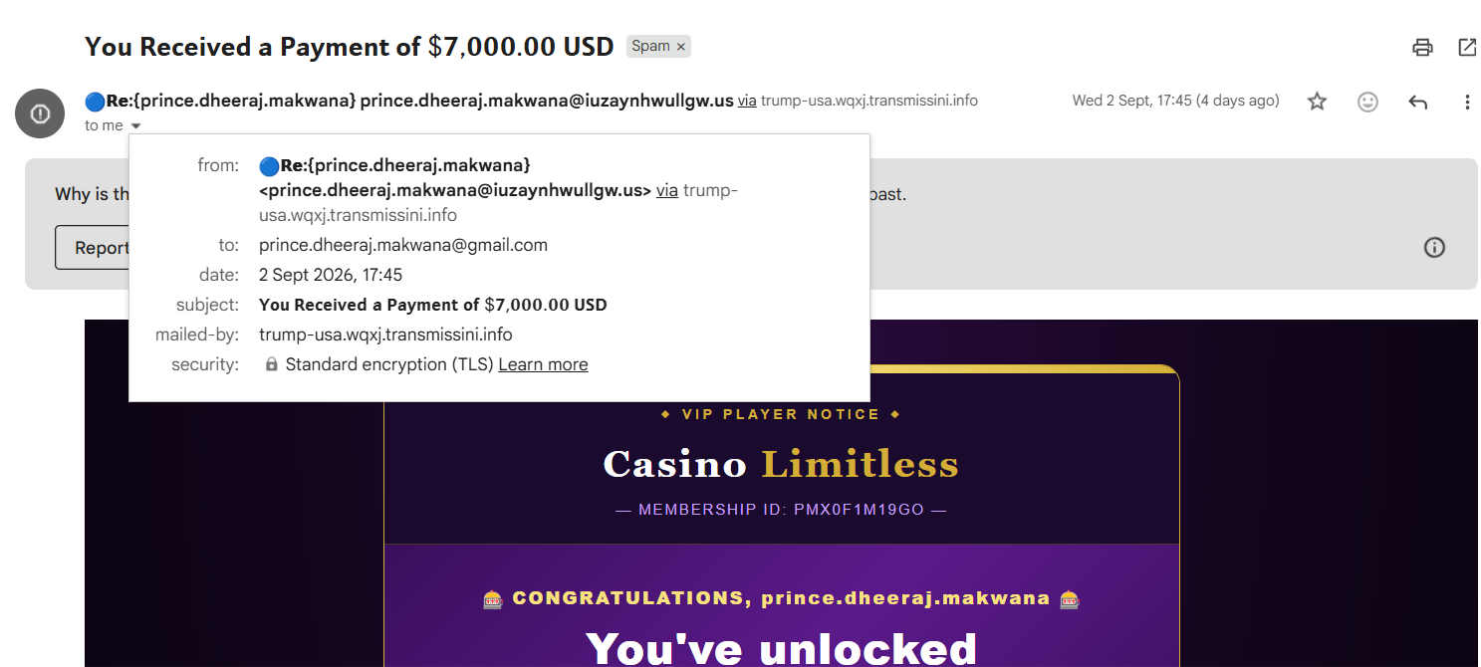
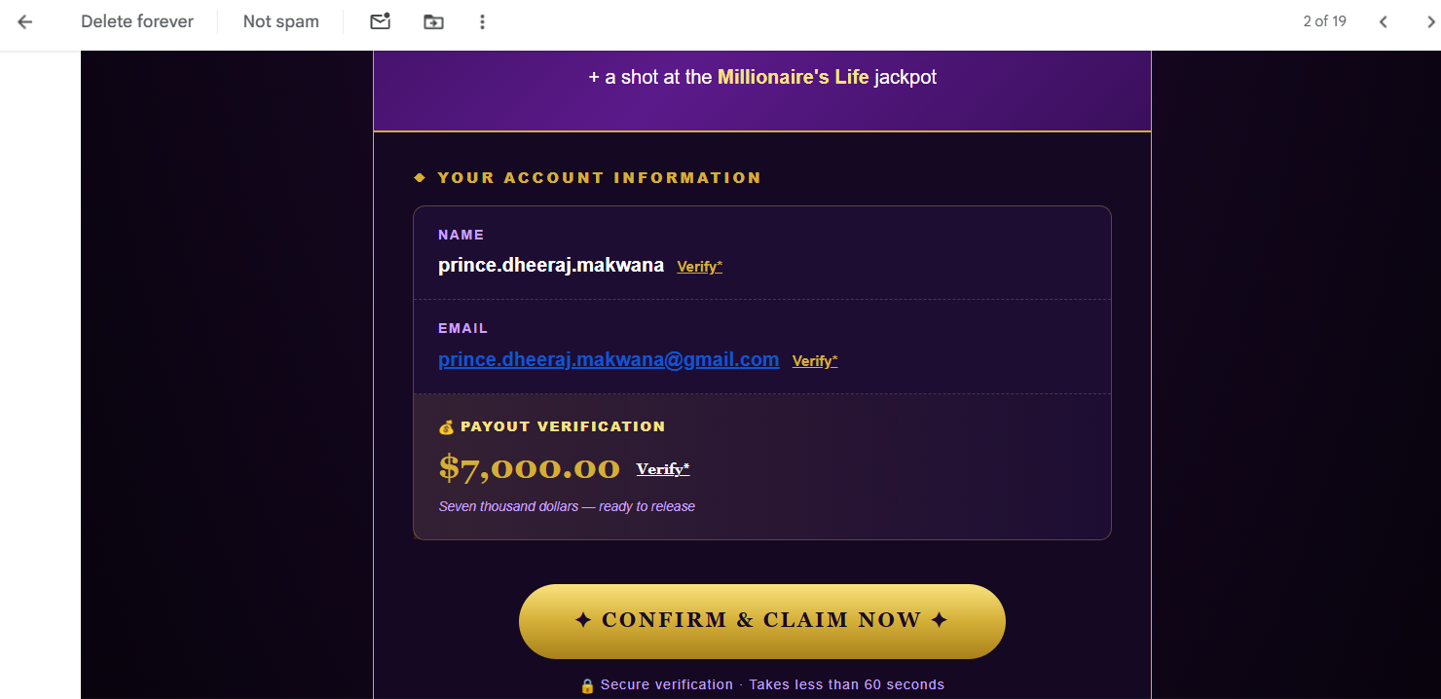

Email 2: "You have received 15.99$ ... Raging Bull Casino"
Classification | PHISHING — High Confidence
Displayed Sender | ybqktdmydruapm.19692330894422@f376re.x8qccv.65wl8t.connect-master.linkedin.com.discover...
Subject Lure | Fake $15.99 casino balance, "No Deposit Required"
Gmail's Own Warning | "It seems to be an auto-reply to a message that pretended to be sent from your email address"
Indicators Identified
- Brand-lookalike domain trick: the sender address contains the string "linkedin.com" deep inside a long subdomain chain, but the actual domain is not linkedin.com at all — this is designed to make an automated scan or a quick glance appear legitimate.
- Gmail explicitly identifies this as a spoofed auto-reply pattern ("backscatter"), a technique where scammers forge the sender to look like a reply to something the victim supposedly sent.
- Deliberately small reward amount ($15.99) — smaller, more "believable" figures are less likely to trigger suspicion than large ones.
- Manufactured urgency: "Account expires: 48 hours" and "your account will be closed within 48 hours" pressure the recipient to act without thinking.
- Call-to-action button ("Confirm Balance Now!") leading to what is very likely a credential-harvesting page.
Business/Personal Impact
The combination of a trusted-brand lookalike domain and a false deadline is designed to bypass critical thinking. Clicking through could expose login credentials, payment details, or personal identifying information to the attacker, and the spoofing technique used here could also implicate the victim's own address in further spam campaigns.
Evidence Screenshots
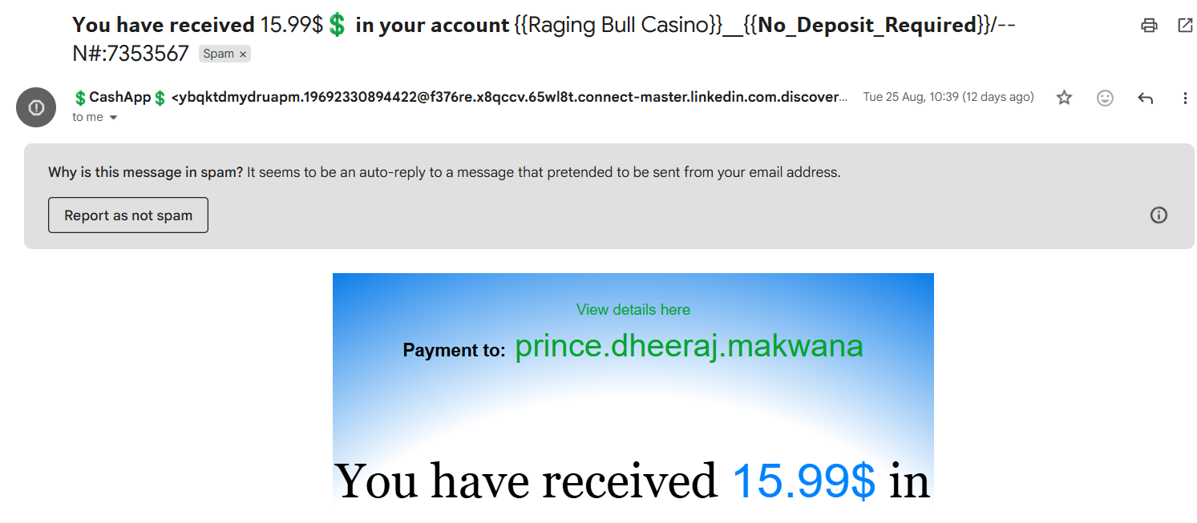
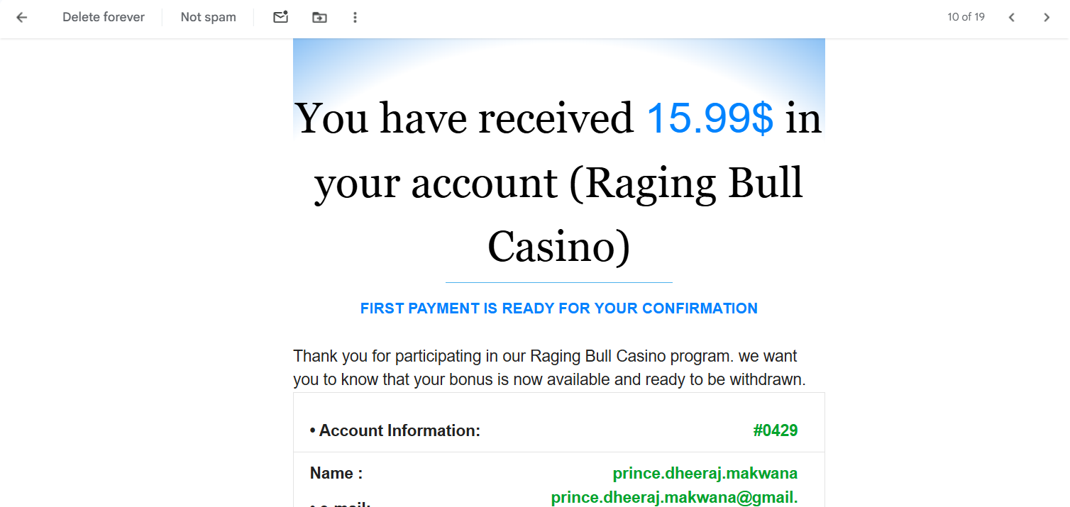
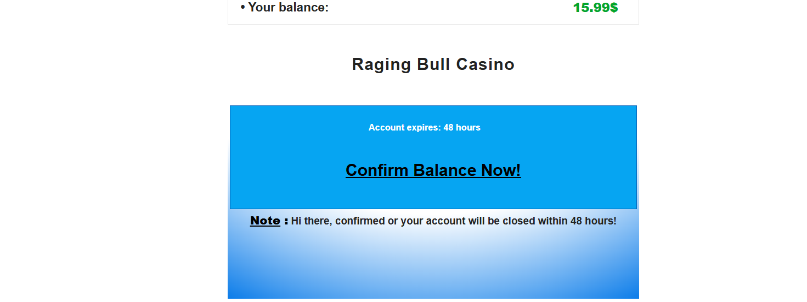

Prevention & Awareness Guidelines
For End Users
- Never click "Verify", "Claim", or "Confirm" links in unsolicited emails promising money, prizes, or account balances — legitimate services never require this to give you money.
- Always check the full sender email address, not just the display name — expand the "From" field to see the real domain.
- Be suspicious of any email using YOUR OWN name/email as the sender — this is a spoofing red flag, not a sign of legitimacy.
- Watch for manufactured urgency ("48 hours", "account will be closed") — this is a pressure tactic, not a genuine deadline.
- If an email claims to be from a known brand (e.g. LinkedIn), check that the domain ends exactly in that company's real domain — not just contains the brand name somewhere in a long string.
- When in doubt, do not click any link — go directly to the official website or app instead.
For Organizations
- Deploy email authentication protocols (SPF, DKIM, DMARC) to reduce sender-spoofing success.
- Run periodic phishing-awareness training and simulated phishing tests for staff.
- Encourage a culture where reporting suspicious emails is quick and has no downside, even if it turns out to be a false alarm.

Conclusion
Both analyzed emails are confirmed phishing attempts using prize/reward-based social engineering combined with either sender-name spoofing or brand-lookalike domains. Both were correctly identified by Gmail's spam filter, but the accompanying manual analysis shows exactly which technical and psychological indicators distinguish a phishing email from a legitimate one — knowledge that is transferable to less obvious cases that automated filters may miss. Awareness of these patterns (spoofed sender names, lookalike domains, manufactured urgency, and too-good-to-be-true rewards) is the most effective first line of defense against phishing.
Prepared as part of Task 2 — Future Interns Cyber Security Internship.

