API SECURITY RISK ANALYSIS
REPORT
REST API Security Assessment
Target API: reqres.in
Prince Makwana
Future Interns — Cyber Security Internship | Task 3
September 2026

Executive Summary
This report documents a security assessment of the public reqres.in REST API using Postman, covering authentication behavior, error handling, response headers, and rate limiting. Testing surfaced two High-risk authentication weaknesses — improper password validation and a user-enumeration flaw on the login endpoint — alongside minor information-disclosure issues in response headers. The API also demonstrated some good security practices, including enforced rate limiting and clean, non-verbose error responses.

Tools Used
- Postman — API request testing and response inspection
- Manual header and payload analysis

Findings Summary
Finding | Risk | Summary
Broken Authentication — Weak Password Validation | HIGH | Login succeeds with an incorrect password
User Enumeration via Login Endpoint | HIGH | Error messages reveal whether an email is registered
Permissive CORS Policy (Wildcard Origin) | LOW | Any website can read API responses cross-origin
Server/Framework Disclosure in Headers | LOW | x-powered-by header reveals backend platform
Rate Limiting Enforced | POSITIVE | Requests capped via ratelimit headers — good practice
Clean 404 Error Handling | POSITIVE | No internal details leaked on invalid resource requests

Detailed Findings

1. Broken Authentication — Weak Password Validation
Risk Level | HIGH
Endpoint | https://reqres.in/api/login
Method | POST
Evidence | Request: {"email": "eve.holt@reqres.in", "password": "wrongpass123"} → Response: 200 OK with a valid token
What This Means
A login request was sent using a known valid email address but a deliberately incorrect password. Instead of rejecting the request, the API returned a successful 200 OK response along with a valid authentication token — as if the password had been correct.
Business Impact
If a production system behaved this way, an attacker would not need to know a user's actual password at all to obtain a valid session token — completely defeating the purpose of authentication. This would allow full account takeover for any known or guessed email address.
Recommended Fix
- Ensure the authentication service validates the password against the stored (hashed) credential before issuing any token.
- Add automated tests that assert login fails with a 401/403 status for any incorrect password.
- Log and alert on repeated failed login attempts as part of monitoring.
Evidence Screenshot(s)
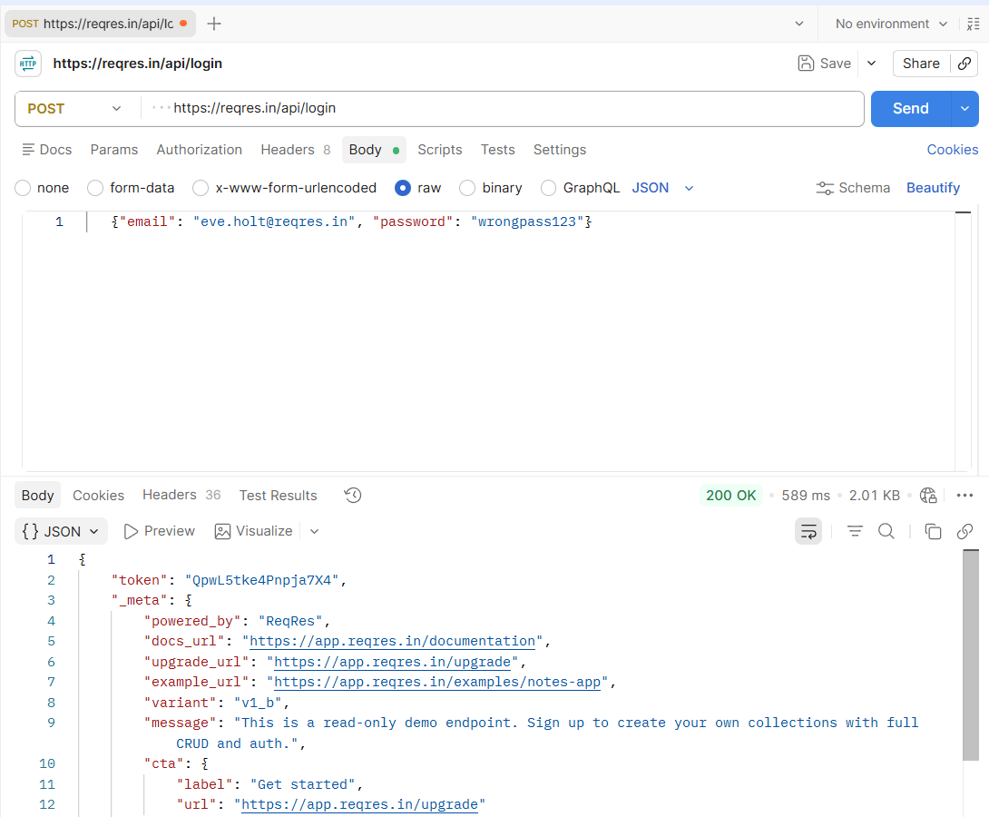

2. User Enumeration via Login Endpoint
Risk Level | HIGH
Endpoint | https://reqres.in/api/login
Method | POST
Evidence | Registered email + wrong password → 200 OK with token. Unregistered email → 400 Bad Request, "error": "user not found"
What This Means
The login endpoint returns two distinctly different responses depending on whether the submitted email exists in the system, regardless of the password supplied. A registered email always succeeds; an unregistered one is explicitly told "user not found."
Business Impact
An attacker can use this difference to systematically test large lists of email addresses and build a confirmed list of valid, registered accounts — without ever needing a correct password. This list can then be used for targeted phishing or credential-stuffing attacks against confirmed real accounts.
Recommended Fix
- Return the same generic error message (e.g. "Invalid email or password") regardless of whether the email or the password was the issue.
- Ensure response time is also consistent between the two cases, as timing differences can leak the same information.
- Rate-limit and monitor login attempts per IP/account to slow down enumeration attempts.
Evidence Screenshot(s)

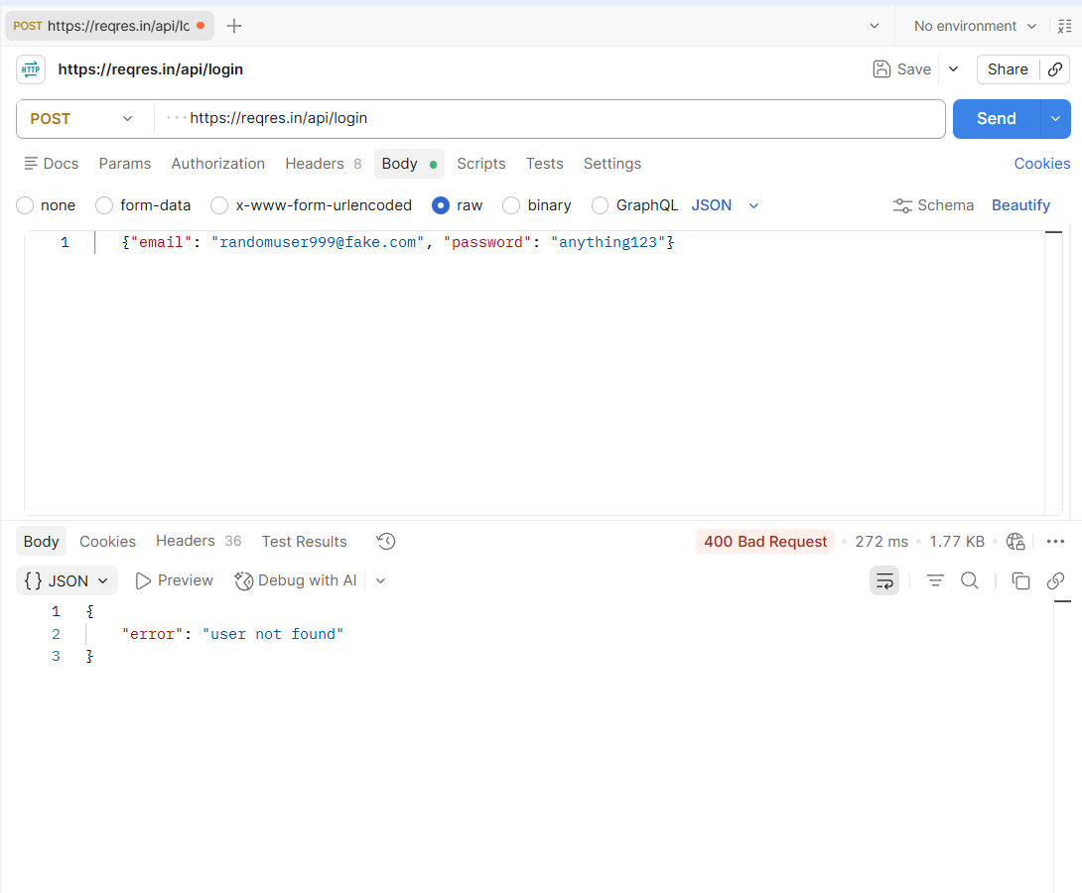

3. Permissive CORS Policy (Wildcard Origin)
Risk Level | LOW
Endpoint | https://reqres.in/api/users (site-wide)
Method | GET
Evidence | Response header: access-control-allow-origin: *
What This Means
The API allows cross-origin requests from absolutely any website ("*"), rather than restricting access to a defined list of trusted domains.
Business Impact
For an API returning non-sensitive public data, this is low risk. However, if this same configuration were applied to an API returning authenticated or personal data, any malicious website could read that data directly from a logged-in victim's browser.
Recommended Fix
- Restrict Access-Control-Allow-Origin to a specific allow-list of trusted domains, especially for any endpoint returning user-specific or sensitive data.
- Never combine a wildcard origin with endpoints that rely on cookies or session credentials.
Evidence Screenshot(s)
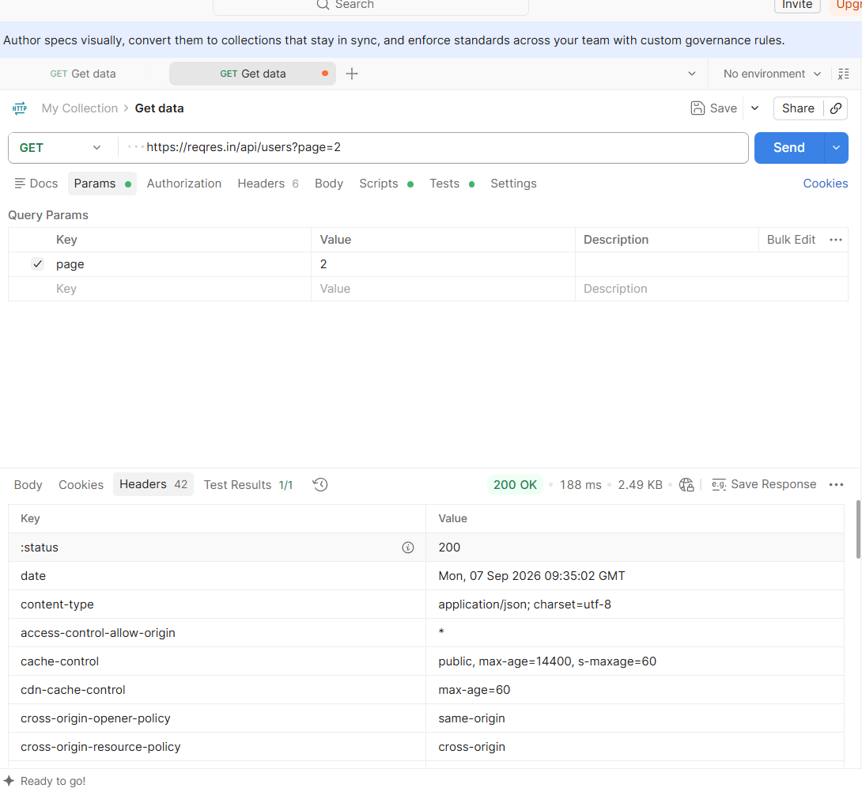

4. Server/Framework Disclosure in Response Headers
Risk Level | LOW
Endpoint | https://reqres.in/api/users (site-wide)
Method | GET
Evidence | Response header: x-powered-by: "ReqRes.in - Deploy backends in 30 seconds"
What This Means
The API reveals details about the backend platform/service powering it directly in a response header.
Business Impact
This gives an attacker a head start on reconnaissance — knowing the exact platform in use narrows down which known vulnerabilities or misconfigurations to try first.
Recommended Fix
- Remove or suppress the X-Powered-By header (and similar identifying headers) at the server/gateway level.
- Periodically audit response headers for any other unintentional technology disclosures.
Evidence Screenshot(s)
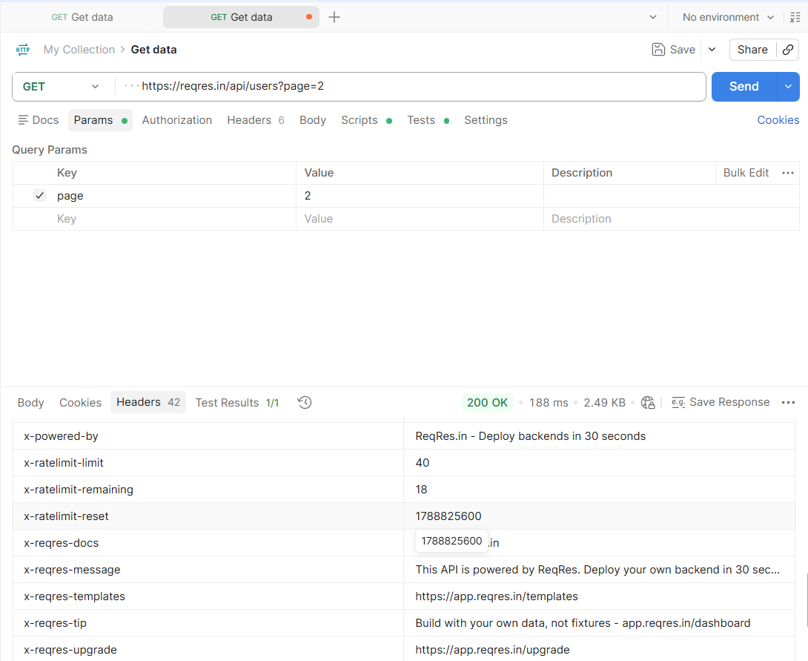

5. Positive Findings
Rate Limiting Enforced
Response headers consistently included ratelimit-limit, ratelimit-remaining, and ratelimit-reset values (e.g. 20 requests per 60-second window), confirming that basic rate limiting is enforced against this endpoint — a good defense against brute-force and scraping attempts.
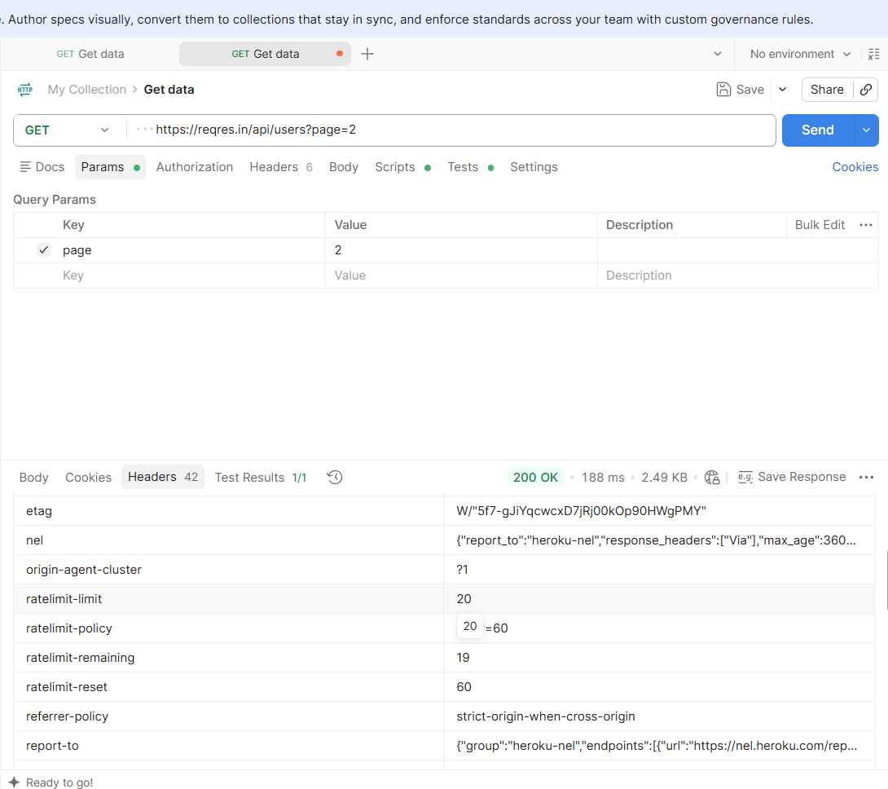
Clean, Non-Verbose Error Handling
Requesting a non-existent resource (GET /api/users/23) returned a clean 404 Not Found with an empty body — no stack traces, internal file paths, or database error details were leaked, which is the correct, secure behavior.
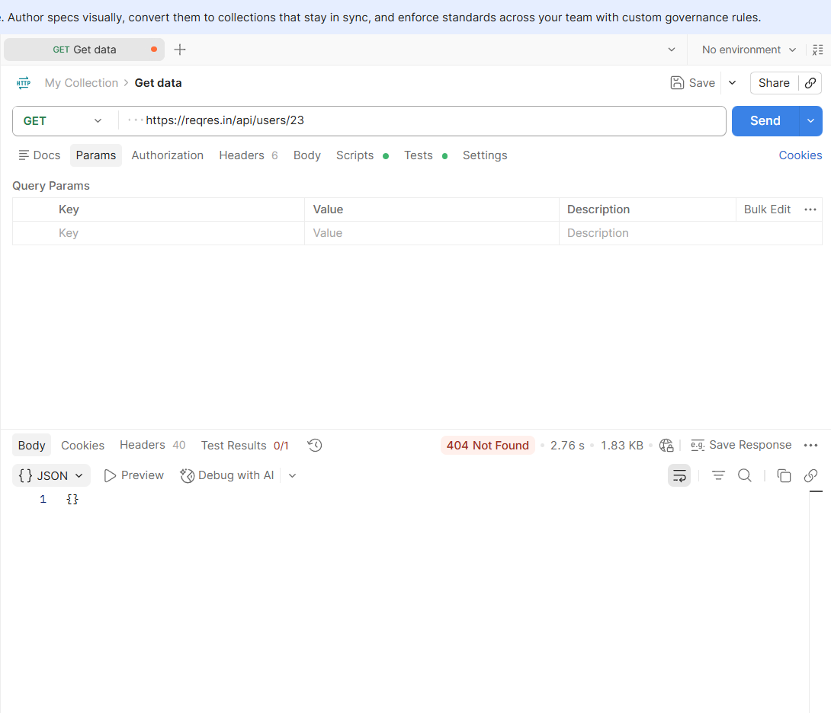

Remediation Priorities
1. Fix password validation on the login endpoint immediately: This is the most critical issue — it undermines the entire authentication system.
2. Standardize authentication error messages: Eliminate the ability to distinguish valid from invalid accounts via error responses.
3. Tighten CORS policy for any endpoint handling sensitive or authenticated data: Replace wildcard origins with an explicit allow-list.
4. Strip identifying technology headers: Reduces reconnaissance value for attackers with minimal engineering effort.

Conclusion
Testing of the reqres.in API surfaced two High-risk authentication weaknesses that, in a real production system, would allow attackers to bypass login security and identify valid user accounts. Two additional Low-risk information-disclosure issues were also found in response headers. On the positive side, the API demonstrated solid rate-limiting and clean error handling, showing that not every aspect of API security needs to be built from scratch — these controls can serve as a model for the areas that need improvement. Addressing the authentication findings should be the top priority for any team maintaining a similar API.
Prepared as part of Task 3 — Future Interns Cyber Security Internship.

