**WEEK 1**

**INTRODUCTION TO THE PROGRAM**

**Front-end, back-end and full-stack developer roles:**

Front end developer works on all part of the website that is visual to the user.

Main technology used: HTML, CSS, JavaScript

JavaScript is the most critical skill for front-end development.

A back end developer works on the parts of the website or the web app that the end users don’t see.

Responsible for creating and maintaining the functionality.

A full stack developer is someone who is equally comfortable with front end and back end technologies.

**HOW THE WEB WORKS**

**-** Network switch connects multiple devices and allows them to communicate with each other. The network switch can connect to other network switches and now two networks can connect. These network switches then connect to more network switches until you have something called interconnected network. This interconnected network is called the internet.

- When we use website or video streaming services on the internet, these are provided by computers called servers. Our devices are called clients. This is known as client-server model.

- The data travel through large undersea cables connecting the world’s networks. These cables can transfer huge volumes of data per second.

- A server is a computer that runs applications and services ranging from websites to instant messaging. It’s called a server because it provides a service to another computer and its user also known as the client.

- Typically stored in data centers.

- We will learn about web servers:

Website storage and administration.

Data storage.

Security.

Managing email.

- A web page is a document that displays images, texts, videos and other content in the web browser whereas a website is a collection of web pages that link together.

- A web browser is a software application that you use to browse

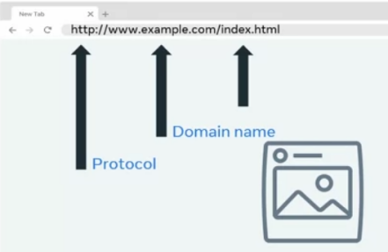

- The browser and server communicate using a protocol known as the Hypertext Transfer Protocol or HTTP.

- This exchange of information is made possible by something known as the request response cycle.

- Developers can launch website to the internet using something known as web hosting. Web hosting is a service where you place your website and files on the hosting companies web server.

- You are essentially renting the space in return for stable and secure storage.

- Types of hosting:

**Shared hosting:** You share the service processing power, memory and bandwidth with other websites that might slow your performance. This website is best for small website with small number of visitors.

**Virtual private hosting:** It’s a virtual server with dedicated CPU, memory and bandwidth resources. Your website is unlikely to be impacted by the performance of other VPS instances. It will be more expensive.

**Dedicated hosting:** A hardware server that is dedicated to you only. Will be more expensive than VPS hosting.

**Cloud hosting:** Your website is run in something called a cloud environment, which spans across multiple physical and virtual servers. If a physical or virtual server fails, your website will run on a different server and stay online. You can use as many resources without hardware limitation. This is how major of web application operate.

**CORE INTERNET TECHNOLOGIES**

**Introduction to Internet Protocols**

- IP addresses function much like addresses in a postal system that make it possible for packets of information to be delivered.

- IP packets include destination IP address and source IP address.

- Packet can get out of order, become damaged or corrupt or lost.

- Transmission Control Protocol can solve those issues.

- UDP solves the corrupt package issues. Suitable for voice call or live video call.

**Introduction to HTTP**

- Core operational protocol of the world wide web.

- Enables your web browser to communicate with a web browser that hosts a website.

- Request-response based protocol.

- HTTP requests consists of a method, path, version and headers.

- Most commonly used HTTP methods are: GET, POST, PUT and DELETE.

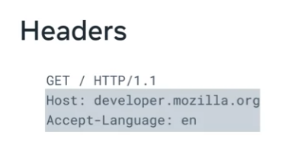

- Headers contain additional information about the request and the client that is making the request.

- Learn about status codes. (for e.g. 404 not found)

- HTTPS is a secure version of HTTP. It uses encryption for a secure connection.

READ READING PART FROM COURSERA APP

**INTRODUCTION TO HTML, CSS AND JAVASCRIPT**

- The web pages you visit everyday are based on three core technologies, HTML, CSS and JavaScript.

**OTHER INTERNET PROTOCOLS**

**-** Dynamic Host Configuration Protocol (DHCP)

- Domain Name System Protocol (DNS)

- Internet Message Access Protocol (IMAP)

- Simple Mail Transfer Protocol (SMTP)

- Post Office Protocol (POP)

- File Transfer Protocol (FTP)

- Secure Shell Protocol (SSH)

- SSH File Transfer Protocol (SFTP)

**WEBPAGES, WEBSITES AND WEB APPS**

**-** A typical web page is one single page that consists of HTML, CSS, JavaScript.

- A website is collection of web pages that link together under one domain name.

- A website can link to other website (Hyperlink)

- The key difference between a website and a web application is the level of interactivity and dynamic content. Website is more informative and web application is more interactive.

**DEVELOPER TOOLS**

- Most web browsers come equipped with a set of developer tools that allow developers to inspect their HTML, CSS and JavaScript code. Also, to trace HTTP request to the web server, investigate performance issues and review web page security.

- Right click on the web page and Inspect.

- Console tab logs JavaScript logs and errors from your web application.

- Sources tab shows all the content resolved for the current page. (Includes HTML, CSS, JavaScript, Images, Videos)

- The performance tab shows what the web browser is doing over time.

- The memory tab displays the part of your code that are consuming the most resources.

- Elements tab can be used to inspect the documents, HTML elements and their properties.

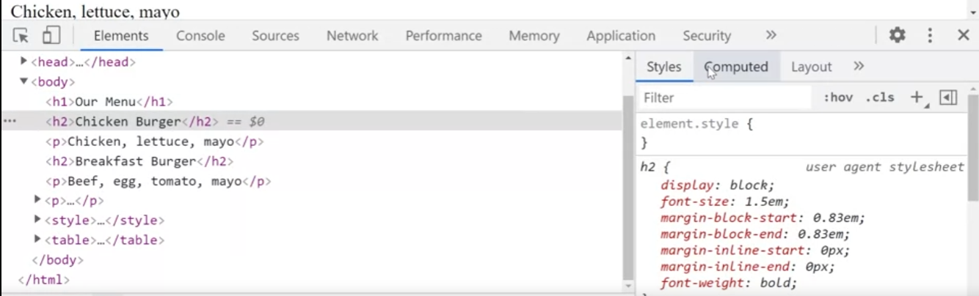

**FRAMEWORKS AND LIBRARIES**

- Some of your build problems have already been solved.

- Main key processes are already developed and contained in framework and libraries that are used in software development every day.

- Libraries are reusable pieces of codes that can be used by your application.

- Framework on the other hand provide a structure for developers to build with.

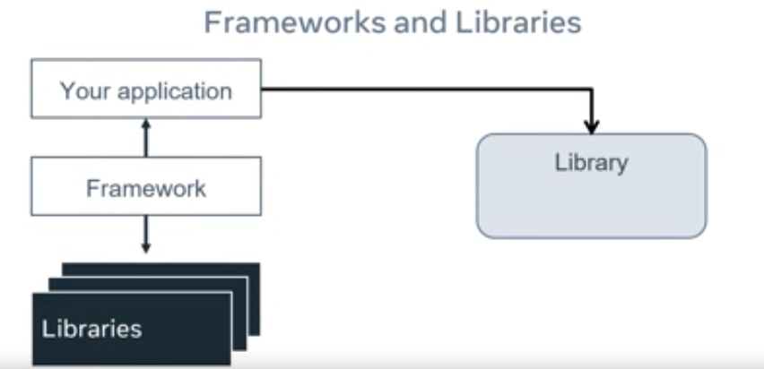

- Most frameworks use many libraries. The libraries that the framework uses can be used for your application. If you wish, your application can also use other libraries.