**Q1**. In the below elements which of them are values or an expression? eg:- values can be integer or string and expressions will be mathematical operators.

**Ans.**

* ( expression )

'hello' (value)

-87.8 (value)

- (expression)

/ (expression )

* ( expression)

6 (value)

**Q2.** What is the difference between string and variable?

**Ans.** A string means its basically a value which we enclose within single or double quotes.

Eg. “Prince” , ‘car5465’

In case of variables we can assign these values to a particular object and when we call these objects they show the value that we have assigned it.

Eg. X= 56 --🡪 Here X is the variable and 56 is the value we have assigned it to.

**Q3.** Describe three different data types.

**Ans**-Three different data types will be :

1. Integer- For eg;56,89,1
2. String – For eg; ‘jlkj’, “lklhkjh”
3. Boolean – For eg: s=’Prince’

s.isalpha()

This will show the answer as True.(Boolean will give answer as either True or False)

**Q4.** What is an expression made up of? What do all expressions do?

**Ans.** An expression is made up of variables and operators.

For eg; a = ‘apple’ ; b=’ bat‘ ; c= a + b

Here c is an expression.

All expressions will try to perform different kinds of operations depending on the operators and data type variables they have.

**Q5.** This assignment statements, like spam = 10. What is the difference between an expression and a statement?

**Ans.** In an assignment statement there will be only the equal to operator(=) i.e we will try to assign a value to the variable. For eg: x= ‘xmas’

In case of an expression these are made up of variables and operators.

For eg; a = ‘apple’ ; b=’ bat‘ ; c= a + b

Here c is an expression.

**Q6.** After running the following code, what does the variable bacon contain?

bacon = 22

bacon + 1

**Ans.** Variable bacon contains a value of type integer.

The result of this expression will give 23.

**Q7.** What should the values of the following two terms be?

**Ans.** 'spam' + 'spamspam' - spamspamspam

'spam' * 3 - spamspamspam

Both of them will yield same answer.

**Q8.** Why is eggs a valid variable name while 100 is invalid?

**Ans.** If we start a variable name with 100 then the compiler or interpreter will show error. We can also say that’s how python is made and it’s a general rule of python.

**Q9.** What three functions can be used to get the integer, floating-point number, or string version of a value?

**Ans.** 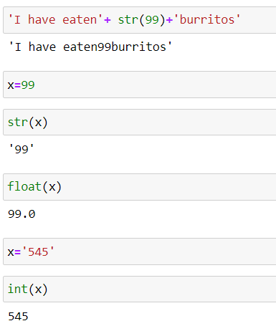

Here the three functions used is int(), str(), float().

**Q10.** Why does this expression cause an error? How can you fix it?

'I have eaten ' + 99 + ' burritos.'

**Ans.** It will show an error because 99 is of the type int and inorder to concatenate all the data types should be same. So inorder to fix it we need to do type casting i.e by predefined functions we have to change the data type of 99 and change it into string.

‘ I have eaten’ + str(99)+ ‘burritos’ 🡪 I have eaten99burritos