**1.What are the two values of the Boolean data type? How do you write them?**

**Ans.** Two value of Boolean type would be False(denotes 0) and True(denotes 1)

We can use it to find to check if a condition is True or not.

For eg:

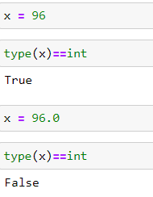

**2. What are the three different types of Boolean operators?**

**Ans.** Three different type of Boolean operators would be AND,OR and NOT.

Eg. 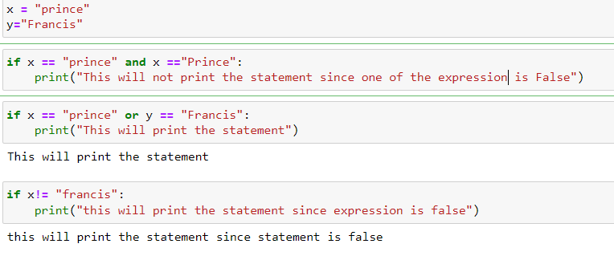

**3. Make a list of each Boolean operator's truth tables (i.e. every possible combination of Boolean values for the operator and what it evaluate ).**

**Ans.** 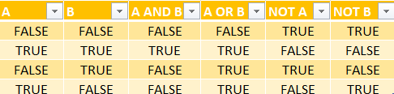

**4. What are the values of the following expressions?**

**ANS.**

(5 > 4) and (3 == 5) = False

not (5 > 4) = False

(5 > 4) or (3 == 5) = True

not ((5 > 4) or (3 == 5)) = False

(True and True) and (True == False) = False

(not False) or (not True) = True

**5. What are the six comparison operators?**

**Ans.** Six comparison operators would be:

1.(==)

2.(<)

3.(>)

4.(<=)

5.(>=)

6.(!=)

**6. How do you tell the difference between the equal to and assignment operators?Describe a condition and when you would use one.**

**Ans.** The assignment to operator is used to assign a value to a variable or an object whereas the equal to operator is used to check if the values are equal or not. We will use assignment operator to check the condition in if statements, assignment operator is used to assign values.

Eg. 

**7. Identify the three blocks in this code:**

spam = 0

if spam == 10:

print('eggs')

if spam > 5:

print('bacon')

else:

print('ham')

print('spam')

print('spam')

**Ans.** 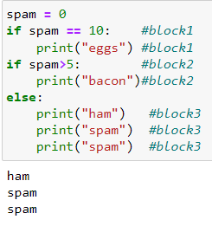

**8. Write code that prints Hello if 1 is stored in spam, prints Howdy if 2 is stored in spam, and prints Greetings! if anything else is stored in spam.**

**Ans.** 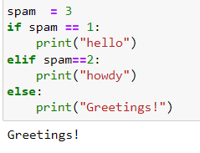

**9.If your programme is stuck in an endless loop, what keys you’ll press?**

**Ans.** I would press interrupt the kernel key to stop the endless loop



**10. How can you tell the difference between break and continue?**

**Ans.** The break statement would break the loop and the continue statement would throw the control to the loop again.

Eg. 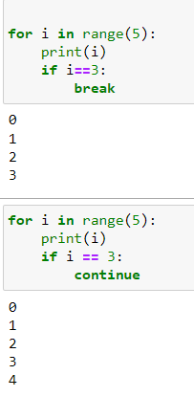

**11. In a for loop, what is the difference between range(10), range(0, 10), and range(0, 10, 1)?**

**Ans.** All are the same, and will generate numbers from o to 9 with the step size of 1 excluding the last index 10.

**12. Write a short program that prints the numbers 1 to 10 using a for loop. Then write an equivalent program that prints the numbers 1 to 10 using a while loop.**

**Ans.** 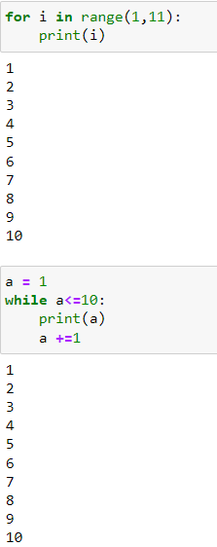

**13. If you had a function named bacon() inside a module named spam, how would you call it after importing spam?**

**Ans.** It will be:

Spam.bacon()