**1. What does an empty dictionary's code look like?**

**Ans.** 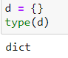

**2. What is the value of a dictionary value with the key ‘foo’ and the value 42?**

**Ans.** 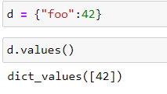

**3. What is the most significant distinction between a dictionary and a list?**

**Ans.** A dictionary can be created while using keys and values , where each key will represent a value.

In case of list the values are stored or accessed with the usage of indexes which start from 0.

**4. What happens if you try to access spam['foo'] if spam is {'bar': 100}?**

**Ans.** It will give an error since there is no key called ‘foo’.

**5. If a dictionary is stored in spam, what is the difference between the expressions ‘cat’ in spam and ‘cat’ in spam.keys()?**

**Ans.** 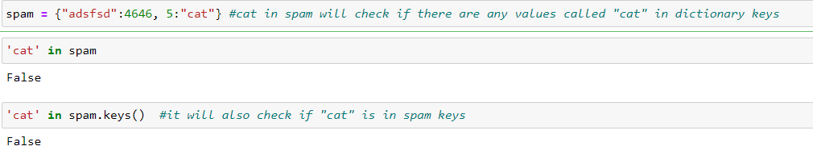

**6. If a dictionary is stored in spam, what is the difference between the expressions ‘cat’ in spam and ‘cat’ in spam.values()?**

**Ans.** 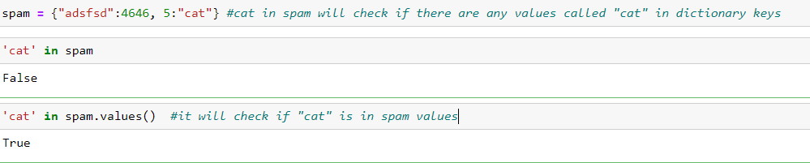

**7. What is a shortcut for the following code?**

**if 'color' not in spam:**

**spam['color'] = 'black'**

**Ans.** The shortcut is spam[“color”] = “black”

**8. How do you "pretty print" dictionary values using which module and function?**

**Ans.** 