**1. What are escape characters, and how do you use them?**

**Ans.** Escape characters are no printable characters when backslash ‘\’ precedes them. For eg. ‘\n’ -for new line , ‘\t’ for a tab or 3 spaces.

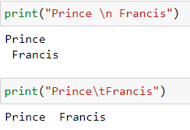

**2. What do the escape characters n and t stand for?**

**Ans.** n stands for new line and t stands for Tab

**3. What is the way to include backslash characters in a string?**

**Ans.** 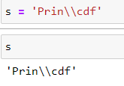

**4. The string “Howl’s Moving Castle” is a correct value. Why isn’t the single quote character in the word Howl’s not escaped a problem?**

**Ans.** The reason is because it is included in double quotes inside the variable.

**5. How do you write a string of newlines if you don’t want to use the n character?**

**Ans. **

**6. What are the values of the given expressions?**

**'Hello, world!'[1]**

**'Hello, world!'[0:5]**

**'Hello, world!'[:5]**

**'Hello, world!'[3:]**

**Ans.** 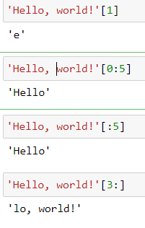

**7. What are the values of the following expressions?**

**'Hello'.upper()**

**'Hello'.upper().isupper()**

**'Hello'.upper().lower()**

**Ans.** 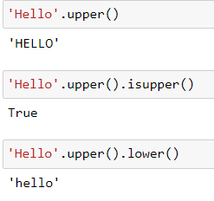

**8. What are the values of the following expressions?**

**'Remember, remember, the fifth of July.'.split()**

**'-'.join('There can only one.'.split())**

**Ans.** 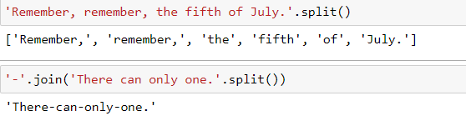

**9. What are the methods for right-justifying, left-justifying, and centering a string?**

**Ans.** 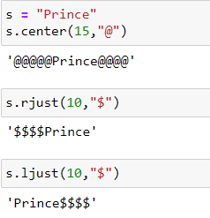

**10. What is the best way to remove whitespace characters from the start or end?**

**Ans.** 