1. What does an empty dictionary's code look like?
Ans.
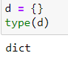
2. What is the value of a dictionary value with the key ‘foo’ and the value 42?
Ans.
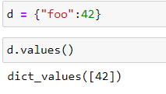
3. What is the most significant distinction between a dictionary and a list?
Ans. A dictionary can be created while using keys and values , where each key will represent a value.
In case of list the values are stored or accessed with the usage of indexes which start from 0.

4. What happens if you try to access spam['foo'] if spam is {'bar': 100}?
Ans. It will give an error since there is no key called ‘foo’.

5. If a dictionary is stored in spam, what is the difference between the expressions ‘cat’ in spam and ‘cat’ in spam.keys()?
Ans. 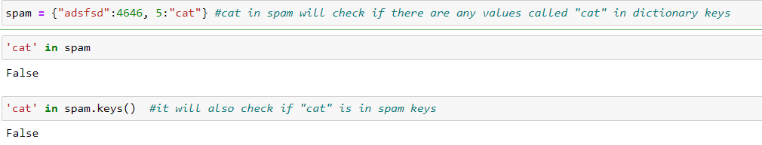

6. If a dictionary is stored in spam, what is the difference between the expressions ‘cat’ in spam and ‘cat’ in spam.values()?
Ans. 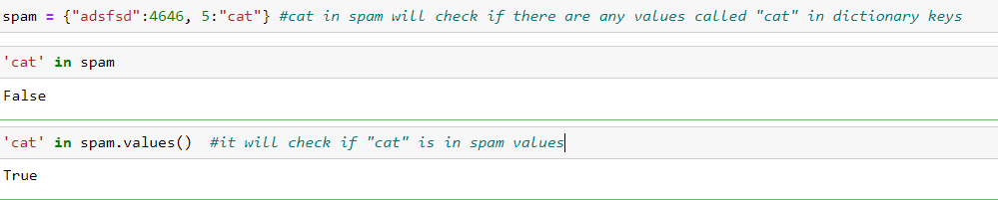

7. What is a shortcut for the following code?
if 'color' not in spam:
spam['color'] = 'black'
Ans.
