1. What are escape characters, and how do you use them?
Ans. Escape characters are no printable characters when backslash ‘\’ precedes them. For eg. ‘\n’ -for new line , ‘\t’ for a tab or 3 spaces.
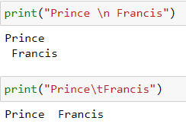

2. What do the escape characters n and t stand for?
Ans. n stands for new line and t stands for Tab

3. What is the way to include backslash characters in a string?
Ans.
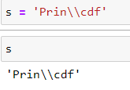
4. The string “Howl’s Moving Castle” is a correct value. Why isn’t the single quote character in the word Howl’s not escaped a problem?
Ans. The reason is because it is included in double quotes inside the variable.
5. How do you write a string of newlines if you don’t want to use the n character?
Ans.
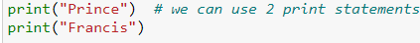
6. What are the values of the given expressions?
'Hello, world!'[1]
'Hello, world!'[0:5]
'Hello, world!'[:5]
'Hello, world!'[3:]
Ans.
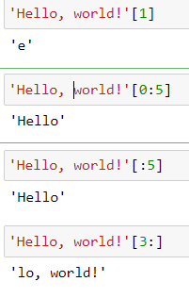
7. What are the values of the following expressions?
'Hello'.upper()
'Hello'.upper().isupper()
'Hello'.upper().lower()
Ans.
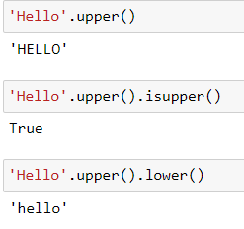
8. What are the values of the following expressions?
'Remember, remember, the fifth of July.'.split()
'-'.join('There can only one.'.split())
Ans.
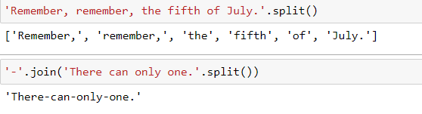
9. What are the methods for right-justifying, left-justifying, and centering a string?
Ans.
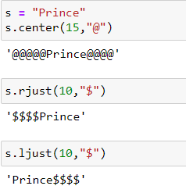
10. What is the best way to remove whitespace characters from the start or end?
Ans. 