Microbiological Water Quality of Lake Lanao Waters

**ABSTRACT**

Studying microbiological water quality of a lake is of primary importance especially when this body of water is used as a source of water for recreation, hygiene, domestic use and especially drinking purposes. Standard Coliform test was used to determine the most probable number of total coliforms and the presence of fecal coliforms particularly *Escherichia coli*, as an indicator bacterium of fecal contamination. Results show that the water samples collected from Lake Lanao from bank up to 25 meters lakeward from Bacolod- Grande, Tamparan, Taraka, Tugaya, and Wato-Balindong, Lanao de Sur were unfit for drinking as shown by the presence of coliform bacteria. Most probable number of these coliforms ranged from an average of

148.97 to 986.80 cells per 100 ml of water during the six sampling periods from June, September, and October 2016 and until January, February, and March 2017; which was far higher as compared to what the Philippine National Standards for Drinking Water (PNSDW) established that fecal coliform count below 1.1 cells per 100 ml water as safe for human consumption. Boiling of water and cooking of fishery products must be done to prevent microbial infections. It is therefore recommended that environmental sanitation and Lake Lanao conservation must be given priority by the local government officials as a part of the Marawi rehabilitation.

Keywords: Microbial Ecology, water quality, coliform test, *Escherichia coli*, Lake Lanao

# INTRODUCTION

Water is life. Water is necessary for the survival of all the living organisms. Our bodies are made up of an average water content of 60% that sustain metabolism and survival of individual cells. However, it is known that more than 88% of the global diarrheal diseases are water-borne infections caused by drinking unsafe and dirty water [1]. It is also estimated that 1.1 billion in developing countries have no access to clean water and 2.4 billion people have no any form of sanitation services. Consequently, 250 million people are exposed to water-borne diseases resulting in 10-20 million deaths every year [2].

Vice President Leni Robredo once said that Lanao del Sur is among the poorest of the poor community in the country. One manifestation of poverty is water quality problems, which is true to most communities living around Lake Lanao. Providing improved water quality has been well-articulated by the United Nations Millennium Development Goals (MDG’s) whose overall objective is to reduce poverty [3]. The MDG stipulates that improvement in drinking water supply and sanitation are major components of the poverty reduction program. Its main target is to double the number of people with sustainable access to safe drinking water and basic sanitation through pipe distribution system in urban centers and household water treatment and storage technologies in rural areas. However, the dilemma of delivering safe water to the population is compounded by population growth [1]. These water sources are also exposed to the forces of urbanization where domestic wastes from poor sanitation services are discharged into water bodies.

Consequently, the dual forces of pollution and population pressure have complicated the provision of safe water to the public and despite the efforts of delivering safe drinking water, the transmission of water-borne diseases is still a matter of major concern [4].

Lake Lanao is the lifeline of the Maranaos or the “people of the lake”, upon which they depend for livelihood, transportation, irrigation, recreation, religious rituals, hygiene, domestic use and especially drinking purposes. Thus, assessment of water quality is necessary to evaluate its safety for human use. Drinking water, or potable water, is defined as having acceptable quality in terms of its physical, chemical, and bacteriological parameters so that it can be safely used for drinking and cooking [2]. A potable water source can be evaluated through microbial analysis such as Coliform Test indicating the presence of these fecal coliforms particularly *Escherichia coli*, a common micro-inhabitant in the large intestines of humans and other warm-blooded animals. Its presence in water such as in Lake Lanao may indicate fecal contamination and possible presence of other waterborne microbial pathogens that cause infectious diseases such as typhoid fever, hepatitis A, cholera, amoebiasis and other forms of infectious diarrhea.

Data on the microbiological water quality will provide scientific evidence that would establish whether or not the Lake Lanao can continually be used as a source of water for drinking purpose by the local community. In order to come up with the results, this study collected water samples from around the lake along Taraka and Tamparan (eastern side) as well as Bacolod-Grande, Tugaya, and Wato-Balindong (western side) of Lake Lanao. Most probable number (MPN) of coliforms per 100 ml of water sample was determined through Presumptive test using multiple tubes of lactose broth and MPN table. Presence of fecal coliforms was determined by using eosin methylene blue agar in Confirmed test. And the presence of coliform bacterium, *Escherichia coli*, was determined in Completed test. The above parameters indicate the microbiological water quality of water samples from Lake Lanao. As the results of this research provide scientific evidence on the non- potable quality of Lake Lanao which has negative implication on the health well-being of the surrounding populations, then, it must be able to elicit a response from the affected populations. It is hoped that policy-makers and legislators will see the need to formulate and approve local ordinances for proper management of solid waste & sewage disposal, toilet facilities, and Lake Lanao conservation. As in the case of the scientific community, this will advance the knowledge base of the science of tropical limnology as well as encourage the younger scientists to pursue further studies on Lake Lanao.

# MATERIALS AND METHODS

Standard procedures in microbial water analysis [5] were done to determine the water quality of Lake Lanao. First, water samples for bacteriological analysis were collected into sterile bottles from five selected municipalities around Lake Lanao (Figure 1) namely; Tamparan and Taraka in the eastern side as well as Bacolod-Kalawi, Tugaya, and Wato- Balindong, Lanao del Sur in the western side of Lake Lanao and then transported inside a styrobox submerged in ice. Bacteriological analysis of the water samples was done in

Microbiology Laboratory Room, Department of Biology, Mindanao State University, Marawi City within 24 hours after water sample collection.

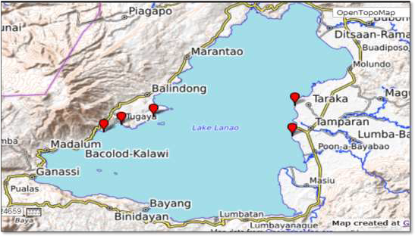

Figure 1. Five selected sampling sites (in red marks) of Lake Lanao along Tamparan and Taraka (eastern side) and Bacolod-Kalawi, Tugaya, and Wato-Balindong (western side).

Coliform test for water quality analysis started with Presumptive test using multiple tube fermentation. Double Strength Lactose Broth (DSLB) and Single Strength Lactose Broth (SSLB) were inoculated in triplicates of 10 ml, 1 ml, and 0.1 ml water samples, respectively, and then incubated at 37°C for 48 hours. Number of tubes positive for gas formation were noted and referred to the MPN table to determine the most probable number (MPN) of total coliforms in the water sample. In Confirmed test, a loopful of inoculum from the presumptive tubes that showed positive results was inoculated into Eosin Methylene Blue (EMB) agar and incubated to grow bacterial colonies in metallic green sheen indicative of the presence of fecal coliforms. In Completed test, a loop of inoculum from green metallic sheen colony in EMB plate was inoculated into tubes of Single Strength Lactose Broth culture medium and incubated at 37oC. Lactose fermentation indicated through gas and acid production confirms the presence of fecal coliforms. This was further confirmed through Gram staining to determine the presence of Gram negative short rods which characterize fecal coliforms particularly, *Escherichia coli.*

Statistical analysis was done to test heterogeneity of the data on the most probable number of total coliform bacteria in the water samples taken from the five stations in the five selected sites during the six sampling periods. Post hoc tests were employed to compare means of the MPN values in the different variables of the study. Photographs were taken for documentation. Isolated coliform bacteria were examined using the Phase Contrast microscope with built-in camera linked to a computer.

# RESULTS AND DISCUSSION

## Comparison of Coliform Bacterial Count among the Five Sampling Sites

Multiple tubes lactose fermentation procedure was done to determine the total coliforms per 100 ml water sample taken from Lake Lanao. Results (Table 1) show that the surface water from Lake Lanao along Tamparan, Lanao del Sur had the highest most probable number or MPN (986.80 cells/100 ml water) of coliform bacteria followed by water samples from Taraka with 871.03 coliforms per 100 ml; both municipalities are in the eastern side of Lake Lanao. Post hoc Tukey’s test shows that the MPN of coliforms in the littoral waters of Tamparan and in Taraka was statistically the same. Coliform count of coliforms in Bacolod-Grande (515.50) and Tugaya (499.07), both in the western side of Lake Lanao were statistically the same as well. Wato-Balindong had the lowest average coliform count of 148.97 cells per 100 ml of water sample (Figure 2).

Data on the most probable number (MPN) indicates estimate of the total coliform bacteria in the water samples obtained from Lake Lanao. High count of total coliforms may indicate a greater risk for the presence of other microbial pathogens of fecal origin such as Bacteroides, Cryptosporidium, Giardia, Salmonella, Shigella, Vibrio, Yersinia and even *Pseudomonas aeruginosa,* which can cause a variety of infections, including skin rashes and external ear infections (*otitis externa*) to swimmers. There was a known high positive correlation between counts of *P. aeruginosa* and total coliform counts, both of which are best used to forewarn recreational users of a potential threat of developing skin rashes and/or ear infections [4].

Although coliform count was lower in Wato being 148.97/100ml, but was still unsafe for direct ingestion based on the Philippine Standard for Drinking Water that must be

<1.1/100ml coliforms. The higher count of coliforms in Tamparan and Taraka could be attributed to the close proximity of the lake bank to the households in the community. Tamparan is a fifth class municipality with a population of 25,874 whereas Taraka is a fourth class municipality with around 23,644 population as of 2015 census by the National Statistics Office [6].

Table 1. Most probable number (MPN) of coliform bacteria in the surface water of Lake Lanao**.**

|  |  |  |  |  |  |  |  |  |
| --- | --- | --- | --- | --- | --- | --- | --- | --- |
| **SITES/SAMPLING**  **PERIODS** | **Jun**  **2016** | **Sep**  **2016** | **Oct**  **2016** | **Jan**  **2017** | **Feb**  **2017** | **Mar**  **2017** | **TOTAL** | **MEAN** |
| **Bacolod-Kalawi** | 612 | 844 | 456 | 74.4 | 464 | 642.6 | **3093** | **515.50** |
| **Tamparan** | 1100 | 928 | 720.8 | 972 | 1100 | 1100 | **5920.8** | **986.80** |
| **Taraka** | 1100 | 782 | 300.2 | 844 | 1100 | 1100 | **5226.2** | **871.03** |
| **Tugaya** | 717 | 113.8 | 588 | 328 | 1100 | 147.6 | **2994.4** | **499.07** |

|  |  |  |  |  |  |  |  |  |
| --- | --- | --- | --- | --- | --- | --- | --- | --- |
| **Wato-Balindong** | 146.4 | 192.2 | 103.4 | 48.6 | 83.8 | 319.4 | **893.8** | **148.97** |
| **Grand Total** | **3675.4** | **2860** | **2168.4** | **2267** | **3847.8** | **3309.6** | **18128.2** | **3021.37** |
| **Grand Mean** | **735.08** | **572** | **433.68** | **453.4** | **769.56** | **661.92** | **3625.64** | **604.27** |

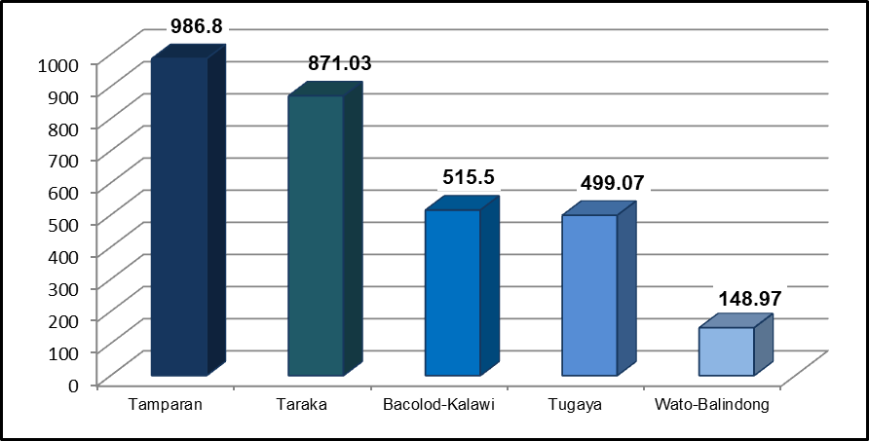

Figure 2. Bar graph on the mean coliform bacterial count of the surface water of Lake Lanao along the five sampling sites showing Tamparan with the highest count.

Coliform count in Lake Lanao waters along Bacolod-Grande and Tugaya was significantly twice lower (Figure 2) as compared to the coliforms in Tamparan and Taraka, which could be attributed to the distant location of the residences, thus, lesser tendency of directly draining of household wastes into the lake. The presence of coliforms in these sites of the lake, however, may be attributed to human activities such as hygiene practices, bathing and washing of clothes. Bacolod-Grande (also Bacolod-Kalawi) is a third class municipality with a population of 20,841 whereas Tugaya is a fifth class municipality with a population of 23, 814 as of 2015 [7].

Water samples from Lake Lanao, along the boundary of Wato-Balindong showed the lowest average bacterial coliform count of 148.97 CFUs per 100 ml. The stations were established below a cliff and densely forested area with lesser anthropogenic disturbance. Wato-Balindong belongs to a fourth class municipality with a population of 29, 180 [7]. Human activities in this site included fishing and hunting only maybe due to its topographical location, being remote from the local residences with lesser chance of receiving pollutants.

The result of this study that showed the presence of fecal coliforms was consistent with the coliform analysis conducted on 2006 by Lagmay *et al.* showing that there was no site in the lake where one can get potable water. Water sampling was done along Kialdan,

Sugod, and center of Lake Lanao on October and November 2006 in response to the occurrence of “green bloom” [8].

Another study also showed the presence of *Escherichia coli* and *Salmonella* sp. in both surface water [9] and surface sediments [10] in Lake Lanao particularly along Ditsaan- Ramain (agricultural land use), Marantao (low populated area), Ganassi (forested area), and Marawi City (highly populated area).

Table 2 shows the average coliform count per site, its population size, and municipality class. Among the three sites with the highest coliform count, Tamparan had the biggest population size over that of Taraka and Bacolod-Grande. This comes to show that the higher the population size, the higher the coliform count such as in Tamparan and Taraka. The lower the populations size such as in Bacolod-Grande, the lower the coliform count. This implies of a possibility that humans were the main sources of coliform contamination in the lakewater.

Table 2. The five selected sites showing its average coliform bacterial count, statistical similarities or differences of the coliform count, population size [7] and municipality class [8].

|  |  |  |  |
| --- | --- | --- | --- |
| SITES | MEAN COLIFORMS | STATISTICAL SIGNIFICANCE* | POPULATION MUNICIPALITY SIZE [7] CLASS [8] |
| Tamparan | **986.80** | A | 25,874 5th |
| Taraka | **871.03** | A | 23,644 4th |
| Bacolod-Kalawi | **515.50** | B | 20,841 3rd |
| Tugaya | **499.07** | B | 23,814 5th |
| Wato-Balindong  * Mean Coliforms in | **148.97** C  similar letters are statistically similar wherea | | 29,180 4th  s different letters mean site differences. |

Between Tugaya and Wato-Balindong, on the other hand, the population size doesn’t seem to correlate with the coliform count. Despite the higher population size in Wato but the coliform count was significantly lower (in fact, lowest among the five sites). Tugaya with a lower human population size than Wato had higher coliform count. This means that the coliform count is not only influenced by the population size but more so with the human practices when utilizing the Lake Lanao waters.

The difference in coliform count in the five selected sites may also be explained in terms of the annual income of the municipality and the lack of budget allocation to enhance environmental sanitation and Lake Lanao conservation. The actual Internal Revenue Allotment (IRA) of the local government unit (LGU) were allocated for basic services which include primary health services, social welfare service, small scale infrastructure facilities, economic services, legislative services, administrative services, and peace and order maintenance [11].

## Comparison of Coliform Bacterial Count among the Six Sampling Periods

This study also showed differences in the most probable number of total coliform bacteria

during the six sampling periods, being highest on February 2017, June 2016, and March 2017, respectively (Figure 3). The highest coliform count on February 2017 could be attributed to both increased nutrients from lake overturn and increased influx of pollutants from allochthonous sources.

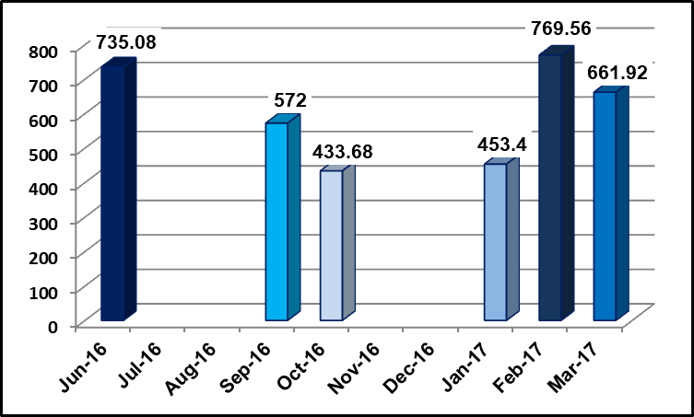

Figure 3.Bar graph on the mean coliform bacterial count of the surface water of Lake Lanao during the six sampling periods (June 2016-March 2017).

Fecal pollution may result from point and nonpoint sources. Point sources such as sewage overflows, agricultural runoff, and streams have been linked to increases in microbial loads to natural bodies of water. Fecal bacteria identified in water are generally derived from either human and/or animal sources and enter bodies of water through a variety of methods [12]. On June 2016, the high MPN may be attributed to the onset of the rainy season after the El Niňo phenomenon for several months bringing nutrients and various species of microorganisms from the upstream and surrounding land when the rainy season started. It is possible that “first flush” (from storm or water discharge pipe or from overland flow) during the rain event caused the increase in coliform observed [12] from river tributaries and surrounding community.

## Comparison of Coliform Bacterial Count among the Five Sampling Stations

Mean bacterial coliform count was also determined in the five stations (Figure 4). Results showed a decreasing number of total coliforms from Station 1, which was five meters from the bank having 687.83 cells per 100 ml of water, followed by Station 2 with 647.73, Station 3 with 608.2, Station 4 with 588.44, and Station 5 with 458.9, respectively. Statistical analysis, however, showed that the mean coliform count among the five stations

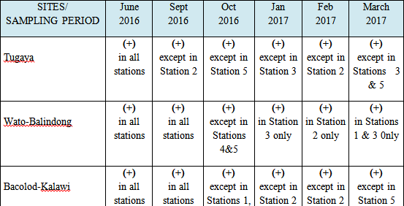did not significantly vary. This means that the surface water of Lake Lanao from the lakeshore up to 25 meters lakeward contained significant amount of coliform bacteria. This implies that these sites contain water which is unsafe for drinking purpose.

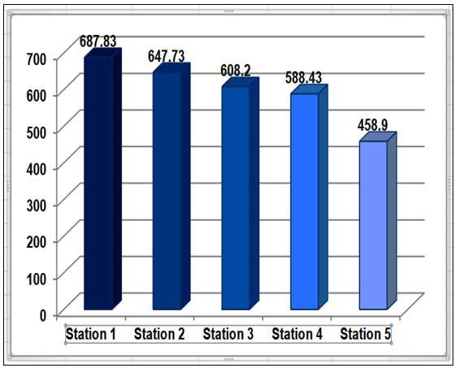

Figure 4. Bar graph on the mean coliform bacterial count of the surface water of Lake Lanao along the five sampling stations per site.

## Confirmed Test and Completed Test

Results in Confirmed and Completed tests (Table 3) further showed the presence of fecal coliforms in the water samples from Lake Lanao as evidenced by the presence of green metallic sheen colonies in eosin methylene blue (EMB) agar when incubated at 37oC. Transfer of these bacterial colonies into sterile lactose broth and incubation at 35oC again showed acid and gas production, confirmative of *Escherichia coli*, a bacterial indicator of fecal contamination in water samples. Gram-staining and microscopic examination showed the presence of Gram-negative short rods characteristics of *Escherichia coli* from the nutrient agar slants.

Table 3. Results of Confirmed and Completed tests showing the presence (+) or absence (-) of fecal coliforms and *Escherichia coli* in the surface waters of Lake Lanao.

DENR classified Lake Lanao as water source of class A [2]. Class A are sources of water supply that will require complete treatment (coagulation, sedimentation, filtration and disinfection) in order to meet the National Standards for Drinking Water (NSDW) and has maximum limits of total coliform of 1,000/100 ml MPN and maximum limit for fecal coliform of 100/100ml [2], thus, requires thorough disinfection. Based on the results of multiple tube fermentation tests, all the sampling sites still met the criteria for the class A water source. It means that it can still be used as water supply source given the condition that it has to undergo complete treatment [3].

# CONCLUSION

Microbiological water quality of Lake Lanao using the Standard procedures of multiple tube fermentation (Presumptive test), eosin methylene blue agar growth (Confirmed test), and lactose fermentation test (Completed test) was done to determine the most probable number (MPN) of total coliforms, the presence of fecal coliforms, and the specific coliform bacterium, *Escherichia coli,* respectively. Results show that the water samples collected from Lake Lanao from bank up to 25 meters lakeward from Bacolod-Grande, Tamparan, Taraka, Tugaya, and Wato-Balindong, Lanao de Sur were not safe for drinking as evidenced by the presence of coliform bacteria and *Escherichia coli*, an indicator bacterium of fecal contamination.

# RECOMMENDATIONS

Scientific evidence on the non-potable water of Lake Lanao should be communicated to the local community through information drive. Health monitoring should also be done by the Department of Health (DOH) of the Bangsamoro Autonomous Region for Muslim Mindanao (BARMM) on waterborne diseases to keep track of the health status of the local

communities along the lake. The local government unit (LGU) officials should review and revive local ordinances to strengthen the implementation of the Philippine Clean Water Act (RA 9275) of 2004 and the Ecological Solid Waste Management (RA 9003) of 2000 that concern environmental sanitation and conservation of Lake Lanao. In the end, the local communities should develop stewardship of their environment by being responsive to the need for conservation and responsible in preventing pollution of Lake Lanao. Good stewardship and community empowerment are needed to maintain a clean Lake Lanao as a legacy for the generations to come.

# ACKNOWLEDGEMENT

“Thank you” would not even half-express our gratitude to the National Research Council of the Philippines (NRCP) of the Department of Science and Technology (DOST) as the funding agency of this research project (E-231), MSU-Iligan Institute of Technology as the implementing agency, and Mindanao State University, Marawi City as the supporting agency. Special thanks to my two project staff, Prof. Mariam C. Kabirun and Prof. Nourshamsia C. Barosa whose passion for research enable them to endure and surmount all the hard work and sacrifices. Ladies, am blessed to have you as my co-researchers. 

# REFERENCE LIST

1. Wright, J., Gundry, S.; and Conroy, R. Household drinking water in developing countries: a systematic review of microbiological contamination between source and point-of-use. T[ropical Med Int Health.](https://www.ncbi.nlm.nih.gov/pubmed/14728614) 2004 Jan;9(1):106-17.
2. World Health Organization. Guidelines for Drinking-water Quality_World Health Organization. https:/[/www](http://www.who.int/water_sanitation_health).[who.int/water_sanitation_health.](http://www.who.int/water_sanitation_health) 2004.
3. Aquino, Albert P. and A.B.D. Correa. Republic Act No. 9275: The Philippine Clean Water Act of 2014. Food and Fertilizer Technology Center for the Asian and Pacific Region (FFTC-AP) 2014. <http://ap.fftc.agnet.org/ap_db.php?id=281>. Accesed 25 August 2018.
4. Bartram, J. & S. Pedley. 1996. Microbiological Analyses- A Practical Guide to the Design and Implementation of Freshwater Quality Studies and Monitoring Programmes. UNEP/WHO ISBN 0 419 22320 7 (Hbk) 0 419 21730 4, 1996.
5. Hauser, A. R. Microbiology. Illinois. [www.feinberg.northwestern.edu](http://www.feinberg.northwestern.edu/), 2006.
6. National Statistics Office (2015) 2015 Census of Population-Philippine Statistics Authority. https://www.psa.gov,ph/sites/default/files/...2016 Accessed August 18, 2018.
7. Philippines Information. Philippine City and Municipality Classes. https://www.in- philippines.com/philippine-city-and-municipality-classes/ Accessed July 13, 2019.
8. Lagmay, J. P.; Hansel, C.G.; Escudero, P.; Autor, N.; Dagot, D.; Estoista, R.; Lopez, L.; Mero, D.; and Nacua, S. Hydrobiological Assessment of Lake Lanao Subsequent to Its Unusual Greening in 2006. Mindanao Journal. XXIX. 2006.
9. Omar, Geemarlyn M. & Mabuhay, J. A. Variations of Some Physico-Chemical Properties and Indicator Microorganisms of Water at Selected Stations in Lake Lanao. Unpublished Graduate Thesis. Master of Science in Biology. Mindanao State University, Marawi City, 2014.
10. Omar, Shellajean M. & Mabuhay, J. A. Variations of Some Physico-Chemical and Microbial Characteristics of Sediments in Selected Stations in Lake Lanao. Graduate Thesis. Master of Science in Biology. Mindanao State University, Marawi City, 2014.
11. Commission on Audit-Autonomous Region in Muslim Mindanao. Annual Audit Report on the Municipality of Tamparan, Lanao del Sur. <https://www.coa.gov.ph/index.php/local-government.../6626-municipalities>. Accessed July 13, 2019.
12. Kleinheinz, G. T., McDermott, C., Hughes, S. Brown, A. Effects of Rainfall on *Escherichia coli* Concentrations at Door Country, Wisconsin Beaches. International Journal of Microbiology 2009 (12): 876050.