Distribution and Relative Abundance of the Endemic Cyprinid, *Barbodes tumba (*Herre,1924) from Lake Lanao

# Introduction

*Barbodes tumba* is one of the 18 endemic species of cyprinids from Lake Lanao of Mindanao, Philippines. Fifteen of these species were described by Herre (1924) as belonging to the genus *Barbodes, B. tumba* among them. Several authors (Herre, 1953; Escudero *et al.*, 1980; Kornfield, 1982; Kornfield and Carpenter, 1984; IUCN, 1990; IUCN, 1994; Ismail, *et al.*, 2014) thereafter used the genus *Puntius* for the species. Kottelat, (2013) however, provided evidence that it should be *Barbodes* for all the Mindanao endemic cyprinids. The International Union for Conservation of Nature and Natural Resources (IUCN) are now using *Barbodes* for all endemic cyprinids in Lake Lanao.

*B. tumba* was first described by Herre in 1924 (Figure 1). In his description of the species he noted that his specimens were collected from the streams and rivers draining into the Lake. It is a small fish whose maximum recorded length is 12.7 cm. The result of some studies (Villaluz, 1966; Escudero, 1994; Rosagaron, 2001; Ismail *et al.*, 2014) would tend to show *B. tumba* and the other endemic cyprinids are becoming rare. Particularly, Escudero and Demoral (1980, 1983) and Escudero (1994) in their survey recorded the total relative weight of cyprinids

as comprising some 55% (1980) of the total and reduced to nine percent of the total in 1994 fish survey. Escudero (1994) pointed out that such could be due to the increasing presence of the introduced species displacing them. In 1996 IUCN placed the conservation status of this fish as vulnerable under the Threatened Category.

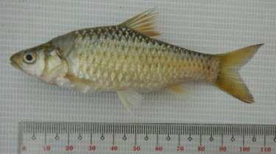

Figure 1. *Barbodes tumba*

There has been no assessment of its IUCN status since then. The most recent survey by Ismael (2011), showed that the cyprinids are very rarely caught by fishermen along coastal areas of Lake Lanao. Of the 18 species, only *B. tumba* (in very reduced numbers) and perhaps another species, *B. lindog* (the author was not sure of its identification of this species) are still extant. Surveys of cyprinids by MSU Biology students (Bacarat, 2001; Ali 2001; Disomangcop 2010; Guinal, 2016; Mohammad, 2016) working on their unpublished undergraduate theses, recorded the two species, and another species *B. sirang,* caught along the streams and river tributaries of the Lake.

The present paper is an attempt to address the question on the actual distribution of this group and the actual species still extant and its abundance in Lake Lanao and its immediate environment. Information generated from this study may help concerned government agencies in crafting some conservation measures that may protect the species.

# Methods

Population assessment of threatened species is always a sensitive issue. If the objective of the assessment is towards the conservation of the species, it is imperative that the sampling method, as much as possible, will not further contribute to the depletion of the population.

In this study, no experimental fishing was done; the specimens used were fish catch from fishermen whose specimens are considered part of unavoidable fishing mortality. A structured and validated interview questionnaire was used to preliminarily determine the distribution of the species on the different sampling sites.

## Preliminary Investigation and Selection of the Study Areas

The choice of the five major rivers (Ramain, Taraka, Gata, Masiu and Agus) as sampling areas was based on both published (Herre, 1924; Kornfield and Carpenter, 1984; Ismail and Escudero, 2011; Ismail *et al.*, 2013) and unpublished (Bacarat, 2001; Ali, 2001; Disomangcop, 2010; Guinal, 2016; Mohammad, 2016) literatures on the presence of *B. tumba* as well as interview with fishermen living near the areas. Of the 5 major rivers, Agus river is the only outlet that drains the Lake towards Iligan Bay the rest are all tributaries draining into the lake from the

surrounding mountains (see figure 1.). The presence of *B. tumba* in Agus river was confirmed personally by the researcher when specimens were bought from the fishermen during the preliminary investigation. Their presence in the other rivers was preliminarily assessed by interviewing known local persons living around the Lake Lanao.

Population abundance of the cyprinids was measured relative to other species and was based on fish catch from fish landing zones of four municipalities around the lake namely: Ramain, Taraka, Ganasi and Marantao. The choice of these municipalities was based on their location (two stations on the east, one on the west and one on the southernmost part of the Lake) and partly considering our security concerns as well (see figure 1).

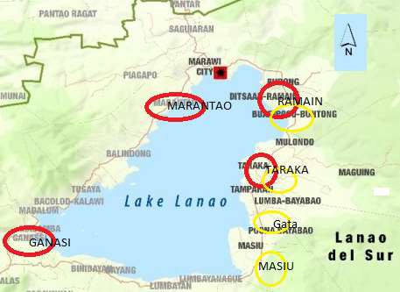

Figure 1. Map of Lake Lanao showing the approximate location of the four major river systems (Ramain, Taraka, Gata and Masiu marked with yellow circles ) draining into the lake, where interview with fishermen was conducted. It also shows the approximate location of the four major fish landing zones (in red) where fish catch data was surveyed. Marawi City is where the Agus river opens from the lake and drains into Iligan City to the north. (from [https://www.icrc.org/sites/default/files/wysiwyg/lake lanao_map.jpg](https://www.icrc.org/sites/default/files/wysiwyg/lake%20lanao_map.jpg) location of the sites was marked by the authors)

**Determination of Presence or Absence of *Barbodes tumba***

Interview with the fishermen residing near the four rivers (see fig. 1) was undertaken to confirm the presence of *B. tumba*. An interview questionnaire was administered for this purpose, which was pretested to at least 10 fishermen for validation before for its actual use.

## Determination by Fish Catch Abundance

Fish catch abundance was recorded from fishermen, using different fishing methods, on fish landing sites by local assistants who were instructed to make the survey between 6:00 – 7:30

A.M. (usual time when fishermen will dock from their night fishing) and measure the total weight of each species collected, and count as well the number of individuals for the bigger species like tilapia. The survey was done from May 2016 until May 2017. Recording of fish catch data in this manner was done every other day from May 2016 until March 2017. *(Some data for some of the sampling months were rendered unreadable after we left our laboratories and instruments in a hurry when the siege of Marawi started*)

# Results

## Identification of the species

Some specimens collected from this study were examined by Torres et al. (2018) for its meristic characters and Labe and Quilang (2019) for DNA analysis. Both meristic characters and DNA barcoding analysis pointed out that our specimens are *Barbodes tumba.*

***Barbodes tumba* Identification in field during the fishermen interview**

Using the photos of *Barbodes lindog*, *B. tumba*, and *B. binotatus* during the interview, fishermen can easily distinguish *B. tumba* and *B. lindog* but when they saw *B. binotatus*, most of them said that they didn’t see that fish in their area. However, based on the common names, some called “tumba” as “pait” or known scientifically as *B. binotatus*, others said that they are just one. “Tumba” and “pait” are very similar in appearance

**Population Distribution of *Barbodes tumba***

A total of 24 fishermen/respondents from the different barangays along the rivers were interviewed about their knowledge on *Barbodes tumba* catch. Of the 24 fishermen interviewed, 18 of them mentioned their years of fishing experience; and seven claimed they have 1-10 years of fishing experience. Twenty-one (21) out of 24 fishermen said that tumba is now rare or very rare. One fisherman with 60 years of fishing experience had the longest experience among the 24 respondents. He said that “tumba” (referring to *B. tumba*) is now very rare when compared to the previous years. One fisherman from Masiu river claimed, however that they can still easily catch tumba in the upper reaches of Masiu River, and another one said its still common in Taraka river. Eighteen fishermen said there are no attempts in fishing in the rivers nowadays except for leisure, or if they missed eating tumba, and that if they try tried to fish in the river, they can surely get at least one to ten “tumba” per fishing trip. Seventeen fishermen claimed that they caught some specimens within the year, while seven said “tumba” is about to become extinct. Six claimed no idea of how often is the “tumba” catch nowadays. All of the

fishermen interviewed reported that they had caught tumba not in the lake itself but can be found only in river.

From the information provided by fishermen during interview and the specimens caught, the distribution of *B. tumba* in the major rivers surrounding the lake was assessed. Actual specimens of *B. tumba* were obtained from fishermen in Masiu, Gata, and Taraka rivers is presented in Table 1.

Table 1. Number of fish samples collected per month in the three study sites.

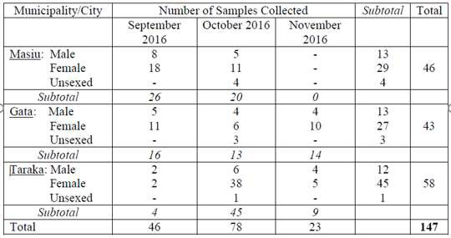

No samples were obtained from Ramain River during the duration of the study but interview with fishermen from the area, and the 14 specimens bought by the researcher on

December 24, 2016 in the Marawi wet market from a middleman who came from Ramain confirmed the presence of *cyprinids* in Ramain river. They showed that samples from these three rivers belong to the same species *B. tumba*. Ten samples were collected at one time by a fisherman from Rorogagos, a barangay of Marawi City, which is along the Agus River. His specimens were given to us

From the information gathered above, the distribution of *B. tumba* is plotted in the map and shown as Figure 2.

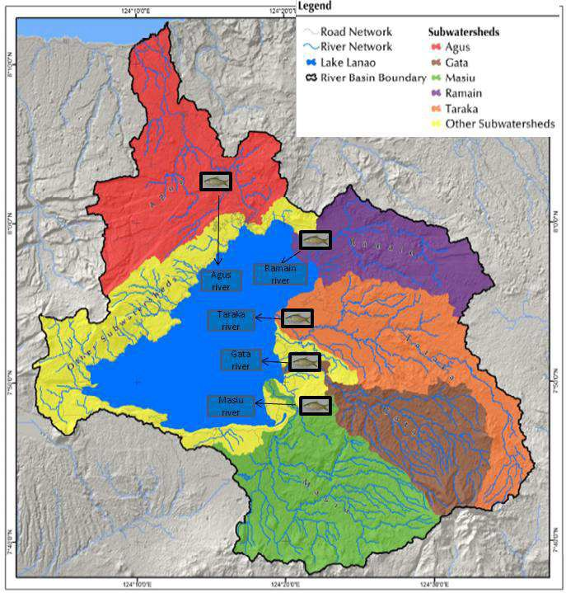

**Figure 2**. Map of Lake Lanao watershed showing the current distribution of *Barbodes tumba* based on specimens collecte*d* during September to November 2016 (specimens from Ramain and Agus rivers were obtained in December as noted earlier). It also shows the corresponding watersheds of the five major river systems connected to Lake Lanao. (photo modified from UPLB & DENR, 2014). It shows that *B. tumba* is still present in the five rivers of the Lake.

## Relative Abundance of *P. tumba* Based on Fish Catch

Relative fish catch abundance from the four fish landing sites is shown in table 2 and figure 3.

Table 2. Monthly relative abundance of fish catch based on weight, from the fish landing zones of the munipalities of Ramain, Taraka, Ganasi and Marantaw of lake Lanao.

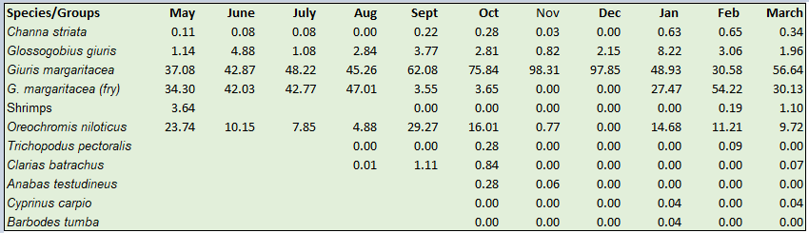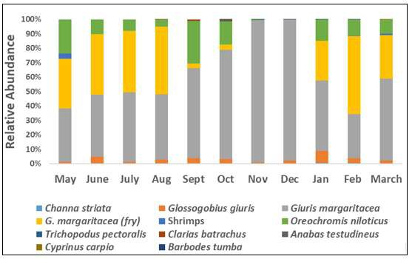

Figure 3. Bar graph of relative abundance data of fish species recorded from the fish landing zones of the of the four municipalities bordering the lake**.** A total of 11 species/groups were recorded with the fries and adults of G*iuris magaritacea* in separate entries to emphasize the months when fries are abundant.

The figure shows that the fish catch was dominated by the introduced species *Giuris magaritacea* and its fries (locally known as “Kuyabog”), together they constitute about 90% of the fish catch for the months of June to August with its adults dominating the fish catch during colder months of October to December while its fries were quite abundant, except during the colder months starting September and totally disappearing during the months of November and December. This is followed in abundance, by *Oreochromis niloticus* and *Glossogobius giuris.*

These three species were all introduced sometime in the 1960s. Whereas, *O. niloticus* was introduced on purpose by the BFAR (and regularly being stocked with fingerlings by the MSU College of Fisheries) the *G. margaritaceae* and G. *giuris* were believed to be introduced accidentally along with the introduction of *O. niloticus* fries.

The figure shows that specimens of *B. tumba* only appeared during the month of January with an abundance of less than one percent during the entire 11 survey months of data collection and together with another introduced fish *Cyprinus carpio*, were the least abundant, both with less than one percent relative abundance.

# Discussion, Conclusion and Recommendation

This study has similar findings with that of Herre (1924), Kornfield and Carpenter (1984) and Ismail (2011) who reported that they had caught *B. tumba* in the streams and not in the Lake Lanao itself. This is similar to the result of the fishermen interviews who said that “tumba” can only be found in the river and not in the lake. If accidentally caught in the lake itself, it is usually near the mouth of

the river or stream. Field samplings in this study also confirmed that “tumba” is usually found in the rivers or streams, and not in the lake itself.

It may be noted that Herre (1924) never collected *B. tumba* from the Lake itself, but from the rivers and streams draining into the Lake. Escudero in his surveys in the 1970s and 1980s recorded the cyprinids as dominated by *B. sirang* and very rarely *B. tumba.* In this study it would seem that the various species of cyprinids which used to be present in considerable abundance in the Lake are now very rare, with *B. tumba* still extant in the streams and rivers of the lake and can still be collected, although very rarely from the lake itself.

The continued presence of *B. tumba* in the streams and the five rivers of the lake, despite the dissapearnce of others, as observed in this study could be due to some attributes of the species itself. A study by Guinal and Dela Sena (2016) suggested a possible physiological characteristic of the species that may explain its persistence in the rivers and streams of the lake. Their measurement of the mean diameter of Red Blood Cells (RBC) of *B. tumba* was proved larger compared to *G. margaritaceae,* which is almost of the same size and the same benthopelagic habit. They also compared it to *Channa striata,* a much bigger species which is native to lake Lanao, with the same result that *B. tumba* has a larger mean RBC diameter. According to them, “the larger diameter of *B. tumba* RBC would mean a relatively lesser surface area relative to its volume, by which oxygen can diffuse across its membrane”. As such, it would mean that they would be disadvantaged in an area with limited dissolved oxygen.

If such is the case, then the rivers and streams draining into the Lake, would provide an ideal environment for *B. tumba* as they are always highly oxygenated (especially the shallow and fast flowing sections) being constantly moving bodies of water, compared to the lake itself which is a lentic environment being a slow-moving body of water and therefore is expected to be less oxygenated. The exception perhaps to this lentic environment of the lake would be the shallow littoral regions near the mouth of the rivers that drains into the lake where oxygenated waters from the rivers will mix with the lentic environment of the lake, and may provide an environment enough for some vagrant populations, washed down from the rivers. Our survey indicated that they are mainly present in the streams and rivers draining into Lake Lanao.

In view of such characteristic of *B. tumba* and its possible implication to the type of environment it favors*,* it would be an interesting study to pinpoint the exact habitat of *B. tumba* and measure the physico-chemical characteristics of the environment, especially in the light of some initiative to capture the species to be cultured for reintroduction into the lake itself.

# Acknowledgement

We wish to acknowledge our local assistants form the four different fish landing zones of Ramain, Taraka, Ganasi and Marantao as well as the municipal mayors of the four municipalities. We wish to acknowledge also Ms. Armi Torres, our Research collaborator from U.P. Los Banos. This paper is part of an NRCP funded project.

# References

Abdulmalik-Labe, OP, Quilang JP. 2019. DNA Barcoding of fishes Lake Lanao, Philippines. Mitochondrial DNA Part B*: Resources* 4(1): 1890-1894

Abdulmalik-Labe, OP, Quilang JP. 2019**.** Genetic diversity among the endemic barb Barbodes tumba (Teleostei: Cyprinidae) populations from Mindanao, Philippines. *Journal of Threatened Taxa* 11(7): 13822-13832

Ali, S. 2001. Status of fish resources in some areas of Lake Lanao based on fishermen’s catch and market surveys. An Undergraduate Thesis. MSU, Marawi City, Philippines.

Bacarat H. 2001. Status of fish resources in the Northeastern part of Lake Lanao based on fishermen’s catch. An Undergraduate Thesis. MSU, Marawi City, Philippines.

Escudero. 1994. Lake Lanao fisheries: problems and recommendations. Philipp Biota 27(1):8–18.

Escudero P. & Demoral, M. 1983. Preliminary studies on the biology and fishery of

*Hypseleotris agilis* Herre. *J Fish Aquac* 4:3–89.

Escudero, P.T.; Gripaldo, O.M.; and Sahay, N.M. 1980. Biological studies of the *Glossogobious giurus* (Hamilton & Buchanan) and the *Puntius sirang* (Herre) in Lake Lanao**.** *Journal of Fisheries and Aquaculture*. 1(1): 11-154.

FishBase. 2016. *Barbodes tumba*, Herre 1924. [*www.fishbase.org,*](http://www.fishbase.org/) *accessed on January 7, 2016.*

Guinal, S. & de la Sena, C 2016. Composition, cytomorphometry, and intersexual variation of the blood of *Puntius tumba* Herre, 1924, an endemic fish in Lake Lanao, Lanao del Sur. An Undergraduate Thesis. Mindanao State University, Marawi City, Philippines.

Hadji Ali K. 2002. Status of fish resources in Southwestern part of Lake Lanao based on fishermen’s catch. An Undergraduate Thesis. MSU, Marawi City, Philippines

Herre A. 1924. Distribution of the true fresh-water fishes in the Philippines. *The Philippine Journal of Science*. 24(3): 249-288.

Herre A. 1933. The Fishes of Lake Lanao: A Problem in Evolution. *The American Naturalist.*

67(709):154-162.

Ismail G. 2011. The Status and Life History Traits of Endemic, Native and Introduced Species in Lake Lanao, Philippines. Master of Science in Fisheries Science. An MS thesis submitted to Oregon State University.

Ismail G. & Escudero P. 2011. Threatened fishes of the world: *Puntius tumba* Herre, 1924 (Cyprinidae). Environ Biol Fis 91:119–120.

Ismail, G.; Sampson, D.; and Noakes, D. 2014. The status of Lake Lanao endemic cyprinids (*Puntius* species) and their conservation*. Environ Biol Fish*. 97:425-434

IUCN, 1994. 1994. IUCN red list of threatened animals. International Union for Conservation of Nature and Natural Resources, Gland, Switzerland and Cambridge, U.K.

Kornfield, I. & Carpenter, K. 1984. The cyprinids of Lake Lanao, Philippines: taxonomic validity, evolutionary rates and speciation scenarios. In: Echelle AE, Kornfield I (eds) evolution of fish species flocks. University of Maine Press, Orono. 69-84.

Kottelat, M. 2013. The fishes of the inland waters of Southeast Asia: a catalogue and core bibliography of the fishes known to occur in freshwaters, mangroves and estuaries. *The Raffles Bulletin of Zoology* 2013 (Suppl. 27): 1-663.

Rosagaron RP. 2001. Lake Lanao: Its past and present status. In CB Santiago, ML Cuvin- Aralar and ZU Basiao (Eds*.). Conservation and Ecological Management of Philippine Lakes in Relation to Fisheries and Aquaculture* (pp. 29-39). Southeast Asian Fisheries Development Center, Aquaculture Department, Iloilo, Philippines; Philippine Council for Aquatic and Marine Research and Development, Los Baños, Laguna, Philippines; and Bureau of Fisheries and Aquatic Resources, Quezon City, Philippines.

Villaluz. 1966. The Lake Lanao fisheries and their conservation. Bureau of Printing, Manila

# Appendices

Appendix 1.

Interview Questionnaire Questionnaire No.

Municipality/Barangay:

Date of Interview: / / Month Day Year

Day of the Week:

Time Started: Time Ended:

**BACKGROUND INFORMATION**

Assalamu a’laykum! I am Nazma D. Eza, an MS student of Mindanao State University. I am currently conducting a survey to the fishermen of Lake Lanao rivers to learn the current status of

tumba of Lake Lanao rivers. Out of 17/18 kinds of endemic cyprinids in Lake Lanao, only 2 species are left (one of which is tumba), the others have gone extinct. Your response to the interview could be useful to protect the remaining tumba in the future. I am conducting this study because *P. tumba* (**SHOW LAMINATED PICTURE OF TUMBA**) is listed as vulnerable by the International Union for Conservation of Nature (IUCN). After the study, you will be informed and be made aware of the current status of *P. tumba* of Lake Lanao. The information that you will provide during this research study will be kept confidential. If the results of this study are published your identity will not be made public. **Can I ask you few questions?**

*Assalamu a’laykum! Kaka, sakn si Nazma D. Eza, studyante sa MSU. Diako di manginterview ko mga patotog’s sa mga lawas a ig sa ranao makapantag ko tumba. Sii ko 17/18 a pithibarangan a klase o mga pamilya o sir’ng (dataro baolan, bitngo, kaobud, bagangan, manalak ago madakl pn) na dowa dowa bo a lambaon, isaon dn so tomba, so pd na langon dn myada. Gyoto so mga andang andang a mga sda a entero a dunya na sii bo khatoon sa ranao. So mga smbag ka sa gya interview na mapakay a makaogop sii ko kaprotektai ko mga lamba a tomba sii ko khaori a masa. Diakn aya di pagistadyan ka gyangjkai a tomba* ***(PIKIILAY SO TOLADAN O TOMBA)*** *na inilista o mga scientist a magaan dn mambo mada a khasowa iyan kon so pd. Mapasad gya a thesis akn na phakatokaw ka bo o antonaa dn i mambbtad o mga tomba sa ranao. So langon a izmbag ka saya na knabapn phakalangkapa a sii rka makapopoon. Knaba ami iplangkap so ngaran ka.* ***Khapakay a makaiza kami sa maito bo a mga pakaiza?***

* Yes
* No **(IF NO, THANK THE PERSON AND TERMINATE INTERVIEW)**

1. **PERSONAL INFORMATION**
   1. What is your name? (Optional): ***Antawaa i ngaran ka?***

119

* 1. What was the month and year of your birth? ***Antonaa olanolan ago ragon i kinimbawataan rka?***

Month Year

(CALCULATE AND REMEMBER AGE FOR LATER USE)

* 1. So you are now years old? ***Pira i edad ka imanto?***
  2. Are you a fisher or not? ***Patotog’s ka o knaba?***
* Yes
* No **(IF NO, THANK THE PERSON AND TERMINATE INTERVIEW)**
  1. How many years have you been fishing? ***Miyakapira ragon i dingka di kathog’s?***

1. ***B. tumba* INFORMATION**

I am now going to ask you on *P. tumba* in Lake Lanao rivers*.*

***Pagizaan akn ska imanto makapantag ko tomba sa lawais a ig sa ranao.***

1. Have you caught *P. tumba* nowadays? ***Ba ka miyakakowa sa tomba sa babago?***

* Yes; when was the last time? ***Anda gawii last a kiyapakakowangka?***
* No **(IF NO, TERMINATE INTERVIEW)**

1. Is your *B. tumba* catch abundant? ***Igira phakakowa ka sa tomba na ba ndadakl?***

* Yes; How much/how many? (estimation only) ***Ai kadakl iyan? (Ikharang bo)***
* No; If not abundant, how many you usually caught? ***O maito, na mga pira i kadakl a pkhakowangka?***

1. a. How often do you collect *B. tumba*? ***Ai kalilid a kaphakakowangka sa tomba?***

* Everyday ***Oman gawii***
* every other day ***Oman isa gawii***
* once a week ***Oman isa ka pito gawii***
* twice a week ***Oman dowa ka pito gawii***
* once a month ***Oman saolan***
* others, specify:

b. If rarely collected, what months do you usually collect it? ***O kanggasalak na antonaa mga olanolan i kaphakakowangkaa sa tomba?***

1. When you usually caught *B. tumba*? (Describe the weather/season)

***Anda i kaphakakowangka sa tomba? Igira pangoran? laon? Antonaa i mambbtad o masa?***

1. What time of the day do you usually collect *P. tumba*?

***Antonaa i kalilid a oras i kaphakakowangka sa tomba?*** 120

□ 04:00 am - 07:00 am

□ 07:00 am - 12:00 nn

□ 12:00 nn - 05:00 pm

□ 05:00 pm - 11:00 pm

* Others, specify:

1. Where you usually caught *B. tumba*? ***Anda ngka pkhakowa so tomba?***

* near the resident area ***Marani sa walay nyo?***
* if far, please point on the map where you usually collect *P. tumba*. ***O mawatan na khapakay a itorooka sa gya mapa?***

1. What are the types of gear you used to collect *B. tumba*? Choose all that apply.

***Antonaa i phagosarn ka sa kaphakakowangka sa tomba?***

* Gill net ***Pok’t***
* Purse seine net ***Libot***
* Electrofishing ***Kurente***
* Traps ***Buo***
* Hooks, baits used: ***Banwit, antonaa i iphaan kawn***
* Others, specify:

Other comments: ***Antonaa pn i pd a maptharo oka makapantag ko tomba?***

Contact No. (if any): (Purpose: for future communication for *P. tumba* samples if ever there is a catch)