Potential Antibiotic-Producing Fungi from the Surface Sediments of Lake Lanao

**ABSTRACT**

The discovery of antibiotics was a breakthrough in medicine; however, its indiscriminate use had caused multi-drug resistance among microbial pathogens resulting to increased fatality due to infectious diseases. With the ultimate purpose of discovering new antibiotics, this study was conducted to isolate fungal species from the surface sediments of Lake Lanao particularly from Ditsaan Ramain and Taraka, Lanao del Sur and Marawi City. Sample plating was done using Spread Plate method in Potato Dextrose Agar. A total of 126 fungal isolates were grown and tested for antibiosis against *Staphylococcus aureus* and *Escherichia coli.* Antibiosis assay showed 10 fungal isolates that showed inhibition to the two test bacteria. Slide Culture Technique for characterization of these mold isolates identified four genera that inhibited both test bacteria with *Acremonium* sp. having mean zones of inhibition (ZOI) of 17.5 mm and 13.75 mm; *Pestalotia* sp. 1 showed 7.25 mm and 3.5 mm ZOI; and both *Cladosporium* sp*.* and *Sporotrichum* sp. had ZOI of 3.25 mm and 2 mm against *S. aureus* and *E. coli*, respectively. *Pestalotia* sp. 2 , *Scopulariopsis* sp., and *Aspergillus* sp. 2 showed inhibition (ZOI 7-9.5 mm) to *S. aureus* only whereas *Curvularia* sp., *Aspergillus* sp. 1, and *Penicillium* sp*.* inhibited *E. coli* only (ZOI 2.75-6.25 mm)*.* These 10 fungal isolates could be potential sources of new antimicrobial drugs.

Keywords: Microbial Ecology, antibiosis, fungi, Spread Plate method, cotton swabbing method, Lake Lanao

# INTRODUCTION

The discovery of antibiotics was a turning point in human history. It saved countless lives over the following decades [1]. Regrettably, the use of these wonder drugs has been accompanied by the rapid appearance of resistant strains [2]. Bacterial pathogens have always evolved so that they can resist the new drugs that medicine has used to combat them. Resistance has increasingly become a problem in recent years because the pace at which we are discovering novel antibiotics has slowed drastically, while antibiotic use is rising. And it is not just a problem confined to bacteria, but all microbes that have the potential to mutate and render our drugs ineffective [3].

Antibiotic resistance occurs as part of a natural process in which microbes evolve; hence it can be slowed but not stopped. Therefore, we will always need new antibiotics to keep up with resistant bacteria. The most common source of antimicrobial compounds was isolated from soil. In the last two decades however, the rate of discovery of novel compounds from this source has significantly declined, as demonstrated by the fact that extracts from soil- derived actinomycetes have yielded high numbers of clinically unacceptable metabolites [3]. The aquatic environment is now becoming increasingly appreciated as a rich and untapped reservoir of useful novel natural products [4].

Fungal habitats in lake ecosystems are numerous, diverse, and often hidden. Due to the specific habitat of freshwater fungi, they might have biosynthetic capabilities different from those of terrestrial fungi [5]. Hence, there is a high possibility of obtaining new antibiotic

metabolites of medical importance from freshwater fungi [6]. Thus, this study was done to isolate fungi from the sediment samples of Lake Lanao using Spread Plate Method, test the antibiotic activity of the fungal isolates against *Staphylococcus aureus* and *Escherichia coli* as well as characterize and identify at genus level the fungal isolates that exhibit antibiotic activity against the two test bacteria*.*

The result of this study is of importance since the data would serve as baseline information on future studies in fungi, particularly for antibiosis screening. Also it would help encourage researchers of the same field to continue the search for a potential source of antibiotics. In the pharmaceutical industries, this study will help in their undertakings to develop new antibiotics to keep away with resistant bacterial pathogens that are becoming prevalent nowadays. If bioactive components against test bacteria will be isolated from these fungi then these antibacterial substances can be further purified, elucidated and developed as a new drug treatment to infectious diseases.

# MATERIALS AND METHODS

Lake Lanao which lies between 8° N. latitude and 124° E. longitude were the sources of surface sediment samples from the littoral zone of Ditsaan-Ramain, Taraka, and Marawi City (Figure 1). In each site, three sampling stations were established which were five meters apart from each other. The collected of composite samples were contained in sterile pre-labelled plastics bags and transported to the laboratory room in an ice box. The fungal species in the collected samples were isolated within 24 hours of collection [7].

Plating and isolation of fungi from the sediment samples were performed in the Microbiology laboratory of the Biology Department, which was disinfected and fumigated prior to the experiment. Before the start of the experiment, all glassware and metal rods were washed, dried, and sterilized in an autoclave at 121ºC, 15 psi, for 15 minutes.

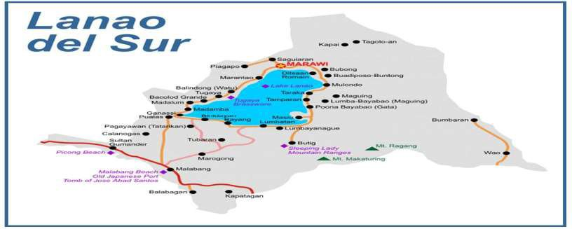

**Taraka**

**Ditsaan-Ramain**

**Figure 1.** Aerial map **s**howing the location of the three sampling sites in Lake Lanao [8].

Isolation of fungi from the sediment samples was done using Spread Plate method in Potato Dextrose Agar with Cefalexin. Incubation period was five to seven days to ensure satisfactory growth of fungal colonies. Repeated streaking was done to isolate the fungal colonies which were maintained in Potato Dextrose Agar slants.

Antibiosis assay was done by first streaking each fungal isolate into a sterile nutrient agar plate. After four days of incubation, test bacteria were cross-streaked using Cotton Swabbing technique [9], onto its assigned plate and then incubated again for 48 hours at 300C to determine if the fungal isolates exhibited inhibition against bacteria. The test for the bioactivity of the isolates was based on the presence of the zone of inhibition around each fungal isolate against the two test bacteria which was measured in millimetre scale.

Characterization of potential antibiotic-producing fungal isolates was done using Slide Culture technique [10] through microscopic examination of pure culture of fungal isolates. The identification of fungi was done using manuals by Hauser [11], Navi [12], and Woodward [13] as guides to classifying the fungi up to the genus level based on the gross appearances of the colonies morphology, reproductive spores and mycelia features.

Data on the zone of inhibition of the fungal isolates against the two test bacteria *Escherichia coli* and *Staphylococcus aureus* were analysed using Analysis of Variance (ANOVA) and Post hoc’s test to determine significant difference of the zone of inhibition by the fungal isolates against the test bacteria. Photomicrographs were taken to show the colonial, morphological, and spore features of the fungal isolates that showed antibiotic activity. Documentation was done using Canon digital camera (16.0 mega pixels).

## RESULTS AND DISCUSSION

A total of 126 fungal species were isolated from the three sites and were maintained in pure culture in Potato dextrose agar slants. Antibacterial assay revealed that only 10 exhibited antibiosis towards either or both of *Staphylococcus aureus* and *Escherichia coli.* These ten fungal isolates were coded and identified as *Acremonium* sp. (YT19), *Aspergillus* sp. 1 (WT1), *Aspergillus* sp*.* 2 (WT19), *Cladosporium* sp. (WT2), *Curvularia* sp. (BT4), *Penicillium* sp. (WT17), *Pestalotia* sp*.* 1 (BT8), *Pestalotia* sp*.* 2 (BT17), *Scopulariopsis* sp*.* (GT17), and *Sporotrichum* sp. (WT15) [11, 12, 13].

Table 1 below shows data on the zone of inhibition (in mm) of the ten fungal isolates against the two test bacteria after 48 hours of incubation. Fungal isolates differed in their

ability to inhibit growth of *S. aureus* and *E. coli. Acremonium* sp. had the widest zone of inhibition against the two test bacteria followed by *Pestalotia* sp.1. and then *Sporotrichum* sp., and *Cladosporium* sp..

*Pestalotia* sp. 1, *Pestalotia* sp. 2, *Scopulariopsis* sp., and *Aspergillus* sp. 2 showed the same level of inhibition against the *S. aureus* whereas *Pestalotia* sp. 1, *Sporotrichum* sp., *Cladosporium* sp, *Curvularia* sp., *Aspergillus* sp. 1, and *Penicillium* sp. showed the same level of inhibition against *E. coli. Curvularia* sp., *Aspergillus* sp. 1, and *Penicillium* sp did not show antibiosis to *S. aureus. Pestalotia* sp. 2, *Scopulariopsis* sp., and *Aspergillus* sp. 2 showed no inhibitory activity against *E. coli.*

Table 1. Zone of inhibition (in mm) of the ten fungal isolates against the two test bacteria after 48 hours of incubation.

|  |  |  |  |  |  |  |  |  |  |  |
| --- | --- | --- | --- | --- | --- | --- | --- | --- | --- | --- |
|  | ZONE OF INHIBITION (in mm) | | | | | | | | | |
|  | TEST BACTERIA | | | | | | | | | |
| ISOLATES | *Staphylococcus aureus* | | | | |  | | *Escherichia coli* | |  |
| R1 | R2 | Total | Mean* | DMRT | R1 | R2 | Total | Mean* | DMRT |
| *Acremonium* sp. | 17 | 18 | 35 | 17.5 | A | 14 | 13.5 | 27.5 | 13.75 | A |
| *Pestalotia* sp. 1 | 6 | 8.5 | 14.5 | 7.25 | B | 0 | 7 | 7 | 3.5 | B |
| *Sporotrichum* sp. | 3 | 3.5 | 6.5 | 3.25 | C | 2 | 2 | 4 | 2 | B |
| *Cladosporium* sp. | 4.5 2 | | 6.5 | 3.25 | C | 0 | 4 | 4 | 2 | B |
| *Curvularia* sp. | 0 | 0 | 0 | 0 | D | 6.5 6 | | 12.5 | 6.25 | B |
| *Aspergillus* sp. 1 | 0 | 0 | 0 | 0 | D | 4 | 4.5 | 8.5 | 4.25 | B |
| *Penicillium* sp. | 0 | 0 | 0 | 0 | D | 3 | 2.5 | 5.5 | 2.75 | B |
| *Pestalotia* sp. 2 | 9 | 10 | 19 | 9.5 | B | 0 | 0 | 0 | 0 | C |
| *Scopulariopsis* sp. | 9 | 9 | 18 | 9 | B | 0 | 0 | 0 | 0 | C |
| *Aspergillus* sp. 2 | 7 | 7 | 14 | 7 | B | 0 | 0 | 0 | 0 | C |
| Grand Total Grand Mean |  |  | 11.35 | 5.675 |  |  | | 6.9 | 3.45 |  |

Among the fungal isolates, a mold of the genus *Acremonium* (Figure 2) showed the most superior ability to inhibit both test bacteria. Mean zone of inhibition was 17.5 mm against

*S. aureus* and 13.75 mm against *E. coli. Acremonium* also known as "*Cephalosporium*", a source of β-lactam antibiotic, cephalosporin. *A. strictum* has been found to produce metabolites that can be of agricultural and pharmaceutical significance in the future [14].

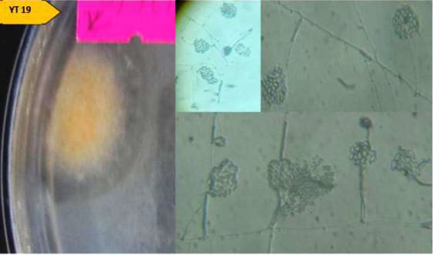

Figure 2. *Acremonium* sp. colony and microscopic features (400 x) showing long slender phialides and conidia are cylindrical or ellipsoidal form in slimy bundles

at the tips of the phialides [11, 12, 13].

*Pestalotia* sp.1 (Figure 3) also showed antibiosis against both *S. aureus* and *E. coli*

with 7.25 mm and 3.5 mm zone of inhibition, respectively. Its pale orange colony on both sides differentiates it from another species of Pestalotia.

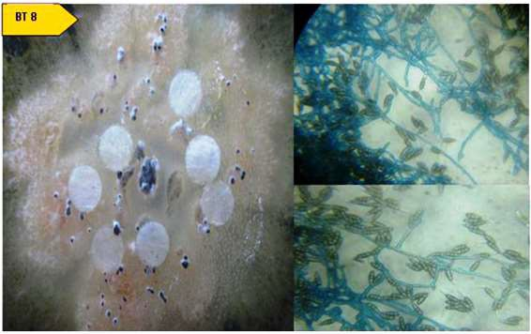

Two

Figure 3. *Pestalotia* sp.1 colony and microscopic features (400 x) showing mycelia and septate spores [11, 12, 13].

4) and

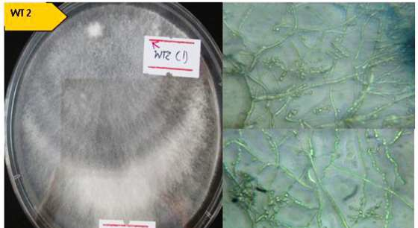*Sporotrichum* sp. (Figure 5). Mean zone of inhibition for both molds were 3.25 mm for *S. aureus* and 2 mm against *E. coli*.

mold isolates which inhibited both test bacteria were *Cladosporium* sp. (Figure

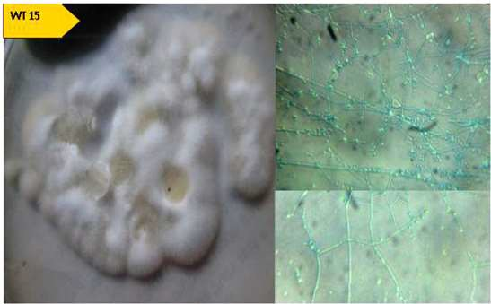

Three

Figure 5. *Sporotrichum* sp. colony and microscopic features (400 x) showing white fluffy white colony in front and yellowish back as well as spores (right side) [11, 12, 13].

, and

*Scopu* means

fungal isolates namely; *Aspergillus* sp*.* 2 (Figure 6), *Pestalotia* sp*.* 2 (Figure 7)

*lariopsis* sp*.* (Figure 8) exhibited antibiosis towards *S. aureus* only. That

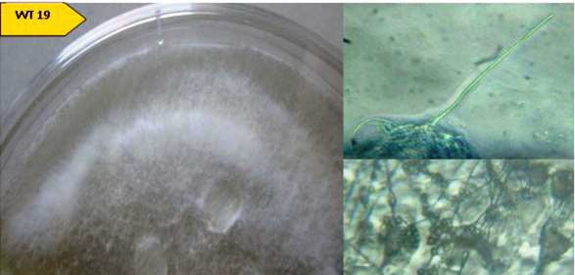these molds showed inhibition to growth of Gram-positive bacteria with mean zone of inhibition of 7 mm, 9.5 mm, and 9 mm, respectively.

Figure 7. *Pestalotia sp.2* colony and microscopic features (400 x) with black and white colony and characteristic spores with three crossed septa and transparent apexes [11, 12, 13].

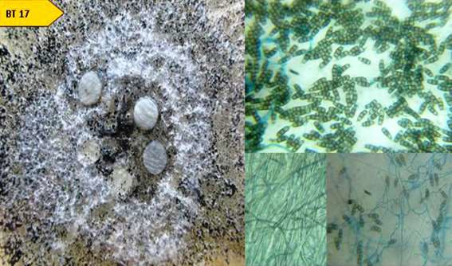

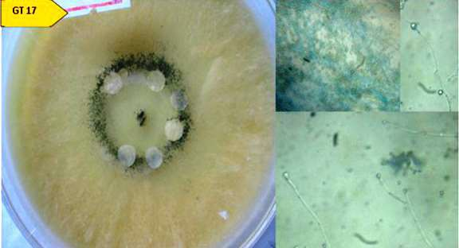

Figure 8 . *Scopulariopsis sp.* colony and microscopic features (400 x) with yellowish to brown color underneath, with annellophore and conidia [11, 12, 13]. .

.

And the three remaining fungal isolates namely; *Curvularia* sp. (Figure 9), *Aspergillus* sp. 1 (Figure 10), and *Penicillium* sp. (Figure 11) exhibited antibiosis against *E. coli* only*.*

Zones of inhibition were 6.25 mm, 4.25 mm, and 2.75 mm, respectively.

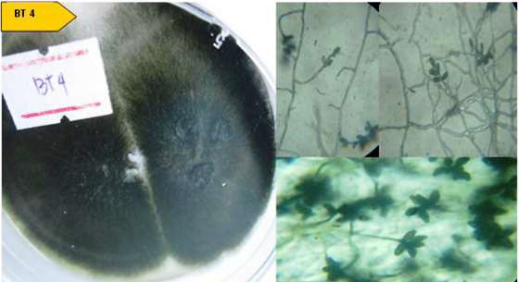

Figure 9. *Curvularia sp.* colony and microscopic features (400 x) with greenish black to black color underneath, conidia pale brown with three or more transverse

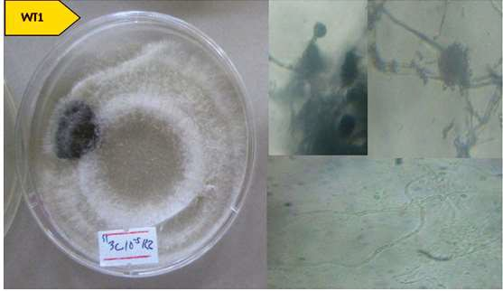septa (phragmoconidia) [11, 12, 13]. .

Figure 10. *Aspergillus* sp 1. colony and microscopic features (400 x) with white color on the

surface and underneath and characteristic radiate spores [11, 12, 13].

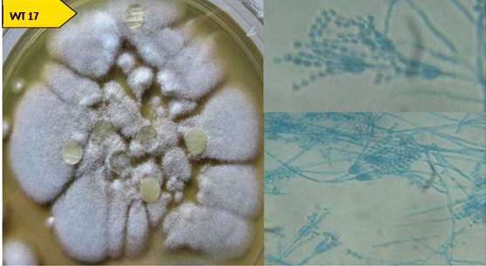

Figure 11. *Penicillium sp.* colony and microscopic features (400 x) with greyish green color on the surface and yellow underneath and characteristic broom-like conidia with conidiospores borne from bottle-shaped phialides [11, 12, 13].

The 10 fungal isolates which exhibited antibiosis belong to eight genera namely; Acremonium, *Aspergillus, Cladosporium, Curvularia, Penicillium, Pestalotia, Scopulariopsis, and Sporotrichum,* Most of the antibiotics derived from fungi came from *Penicillium* and *Aspergillus*. The antibiotic-producing ability of *Penicillium* and *Aspergillus* are well known at industrial scale particularly of organic acids, citric, gluconic, and oxalic acids, phenylacetic acid, p-hydroxyphenylethyl alcohol, and l-phenyllactic acid were isolated from the crude extract of *Cladosporium* which were the first reported secondary metabolites for the genus *Cladosporium*, as strong antimicrobial compounds [15].

Haloperoxidase isolated from the filamentous fungus *Curvularia verruculosa* has an antimicrobial activity. It is believed, although not experimentally verified, that reactive

oxygen species with antimicrobial effects were produced. The enzyme oxidizes halides, such as bromide, chloride, and iodide, in the presence of hydrogen peroxide [16].

Three other fungal species that showed inhibition towards the two test bacteria were *Sporotrichum* sp. *Scopulariopsi*s sp., and *Pestalotia* sp. By the release of organic acids in the culture media which are toxic substances, these fungal species may have the ability to inhibit the growth of bacteria. During the early stages of fungal growth it is usual for appreciable amounts of organic acids to be produced and be utilized by molds when other sources of carbon become exhausted. Such organic substances could have the ability to inhibit the growth of bacteria, and hence is considered to have antibacterial properties. Some active fungal isolates may have the ability to decrease the pH which the bacteria can no longer tolerate. This mechanism could also be an explanation as to how the three fungal species *Sporotrichum* sp. *Scopulari*s sp., and *Pestalotia* sp. which were not known to release antibiotic substances could inhibit bacterial growth [17].

The detection of antibiotic activity against the test bacteria depends on the intrinsic activity of the antibiotic and the quantity of antibiotic produced. It does not necessarily mean that the active isolate produces high amounts of antibiotic substances if it shows a large zone of inhibition, but rather the remarkable ability of the antibiotic substance to readily diffuse into medium. Other factors like the age of the culture, constituents of the medium, temperature, and strain of bacteria influenced the production of antibiotic [6].

Comparing the grand mean of the zone of inhibition of the fungal isolates (Table 1) towards the two best bacteria, it can be observed that larger mean value of ZOI (5.675 mm) were recorded against *Staphylococcus aureus* (Gram-positive) while smaller mean value of ZOI (3.45 mm) were recorded against *Escherichia coli* (Gram-negative). This only indicates that Gram-positive bacteria are more susceptible than Gram-negative bacteria. This could be explained by the complexity of the structure and function of their cell wall. The Gram-negative envelope is chemically more complex compared to the Gram-positive wall. The major portion of the Gram-positive cell wall is constituted by peptidoglycan or murein and is exposed to the external environments. As a result Gram-positive wall is generally more susceptible than Gram-negative envelope caused by the destruction of lysozymes. Moreover, the substrate for the enzyme is not only more abundant in Gram- positive bacteria than Gram-negative bacteria, but is also more accessible. Furthermore, antibiotics that interfere with murein synthesis are usually more operative with Gram- positive cells compared to Gram-negative cells. Another difference is the extent of participation of the two structures in the transport and selective permeability. The Gram- negative envelope is much more involved in this course of action than Gram-positive wall. Various receptors in the outer membrane of the Gram-negative bacterium facilitate selective accumulation of materials at the cell exterior. Combined with porins, hydrolytic enzymes, and receptors in the periplasmic space allow the entrance of materials into the cell that might otherwise be excluded [7, 15].

In summary, the fungal genera namely; *Aspergillus, Cladosporium, Penicillium, Curvularia,* and *Acremonium* were already recorded to produce antibiotic substances. Some of these bioactive metabolites were being utilized as antibiotic drugs in an industrial scale,

particularly those that comes from *Aspergillus* and *Penicillum.* The other three genera *Sporotrichum, Pestalotia,* and *Scopulariopsis* were not recorded to produce antibiotic substances. Thus, this study could serve as a reference for further testing of these fungal species for antibiotic production, which were not well known to produce substances that have antimicrobial properties. The fungal isolate with highest antibiotic activity was *Acremonium* sp. coded as YT19. This study had demonstrated the rich diversity of fungal species that can be isolated from Lake Lanao, and hence is an excellent ecosystem to harbor fungal species that can produce novel metabolites that could be of great economic and medical significance in the future.

## CONCLUSION AND RECOMMENDATIONS

Of the 126 fungal species isolated from the three sites of Lake Lanao, 10 molds exhibited antibiosis against *Staphylococcus aureus* and *Escherichia coli*. *Acremonium* sp. showed superior activity followed by *Pestalotia* sp.1, *Sporotrichum* sp., and *Cladosporium* sp. which also inhibited growth of both Gram-positive and Gram-negative test bacteria. Three fungal isolates showed antibiosis against *S. aureus* only namely *Aspergillus* sp*.* 2, *Pestalotia* sp*.* 2, and *Scopulariopsis* sp*.* And the three remaining fungal isolates inhibited growth of *E. coli* only namely; *Curvularia* sp., *Aspergillus* sp. 1, and *Penicillium* sp.

## ACKNOWLEDGEMENT

“Thank you” would not even half-express our gratitude to the National Research Council of the Philippines (NRCP) of the Department of Science and Technology (DOST) which partly support this research, MSU-Iligan Institute of Technology as the implementing agency, and Mindanao State University, Marawi City as the supporting agency. My salute is due to Ms Catherine Grace M. Chua (soon to be MD) for her excellent diligence to this research. Congratulations for the Best Thesis Award! ☺ Special thanks to my two project staff, Prof. Mariam C. Kabirun and Prof. Nourshamsia C. Barosa who assisted Ms Chua’s overtime and overnight stay in the lab. Your kindness and passion for research enable you to extend help wholeheartedly. Ladies, thank you so much. 

# REFERENCES

1. Bérdy, J. Thoughts and facts about antibiotics: Where we are now and where we are heading [Review]. The Journal of Antibiotics, 65:385–395, 2012.
2. Davies, J., & Davies, R. Origins and Evolution of Antibiotic Resistance. Microbiology and Molecular Biology Reviews. 74(3): 417-433, 2010.
3. O’Neill, J. Antimicrobial Resistance: Tackling a crisis for the health and wealth of nations. The Review on Antimicrobial Resistance. 1-20, 2014.
4. Tawiah, A., Gbedeme S. Y., Boamah, V. E., and Annan, K. Antibiotic- producing microorganisms from River Wiwi, Lake Bosomtwe and the Gulf of Guinea at Doakor Sea Beach, Ghana. BMC Microbiology, 12, 1471-2180. Available at <http://www.biomedcentral.com/1471-2180/12/234>, 2012.
5. Wurzbacher, C.M., Bärlocher, F., Grossart, H. P. Fungi in lake ecosystems [Review]. Aquatic Microbial Ecology, 59: 125–149, 2010.
6. Ho, W. H., To, P. C., and Hyde, K. D. Induction of antibiotic production of Fresh- water fungi using mix-culture fermentation. Fungal Diversity 12: 45-51, 2003.
7. Hauser, A. R. Microbiology. Illinois. [www.feinberg.northwestern.edu](http://www.feinberg.northwestern.edu/), 2006.
8. Google map. [https://www.google.com/maps/place/Lake+Lanao/@7.892169,124](https://www.google.com/maps/place/Lake%2BLanao/%407.892169%2C124).

.097872,11z/data=!3m1!4b1!4m5!3m4!1s0x3255eb6124e88a43: Accessed November 29, 2020.

1. Mabuhay, Jhonamie C. Basic Microbiology Laboratory Manual. Mindanao State University, Marawi City. 2016.
2. Dagani, C. J. Isolation of Fungi exhibiting antibiosis towards *Escherichia coli* and *Staphylococcus aureus.* Unpublished Undergraduate Thesis. Biology Department, Mindanao State University, 2006.
3. Hauser, J.T. Techniques for Studying Bacteria and Fungi. Carolina Biological Supply, USA, 2006.
4. Navi, S.S.; Bandyopadhyay, R.; Hall, A.J.; Bramel-Cox, P. A Pictorial Guide for the Identification of Mold Fungi in Sorghum Grain. Information Bulletin No. 59. International Crop Research Institute for Semi-Arid Tropics, 118 pp., 1999.
5. Woodward, J.W. Simplified Fungi Identification Key. Cooperative Extension Service. Collage of Agricultural and Environmental Sciences University of Georgia, 1-12. 2001.
6. Sauberan, J.B.; Bardley, J.S. Antimicrobial Agents. Principles and Practice of Pediatric Infectious Diseases (5th edition), 2018.
7. Ding, L.; S. Qin; F. Li; H.Laatsch. Isolation, Antimicrobial Activity, and Metabolites of Fungus C*ladosporium* sp. Associated with Red Alga *Porphyra yezoensis*. Current Microbiology, Springer, 2008.
8. Hansen, E., Albertsen, L., Schafer, T., Johanssen, C., Frisvad, J., Molin, S., Gram, M. Curvularia Haloperoxidase: Antimicrobial Activity and Potential Application as a Surface Disinfectant. NCBI, 69(8): 4611–4617. 2003.
9. Zhitnitsky, D.; J. Rose; and O. Lewinson. The Highly Synergistic, broad spectrum, antibacterial activity of organic acids and transition metals. Scientific Reports. Vol. 7, 44554. 2017.