**Implementation of Fuzzy Logic Algorithm in Identifying Gender and Development Interventions**

**111**

ROLAIDA L. SONZA, Nueva Ecija University of Science and Technology- Philippines

**The Philippine State Universities and Colleges (SUCs) have established Gender and Development (GAD) mechanisms where the government provides funds for the implementation of its programs and projects. On the other hand, it was found out that most of the SUCs have non-automated data sources and systems without analytics functions. In this study, the authors present innovative solutions as the basis for gender interventions using a fuzzy logic algorithm. Different applications were utilized and implemented the Single- Input-Single-Output Mamdani fuzzy inference type. This is an advanced approach for determining relevant interventions for university that can promote gender equality and inclusivity.**

KEYWORDS

Fuzzy Logic, Gender and Development, Information Technology, interventions

1. INTRODUCTION

In the present era, everyone trusted the utilization of technology. People applied and used it in different situations such as business process and management, learning process, researches, health analytics, social analysis, and many aspects that help people to store data, make their tasks easy, convenient and organized. Many of us always find some procedures or methods that can improve the present situations. If there are problems, the initial task is to find better solutions, better interventions.

In the Philippines, the Gender and Development (GAD) programs and projects are supported by the government where all government instrumentalities, units, and State Universities and Colleges (SUC) allow to use the five percent of their gross income.

Annually, these agencies have their yearly plan and budget that stated their interventions whether it is projects, strategies, or programs to promote gender fairness and eliminate discriminations [1].

The State Universities and Colleges (SUC) GAD Focal Persons in the Second Luzon SUCs GAD Advocacy Forum last June 6-7, 2018, confirmed that they are still lack of mechanisms to gather important data that monitors the needs of their clients, their gender issues, and problems. They also have a hard time to think accepted projects or activities to comply with the government mandate.

This is the concern of researchers; therefore, the different automated data source mechanisms were designed and developed with analytics functions that classify and identify interventions using a fuzzy logic algorithm. In order to understand these automated systems, the following are its descriptions:

**Online Survey.** Under this app, the users are students, employees, and system admin. The students and employees can have their accounts and answer the survey. The system admin can manage accounts, create questions, and view the statistics and interventions.

**Training Assessment App**. The app can evaluate the training conducted by the GAD Center. The participants can have their account and use their phone with an internet connection to give their rate and some suggestions to improve the service.

**Financial Assistance Application**. The users are students and the system administrator. The students can apply for the available financial assistance particularly if they are solo parent, orphan, PWD. The system admin can approve the applications if the students submitted all the requirements.

**Knowledge-based Management System**. The students and employees are the users of this system who can access the media provided through their account. They can read articles or play videos available. They can also click Like button if they like the media or click Unlike button if they do not like the media. The system admin can view the result of their answers and view the interventions.

**Project Tracker App.** This app can be accessed by the GAD focal person, they can add the project/activity and enter the budget allocated and expenses. They can monitor the projects implemented and not implemented.

According to Dadios(2012), fuzzy logic is really needed in problem-solving methods. He stated that it gives a remarkable influence in designing an intelligent system particularly in decision support [2]. Wang(2016) stated the fuzzy Mamdani method is a Min-Max method that has characters working under the rules of language with an estimate to enter mathematical analysis[3]. Nursikuwagus(2017)successfully used the fuzzy logic algorithm Model to the choosing system for eligible students in their university[4].

With this, the researchers utilized the Mamdani type Single-Input Single-Output (SISO) inference system as the simplest model and easy to implement. In the different GAD data sources, each has different membership functions as input and through the process of fuzzy inference system, it has also had its own crisp output to identify its linguistic equivalent.

**112**

## RELATED STUDIES

The Philippine government made its effort to continue the programs and formation of various Laws for Gender and Development to pursue the full actions of gender fairness in which the GAD concerns on the planning, budgeting processes, and annual performance reports were incorporated [5]. The Magna Carta of Women is a mandate of non-discriminatory and pro-gender equality and equity in the formulation and implementation of policies and plans for national development [6]. It is also the basis of Commission on Higher Education in developing the Commission on Higher Education Memorandum 1 series of 2015 or the Establishing the Policies and Guidelines on Gender and Development in the Commission on Higher Education and Higher Education Institutions (HEIs) [7]

Pulmona(2016) stated that the assessment of GAD programs in the Philippines especially in region 3 showed little improvement in the implementation process. According to her, in order to achieve gender equality and women empowerment, the different mechanisms must be implemented and provide full support in resources’ allocations like manpower who will manage the GAD center and enough budget to support its different projects [8].

The Los Baños of Laguna Philippines has it GAD database spearheaded by its GAD Office. They have a strong belief that it is essential in their planning, programming, and policy formulation. The purpose also of this technology-based system is to share the information with interested researchers. The database has a list of sectors such as social development, economic development, infrastructure, environment, institutional, and gender mainstreaming. The GAD Office shall ensure continuous and regular monitoring and updating the database to make sure that all possible facets of necessary data are covered [9].

Automation was applied by the researchers in this study by reducing the human efforts, and the machine will work for it [10], [11] using the fuzzy logic algorithm. The rule utilized is fuzzy if-then rules and just like the work of Kumar et al, the rules are created based on the concept of the domain rule of a data sample [12].

Favian et al(2019) utilized the Mamdani fuzzy logic inference system in their intelligent systems with two primary components including the knowledge database and the knowledge rule base.[13]. Azeem identified two categories of Mamdani fuzzy inference system such as Multiple Input and Single Output (MISO) and Single Input and Single Output (SISO)[14]. These inference systems can help the decision-makers in classification and analytics systems.

1. RESULTS AND DISCUSSION

In improving the system, the iterative process flow model was utilized [15], [16]. The combination of coding, verification, unit testing and debugging for necessary automated applications were done using the Laravel Framework and MariadB is the database management system.

# GAD Database System and Data Collections

The GAD Database System developed were utilized as mechanism of data sources. Among the automated systems developed by the researchers are shown in Fig. 1 which included the online survey system, application for financial assistance, knowledge-based management system, project tracker and training assessment. The data were collected from Nueva Ecija University of Science and Technology-Philippines from October 2018 to January 2019. The data consist of 8,000 records gathered from users of the two campuses.

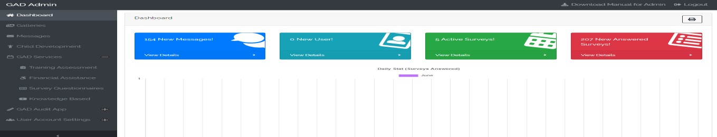

Fig 1. GAD Database System

# Logical Implementation of Fuzzy Logic Algorithm

**113**

To build the fuzzy inference system for the GAD interventions, the researchers used the MatLab Simulink R2019b with Fuzzy Logic Toolbox Graphical User Interface Tools. The researchers set some fuzzy variables and its field of linguistics value for each fuzzy variable. These are the basis of how the fuzzy logic algorithm processed to identify the interventions in the different web-based applications.

In the Fuzzy Inference System (FIS) of Online Survey System, the researchers set the membership functions for GenderGap as input variable and InterventionType as output variable. When the fuzzy inference process was done, the Surface and Rule Viewers can display the behavior of the inference. As shown in Fig 2, the researchers set 1-500 range of the membership function and when the GenderGap input crisp value is 450, the Intervention Type or output crisp value is 408. It means that the InterventionType is ProjectProgram&Strategy. To compute the crisp output, the researchers used the Centroid Method for defuzzification process. The formula for centroid is given by the equation

r𝐶𝑂𝐴 =∫ 𝜇𝐴(r) ∙ r𝑑r

r∫𝜇 r 𝐴(r)

where r is the output variable, and 𝜇𝐴(r) is the membership function of the aggregated fuzzy set input with respect to r.

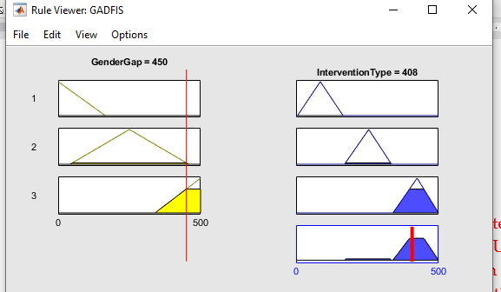

**Fig *2*.** Implication and Aggregation Process Trial for Online Survey System FIS

The researchers also do some trial input to check the other crisp output for the online survey system FIS. The trial values for GenderGap is shown in the Table 1. The crisp input is not equal to the crisp output due to adjustment in the centroid method.

## Table 1

Trial Values for Survey System Fuzzy Inference System

|  |  |  |
| --- | --- | --- |
| Number of Trials | GenderGap(Crisp Input Value) | InteventionType (Crisp Output Value) |
| 1 | 10 | 85 |
| 2 | 15 | 85 |
| 3 | 400 | 345 |
| 4 | 500 | 422 |

Shown in Fig. 3 is the Fuzzy Logic Algorithm used in identifying the GAD interventions of Online Survey. This algorithm composed of a rule-based system that consists of a collection of “fuzzy if then rules” that has linguistic scale defining how intense is the GenderGap of the given data. From the GenderGap scale, there are equivalent interventions classified as projects, programs, activities or strategies. The set of rules are given below for the implementation of the algorithm stated:

**Rule 1**. If the difference of male and female ranges from 1-167, the gender gap is low, the output is Low with equivalent interventions of activities only.

**Rule2.** If the difference of male and female ranges from 168-334, the gender gap is medium, the output is Medium with equivalent interventions of activities, strategies and programs

**114**

**Rule 3**. If the difference of male and female ranges from 335-500 the gender gap is high, the output is High with activities, programs, projects and strategies interventions

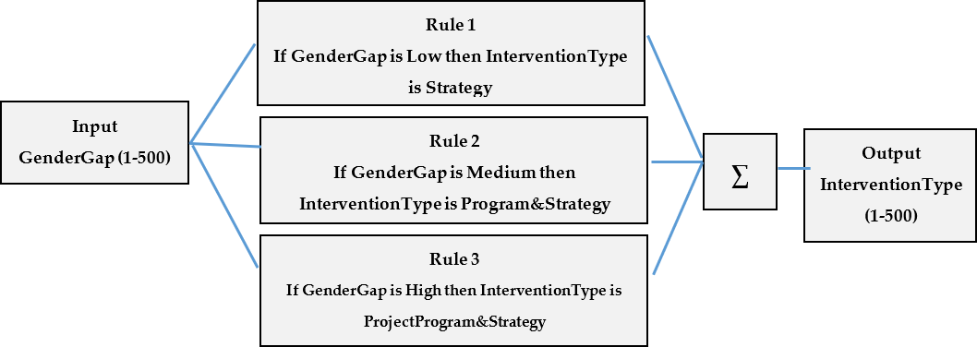

Fig.3. Logical Implementation of SISO Fuzzy Inference System in Online Survey System

Fig.4 shows the implementation of Fuzzy Logic under the Knowledge-based system where the author set also some rules to consider and the database for the knowledge-based system. At first, the system compares the number of Likes to the media uploaded and rated and the interventions are based on the scale given weather it is low or high satisfaction. The following rules are made for this application:

**Rule 1.** If the Like is less than 200, the LevelOfLikes is low, the output is Low with equivalent interventions of

strategies

**Rule 2**. If the Like is greater than 200 the LevelOfLikes is high, the output is High with programs, and strategies

interventions

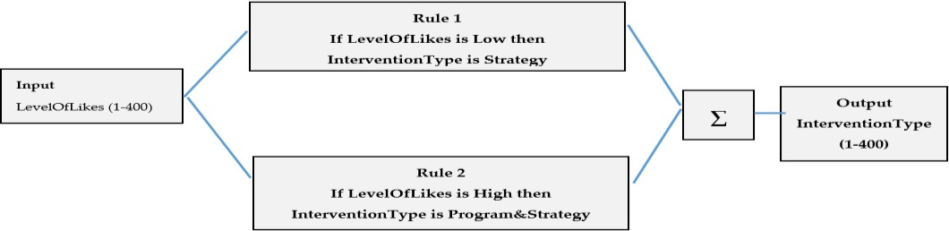

**Fig. 4.** Logical Implementation of SISO Fuzzy Inference System of Knowledge-based Management System

In the logical implementation of the Fuzzy Inference system in Application for Financial Assistance the authors considered also some rules and used linguistic scale such as Few, More and Many.

**115**

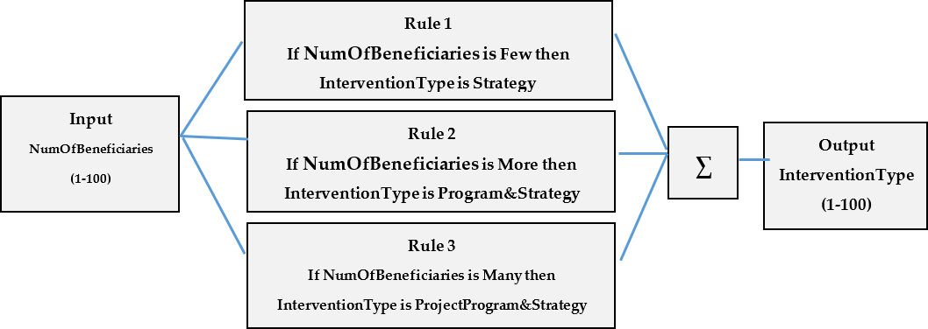

**Fig. 5.** Logical Implementation of SISO Fuzzy Inference in Application for Financial Assistance

To show the agregation process and input-output relation of membership functions, the MatLab rule viewer and surface viewer can show it in Figure 6. It shows positive correlation where if the number of beneficiaries increases, the interventiontype crisp output become increase as well.

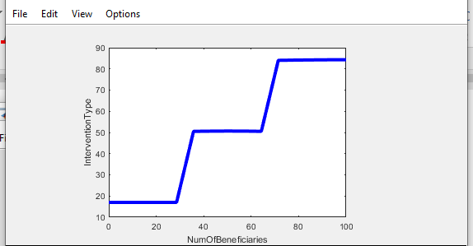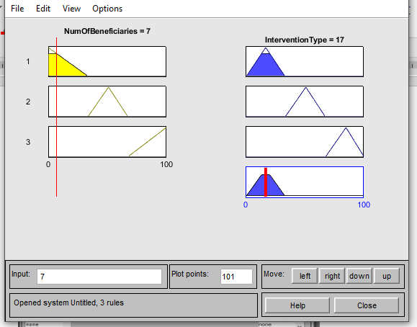

**Fig 6.** Agregation Process and Input-Output Relation of the Application for Financial Assistance FIS

# GAD Intervention Reports

The GAD data sources applications were innovate by adding features of interventions based on the result of fuzzy logic identified within the databases. The recommended interventions were validated from the Philippine Commission on Women pool of expert and members of GAD Focal Point System of different State Universities in the Philippines. The multiple interventions sets are based on the intense of the gap and problems encountered of the students. Some of the reports obtained are shown in Fig.7 and Fig. 8.

Fig.7 shows the GAD data having 12 Male applicants and 44 female applicants. The system consists of 56 beneficiaries suggests program and strategies interventions.

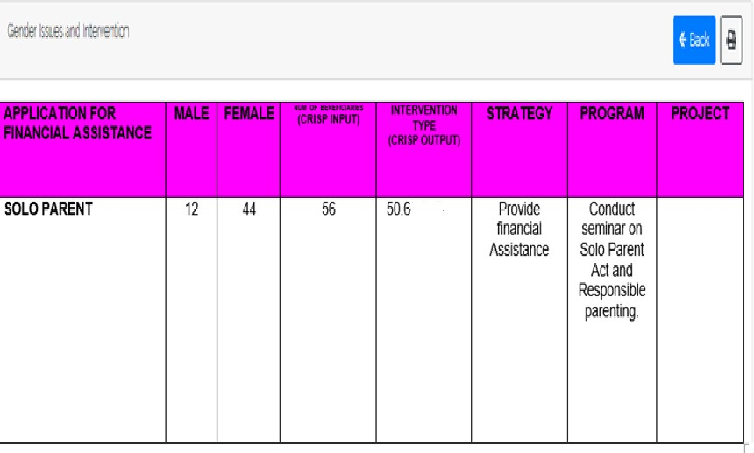

**116**

Fig. 7: GAD Interventions to the Applicants for Solo Parent Financial Assistance

Fig.6 shows the Fuzzy logic inference result as basis for the implementation of interventions in Survey System. It illustrates in the figure that when the value of GenderGap is 422 male students enrolled in the Bachelor of Science in Information Technology, the level of GenderGap is High, and it recommends that the university provides projects, programs, and strategies to end the biases or gaps. As stated, there should be provision for financial assistance for new women who will enroll in this program/course, counseling program on GAD Sensitivity, symposium on choosing the right career path, and more slots are given to women under this program/degree.

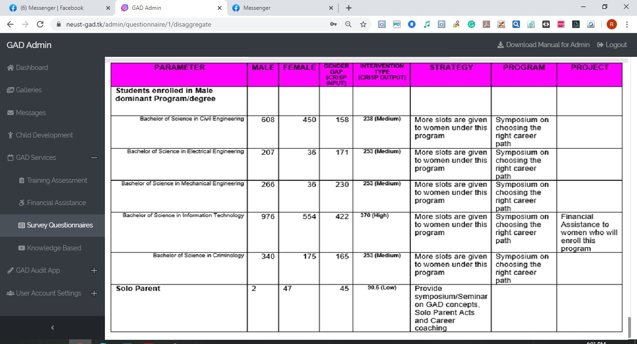

Fig.6. GAD Interventions from the data collected from Online Survey System

4. CONCLUSION

**117**

The fuzzy inference system using MatLab and Simulink r2019b was successfully executed to simulate the relationship of membership functions and the interventions. The fuzzy logic algorithm was implemented in the developed programs and it was applied to online survey system, knowledge management system, application for financial assistance and training assessment where different interventions are gathered. The logical framework of the Fuzzy Logic Algorithm in identifying the GAD interventions really help the GAD Focal Point System of university in mainstreaming gender equality.

ACKNOWLEDGMENTS

The authors sincerely appreciate all the insights and support shared by the generous people such as GAD Focal Persons of the different SUCs, the staff of Commission on Higher Education R3, Philippine Commission on Women and faculty members from Angeles University Foundation. Also, to the administrators, students, and employees of Nueva Ecija University of Science and Technology who shared their data and support to this endeavor. To our families who always encouraged us in doing and make this study completed.

REFERENCES

1. CMO-o.-01-s.-2015.Retrieved from https://ched.gov.ph/wp-content/uploads/2017/10/CMO-no.-01-s.-2015.pdf, pp. 24
2. Dadios, Elmer. 2012.Fuzzy Logic Algorithm, Techniques and Implementation..De La Salle University.Philippines
3. Wang, Chonghua. 2016."A Study of Membership Functions on Mamdani-Type Fuzzy Inference System for Industrial Decision-Making".

Theses and Dissertations. Paper 1665

1. Nursikuwagus, Agis and Baswara, Agis.2017. A Mamdani Fuzzy Model to Choose Eligible Student Entry retrieved from [https://www.researchgate.net/publication.](https://www.researchgate.net/publication)
2. Philippine Plan for Gender and Development (PPGD). Retrieved from <https://pcw.gov.ph/sites/default/files/documents/>resources/ppgd_framework.pdf, pp.5.
3. Senate and House of Representatives of the Philippines in Congress. Republic Act 9710 An Act Providing for the Magna Carta of Women.July 28, 2008. pp 7
4. CMO-no.-01-s.-2015. Retrieved from https://ched.gov.ph/wp content/uploads/2017/10/CMO-no.-01-s. 2015.pdf, pp.25
5. Pulmano, Rita. Implementation Of The Gender And Development Program Of State Universities And Colleges In Region Iii: An Evaluation.2016.

International Journal of Education and Research. Vol. 4 No. 5 May 2016

1. GAD database. August 2018. Retrieved from <http://www.losbanos.gov.ph/gender-and-development/page/1>
2. Jantan, Hamidah, Hamdan Abdul and Othman, Zulaiha.Intelligent Techniques for Decision Support System in Human Resource Management.

Research Gate, March 2010

1. Automation - Definitions from Dictionary.com". dictionary.reference.com. Archived from the original on 29 April 2008. Retrieved 22 April 2008
2. Kumar, Darshan, Singh, Jagdev, Singh, Om Pal.2013. A fuzzy logic based decision support system for evaluation of suppliers in supply chain management practices. Elsevier [Volume 58, Issues 11–12,](https://www.sciencedirect.com/science/journal/08957177/58/11) December 2013, Pages 1679-1695

[13 Yamid Fabián Hernández-Julio ,*, Martha Janeth Prieto-Guevara , Wilson Nieto-Bernal , Inés MeriñoFuentes and Alexander Guerrero-Avendaño.

Framework for the Development of Data-Driven Mamdani-Type Fuzzy Clinical Decision Support Systems. Diagnostics, May 9, 2019, doi:10.3390

1. Azeem, Mohamma.2015. Fuzzy Inference System: Theory and Applications. Published by InTech, Croatia. pp 45
2. Richey R. et al.2015. Developmental Research Methods: Creating Knowledge from Instructional Design and Development Practice. Wayne State University from Journal of Computing in Higher Education 2005 Vol. 16(2), 23-38 from <http://www.researchgate.net/publication>
3. Pressman, Roger. 2010.Software Engineering The Practitioners Approach.McGraw-Hill.Education Asia