Acute Oral Toxicity and Hypoglycemic Activity of *Artocarpus odoratissimus* Blanco (Moraceae) fruit extract

# ABSTRACT

Most of the plant species of the genus *Artocarpus* have polyphenolic compounds. A native plant species of the said genus is *Artocarpus odoratissimus* Blanco. There is less scientific evidence about its medicinal properties. This study determined the preliminary toxicity and hypoglycemic property of the dichloromethane semi-crude fruit extract of *Artocarpus odoratissimus*. The semi-crude extract sample was obtained through fractionation of the ethanolic extract. The acute oral toxicity testing was done through OECD guidelines for the main 425 test, and Sprague Dawley rat model was used in the *in vivo* hypoglycemic bioassay. It was found out that the extracted sample was non-toxic up to 2000 mg/kg BW of test animals. Doses of 250 mg/kg, 500 mg/kg, and 2000 mg/kg showed a time-dependent lowering of mean blood glucose levels of the test animals after 21 days of treatment period. The 250 mg/kg and 500 mg/kg doses showed minimal glucose-lowering activity. The high dose of the extract has comparable hypoglycemic activity with the positive control, Acarbose (10 mg/kg BW).

Keywords: *Artocarpus odoratissimus, Acute Oral Toxicity, Hypoglycemic, Acarbose*

# INTRODUCTION

One of the sources of medicinal agents would come from plants. Fifty plant species belong to the genus *Artocarpus* which is under the Moraceae family. Most of these plant species contain polyphenolic compounds that are deemed to possess biological activities. The most popular plant species of this genus is *Artocarpus heterophyllus* which has established medicinal properties such as hypoglycemic activity. A native plant species of the genus *Artocarpus* in the Philippines is *Artocarpus odoratissimus* Blanco. It is locally known as *Marang* and *Tarap*. It is a tree that grows at the height of not more than 25 m. Its leaves are alternate, ovate, glossy in appearance and dark-green in color. Flowers have stiff spikes and have conical heads. The fruit is subglobose up to 20 cm in diameter green-yellow in color with hairy processes, seeds are embedded in pulp. The pulp flesh is white, edible, and fragrant [1]. Studies on its medicinal uses are limited. Due to this reason, this present study assessed its acute oral toxicity and therapeutic potential, particularly its hypoglycemic activity in rodent animal models.

# MATERIALS AND METHODS

Chemicals and reagents

Ethanol (95%), Dichloromethane, Hexane, n-Butanol, Acarbose (analytical grade) and Alloxan were purchased from Bellman Corporation. Clinical chemistry kit glucose liquicolor (HUMAN Diagnostics) was procured from Biocare Health Resources.

Plant authentication and extraction

Fresh fruit samples of *Artocarpus odoratissimus* were collected at Magsaysay, Marilog District, Davao City, Philippines, and its sample specimen was verified by the curator of the Research Center for Natural and Applied Sciences of University of Santo Tomas, Manila. The fruit pulp samples were vacuum dried and ground to a fine powder. The powder was macerated with ethanol (1:10 w/v) for 24 hours and concentrated under *vacuo* at 45C until a viscous consistency to obtain the crude extract and was then fractionated using hexane, dichloromethane, and n-butanol through solvent partitioning [2-3]. The semi-crude extracts were concentrated under *vacuo* and kept at 0 to 8C for further analysis. The dichloromethane semi-crude extract was used in further assays.

Acute oral toxicity testing and hypoglycemic bioassay

The study protocol was approved by the Bureau of Animal Industry (Animal research permit number AR-2019- 143). Sprague Dawley rats (weighing 150-250 grams at least 6 weeks old) were used. The temperature in the animal room facility was 21C with 12-hour light and dark cycles. The relative humidity was 50  5%. For the feeding, rodent pellets were given with an *ad libitum* supply of distilled water. The rodents were acclimatized for 7 days before the testings. The doses of the extract were prepared in 1% tween 80 in normal saline solution [4].

Acute oral toxicity using Organization for Economic Cooperation and Development (OECD) main test 425

Six female Sprague Dawley rats were used, including a normal control test rodent. The OECD main test 425 (up-and-down dose procedure) was utilized using doses of 175 mg/kg, 550 mg/kg, 1750 mg/kg, and 2000 mg/kg of the extract. The test animals have undergone fasting overnight before administering the extract using oral gavage. The first set of test animals was administered with a dose of 175 mg/kg. When the animal survived after 48 hours, the dose that was given to the next sets of rodents was increased by a factor 3.2 which was 550 mg/kg, then after 48 hours of survival the next test animal was given 1750 mg/kg then same cycle is repeated and the upper bound dose of 2000 mg/kg was given to the test rodents. The testing was ended until the last three animals survived the upper bound dose, and all of the test animals were observed up to 14 days [5]. A licensed veterinarian conducted the post toxicity gross necropsy of the rodents. Liver and kidney organs

of the test animals were isolated, stored in 10% buffered formalin solution, and subjected to histopathological examination.

*In vivo* hypoglycemic bioassay

Thirty-six Sprague Dawley rats were randomly distributed into 6 different experimental groups (Group I – normal control, group II – negative control, group III – positive control Acarbose 10 mg/kg, group IV – 250 mg/kg extract dose, group V – 500 mg/kg extract dose and group VI – 2000 mg/kg extract dose) with 6 test rodents per group. The inducing agent for hyperglycemia utilized was Alloxan trihydrate solution (150 mg/kg BW) through the intraperitoneal route. The test animals underwent 18 hours of fasting before the induction of hyperglycemia. Groups II to VI were induced with hyperglycemia. Oral administration of the semi-crude extract and Acarbose took for 21 days. Blood extractions were done through the tail vein. Measurements of blood glucose were conducted 5 times (baseline, post-induction, treatment day 7, treatment day 14, and treatment day 21) before blood collection; the test animals were fasted overnight. The collected blood sample was centrifuged at 4000 rpm for 10 minutes [6]. Blood glucose levels were biochemically measured using spectrophotometric methods with the liquicolor kit.

Statistical analysis

Data obtained from the assay was statistically analyzed using a 2-way analysis of variance and post hoc Duncan's multiple range test (*p* = 0.05) through licensed computer package Prism 7.0.

# RESULTS AND DISCUSSION

Plant extraction and fractionation

The dichloromethane semi-crude extract of *A. odoratissimus* yield was 2.40%, and it is a dark brown to green viscous mass.

Acute oral toxicity (OECD main test 425)

The extract was non-toxic up to 2000 mg/kg body weight of test rodents. There were no significant changes that occurred in the pattern of behavior of the test animals. No mortality was noted for 14 days. Gross necropsy findings revealed that all of the essentials organs such as the liver, kidneys, lungs, and heart were normal with a firm consistency. These results present that the extract is non-toxic up to 2000 mg/kg BW of rodents. Figures 1 and 2 present the histological results of the liver and kidney samples of test animal treated with the high dose of the extract.

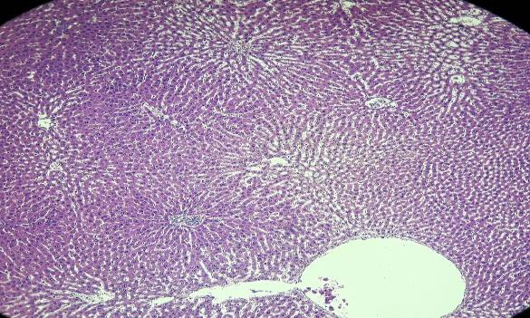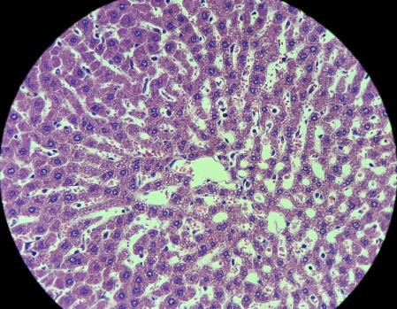

**Figure 1**. Liver tissue section of rat treated with 2000 mg/kg *A. odoratissimus* DCM extract showing the central vein and sinusoids; (left photo) LPO and (right photo) HPO

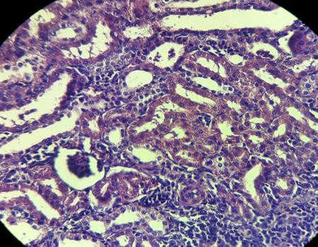 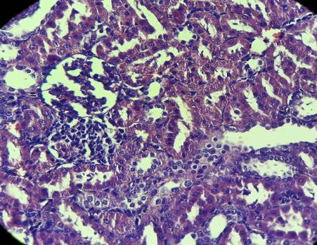

**Figure 2**. Kidney tissue section of rat treated with 2000 mg/kg *A. odoratissimus* DCM extract showing intact bowman’s capsule and glomerulus; (left photo) left kidney and (right photo) right kidney

*In vivo* hypoglycemic bioassay

The mean blood glucose levels were measured in all test groups of rodents on the baseline, pre-hyperglycemia induction, treatment day 7, treatment day 14, and treatment day 21. Alloxan-induced hyperglycemic rats have higher levels of blood glucose compared to that of Group I (*p* < 0.05). Oral administration daily of the extract produced a substantial decrease in blood glucose levels, observed from treatment day 14 and day 21 compared to group II (*p* < 0.05). However, after the 21-day treatment period, blood glucose values between groups III and VI are not statistically significant with each other (*p* = 0.10). The result indicates that a 2000 mg/kg BW dose of the extract has comparable activity with Acarbose (10 mg/kg) in decreasing blood glucose levels. The blood glucose levels of the experimental groups are shown in Figure 3.

700.00

600.00

500.00

400.00

300.00

200.00

100.00

Baseline

Post Induction Treatment Day 7

Treatment Day 14

Treatment Day 21

0.00

I

II

III

IV

V

VI

**Experimental groups**

**Mean blood glucose levels**

**(mg/dL)**

**Figure 3**. Mean blood glucose levels on baseline to treatment day 21 measurements.

*I* = Normal control group; *II* = Negative control group; *III* = Positive control group (Acarbose 10 mg/kg); *IV* = 250 mg/kg extract treated group; *V* = 500 mg/kg extract treated group; *VI* = 2000 mg/kg extract treated group

Maintenance of normal levels of glucose in the bloodstream is considered with high importance through the utilization of hypoglycemic agents such as sulfonylureas, meglitinides, and -glucosidase inhibitors [7]. One of the mechanisms of action in decreasing blood glucose levels is by affecting the activity of the -glucosidase enzyme so that the polysaccharide units would not be disrupted to simple glucose units that might flow freely to the bloodstream [8].

Polyphenols are ubiquitous, non-volatile and biologically active compounds that possess medicinal properties [9]. One class of polyphenolic compounds are flavonoids, in which these compounds have an action to modulate secretion of insulin, a hormone that affects the reuptake of glucose in the physiological systems [10]. Flavonoids targets disaccharides through inhibiting enzymes such as -glucosidase in order to regulate glucose absorption *in vivo* [11]. Other reports demonstrated that the phenyl rings of flavonoids are responsible for its activity in inhibiting -glucosidase and -amylase enzymes thus affecting glucose homeostasis in metabolic processes [12].

Flavonoids highly occur in plant species under the *Artocarpus* genus which have medicinal value [13]. One of its native species here in the Philippines is *Artocarpus odoratissimus*. This group of compounds might be responsible for its hypoglycemic effect *in vivo*. Plants with therapeutic properties can also be employed as an alternative source of treatment, but these must undergo broad pre-clinical and clinical investigations. The outputs of this study suggest that the *A. odoratissimus* extract possesses a biological potential in decreasing blood glucose levels in rodent test animal models.

# CONCLUSION

The *Artocarpus odoratissimus* semi-crude extract is safe and non-toxic up to 2000 mg/kg based from OECD main test 425 for acute oral toxicity standards. Its high dose (2000 mg/kg) presented a comparable hypoglycemic property as with the positive control, Acarbose. The results revealed that the *A. odoratissimus* extract is a potential medicinal agent.

# CONFLICT OF INTEREST STATEMENT

The authors declare that there are no conflicts of interest.

Acknowledgments

The work was supported by the National Research Council of the Philippines (NRCP) and Philippine Council for Health Research and Development of the Department of Science and Technology (PCHRD-DOST) with the grant number: O-008.

# REFERENCES

1. Abu Bakar FI, and Abu Bakar MF. Tarap – *Artocarpus odoratissimus*. Exotic fruits [Internet]. 2018 [cited 2019 July 24]; 413-418. Available from https:/[/www.sci](http://www.sciencedirect.com/science/article/pii/)e[ncedirect.com/science/article/pii/](http://www.sciencedirect.com/science/article/pii/) B978012803184000411.
2. Salcedo EM, Mena P, Viguera CG, et al. Phytochemical evaluation of white (*Morus alba* L.) and black (*Morus nigra* L.) mulberry fruits, a starting point for the assessment of their beneficial properties. Journal of functional foods [Internet]/ January 2015 [cited 2019 July 25]; 12: 399-408. Available from https:/[/www.sci](http://www.sciencedirect.com/science/article/abs/pii/S1756464614003892)e[ncedirect.com/science/article/abs/pii/S1756464614003892.](http://www.sciencedirect.com/science/article/abs/pii/S1756464614003892)
3. Corpuz MJ, Osi MO, and Santiago LA. Free radical scavenging activity of *Sargassum siliquosum* J. G. Agardh. International Food Research Journal. 2013 [cited 2019 July 26]; 20(1): 291-297.
4. Querequincia JM, Osi MO, and Sy SC. Cholesterol-lowering activity of *Artocarpus ovatus* Blanco (Moraceae) ethanolic leaf extract in animal models. Journal of Chemical and Pharmaceutical Research [Internet]. 2015 [cited 2019 July 26]; 7(3): 861-864. Available from <http://www.jocpr.com/articles/cholesterollowering-activity-of-artocarpus-ovatus-blanco-moraceae-> ethanolic-leaf-extract-in-animal-models.pdf.
5. Organization for Economic Cooperation and Development [Internet]. Acute Oral Toxicity Main Test Guidelines 425 [cited 2019 July 27]. Available from <http://www.oecd.org/chemicalsafety/risk-> assessment/1948378.pdf.
6. Mourya P, Shukla A, Rai G and Lodhi S. Hypoglycemic and hypolipidemic effects of ethanolic and aqueous extracts from *Ziziphus oenoplia* (L) Mill on alloxan-induced diabetic rats. Beni-Suef University Journal of Basic and Applied Sciences [Internet]. March 2017 [cited 2019 July 27]; 6(1): 1-9. Available from https:/[/www.sci](http://www.sciencedirect.com/science/article/pii/S2314853516300579)e[ncedirect.com/science/article/pii/S2314853516300579.](http://www.sciencedirect.com/science/article/pii/S2314853516300579)
7. Trevor A, Katzung B, Masters, S, and Hall M. Katzung & Trevor’s Pharmacology Examination and Board Review. 10th ed. New York: McGraw Hill Professional; 2012. 367.
8. Campbell MK and Farrell SO. Biochemistry. 8th ed. Singapore: Cengage Learning Asia; 2015. 149.
9. Galanakis, CM. Polyphenols: Properties, Recovery, and Applications. Amsterdam: Elsevier; 2018. 429- 438.
10. Dias Soares JM, Pereira Leal AE, Silva JC, Almeida JR, de Oliveira HP. Influence of flavonoids on of modulation of insulin secretion. Phcog Mag [serial online] 2017 [cited 2019 Aug 22]; 13:639-46. Available from: [http://www.phcog.com/text.asp?2017/13/52/639/218135.](http://www.phcog.com/text.asp?2017/13/52/639/218135)
11. Pereira DF, Cazarolli LH, Lavado, C, Menggatto, V, Figueiredo, MSRB, Guedes, A, et al. Effects of flavonoids on α-glucosidase activity: Potential targets for glucose homeostasis. Nutrition [Internet]. November 2011 [cited 2019 Aug 20]; 27(11-12): 1161-1167. Available from: https://[www.sciencedirect.com/science/article/pii/S0899900711000451.](http://www.sciencedirect.com/science/article/pii/S0899900711000451)
12. Proenca C, Freitas M, Ribeiro D, Oliveira EFT, Sousa JLC, Ramos MJ, et al. -glucosidase inhibition by flavonoids: an in vitro and in silico structure-activity relationship study. Journal of Enzyme Inhibition [Internet]. 2017 [cited 2019 Aug 20]; 32(1): 1216-1228. Available from https://pdfs.semanticscholar.org/aefa/52e88b5cc0e5f223435d03a4fdc735f6dbd6.pdf?_ga=2. 199759342.1718614210.1566474026-1892116434.1566474026
13. Jagtap UB, and Bapat VA. *Artocarpus*: A review of its traditional uses, phytochemistry and pharmacology. Journal of Ethnopharmacology. 2010 [cited 2019 Aug 21]; 129: 142-166.