Feelings, Cognitions, Behaviors of Filipinos during the COVID-19 Pandemic

# Abstract

The onset of the COVID-19 pandemic in the Philippines has induced significant disruptions and upheavals in the daily lives of Filipinos. Consequently, various feelings, thoughts, and behaviors have been elicited in reaction to the information and actions of various societal actors (i.e. government and media). This study explored these pandemic-related reactions in two phases. The first phase employed a sentiment analysis of people’s online comments in highly viewed articles and videos across selected newspaper publications and news agencies’ posted reports on YouTube. The second phase complemented the sentiment analysis with an online survey which gathered data on emotions, thoughts, and behaviors relating to: (1) individual reactions to the pandemic and (2) government response. The second phase also aimed at determining factors which predicted citizenries’ emotional wellbeing, mental health, and precautionary-preventative behaviors. Recommendations for policy are provided in light of the research findings.

From March to August of this year, the COVID-19 pandemic has been at the center of every activity and life in the country. The Philippine Government, just like governments in other countries in the world, is facing an extremely tough battle against the COVID-19 pandemic. The government’s capability and medical systems in handling this crisis are being challenged while the economy and every individual’s social life is significantly disrupted.

The pandemic has generated a large volume of research in less than a year since it started. If one searches for “research on COVID-19” on Google, one gets over 5.4 billion hits and if one limits the search to “scholarly articles for research on COVID-19” the number of hits go down but the number is still large at over 1.2 million hits. The pandemic has posed three big challenges: 1) to science and the medical profession, to know all there is to know about the novel Coronavirus, to find a vaccine and cures for this disease as soon as possible; 2) to social scientists, to understand the thoughts, feelings and behaviors aroused by the disruptions and upheaval triggered by the pandemic and their impact on subsequent thoughts, feelings and behaviors and people’s responses to the events; 3) to government, to provide good leadership and effective strategies and solutions for its citizens to be able to navigate this crisis safely and maintain their general well-being. Finally, one can also envision as an additional challenge these sectors working together cohesively to provide targeted as well as holistic resolutions to macro- and micro- issues posed by the pandemic’s onset and continuance.

This study picks up on the challenge to the social scientist and was conducted to look into the emotions, feelings, and behaviors of people during the COVID-19 pandemic. The information gathered in the study is potentially useful for the government, media and communications specialists and mental health professionals by bringing awareness to these issues and providing information that can be used in addressing and managing detrimental cognitions, emotions and behaviors during the pandemic.

# General Objective

To investigate people's feelings and responses to the COVID-19 pandemic across the timeline of the pandemic and through the various government actions.

## Specific Objectives:

1. To describe how people felt about COVID-19 (the disease and the pandemic) from when it was just a small news item about the W uhan epidemic to when the Philippine government took drastic action via a Metro Manila lockdown, initially, to a wider Luzon lockdown, and, eventually, to enforcing enhanced community quarantine.
2. To find out how people get their information (i.e., sources) about COVID-19 and how they feel, process and react to these information and their sources.
3. To look into how people feel about the government's response and pronouncements related to the pandemic
4. And finally, to find out how people deal with these feelings and how these, in turn, affect them and their behavior towards others.

Emotion and strong affect are major drivers to action (or inaction) and activate other emotions that may even have physiological consequences. Documented in the psychological literature are studies that make these various connections, particularly in the time of disasters (1-5). The Cava et al. (4) study is particularly noteworthy in highlighting the pattern of emotions triggered by a quarantine experience (e.g, during the SARS epidemic in Toronto) from uncertainty to fear to boredom to stigmatization and ultimately to self- reliance and support.

More recently, there have been a number of studies focused on the psychological effects of our drastically altered social scenario in the time of the COVID-19 pandemic. A study by Australian researchers looked at the impact of a month’s confinement due to the pandemic on fairly healthy adults living in 64 cities in China. Adverse effects on mental and physical health, life satisfaction and well-being were noted for those who stayed at home mainly, especially for those who stopped working completely and for those who had once been physically active (6). A literature review of studies on the emotional impact of the pandemic came up with similar conclusions, noting the increase of psychological problems during the pandemic (e.g., anxiety, depression and stress) and the rise in fear during mass quarantine (7). One source of the psychological distress could be repeated media exposure to the pandemic which only serve to amplify the anxiety and distress (8).

The American Psychological Association (9), noting the crucial role that leaders play in times of crisis, provided several research-based tips for improving leader communication skills to maximize trust and minimize stress during the pandemic. These included suggestions like managing their own stress so as not to amplify their constituents’ anxieties, sharing information with empathy and optimism, using credibility to build trust, being honest and transparent, providing regular communication, providing a forum for feedback, and being a role model. A leader seen to violate their own government’s rules and regulation quickly brings down trust levels and greatly diminishes people’s willingness to support and follow public health policies. This was exemplified in the incident in the UK that was eventually labelled the Cummings effect (10) and in the Philippine case when Sen. Koko Pimentel violated the rules of quarantine despite having tested positive for the virus.

Most of the studies conducted have been done in other countries, however, where the culture is most likely different from the Philippine collectivist culture and the socio- economic divisions less extreme. This is an initial study to explore these factors in the local setting.

There were two phases to the study. The first phase was meant to obtain a general overview of the feelings people were experiencing across the pandemic’s timeline by looking at the comments posted by people on the social media sites of several news agencies (e.g., ABS-CBN, GMA, Sunstar, Philstar). The qualitative evaluation of these postings provided a general picture of how people were feeling and reacting to the events as they unfolded and as the pandemic progressed. The second phase looked more

closely at individual’s feelings, perceptions and cognition of the events and main actors in the pandemic scenario, using an online survey. We also inquired into initial attitudes towards and behaviors during quarantine.

# Phase 1: Sentiment Analysis

## Methodology

The qualitative sentiment analysis is premised on two important methodological considerations – case sampling and the coding process.

Case sampling. The initial step in this phase was the construction of an overall timeline of events, based on the timelines of two major news agencies, ABS-CBN and Sunstar. At the outset, there were 76 identified case events for the period from January 20 to April 30, 2020, the timeframe of our study. These 76 cases were further narrowed down to 48 case events by eliminating minor, insignificant events and citations that were repeat mentions. These 48 case events were then discussed by the research team and further narrowed down to the final 18 cases deemed as important and noteworthy during the pandemic and, hence, included in our case sample.

To more easily grasp the development of COVID 19-related events according to the news reports, we devised a study timeline that represents the entire period of data gathering as a series of phases, as shown in the following, together with a description of the general themes of each phase based on the news items:

* Beginning (January to February 2020): Case of COVID 19 infection of Chinese tourists in the Philippines
* Middle (March 2020): Local transmission and initial imposition of lockdown or quarantine measures
* End (April 2020): Extension of lockdown or quarantine measures

The 18 sampled cases were searched in main social media outlets, specifically YouTube and Facebook, by looking at the pages of the various news sources - ABS-CBN, CNN, GMA, Philippine Daily Inquirer, Philippine Star, Rappler, Cebu Daily News and Sunstar. The final decision to include a source case item was based on the traffic or the number of views of the said case event. (See Appendix 1 for a list of the sampled news items.) News reports included in the analysis were the most viewed for a particular period in the development of COVID 19-related events.

Coding process. After obtaining the sample of events, the next stage was to harvest the comments made by viewers of the news item. Given the large volume of comments, the research decision was to select only the top 20 comments (based on the medium’s algorithm) under each news item to be analyzed for their sentiment content through inter- rater open coding.

A qualitative approach to sentiment analysis goes beyond merely assessing affective valence of linguistic cases as positive or negative but considers the context and more nuanced significance of people’s emotional or affective state in specific instances of their emotive expressions (11). Four members of the research team reviewed the comments with two reviewers assigned per comment to do the sentiment analysis. Agreement by the judges on the comments (i.e., arriving at the same or similar sentiment assessment) was critical. When there was disagreement on a judgment call, all four raters came together to discuss the most precise classification until consensus was attained. A total of 748 emotion codes were generated from the comments.

## Main insights

Figure 1 exhibits the sentiment shifts throughout the devised timeline featuring the top 20 sentiments or affective responses identified in the open coding.

Beginning. Anger, concern, worry, and panic are the most salient sentiments during this phase. Certain comments bear out initial denial and slow response of the government in addressing the issue as the root of said sentiments, which the following example aptly shows: “Happy now? Looks like these people is very confident about our medical capabilities where in fact we can't handle such! These idiots are getting Filipinos killed.” It is worth noting that the sense of panic is directed toward the incidence of a Chinese national who was found infected with the virus while on tour in the Philippines.

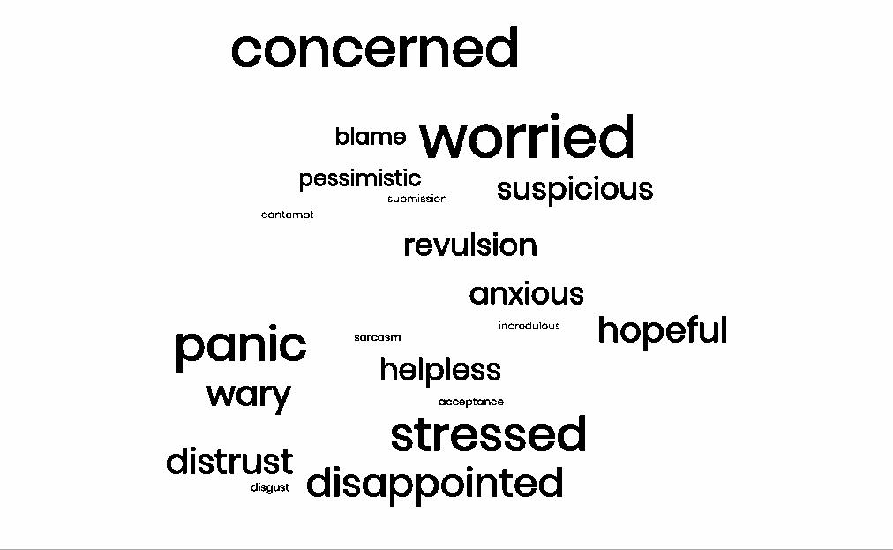

Figure 1: Sentiments in the beginning period

Contempt or disgust is also of consequence not only because it is as prominent as panic but because said affective stance is only partly attached to the (infected) Chinese national,

per news reports, as it quickly extends to sticking to the Chinese as a people or China as a country in toto. Such instances signal the potential for particular incidents to produce racist and xenophobic attitudes, which to an extent is obscured by a state of urgency and concern, as demonstrated by this comment: “W hen China take ownership everything they can have around Asia. And now they're spreading virus rapidly with the help of Chinese New Year celebration. A tactic to kill their enemies around neighborhood in Asia. Next zombie apocalypse.” (See Figure 1 for the word cloud representation of this phase).

Middle. Anger peaks towards the end of the first lockdown alongside a rise in contempt or disgust. This is fueled by the actions of two high-ranking officials - Congressman Lagman, as he made statements that opposed the provision of extra powers to the president, and Senator Pimentel, when he broke quarantine rules by visiting a hospital with his pregnant wife, potentially compromising the safety of everyone in the facility as he was later found to be COVID-19 positive. Compared to the beginning phase above, contempt and anger in the middle phase are directed at prominent state officials who are seen as acting contrarily to what is deemed as desirable considering the exigencies of the situation (note that the two officials belong to opposing camps).

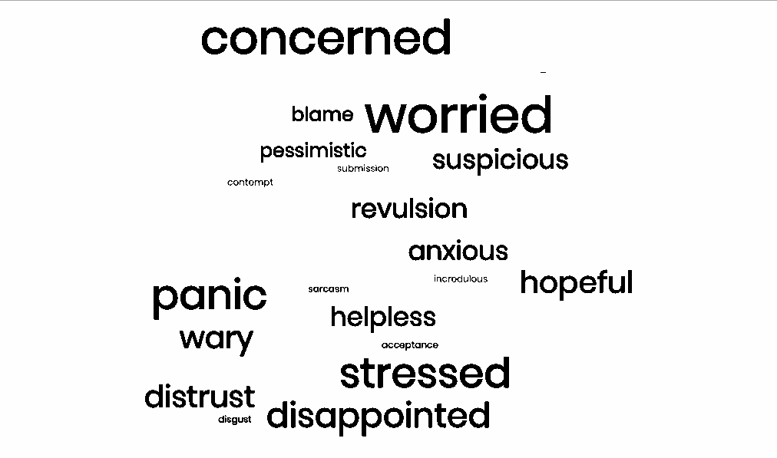

Figure 2: Sentiments in the middle period

What is interesting in this phase is the surfacing of “hopefulness” and “satisfaction”, which should be seen with reservation since most of the comments accounting for them are in “praise” of Duterte and not of particular programs related to the health crisis. It can even be argued that these comments bear features akin to a “manufactured script” used by alleged troll farms or troll armies. See this comment, for instance: “Kita na yung pagod sa mahal natin PANGULO...salamat po,kasi kahit pagod na kayo,anjan pa din kayo para gampanan ang tungkulin nyo...matatapos din po ang lahat ng ito.” Nevertheless, feelings of dissatisfaction and indignation are also relevant in this phase, presenting a counterpoint

to the more agreeable position offered by the former ones. (See Figure 2 for the word cloud representation of this phase.)

End. During the extended quarantine, most noticeable is the rise in suspiciousness or distrust coupled with frustration up to the end of the period. Said sentiments are mostly founded on unclear quarantine guidelines, lack of adequate support for particular sectors (e.g. middle class aid), and unreliable data reports from government agencies (e.g. DOH). From confusion, *“Oh na libog ko. So meaning were not off the hook yet on May 15 which the president announced?”,* to recognition of unfairness, *“Sad to say when rich and famous u get tested when ur still ok, but the rest of us get tested when we’re dying*  “, the uncertainty that appears to define the period of quarantine, as can be gleaned from the comments, and possibly related to the looming second extension of the lockdown, moves toward sentiments that question the efficacy and integrity of government measures to address pandemic-related issues. The following set of comments capture such feelings of distrust that are, again, capable of branching out to more complex issues that go beyond the initial subject matter [emphasis added]: “Hahaha are there any adults here making these decisions? It's like they have decisions written on the wall, someone is blind folded, they are spun around and throw darts at the wall to see what their decisions will be/These are the people that control your lives/ Incompetence breeds bad decisions/***This is what socialism and communism looks like***.” (See Figure 3 for the word cloud representation of this phase.)

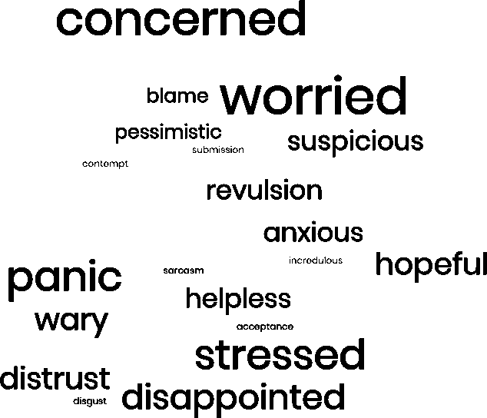

Figure 3: Sentiments in the end period

Overall, at least based on the period covered by the research, sentiments related to COVID 19-related news reports begin with anger, concern, worry, and panic before moving toward greater anger and disgust, and finally ending in frustration and

suspiciousness. Worry and panic are understandably more prominent in the earlier phase since people are coming from government denial of the seriousness of the situation. It will be recalled that no less than the president and the Department of Health (DOH) secretary themselves tagged the virus as no different from the common seasonal flu. Not long after the confirmation of the first local transmission, the government was deemed ill- prepared to tackle the health crisis. This negative perception is exacerbated by officials who were deemed to behave inappropriately considering the gravity of the situation the nation faces, thus, contempt and disgust alongside anger emerge during the middle phase. As demonstrated by the confusion and uncertainty contained in the comments belonging to the final phase of the devised timeline, the period of extended quarantine is characterized by frustration—due to perceived government inefficiency and incompetence—and suspiciousness —brought about by a lack of reliable information on the actual state of the country in the midst of a global health scare. (See Figure 4 for the word cloud representation of the overall situation.)

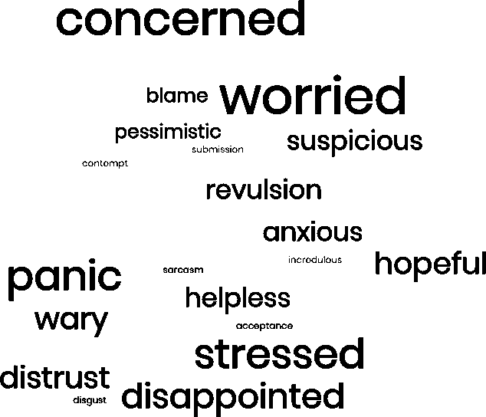

Figure 4: Sentiments over the whole period

# Phase 2 – Online Survey

## Methodology

The second phase involved a survey conducted via *Zoho*, an online survey application, to look into how individuals felt at various stages of the pandemic, where they sourced their information and how that made them feel, how they felt about the action of government and its various agencies, how they dealt with their feelings and how they see the future with this pandemic.

Sample. Participants to the study were recruited through online invitations coursed through the professional and social contacts of the research team members. The link to the study site was indicated in the invitations. There were 1313 survey site visits but only 577 actually responded. However, only 288 participants ultimately completed the survey, for a 50% response rate. The participants came from all over the country: NCR – 14.2%, Luzon – 10.8%, Visayas – 68.1%, and Mindanao – 6.6%. Ages ranged from 18 to 69, with a mean of 30.5 years (SD=9.8). Majority of the respondents were female (73%). Majority self- classified as middle class (81% placed themselves on rungs 4 to 7 on a 10-step SES ladder), 15% marked themselves as upper SES (steps 8 to 10 on the ladder) and only 4% classified themselves as lower SES (steps 1 to 3 on the ladder. Everybody had at least a high school education or better. At the time of the survey, majority of the respondents were living with their families (87%) or friends (5%) and had a fair amount of communication with both family members and friends. Only 8% of the respondents were living alone.

Procedure and ethics considerations. Interested respondents opening the study’s online link were first directed to an informed consent page where they were given information about the study objectives and the nature of their involvement, to answer a 20 to 30-minute questionnaire on their thoughts, feelings and behaviors during the pandemic. They were also informed that they were free to quit any time they felt uncomfortable with the questions or for whatever other reasons without any adverse consequences and were provided the name and contact information of the principal investigator for any queries or issues. Potential respondents were assured of confidentiality of their answers and data protection measures were described. If the person met the age criteria (18 years and above), understood the information provided and were willing to participate, he or she clicked the appropriate response buttons and the page opened to the survey questionnaire. The questionnaire had four sections with questions meant to address each of the specific study objectives. After answering the survey, respondents were provided a short debriefing statement where the names and contact information of institutions providing psychosocial support via online counseling and therapy were also provided.

## Main Findings

At the time of the survey (from April 25 to May 25, 2020), there was limited awareness of COVID-19 positive cases among the respondents, with only 23% having personal knowledge of anyone who was positive for the virus. Only 12% of the respondents personally knew somebody who died from COVID-19 and 20% had personal knowledge of somebody recovering from COVID-19. Consistent with the limited personal knowledge of actual cases of COVID-19, majority had fairly low estimates (not more than 25%) of the number of cases in their barangay and their cities or municipalities.

Despite the limited personal knowledge of actual cases, however, respondent assessments of the COVID-19 threat (on a 1-5 scale, with 5 being strong agreement) indicated a fairly high overall perception of threat (M=4.06, SD=0.74). There was strong agreement with the statement that anyone could be COVID positive (M=4.01, SD=1.01), that one’s health has been threatened by the virus (M=3.83, SD=1.01), that one’s life has

been threatened by this (M=3.77, SD=1.08) and that one should take all actions to avoid being infected (M=4.62, SD=0.74).

Perceptions of one’s personal risk of getting COVID was middling (M=2.95, SD=.97) although perception of survival odds was on the optimistic side (M=3.54, SD=.83).

However, confidence in the Philippines medical system is fairly low (M=2.72, SD=1.1), perhaps compounding one’s perception of threat from the COVID-19 pandemic.

Feelings about the pandemic and behavioral responses

Following from the findings of the sentiment analysis, this survey was intended to look more closely into the individual’s emotions, outside social media which is often viewed as an echo chamber and not necessarily an accurate portrayal of a person’s feelings, and explore possible contributory cognitions and behavioral outcomes of such emotions.

Respondents were asked how often they experienced ten top emotions identified in previous crisis studies and also indicated in the sentiment analysis, eight of which were negative (worried, afraid, stressed, anxious, pessimistic, helpless, angry, depressed) and two of which were positive (hopeful, relaxed). Judgements were made for each of three selected events that could be categorized with the beginning, middle and end phases identified in the phase 1 study. Point 1 was when the outbreak started, point 2 was when the enhanced community quarantine (ECQ) was declared, and point 3 was when the ECQ was declared as extended.

Table 1: Fluctuations of emotions across time (n = 288)

|  |  |  |  |
| --- | --- | --- | --- |
| **Start of Outbreak**  Mean (SD) | | **Declaration of ECQ**  Mean (SD) | **Extension of ECQ**  Mean (SD) |
| Worried | 3.22 (1.10) | 3.73 (1.12) | 3.33 (1.23) |
| Afraid | 3.05 (1.25) | 3.30 (1.26) | 3.06 (1.28) |
| Stressed | 2.93 (1.22) | 3.36 (1.17) | 3.19 (1.24) |
| Anxious | 3.17 (1.18) | 3.49 (1.15) | 3.26 (1.14) |
| Pessimistic | 2.52 (1.21) | 2.78 (1.25) | 2.79 (1.27) |
| Helpless | 2.33 (1.24) | 2.78 (1.30) | 2.78 (1.34) |
| Angry | 2.44 (1.26) | 2.41 (1.24) | 2.40 (1.29) |
| Depressed | 2.07 (1.09) | 2.43 (1.25) | 2.42 (1.34) |
| Hopeful | 3.45 (1.25) | 3.59 (1.11) | 3.56 (1.16) |
| Relaxed | 2.81 (1.19) | 2.79 (1.12) | 2.80 (1.13) |

Feelings of being afraid, worried, anxious and stressed were already experienced every now and then (ratings around 3 on a 1 to 5 scale, with 5 = all the time) when the outbreak first made the news, increased with the declaration of the ECQ and went down slightly or stayed the same with the extension of the ECQ. Pessimism, helplessness and being depressed were only rarely experienced (below 3) even with the declaration of the outbreak but increased slightly, although still below the midpoint, with the declaration of the ECQ and its extension. Anger was rarely experienced by the respondents and this affect stayed stable throughout the three identified events. Being hopeful and being relaxed were also fairly stable throughout the three periods with hopeful slightly above the midpoint and relaxed slightly below the midpoint, meaning they were both possibly being experienced every now and then by the respondents. (See Table 1 for the statistics on

fluctuations in emotions across the three events.) Seventy percent (70%) of the respondents claimed to be in good mental health (i.e., all those who rated themselves as feeling okay to being in tiptop shape) and 30% felt less positive about their mental health status, with 4.5% claiming they needed professional help.

Feelings are typically influenced by events around us and, during the pandemic, many sources of worry can arise. Our respondents expressed worry and concern for the elderly (M=4.64, SD=.68), their families (M=4.25, SD=.97) and for young people (M=3.9, SD=1.1). They were also experiencing threat from the COVID-19 virus and a lack of confidence in the Philippine medical system to handle this new threat, as noted above. However, these negative feelings may be counteracted by certain positive attitudes and experiences.

Overall, respondents had a positive attitude towards being quarantined (overall mean of 4.42, SD=.80). They strongly agreed that COVID-19 is a disease in which exposed people need to be quarantined (M=4.57, SD=0,94); they would agree to be isolated for three to four weeks if they were positive for the virus (M=4.63, SD=0.84); they would agree to quarantine if exposed to it (M=4.62, SD=0.84); and would even agree to quarantine even if healthy and knowing no one with COVID-19 among their contacts (M=3.89, SD=0.12).

Similar to the ADB findings (12), our respondents were also highly compliant with the conditionalities of quarantine – wearing facemasks whenever they go out (M=4.83, SD= 0.47), staying home and going out only for necessities (M=4.74, SD=0.71), physical distancing (M=4.47, SD=0.70), more online interactions (M=4.46, SD=0.79), work/study at home (M=4.42, SD=1.11), having stored food and money at home (M=4.39, SD=0.88), handwashing (M=4.36, SD=0.85), frequent use of alcohol and sanitizer (M=4.29, SD=0.87), taking nutrients and medications to prevent getting sick (M=3.92, SD=1.16), taking one’s temperature several times a day (M=1.76, SD=0.99). The overall compliance rate is high (M=4.16, SD=0.42) with our respondents performing preventive behaviors often, except for the frequent taking of one’s temperature.

Experiences with quarantine were also generally positive for the respondents as most agreed experiencing relatively few difficulties. The greatest difficulties were with working or studying from home (M=3.48, SD=1.30), adverse effects on income from missing work days (M=3.13, SD=1.43), restlessness from staying in the house more than two weeks (M=3.04, SD=1.34), and difficulties in getting regular medical care and prescription (M=3.02, SD=1.26). But even these difficulties were middling or moderate. There was little difficulty with talking to family members not physically present (M=2.80, SD=1.25) or getting food and water (M=2.31, SD=1.10). Perhaps, these relative ease with quarantine strictures may be attributed to the fact that the majority or our respondents were fairly comfortable in their economic status (i.e., majority reported belonging to the middle income levels) and were living with family and friends and had the possibility of eased access to basic material resources like food and water and communication to significant social others.

Sources of information and their assessment

Closely connected to our emotions are our cognitions and thoughts which are often fueled by information we obtain from various sources. In times of uncertainty, the tendency is to seek out information. We asked our respondents how much information they obtained, especially about the pandemic, where they sourced their information and how valid and useful they found the information from various sources.

For our respondents, the first and main sources of information were the internet (31%), followed by friends (20%), television (19%) and family (18%). Only 7% used the radio and 3% cited newspapers as first sources. Satisfaction with each specific source did not, however, match what they sourced first or mainly. Ratings of satisfaction with the overall amount of information obtained were highest for newspapers (M=4.40, SD=1.59)), followed by radio (M=4.25, SD=1.60), television (M=3.81, SD=1.33), the internet (M=3.80, SD=1.02), friends (M=3.66, SD=1.07) and family (M=3.57, SD=1.31). Perceived information utility ratings matched satisfaction with amount ratings – newspapers first (M=4.73, SD=1.54), followed by radio (M=4.60, SD=1.48), television (M=4.41, SD=1.17), internet (M=4.38, SD=0.85), friends (M=3.9, SD=1.12) and family (M=3.81, SD=1.30).

The pattern of responses would appear to indicate that people normally access information from the closest and most accessible sources, the internet which has become ubiquitous these days and easily accessible through our smart phones, and our friends and family. Unfortunately, although these are their first “go-to” sources, respondents appeared aware of their inadequacies in terms of amount and utility of the information obtained. Nevertheless, if people continue to rely on these sources mainly, then problems are sure to arise. Limited information or even fake news are easily shared this way and can only lead to the amplification of distress and negative feelings. Furthermore, wrong information can lead to incorrect behavior and exacerbate the problem.

Feelings about government pronouncements and response

Aside from the sources mentioned above, government is another major source of information. They provide regular statistics to update the population on the situation, educational information and various pronouncements for handling the pandemic. How is government and its response to the pandemic perceived and how are its various spokespersons evaluated? Trust is particularly significant and various studies have found that political trust is associated with law compliance (13) and that trust is an important factor in compliance or non-compliance to public health policies in times of COVID-19 (10,14).

For the respondents of this study, levels of trust for various government officials were middling to fairly high. The most trusted official was the local governor (M=4.19. SD=1.3) followed by the local mayor (M=4.08, SD=1.2), Vergiere (M=3.74, SD=1.5), barangay leaders(M=3.66, SD=1.3), Duterte (M=3.66, SD=1.5), Duque (M=3.44, SD=1.2), Roque

(M=3.30, SD=1.3), Nograles (M=3.26, SD=1.5), and least trusted, Panelo (M=2.99, SD=1.2). It would appear from this ranking that local government officials are viewed with more trust than those in the national government, except for the president and DOH Undersecretary Vergiere. W hen freely asked which government official respondents

perceived to be most effective, the name of Mayor Vico Sotto was mentioned in 33% of the responses, followed by Robredo (13%), Duterte (11%) and Gov. Garcia (10%). The other names mentioned were mostly local government officials (Mayors Chan, Teodoro, Moreno, Gomez and Labella) except for DOH Undersecretary Vergiere.

Respondents were also asked about information obtained from national government, local government (LGU) and medical experts. The assessment of amount of information was moderate to high – national government (M=3.84, SD=0.87), local government (M=3.49, SD=1.05), medical experts (M=3.57, SD=1.00). W hen queried about sufficiency of information received, the ranking reverses – medical experts (M=3.64, SD=0.98), LGU (M=3.11, SD=1.07), national government (M=2.90, SD=1.12). Perceptions of information reliability follows the pattern for information sufficiency assessments – medical experts (M=3.92, SD=0.88), LGU (M=3.02, SD=1.03), national government (M=2.83, SD=1.07).

Based on this data, information from national government is apparently viewed as lagging behind that provided by medical experts and local government officials in terms of sufficiency and reliability.

The performance of the national government in terms of information provision on specific areas related to COVID-19 is perceived as even more insufficient. These include information on vaccines and cures (M=2.51, SD=1.19), how to deal with COVID-19 cases in quarantine at home (M=2.84, SD=1.14), treatment of COVID-19 infection (M=2.80, SD= 1.14). Other topics were rated as handled as moderately satisfactory.

It was not only information provision by government that was perceived as unsatisfactory. Respondents also felt that the quality of government response was below par on all the points noted – testing (M=2.23, SD=1.11), contact tracing (M=2.25, SD=1.07), enforcing quarantine (M=2.75, SD=1.20), implementing distancing (M=2.56, SD=1.15), provisions and aid (M=2.22, SD=1.12), providing PPEs (M=2.27, SD=1.14), and ensuring adequate medical attention for COVID-19 patients (M=2.56, SD=1.11).

Coping behaviors and their outcomes

Given these thoughts and feelings and dissatisfaction with government performance, how did respondents cope? A variety of coping mechanisms are available and used by the respondents for dealing with the current situation. Overall, the top five coping responses were acceptance (M=4.06, SD=0.87), self-distraction (M=3.99, SD=1.06), positive reframing (M=3.87, SD=1.00)), emotional support (M=3.83, SD=1.05), and planning (M=3.69, SD=0.94).

When asked what they thought the future would be like, respondents appeared fairly optimistic. Qualitative responses provided were reviewed and categorized (by two coders with a 95.8% inter-coder agreement) with 63% of the responses (N=174) classified as positive and 36% as negative (N=100).

Finally, the research attempted to look at the connections among the variables of affect, cognitions and behavior by doing three hierarchical regression analysis, looking at the

factors influencing three dependent variables – overall negative affect, self-ratings of mental health status, and compliance with prescribed precautionary behaviors for preventing contagion.

Factors contributory to overall negative affect. The causal factors examined and entered by blocks in a hierarchical regression were age and sex (first block), attitude towards quarantine, experience of (difficulties in) quarantine and perception of threat (added in the second block), coping mechanisms: planning, positive reframing, acceptance, emotional support, self-distraction (added in the third and final block). The final equation, explaining 30% of the variance on overall negative affect, showed that age negatively contributed to overall negative affect (i.e., the older one is, the lower overall negative affect); high negative experience of quarantine contributed to higher overall negative affect; a higher perception of threat contributed to higher overall negative affect. The more one used planning as coping mechanism, the higher overall negative affect but the higher one’s acceptance of the situation, the lower overall negative affect is. (Refer to Table 2).

Table 2: Hierarchical regression on factors contributing to overall negative affect (n = 288)

|  |  |  |  |
| --- | --- | --- | --- |
|  | **1** | **Block**  **2** | **3** |
| Age Sex | -.23**  -.08 | -.16**  -.11* | -.17**  -.10 |
| Attitude toward quarantine |  | -.11 | -.11 |
| Experience of quarantine | .42** | .36** |
| Perception of threat | .18** | .15** |
| Planning |  | .17** |
| Positive reframing |  | -.04 |
| Acceptance |  | -.15** |
| Emotional support |  | -.02 |
| Self-distraction |  |  | .06 |
| Adjusted R2 F | .06  9.56** | .27 22.50** | .30 13.34** |

*p<.05; **p<.01

Factors contributory to subjective assessments of mental health. The first and second blocks included the same variables as in the previous analysis, this time examining the effect on subjective assessments of mental health. The third block had overall negative affect and the fourth block included overall positive affect to check for a possible buffering effect of positive affect on the impact of negative affect on mental health. The fifth and last block included the five coping mechanisms included in the previous analysis. The final equation explains 30% of the variance on subjective assessments of one’s mental health. Once again, age is positively related to mental health (i.e., the older, the better mental health); the greater overall negative affect, the poorer one’s assessment of own mental health; but the more emotional support one has, the better one’s mental health.

Positive affect did indeed provide a buffering effect by tamping down the effect of negative affect on mental health. Positive affect has a positive impact on subjective assessments of mental health, the greater overall positive affect, the better one’s assessment of own mental health (Refer to Table 3).

Table 3: Hierarchical regression on factors contributing to mental health (n = 288)

|  |  |  |  |  |  |
| --- | --- | --- | --- | --- | --- |
|  | **1** | **2** | **Block**  **3** | **4** | **5** |
| Age | .23** | .17** | .11* | .09 | .10 |
| Sex | .10 | .12* | .07 | .08 | .09 |
| Attitude toward quarantine |  | .02 | -.03 | -.03 | -.01 |
| Experience of quarantine |  | -.28 | -.10 | -.06 | -.03 |
| Perception of threat |  | -.08 | -.01 | -.00 | -.01 |
| Overall negative affect |  | -.42** | -.36** | -.35** |
| Overall positive affect |  |  | .19** | .16* |
| Planning |  |  |  | -.07 |
| Positive reframing |  |  |  |  | .09 |
| Acceptance |  |  |  |  | .03 |
| Emotional support | .15** |
| Self-distraction | -.03 |
| Adjusted R2 | .06 | .14 | .27 | .29 | .31 |
| F | 10.39** | 10.44** | 18.45** | 18.01** | 11.77** |
| *p<.05; **p<.01 |  |  |  |  |  |

Table 4: Hierarchical regression on factors contributing to preventive behaviors (n = 288)

|  |  |  |  |  |
| --- | --- | --- | --- | --- |
|  | **1** | **2** | **Block**  **3** | **4** |
| Age Sex  Sufficiency of information from government | .18**  -.19** | .18**  -.19**  .03 | .17**  -.17**  .03 | .18**  -.17**  .02 |
| Quality of government response |  | .00 | .01 | .02 |
| Experience of quarantine Perception of threat  Attitude towards quarantine |  | .01 | -.03  .18**  -.05 | -.05  .17**  -.04 |
| Overall negative affect |  |  |  | .03 |
| Mental health |  |  |  | .08 |
| Adjusted R2 F | .05  9.41** | .05  3.78** | .07  3.94** | .06  3.18** |

*p<.05; **p<.01

Factors contributory to engaging in the preventive behaviors. We sought to explore some factors that could possibly affect compliance with precautionary preventative behaviors, using as dependent variable the overall mean compliance with the ten prescribed behaviors. The first block of factors included age and sex; the second block included perceptions of sufficiency of information from government; quality of government response and experience of (difficulties during) quarantine; the third block included perception of threat and overall attitude towards quarantine; the fourth and last block included overall negative affect and subjective mental health assessment. The third equation explains more of the variance (6.7%) compared to the fourth equation (6.4%), meaning the addition of negative affect and mental health did not contribute further to explaining compliance with preventive behaviors and hence may be left out. Nevertheless, although the F is significant, only 6.7% of the variance is explained by the third equation. Age is a

significant factor (the older one is, the more preventive behavior one engages in); females are more likely to engage in these preventive behaviors than males; and the higher one’s perception of threat, the more likely one will engage in these behaviors (Refer to Table 4)

# Summary and Conclusions

The pandemic has generated much negative affect since it began. Worry, anger, concern and frustration have been the top affective responses to news from various sources uploaded to YouTube and FB. And while the salience of various emotions appeared to fluctuate across the pandemic timeline, the top emotions remained worry and anger. The only positive emotion to surface was hopefulness but it was not one of the top sentiments to surface.

The findings of the qualitative sentiment analysis were also reflected in the survey although many mitigating factors served to tamp down their intensity. Negative emotions were elicited by the first news of an outbreak and intensified with the government declaration of ECQ which possibly signaled the confirmation of some of their fears that this was a serious matter. Some of these negative emotions were calmed somewhat by the continuation of ECQ or maintained at the same level. No negative affect returned to a level below that which was first stirred up at the start of the outbreak. The overall perception of threat was high and there was low confidence in the Philippine medical system to handle the COVID-19 situation.

Information access plays an important role in assessing the risks from COVID-19. The internet, friends, family and television were the first main sources of information although perceived as providing less sufficient or less useful information compared to newspapers and radio. However, considering how major news agencies have uploaded their material on the net, the internet has the greatest capacity for information dissemination from many various sources. The only problem will be sorting fake from genuine news, given that the internet is so huge and “wild.” Information overload, particularly from the internet, can also have deleterious effects on one’s mental health.

Government and government officials play a large role in times of pandemic. Political trust can play a large role in managing people’s fears and encouraging them to follow public health policies and guidelines. Trust in government was moderate to high, with local governments more trusted compared to national government spokespersons. Although the national government and its offices were seen as providing the most information, information from medical sources were still seen as most reliable and sufficient.

Government information about vaccines and cures, treatment, and guidelines for people with COVID quarantining at home, were seen as inadequate. Government response in terms of testing, contact tracing, enforcing quarantine, implementing distancing, providing assistance and aid, providing PPEs for front-liners, ensuring medical attention for COVID patients were all seen as needing improvement.

In general, our respondents appeared to be coping, assessed their mental health conditions as fine, and had a fairly positive view of the future. The main contributors to

mental health were age and emotional support. Overall negative affect, on the other hand, was a negative factor in mental health self assessments. Whether individuals chose to engage in risk protective behaviors was influenced by age, sex, and the perception of threat. Older participants, females and those who perceived higher levels of threat were more likely to engage in greater efforts to protect themselves from the risk of COVID.

## Caveat

It must be noted, however, that the data collected is time bound; the qualitative data analyzed from YouTube and Facebook news accounts only covered the period from January to April 2020 whereas the online survey ran only for a month from April 25 to May 25, 2020. Hence the sentiments and responses may have changed since, as the pandemic rages on and the government continues to struggle with how to deal with the shifting situation. Furthermore, the online format of the survey may have been a source of bias in sample selection and this is reflected in the characteristics of the sample described in the methodology section. Nevertheless, the findings are informative and provide us some foothold for understanding how people’s feelings and cognitions may influence their behaviors in dealing with an unpredictable event of this order.

# Recommendations

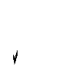 **Communication and coordination.** The constant bombardment of COVID-19 information from both traditional and social media should be toned down and checked first for veracity and factuality before publication or dissemination. The irresponsible distribution of fake (or unverified) news which only serve to incite negative affect further is counterproductive and can only exacerbate precarious mental health conditions in the population. Media should be responsible and present news that is factual and informative. Media coverage should avoid sensationalism and disturbing images to help prevent distress in the consumers of media.

 Sufficient and reliable information about different aspects of the COVID-19 pandemic should be channeled through reliable and credible sources (i.e., medical experts).

Government spokespersons should consult and collaborate with these medical experts to provide clear, reliable and actionable information. Stronger collaboration between government, the scientific and medical community, and media practitioners is highly recommended for better information provision and dissemination.

 Government information provision (and compliance to its public health policies) could be improved by having trusted, credible and knowledgeable spokespersons.

Furthermore, government communicators should be consistent in their information provision, else it only confuses, frustrates and increases the anxiety of the message recipient, as well as increases the distrust in government.

 Government service provision should be improved in the areas of testing, contact tracing, quarantine regulation and safety protocol enforcement (without resorting to extreme force or violence), aid provision, provision of protective gear for health workers, and providing adequate medical attention for COVID-19 patients. There is also a need to improve the overall state and quality of the Philippine medical system.

 Design an easily accessible set of FAQs on the various services provided by government and the procedures and processes to access them, an integrated COVID health services primer. This could be distributed both online and in print and widely disseminated through various media outlets.

 Local government units, as they are closer to their constituents, should be available and accessible and provide clear information and guidelines for accessing fair and sufficient services.

 To help capacitate LGU workers, they should be given adequate training and information about the COVID-19 pandemic, the proper safety measures and protocols, and government services available to their constituents.

 The national government should coordinate better information provision and service delivery with the local government units down to the barangay level.

 **Addressing the increasing mental health concerns**: As the COVID pandemic continues, more people’s mental health is being adversely affected. The uncertainty, plus the continued isolation and restriction of movement negatively affects one’s mental health. It also affects one’s work and economic situation, further increasing the challenges and stresses the individual has to contend with. If professional help is needed for handling these, one should know where to go and who to consult.

 Information should be provided to the public on resources that can be accessed and how to access these resources, should one feel overwhelmed. The LGU can take the lead in this campaign and work in tandem with media and mental health professionals, organizations and institutions in their communities.

 Natural support groups (e.g., families and friends) should be provided more information on how to help each other and how to identify and assist group members who might need professional help. A referral list or directory of mental health professionals, organizations and institutions should be available at the barangay or the barangay health center.

 Public information on self-care should be made more available. Virtual exercise, meditation, hobby groups are welcome developments to mitigate negative affect.

 While physical distancing is part of the safety protocol, this is not to be (mis)construed as social distancing. People should be encouraged to maintain their social interconnectivity, using online channels, if need be, to stay in touch with family and friends. We are social beings and isolation can be detrimental for one’s mental health.

 Unfortunately, the internet and social media have become both boon and bane.

Addiction to the medium, the proliferation of fake news, diminished empathy are just some of the issues. Information should be provided on how to discriminate fake news from what is real or true. And information on viable alternatives to being glued to the internet and social media should be made available.

# Acknowledgements

This project was supported by a consultancy grant from the National Research Council of the Philippines to the first author.

# References

1. Bavel J, Boggio V, Cichocka A, Cikara M, Crockett M, Crum A, et al. PsyArXiv Preprints [Internet]. Ithaca, New York: Cornell University; Using social and behavioural science to support COVID-19 pandemic response; 2020 March 24 [2020 April 9; 2020]. Available from: https://psyarxiv.com/y38m9
2. Qian M, Ye D, Zhong J, Xu K, Zhang L, Huang, Z, et al. Behavioural, cognitive and emotional responses to SARS: Differences between college students in Beijing and Suzhou. Stress Health. 2005; 21: 87-98.
3. Yeung DY, Fung HH. Age differences in coping and emotional responses toward SARS: A longitudinal study of Hong Kong Chinese. Aging Ment Health. 2007; 11(5): 579-587.
4. Cava MA, Fay KE, Beanlands HJ, McCay EA, Wignall R. The experience of quarantine for individuals affected by SARS in Toronto. Public Health Nurs. 2005; 22(5): 398-406.
5. Nicomedes CJC, Avila RMA. An analysis on the panic during COVID-19 pandemic through an online form. J Affect Disord. 2020; 276: 14-22.
6. Zhang SX, Wang Y, Rauch A, Wei F. Unprecedented disruption of lives and work: Health, distress and life satisfaction of working adults in China one month into the COVID-19 outbreak. Psychiatry Res. 2020; 288:112958.
7. Lima CKT, Carvalho PMM, Lima IAAS, Nunes JVAO, Saraiva JS, de Souza RI, da Silva CGL, Neto MLR. The emotional impact of Coronavirus 2019-nCoV (new Coronavirus disease). Psychiatry Res. 2020; 287:112915.
8. Holman EA, Garfin DR, Lubens P, Silver RC. Media exposure to collective trauma, mental health, and functioning: Does it matter what you see? Clin Psychol Sci. 2020; 8(1): 111-124.
9. American Psychological Association. American Psychological Association [Internet].

Washngton, DC: American Psychological Association; How leaders can maximize trust and minimize stress during the COVID-19 pandemic; 2020 March 20 [2020]. Available from: htt[ps://www.a](http://www.apa.org/news/apa/2020/03/covid-19-leadership)p[a.org/news/apa/2020/03/covid-19-leadership](http://www.apa.org/news/apa/2020/03/covid-19-leadership)

1. Fancourt D, Steptoe A, Wright L. The Cummings effect: politics, trust, and behaviours during the COVID-19 pandemic. Lancet. 2020; 396(10249): 464-465.
2. Gaspar R, Pedro C, Panagiotopoulos P, Seibt C. Beyond positive or negative: qualitative sentiment analysis of social media reactions to unexpected stressful events. Comput Human Behav. 2016; 56: 179-191.
3. Ronquillo MV. ADB findings shatter ‘pasaway’ myth. The Manila Times [Internet]. 2020 July 15 [cited 2020 Aug 24]. Available from: https:[//www.manilatimes.net/2020/07/15/opinion/columnists/topanalysis/adb-findings-](http://www.manilatimes.net/2020/07/15/opinion/columnists/topanalysis/adb-findings-) shatter-pasaway-myth/741998/
4. Marien S, Hooghe M. Does political trust matter? An empirical investigation into the relation between political trust and support for law compliance. Eur J Polit Res. 2011; 50: 267-291.
5. Bargain O, Aminjonov U. IZA Institute of Labor Economics [Internet]. Bonn, Germany: Deutsche Post Foundation; Trust and compliance to public health policies in times of COVID-19; 2020 May [cited 2020 Aug 24]. Available from: https:[//www.iza.org/publications/dp/13205/trust-and-compliance-to-public-health-](http://www.iza.org/publications/dp/13205/trust-and-compliance-to-public-health-) policies-in-times-of-covid-19.

# Appendix 1

ABS-CBN Investigative and Research Group; Merez, A; Sabillo, K. and Ramos, P. (2020 April 14). Timeline: The coronavirus disease crisis in the Philippines, *ABS-CBN.* Retrieved from: [https://news.abs-cbn.com/news/multimedia/infographic/04/14/20/philippines-policies-](https://news.abs-cbn.com/news/multimedia/infographic/04/14/20/philippines-policies-timeline-coronavirus-disease-cvoid19-pandemic-enhanced-community-quarantine) [timeline-coronavirus-disease-cvoid19-pandemic-enhanced-community-quarantine](https://news.abs-cbn.com/news/multimedia/infographic/04/14/20/philippines-policies-timeline-coronavirus-disease-cvoid19-pandemic-enhanced-community-quarantine)

ABS-CBN News. (2020, Jan 20). *Child from China checked for Wuhan coronavirus, positive for non-specific strain.*

Youtube.[https://www.youtube.com/watch?v=YAgi8bXt_hQ&t=126s](https://www.youtube.com/watch?v=YAgi8bXt_hQ&amp%3Bt=126s)

ABS-CBN News (2020, Jan 30) *Philippines confirms first case of new coronavirus.*

Youtube. [https://www.youtube.com/watch?v=y5h-ehQh1jI&t=103s](https://www.youtube.com/watch?v=y5h-ehQh1jI&amp%3Bt=103s)

ABS-CBN News (2020, Mar 8) *President Duterte declared public health emergency due to coronavirus.* Youtube. [https://www.youtube.com/watch?v=hfsrh8TKQi4&t=35s](https://www.youtube.com/watch?v=hfsrh8TKQi4&amp%3Bt=35s)

ABS-CBN News (2020, Mar 16). *President Duterte declares enhanced community quarantine over Luzon to contain COVID-19.* Youtube. <https://www.youtube.com/watch?v=P8GZw4q_MkU>

ABS-CBN News (2020, Mar 24). *Kongreso nagkasudo sa panukalang ‘Bayanihan to Heal As One Act’ vs COVID-19.* Youtube.<https://www.youtube.com/watch?v=BuMFjapycII>

ABS-CBN News (2020, April 6). *Philippines extends lockdown of millions in Luzon to April*

*30.* Youtube. <https://www.youtube.com/watch?v=-gFQBxmwogE>

ABS-CBN News (2020, April 15). *Middle class cash aid targets 3.4 million small business workers: DOF.* Youtube. <https://www.youtube.com/watch?v=NWOt6s-aDwU>

ABS-CBN. (2020, April 30). *Philippines log 8,488 coronavirus infections 3 months since 1st case.* Youtube. <https://www.youtube.com/watch?v=DtGfFNj184Q>

CNN Philippines (2020, April 22). *Philippines reports 11 new COVID-19 cases as recoveries near 700.* Facebook. [https://web.facebook.com/CNNPhilippines/posts/2801876713385543?_rdc=1&_rdr](https://web.facebook.com/CNNPhilippines/posts/2801876713385543?_rdc=1&amp%3B_rdr)

GMA News (2020, Mar 16). *BT: Community quarantine sa Cebu City, ipinatupad na.*

Youtube.<https://www.youtube.com/watch?v=0HXMvFspVQw>

GMA News (2020, April 22). *GMA News COVID-19 Bulletin: Cebu City extend ECQ until May 15.* Youtube. <https://www.youtube.com/watch?v=CH25UxAH-Vw>

Philstar News (2020, Mar 12) *Duterte imposes community quarantine on Metro Manila.*

Youtube.<https://www.youtube.com/watch?v=kwjvbRFPans>

Philstar News (2020, April 23). *Duterte addresses the nation April 24.* Youtube. <https://www.youtube.com/watch?v=w0JITvtw0BY>

Rappler (2020, Mar 6) *DOH confirms 2 Filipinos found with coronavirus locally.* Youtube. <https://www.youtube.com/watch?v=uzgXgpgITWU>

Rappler (2020, Mar 25). Makati Med denounces Pimentel’s irresponsible, reckless protocol breach. Youtube. <https://www.youtube.com/watch?v=wEtCm6tLmYk>

Rappler (2020, April 15). *DOH updates on coronavirus/Wednesday, April 15.* Youtube. <https://www.youtube.com/watch?v=jUhQ6TmOMmg>

Sunstar Cebu (2020, April 2). Timeline: Covid-19 Cases in the Philippines, *Sunstar.*

Retrieved from: <https://www.sunstar.com.ph/article/1851028>

Sunstar Cebu (2020, April 9). *Crowd gathers at Carbon Market for binignit ingredients.*

Facebook. [https://web.facebook.com/sunstarcebu/posts/2879690985411776?_rdc=1&_rdr](https://web.facebook.com/sunstarcebu/posts/2879690985411776?_rdc=1&amp%3B_rdr)

Sunstar Cebu (2020, April 18). Cebu: Outbreak City, *Sunstar.* Retrieved from: <https://www.sunstar.com.ph/article/1853067>

Sunstar Cebu (2020, April 29). *Should the general community quarantine will push through on May 21, 2020, the operation of public transportation will resume, but it will only limit to buses, said Presidential Assistant for the Visayas Secretary Michael Dino.*

Facebook. [https://web.facebook.com/sunstarcebu/posts/2930711840309690?_rdc=1&_rdr](https://web.facebook.com/sunstarcebu/posts/2930711840309690?_rdc=1&amp%3B_rdr)