**Philippine Journal of Science**

150 (1): 209-221 February 2021

## ISSN 0031 - 7683

Date Received: 13 Apr 2020

First Report on the Density and Size Frequency Distribution of the Napoleon Wrasse,

***Cheilinus undulatus* in the Tubbataha Reefs Natural Park, Philippines**

**Cleto L. Nañola Jr.1*, Mae Angelie C. Paradela 2, Angelique M. Songco3, Maria Retchie C. Pagliawan3, Rowell C. Alarcon3, and Mudjekeewis D. Santos4**

1University of the Philippines Mindanao Mintal, Davao City 8022 Philippines 2University of the Philippines Los Baños College, Laguna 4030 Philippines 3Tubbataha Management Office

Puerto Princesa City, Palawan 5300 Philippines 4National Fisheries Research and Development Institute Quezon City, Metro Manila 1103 Philippines

**The Napoleon wrasse – *Cheilinus undulatus*, locally known as “mameng” – was assessed as “endangered” in 2004 under the International Union for Conservation of Nature (IUCN) Red List assessment and is also listed under the Appendix II of the Convention on International Trade in Endangered Species of Wild Fauna and Flora (CITES). Although there are numerous reports of Napoleon wrasse sightings by tourists and researchers in the two atolls within the Tubbataha Reefs Natural Park (TRNP), its density and size-frequency distribution have not been formally documented. A thorough survey was conducted in TRNP in May 2017 employing the fish visual census (FVC) technique but with a much broader swath width. A total reef area of 103 hectares not frequently visited by tourists was surveyed in the North and South Atolls, where a total of 641 individuals was recorded with an average density of 6.83 individuals/ha. Density comparison between atolls showed a significant difference (Welch’s two-sample t-test (t5.42 =**

**–3.28,** *p* **< 0.05). South Atoll has a higher density (8.13 individuals/ha ± 1.11 se) than the North**

**Atoll (4.20 individuals/ha ± 0.46 se). However, by size class, the North Atoll was significantly larger (n = 398; median = 65 cm) than in the South Atoll (n = 243; median = 60 cm) based on Wilcoxon Rank Sum test (W = 55,674,** *p* **< 0.05). A comparison of density and size class between the NW and SE coastline in the North Atoll showed no significant difference. Juveniles were also found at a site at the North Atoll. Taken together, these findings suggest that TRNP may serve as a source and a sink at the same time. This implies that TRNP is a key habitat for the Napoleon wrasse in the Sulu Sea and possibly in the adjacent seas through its pelagic larvae.**

Keywords: *Cheilinus undulatus*, endangered reef fish, fish visual census, marine protected area, Napoleon wrasse, Tubbataha Reefs Natural Park

*Corresponding Author: [clnanola@up.edu.ph](mailto:clnanola@up.edu.ph)

# INTRODUCTION

The Napoleon wrasse – *Cheilinus undulatus* (Labridae: Cheilini), locally known as “mameng” – belongs to the Family Labridae (Figure 1). This family is among the largest and most diverse under Class Osteichthyes, with 70 genera and 504 species (Parenti and Randall 2011). The species is widely distributed in the Indo-Pacific region

* from the Red Sea, East Africa, Indian Ocean, Western Pacific Ocean, Ryukyu Islands, Melanesia, including the Great Barrier Reef (GBF; Australia), Micronesia, Line Island, and the French Polynesia (Sadovy *et al.* 2003; Allen and Erdmann 2012). The main diet of adults consists of mollusks such as trochus and turbo snails, and many other invertebrates such as crustaceans, echinoids, brittle stars, sea stars (Randall *et al.* 1978; Sadovy *et al.* 2003), including the crown-of-thorns-starfish (Randall *et al.* 1978).

*C. undulatus* is one of the largest bodied reef fishes, reaching more than 200 cm total length (TL), which is almost 200 kg in weight. However, it is uncommon for this species to reach beyond 150 cm TL (Choat *et al.* 2006; Sadovy de Mitcheson *et al.* 2019). Having a large body (> 100 cm) in labrids is also uncommon and this trait appears to be exclusive in three labrid groups, namely Cheilines (*Cheilinus undulatus*), Scarines (*Bolbometopon muricatum, Scarus coeruleus*, and *S. guacamaia*), and Hypsigenyines (*Achoerodes gouldii*) (Froese and Pauly 2003; Sadovy *et al.* 2003; Choat *et*

*al.* 2006). Choat *et al.* (2006) examined the evolutionary and habitat relationships of labrids and found that only 4% achieved the 75 cm threshold of large-sized labrids. In evolutionary terms, *C. undulatus* is more closely related to the ecologically and morphologically distinctive bumphead parrotfish *Bolbometopon muricatum* (Labridae: Scarini) than Hypsigenyines (Choat *et al.* 2006). However,

*C. undulatus* is the larger species (Sadovy *et al.* 2003; Choat *et al.* 2006).

The biology and fisheries of Napoleon wrasse were first reviewed by Sadovy *et al.* (2003). Areas where field assessments were conducted include Indonesia (Colin 2006; Sombo *et al.* 2017; Sadovy de Mitcheson *et al.* 2019), the GBF, Australia (Pogonosky *et al.* 2002; Choat *et al.* 2006), Maldives (Sluka 2000), Fiji (Taylor *et al.* 2002), French Polynesia (Galzin 1985), and Tutuila Island in American Samoa (Sabater 2010). Other areas that have information on their density include New Caledonia, Niue, Palau, Papua New Guinea, Solomon Islands, Tonga, and Wake Atoll (Sadovy *et al.* 2003). Within the known range distribution of this species, the recorded natural (unfished) density rarely exceeds more than 10 individuals/ha (Russell 2004; Chateau and Wantiez 2007), with a single report of 20 individuals/ha for pristine and unfished reefs (Sadovy *et al.* 2003). In the Philippines, assessment specifically targeting Napoleon wrasse has been done only in Tawi-Tawi Province, particularly in the municipalities of Sibutu and Sitangkai. Romero and Injani (2015) reported that the *C. undulatus* density ranged

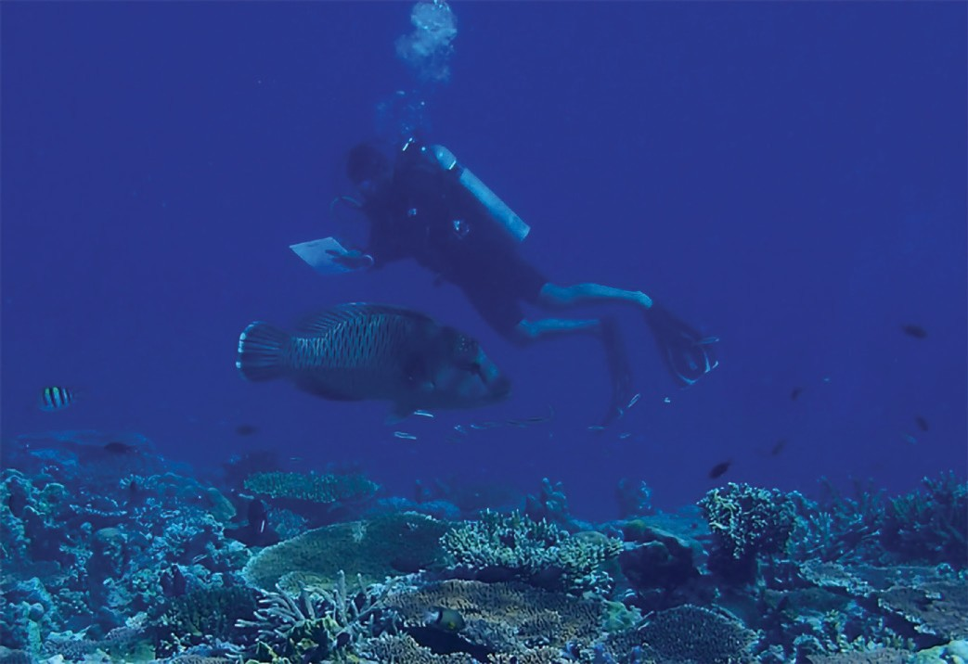

**Figure 1.** A large *Cheilinus undulatus* (~ 140 cm TL) approaching one of the dive team members (Noel Bundal, height 173 cm) during the survey in TRNP. Photo by RC Alarcon.

from 0.006 to 0.033 individuals/1000m2 or 0.06 to 0.33 individuals/ha whereas further south in Indonesia, the density ranged from 0.34 to 4.0 individuals/ha (Sadovy de Mitcheson *et al.* 2019).

The species is protogynous where females turn into males when they are larger and older (Sadovy de Mitcheson *et al.* 2010). An age-based study of Choat *et al.* (2006) revealed that sex change can occur as early as 9 yr old at an estimated size of 70 cm fork length (FL) and some females that did not change to males were recorded to have higher longevity. Sexual maturity in females is attained between 5–7 yr at an approximate size of 40–60 cm FL (Sadovy *et al.* 2003; Choat *et al.* 2006; Sadovy de Mitcheson *et al.* 2010; Graham *et al.* 2014). Males reach larger sizes (100 cm FL) estimated at 16 yr old, suggesting that the species has a slow growth rate (male 44.6 ± 14.4 mm/yr; female 17.9 ± 2.1 mm/yr) (Choat *et al.* 2006). Longevity was computed at around 25 yr for males and 32 yr for females, with an annual mortality of 0.10–0.14 in the case of a low-intensity fishing area like Australia (Choat *et al.* 2006).

Juveniles and adults show some differences in their habitat use. Juveniles greater than 3 cm TL are found in thickets of staghorn corals in lagoonal reefs (Sadovy *et al.* 2003; Colin 2006; Tupper 2007; Gillett 2010; Graham *et al.* 2014). Individuals ranging from 2.5–120 cm TL are observed on seagrass beds and coral reefs (Dorenbosch *et al.* 2006; Romero and Injani 2015). During regular FVC surveys, the smallest individual seen in an open reef is greater than 25 cm TL (Nañola 2012). Adults are found at the reef edge and are especially associated with outer reef areas near deep water drop-offs. Sadovy *et al.* (2003) reported that *C. undulatus* form spawning aggregations of up to a hundred individuals. This reproductive strategy is hypothesized to optimize reproductive success, increase larval survival, and facilitate genetic mixing (Colin 1992; Domeier 2012). The species is also a residential aggregation spawner, which spawns regularly at a particular area of the reef close to its residential reef and may spawn monthly or even daily (Colin 2010).

The life history characteristics of some reef fishes can make them vulnerable to overfishing. For example, spawning aggregations of fish populations are at risk of being easily exploited and overfished due to high catch rates and this is possible when many adults are briefly and predictably gathering to spawn (Domeier and Colin 1997). The unsustainable and unmanaged fishing in areas of aggregation could severely deplete the population before it was even able to replenish its stock (Choat *et al.* 2006; Sadovy de Mitcheson 2016). Species with slower growth rates and longer lifespan such as groupers (*Epinephelus striatus*), some scarines, and typically large species – including the Napoleon wrasse – are also easily overfished

(Hostetter and Munroe 1993; Choat and Robertson 2002; Sherman *et al.* 2016). The Napoleon wrasse, however, is not regularly targeted on its spawning aggregations nowadays because the main demand for this species is directed to smaller sizes.

In 1996, the IUCN Red List of Threatened Species classified the Napoleon wrasse as “vulnerable.” By 2004, its conservation status was elevated to “endangered” (Russell 2004). It is also listed under Appendix II of CITES. Species listed under the CITES Appendix II are “those that are not necessarily now threatened with extinction but may become so unless trade is closely controlled.”

Philippines is a known supplier of Napoleon wrasse, particularly the “plate-sized” individuals (*i.e.* immature) in the live reef food fish trade (LRFFT) (Bentley 1999; Donaldson and Sadovy 2001; Sadovy and Vincent 2002; Sadovy *et al.* 2003; Colin 2006; Romero and Injani 2015; Wu and Sadovy de Mitcheson 2016). Trading of this species was reported in Guiuan, Samar (Bentley 1999) and in Tawi-Tawi (Romero and Injani 2015) – the latter known to be highly engaged in the LRFFT since 2000. Reports of Sadovy *et al.* (2003) mentioned that Palawan is also involved in the grow-out mariculture cages of *C. undulatus*. In the same paper, it was reported that the southwestern part of the Philippines has been exporting

*C. undulatus via* Malaysia since 1995. This only suggests that many parts of the country, both along the eastern (Guiuan) and western parts (Palawan and Tawi-Tawi) are major sources of this species for the LRFFT. Romero and Injani (2015) added that young adults of Napoleon wrasse were not part of the fish catch but they are now targeted deliberately because it provides greater income among fishermen.

In the Philippines, *C. undulatus* is protected under Section 102 of the Republic Act 10654 or “An Act to Prevent, Deter and Eliminate Illegal, Unreported and Unregulated Fishing,” amending the Republic Act No. 8550, otherwise known as “The Philippine Fisheries Code of 1998.” Most fishermen, middlemen, and vendors are aware that the trading of this species is banned throughout the country. However, some individuals of Napoleon wrasse are still encountered in fish landing sites where most fishermen claim that they were caught unintentionally. The apparent reason for their presence in the fish catch is that they were caught using illegal fishing gear, particularly blasting devices. This practice was confirmed in Tawi-Tawi and one large Napoleon wrasse was also seen recently in a landing site in Davao Gulf. More anecdotal accounts revealed that the live trading of “mameng” is still happening in Tawi-Tawi – termed as “backdoor entry”

* *via* Sabah, Malaysia. This is most likely true because illegal imports were still detected in Hong Kong (Wu and

Sadovy de Mitcheson 2016). The Hong Kong government has implemented measures to reduce illegal trade. For example, a facial recognition software was developed to easily identify and track the species in wet markets to help address enforcement and curb its illegal trading (Hau and Sadovy de Mitcheson 2019).

In the Philippines, several law enforcement bodies were created to curb the illegal trade of Napoleon wrasse, including the creation of national and regional Bureau of Fisheries and Aquatic Resources (BFAR) Aquatic Wildlife Technical Working Groups and the development and implementation of an aquatic wildlife traceability system (BFAR-NFRDI 2017). In addition, BFAR is currently empowering its Aquatic Wildlife Enforcement Officers, pursuant to the Republic Act 9147 or the Wildlife Resources Conservation and Protection Act. It has also established a DNA barcoding system to help in monitoring the illegal trade of aquatic species (Asis *et al.* 2014). In 2017, BFAR-NFRDI published the Philippine Status Report and a National Plan of Action 2017–2022 for *C. undulatus*. However, enforcement is still weak. It was further noted that there is no country-level status report on the density and abundance of Napoleon wrasse in the wild.

FVC surveys done in the country from 1996–2010 (Nañola *et al.* 2011; Nañola 2012), including the recent surveys conducted by CL Nañola (pers. obs.) although intended for other purposes, resulted in rare encounters with Napoleon wrasse. Further, the presence of Napoleon wrasse during FVC surveys is duly noted and considered as the highlight of that particular site. These encounters were seen in Basco (Batanes), Mindoro (Puerto Galera), Northern Palawan, Cordova (Cebu), TRNP, Turtle Islands, Sitangkai, Kiamba, and Maasim (Figure 2). Out of 1,937 transects, a total of 27 individuals were encountered in these areas (see Nañola *et al.* 2011) with an equivalent area of 96.85 ha (area per transect is 500 m2). One to two individuals were seen for all sites in Northern Palawan, Turtle Islands, Sitangkai, and Kiamba while all of the other sites have only one individual. Relatively, more than 10 individuals were observed in TRNP. Additionally, BFAR-NFRDI (2017) reported the presence of Napoleon wrasse in Pasaleng Bay (Ilocos Norte), Fuga Island, Calayan Island, Tayabas Bay, Imuruan Bay (Palawan), Tablas Strait, Pandan Bay, Hagnaya, Hinundayan, Iligan Bay, Surigao Strait, Hinatuan Bay, Dinagat Sound, Mabini (Davao de Oro), and Sibutu (Tawi-Tawi Province) based on fish landings and sightings. The species was also seen by R. Murray (pers. comm., LAMAVE Research Institute, 07 Jun 2018) in Apo Reef (Occidental Mindoro) and in the island chain of Cagayancillo (Palawan). Database records from FishNet2 indicate that it also occurs in Gubat, Sorsogon, suggesting that *C. undulatus* is present throughout the country (Figure 2). Further, Lavides *et al.*

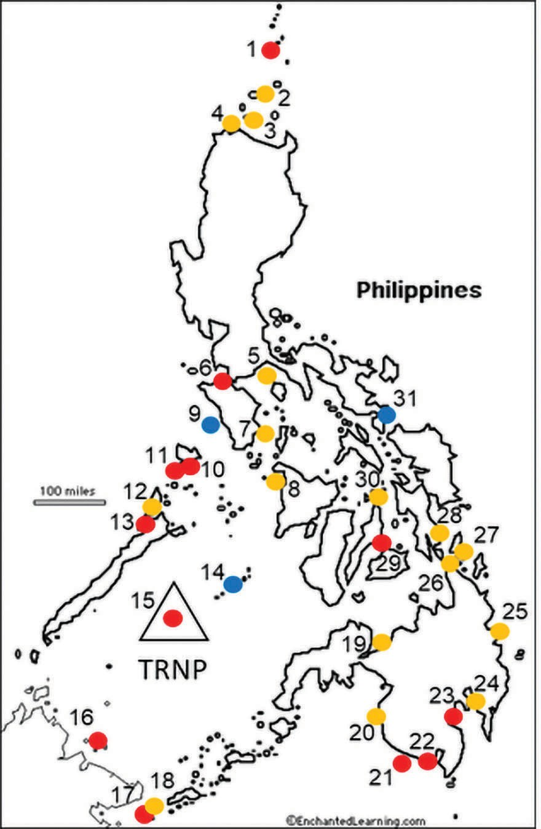

**Figure 2.** Philippine map showing the sightings of *Cheilinus undulatus* based from FVC surveys (●) [Nañola *et al.* (2011); Nañola (unpublished data)], wet market landings (●) (BFAR-NFRDI 2017), and other sources of information (●). 1 – Basco, 2 – Calayan Islands, 3 – Fuga Island, 4 – Pasaleng Bay, 5 – Tayabas Bay, 6 – Puerto Galera, 7 – Tablas Strait, 8 – Pandan Bay, 9 – Apo Reef,10

– Coron, 11 – Culion, 12 – Bacuit Bay, 13 – Imuruan Bay, 14 – Island chain of Cagayancillo, 15 – TRNP, 16 – Turtle Islands, 17 – Sitangkai, 18 – Sibutu, 19 – Iligan Bay, 20 – Kalamansig, 21 – Kiamba, 22 – Maasim, 23 – Sta Cruz, 24 – Mabini, 25 – Hinatuan Bay, 26 – Dinagat Sound, 27 – Surigao Strait, 28 – Hinundayan, 29 – Cordova, 30 – Hagnaya, 31 – Gubat. For the FVC data, most of the sites had only one Napoleon wrasse sighting except for Turtle Islands (16), Sitangkai (17), and Kiamba (21) with more than one NW individual observed. TRNP (15) at that time had more than 10 sightings. Philippine map obtained from EnchantedLearning.com.

(2016) reported that *C. undulatus* is present in many areas in the country but the species may have been nearly or already extirpated in five marine key biodiversity areas they studied – namely Danajon Bank, Lanuza Bay, Honda Bay, Polillio Islands, and Verde Island Passage.

The TRNP is the largest national marine protected area

in the Philippines, covering an area of 970 km2 (WWF 2006; TNC-WWF-CI-WCS-USAID 2008; Dygico *et al.*

2013) and was declared as UNESCO World Heritage Site in 1993. The TRNP has two atolls – namely the North and South Atolls and another exposed reef, the Jessie Beazley Reef (Figure 3). Both atolls and the isolated reef have steep slopes that descend over 100 m in depth. This type of terrain, including the presence of lagoons in TRNP, makes it a highly suitable habitat for the Napoleon wrasse. Tourists and researchers claimed the high presence of Napoleon wrasse in the TRNP, but this was not formally assessed.

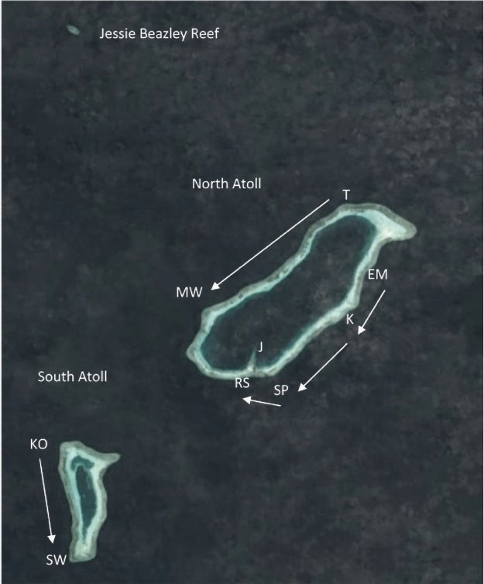

**Figure 3.** Satellite image of the TRNP showing the location of the North and South Atolls and Jessie Beazley Reef [lifted from Murray *et al.* (2018)]. Major reference points used in the survey are South Park (SP), Ranger Station (RS), Elbow Ma (EM), Kanto (K), Terraces (T), Malayan Wreck (MW), Ko-ok (KO), Southwest Wall (SW), and J, which was visited for observation of juveniles. Arrows indicate the stretch of the reef surveyed between two points (see Table 1 for details). All survey tracks except J were conducted from above the reef crest towards the open shelf-edge or drop-off area.

This study focused on reporting the density distribution of Napoleon wrasse in both the North and South Atolls of the TRNP. Knowing that the Napoleon wrasse has limited home range, moves within a contiguous reef (Weng *et al.* 2015; Daly *et al.* 2020), and are highly sedentary (Sadovy *et al.* 2003), we also investigated for possible variations in the density and size-frequency distribution of the species

between atolls and within atolls, particularly in the North Atoll. Lastly, the study aimed to confirm whether the lagoons with staghorn corals harbor Napoleon wrasse juveniles, with sizes estimated at < 15 cm TL.

# MATERIALS AND METHODS

The study was conducted in the North and South Atolls of TRNP, with an aggregate reef area of approximately 100 km2 (Figure 3). The North Atoll is approximately 16.85 km in length, with the widest width of 6.6 km while the South Atoll is almost half the size of the North Atoll, extending 8.5 km in length and the widest width of 3.9 km (Murray *et al.* 2018). The Jessie Beazley Reef, which is located 15 km northwest of North Atoll, was excluded in this survey because this area is relatively small. The survey was done for five consecutive days, covering both atolls from 15–19 May 2017.

A day prior to the actual survey, all observers involved were trained on fish size estimation using fish dummies (Figure 4). Fish dummies had the actual outline of the Napoleon wrasse. It was deemed necessary to use the actual outline of fish dummies to achieve best size estimates because by experience, using a “stick” as a form of measurement (English *et al.* 1997) provides a different perspective rather than seeing the fish in its actual form. These dummies were constructed out of thin rubber mat (~ 1 cm) in varying sizes (TL): 30 cm, 50 cm, and 100 cm. During the deployment, the fish dummies were supported with bamboo sticks to prevent them from folding underwater (Figure 4).

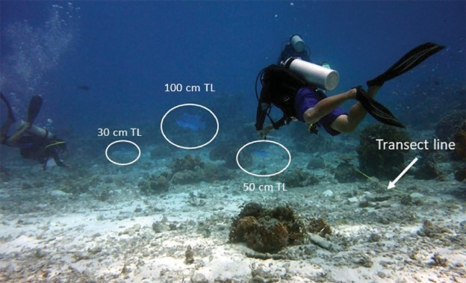

**Figure 4.** White circles indicate the actual sizes of the three fish dummies shaped like Napoleon wrasse that were used for standardization of size estimates. The fish dummies appeared to be small in reference to the size of the diver because of the effect of the two-dimensional shot coupled with the wide-angle perspective of the lens used. Photo by RC Alarcon.

All the dummies were deployed on one end of the reef. The dummies were lined up at approximately 2 m apart, anchored to the seabed using lead weights to prevent them from moving around. A 30-m transect line was laid perpendicularly from where the fish dummies are fixed. The observers calibrated their size estimation of the fish dummies starting at a 30-m distance and moved closer to 5-m mark, which is the nearest possible distance of encountering a live Napoleon wrasse underwater in TRNP. After the calibration exercise, a dry run of FVC was made, after which the divers compared notes with the FVC expert (CL Nañola) to recalibrate their size estimation.

Two diving teams were formed, each composed of between five to seven divers. All members of the team were briefed regarding the diving strategy such as the areas to be surveyed (Figure 3), dive time, the target distance per dive, and the manner of counting. All dives conducted were drift dives that commenced at 07:00 in the morning and ended at 03:00 in the afternoon. In each dive, the aim is to cover at least a stretch of the reef of about 1-km distance. In each dive station, divers were lined up across the reef from the shallowest depth (2–4 m) all the way down to the reef edge/wall at depths beyond 10 m. In this set-up, the width of the observation was around 50

m. The team members moved at the same pace, in effect approximating the swath width as described by Colin (2006) and Sadovy and Suharti (2008). The designated team leader ensured that each diver estimates the size of the same fish by calling the team’s attention using a tank banger and pointing to Napoleon wrasse. Entries on the slate carried by each diver were numbered. Divers that heard the signal but did not see the fish marked the number of the entry with a “blank.” More importantly, all the Napoleon wrasse coming from behind the divers were not counted to avoid recounting the same individuals (English *et al.* 1997). At the end of each dive, each team gathered together to align their counts and entered the consolidated data into a spreadsheet. The consolidated data is the summation of all “unique individuals” per tank bang observed by all members of the team. In consolidating the “unique individual per observation,” the outliers (*e.g.* mostly too big) were discarded and the average size was obtained per individual observation. During the dive, it was observed that banging the tank did not affect the Napoleon wrasse since it did not elicit any response from the tank banging. It should be noted that tank banging in TRNP is being practiced by divemasters to get the attention of recreational divers visiting the area.

Following Colin (2006), the distance covered per dive was measured by getting the coordinates at the start and end of each dive using GPS. The specific location where Napoleon wrasse was sighted was not critical in this paper and, hence, was not recorded. At the end of each dive, a

diver’s buoy was placed to mark the end point that served as the starting point in the next dive normally followed by the next team.

The GPS automatically measures the distance between the two given coordinates. The width used was approximately 50 m, which was based on the distances among observers. Hence, the unit of measurement is per dive of each team over the unit area expressed as individuals/ha. The count ha–1 was favored over m–2 because most of the density reports for Napoleon wrasse are indicated in hectares (Sadovy *et al.* 2003; Choat *et al.* 2006; Chateau and Wantiez 2007).

Statistical analyses were performed using R (v.3.5.0, R Core Team 2018). Data wrangling was aided by the following packages: *dplyr* (Wickham *et al.* 2019), *purrr* (Henry and Wickham 2018), and *magrittr* (Bache and Wickham 2014). Statistical tests and visualization utilized the packages *car* (Fox and Weisberg 2011), *ggplot2* (Wickham 2016), and *ggpubr* (Kassambara 2018). The spatial variation of Napoleon wrasse populations between the (1) North and South Atoll, and (2) the northwest and southeast coastline within the North Atoll were tested. A comparison between coastlines was only possible for North Atoll due to data limitations, *i.e.* data were not available for the eastern coastline of the South Atoll (Figure 3). From here, two variables were tested: (1) the density, expressed in terms of no. of individuals/ha; and

(2) the size class distribution or the counts recorded for each defined size class.

The mean fish densities were compared using a two- sample t-test (Eggleston *et al.* 2004; Nagelkerken *et al.* 2016), with Welch’s modification to account for unequal sample sizes. Tests for normality (Shapiro-Wilk’s test) and homogeneity of variance (Levene’s test) showed that the data did not violate parametric assumptions after outliers were removed. The outliers correspond to aggregates in order to normalize the dataset for statistical comparison. Meanwhile, the size-frequency distribution was compared using (1) Wilcoxon rank-sum test and (2) two-sample Kolmogorov-Smirnov (KS) test; the former was used to compare overall variation in size classes, while the latter was used to assess the differences between the size- frequency distribution (Silva *et al.* 2011; Nagelkerken *et al.* 2016). KS test was done using *clus.lf* function of the *fishmethods* package (Nelson 2019); a total of 100 resamples was used to generate the null probability distribution from which the observed length-frequency distribution will be compared to assess significance. For all tests, the significance level (α) was set to α = 0.05.

The presence of juvenile Napoleon wrasse was deliberately searched in one section of the reef at the North Atoll, specifically the lagoon part near the Ranger Station

(Figure 3). In search of the juveniles, snorkeling gear was used (Dorenbosch *et al.* 2006) instead of SCUBA because of the limited depth in these habitats (< 3 m). The aim here is to search for the juveniles (< 15 cm TL) along the thickets of staghorn corals.

# RESULTS

The aggregated total distance surveyed was 20.643 km

* 15.113 km in the North Atoll and 5.53 km in the South Atoll (Table 1). The area of the North Atoll was surveyed as much as the dive team could (Figure 2). For South Atoll, only the western stretch was surveyed because the eastern side has a very low density of Napoleon wrasse according to visual observations of the park rangers. Based on the conservative width estimate of 50 m, the total area covered was 1,032,150 m2 (or 103.22 ha). In both atolls, the raw total count was 641 individuals, accounting for 398 and 243 individuals in the North and South Atolls, respectively. The overall average density is

6.83 individuals/ha while the overall size class observed ranged from 25–150 cm TL (Figure 5).

The variation in density between the two atolls is presented in Figure 5. The mean density of *C. undulatus* in the North Atoll (4.20 individuals/ha ± 0.46 se) was significantly lower than in the South Atoll (8.13 individuals/ha ± 1.11 see; Table 2) based on Welch’s two-sample t-test (t5.42 =

–3.28, *p* < 0.05; Figure 5A). Meanwhile, the size class

in the North Atoll (n = 398; median = 65 cm TL) was significantly larger than in the south (n = 243; median = 60 cm TL) based on Wilcoxon rank sum test (W = 55,674, *p* < 0.05; Figure 5B). Although the size frequency distribution between the two atolls appeared to be variable (Figure 5C), no significant variation was observed (two-sample KS test: Ds = 0.141, *p* > 0.05).

The variation in density between coastlines (Northwest

*vs.* Southeast) in the North Atoll is presented in Figure

6. Although the average fish density along the northwest (5.02 individuals/ha ± 0.98 se) was higher than in the southeast coastline (3.83 individuals/ha ± 0.49 se; Table

**Table 1.** Location of the surveyed sites, the coordinates, and the corresponding number of *Cheilinus undulatus* that were counted in both North and South Atolls. The last column shows the standardized density per sampling unit.

**Atoll Side Day 1, 15 May 2017**

**Transect name (grp-dive#)**

|  |  |
| --- | --- |
| Start | End |
| 8.84691 | 8.84610 |
| 119.93117 | 119.92364 |
| 8.84745 | 8.84646 |
| 119.93113 | 119.91899 |
| 8.92353 | 8.92556 |
| 119.99735 | 120.00618 |
| 8.92353 | 8.91590 |
| 119.99735 | 119.99277 |
| 8.91590 | 8.90815 |
| 119.99277 | 119.98763 |
| 8.90815 | 8.89846 |
| 119.98763 | 119.98393 |
| 8.89846 | 8.88965 |
| 119.98393 | 119.98216 |
| 8.94650 | 8.94724 |
| 119.97923 | 119.98625 |
| 8.94168 | 8.93842 |
| 119.96585 | 119.96005 |
| 8.92351 | 8.93230 |
| 119.94758 | 119.95222 |
| 8.91166 | 8.91877 |
| 119.93727 | 119.94348 |
| 8.89761 | 8.90145 |
| 119.91293 | 119.92178 |
| 8.88596 | 8.87859 |
| 119.89002 | 119.88862 |

**Site description**

**Latitude/Longitude (degrees)**

**Distance covered (m)**

**Area (distance x width at 50m) in ha**

**Total counts**

**Density/ ha**

N SE G1-2

N SE G2-2

**Day 2, 16 May 2017**

South Park to RS

833 4.17 21 5.04

Mac nto

|  |  |  |  |
| --- | --- | --- | --- |
| 1050 | 5.25 | 27 | 5.14 |
|  |  |  |  |
| 998 | 4.99 | 25 | 5.01 |
| 987 | 4.94 | 16 | 3.24 |
| 1030 | 5.15 | 11 | 2.14 |
| 1150 | 5.75 | 20 | 3.48 |
| 1000 | 5.00 | 10 | 2.00 |
|  |  |  |  |
| 775 | 3.88 | 75 | 19.35 |
| 734 | 3.67 | 40 | 10.90 |
| 1100  1050 | 5.50  5.25 | 27  41 | 4.91  7.81 |
| 1060 | 5.30 | 18 | 3.40 |
| 986 | 4.93 | 29 | 5.88 |

|  |  |  |
| --- | --- | --- |
| N | SE | G1-1 |
| N | SE | G2-2 |
| N | SE | G1-3 Elbow to Ka |
| N | SE | G2-4 |
| N | SE | G1-5 |
| **Day 3, 17 May 2017** | | |

|  |  |  |  |
| --- | --- | --- | --- |
| N | NW | G2-1 |  |
| N | NW | G1-2 |
| N | NW | G2-3 | Terraces to |
| N | NW | G1-4 | Malayan Wreck |
| N | NW | G2-5 |  |
| N | NW | G1-6 |  |

**Atoll Side Day 4, 18 May 2017**

|  |  |  |  |
| --- | --- | --- | --- |
| S | E | G1-1 |  |
| S | E | G2-2 |
| S | E | G1-3 | Ko-ok to |
| S | E | G2-4 | Southwest Wall |
| S | E | G1-5 |  |
| S | E | G2-6 |  |

**Transect name (grp-dive#)**

**Site description**

**Latitude/Longitude (degrees)**

Start End

|  |  |
| --- | --- |
| 8.80002 | 8.79541 |
| 119.80594 | 119.80690 |
| 8.77685 | 8.76852 |
| 119.81046 | 119.81244 |
| 8.75241 | 8.74410 |
| 119.81341 | 119.81143 |
| 8.75878 | 8.75219 |
| 119.82990 | 119.82768 |
| 8.77076 | 8.78024 |
| 119.83348 | 119.83358 |
| 8.78580 | 8.79586 |
| 119.83122 | 119.83669 |
| 8.85728 | 8.84961 |
| 119.94310 | 119.93481 |
| 8.87012 | 8.86338 |
| 119.95730 | 119.94982 |

**Distance covered (m)**

**Area (distance x width at 50m)**

**Total counts**

|  |  |  |  |
| --- | --- | --- | --- |
|  | **in ha** |  | |
| 524 | 2.62 | 47 | 17.94 |
| 953 | 4.77 | 31 | 6.51 |
| 950  773 | 4.75  3.87 | 48  42 | 10.11  10.87 |
| 1060 | 5.30 | 44 | 8.30 |
| 1270 | 6.35 | 31 | 4.88 |

**Density/ ha**

**Day 5, 19 May 2017**

N SE G1-1

N SE G1-2

Kanto to South Park

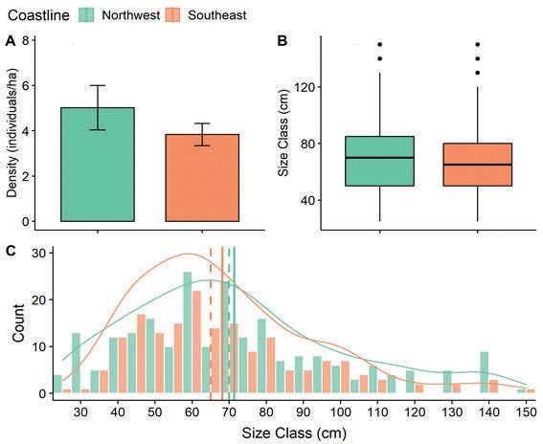

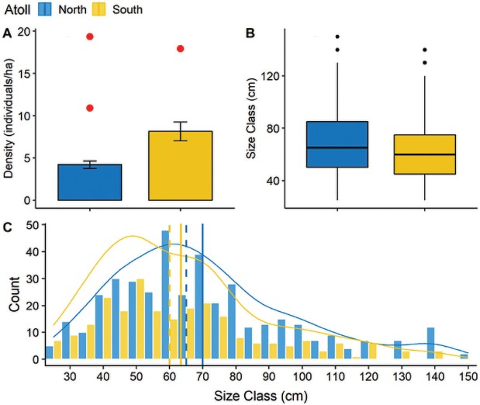**Figure 5.** Comparison of *Cheilinus undulatus* density between the North and South Atolls. (A) Bar plot of mean densities (± se). Removal of outliers (red dots) in the analyses did not violate parametric assumptions. (B) Boxplot of the size classes. (C) Size-frequency distribution overlaid with the probability density function. Vertical lines indicate the measures of central tendencies (solid – mean; broken – median).

2), such difference was not significant (Welch’s two-

**Figure 6.** Comparison of *C. undulatus* density between the northwest and southeast coastline within the North Atoll. (A) Bar plot of mean densities (± se). (B) Boxplot of the size classes. (C) Size-frequency distribution overlaid with the probability density function. The vertical lines indicate the measures of central tendencies (solid = mean; broken

= median).

6C) was also not significant (two-sample KS test: Ds =

sample t-test: t

4.56

= 1.08, *p* > 0.05; Figure 6A). Likewise,

0.083, *p* > 0.05).

the size class in the northwest (n = 223; median = 70 cm TL) and in the southeast (n = 175; median = 65 cm TL) was also not significant (Wilcoxon rank sum test: W = 20,593, *p* > 0.05; Figure 6B). Lastly, the variability in the size frequency distribution between coastlines (Figure

|  |  |  |  |
| --- | --- | --- | --- |
| 1250 | 6.25 | 16 | 2.56 |
| 1110 | 5.55 | 22 | 3.96 |
| 20643 | 103.2 | 641 | 6.21 |

Based on the known size-at-age maturity of the species (Sadovy *et al.* 2003; Choat *et al.* 2006; Sadovy de Mitcheson *et al.* 2010; Graham *et al.* 2014), around 9% of the population is young (25–40 cm TL). The majority of the population (68%) fell within the size class range from

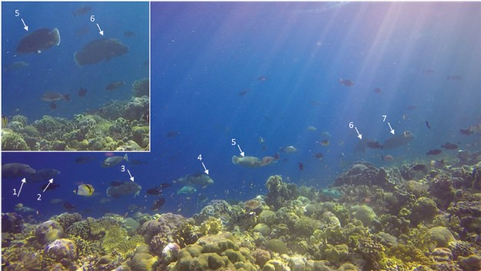

**Figure 7.** About 10 individuals of *Cheilinus undulatus* observed in one spot at the North Atoll, most likely heading to an aggregation site. Seven individuals are seen in the figure but there were more Napoleon wrasse heading the same direction observed in this area. Number 6 was the largest individual in the group (~ 100 cm TL). The others have size estimates in TL as follows: 1 ~ 80 cm, 2 ~ 70 cm, 3 ~ 80 cm, 4 ~ 60 cm, 5 ~ 80 cm, and 7 ~ 90 cm. Image was captured from a video by CL Nañola.

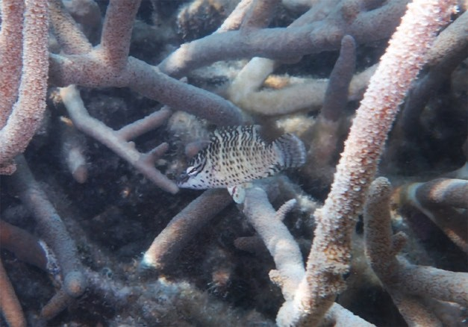

**Figure 8.** An enhanced photograph of a juvenile *Cheilinus undulatus* (~ 7 cm TL) seen in a patch of staghorn corals in North Atoll. Photo by RC Alarcon.

40–80 cm TL, which falls within their size-at-maturity. About 11% of the population can be considered as mature males, with a size class greater than 100 cm TL (Figure 5C).

For the observation on the presence of juvenile *Cheilinus undulatus* (< 20 cm TL), one juvenile was seen hiding in thickets of staghorn coral after 20 min of snorkeling (Figure 3). Several minutes later, more juveniles were observed, with sizes ranging from 7–10 cm TL (Figure 8).

# DISCUSSION

Based on the available information on the density of Napoleon wrasse in the Philippines, TRNP holds the highest density at an average of 6.83 individuals/ha in

both atolls, which may reach as high as 8 individuals/ha in the South Atoll alone. It is likely that once recruited, it cannot traverse non-contiguous reefs separated by deep water, which is the case between North and South Atolls in TRNP.

The Napoleon wrasse population under study is inside a large well-managed and fully protected conservation area (Dygico *et al.* 2013). Hence, the density observed may be associated with the “conservation-dependent nature of the species,” as explained by Colin (2006). The record observed in TRNP is more than twice the density counts reported in Queensland, Australia, which is around 3 individuals/ha (Pogonosky *et al.* 2002) and is close to the highest projection of 9 individuals/ha, as observed by Chateau and Wantiez (2007) in New Caledonia. In areas with very low fishing pressure, Sluka (2005) reported that the observed density ranges from 4–20 individuals/ ha. However, on a per transect basis, the highest density observed in TRNP was observed on the NW coastline of the North Atoll with 19 individuals/ha, followed by the South Atoll with 17 individuals/ha (Table 1). The results of this study still fell within the limit, as suggested by Sadovy *et al.* (2003), which did not exceed 20 individuals/ha.

It is presumed that Tawi-Tawi, particularly the municipalities of Sibutu and Sitangkai have a high density of Napoleon wrasse, which may have declined due to the LRFFT (Romero and Injani 2015). The density was reported anywhere from 0.06–0.33 individuals/ha (Romero and Injani 2015). Locals also claim that hundreds of this species occur in the area during their spawning period. This might be possible considering that there were 350 mariculture pens, with a total of 31,071 fingerlings (0.2–0.5 g/individual), 6,914 pieces medium-sized (0.6–0.8 g/individual), and 4,765 pieces of marketable size (about 1.2 kg/individual) of Napoleon wrasse reported in the area in 2015 (Romero and Injani 2015). Catching Napoleon wrasse became popular because this translates to PHP 1,200.00/individual per live fish with a potential income per family of PHP 6,732,000.00, for a total gross sale per year of PHP 80,956,800.00 for the community (Romero and Injani 2015) (conversion rate of US dollar to Philippine Peso in December 2015: USD 1 = PHP 47.07). The trading in these areas is believed to be illegal, unreported, and unregulated, which validates that the Philippines is not vigilant in the enforcement of CITES trade (Wu and Sadovy de Mitcheson 2016).

So far, the spawning period of the Napoleon wrasse in the TRNP is not known. The spawning aggregations of this species were reported between 10–15 females per male individual (Sadovy *et al.* 2003). This aggregation was only seen once in the TRNP during the entire survey period. It was composed of 10 individuals swimming back and forth, with size ranging from 60–100 cm TL

(Figure 7). The presence of a large individual, which is most likely male (Choat *et al.* 2006) in that patch of the reef may indicate a potential group for a small spawning aggregation considering that spawning for this species may occur as often as every day (Colin 2010). These reflect the described nature of this species being sedentary and occurring in aggregations (Sadovy *et al.* 2003; Chateau and Wantiez 2007).

The right-skewed shape of the size-frequency distribution (Figures 5C and 6C) conforms to the pattern reported by Choat *et al.* (2006). This further suggests that their abundance in the TRNP is in a natural state. The current study reports a modal length of 60 cm TL for the North Atoll and 50 cm TL for the South Atoll. This is comparable with the work of Choat *et al.* (2006) who reported a modal length of 50 cm TL in a protected reef in GBF, Australia. As mentioned, this is associated with the protection efforts made in the TRNP. The absence of younger individuals (< 25 cm TL) in the outer reef suggests that they are inhabiting elsewhere for protection (Sadovy *et al.* 2003). At sizes greater than 25 cm TL, they attain a size large enough to venture the exposed regions of the reefs. Furthermore, the presence of juveniles observed in the lagoon of the North Atoll implies that the TRNP is most likely a “self-recruiting system” functioning as a source and a sink.

# CONCLUSION

Considering that the Napoleon wrasse has a known home range length within a contiguous reef (Daly *et al.* 2020; Weng *et al.* 2015), it appears that the only possible dispersal mechanism of the population in the TRNP is during its pelagic larval stage. This can be further investigated by conducting a population connectivity study within the Sulu Sea area, following its occurrence in the municipality of Cagayancillo and Tawi-Tawi Province. From here it can be certainly identified that the TRNP serves as a source of larvae, which may facilitate the recovery of this species in adjacent but depleted habitats.

The management measures implemented in the TRNP, being the largest marine protected area in the country, as well as the state of the reef environment itself are favorable for the population of the iconic Napoleon wrasse in the area. This was demonstrated by their a) high population density (6.83 individuals/ha); b) normal right-skewed size- frequency distribution; where c) 68% of the population are within their known maturation size (40–80 cm TL); and d) in some way, the habitat may function as both source and sink by means of larval dispersal. It is also interesting to investigate whether the pelagic larval stage from TRNP is reaching the other adjacent areas within the Sulu Sea biogeographic region.

# ACKNOWLEDGMENTS

The authors would like to thank the following: Segundo Conales Jr., Noel Bundal, Jeffrey David, Cresencio Caranay Jr., Rodulf Anthony Balisco, and Francisco Torres; the TRNP Marine Park Rangers (Michael Ortega

* PN, Roy Joseph Radam – PCG, Dennis Favilla – LGU Cagayancillo) who took part in the underwater surveys. We also thank the crew of M/V Navorca headed by Capt. Ronald de Roa for providing support. We also like to thank GIZ Sulu-Sulawesi Seascape Project for funding support. Special thanks to Kevin Labrador for the assistance in the statistical analyses and to Maybelle Fortaleza for proofreading the manuscript. We are very grateful to the three reviewers for their great contribution to the improvement of this manuscript.

# STATEMENT ON CONFLICT OF INTEREST

This is to declare that there is no conflict of interest among the authors.

# REFERENCES

ALLEN GR, ERDMANN MV. 2012. Reef fishes of the East Indies. Perth, Australia: University of Hawai'i Press, Volumes I-III. Tropical Reef Research.

## ASIS AMJM, LACSAMANA JKM, SANTOS MD.

2014. Illegal trade of regulated and protected aquatic species in the Philippines detected by DNA barcoding. Mitochondrial DNA. p. 1–8.

BACHE SM, WICKHAM H. 2014. magrittr: a forward- pipe operator for R.

BENTLEY N. 1999. Fishing for solutions: can the live trade in wild groupers and wrasses from Southeast Asia be managed? TRAFFIC Southeast Asia, Petaling Jaya, Malaysia, 100p.

[BFAR-NFRDI] Bureau of Fisheries and Aquatic Resourc- es – National Fisheries Research and Development Institute. 2017. Napoleon Wrasse (*Cheilinus undulatus*) “Mameng” Philippine Status Report and National Plan of Action 2017–2022. Quezon City, Philippines. 44p.

CHATEAU O, WANTIEZ L. 2007. Site fidelity and activ- ity patterns of a humphead wrasse, *Cheilinus undulatus* (Labridae), as determined by acoustic telemetry. Envi- ron Biol Fish 80: 503–508.

## CHOAT JH, DAVIES CR, ACKERMAN JL, MAP-

STONE BD. 2006. Age structure and growth in a

large teleost, *Cheilinus undulatus*, with a review of size distribution in labrid fishes. Mar Ecol Prog Ser 318: 237–246.

CHOAT JH, ROBERTSON DR. 2002. Age-based studies on coral reef fishes. In: Sale PF (ed) Coral reef fishes. Dynamics and diversity in a complex ecosystem. San Diego, CA: Academic Press. p. 57–80.

COLIN P. 1992. Reproduction of the Nassau grouper, *Epi- nephelus striatus*, and its relationship to environmental conditions. Environ Biol Fish 34: 357–377.

COLIN P. 2006. Napoleon Fish (Humphead Wrasse), *Cheilinus undulatus*, Trade in Southern China and Underwater Visual Census Survey in Southern Indo- nesia. 25p.

COLIN P. 2010. Aggregation and spawning of the hump- head wrasse *Cheilinus undulatus* (Pisces: Labridae): general aspects of spawning behaviour. J Fish Biol 76: 987–1007.

## DALY R, KEATING CA, GRAY AE, PEEL LR, GOR- DON L, LEA JSE, CLARKE CR, WENG KC. 2020.

Investigating the efficacy of a proposed marine pro- tected area for the endangered humphead wrasse *Chei- linus undulatus* at a remote island group in Seychelles. Endang Species Res 42: 7–20.

DOMEIER ML, COLIN PL. 1997. Tropical reef fish spawning aggregations: defined and reviewed. Bull Mar Sci 60(3): 698–726.

DOMEIER ML. 2012. Revisiting spawning aggregations: definitions and challenges. In: Reef Fish Spawning Ag- gregations: Biology, Research and Management. Fish & Fisheries Series, Vol. 35. Sadovy de Mitcheson Y, Colin P eds. Dordrecht: Springer.

DONALDSON TJ, SADOVY Y. 2001. Threatened fishes of the world: *Cheilinus undulatus* Ruppell, 1835 (Lab- ridae). Environ Biol Fish 6: 428–428.

## DORENBOSCH M, GROL MGG, NAGELKERKEN

I, VAN DER VELDE G. 2006. Seagrass beds and mangroves as nurseries for the threatened Indo-Pacific Humphead wrasse, *Cheilinus undulatus* and Caribbean Rainbow parrotfish, *Scarus guacamaia*. Biol Conserv 129: 277–282.

## DYGICO M, SONGCO A, WHITE AT, GREEN SJ. 2013.

Achieving MPA effectiveness through application of responsive governance incentives in the Tubbataha reefs. Mar Pol 41: 87–94.

## EGGLESTON DB, DAHLGREN CP, JOHNSON EG.

2004. Fish density, diversity, and size-structure within multiple back reef habitats of key west national wildlife refuge. Bull Mar Sci 75: 175–204.

ENGLISH S, WILKINSON C, BAKER V eds. 1997.

Survey manual for tropical marine resources—sec- ond edition. Australian Institute of Marine Science, ASEAN-Australia Marine Science Project.

FROESE R, PAULY D eds. 2020. FishBase. World Wide Web electronic publication. [www.fishbase.org.](http://www.fishbase.org/)

FOX J, WEISBERG S. 2011. An {R} Companion to Ap- plied Regression. Sage.

GALZIN R. 1985. Ecologie des poissons récifaux de Polynésie Française. Variations spatio-temporelles des peuplements. Dynamique des populations de trois espéces dominantes des lagons nord de Mooréa. Evaluation de la production ichtyologique d’un secteur récifo-lagonaire. These Univ Sci Tech, Languedoc, Montpellier, France. 195p.

GILLETT R. 2010. Monitoring and management of the humphead wrasse, *Cheilinus undulatus*. Rome: Food and Agriculture Organization of the United Nations. 62p.

## GRAHAM KS, BOGGS CH, DEMARTINI EE, SCHRO-

EDER RE, TRIANNI MS. 2014. Status review report: humphead wrasse (*Cheilinus undulatus*). Report to National Marine Fisheries Service, Office of Protected Resources. September 2014. 123p.

HAU CY, SADOVY DE MITCHESON Y. 2019. A facial

recognition tool and legislative changes for improved enforcement of the CITES Appendix II listing of the humphead wrasse, *Cheilinus undulatus*. Aquatic Con- serv: Mar Freshw Ecosyst 29(12): 2071–2091.

HENRY L, WICKHAM H. 2018. purrr: Functional Pro- gramming Tools.

HOSTETTER EB, MUNROE TA. 1993. Age, growth,

and reproduction of tautog *Tautoga onitis* (Labridae: Perciformes) from coastal waters of Virginia. Fish Bull 91: 45–64.

KASSAMBARA A. 2018. gpubr: “ggplot2” Based Pub- lication Ready Plots.

## LAVIDES MN, MOLINA EPV, DE LA ROSA JR GE, MILL AC, RUSHTON SP, STEAD SM, POLUNIN

NVC. 2016. Patterns of coral-reef finfish species disappearances inferred from fishers’ knowledge in global epicentre of marine shorefish diversity. PLoS ONE 11(5): e0155752.

## MURRAY R, CONALES S, ARAUJO G, LABAJA J, SNOW SJ, PIERCE SJ, SONGCO A, PONZO A. 2018.

Tubbataha Reefs Natural Park: the first comprehensive elasmobranch assessment reveals global hotspot for reef sharks. J Asia Pac Biodivers 12: 49–56.

NAÑOLA CL. 2012. Diversity, distribution and ecology

of Philippine reef fishes [Ph.D. Dissertation]. Marine Science Institute, University of the Philippines Dili- man. 174p.

## NAÑOLA CL, ALIÑO PM, CARPENTER KE. 2011.

Exploitation-related reef fish species richness depletion in the epicenter of marine biodiversity. Environ Biol Fish 90: 405–420.

## NAGELKERKEN I, RUSSELL BD, GILLANDERS BM,

CONNELL SD. 2016. Ocean acidification alters fish populations indirectly through habitat modification. Nature Clim Change 6: 89–93.

NELSON GA. 2019. fishmethods: Fishery Science Meth- ods and Models.

PARENTI P, RANDALL JE. 2011. Checklist of the spe- cies of the families Labridae and Scaridae: an update. Smithiana Bulletin 13: 29–44.

## POGONOSKY JJ, POLLARD DA, PAXTON JR. 2002.

Conservation overview and action plan for Australian threatened and potentially threatened marine and es- tuarine fishes. Environment Australia, Canberra. 373p.

## RANDALL JE, HEAD SM, SANDERS APL. 1978.

Food habits of the giant humphead wrasse *Cheilinus undulatus* (Labridae). Environ Biol Fish 3: 335–338.

R CORE TEAM. 2018. R: A language and environment for statistical computing. R Foundation for Statistical Computing, Vienna, Austria.

ROMERO FG, INJANI AS. 2015. Assessment of humphead wrasse *Cheilinus undulatus*, spawning aggregations and declaration of marine protected area as strategy for enhancement of wild stocks. In: Resource Enhancement and Sustainable Aquaculture Practices in Southeast Asia: Challenges in Responsible Production of Aquatic Species. Romana-Eguia MRR, Parado-Estepa FD, Salayo ND, Lebata-Ramos MJH eds. Proceedings of the International Workshop on Resource enhancement and Sustainable Aquaculture Practices in Southeast Asia 2014 (RESA). p. 103–120.

RUSSELL B. 2004. *Cheilinus undulatus*. The IUCN Red List of Threatened Species 2004: e.T4592A11023949.

SABATER M. 2010. Mapping and assessing critical habitats for the Pacific humphead wrasse (*Cheilinus undulatus*). Western Pacific Regional Fishery Manage- ment Council, Honolulu, HI. 15p.

SADOVY Y, KULBICKI M, LABROSSE P, LETOUR- NEUR Y, LOKANI P, DONALDSON TJ. 2003. The

humphead wrasse, *Cheilinus undulatus*: synopsis of a threatened and poorly known giant coral reef fish. Rev Fish Biol Fisher 13(3): 327–364.

SADOVY Y, SUHARTI S. 2008. Napoleon fish, *Cheilinus*

*undulatus*, Indonesia. NDF Workshop Case Studies WG 8 – Fishes Case Study 3. p. 1–13.

SADOVY YJ, VINCENT ACJ. 2002. Ecological issues and the trades in live reef fishes. In: Coral Reef Fishes Dynamics and Diversity in a Complex Ecosystem. Sale PF ed. San Diego, CA: Academic Press. p. 391–420.

## SADOVY DE MITCHESON Y, LIU M, SUHARTI S.

2010. Gonadal development in a giant threatened reef fish, the humphead wrasse *Cheilinus undulatus*, and its relationship to international trade. J Fish Biol 77(3): 706–718.

SADOVY DE MITCHESON Y. 2016. Results of monthly survey on numbers and sizes of live Napoleon (=Hump- head) wrasse, *Cheilinus undulatus*, on retail sale in Hong Kong (November 2014–December 2015) [un- published report]. IUCN Species Survival Commission Groupers & Wrasses Specialist Group.

## SADOVY DE MITCHESON Y, SUHARTI S, COLIN

PL. 2019. Quantifying the rare: Baselines for the en- dangered Napoleon wrasse, *Cheilinus undulatus*, and implications for conservation. Aquat Conserv: Mar Freshw Ecosyst 29: 1285–1301.

## SHERMAN KD, DAHLGREN CP, STEVENS JR, TY-

LER CR. 2016. Integrating population biology into conservation management for endangered Nassau grouper *Epinephelus striatus*. Mar Ecol Prog Ser 554: 263–280.

SILVA CNS, BROADHURST MK, SCHWINGEL A, DIAS JH, CATTANI AP, SPACH H. L. 2011. Refining

a Nordmøre-grid for a Brazilian artisanal penaeid-trawl fishery. Fish Res 109: 168–178.

SLUKA RD. 2000. Grouper and Napoleon wrasse ecol- ogy in Laamu atoll, Republic of Maldives: Part 1. Habitat, behaviour and movement patterns. Atoll Res Bull 491: 26.

SLUKA RD. 2005. Humphead wrasse (*Cheilinus undu- latus*) abundance and size structure among coral reef habitats in Maldives. Atoll Research Bulletin No. 538.

## SOMBO H, KAMAL MM, WARDIATNO Y. 2017.

Abundance and size distribution of the humphead wrasse (*Cheilinus undulatus*) in Raja Ampat waters, West Papua Province, Indonesia. AACL Bioflux 10(5): 1026–1036.

TAYLOR OJS, HUGHES A, LOVELL E. 2002. Greenforce

Management Proposal: the coral reef of Yadua and YaduaTaba for the National Trust for Fiji. London, UK.

[TNC] The Nature Conservancy, [WWF] World Wildlife Fund, [CI] Conservation International, [WCS] Wildlife Conservation Society, [USAID] United States Agency

for International Development. 2008. Marine protected area networks in the Coral Triangle: development and lessons. Cebu City, Philippines.

TUPPER M. 2007. Identification of nursery habitats for commercially valuable humphead wrasse *Cheilinus undulatus* and large groupers (Pisces: Serranidae) in Palau. Mar Ecol Prog Ser 332: 189–199.

## WENG KC, PEDERSEN MW, DEL RAYE GA, CA-

SELLE JE, GRAY AE. 2015. Umbrella species in ma- rine systems: using the endangered humphead wrasse to conserve coral reefs. Endanger Species 27: 251–263.

WICKHAM H. 2016. ggplot2: Elegant Graphics for Data Analysis. Gentleman R, Hornik K, Parmigiani G eds. Springer.

## WICKHAM H, FRANCOIS R, HENRY L, MULLER

K. 2019. dplyr: a grammar of Data Manipulation. R package version 0.4, Vol. 3.

WU J, SADOVY DE MITCHESON Y. 2016. Humphead

(Napoleon) wrasse *Cheilinus undulatus* trade into and through Hong Kong. TRAFFIC, Hong Kong.

[WWF] World Wildlife Fund for Nature. 2006. Tubbataha Reefs: a marine protected area that works: a case study on the Philippines. WWF-Philippines, Quezon City, Philippines. p. 1–41.