Ciliate abundance in Lake Lanao and its bioindication on water quality

## Abstract

One-celled ciliated protozoans are characterized by hair-like structures called cilia projecting from cell surfaces. They are known as bioindicators of organic pollution in freshwater systems. Ciliate abundance was utilized to monitor the water quality of Lake Lanao from 2016 to 2018 in littoral and pelagic water zones of Marawi City, Ramain, Balindong, Taraka, and Binidayan, Lanao del Sur, across four different seasons; non-mixing, mixing, dry, and rainy seasons. The results exhibited that the mean abundance of ciliates in the lake fell within the ultra-oligotrophic category indicating that the water quality of Lake Lanao, from all sampled sites, depths, and seasons, is still good, clean and healthy, and not organically polluted. The ciliate abundance scored significantly lowest in the non-mixing season than the rest of the seasons. Dry season topped the ciliate abundance but it did not significantly differ from mixing and rainy seasons which also scored higher abundance. Temporal changes influenced ciliate abundance indicative of organic load fluctuations in the lake as the season changed. The use of ciliates as indicators of organic pollution in freshwater systems would serve as baseline data for future monitoring of the lake’s water quality. The local government units were informed of the research findings as a basis to strengthen their policies in conserving the healthy conditions of the lake.

Keywords: Ciliates, bioindicators, Lake Lanao, freshwater ecosystem, organic pollution

# Introduction

Lake Lanao in Lanao del Sur, Mindanao, is known for its endemic cyprinid fishes [1] and its importance as a source of power supply in the Southern Philippines. The lake is vital to the lives of the Meranaw, “people of the lake”; and is intricately interwoven in their cultural and religious practices. Bordering the lake's shores are 17 municipalities and a city, Marawi City. Compared with the other lakes in the country, Lake Lanao is relatively free from industrial effluents. But it is reportedly deteriorating due to increased human population and activities around the lake [2]. Being one of the ancient lakes in the world [3,4], the conservation of Lake Lanao is not just a local or national concern but also a global one. One conservation approach is to study the trophic status of the lake and its water quality using biological indicators, as in this case, the ciliated protozoans. Ciliates are one-celled animal-like organisms characterized by the presence of hair-like structures called cilia projecting from their body surfaces [5]. They are abundant in almost every environment with liquid water: ocean waters, marine sediments, lakes, ponds, and rivers, and even soils. More than 50% of the population in organically polluted rivers and streams are ciliates, playing an impressive role in the ecosystem as a warning indicator of changes in the environment. Ciliated protozoans usually inhabit environments that are low in oxygen concentration. Some members are facultative anaerobes while others are obligate anaerobes that are limited to

an environment with no oxygen [[6](https://mail.yahoo.com/d/compose/0752715848?guce_referrer=aHR0cHM6Ly9sb2dpbi55YWhvby5jb20v&guce_referrer_sig=AQAAAKonZkc-ftN2zVImsY-PrbiBBcgFVrcpvC23wysBn26vbpdibN_aZyLkXpKPbU3Ule6eQC46hBi6AqM-sZhK6hCH3sDfZiF9X00tpYk7PrxwuT3aB3twlJ5tymXg0V4Yz9-0q5zygIjfkw2Mkx31LEtFQgTAQJcXCGxNlu9wnpC9&_ENREF_4)]. They have been utilized as indicators of organic pollution and in monitoring the health of aquatic ecosystems [7,8,9,10]. Ciliates play a very significant link in the food chain as bacterial feeders and algal grazers. Moreover, their grazing activity increases the rate of decomposition and thus their presence and abundance are good indicators of organic pollution [[11](https://mail.yahoo.com/d/compose/0752715848?guce_referrer=aHR0cHM6Ly9sb2dpbi55YWhvby5jb20v&guce_referrer_sig=AQAAAKonZkc-ftN2zVImsY-PrbiBBcgFVrcpvC23wysBn26vbpdibN_aZyLkXpKPbU3Ule6eQC46hBi6AqM-sZhK6hCH3sDfZiF9X00tpYk7PrxwuT3aB3twlJ5tymXg0V4Yz9-0q5zygIjfkw2Mkx31LEtFQgTAQJcXCGxNlu9wnpC9&_ENREF_2)]. Their abundance increases as the trophic state of freshwater changes from oligotrophic to mesotrophic or to the eutrophic condition [[12](https://mail.yahoo.com/d/compose/0752715848?guce_referrer=aHR0cHM6Ly9sb2dpbi55YWhvby5jb20v&guce_referrer_sig=AQAAAKonZkc-ftN2zVImsY-PrbiBBcgFVrcpvC23wysBn26vbpdibN_aZyLkXpKPbU3Ule6eQC46hBi6AqM-sZhK6hCH3sDfZiF9X00tpYk7PrxwuT3aB3twlJ5tymXg0V4Yz9-0q5zygIjfkw2Mkx31LEtFQgTAQJcXCGxNlu9wnpC9&_ENREF_1)]. Their size is relatively larger than other microbes, their community structure can be studied easily [[13]](https://mail.yahoo.com/d/compose/0752715848?guce_referrer=aHR0cHM6Ly9sb2dpbi55YWhvby5jb20v&guce_referrer_sig=AQAAAKonZkc-ftN2zVImsY-PrbiBBcgFVrcpvC23wysBn26vbpdibN_aZyLkXpKPbU3Ule6eQC46hBi6AqM-sZhK6hCH3sDfZiF9X00tpYk7PrxwuT3aB3twlJ5tymXg0V4Yz9-0q5zygIjfkw2Mkx31LEtFQgTAQJcXCGxNlu9wnpC9&_ENREF_5). The study therefore aimed to monitor the water quality of Lake Lanao for two years by using ciliate abundance as bioindicators of organic pollution in the littoral and pelagic zones of the five selected sites. The temporal fluctuations of ciliate abundance in four different seasons, namely, mixing, non-mixing, rainy, and dry seasons were also determined.

# Methodology

## Sampling sites and collection of ciliates

The sampling sites purposively included representations of the north, south, west, and east parts of Lake Lanao, Lanao de Sur (Figure 1); Marawi City, Ramain, Balindong, Taraka, and Binidayan. The sampling of ciliates was conducted in four different seasons, namely non- mixing season (November 2016), mixing season (February 2017), summer or dry season (May 2018) and rainy or wet season (August 2018). Ciliates were sampled using conical plankton net (WaterMark®Simple Plankton Nets, USA, mesh 53 µm, mouth diameter 0.488 m). In each site, the littoral zone was established within 50-100 meters off the lakeshore while the pelagic zone was beyond 100 meters from the shoreline (minimum depth of about 20 meters); three replicates of water samples were taken from each zone, approximately 100 meters away from each other. The plankton net was towed obliquely to get an integrated water sample representing the surface and middle parts of the water column at a distance of 10 meters per replicate. Only the planktonic ciliates were considered in this study. The water collected by plankton net was concentrated, transferred into fresh sampling bottles and the ciliates were fixed by adding a modified formalin-acidified Lugol’s solution (i.e. 1mL of 5% formalin and a drop of acidified Lugol’s solution per 10mL of water sample).

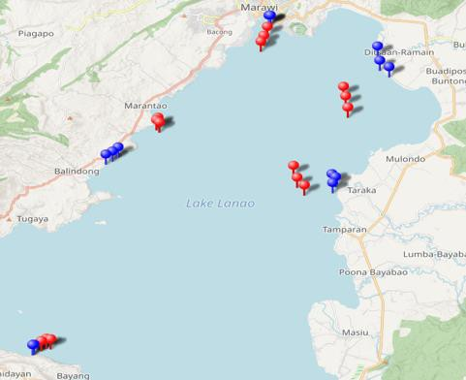

**A**

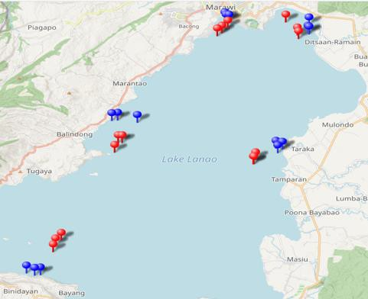

**B**

**Figure 1.**

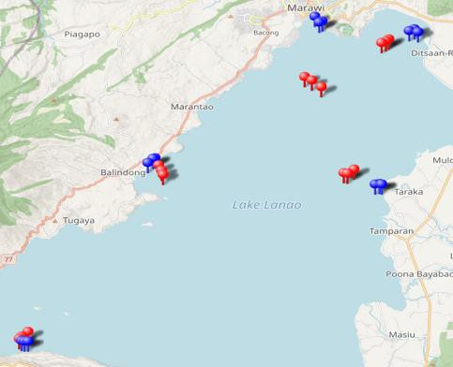

**C**

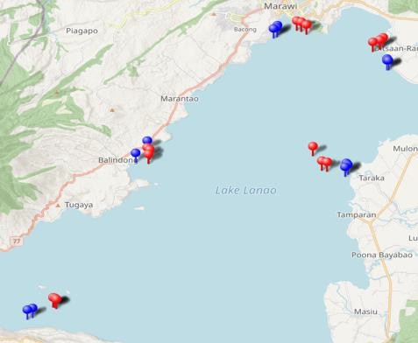

**D**

Map of Lake

Lanao showing the sampling sites and replicates; blue

pins, littoral zone while red pins, pelagic zone. A, non-mixing season; B, mixing season; C, dry season; and D, rainy season. The image is generated at http:// [www.gpsvisualizer.com](http://www.gpsvisualizer.com/) and map data from [OpenStreetMap.org](http://www.openstreetmap.org/copyright), relief from ESRI/ArcGIS.

## Microscopic observations, ciliate counting and Calculating ciliate abundance

Microscopic observations and counting of fixed ciliates were performed at the Ciliate Research Lab, Biology Department, College of Natural Sciences and Mathematics, Mindanao State University-Marawi City using a stereomicroscope, light microscope (EUROMex―iScope & Microblue Series) and inverted microscope (Olympus CK, Japan). Photomicrographs and videos of the observed ciliates were taken using a digital camera (12-Megapixel, Sony) and iPhone 6 camera. Ciliates were chiefly identified based on the presence of cilia, the size (average size 20-300 μm), and shape of the body [5,14].

To determine the ciliate abundance (cells/m3), ciliates were counted manually from fixed samples using the right-hand rule method for microscopy. Abundance was calculated according to Harris *et al.*, (2000) [15]:

𝐴𝑏𝑢𝑛𝑑𝑎𝑛𝑐𝑒 (𝐴 = 𝑖𝑛𝑑𝑖𝑣) = 𝑛∗𝑘

*eq.1*

Where:

𝑚3 𝑉

n = number of count for a particular ciliate species

k = the part of sample counted (sample volume/subsample) V = actual volume of the water sample during towing

## Statistical analysis

Data on abundance were analyzed using Statistical Package for Social Sciences (SPSS) for Windows. The data were checked for normal distribution using the Shapiro-Wilk test and Levene's test for equality of variances. Kruskal Wallis and Mann-Whitney tests were also used.

# Results and Discussion

## Ciliate abundance and its bio-indication on lake’s water quality

Ciliated protozoans were observed in Lake Lanao in all sites; *Paramecium*, *Vorticella* and *Tetrahymena* species were observed with cosmopolitan distribution (Figure 2). Table 1 shows the mean abundance data of ciliates in Lake Lanao across sites, depths and seasons. The highest mean abundance was observed in the littoral zone of Balindong during the dry season while the lowest was in the non-mixing season in the pelagic zone of Binidayan. Comparing these values with the previous study of Beaver and Crisman [12], categorized lakes as ultra-oligotrophic when their ciliate abundance is equal to or lower than 2.4 cells/mL (Table 2), Lake Lanao, therefore, is ultra-oligotrophic having ciliate abundance in all sampling sites, depths, and seasons below the set range mentioned above! Such lake trophic category has very low nutrients, scarce growth of plants and algae, and high dissolved oxygen indicative of a clean, clear, healthy, good drinking water quality and not organically polluted lake [16, 17, 18, 19]. Moreover, results of this study were corroborated by the findings of another research team under the same NRCP program on Lake Lanao Sustainable Development titled *Physical and chemical characterization of Lake Lanao* by Hansel & Sanguila (published also in this issue). Their data reported that the values of various physical and chemical parameters of Lake Lanao were following those quantities usually obtained in most nonpolluted, good water quality healthy lakes.

Organic pollution occurs when large quantities of organic compounds are released into aquatic ecosystems. Sources of pollution usually come from wastes generated by agricultural, residential, and industrial activities. High levels also of inorganic nutrients such as nitrogen and phosphorus in water can cause an overgrowth of plants and algae. As plants

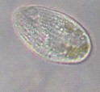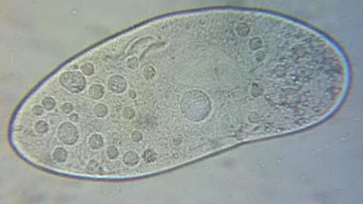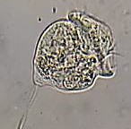

**75 µm**

**25 µm**

**25 µm**

***Paramecium* sp*.***

***Tetrahymena* sp.**

***Vorticella* sp*.***

**Figure 2.** The ciliated protozoans commonly observed in all sites.

**Table 1.** The ciliate mean abundance (cells/m3) in Lake Lanao across sites, depths and seasons.

|  |  |  |  |  |  |  |  |  |
| --- | --- | --- | --- | --- | --- | --- | --- | --- |
| **Sites** | **Non-mixing season** | | **Mixing season** | | **Dry season** | | **Rainy season** | |
|  | Littoral | Pelagic | Littoral | Pelagic | Littoral | Pelagic | Littoral | Pelagic |
| **Marawi** | 156 | 2,379 | 637 | 648 | 1,728 | 296 | 1,892 | 2,670 |
| **Ramain** | 372 | 369 | 1,872 | 740 | 870 | 1,644 | 1,689 | 2,957 |
| **Taraka** | 151 | 1,140 | 722 | 435 | 774 | 543 | 2,528 | 3,250 |
| **Binidayan** | 194 | 155 | 3,257 | 1,222 | 4,548 | 5,327 | 1,559 | 1,886 |
| **Balindong** | 1,242 | 1,059 | 4,752 | 2,445 | 6,064 | 1,288 | 1,514 | 1,931 |

**Table 2.** Summary of data on annual abundances of planktonic ciliates in lakes, modified from Beaver & Crisman [12].

|  |  |
| --- | --- |
| Trophic state | Range of observed abundances (cell/ml) |
| Ultraoligotrophic | 2.4 |
| Oligotrophic | 2.3-10.8 |
| Mesotrophic | 18.0-70.9 |
| Eutrophic | 55.5-145.1 |
| Hypereutrophic | 90.0-215.0 |

and algae die, they become organic materials in the water. Decomposition of these organic materials uses up high amounts of oxygen, thus depriving the fish population of needed oxygen that causes fish kills in the lake. These decaying organic compounds serve as substrates for the microorganisms, increasing the bacterial population which in turn supports the abundant growth of ciliates, thus linking ciliates to organic pollution [9, 12, 20, 21]. It is implied in our study that the organic load in the sampling sites was not substantial enough to support abundant growth of ciliates to indicate organic pollution.

One possible factor that contributes to its healthy condition is the absence of industries around the lake. In addition, Lanao del Sur is a massive agricultural area but farming activities were not so evident around the lake, probably because Meranaws are historically and enterprisingly merchants and traders rather than farmers [22]. It must be noted also that the plankton net was used during sampling thus samples were not directly collected from the lakeshores (the direct receptacle of anthropogenic wastes in populated areas) but some 50-100 meters away from the lakeshore in the shallower littoral zone and towards the deeper open water in the pelagic zone.

|  |  |  |  |  |
| --- | --- | --- | --- | --- |
| 2500.0 |  | | | |
| 2000.0 |  |  |  |  |
| 1500.0 |  |  |  |  |
| 1000.0 |  |  |  |  |
| 500.0 |  |  |  |  |
| 0.0 | **Non-Mixing** | **Mixing** | **Dry** | **Rainy** |

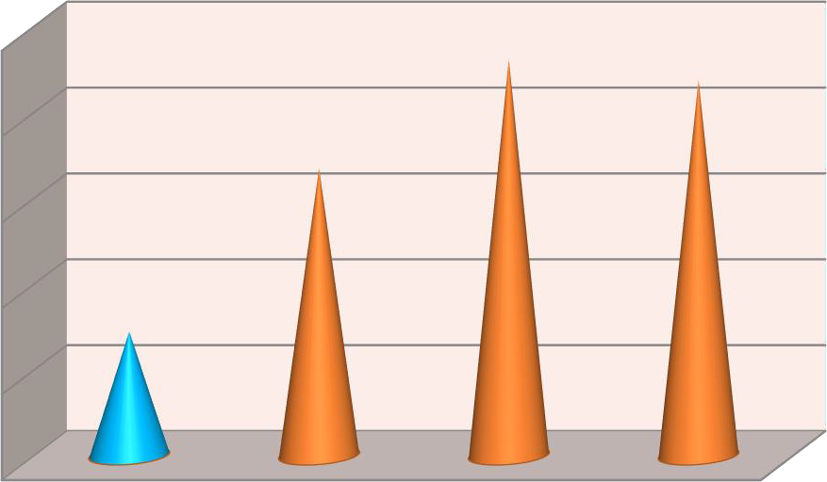**Figure 3.** The seasonal variation of ciliate mean abundance in Lake Lanao; statistically significant by Kruskal Wallis Test (p = 0.001). Mean values with different colors are significantly different by Mann- Whitney comparison (p < 0.05).

**Ciliate Mean Abundace (Cells /m3)**

Zingel [23] studied a strongly stratified hypertrophic lake and reported ciliate abundance at 86 cells/ml indicating hypereutrophic water condition. In the study of Paolo Madoni [24] in rivers of Taro River (Italy), recorded ciliate abundance scores ranging from 9 to 23 cells/ml indicating the mesotrophic condition of the rivers they sampled. Mieczan [25] studied the diversity and vertical distribution of planktonic ciliates in Lake Piaseczno*,* Poland which is a stratified mesotrophic lake. The highest ciliate density he documented was at 21 cells/ml which indeed fell under mesotrophic water condition. The study also of Šimek *et al.* [26] on a eutrophic reservoir reported a ciliate density of 5 to 70 cells/ml.

# Temporal Variation of Ciliate abundance

Kruskal Wallis test demonstrated that the variation of ciliate mean abundance significantly differed across sites (p = 0.038) and seasons (p = 0.001) but not between depths, that is, the littoral and pelagic zones (p = 0.856). The seasonal variation (Figure 3) is significant by the Mann-Whitney test (p < 0.05). The non-mixing season had the lowest score and it was significantly different from the rest of the seasons. Dry season topped the ciliate abundance, however, it did not vary significantly from mixing and rainy seasons which also scored higher abundance.

Non-mixing season having the lowest ciliate abundance actually conformed to the expectation since in this season Lake Lanao water is thermally stratified [27]; no mixing of water in the lake thus low nutrients present in the water to support primary production

consequently, fewer algae and plants, resulting in fewer detritus to feed bacteria and therefore reducing ciliate growth. Mixing season, on the other hand, happens during colder months of the year, that is, January to February where the lake water overturns due to the absence of thermal lake stratification bringing nutrient-rich water to support the primary production which eventually accumulates high organic materials for bacterial substrates thus increasing their population; and this consequently increased ciliate abundance, explaining the increase of ciliates in mixing season. The decomposition of the plants and algae is carried over to the next season hence accounting for the dry season to top the ciliate abundance. Similar studies reported the biomass of ciliates was observed highest during summer [28,29]. The increase also of ciliate abundance in rainy season, as seen in the data, was imminent because rain brings about an increase in mineral and organic nutrients into the lake by run-off waters [30, 31].

Temporal changes are associated with fluctuations of nutrients and organic load in the lake

i.e. mixing brings about higher nutrients in the lake’s surface and rainwater floods the lake with run-off nutrients and organic wastes. These fluctuations in turn influenced the temporal variation of ciliate abundance in the lake.

# Conclusion and Recommendation

The water quality of Lake Lanao, monitored for two years across sites, depths and seasons, was categorized as ultra-oligotrophic as pointed out by the abundance of one-celled protozoan ciliates primarily utilized as the bio-indicators of organic pollution. The ultra- oligotrophic category characterized the lake to have very low nutrients, scarce growth of plants and algae, and well-oxygenated indicative of a clean, healthy, good water quality and not organically polluted. The abundance varied as the season changed. The use of ciliates as indicators of organic pollution in freshwater systems would serve as baseline data for future monitoring of the lake’s water condition. The local government units were informed of the results, serving as a basis to make stricter policies and regulations to conserve the lake’s water quality.

# Acknowledgement

This study is funded by the National Research Council of the Philippines (NRCP)-Grants-In- Aid.

# References

1. Herre AW. The fishes of Lake Lanao: a problem in evolution. Am Nat. 1933:154-162.
2. Rosagaron RP. Lake Lanao: its past and present status, In: C. B. Santiago, M. L. Cuvin- Aralarand Z. U. Basiao (editors.) Conservation and Ecological Management of Philippine

Lakes in Relation to Fisheries and Aquaculture, Southeast Asian Fisheries and Development Center, Aquaculture Department, Iloilo, Philippines. 2001:187.

1. LakeNet [internet]. Ancient Lakes of the World. 2003 [cited 2016 Sept 12]. Available from [http://www.worldlakes.org](http://www.worldlakes.org/).
2. Duker L and Borre L. Biodiversity conservation of the world's lakes: A preliminary framework for identifying priorities. 2001. LakeNet Report Series Number 2. LakeNet Secretariat, Annapolis Maryland USA. Available from <http://www.worldlakes.org/biodiversity_LakeNet_report.htm>
3. Jahn T L, Bovee E C and Jahn FF. How to know the protozoa. 2nd ed. (McGraw- Hill Science/Engineering/Math); 1979.
4. Bernard C, Fenchel T. Some microaerobic ciliates are facultative anaerobes. Eur J Protistol. 1996; 32(3):293-297.
5. Lynn D, Gilron G. A brief review of approaches using ciliated protists to assess aquatic ecosystem health. J. Aquatic Ecosyst Health.1992;1: 263-270.
6. Tushmalova N, Lebedeva N, [Igolkina](https://link.springer.com/article/10.3103/S0096392514020138#auth-3) Y, [Sarapultseva](https://link.springer.com/article/10.3103/S0096392514020138#auth-4) E. *Spirostomum Ambiguum* as a bioindicator of aquatic environment pollution. Moscow Univ Biol Sci Bull. 2014; 69(2): 67-70.
7. Mason C. Biology of Freshwater Pollution. 3rd ed. Singapore Publishers, Ltd.; 1996.
8. Radhakrishnan R, Jayaprakas V. (2015). Free living protozoans as bioindicators in Vembanad lake, Kerala, India, an important Ramsar site. Int. J. Fish. Aquat. 2015;2(3): 192-197.
9. Palm HW, Dobberstein RC. Occurrence of trichodinid ciliates (Peritricha: Urceolariidae) in the Kiel Fjord, Baltic Sea, and its possible use as a biological indicator. Parasitol Res. 1999;85(8-9):726-732.
10. Beaver JR, Crisman TL. The role of ciliated protozoa in pelagic freshwater ecosystems. Microb Ecol. 1989;17(2):111-136.
11. Boudouresque CF. Taxonomy and phylogeny of unicellular eukaryotes. In: Bertrand JC et al., editors. Environmental Microbiology: Fundamentals and Applications. France: Springer: 2015:191-257.
12. Foissner W, Berger H. A user-friendly guide to the ciliates (Protozoa, Ciliophora) commonly used by hydrobiologists as bioindicators in rivers, lakes, and waste waters, with notes on their ecology. Freshw Biol. 1996;35:375-482.
13. Harris R, Wiebe P, Lenz J, Skjoldal HR, Huntley M, editors. ICES zooplankton methodology manual. 2000: Academic Press.
14. Prasad, AGD Siddaraju P. Carlson’s Trophic State Index for the assessment of trophic status of two Lakes in Mandya district. Adv Appl Sci Res. 2012:3(5), 2992-2996.
15. WorldAtals [internet]. What Are Oligotrophic, Mesotrophic, And Eutrophic Lakes? [cited 2021 Jan 10]; Available from [https://www.worldatlas.com/articles/what-are-oligotroph](https://www.worldatlas.com/articles/what-are-oligotroph%20ic-mesotrophic-and-eutrophic-lakes.html) [ic-mesotrophic-and-eutrophic-lakes.html](https://www.worldatlas.com/articles/what-are-oligotroph%20ic-mesotrophic-and-eutrophic-lakes.html).
16. Carlson RE, Simpson J. [A Coordinator’s Guide to Volunteer Lake Monitoring](http://www.nalms.org/home/publications/free-nalms-publications/free-nalms-publications.cmsx) [Methods.](http://www.nalms.org/home/publications/free-nalms-publications/free-nalms-publications.cmsx) North American Lake Management Society. 96 pp.
17. Bhateria R, Jain D. Water quality assessment of lake water: a review. Sustain. Water Resour Manag. 2016;2:161–173. https://doi.org/10.1007/s40899-015-0014-7
18. Organic compounds in freshwater [internet]. 2020 [cited 2020 Dec 18]. Available from <https://www.lenntech.com/aquatic/organic-pollution.htm>
19. Smith VH. Eutrophication, Editor(s): Gene E. Likens, Encyclopedia of Inland Waters Academic Press. 2009., Pages 61-73. ISBN 9780123706263,
20. Lucman HA. Our Marawi: The Resilient Maranao. [Internet]. 2017 [cited 20 Dec 2020]. Available at [https://www.mindanews.com/mindaviews/2017/07/our-marawi-the-resilient-](https://www.mindanews.com/mindaviews/2017/07/our-marawi-the-resilient-maranao/) [maranao/](https://www.mindanews.com/mindaviews/2017/07/our-marawi-the-resilient-maranao/)
21. Zingel P. Vertical and seasonal dynamics of planktonic ciliates in a strongly stratified hypertrophic lake. Hydrobiologia. 2005;547:163–174.
22. Madoni P, Zangrossi S. Ciliated protozoa and saprobical evaluation of water quality in the Taro River (northern Italy), Italian Journal of Zoology. 2005;72(1):21-25.
23. MieczanT.Diversity and vertical distribution of planktonic ciliates in a stratified mesotrophic lake: relationship to environmental conditions. Oceanol Hydrobiol Stud. 2008; 37(1):84-95.
24. Šimek K, Bobkova J, Macek M, Nedoma J, Psenner R. Ciliate Grazing on Picoplankton in a Eutrophic Reservoir During the Summer Phytoplankton Maximum: A Study at the Species and Community Level. Limnol Oceanogr. 1995;40:1077-1090.
25. Lewis W. The Thermal Regime of Lake Lanao (Philippines) And Its Theoretical Implications For Tropical Lakes. Limnol Oceanogr. 1973;18(2):200-2017.
26. [Haraguchi](https://www.tandfonline.com/author/Haraguchi%2C%2BLumi) L, [Hans A, Jakobsen](https://www.tandfonline.com/author/Jakobsen%2C%2BHans%2BH) H, [Carstensen](https://www.tandfonline.com/author/Carstensen%2C%2BJacob) J. Composition of natural phytoplankton community has minor effects on autochthonous dissolved organic matter characteristics. Mar Biol Res. 2019;15 (4-6):357-375.
27. Giere O. Meiobenthology. The microscopic motile fauna of aquatic sediments. 2nd ed. Berlin, Heidelberg: Springer-Verlag. 2009:113 p.
28. Polameesanaporn Y. Biodiversity of Protozoa in Freshwater Case Study in the Chao- Praya River, Thailand. In: M. Sengupta and R. Dalwani (eds).Proceedings of Taal 2007: The 12th World Lake Conference. [internet]. 2008. [cited 2018 March 3]:p484-489. Available from <https://www.scribd.com/document/188121312/Biodiversity-thailand>
29. Habibiandehkordi R, Reid DK, Goel PK et al. Phosphorus loss assessment tools: a review of underlying concepts and applicability in cold climates. Environ Sci Pollut Res. 2020;27:3794–3802. https://doi.org/10.1007/s11356-019-06800-9.