**FUNDED BY THE NATIONAL RESEARCH COUNCIL OF THE PHILIPPINES (NRCP)**

GENDER-SPECIFIC INSIGHTS BASED ON COVID-19 EPIDEMIOLOGICAL AND SOCIO-ECONOMIC DATA

Project Report

Link to the dashboard: https://datastudio.google.com/s/rHHWJSPHmx4

COVID-19, a highly contagious viral disease, has been declared by the World Health Organization as a pandemic [1]. At first, we can look at the issue as an epidemiological and health problem. As of 07 June 2020, this disease has infected around 7 million people worldwide [2]. In the Philippines, more than 21 thousand confirmed cases are reported with 1,003 are expired cases [3]. It is projected that more than a million Filipinos could be infected by COVID-19 if no effective interventions are imposed [4].

Because of the extent of the impact of the COVID-19 pandemic, this epidemiological and health crisis also becomes a pressing social and economic problem. The jobs, businesses, and other socio-economic activities of many Filipinos are constrained by the need to do physical distancing, especially during the government-imposed community quarantine. The effect of the interventions to stop the outbreak has epidemiological advantages, but also affected the personal, mental, social and economic lives of many citizens across all age and sex groups. The internet has helped us connect during this pandemic, but the intimate needs of people, especially by family members living in separate locations, have been sacrificed.

One of the neglected social dimensions of the COVID-19 pandemic is gender. From family to occupation up to the community level, gender plays a crucial role. The health, social and economic risks brought about by the disease have associated gender-specific aspects, such as role of gender in the healthcare system, sex-dependent health vulnerabilities of individuals, and gender- related occupational hazards. In this research, we provide some gender-specific insights based on available epidemiological data, and connect these insights to social and economic datasets.

# *“Good health and well-being, and gender equality” – SDG 3 and 5*

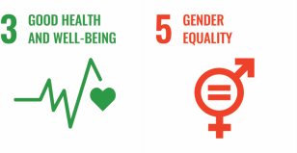

The project focused on (i) gathering and organizing epidemiological datasets as well as social and economic datasets from DOH Datadrop (https://[www.doh.gov.ph/covid19tracker)](http://www.doh.gov.ph/covid19tracker)) and Philippine Statistics Authority (https://psa.gov.ph), (ii) analyzing the data and connecting the different datasets, and (iii) creating visuals and data storyboards that can be used to draw gender- specific insights. The created online interactive dashboard, showing gender-specific insights related to COVID-19, can be used for academic or policy-making purposes.

**General Objective**: To generate gender-specific insights related to the COVID-19 epidemic in the Philippines using data science tools

## Specific Objectives:

* To mine epidemiological datasets on COVID-19, especially sex disaggregated variables and features
* To integrate the gender-specific epidemiological information to social and economic data
* To build online storyboards that can be used in visualizing information and in drawing insights related to gender

## Methodology:

* Download and organize COVID-19 epidemiological data from DOH Datadrop (https://[www.doh.gov.ph/covid19tracker)](http://www.doh.gov.ph/covid19tracker))
* Download socio-economic data, such as from the Philippines Statistics Authority website (https://psa.gov.ph)
* Mine, connect and analyze the different datasets, especially focusing on gender-related variables and features
* Build an online interactive dashboard to visualize the generated information and to present data-driven stories and insights related to gender (https://datastudio.google.com/s/rHHWJSPHmx4)

# *Features of the interactive online dashboard*

(updated daily unless there are issues on the DOH Datadrop) Link: https://datastudio.google.com/s/rHHWJSPHmx4

Figure 1 shows the home page of the dashboard. The list of interactive charts includes the epidemic curve, cumulative cases, distribution of cases based on the health status, age distribution, sex, pregnancy status of female cases, date of death or recovery, number of days from symptom onset to death or recovery, and location of cases. Data on delays, testing, and health care capacity are also added in the dashboard. The data visualizations can be filtered, such as to show sex-disaggregated charts --- this can be done by using the dropdown button or directly clicking the “male” or “female” element of a specific chart.

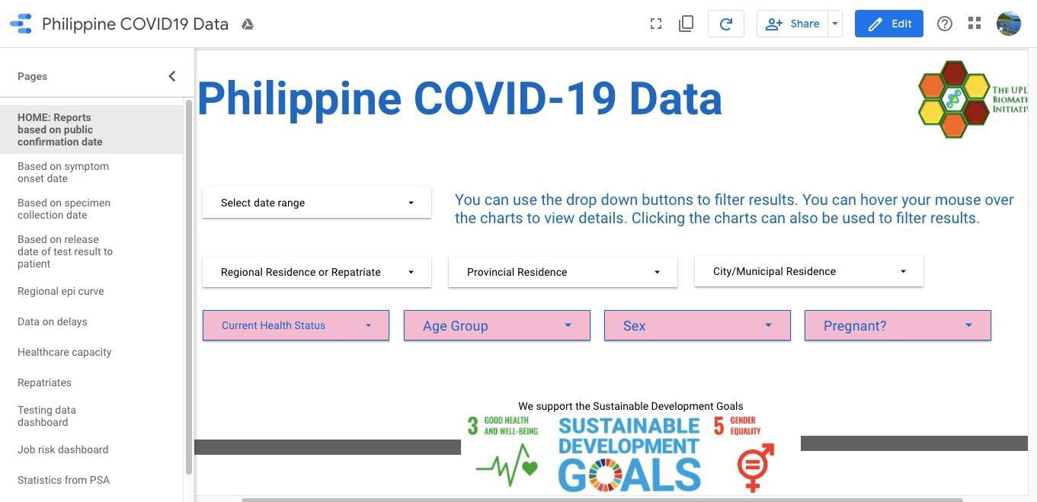

Figure 1. The home page of the dashboard.

The following figures are some of the charts that can be found on the dashboard.

Charts with sex-disaggregated information:

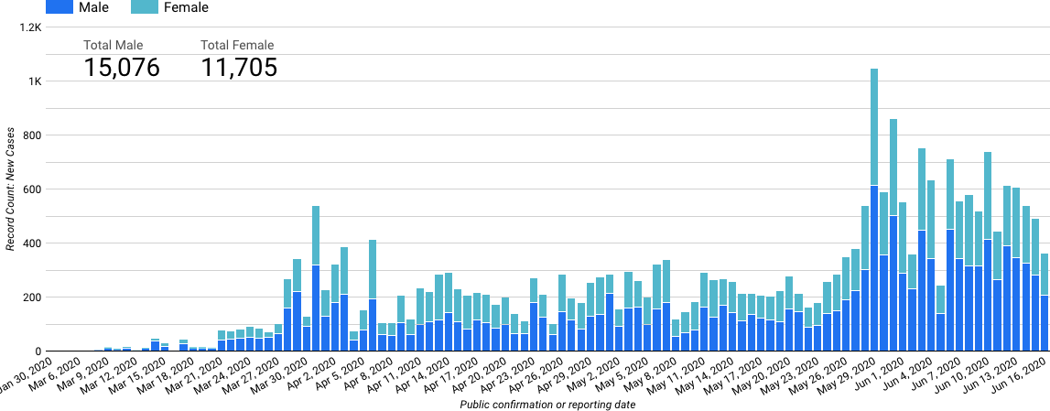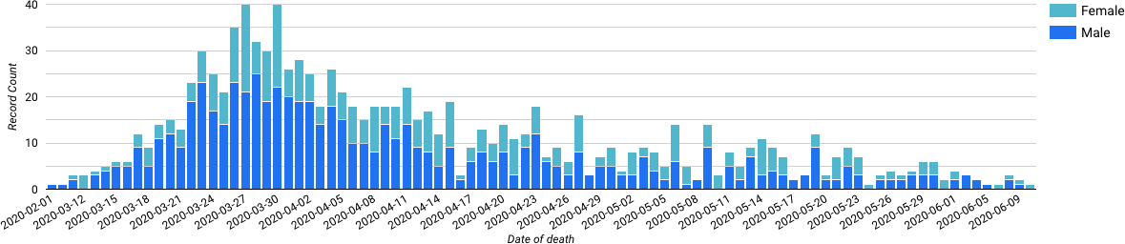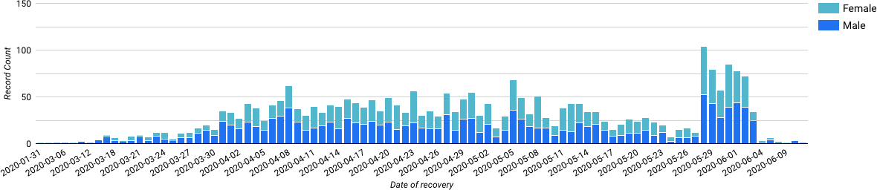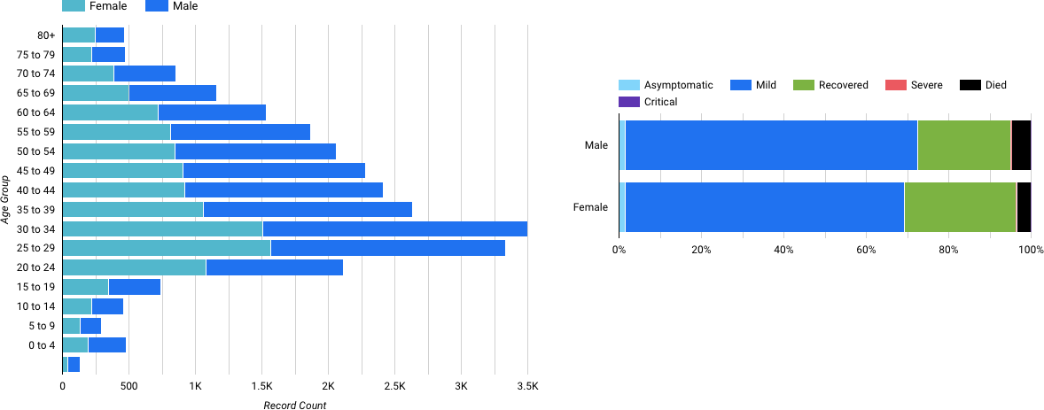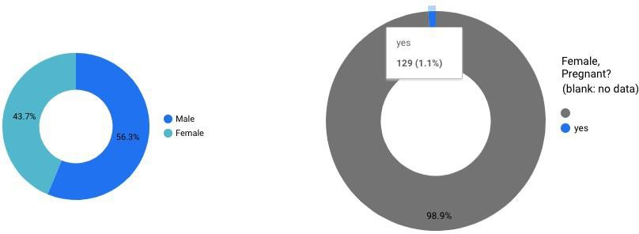

Charts with sex-disaggregated information about repatriates only:

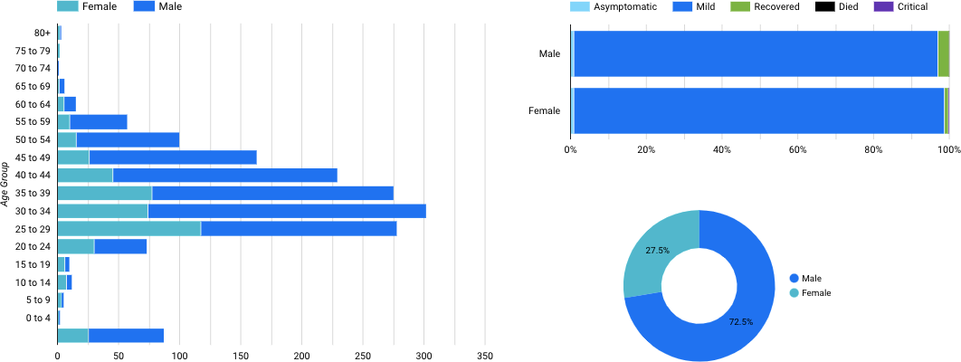

Charts with health status and age distribution:

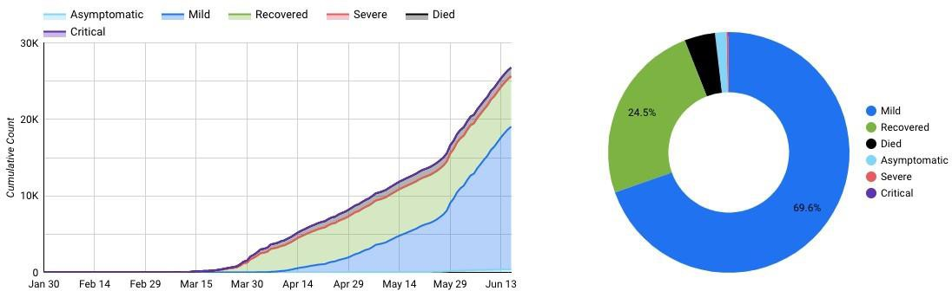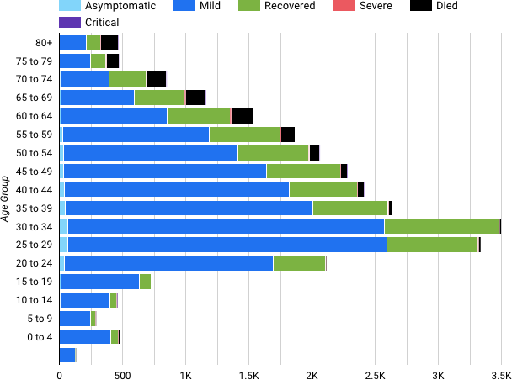

Charts with information about the location:

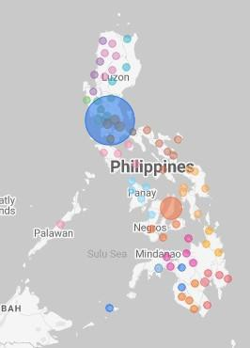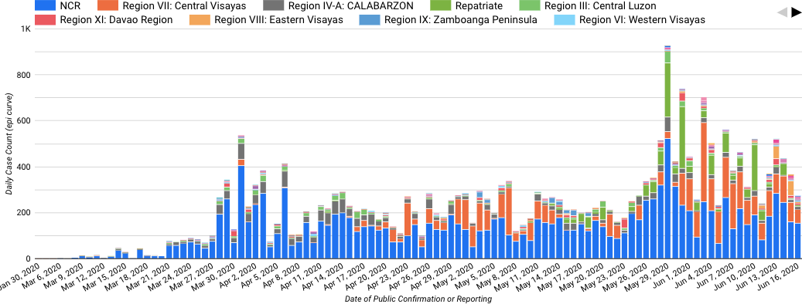

Charts with testing positivity rate, time-varying reproduction number, and health care occupancy:

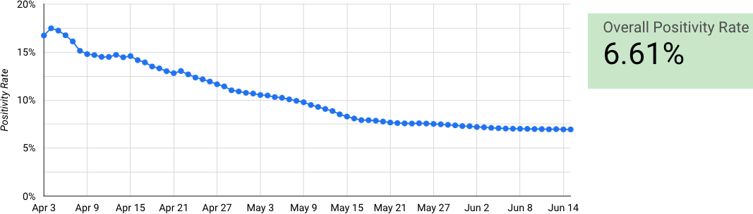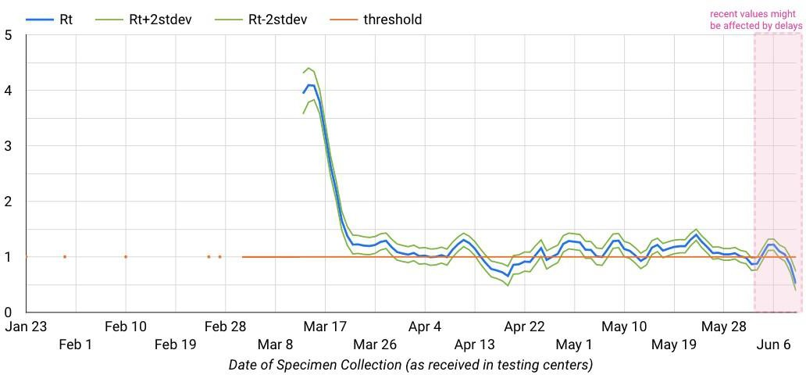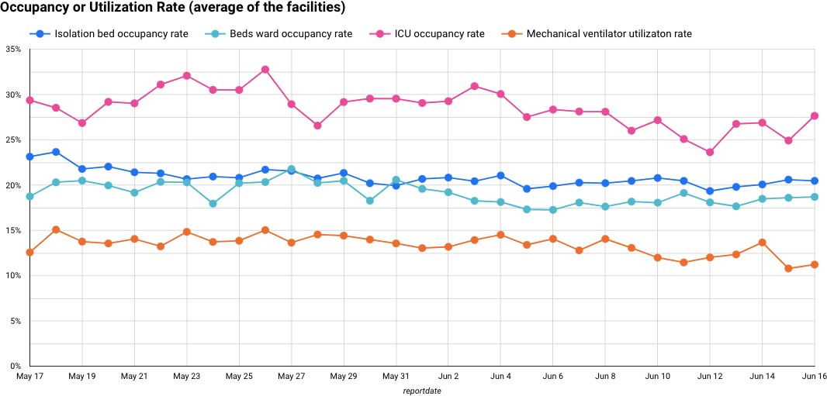

# *Connecting epidemiological variables with demographic data*

(with data from the Philippine Statistics Authority or PSA)

COVID-19 is a respiratory illness and can be transmitted through direct contact with respiratory droplets from an infected person. Physical distancing is one of the suggested strategies to minimize the further spread of the disease. Consequently, in a place with high population density, the risk of COVID-19 infection is high, and more stringent interventions are needed.

On the dashboard, four main demographic variables are considered to investigate COVID-19 risks per location: population size, density, age distribution, and poverty incidence. The geographical patterns of population size, density and age distribution (Figures 2a-2c) inversely follow the trend of poverty incidence (Figure 2d). Urbanized cities are usually denser and have higher COVID-19 outbreak risk than rural areas.

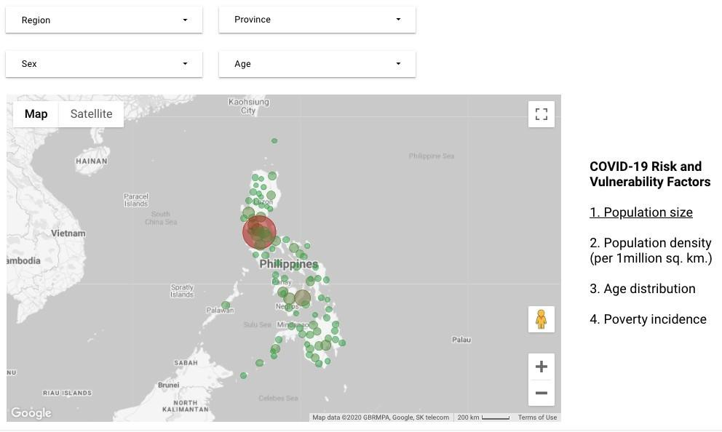

Figure 2a. Population distribution in the Philippines

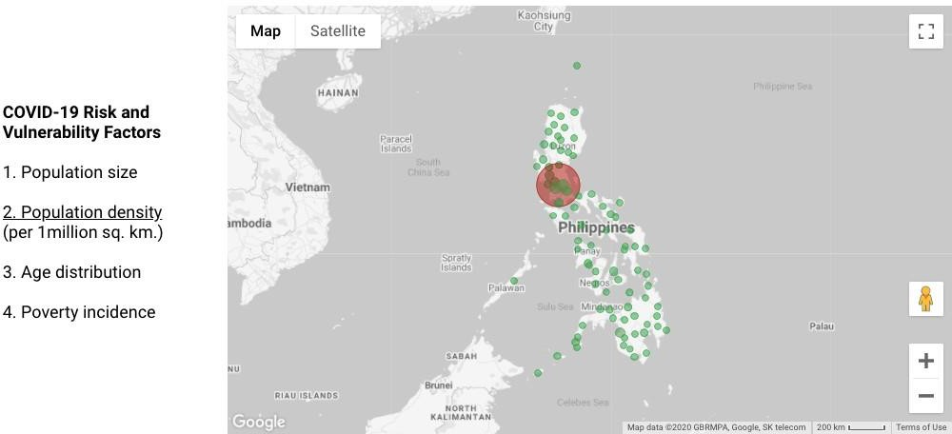

Figure 2b. Average population density in the provinces

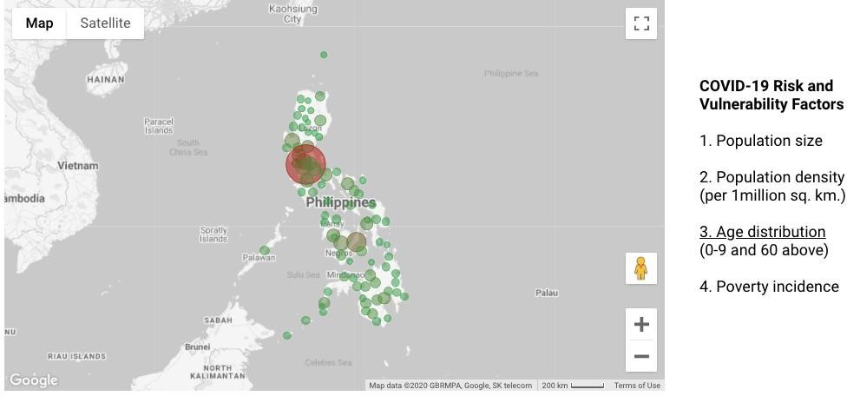

Figure 2c. Population size distribution by age (0-9 and 60 above)

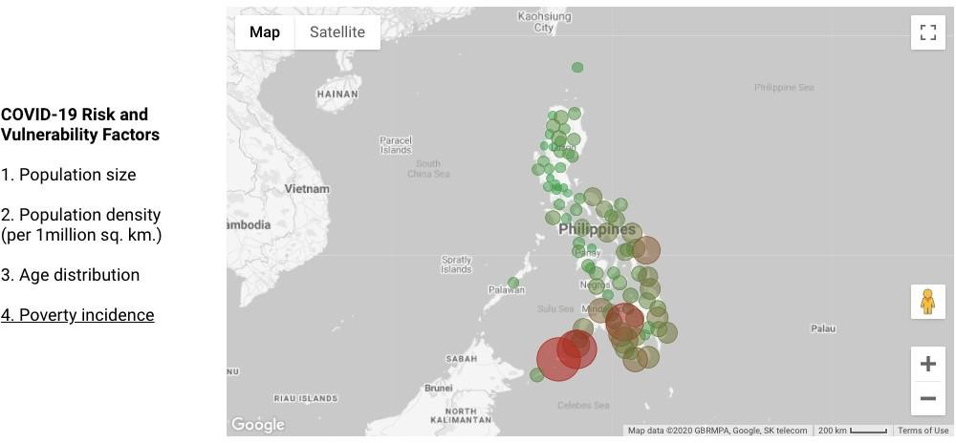

Figure 2d. Poverty incidence per province

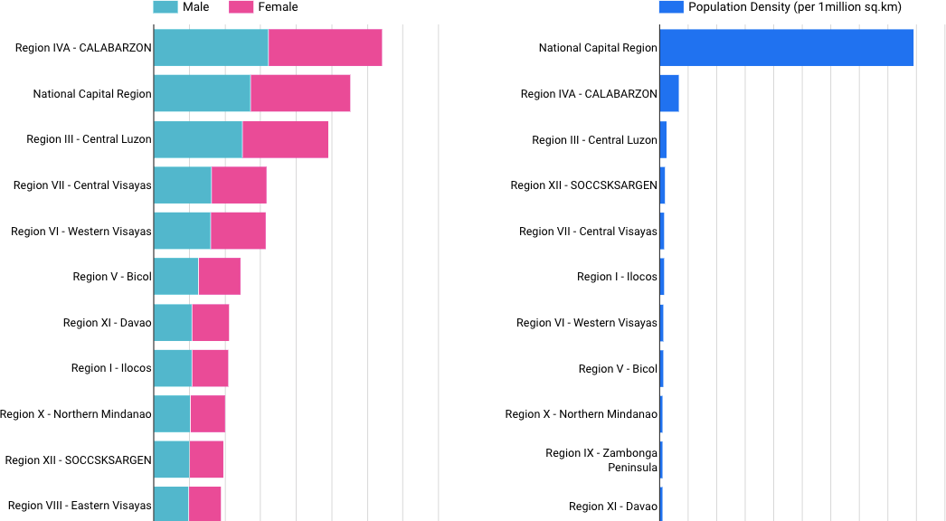

Figure 2e. Top provinces by population size (left chart) and density (right chart)

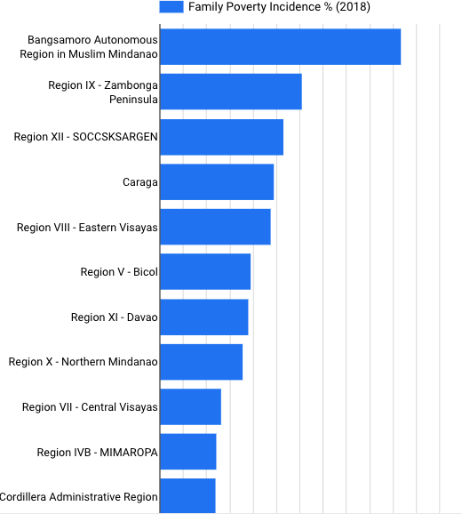

Figure 2f. Top provinces by poverty incidence

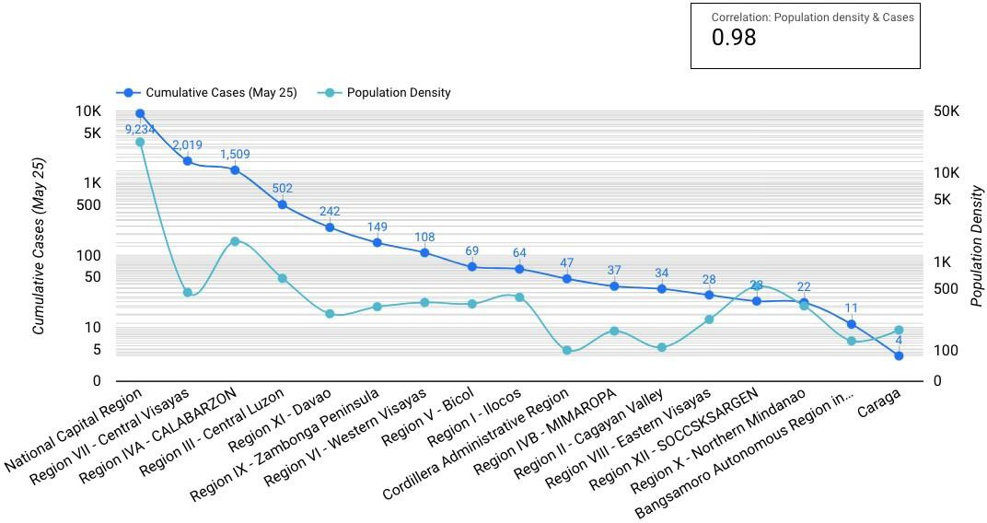

Figure 2g. Correlation of COVID-19 cases and population density

From the PSA data, it can be observed that the percentage of women increases as age bracket increases (Figure 3). Focusing on persons with age 60 and above, we can compare COVID-19 epidemiological data and PSA data (Figures 4 and 5). There are more COVID-19 positive cases as well as expired cases who are males.

Mortality risk due to COVID-19 is increased by the presence of pre-existing illnesses, such as hypertension and diabetes. Such comorbidities are usually higher in men than in women, which may provide an explanation why males are more at risk of succumbing to COVID-19. There are several existing studies that presented evidence of gender-related COVID-19 risk [7,8].

Data show that men have higher mortality rates than women, this could be attributed to lower handwashing rates of men, and higher rate of smoking and underlying comorbidities in men than women, such as respiratory and heart disease. The biological differences between men and women such as hormones and stronger immune system of women, put men far at risk than women [9].

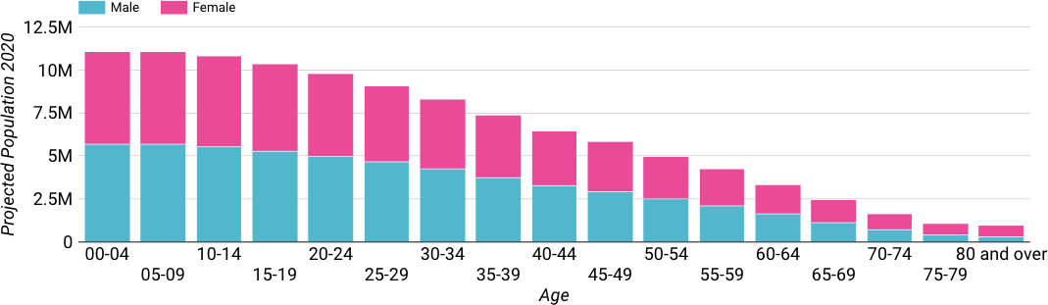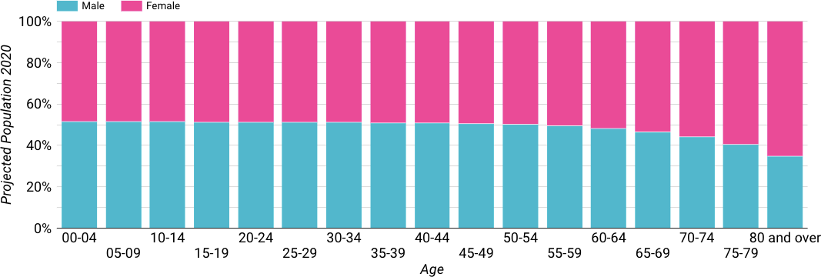

Figure 3. Age distribution of Philippine population (from PSA)

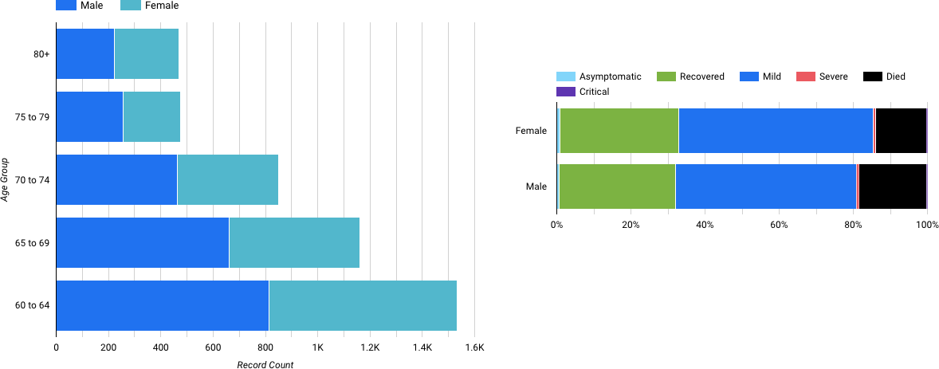

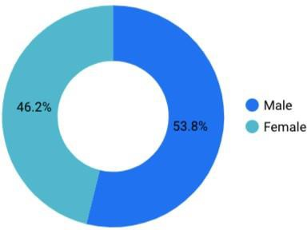

Figure 4. Sex-differentiated COVID-19 epidemiological data from DOH Datadrop (age 60 and above)

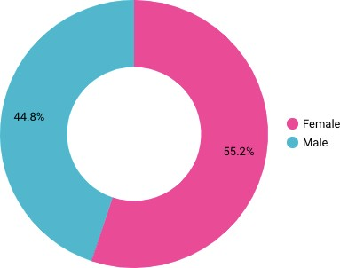

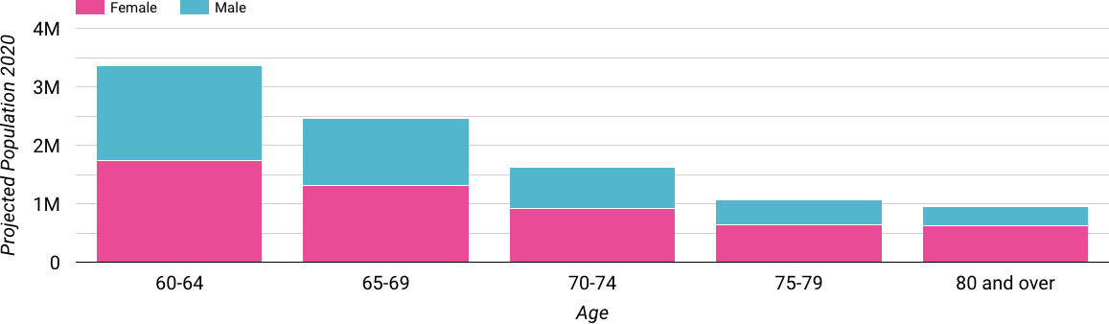

Figure 5. Sex-differentiated demographic data from PSA (age 60 and above)

Figure 6 and 7 show the sex-related differences in the length of expiration or recovery from symptom onset date. On the average, males succumb to COVID-19 12.44 days after having symptoms, while females take shorter duration (10.99 days). The recovery duration from symptom onset are similar for both males and females.

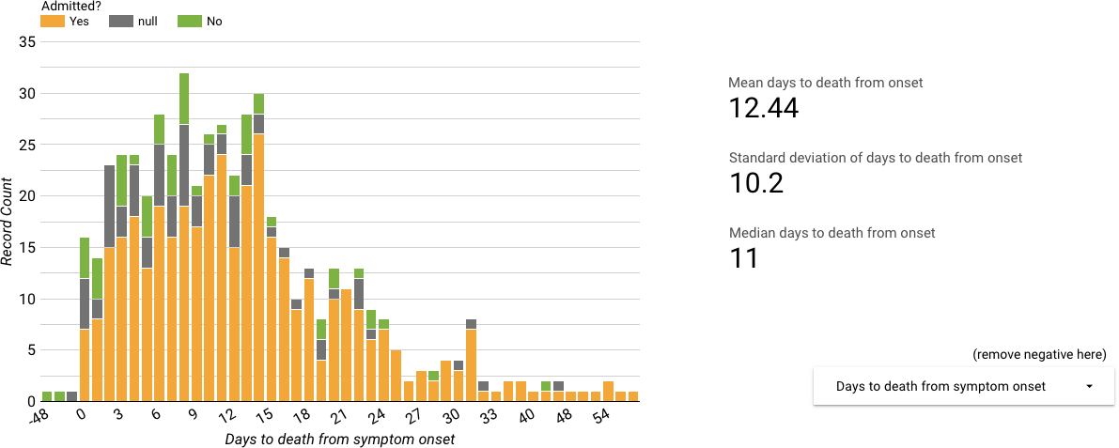

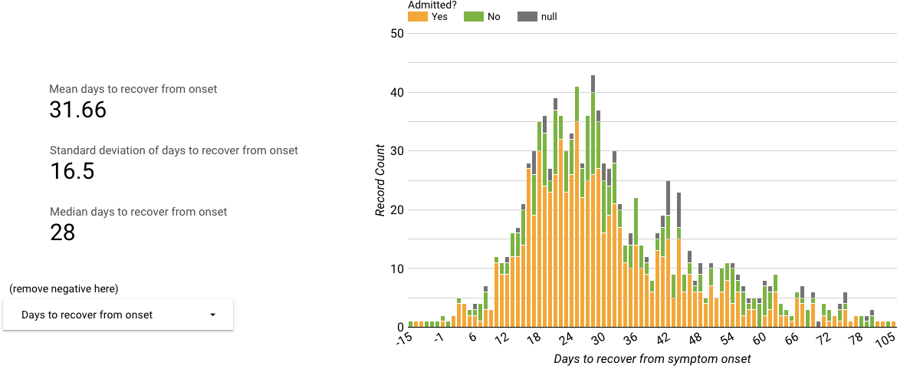

Figure 6. Distribution of the number of days from symptom onset date to death or recovery (Males)

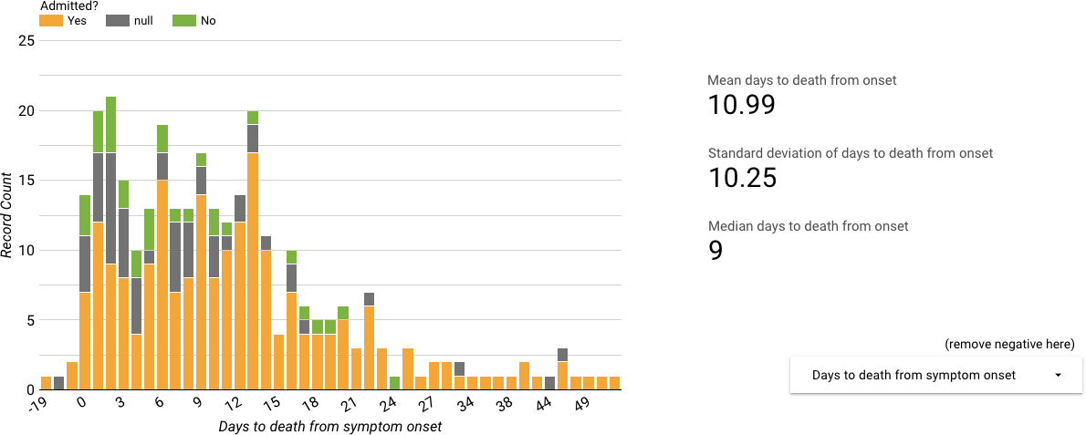

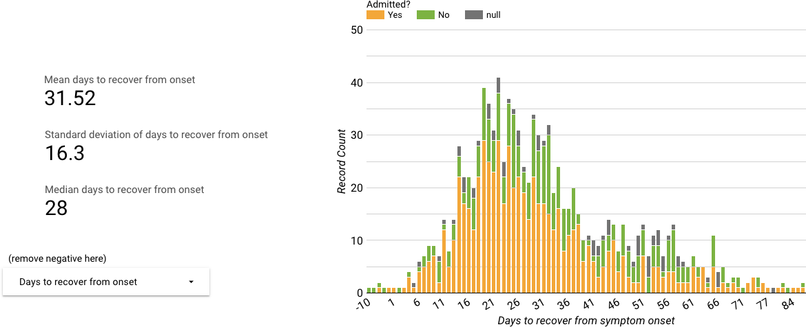

Figure 7. Distribution of the number of days from symptom onset date to death or recovery (Females)

For Figures 6 and 7, negative values could be due to data encoding errors.

There are vital points that are essential to be discussed when it comes to Gender and the COVID- 19 pandemic. Women are at the frontline of health and care response in different agencies, be it health centers, social services, communities and households, often ensuring the wellness and well-being of care and resilience in families. Women in poverty have high vulnerability, because of the increase in the burden of care, and loss of income of those in the informal sectors.

In one of the linked dashboards in the website, we show the risk scores of job sectors based on the number of encounter with other people, and usual crowd density in the workplace. Health care workers indeed face the highest risk of COVID-19 infection, and generally they are the ones who cannot work from home (Figure 8 and 9).

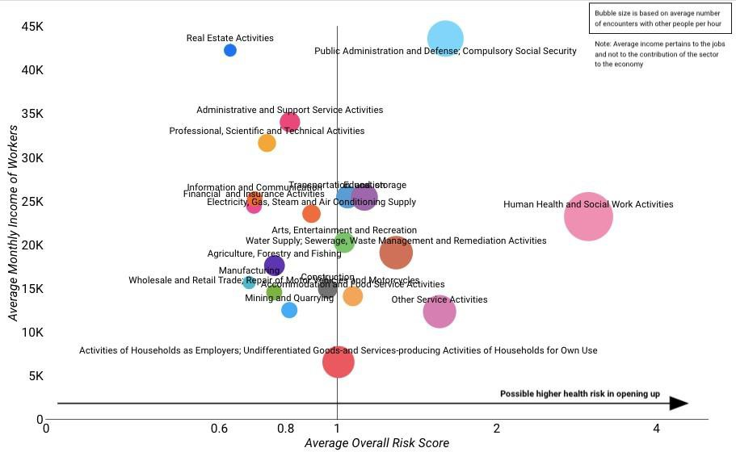

Figure 8. COVID-19 risk assessment of job sectors

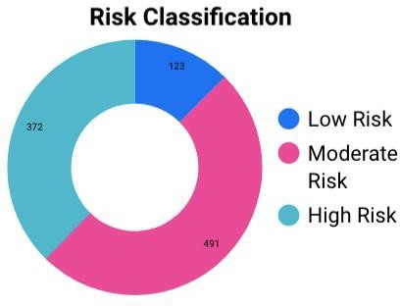

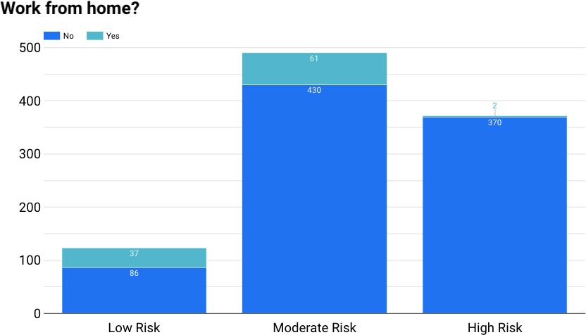

Figure 9. COVID-19 risk classification of jobs

Public health, social and economic points to be considered during this pandemic include the provision of care for the frontline worker and caregivers noting the different needs of both women and men. There is also a need to safeguard and prepare for the possibility of increase in gender- based violence throughout the COVID-19 outbreak, due to the prolonged lockdown which could exacerbate situations. Gender data should be available, for further analysis and action.

Due to the lockdown, stay at home orders, school closures and the increase in the number of unemployed individuals, the pandemic has resulted in the changing of gender roles. Men now do the grocery shopping because only one individual per household can leave the house and do such tasks. Fathers, doing work from home now have the burden of juggling household chores, taking care of the household and doing conference calls.

Furthermore, due to the pandemic, access to health services become difficult, regular health checks and other basic services for reproductive health have become a struggle. The provision of Sexual and Reproductive Health (SRH) services have decreased. Access to information about family planning and education when it comes to SRH are critical to prevent the increase of unintended pregnancies, sexually transmitted infections, and HIV transmission. These are indirect consequences of the pandemic, that are overlooked, and should be studied further.

There are various challenges faced in creating the dashboard. There are reporting issues, and limited sex-disaggregated variables in the DOH Datadrop. In the future, the dashboard will be updated once the variables are available in the DOH Datadrop, such as detailed information on occupation and comorbidities.

References:

1. Q&A on coronaviruses (COVID-19). World Health Organization. https://[www.who.int/news-](http://www.who.int/news-) room/q-a-detail/q-a-coronaviruses
2. Novel Coronavirus (COVID-19) Cases. JHU CSSE. https://github.com/CSSEGISandData/COVID-19
3. University of the Philippines COVID-19 Pandemic Response Team. https://endcov.ph/dashboard
4. Initial COVID-19 Philippine Provincial Estimates and Projections. UPLB Biomathematics. https://sites.google.com/up.edu.ph/initialcovid19phestimates
5. Department of Health COVID19 Tracker and Datadrop. https://[www.doh.gov.ph/covid19tracker](http://www.doh.gov.ph/covid19tracker)
6. Philippine Statistics Authority. https://psa.gov.ph
7. Wenham C., Smith J. & Morgan R. (2020). COVID-19: the gendered impact of the outbreak.

*The Lancet*, 395: 846-848.

1. Jin J, et al. (2020). Gender differences in patients with COVID-19: Focus on severity and mortality. *Frontiers in Public Health*, 8: 152.
2. Mooney, C., Kaplan, S., & Dennis, B. (2020, April 4). All across the United States, the coronavirus is killing more men than women, data show. The Washington

Post. https://[www.washingtonpost.com/health/2020/04/04/coronavirus-men.](http://www.washingtonpost.com/health/2020/04/04/coronavirus-men)