**SURIGAO DEL SUR STATE UNIVERSITY**

# Lianga Campus

Lianga, Surigao del Sur

**COLLEGE OF TEACHERS EDUCATION**

**CHAPTER I INTRODUCTION**

River water pollution becomes now a major global problem in our country; the polluted aquatic ecosystems are increasing at an alarming rate. The intensity of anthropogenic activities leads to large degradation of water bodies. Tambis River, which is geographically located at Barangay Tambis, Barobo, Surigao del Sur, is an area with numerous big and small scale mining activities for gold. This activity is very common to the people living in the area, and this is the only source of their income. More than a decade the color of the river is turbid yellow, and it is a clear proof that the river is contaminated. It is highly vulnerable to change and visually affects the river’s ecosystem caused by the siltation of sediments and chemical wastes like mercury that is discharged directly to the river. Human activities like this becomes a big threat and may cause a negative impact on the small animals living on it.

Macroinvertebrates are aquatic animals with no backbone and can be seen even without the aid of a microscope (Plafkin 1985). On some period of their life, these organisms live on or inside the deposit at the bottom of a water body (Idowu & Ugwumba, 2005; Dacayana *et al.,* 2013) or can be found on rocks, logs, sediments,

debris and aquatic plants (Tampus *et al.,*2012). They are an important link in the aquatic food chain as larger animals such as fish and birds rely on them as a food source (Roxas et al. 2005).

The use of macroinvertebrates as a biological indicator to assess water quality have been known worldwide (Ogbeibu, 2001; Hart & Zabbey, 2005; Arimoro & Osakwe, 2006; Dacayana *et al.,* 2013). Monitoring macroinvertebrates can be useful indicators of water quality because these communities respond to integrated stresses over time, which reflect fluctuating environmental conditions (Dhakal 2006). Therefore, the richness of macroinvertebrate community composition in a waterbody can be used to provide an estimate of waterbody health (Water and Rivers Commission 2001).

.

Investigation of the present status of macroinvertebrates in Tambis River could provide information and could yield insights about the degradation of the river. Threats like small and large scale mining for gold effluents are present in Tambis, Barobo, Surigao del Sur. Pollution and fine sedimentation flowing in the river could alter the fauna living on it. Hence, an assessment of water quality and documentation of the present status macroinvertebrate species in Tambis River is highly needed.

**OBJECTIVES OF THE STUDY**

# General objective:

The main objective of the study is focused on the water quality assessment using macroinvertebrate species in Tambis River, Barobo, Surigao Del Sur. Specifically it aimed to;

1. Identify the macroinvertebrates found in the sampling area;
2. Determine the composition, abundance, and diversity of macroinvertebrates during the wet and dry season;
3. Determine the water quality of the river using biological monitoring working for party; and
4. Compare macroinvertebrate species assemblages between wet and dry season.

**FORMULATION OF NULL HYPOTHESIS**

Ho: There is no significant difference of macroinvertebrates diversity during wet and dry seasons.

**CONCEPTUAL FRAMEWORK OF THE STUDY**

Independent Variable Dependent Variable

**Water Quality in Tambis River**

Biological indices/

matrices

* Biological Monitoring Working Party

**Present Status**

Macroinvertebrate Abundance

* Composition
* Species Macroinvertebrate Diversity
* Richness
* Evenness
* Dominance
* Wet and Dry season

Intervening Variable

**Figure 1.** Schematic Diagram of the study

Figure 1 shows the variables used in the study. The identified dependent variable is the water quality of river that is expressed in biological monitoring working party. The independent variable is the present status expressed in diversity indices that includes, Evenness, Species Richness index (d`), Shannon- Wiener index (H’), and Simpson’s Dominance index (D) and abundance that is expressed in composition and species. The identified intervening variables are the wet and the dry season.

# Scope and Limitations of the Study

This study focused on the macroinvertebrates species as water quality indicator in Tambis River; its relationships to the good water quality, the determination of its composition, diversity, abundance of the species during wet and dry season; and the effectiveness of the Biological monitoring working party as biological indices in determining the quality of the river. Physico-chemical parameters of water were not included in this study.

# The Significance of the study

This study aimed to provide baseline information on the macroinvertebrates species diversity, abundance between the wet and the dry seasons; and effectiveness of the biological matrices/indices about anthropogenic disturbances in Tambis River. This study served as a bridge for further investigation such as assemblage-specific response to the environment.

Furthermore, the result could be used by the locals and the Department of Environment and Natural Resources (DENR) for the formulation of sound and effective policies in the implementation of environmental protection and conservation of rivers.

# Definition of Terms

**Abundance** - This refers to the relative representation of a species in a community.

**Anthropogenic** - This refers to the resulting influence of human to nature.

**Bio indicator**- This refers to the species that are very sensitive to pollution.

**Biological Monitoring Working Party**- This refers to a procedure for measuring the water quality using families of macroinvertebrates as biological indicators

**Composition**- This refers to the contribution of each macroinvertebrate to the sampling sites

**Diversity**- This refers to the differences or variety of macroinvertebrate in the area.

**Macroinvertebrates**- This refers to the animals that are big enough (macro) to be seen with our naked eye.

**Shannon index**- This refers to an index that commonly used to characterized species diversity in a community.

**Simpson dominance Index** - This refers to the measurement of diversity which takes into account the number of species present, as well as the relative abundance of each species.

**Species evenness**- This refers to how equal the distribution of individuals per species.

**Tambis River**- This refers to the river located in Baranggay Tambis, Barobo, Surigao Del Sur.

**Taxa** -This refers to the taxonomic group of macroinvertebrate species.

**SURIGAO DEL SUR STATE UNIVERSITY**

# Lianga Campus

Lianga, Surigao del Sur

**COLLEGE OF TEACHERS EDUCATION**

**CHAPTER II**

**REVIEW OF RELATED LITERATURE**

The review of related literature covers the study of macroinvertebrates species as a water quality indicator. This related literature provides a fundamental background for discussion and consideration in finding the present study.

# Importance and Over exploitation of Freshwater Ecosystems

Biodiversity in freshwater provides a wide range of valuable goods and services to human societies, some of which are irreplaceable (Dudgeon et al. 2006), but human activities have always affected aquatic ecosystems. Globally, the biodiversity of freshwater ecosystems is deteriorating rapidly (Dahl et al. 2004).

The quality of freshwater ecosystems may be negatively affected by anthropogenic disturbances, altering the diversity, structure, distribution, and functioning of aquatic communities (Vásquez et.al. 1999, Doi et al. 2007). Activities such as agriculture, silviculture, mining, and urbanization produce contaminated runoffs and excessive sediments that disturb physical habitat

(Barbour et al., 1996). Combined with highly erodible soils and local rainfall events, these activities create high potential for non - point source pollution in water bodies (U.S. Department of Agriculture, 1997). Such effects can reduce the diversity of invertebrate species, increase the abundance of tolerant species, and change the composition of the community (Shieh and Yang, 2000).

Over - river exploitation and irrigation aquifers are already a serious problem in many places, especially in the Mediterranean region. This activity may result in drought and removal of aquatic inland habitats (Abellán et al., 2006; Belmar et al., 2010) or changes in physical and chemical properties (Velasco et al., 2006). Contamination due to various pollutant types, such as fertilizers, sewage, heavy metals or pesticides, is a big problem worldwide. Increasing urbanization and industrialization generates various non - point contamination sources, causing river water quality impairment (Beasley & Kneale, 2003). Many studies have addressed the negative impact on aquatic biota of pollutants, resulting in biodiversity loss and poor water quality (Beasley & Kneale, 2003, 2004; Benetti & Garrido, 2010; Fernández - Díaz et al., 2008; Garrido et al., 1998; Harper & Peckarsky, 2005; Hirst et al., 2002; Lytle & Peckarsky, 2001; Smolders et al., 2003; Song et al., 2009). Changes in marginal vegetation and flow velocity may result in changes in the composition of aquatic assemblies, with some species being replaced by others due to microhabitat destruction and new ones created (Fulan et al., 2010; Lessard & Hayes, 2003; Sarr, 2011).

Heavy metals in rivers originate from multiple sources such as geological weathering, industrial efﬂuents, domestic efﬂuents, and agricultural fertilizers

(Forstner and Wittmann 1983). One of the contributors to river basin metal pollution is (historical) mining (A. J. P. Smolders 2002). Gold mining on a small scale is an activity that relies heavily on manual labour, using simple tools and methods. Mining of minerals, which often creates imbalances, adversely affects the environment and its impact on wildlife and fishing habitats, water balance, local climates and patterns of rainfall, sedimentation, forest depletion and ecological disruption (Mehta, 2002).

Next, mining residue tailings that are accidentally or deliberately released into river systems are crucial. Mine tailing accidents have often occurred, such as Spain's Aznalcollar accident (1998), which severely contaminated the Guadiamar River (Grimalt et al. 1999), and the El Porco mine accident in Bolivia (1996, 50 km from the town of Potosi) contaminating the Pilaya River and the Pilcomayo River (Edwards 1996; García - Guinea and Huascar 1997; Medina Hoyos 1998). As a result of the El Porco disaster 400,000 tons of tailings were released of which only a part reached the Pilcomayo River (Garcia-Guinea and Huascar 1997).

# Biological indicators

Many methods have been developed to analyze water quality impairments. Analyzes were investigated for the assessment of water quality (Aweng et al. 2011; Zarei & Bilondi 2013). Biological monitoring, on the other hand, provides an indication of past and current conditions (Resh et al. 1996; Suhaila et al. 2014). Additional integration of biological parameters into physicochemical evaluations has been shown to be a more comprehensive method for fully assessing polluting effects in aquatic ecosystems, especially in lotic systems (Oliveira & Cortes

2006). In numerous bioassessment studies, benthic macroinvertebrates have been used to indicate their importance as bioindicators and the endless benefits they offer in assessing the presence and extent of pollutants in the environment (Rosenberg & Resh 1993; Xu et al. 2014).

Although there are several reviews suggesting that different bioindicators should be used for assessing water quality, the use of aquatic macroinvertebrates is still the best (Duran 2006 and Fajardo et al 2015) and it is well documented because of the amount of samples that the researcher could obtain, they were manageable and relatively easy to collect. The use of biological indicators is more appropriate for detecting long - term changes in water quality as aquatic organisms are adapted to specific conditions of the environment. Some organisms may disappear (intolerant) and be replaced by others (tolerant) if these conditions change. Thus, variations in the composition and structure of aquatic organism assemblies may indicate possible pollution in running waters (Alba - Tercedor, 1996). The use of biological variables to monitor the environment is biomonitoring (Gerhardt, 2000). In this type of monitoring, the first step is to find the ideal bioindicator whose presence, abundance and behavior reflects a stressor's effect on biota (Bonada et al., 2006b). Benthic macroinvertebrates are considered to be good indicators of local scale (Metcalfe, 1989; Freund & Petty, 2007).

Because of their great diversity of form and habits, aquatic macroinvertebrates are used for bioassessing the quality of aquatic ecosystems (Rosenberg & Resh, 1993). A biological indicator must meet different

characteristics, according to Johnson et al. (1993): To be taxonomically easy and well – known, to be widespread, to be abundant and easy, to capture to present low genetic and ecological variability to be preferably large, to have low mobility and a long life cycle, to present well - known ecological characteristics and to be used in laboratory studies.

# Macroinvertebrates as water quality indicators

Macroinvertebrates were used as indicators of environmental conditions, particularly in assessing the impact of specific pollutants in the aquatic environment due to their limited mobility, long life, sensitivity to changes in their environment and tolerance of some to contamination (Barbosa et al., 2001; Superales & Zafaralla, 2008 Flores & Zafaralla, 2012; Campus et al., 2012; Sharma et al., 2013). Their community characteristics such as diversity, richness, and abundance, are often used as indicators of the degree of pollution of bodies of water, to supplement and deepen the meaning of physicochemical information (Arimoro et al., 2007; Edward & Ugwumba, 2011; Superales & Zafarall2008, Flores & Zafaralla, 2012). Several studies have considered the use of abundance and species richness among macroinvertebrates to detect environmental responses because of their variable sensitivity towards multiple disturbances (Davis 2003; Ferreira et al. 2011; Friberg et al. 2011).

Benthic macroinvertebrates have a high potential bioindicator due to their high sensitivity to water quality changes, rapid response to disturbances, and easy sampling and taxonomic identification (Courtney & Clements 2000, Doi et al.

2007). These animals can be used effectively as environmental quality bioindicators in mining residual contaminated sites.

Macroinvertebrate monitoring has been recognized as a front line indicator of stream health (<http://www.ecn.ac.uk/>freshwater/state_taxa.htm). According to

Roxas et al. 2005, generally in a clean stream, a wider variety of macroinvertebrates is observed while only a few types of tolerant ones (e.g., worms, leeches, and sludge worms) are present in an unhealthy stream. Studies have been done using the macroinvertebrates as water quality indicators. Because these kinds of animals need different amounts of oxygen, their presence or absence can indicate the levels of pollution. Their presence or absence was found to indicate whether a stream condition is excellent, good, fair or poor (Sangpradub et al. 1997 and Roxas et al. 2015).

Triest et al. (2001) reported that monitoring the biological and ecological status of running waters can be carried out using diverse groups of organisms. Consequently, macroinvertebrates are used to evaluate community condition and diagnose causes of degradation in a river or stream. Recently, biological methods have been replacing or complementing physical and chemical measurements in assessing river conditions (Barbosa *et al*. 2001). Arimoro *et al*. (2009) related that the study of the composition and structure of aquatic insects is vital to monitoring the changes in water quality and the ecological integrity of streams and rivers. Beuager (2008) supports this by reporting that the strong sensitivity of the macroinvertebrate fauna makes them ideal indicators of ecosystem health.

Because macroinvertebrates have varying sensitivity to water quality changes (Water Facts 2001), the US – EPA argues that high diversity of environmentally sensitive macroinvertebrates indicates a well - functioning ecosystem process (Peterson et al. 2006).

Advantages of using benthic macroinvertebrates in water quality assessment according to Barbour et al. (1999) include: Assemblies of macroinvertebrate are good indicators of localized conditions. Because many benthic macroinvertebrates have limited migration patterns or a sessile lifestyle, they are particularly suitable for site - specific impact assessments (upstream - downstream studies). Macroinvertebrate assemblies are good indicators of located conditions. Because many benthic macroinvertebrates have limited patterns of migration or a sessile lifestyle, they are especially suitable for site - specific impact assessments (upstream - downstream studies).The effects of short-term environmental variations are also integrated because most species have a complex life cycle of about one year or more. Sensitive stages in life will respond to stress quickly; the overall community will respond more slowly. Less expertise is required to identify macroinvertebrates to family level; many "intolerant" taxa can be easily identified to lower taxonomic levels. Most streams contain abundant benthic macroinvertebrates. Sampling is also relatively easy, requires few people and cheap gear, and has minimal harmful effects on the resident biota. Benthic macroinvertebrate assemblies are made up of species that

constitute a wide range of trophic levels and tolerances of pollution, thus providing strong information for cumulative effects interpretation.

# Biological metrics/indices

To evaluate the water quality of rivers and streams, different sampling protocols and metrics are used. Biotic indices are among them the most widely used because they are highly robust, sensitive, cost-effective, easy to use and easy to interpret (Bonada et al. 2006a; Chessman et al. 1997; Dallas, 1995, 1997). Biotic indices are tools for quality assessment based on the different response of organisms to changes in the environment (Ministry of Environment, 2005). One of the most frequently used biotic indices in the Iberian Peninsula is the former BMWP' (Alba- Tercedor & Sánchez-Ortega, 1988) IBMWP (Iberian Biological Monitoring Working Party), an adaptation of the British BMWP (Armitage et al., 1983) for the Iberian Peninsula. The BWMP is easy to apply and has significantly reduced costs compared to physicochemical analyzes, which may require processing of samples outside laboratories. Using the BMWP as a rapid, effort-intensive bioassessment can produce scientifically valid and repeatable environmental monitoring results. The taxonomic resolution of this index is mostly at the family level, and in some cases is even considered at a higher level.

# Macroinvertebrates in the Wet and Dry Seasons

Rainfall can increase the flow of water in lotic environments in mountainous regions (Oliveira & Froehlich 1997). Headwater streams react quickly at the advent of the rains and can change in an hour or two from quiet, trickling streams

to torrents (Payne 1986). Invertebrate fauna in streams tend to be low during high water periods (Dudgeon 2008). During the rainy season, Oliveira and Froehlich (1997) and Bispo et al. (2004) observed a decline in Trichoptera density due to sudden increases in flow rates that may lead to stone rolling and consequent insect removal (Flecker & Feifarek 1994).

During the wet season, Trichoptera had a decline in abundance in all rivers. Trichopteran fauna was probably influenced by the rainfall because their beds (bedrocks) were more disturbed by the river with increased drift and fauna dispersion (Bispo et al. 2004). Moreover, higher water levels in the wet season made the riverbed less conducive to. Trichoptera, thereby reducing its abundance (Dudgeon 1997). In the wet season, the higher frequencies of disturbances due to flow rate increases have reduced the number of Trichoptera (Flecker & Feifarek 1994; Jacobsen & Encalada 1998). In the wet season, the higher frequencies of disturbances due to flow rate increases have reduced the number of Trichoptera (Flecker & Feifarek 1994; Jacobsen & Encalada 1998). In the wet season, the higher frequencies of disturbances due to flow rate increases have reduced the number of Trichoptera (Flecker & Feifarek 1994 ; Jacobsen & Encalada 1998).The seasonal effects on the composition of the macroinvertebrate community are therefore important, should not be neglected and for biomonitoring purposes should be taken into account. (The 2010 Gabriels W et al. and the 2004 Irvine K.).

High discharge events can lead to severe population losses during the wet season, as well as changes in macroinvertebrate community composition and structure (Mariana L. 2012 and Leung AL et al. 2012).Thus, the fluctuations in densities of macroinvertebrates are associated with the unpredictable floods and different life histories of most macroinvertebrates in tropical areas (Mathooko J, and Mavuti 1992). The disturbances are more intense and frequent during the wet season; disturbed habitats take longer to recover (Bispo et al. 2006). Significant declines in the abundance of benthic macroinvertebrates have therefore been observed following bed - moving flooding (Brewin et al. 2000, Moya et al. 2003, Bogan and Lytle 2007, Mesa et al. 2009, Mesa 2010).

According to Cowell et al. 2004, flow fluctuation and extreme conditions such as floods are primary sources of variability and disturbance. High discharge events can result in severe loss of population and changes in the composition and structure of the community (Hart and Finelli 1999; Lytle et al. 2008). Higher densities of macroinvertebrates were recorded in the dry season in a municipal stream in Nigeria, Arimoro and Ikomi, 2008, and these authors suggested that the dry season usually favors various macroinvertebrate taxa because of less washing - off effects.

# Macroinvertebrate in different Taxa groupings

The collected macroinvertebrates were grouped into 3 taxa based on their sensitivity or tolerance to pollution or aquatic disturbance: Taxa 1, Taxa 2 and Taxa 3 (Barbour et al., 1999).Taxa 2 species may exist under a wide range of

water quality or moderate water quality conditions and may include species belonging to Hemiptera, Diptera, Odonata, Decapoda and Veneroida orders. Taxa 3 are highly tolerant of poor quality of water. Thus, the presence of tolerant and intolerant (i.e., sensitive) taxa informs about the quality of the water.

**SURIGAO DEL SUR STATE UNIVERSITY**

18

# Lianga Campus

Lianga, Surigao del Sur

**COLLEGE OF TEACHERS EDUCATION**

**CHAPTER III RESEARCH METHODOLOGY**

This chapter explains the research locale, sampling sites, research design, data processing procedures, identification and statical treatment.

# Research Locale

Tambis River is a stream located in the barangay Tambis, Barobo, Surigao del Sur, Caraga, Philippines. The estimate terrain elevation above sea level is 10 meters. It coordinates lie between **9°22'0.01"** Latitude and a Longitude: **125°58'0"**. It is the main river system in Barobo municipality running through Barangay Tambis, Bahi, Mamis, Javier, and San Jose. It passes the municipality of Tagbina and the municipality of Hinatuan from where it flows into the Philippines Sea (http:/ article.wn.com/view/2011/04/02/Youth turns to the web to saveriver/).

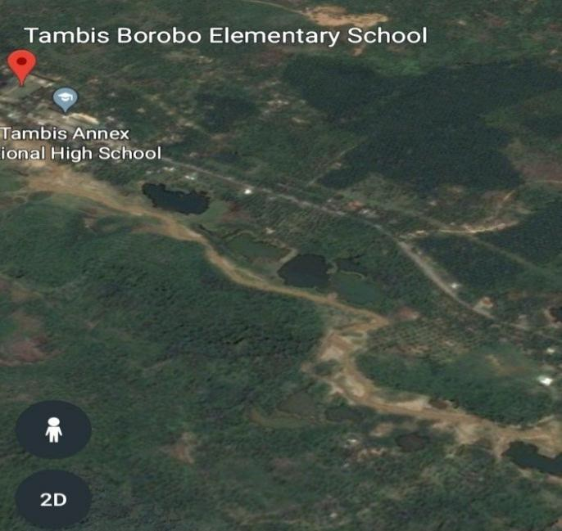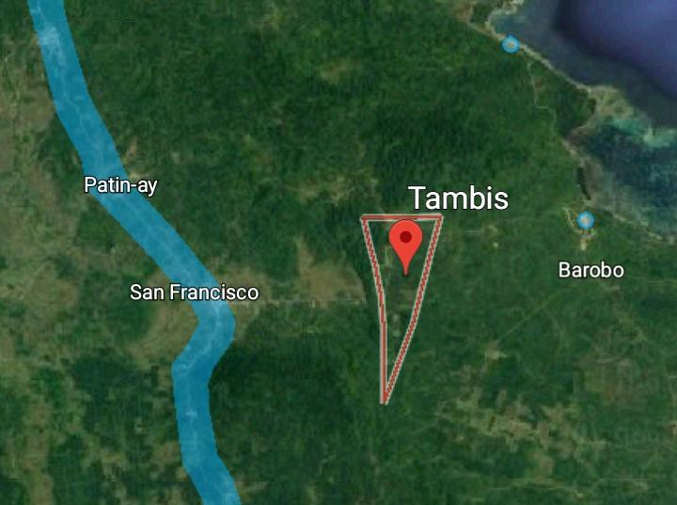

Station 2

Station 1

**Figure 2.** Map showing Tambis River and sampling stations used in the study (Googlemaps.com, 2017).

# Sampling Sites

The river consists of transect lines with a length of 100 m. In the accessible area, a 100-meter transect line parallel to the stream flow or perpendicular to the water body was established. Five sampling points were established by marking ten meters with an interval of ten meters in a transect line of 100 meters (Cuadra

do et

al. 2017).

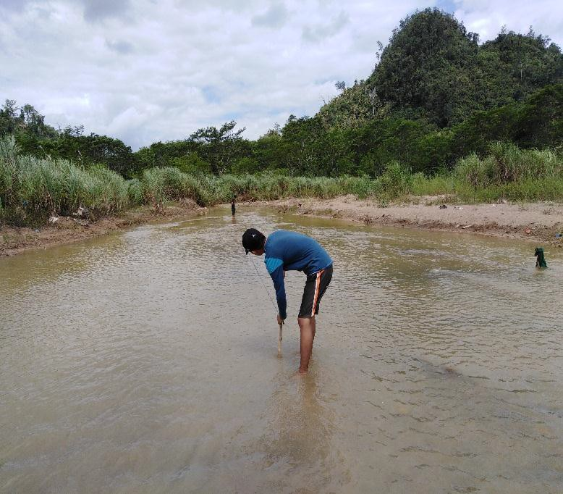

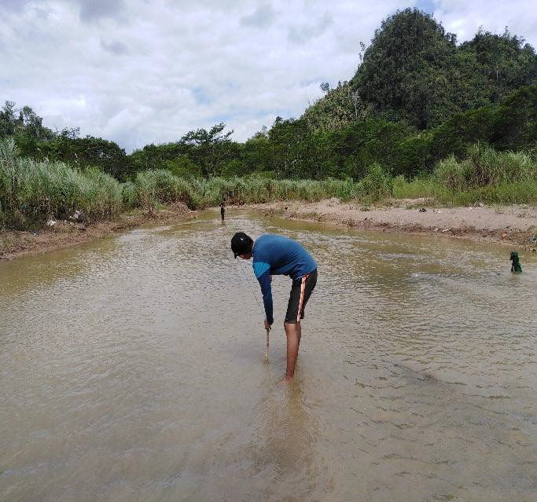

**Figure 3.** Establishing of Transect Lines

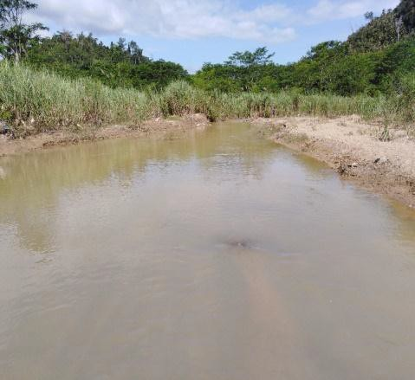The sampling sites are located in Sitio Banangilid (8'32.562' N126'2.458 E).It

has a flat slope with a disturbed type of vegetation. Station 1 (Fig. 4) is a forested mountain on its side. Banana

(Musa sp.) and coconut (Cocos nucifera) were abundant in residential areas on

the sides of the river. Rocks are

**Figure 4.** Station 1 prevalent, with mud flowing through it.

Two roads are built across it, one is a dirt for heavy machinery, the other a bridge for for lighter ones. With many houses on its left side. Residential activities dominated the area, such as washing and bathing. Waste from homes is deposited directly to the river.

Station 2 (Fig.5) located in Purok 2, Tambis,

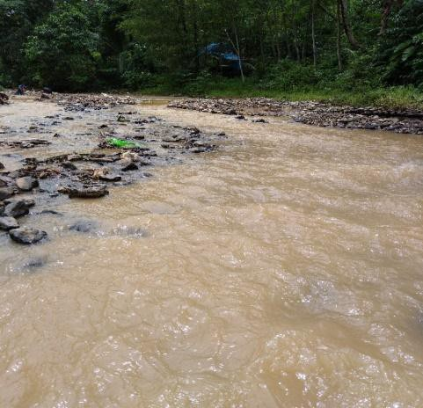

Barobo, Surigao

6'2.738 E). It has flat slopes and disturbed vegetation. The site is an open field with a wide range of grasses. The type of soil is muddy

with some protruding rocks. Households are about 50 meters from the river. It has two big holes on both sides created by Chinese

miners. Falcata (*Paraserianthes falcataria*) is

**Figure 5.** Station 2 abundant on both sides.

# Research Design

This study utilized a descriptive-comparative method to compare the abundance and the diversity of the species during the two seasons.

# Macroinvertebrates collection

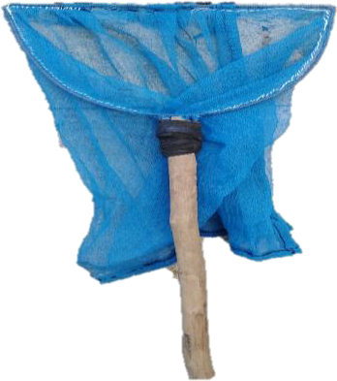The collection of macroinvertebrates (Fig. 7) during wet season was conducted in the month of December and the dry season in April. The kick - net method was used. D-frame net measuring 0.3 m wide with 500 μm opening mesh size was used to collect organisms (Fig.6).The Collection was made in a standard three-minute kick/sweep method (Armitage et al. 1990) by disturbing the riverbed in a kicking motion towards the direction of the D-framed net. The collected organisms were placed in a container with appropriate label. However, if samples have mixtures of sediments, they were sieved in a sieve of 0.5mm-mesh size to separate the organisms from soil sediments with the help of a forceps this procedure was suggested also by (Flores et al. 2012). The macroinvertebrates were carefully separated from the substrate (if present). Macroinvertebrates that were easily seen in all habitats were captured using forceps and carefully transferred to the bucket. Each macroinvertebrate was gently handled to avoid breaking appendages. Collected specimens were sort in the laboratory and were preserved with 70% ethyl alcohol(Fig. 8 & 9).

# Figure 6. kick-net Frame

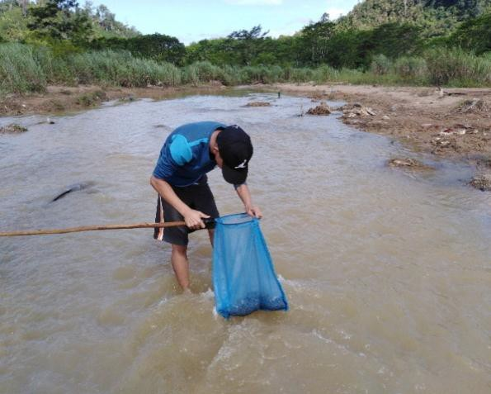

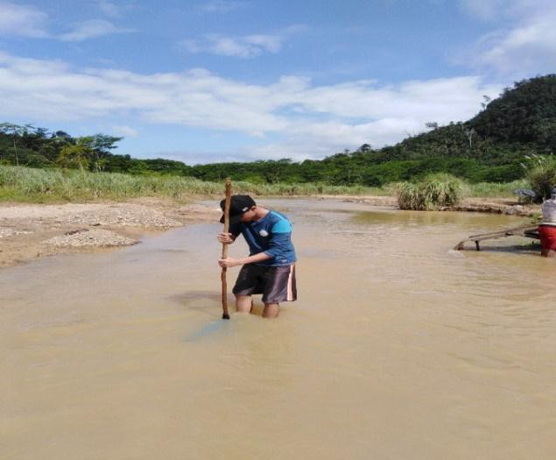

Flow direction

**Figure 7.** Macroinvertebrates collection

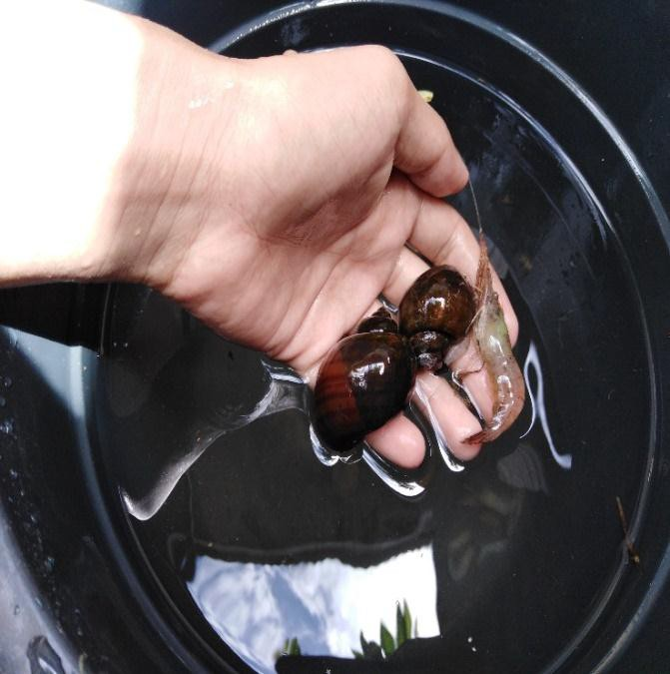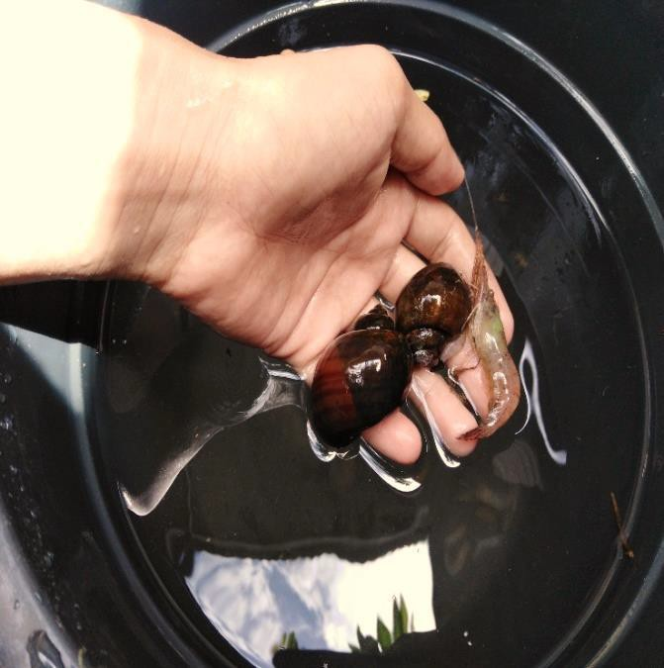

**Figure 8.** Washing of species

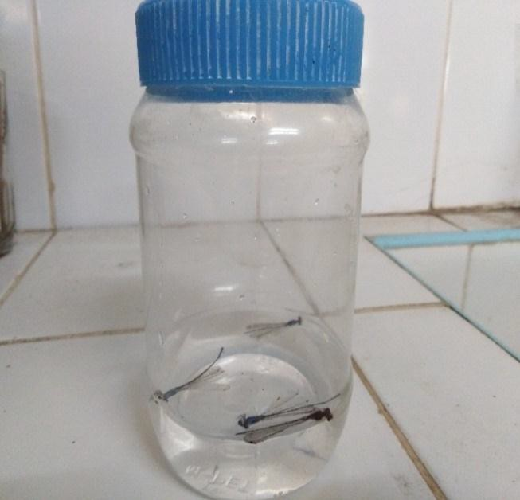 

**Figure 9.** Transferring of species in the plastic bottle with 70% ethyl alcohol

# Macroinvertebrates Identification

The identification guide from Waterwatch Queensland Dawyer (1999) and the taxonomic keys from the different journals were used.

# Statistical Treatment

* 1. To answer objective number one, the identification guide from Waterwatch Queensland and the taxonomic keys from the different journals were used by Christina Dawyer (1999).
  2. To respond to objective number two, the composition and diversity of macroinvertebrate species, PAST software was used. The number of abundances was computed using the formula below adapted from (Ancog 2012).

no. of individuals per genus/species

Relative abundance= X 100%

total no. of individuals

* 1. To answer objective number three, BMWP was calculated by summing the individual scores of all indicator species present. The overall BMWP score evaluation is the sum of all taxon scores (class, order, or family) described in Table 1.

**Table 1**. Biological Monitoring Working Party classes, scores, categories, and result interpretation (Armitage et al.1983 and Alba-Tercedor, 1996).

|  |  |  |  |
| --- | --- | --- | --- |
| Class | BWMP score | Category | Interpretation |
| I | >150  101–150 | Good | Very clean water  Clean or not significantly altered |
| II | 61–100 | Acceptable | Clean but slightly impacted |
| III | 36–60 | Questionable | Moderately impacted |
| IV | 15–35 | Critical | Polluted or impacted |
| V | <15 | Very critical | Heavily polluted |

* 1. To answer objective number four, the comparison of macroinvertebrate species assemblages between wet and dry season was based on the number of species present and absent during the two seasons.

**SURIGAO DEL SUR STATE UNIVERSITY**

# Lianga Campus

Lianga, Surigao del Sur

**COLLEGE OF TEACHERS EDUCATION**

**CHAPTER IV RESULTS AND DISCUSSION**

This chapter contains the results and discussion of the study which answer the queries posted in Chapter 1. The analyzing and interpretation of the data gathered is briefly discussed in this chapter.

# Species composition and abundance on Tambis River

A total of 136 individuals belonging to six (6) orders, representing 12 families, 15 species were collected and identified in Tambis River. Most of the species belong to phylum arthropods with 13 species followed by the mollusks with (two) 2 species only as shown in Table 2.

**Figure 10.** Macroinvertebrate Species found in Tambis River.

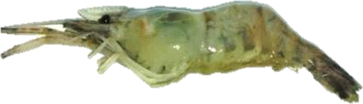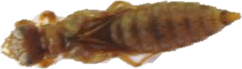

*Palaemonid sp.*

*Erythrodiplax berenice*

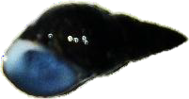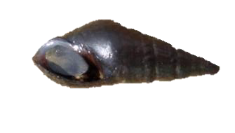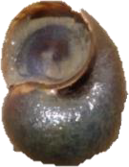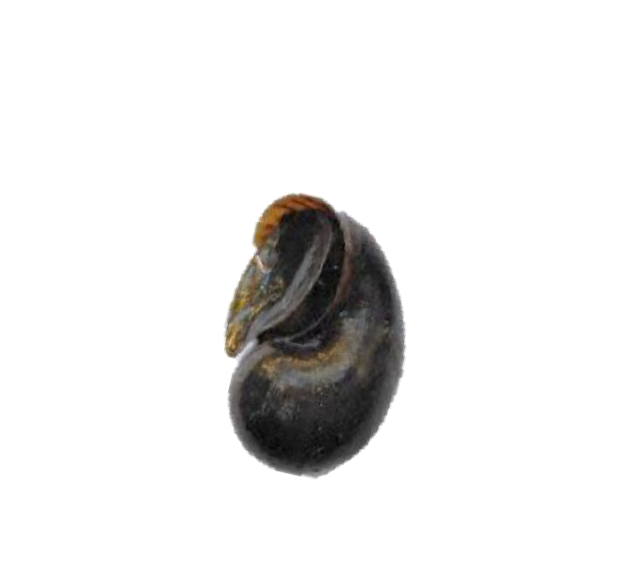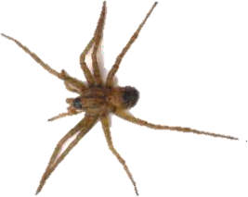

*Argyroneta aquatica*

*Guildfordia aculeata*

*Viviparus conectus*

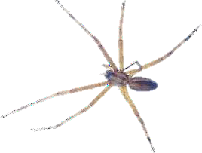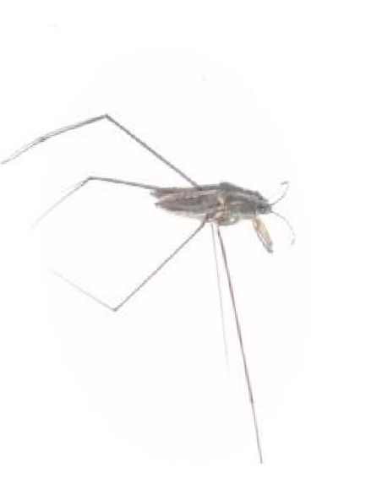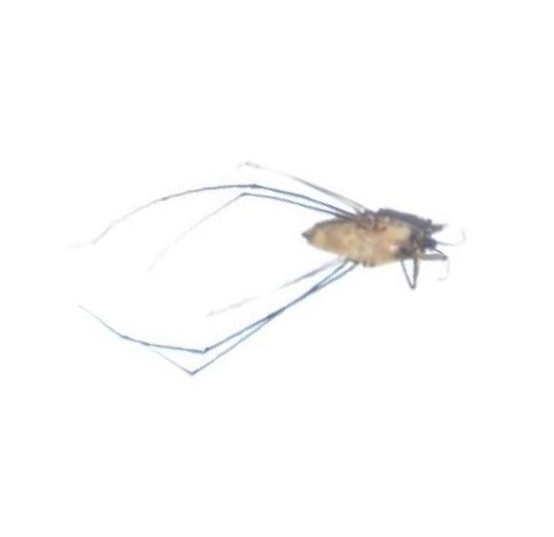

*Enallagma sp.*

*Dolomedes fimbriatus*

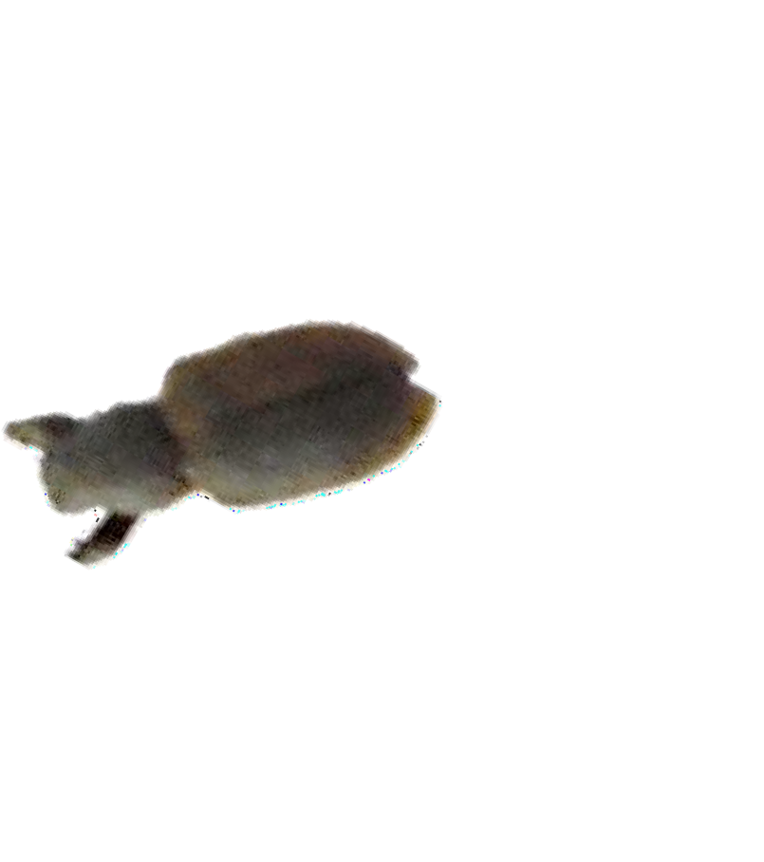

*Hydrophilidae*

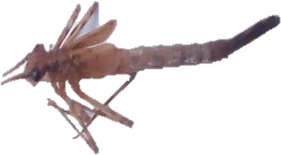

*Ischnura sp.*

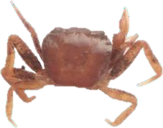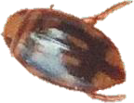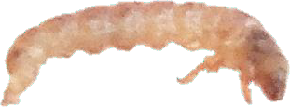

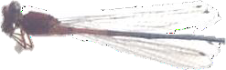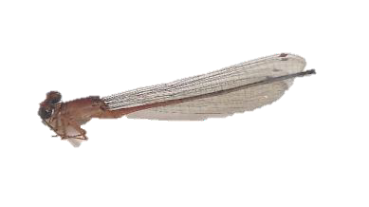

*Argyroneta aquatica*

*Enallagma sp.*

*Dryopidae*

*Gerris marginatus*

**Table 2.** Number of Species found in Tambis River

|  |  |  |  |  |  |
| --- | --- | --- | --- | --- | --- |
| Species |  | | | | Total |
| Wet | | Dry | |
| Station 1 | Station 2 | Station 1 | Station 2 |
| Group 1 |  |  |  |  |  |
| Hydrophilidae | 5 | 2 | 0 | 0 | 7 |
| Dryopidae | 0 | 0 | 0 | 1 | 1 |
| Dycitus marginales | 0 | 0 | 0 | 5 | 5 |
| Notopala sublineata | 0 | 0 | 1 | 6 | 7 |
| Guilfordia aculeata | 0 | 0 | 0 | 15 | 15 |
| Group 2 |  |  |  |  |  |
| Brachyurid sp. | 0 | 0 | 0 | 1 | 1 |
| Gerris marginatus | 6 | 8 | 4 | 6 | 24 |
| Palaemonid sp. | 9 | 6 | 6 | 11 | 32 |
| Enallagma sp. | 0 | 0 | 0 | 1 | 1 |
| Ischnura sp. | 0 | 0 | 0 | 5 | 5 |
| Gomphidae | 3 | 5 | 2 | 3 | 13 |
| Erythrodiplax berenice | 3 | 5 | 2 | 4 | 14 |
| Argyroneta aquatica | 1 | 0 | 0 | 0 | 1 |
| Dolomedes fimbriatus | 0 | 4 | 0 | 6 | 10 |
|  | **27** | **30** | **15** | **64** | **136** |

**Table 3.** Inventory of mocroinvertebrates found in the Tambis River

|  |  |  |  |  |  |
| --- | --- | --- | --- | --- | --- |
| Phylum | Order | Family | Scientific Name | Common Name | Taxa |
| Arthropoda | Coleoptera | Hydrophilidae | *Hydrophilidae* | Adult water beetle | 1 |
|  |  | Dryopidae | *Dryopidae* | Riffle beetle larvae | 1 |
|  |  | Dytiscidae | *Dycitus marginales* | Diving Beetle | 1 |
|  | Decapoda | Parathelpusidae | *Brachyurid sp.* | Small freshwater crab | 2 |
|  |  | Palaemonidae | *Palaemonid sp.* | Freshwater shrimp | 2 |
|  | Hemiptera | Gerridae | *Gerris marginatus* | water strider | 2 |
|  |  |  | *Gerris marginatus* | water strider (small) | 2 |
|  | Odonata | Coenagrionidae | *Enallagma sp.* | Damsefly | 2 |
|  |  | Coenagrionidae | *Ischnura sp.* | Damsefly nymph | 2 |
|  |  | Gomphidae | *Gomphidae* | Dragonfly | 2 |
|  |  |  | *Erythrodiplax berenice* | Dragonfly nymph | 2 |
|  | Arachnida | Cybidea | *Argyroneta aquatica* | Water spider | 2 |
|  |  |  | *Dolomedes fimbriatus* | Water spider | 2 |
| Mollusca | Gastropoda | Viviparidae | *Viviparus conectus* | River snail | 1 |
|  | Gastropoda |  | *Guildfordia aculeata* | Gilled snail | 1 |

This reveals the classification of macroinvertebrates species according to their taxa or group. Some authors have categorized most of the stream animals in order of pollution tolerance, from those that can live in the cleanest water to those that can put up with dirty water (Miller, 1983). Taxa 1, pollution sensitive organisms found in good water quality. Taxa 2 can exist in a wide range of water quality conditions; moderate water quality. Taxa 3, can be found in a wide range quality of water quality conditions or highly tolerant to poor water quality. Thus, the presence of tolerant and intolerant (i.e., sensitive) taxa informs about the quality of the water (Barbour *et al.* 1999).

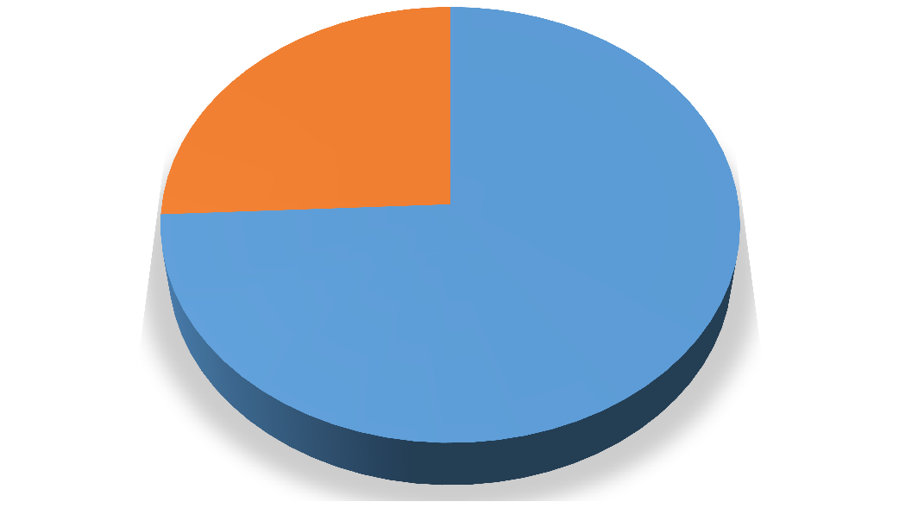

**26%**

**74%**

* **TAXA 2**
* **TAXA 1**

**Figure 11.** Macroinvertebrates in their Taxa grouping

Taxa 1

Taxa 2

This illustrates that of all three taxa or group, taxa 2 comprise (74 %) got the highest number of species. Meanwhile, taxa 1 consisting (26%) were present during the study. On the other hand, taxa three (3) was not found the river. This is because Taxa 2 species can exist in a wide range of water quality conditions, or moderate water quality.

**Table 4.** Abundance of macroinvertebrates in Tambis River.

|  |  |  |  |  |  |  |  |
| --- | --- | --- | --- | --- | --- | --- | --- |
| Family | Species | Abundance (# of individual) | | | | Total | %Relative Abundance |
| Wet | | Dry | |
| Station 1 | Station 2 | Station 1 | Station 2 |
| Group 1 |  |  |  |  |  |  |  |
| Hydrophilidae | Hydrophilidae | 5 | 2 | 0 | 0 | 7 | 5.14 |
| Dryopidae | Dryopidae | 0 | 0 | 0 | 1 | 1 | 0.73 |
| Dytiscidae | Dycitus marginales | 0 | 0 | 0 | 5 | 5 | 3.67 |
| Viviparidae | Notopala sublineata | 0 | 0 | 1 | 6 | 7 | 5.14 |
|  | Guilfordia aculeata | 0 | 0 | 0 | 15 | 15 | 11.02 |
| Group 2 |  |  |  |  |  |  |  |
| Parathelpusidae | Brachyurid sp. | 0 | 0 | 0 | 1 | 1 | 0.73 |
| Gerridae | Gerris marginatus | 6 | 8 | 4 | 6 | 24 | 17.64 |
| Palaemonidae | Palaemonid sp. | 9 | 6 | 6 | 11 | 32 | 23.52 |
| Coenagrionidae | Enallagma sp. | 0 | 0 | 0 | 1 | 1 | 0.73 |
|  | Ischnura sp. | 0 | 0 | 0 | 5 | 5 | 3.67 |
| Gomphidae | Gomphidae | 3 | 5 | 2 | 3 | 13 | 9.55 |
|  | Erythrodiplax berenice | 3 | 5 | 2 | 4 | 14 | 10.29 |
| Cybidea | Argyroneta aquatica | 1 | 0 | 0 | 0 | 1 | 0.73 |
|  | Dolomedes fimbriatus | 0 | 4 | 0 | 6 | 10 | 7.35 |
|  |  | 27 | 30 | 15 | 64 | 136 |  |

This table reveals the highest relative abundance among the species collected and accounted to *Palaemonid sp.* (freshwater shrimp) 23.52 %, followed by *Gerris marginatus* (water strider), then 17.64% *Guilford aculeate* (right handed snail) 11.02% and *Erythrodiplax Berenice* (dragonfly nymph) 10.29%. However, *Gerris marginatus, Palaemonid sp, Macromiidae sp*. were observed in both wet and dry seasons

According to Archna, et al. 2015, *Palaemonid sp.* or freshwater shrimps moderately intolerant of pollution. These species can be observed in a variety of standing and flowing waters, hiding in plants of shallow waters under the debris and

9organic detritus. In a tropical ecosystem, they are an important faunal component (Crowl et al. 2001). They often dominate the biomass in tropical streams and rivers (Covich and McDowell 1996; Mantel and Dudgeon, 2004b; Great house, 2006). Shredders of leaf litter in the stream ecosystem and they are considered as the key component of the food web as scavengers (March et al. 2001; Crowl et al. 2006).

Meanwhile, *Dryopidae* or Riffle beetle larvae, *Brachyurid species* or small freshwater crab, *Enallagma species* or Damselfly and *Argyroneta aquatic* or water spider got the lowest abundance comprising 0.73 % with one representative species only. According to Grumiaux et al.1998 and Doi et al*.* 2007, anthropogenic disturbances may negatively affect the quality of freshwater ecosystems, altering the diversity, structure, distribution, and functioning of aquatic communities. Many studies have examined the negative effects of various pollutants on aquatic biota, resulting in loss of biodiversity and poor water quality (Beasley & Kneale, 2003, 2004; Benetti & Garrido, 2010; Fernández - Díaz et al. 2008; Garrido et al. 1998; Harper & Peckarsky, 2005; Hirst et al. 2002; Lytle & Peckarsky, 2005; Smolders et al. 2003; Song et al. 2009).

Mining of minerals, which often creates imbalances adversely affects the environment and its key environmental impacts are on wildlife and fishery habitats, the water balance, local climates & the pattern of rainfall, sedimentation, the depletion of forests and the disruption of the ecology (Mehta, 2002).

6

**S1**

**S2**

**S1**

**S2**

5.4

4.8

4.2

3.6

3

Y

2.4

1.8

1.2

0.6

0

1

_ n

o i t

a t

S

2

_ n

o i t

a t

S

1

_ n

o i t

a t

S

2

_ n

o i t

a t

S

**Wet Season**

**Dry Season**

**Figure 12.** Comparison of Macroinvertebrates abundance between sampling stations.

Figure 12 illustrates the comparison of macroinvertebrates species abundance between the two sampling stations. The higher number of species were found in station 2 compared to station 1 in both seasons. This is because station 1 is near to houses and to household waste. Community sewage disposal is directly discharged to the river and other human activities (Superada et al. 2015). The small scale is present in the area. While station 2 is away from homes and there are no related small scale mining activities in the area.

**Table 5.** Diversity indices of macroinvertebrates in the two seasons.

|  |  |  |
| --- | --- | --- |
| Diversity Indices | Wet | Dry |
| Individuals | 54 | 73 |
| Dominance_D | 0.1694 | 0.1068 |
| Simpson_1-D | 0.8306 | 0.8932 |
| Shannon_H | 1.926 | 2.402 |
| Evenness_e^H/S | 0.7627 | 0.7886 |

During the dry season, high species richness were observed than in wet season. Also, it was noted that more species evenness (0.7886) than in wet season (0.7627). The abundance of species in the dry season was higher compared to the wet season. However, species dominance was higher during the wet season (0.1694) than in the dry season. Total diversity results revealed higher Shannon diversity index in the dry season (2.402) than in wet season (1.926). Dry season emphasizes more species and more individuals were collected. Significant decreases in the abundance of macroinvertebrates were recorded after bed-moving floods wet season, (Brewin et al. 2000, Moya et al. 2003, Bogan and Lytle 2007, Mesa et al. 2009). According to Cowell et al. 2004, flow fluctuation and extreme conditions such as floods are primary sources of variability and disturbance. High discharge events can cause severe population losses and changes in the community composition and structure (Hart and Finelli 1999; Lytle et al. 2008). To confirm if there was a significant difference between the diversity indices of macroinvertebrate during the two seasons, one-way ANOVA was applied. It showed that there was a significant difference between the diversity indices of macroinvertebrates giving a p-value of 0.8. Hence, Ho is rejected.

# Comparison of macroinvertebrates assemblage during the wet and dry season

The sampling were done during the dry and wet season. The said sampling technique were used to confirm whether the same species of macroinvertebrates were collected between those two seasons. Table 5 illustrates that there was a difference in terms of species present during the wet and dry season.

**Table 6.** Macroinvertebrates assemblage in Tambis River, Barobo, Surigao del Sur during wet and dry season.

|  |  |  |  |
| --- | --- | --- | --- |
| FAMILY | SPECIES | WET | DRY |
| Hydrophilidae | Adult water beetle | X | - |
| Dryopidae | Riffle beetle larvae | - | X |
| Dryopidae | Riffle beetle | - | X |
| Dytiscidae | Dycitus marginales | - | X |
| Viviparidae | Notopala sublineata | - | X |
|  | *Guildfordia aculeata* | - | X |
| Parathelpusidae |  | - | X |
| Gerridae | Gerris marginatus | X | X |
| Palaemonidae | Freshwater shrimp | X | X |
| Coenagrionidae | Enallagma sp. |  | X |
|  | Ischnura sp. |  | X |
| Macromidae | Dragonfly | X | X |
|  | Erythrodiplax berenice |  | X |
| Cybidea | *Argyroneta aquatica* | X | - |
|  | *Dolomedes fimbriatus* | - | X |

Legend: x= present; -= absent

Among the 15 species of macroinvertebrates found in Tambis River, Barobo, Surigao del Sur sampling area. During the wet season, five (5) species were collected. In the dry season, 10 species were collected with three (3) common species implying high species richness of macroinvertebrates in the dry season. In the study conducted by Arimoro and Ikomi in 2008, higher densities of macroinvertebrates were recorded in the stream of Nigeria during the dry season, and these authors suggested that the dry season usually favors various macroinvertebrate taxa because of less washing - off effects. Also during the wet season, high discharge events can cause severe population losses and changes in the community composition and structure of macroinvertebrates (Mariana L. 2012

and Leung AL et al. 2012). Thus, the fluctuations in densities of macroinvertebrates are associated with the unpredictable floods and the different life histories of most macroinvertebrates in tropical areas (Mathooko J, and Mavuti 1992). In the wet season, the perturbations are more intense and frequent; disturbed habitats take a longer time to recover (Bispo et al*.* 2006). Consequently, significant decreases in the abundance of benthic macroinvertebrates had been recorded after bed-moving floods (Brewin et al. 2000, Moya et al. 2003, Bogan and Lytle 2007, Mesa et al. 2009, Mesa 2010).

# Water quality of the river in two seasons using BMWP

The Biological Monitoring Working Party is easy to apply and has significantly reduced costs compared to physicochemical analyzes that may require sample processing outside laboratories. Using the BMWP as a rapid bio assessment requiring limited effort can produce scientifically valid and repeatable environmental monitoring results.

Based on the BMWP scores as shown in Table 7, the water quality of the river during the wet season is in critical condition, which means it is polluted or impacted with the score of 35. While the dry season water quality is acceptable, it is clean but slightly impacted with a score of 73. This is because small-scale miners are highly active during the wet season compared to the dry season. And due to the presence of 2 species *Dryopidae, Dycitus marginales*, *Notopala sublineata, Guilford aculeata* who are pollution tolerant in the dry season. This results could be due to

the presence of big and small scale mining present in the area. And the domestic waste, community sewage disposal is discharge directly to the river. Overall the results are very alarming. The activity of the river directly disturbed the macroinvertebrates species living on it.

**Table 7.** Scores accounted by Macroinvertebrates species.

**SURIGAO DEL SUR STATE UNIVERSITY**

|  |  |  |
| --- | --- | --- |
| SPECIES | DRY | WET |
| Adult water beetle | 5 | 0 |
| Riffle beetle larvae | 6 | 0 |
| Diving Beetle | 0 | 0 |
| Small fresh water crab | 6 | 0 |
| Freshwater shrimp | 6 | 6 |
| Water strider | 3 | 3 |
| Water strider (small) | 3 | 3 |
| Damsefly | 8 | 0 |
| Damsefly nymph | 8 | 0 |
| Dragonfly | 8 | 8 |
| Dragonfly nymph | 8 | 8 |
| Water spider | 3 | 0 |
| Water spider | 3 | 0 |
| River snail | 3 | 6 |
| Gilled snail | 3 | 0 |
| Total | 73 | 35 |

# Lianga Campus

Lianga, Surigao del Sur

**COLLEGE OF TEACHERS EDUCATION**

**CHAPTER V**

**SUMMARY, CONCLUSION AND RECOMMENDATION**

This chapter presents the summary, conclusions, and recommendations based on the findings derived from analysis and interpretation.

# Summary

The study revealed that there were 15 species of macroinvertebrate found in Tambis River, Barobo, Surigao del Sur, and it was listed from the highest to lowest number of individuals counted: *Palaemonid sp., Gerris marginatus, Guildfordia aculeata, Erythrodiplax Berenice, Gomphidae, Dolomedes fimbriatus, Notopala sublineata, Hydrophilidae, Dycitus marginales, Ischnura sp., Dryopidae, Brachyurid sp., Enallagma sp. Dolomedes fimbriatus*. Among the 15 species assessed, *Palaemonid species* was found to be the most abundant species; comprising about 23.52% relative abundance among the total number of individuals collected. As observed, more macroinvertebrates collected from station 2 compared to station 1. Nevertheless, the assemblage of macroinvertebrates was found to be more diverse in dry season compared to the wet season due to its higher evenness (0.7886) and Shannon (2.402). Water quality using Biological Monitoring Working Party revealed that during the wet season the river is in critical condition, with the scores ranging

from 35. While the water quality in the dry season is acceptable with a score of 73. Small-scale miners are highly active during the wet season compared to the dry season. And this is because of the presence of group 1 in the dry season. Of all three taxa, Taxa 2 dominated during the study, which can exist in a wide range of water quality conditions generally moderate water quality. Even though there are small scale miners and other human-related activities Taxa 1- pollution sensitive organisms found in good water quality were also present during the study.

# Conclusion

This study concluded that the macroinvertebrate species can be used as an indicator of water quality. The researchers of this study supported the use of the Biological Monitoring Working Party scoring system as useful in determining the water quality of the river. The Study also revealed that Tambis River is dominated by palaemonid sp. Macrovertebrates are representing 12 families, 15 species were collected and identified. The study also revealed that more macroinvertebrates were collected in the dry season than in wet season. The species richness of macroinvertebrates in the river during dry season is good but declined during the wet season.

The river's water quality revealed that it is in critical condition during the wet season, whereas it is acceptable in the dry season. Artisanal miners and domestic waste, community sewage disposal, are one of the causes of decreasing the diversity and abundance of the said species. If this type of anthropogenic activity continues, macroinvertebrtes will diminish and may not be given a chance to reproduce. If actions are not initiated, this could lead to serious consequences.

# Recommendations

Based upon the results of the study the following recommendations are hereby presented.

1. Future studies should include the Physico-Chemical parameters of water and soil.
2. Formulation of stricter policies on management of waste disposal for small and big scale mining activities
3. Use other biological indices to test the river's water quality.
4. Conduct two months sampling for wet and dry seasons to distinguish the differences between the two seasons in the composition of macroinvertebrate species.
5. Future studies should also include the analysis of mercury.
6. Constant monitoring of the river to be able to immediately identify the necessary mitigating measures that can be applied to prevent the further deterioration of Tambis River.
7. More efficient rehabilitation of mining- impacted aquatic bodies.

**REFERENCES**

Abellán, P.; Sánchez-Fernández, D.; Millán, A.; Botella, F.; Sánchez-Zapata, J.A. & Giménez, A. (2006). Irrigation pools as macroinvertebrate habitat in a semi-arid agricultural landscape (SE Spain). *Journal of Arid Environmenats*, 67, 255-269.

Alba-Tercedor, J. (1996). Macroinvertebrados acuáticos y calidad de las aguas

de los ríos. *IV Simposio del Agua de Andalucía (SIAGA)*, vol. 2, pp. 203-213, Almeria, Spain, 1996.

Alba-Tercedor, J.; Jáimez-Cuéllar, P.; Álvarez, M.; Avilés, J.; Bonada, N.; Casas, J.;Mellado, A.; Ortega, M.; Pardo, I.; Prat, N.; Rieradevall, M.; Robles, S.; Sáinz-Cantero, C.E.; Sánchez-Ortega, A.; Suárez, M.L.; Toro, M.; Vidalabarca, M.R.; Vivas, S. & ZamoraMuñoz, C. (2002). Caracterización del estado ecológico de ríos mediterráneos Ibéricos mediante el índice IBMWP (antes BMWP’). *Limnetica,* 21(3-4), 175- 185.

Alba-Tercedor, J. & Sánchez-Ortega, A. (1988). Un método rápido y simple para evaluar la calidad biológica de las aguas corrientes basado en el de Hellawell (1978).*Limnetica*, 4, 51–56.

A. J. P. Smolders 2002. Effects of Mining Activities on Heavy Metal Concentrations in Water, Sediment, and Macroinvertebrates in Different Reaches of the Pilcomayo River, South America.

Armitage, P.D.; Moss, D.; Wright, J.F. & Furse, M.T. (1983). The performance of

a new biological water quality score system based on macroinvertebrates over a wide range of unpolluted running water sites. *Water Research*, 17, 333–347.

Arimoro FO, Ikomi RB. 2009. Ecological integrity of upper Warri River, Niger 4 Delta using aquatic insects ad bioindicators. Ecol Indic 9: 455–461.

Arimoro, F. O., N. O. Odume, S. I. Uhunoma & A. O. Edegbene. 2015.

Anthropogenic impact on water chemistry and benthic macroinvertebrate associated changes in a southern Nigeria stream. Environental Monitoring Assessment 187: 1–14.

Arimoro, F. O. & R. B. Ikomi. 2008. Response of macroinvetebrate communities

to abattoir wastes and other anthropogenic activities in a municipal stream in the Nigeria

Aweng, E.R., Ismid, M.S. & Maketab, M. 2011. The effect of land uses on

physicochemical water quality at three rivers in Sungai Endau watershed, Kluang, Johor, Malaysia. *Australian Journal of Basic and Applied Sciences* 5(7): 923-932.

Barbosa FAR, Callisto M, Galdean N. 2001. The diversity of macroinvertebrates

as an indicator of water quality and ecosystem health: A case study of 10 Brazil. J Aquatic Ecosystem Health and Restoration. 4:51–59.

Barbosa, F. A. R., Callisto, M., & Galdean, N. (2001). The diversity of benthic macroinvertebrates as an indicator of water quality and ecosystem health: A case study for Brazil. *Aquatic Ecosystem Health & Management*, *4*(1), 51-59.

Barbour MT, Gerritsen GE, Snyder BD, Stribling JB. 1999. Rapid Bioassessment Protocols for Use in Streams and Wade able Rivers: Phytoplankton, Benthic Macroinvertebrates and Fish. Second Edition. EPA 841- B-99- 002., U.S. Environment Protection Agency; Office of Water; Washington, D.C.

Barbour MT, Diamond JM, and Yoder CO (1996) Biological assessment

strategies: Applications and Limitations. In: Whole effluent toxicity testing: an evaluation of methods and prediction of receiving system impacts (Grothe, D.R., Dickson, K.L. and Reed-Judkins D.K., eds), SETAC Press, Pensacola. pp. 245-270.

Beasley, G. & Kneale, P. (2003). Investigating the influence of heavy metals on macroinvertebrate assemblages using Partial Canonical Correspondence Analysis (pCCA). *Hydrology and Earth Systems Sciences,* 7(2), 221-233.

Beasley, G. & Kneale, P. (2004). Assessment of heavy metal and PAH contamination of urban streambed sediments on macroinvertebrates. *Water, Air and Soil Pollution*, 4, 563-578.

Belmar, O.; Velasco, J.; Martínez-Capel, F. & Marín, A.A. (2010). Natural flow regime, degree of alteration and environmental flows in the Mula stream (Segura River basin, SE Spain). *Limnetica*, 29(2), 353-368.

Benetti, C.J. & Garrido, J. (2010). The influence of stream habitat and water

quality on water beetles assemblages in two rivers in northwest Spain.

*Vie et milieu,* 60(1), 53-63.

Bonada, N.; Prat, N.; Resh, V.H. & Statzner, B. (2006b). Devolopments in

aquatic insect biomonitoring: A Comparative Analysis of Recent Approaches. *Annual Reviews of Entomology*, 51, 495–523.

Bonada, N.; Dallas, H.; Rieradevall, M.; Prat, N. & Day, J. (2006a). A comparison

of rapid bioassessment protocols used in 2 regions with Mediterranean climates, the Iberian Peninsula and South Africa. *Journal of the North American Benthological Society*, 25(2), 487–500.

Bouchard RW. 2004. Guide to aquatic macroinvertebrates of the Upper Midwest.

Water Resources Center, University of Minnesota, St. Paul, MN. 208 P.

Bispo, P.C., Oliveira, L.G., Crisci-Bispo, V.L. & Sousa, K.G. 2004. Environmental factors influencing distribution and abundance of trichopterans in Central Brazilian mountain streams. *Studies on Neotropical Fauna and Environment* 39: 233-237

Bispo, P.C., Oliveira, L.G., Bini, L.M. & Sausa, K.G. 2006. Ephemeroptera, Plecoptera and Trichoptera assemblages from riffles in mountain streams of central Brazil: Environmental factors influencing the distribution and abundance of immatures. *Brazilian Journal of Biology* 66: 611-622.

Bogan MT, Lytle DA. Seasonal flow variation allows ‘time-sharing’ by disparate aquaticinsect communities in montane desert streams. *Freshwater Biol.* 2007; 52(2): 290-304.

Brewin PA, Buckton ST, Ormerod SJ. The seasonal dynamics and persistence of stream macroinvertebrates in Nepal: do monsoon floods represent disturbance? *Freshwater Biol.* 2000; 44 (4): 581-594.

Chessman, B.C.; Growns, J.E. & Kotlash, A.R. (1997). Objective derivation of macroinvertebrate family sensitivity grade numbers for the SIGNAL biotic index: application to the Hunter River system, New South Wales. *Australian Journal of Marine and Freshwater Research*, 48, 159–172.

COURTNEY, L. A. & CLEMENTS, W. H. 2000. Sensitivity to acidic pH in benthic invertebrate assemblages with different histories of exposures to metals. *Journal of the North American Benthological Society, 19*: 112- 127.

Cowell BC, Remley AH, Lynch DM. Seasonal changes in the distribution and abundance of benthic invertebrates ``in six headwater streams in central Florida. *Hydrobiologia* 2004; 522 (1-3): 99-115.

Dacayana CML, Hingco JT, Del Socorro MML. 2013. Benthic macroinvertebrates

assemblage in Bulod river, Lanao del Norte, Philippines. Journal of Multidisciplinary Studies, 2(1). Retrieved from: <http://dx.doi.org/10.7828/jmds.v2i1.398>.

Dallas, H.F. (1995). *An evaluation of SASS (South African Scoring System) as a*

*tool for the rapid bioassessment of water quality,* MSc Thesis, University of Cape Town, Cape Town, South Africa.

Dahl, J.; Johnson, R.K. & Sandin, L. (2004). Detection of organic pollution of streams in southern Sweden using benthic macroinvertebrates. *Hydrobiologia*, 516, 161-172.

Davis S, Golladay SW, Vellidis G, Pringle CM. 2003. Macroinvertebrate biomonitoring in intermittent coastal plain streams impacted by animal agriculture. Journal of Environmental Quality. 32(3):1036-1043.

DOI, H., TAKAGI, A. & KIKUCHI, E. 2007. Stream macroinvertebrate community affected by point-source metal pollution. *International Review of Hydrobiology, 92*(3): 258-266.

Dudgeon, D.; Arthington, A.H.; Gessner, M.O.; Kawabata, Z.I.; Knowler, D.J.; Lévêque, C.; Naiman, R.J.; Prieur-Richard, A.H.; Soto, D.; Stiassny,

M.L.J. & Sullivan, C.A. (2006). Freshwater biodiversity: importance, threats, status and conservation challenges. *Biological Reviews of the Cambridge Philosophical Society*, 81, 163-182.

Dudgeon, D. 2008. *Tropical Stream Ecology.* California: Elsevier Inc.

Dudgeon, D. 1997. Life histories, secondary production and micro distribution of hydropsychid caddisflies (Trichoptera) in a tropical forest stream. *Journal of Zoology* 243: 191-210.

Duran M. Monitoring Water Quality using Benthic Macroinvertebrates and Physicochemical Parameters of Behzat stream in Turkey. Polish J of Environ. 2006;15:709-717.

Edward, J. B., & Ugwumba, A. A. A. (2011). Macroinvertebrate fauna of a tropical Southern Reservoir, Ekiti State, Nigeria. *Continental J. Biological Sciences, Wilolud Journals*, *4* (1), 30-40.

Fajardo Dawn Rosarie M, Romell A Seronay, Joycelyn C Jumawan (2005).

Aquatic macroinvertebrate diversity and physico-chemical characteristics of freshwater bodies in Tubay, Agusan Del Norte, Philippines. Journal of Entomology and Zoology Studies 2015; 3(5): 440-446 E-ISSN: 2320-7078 P-ISSN: 2349-6800

Israel Danilo C and Jasminda P. Asirot (2002). Mercury Pollution Due to Small

Scale Gold Mining in the Philippines: An Economic Analysis PHILIPPINE INSTITUTE FOR DEVELOPMENT STUDIES. Surian sa

mga Pag-aaral Pangkaunlaran ng Pilipinas 2002

Fernández Díaz, M. (2003). *Estudio faunístico y ecológico de los coleópteros acuáticos (Adephaga y Polyphaga) en la cuenca del río Ávia (Ourense, NO España): Distribución espacial y temporal*, Degree Thesis, Universidad de Vigo, Vigo, Spain.

Fulan, J.A.; Raimundo, R.; Figueiredo, D. & Correia, M. (2010). Abundance and diversity of dragonflies four years after the construction of a reservoir. *Limnetica*, 29(2), 279-286.

Freund, G.J. & Petty, J.T. (2007). Response of fish and macroinvertebrate bioassessment indices to water chemistry in a mined Appalachian Watershed. *Environmental Management*, 39, 707-720.

Ferreira WR, Paiva LT, Callisto M. 2011. Development of a benthic multimetric

index for biomonitoring of a neotropical watershed. Brazilian Journal of Biology. 71(1):1525.

Flores, M. J. L., & Zaffaralla, M. T. (2012). Macroinvertebrate composition, diversity and

richness in relation to the water quality status of Mananga River, Cebu, Philippines. *Philippine Science Letter*, *5*(2), 103-113.

Freshwater Macroinvertebrate Communities In Streams of the Chiquibul Forest Boris Arevalo 2014

Friberg N, Bonada N, Bradley DC, Dunbar MJ, Edwards FK, Grey J, Hayes R, Hildrew A, Lamouroux N, Trimmer M, Woodward G. 2011. Biomonitoring of human impacts in freshwater ecosystems: the good, the bad and the ugly. Advances in Ecological Research. 44:1-68.

Flecker, A.S. & Feifarek, B. 1994. Disturbance and temporal variability of invertebrate assemblages in two Andean streams. *Freshwater Biology* 31: 131-142.

Gabriels W, Lock K, De Pauw N, Goethals PL. Multimetric Macroinvertebrate

Index Flanders (MMIF) for biological assessment of rivers and lakes in Flanders (Belgium). Limnol Ecol Manag Inland Waters. 2010; 40:199– 207.

Garrido, J.; Membiela, P. & Vidal, M. (1998). Calidad biológica de las aguas del río Barbaña. *Tecnología del agua,* 175, 50-54.

Gerhardt, A. (2000). *Biomonitoring of Polluted Water: Reviews on Actual Topics*.

Trans Tech Publications Inc., Zürich, Switzerland.

Harper, M.P. & Peckarsky, B.L. (2005). Effects of pulsed and pressed

disturbances on the benthic invertebrate community following a coal spill in a small stream in northeastern USA. *Hydrobiologia*, 544, 241- 247

Hartman A. 2006. Key to Odonata (Dragonflies andDamselflies) of Hindu Kush Himalayan (HKH)Region. Kathmandu University Dhulikhel, Nepal.

Hauer, F.R. & Resh., V.H. (1996). Benthic Macroinvertebrates, In: *Methods in Stream Ecology*, F.R. Hauer & G.A. Lamberti (eds), pp. 339-369, Academy Press, New York, USA.

Hirst, H.; Jüttner, I. & Ormerod, S.J. (2002). Comparing the responses of diatoms and macroinvertebrates to metals in upland streams of Wales and Cornwall. *Freshwater Biology*, 47, 1752-1765.

Idowu EO, Ugwumba AA. 2005. Physical, chemical and benthic faunal characteristic of a Southern Nigeria Reservoir. The Zoologist 3, 15.

Irvine K. Classifying ecological status under the European Water Framework Directive: the need for monitoring to account for natural variability. Aquat Conserv Mar Freshwat Ecosyst. 2004; 14:107–12.

Jacobsen, D. & Encalada, A. 1998. The macroinvertebrate fauna of Ecuadorian

high land streams in wet and dry season. *Archives fur Hydrobiology*

142: 5370.

Johnson, R.K.; Wiederholm, T. & Rosenberg, D.M. (1993). Freshwater

biomonitoring using individual organisms, populations, and species assemblages of benthic macroinvertebrates, In: *Freshwater Biomonitoring and Benthic Macroinvertebrates*,

D.M. Rosenberg & V.H. Resh (eds), pp. 40-158, Chapman & Hall, New York, USA.Jerry T. Cuadrado and Laurence B. Calagui (2017). Aquatic Macroinvertebrates composition, diversity and richness in Agusan river tributaries, Esperanza, Agusan del Sur, Philippines. Journal of Biodiversity and Environmental Sciences (JBES) ISSN: 2220-6663 (Print) 2222-3045 (Online) Vol. 10, No. 3, p. 25-34, 2017

Kasangaki, A., D. Babaasa, J. Efitre, A. McNeilage & R. Bitariho. 2006. Links

between anthropogenic perturbations and benthic macroinvertebrate assemblages in Afromontane forest streams in Uganda. Hydrobiologia 563: 231–245.

Lytle, D.A. & Peckarsky, B.L. (2001). Spatial and temporal impacts of a diesel fuel spill on stream invertebrates. *Freshwater Biology*, 46, 693-704.

Lessard, J.L. & Hayes, D.B. (2003). Effects of elevated water temperature on fish and macroinvertebrate communities below small dams. *River Research Applications,* 19,721-732.

Metcalfe, J.L. (1989). Biological quality assessment of running waters based on macroinvertebrate communities: History and Present Status in Europe. *Environmental Pollution*, 60, 101-139.

Mehta PS. 2002. The Indian Mining Sector: Effects on the Environment & FDI Inflows.CCNM Global Forum on International Investment Conference on Foreign Direct Investment and the Environment. OECD Headquarters, 2 rue Andruu Pascal, 75775 CEDEX 16, Paris, France, p.1-10.

Miller GT Jr. 2002. Living in the Environment 12 Edition. Brooks/Cole Publication.

USA,p. 320-327. DOI, H., TAKAGI, A. & KIKUCHI, E. 2007. Stream

macroinvertebrate community affected by point-source metal pollution.

*International Review of Hydrobiology, 92*(3): 258-266.

Ministry of Environment (2005). *Metodología para el establecimiento del estado ecológico según la Directiva Marco del Agua. Protocolos de muestreo y análisis para invertebrados bentónicos*, Madrid, España.

Muños CZ, Cantero CES, Ortega AS, Tercedor JA. Are Biological Indices BMPW and ASPT and Their Significant Regarding Water Quality Seasonally Dependent? Factors explaining their variations. Water Res. 1995; 29:285-290.

Mathooko J, Mavuti K. Composition and seasonality of benthic invertebrates, and drift in the Naro Moru River, Kenya. Hydrobiologia. 1992; 232:47–56.

Mariana L. Interannual and seasonal variability of macroinvertebrates in

monsoonal climate streams. BrazArch Biol Technol. 2012; 55:403–10.

32. Leung AL, Li AOY, Dudgeon D. Scales of spatiotemporal variation in macroinvertebrate assemblage structure in monsoonal streams: the importance of season. Freshw Biol. 2012; 57:218–31.

Mesa LM, Fernández HR, Manzo MV. Seasonal patterns of benthic arthropods in

a subtropical Andean basin. *Limnologica* 2009; 39(2): 152-162. Mesa LM. Effect of spates and land use on macroinvertebrate community in Neotropical Andean streams. *Hydrobiologia* 2010; 641(1): 85-95.

Moya N, Goitia E, Siles M. Tipología de ríos de la región del piedemonte Andino en Cochabamba. *Rev Boliv Ecol.* 2003, 13: 95-115.

Oliveira, S.V. & Cortes, R.M.V. 2006. Environmental indicators of ecological

integrity and their development for running waters in northern Portugal.

*Limnetica* 25(1-2): 479-498.

Oliveira, L.G. & Froehlich, C.G. 1997. The Trichoptera (Insecta) fauna of a Cerrado stream in Southeastern Brazil. *Naturalia* 22: 183-197.

Plafkin JL, Barbour MT, Porter KO, Gross SK, Hughes RM. 1985. Rapid 28 bioassessment protocols for use in streams and rivers: Benthic 29 macroinvertebrates and fish. Assessment and Water Protection 30 Division, US Environmental Protection Agency, Report EPA 440/4-89- 31 001.

Payne, A.I. 1986. *The Ecology of Tropical Lakes and Rivers*. Chichester: John Wiley and Sons.

Rosenberg, D. M. & V. H. Resh (eds). 1993. Fresh Water Biomonitoring and Benthic Macroinvertebrates. Chapman & Hall, New York.

Rosenberg, D.M. & Resh, V.H. (1993). Introduction to freshwater biomonitoring

and benthic macroinvertebrates, In: *Freshwater Biomonitoring and Benthic Macroinvertebrates*, D.M. Rosenberg & V.H. Resh (eds), pp. 1- 9, Chapmann & Hall, New York, USA.

Roxas, P. G. et.al 2005 Community-Based Inventory and Assessment of Riverine and Riparian Ecosystems in the Northeastern Part of Mt. Malindang, Misamis Occidental p.11-12.

Resh, V.H., Myers, M.J. & Hannaford, M.J. 1996. Macroinvertebrates as biotic indicators of environmental quality. In *Method in Stream Ecology*, edited by Hauer, F.R. & Lamberti, G.A. New York: Academic Press. pp. 647-667.

Shieh SA, Yang PS (2000). Community structure and functional organization of

aquatic insects in an agricultural mountain of Taiwan. Zool. Stud. 39:191-202.

Suhaila, A.H., Che Salmah, M.R. & Nurul Huda, A. 2014. Seasonal abundance

and diversity of aquatic insects in rivers in Gunung Jerai Forest Reserve, Malaysia. *Sains Malaysiana* 43(5): 667-674.

Smolders, A.J.P.; Lock, R.A.C.; Van der Velde, G.; Medina Hoyos, R.I. &

Roelofs, J.G.M. (2003). Effects of mining activities on heavy metal concentrations in water, sediment, and macroinvertebrates in different reaches of the Pilcomayo River, South America. *Archives of Environmental Contamination and Toxicology,* 44, 314-323.

Song, M.Y.; Leprieur, F.; Thomas, A.; Lek-Ang, S.; Chon, T.S. & Lek, S. (2009).

Impact of agricultural land use on aquatic insect assemblages in the Garonne river catchment (SW France). *Aquatic Ecology*, 43, 999-1009.

Sharma, S., Sudha, D., & Dave, V. (2013). Macroinvertebrate community

diversity in relation to water quality status of Kunda River, (M.P), India.

*Discovery Publication*, *3*(9), 40-46.

Superales, J. B., & Zafaralla, M. T. (2008). Distribution of benthic

macroinvertebrates at Malubog Bay of Moro Gulf, Western Mindanao, Philippines. *Journal of Environmental Research and Development*, *2*(3), 303-313.

Sarr, A.B. (2011). *Evaluación del estado de conservación de ríos afectados por minicentrales hidroeléctricas mediante el estudio de coleópteros acuáticos*. PhD Thesis, University of Vigo, Vigo, Spain.

Triest L, Kaur P, Heylen S, de Pauw N. 2001. Comparative monitoring of 7

diatoms, macroinvertebrates and macrophytes in the Woluwe River 8 (Brussels, Belgium). Aquat Ecol 35: 183–194.

Tampus, A. D., Tobias, E. G., Amparado, R. F., Bajo, L., & Sinco, A. L. (2012).

Water quality assessment using macroinvertebrates and physico- chemical parameters in the riverine system of Iligan City, Philippines. *Environmental Sciences-International Journal of the Bioflux Society*, *4*(2), 59-68.

US Department of Agriculture (1997). Choctawhatchee and Pea River Basin

Study, Alabama and Florida Reconnaissance Report. Water Resources Planning Staff Auburn, Alabama, Gainesville, Florida.

VÁSQUEZ, J. A., VEGA, J. M. A., MATSUHIRO, B. & URZÚA, C. 1999. The

ecological effects of mining discharges on subtidal habitats dominated by macroalgae in northern Chile: population and community level studies. *Hydrobiologia, 398/399*: 217-229.

Velasco, J.; Millán, A.; Hernández, J.; Gutiérrez, C.; Abellán, P.; Sánchez, D. &

Ruiz, M. (2006). Response of biotic communities to salinity changes in a Mediterranean hypersaline stream. *Saline Systems*, 2 (12), 1-15.

Whiles MR, Brook BL, Franzen AC, Dinsmore SC II. Environmental Auditing

Stream Invertebrate Communities, Water Quality, and Land-Use Patterns in an Agricultural Drainage Basin of Northeastern Nebraska, USA. Environmental Management, Springer-Verlag New York Inc 2000; 26:563-576.

Xu, M., Wang, Z., Duan, X. & Pan, B. 2014. Effects of pollution on macroinvertebrates and water quality bio-assessment. *Hydrobiologia* 729: 247-259.

Zarei, H. & Bilondi, M.P. 2013. Factor analysis of chemical composition in the Karoon River basin, southwest of Iran. *Applied Water Science* 3: 753- 761.