MAPPING OF MENTAL HEALTH & PSYCHOSOCIAL SUPPORT SERVICES IN THE PHILIPPINES IN THE TIME OF COVID-19

**Elizabeth P. De Castro, PhD1; Dinah Palmera Nadera, M.D.2; Miguel Silan1; Maria Clarissa Coronel2; Dhan Lawrenz G. De Leon1\***

1 Psychosocial Support and Children's Rights Resource Center, Mira-Nila Homes, Barangay Pasong Tamo, Quezon City

2 Ateneo School of Medicine and Public Health Center for Research and Innovation, Don Eugenio Lopez Sr. Medical Complex, Ortigas Avenue, Pasig City

beth_pst@yahoo.com; dnadera@ateneo.edu; miguelsilan@gmail.com; clarissacoronel@gmail.com; [dhanlawrenzdeleon@gmail.com](mailto:dhanlawrenzdeleon@gmail.com)

# ABSTRACT

The COVID-19 pandemic has posed mental health risks to people and challenges to the mental healthcare system. In line with this, different individuals and groups have addressed the psychosocial needs of individuals through various MHPSS services. Thus, this paper aims to explore and map the various MHPSS provided by individuals, groups, and organizations in the Philippines in response to the COVID- 19 outbreak. The results show that MHPSS service providers were spread all over the country, and their services were aligned with the IASC guidelines for COVID-19 response. Many of these services were also available online. Meanwhile, the DOH MHPSS cluster response has services that were usually more general, supportive, and/or coordinative in nature.

**Keywords:** MHPSS, mental health, mental health services, psychosocial support, COVID-19 pandemic

**\* This condensed version of this study is principally re-written by Dhan Lawrenz G. De Leon.**

The original version of this document can be accessed at tinyurl.com/MHPSSMappingStudy

# INTRODUCTION

The COVID-19 pandemic has affected various sectors, leaving lasting repercussions in a short span of time, including financial losses, resource shortages, and constraining public health measures (Pfefferbaum & North, 2020). Globally, there have been 178,837,204 confirmed cases of COVID-19, including 3,880,450 deaths, as of June 23, 2021 (WHO, 2021). On the same date, the Department of Health’s (DOH) (2021) COVID-19 tracker reported 1,372,232 total cases, including 23,928 deaths, which makes it only behind Indonesia in terms of total COVID-19 in Southeast Asia with 2,033,421 cases (WHO, 2021).

The public health emergency has unleashed a host of psychosocial implications and a new set of stressors, including long-lasting health problems, such as symptoms of anxiety and depression compounded by isolation, stigma, and conflicting/fallacious news on the matter (IASC, 2020; Torales et al., 2020; Rajkumar, 2020). Its impact cuts across all sectors, leaving some individuals more vulnerable than others (Holmes et al., 2020; Galea, Merchant, & Lurie, 2020). Locally, a study by Tee et al. (2020) found that a considerable portion of their respondents (n = 1879) reported moderate to severe levels of psychological impact (16.3%), depressive symptoms (16.9%), anxiety symptoms (28.8%), and stress signals (13.4%) during the early stage of the COVID-19 pandemic.

There have been numerous responses towards the COVID-19 pandemic from different sectors. For instance, globally, WHO‘s Special Initiative for mental health covers the five-year period of 2019 to 2023, with the goal that 100 million more people should have access to quality and affordable mental health care by 2023 (WHO, 2020b). The Inter-Agency Standing Committee (IASC) (2020) has also released guidelines specifically for the COVID-19 pandemic that recommend multi- level interventions, also known as the MHPSS intervention pyramid, with fulfilling basic needs at the bottom and providing specialized services at the top (see Figure 1).

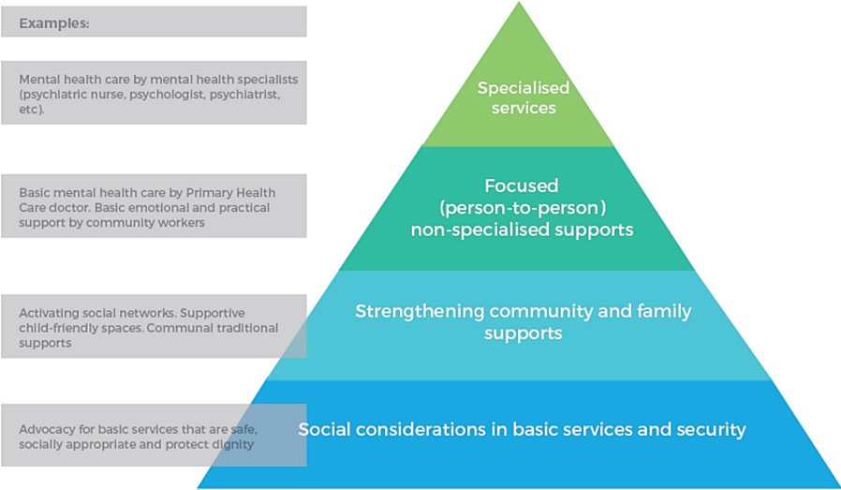

*Figure 1. Intervention Pyramid for MHPSS (IASC, 2020)*

Locally, DOH partners with various government and non-government organizations for their multi-sectoral approach for mental health across a variety of settings, including information campaigns and psychosocial services (DOH, 2020b). Several professional institutions have also provided free telepsychotherapy services that were made available during the pandemic (Rappler, 2020).

With these increasing efforts to address the psychosocial needs of different individuals, this mapping study aimed to explore the various MHPSS services provided by individuals, groups, and organizations in the Philippines in response to the COVID-19 pandemic using the Who is Where, When, doing What (4Ws) in Mental Health and Psychosocial Support (IASC Reference Group for Mental Health and Psychosocial Support in Emergency Settings, 2012). It was designed to identify

(1) the key players in the delivery of MHPSS services, including their clientele and/or institutional partners; (2) the geographical reach of their services; (3) the nature of the cases handled; and (4) the type of programs and/or services offered. This study also aimed to analyze the service gaps according to the IASC MHPSS Intervention Pyramid (IASC, 2020).

# METHODOLOGY

## Participants and Procedures

The study was divided into two parts: Part 1 included individuals and non- government organizations (NGOs) (i.e., international and local non-profit organizations, professional organizations, university and academic-affiliated organizations, and private health clinics) while Part 2 included government organizations (GOs) and government-related agencies (i.e., DOH, DSWD, DepEd, and NCMH).

For Part I, the main inclusion criterion for individuals and NGOs was having their MHPSS services publicly advertised on different social media platforms and among their colleagues and friends. A general search using purposive sampling was conducted, and the respondents were able to identify 169 prospective respondents, with 118 individuals and 51 organizations. They were then recruited through an email blast and were given three options to participate: (1) online survey, (2) online interview, and (3) phone interview.

For Part II, the data were obtained from DOH’s (2020a) consolidated MHPSS cluster report which contained the various activities that the 29 cluster members were undertaking as a response to the COVID-19 pandemic. These cluster members, which consisted of GOs, government-related agencies, and NGOs, were asked to respond to an IASC-guided template. For NGOs that already participated in Part I, their responses were already excluded from the analysis. Meanwhile, the responses from GOs and other government-related agencies were retained and included in the analysis.

## Measures

The questionnaire design was based on the IASC’s (2012) 4Ws in Mental Health and Psychosocial Support. This was deemed an appropriate model due to its utility for mapping MHPSS activities in humanitarian settings across different sectors. It also specifically maps coordination among different individuals and organizations in the context of MHPSS.

Meanwhile, the specific questions were adapted and modified based on the survey tool that was used in the study entitled “Rapid 4Ws Mapping of MHPSS Response to 2019 Easter Sunday Attacks in Sri Lanka” (Galappatti, 2019). The resulting categories of MHPSS services are as follow: (1) Information dissemination to the

community at large; (2) Strengthening of community and family support; (3) Psychosocial support in education; (4) Psychosocial intervention; (5) Psychological intervention; (6) Clinical management of mental disorders by non-specialized health care providers (e.g. workers or staff); (7) Clinical management of mental disorders by specialized mental health care providers (e.g. psychiatrists, psychiatric nurses and psychologists working at general health facilities/mental health facilities); (8) General activities to support MHPSS; and (9) Other/Miscellaneous MHPSS-related activities. Answer options were also modified based on the IASC’s (2020) recommended MHPSS activities for COVID-19 that were implemented by DOH.

## Statistical analyses

For Part I, the data, which were mostly in the form of count data from the check-all- that-apply options, were analyzed using descriptive statistics. They were also visualized and graphed using Tableau (version 2020.2), which was also used to create the online interactive results. Responses to the “Others (Please specify)” field were qualitatively probed to contextualize the given results. Results and interpretation of the data were then subject to team discussions. For Part II, the data from the DOH MHPSS cluster report were reclassified to fit the categories of the questionnaire in Part I. Then, a similar statistical analysis done in Part I was applied in Part II.

# RESULTS

## Part I: Results from the Questionnaire

### *Demographics*

The response rate in the online survey and online/phone interviews was 64.50%. A total of 109 respondents were recruited in the study, with 48 individuals (44%) and 61 organizations (56%). Geographically, MHPSS service providers spanned several locations, with a large proportion providing services online/virtually (n = 47). The top 3 online platforms used to deliver their services were Facebook Messenger, Zoom, and Viber. Moreover, a large proportion was based in Metro Manila (n = 32) and was followed by Central Visayas (n = 11) (see Table 1). However, none were based in Regions 4-B, 5, 12, and 13.

*Table 1. Number of MHPSS service providers per region. Service providers could list down more than one region where they provided MHPSS services.*

|  |  |
| --- | --- |
| **Region** | **Number of service providers** |
| National Capital Region | 32 |
| Region 1 – Ilocos Region | 2 |
| Region 2 – Cagayan Valley | 1 |
| Region 3 - Central Luzon | 4 |
| Region 4-A - Calabarzon | 6 |
| Region 6 – Western Visayas | 6 |
| Region 7 – Central Visayas | 11 |
| Region 8 – Eastern Visayas | 3 |
| Region 9 – Zamboanga Peninsula | 5 |
| Region 10 – Northern Mindanao | 1 |
| Region 11 – Davao Region | 5 |
| CAR | 7 |
| BARMM | 1 |
| Virtual / Places with internet reach | 47 |
| Nationwide | 6 |

### *Specific Services*

Overall, the respondents reported (1) Psychosocial intervention (n =94); (2) Information dissemination to the community at large (n = 92); and (3) Psychological intervention (n = 88) as their top 3 most frequently provided categories of MHPSS services (see Figure 2). Meanwhile, the 3 least frequently provided categories were as follow: (1) Clinical management of mental disorders by specialized mental health care providers (n = 63); (2) Psychosocial support in education (n = 57); and (3) Clinical management of mental health disorders by non- specialized health care providers (n = 39).

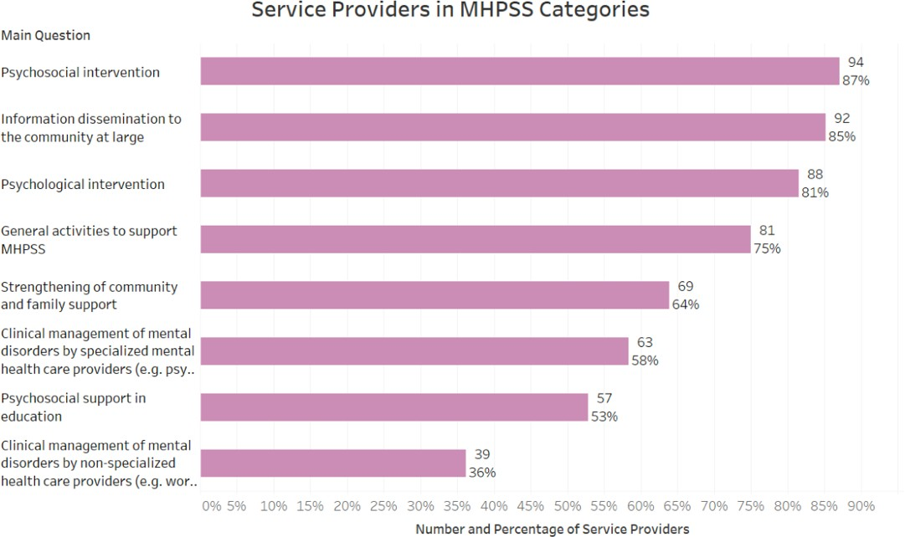

*Figure 2. Number of Service Providers in each MHPSS category. The percentage below each count shows the proportion of service providers that have services under that particular category (i.e., 85% of all service providers in the sample have at least one service under Information Dissemination).*

For the specific services, the five most frequently provided were as follow: (1) Basic counseling for individuals (n = 79); (2) Information, education, & communication (IEC) materials on the current situation, relief efforts, or available service (n = 77);

(3) Psychological first aid (n = 74); (4) Psychological support for staff/volunteers/frontliners (n = 63); and (5) Case management, referrals, and linking vulnerable individuals to resources (n = 60) (see Figure 3). Meanwhile, the respondents reported the following as their 5 least provided services among the options given in the questionnaire: (1) Structured recreational or creative activities (n = 14); (2) Facilitation of conditions for indigenous traditional, spiritual or religious supports (n = 10); (3) Unstructured social activities (e.g., group activities) (n = 9); (4) Unstructured recreational or creative activities (n = 8); and (5) Early childhood development (ECD) activities (n = 6) (see Figure 4).

Psychological Intervention

Information dissemination to the community at large

Psychosocial Intervention

General Activities to support MHPSS

*Figure 3. Number of Service Providers for each of the most frequently provided MHPSS services*

Most Frequently Provided MHPSS Services (Top 5)

Basic counseling for individuals

79

Information, education, & communication (IEC) materials on the current situation,…

77

Psychological first aid

74

Psychological support for staff/volunteers/frontliners

Case management, referrals, and linking vulnerable individuals to resources

63

60

0 10 20 30 40 50 60 70 80

Number of Service Providers

Least Frequently Provided MHPSS Services (Bottom 5)

Structured recreational or creative activities

14

Facilitation of conditions for indigenous traditional, spiritual or religious supports

Unstructured social activities (e.g., group activities)

Unstructured recreational or creative activities

10

9

8

Early childhood development (ECD) activities

6

0 10 20 30 40 50 60 70 80

Number of Service Providers

MHPSS Services

MHPSS Services

Strengthening community and family support

*Figure 4. Number of Service Providers for each of the least frequently provided MHPSS services*

### *Target Beneficiaries*

In terms of age, most services across different MHPSS categories were catered to individuals 18 years old and above, and almost half as many were accessible to children and adolescents aged 18 and below. For gender, there were no notable differences between males and females; MHPSS services were almost equally available for both genders.

Moreover, in terms of the target groups, the majority of these services catered to the general public, and at least half were available for COVID-19 patients, families, relatives, and friends of COVID-19 patients, medical frontliners, and other vulnerable groups (e.g. PWDs, elderly, etc.). Meanwhile, there was less focus on non- medical frontliners as only 37% of MHPSS services were specifically directed towards them (see Figure 5). However, it cannot be determined with the current data if the various target groups availed of the services that were made available for them.

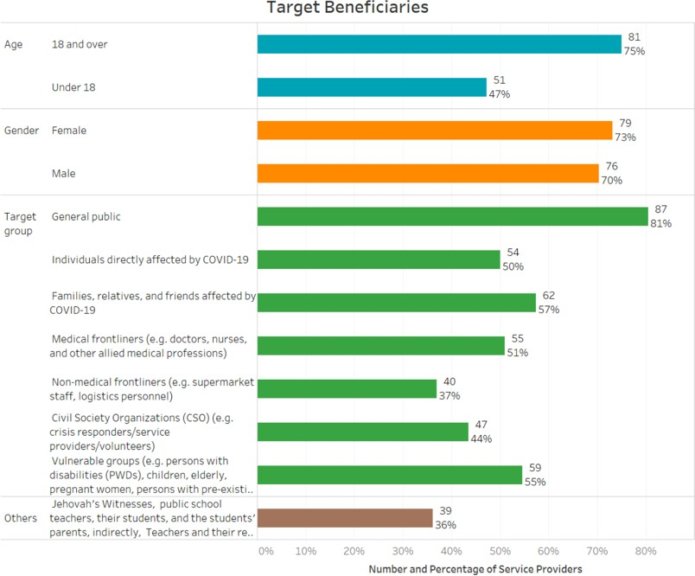

*Figure 5. Number of Services Catering to Specific Groups. Because the response option was “Check all that apply,” the percentages do not add up to 100% and is rather interpreted as the proportion of service providers who provided a specific service (i.e., 50% of all service providers in the sample reported that at least one of their service was open to individuals directly affected by COVID-19).*

## Part II: Analysis of the DOH MHPSS Cluster Report

Among the MHPSS activities reported by the different regional Centers for Health Development (CHDs) that were recategorized according to the current MHPSS categories, the “General activities to support MHPSS” was the most frequently conducted (n = 46), with a large gap from the rest of the categories. In contrast, none of the CHDs reported conducting “Clinical management of mental disorders by non- specialized health care providers.” Moreover, “Psychosocial support in education” was only reported once (see Figure 6).

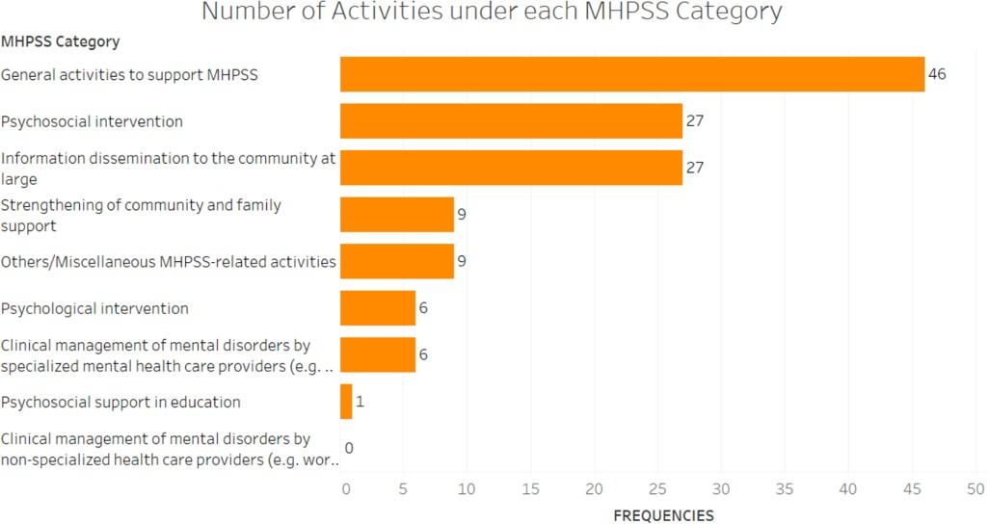

*Figure 6. Number of Activities by CHDs under each MHPSS category*

For the specific services, the five most frequently reported subcategories were the following: (1) Psychosocial support for staff/volunteers/frontliners (n = 22); (2) Information, education, & communication (IEC) materials on the current situation, relief efforts, or available service situation (n = 20); (3) Others (e.g. procurement of psychotropic medications, etc.) (n = 12); (4) Technical or clinical support/supervision (n = 11); and Structured training (n = 11) (see Figure 7). Meanwhile, the least frequently reported subcategories, which were all mentioned once, were as follow: (1) Support for psychosocial activities that are initiated by the community; (2) Research; (3) Psychosocial support to teachers/other personnel at

schools/learning places; (4) Pharmacological management of mental disorder by specialized health care providers; (5) Interventions for alcohol/substance use problems; (6) In-patient mental health care; and (7) Basic counseling for individuals.

There were also a number of MHPSS subcategories that have no corresponding activity reported by any CHD, including (1) Unstructured social activities, (2) Unstructured recreational or creative activities; and (3) Structured social activities, among others.

Most Frequently Provided MHPSS Services (Top 5)

Psychosocial support for staff/volunteers/frontliners

22

Information, education, & communication (IEC) materials on the current situation,…

20

Others

12

Technical or clinical support/supervision

11

Structured training

11

0

5

10 15 20 25

Number of Service Providers

MHPSS Services

General Activities to support MHPSS

Information dissemination to the community at large

Others/ Miscellaneous MHPSS-related activities

*Figure 7. Number of CHD Activities for each of the most frequently provided MHPSS subcategories*

# DISCUSSION

The survey and interviews were conducted from June to July 2020 while the DOH MHPSS cluster report was released in June 2020. Hence, the current study provided an outlook of the existing MHPSS service providers and MHPSS services in the early months of the COVID-19 pandemic in the Philippines, particularly 3 months into the imposed community lockdown. These service providers, which were spread all over the country, were mainly composed of various individuals, NGOs, academic institutions, mental health facilities, and professional organizations. Notably, a considerable portion was concentrated in Metro Manila and Central Visayas, which were both COVID-19 hotspots during the study period (De Guzman & Guido, 2020).

A large proportion also provided services online/virtually, with Facebook Messenger, Zoom, and Viber as the most popular online platforms for delivering MHPSS services. This is also the case globally wherein distance care, including telemental health via videoconferencing and telemedicine, is seen as the primary or default modality for MHPSS services (Burgess et al., 2020; Osser, 2021). Unfortunately, this study did not determine whether the adoption of information and communication technologies (ICTs) was done before the pandemic or as a response to the COVID-19 pandemic.

The top three MHPSS categories that were most frequently provided by the respondents, particularly psychological and psychosocial interventions and information dissemination to the community at large, aligned well with the IASC’s (2020) guidelines for mental health response amidst the COVID-19 outbreak in which the highest priority lies in social considerations and advocacy for basic services that promote mental health in safe, dignified, and socio-culturally appropriate ways. Meanwhile, the least frequently provided MHPSS categories were all related to clinical management of mental disorders and psychosocial support in education. Globally, the COVID-19 pandemic has negatively impacted schools and workplace mental health services, with 78% and 75% reporting at least partial disruptions, respectively (WHO, 2020a). Moreover, COVID-19 preventive and treatment measures resulted in the reduction of outpatient appointments and psychiatric wards as they were converted into isolation rooms and COVID-19 wards (Moreno et al., 2020).

For the specific services, basic counseling, psychological first aid, and MHPSS information dissemination initiatives were frequently provided as the COVID-10 pandemic has negatively impacted people’s mental health and created new barriers and challenges for people already suffering from mental disorders (Panchal et al.,

2021). In the early stage of the pandemic in the Philippines, there were reports of alarming levels of stress, anxiety and depressive symptoms, and other psychological impacts (Tee et al., 2020). Psychological support was also extended to staff, volunteers, and health care workers. Health care workers experience aggravated psychological pressure and mental illness during the outbreak (Vizheh et al., 2020). Moreover, those who are in high infection areas and have direct contact with COVID-19 patients were found to be associated with more severe levels of psychological distress, anxiety, and depression (De Kock et al., 2021; Vizheh et al., 2020). Meanwhile, the least provided were mostly group activities that were prohibited as part of the social distancing measures to curb the spread of SARS-CoV- 2.

Most MHPSS services catered to the general public, and this shows that everyone’s mental health is affected during this time of uncertainty, regardless of age and gender. A substantial portion of services was specifically available for the following: COVID-19 patients; family, relatives, and friends of COVID-19 patients; and other vulnerable groups. COVID-19 patients were found to be more vulnerable to psychological distress than uninfected individuals (Raihan, 2021). In Japan, it was found that individuals with COVID-19 patients in a close setting had higher psychological distress, and this is indicative of the need for MHPSS services that are tailored to family, friends, and co-workers of COVID-19 patients (Tanoue et al., 2020). For the vulnerable population in the Philippines, PWDs face risk factors for mental health issues, including lack of information on the types of disability (e.g. learning disability), negative social perceptions (e.g. negative stereotypes and biases), and lack of access to medical and mental health services (Rotas & Cahapay, 2021). The COVID-19 outbreak can also exacerbate the symptoms and cause relapse among individuals with pre-existing mental disorders (Chatterjee, Malathesh, & Mukherjee, 2020). Meanwhile, there were fewer services that cater to non-medical frontliners. A possible reason can be that this group was already assumed to be part of the general population.

Among the different CHDs, they most commonly conducted general activities to support MHPSS. This is also reflected in their top subcategories of MHPSS services, namely psychosocial support for staff/volunteers/frontliners, technical or clinical support/supervision, structured training, and other MHPSS-related activities. These, in turn, reflect the more general, supportive, and coordinating role of these health agencies. The general role was displayed through their information dissemination initiatives, structured training, and manning of hotlines. Meanwhile, the support role was seen in psychosocial support for other responders and other activities that provided technical assistance. Lastly, the coordinating role was

observed in CHD‘s partnership with local networks and organizations to provide direct MHPSS services and in case referrals to specialized mental health professionals.

# LIMITATIONS

There are a number of limitations to this study. The current study provided an overview of the MHPSS players and their services in the Philippines. However, it did not provide a profile of the MHPSS service recipients, including their demographic information and the specific MHPSS services that they availed. The researchers also employed purposive sampling in identifying and recruiting prospective respondents; hence, the researchers may not have exhausted as many existing service providers as possible during the study period. For instance, there was a possibility that those who had not publicly advertised their services and those who had not adopted distance care during the study period were not recruited in this study.

Moreover, this study provided the foundation for a needed directory of MHPSS services. However, making the directory accessible to the general public and continuously updating it remains a challenge. It was also observed that the IASC guidelines in the form of the eight MHPSS categories in the instrument were not uniformly or clearly understood by some participants in the study. This raised the question of how familiar mental health professionals are with the IASC guidelines, and if they are, whether they apply and follow these guidelines.

Finally, the current study mapped the MHPSS services available during the pandemic, but this study did not answer the other side of the equation – that of the mental health needs, difficulties, awareness of services, risk factors, and ultimately, the support needed by the Filipinos themselves. Unlike the COVID-19 data in which incidence is known and tracked to help in the response, there is currently no equivalent counterpart for mental health disorders and psychosocial difficulties.

# CONCLUSION

The overall pattern of MHPSS services mapped across various service providers in the Philippines aligned well with the IASC guidelines for emergency settings, such as the COVID-19 pandemic. The mental health service providers in Part I generally offered direct MHPSS services to the general population, with some services specifically made available for certain groups (e.g. COVID-19 patients, medical frontliners, etc.). Meanwhile, the DOH MHPSS cluster response has services that were usually more general, supportive, and/or coordinative in nature, although they varied across regional CHDs,

MHPSS services were often delivered online/virtually as reported by several service providers. This has also been the general trend across all mental health services worldwide due to the preventive and safety measures imposed to curb the transmission of SARS-CoV-2, such as social distancing, prohibition of mass gatherings, and community lockdowns, among others. While this provides a set of advantages especially during these unprecedented times, distance care (i.e., telemental health and telemedicine) also faces new limitations and barriers that must be addressed to effectively cater to the psychiatric and psychosocial needs of people.

With the direct and indirect effects of COVID-19 in the Philippines, there is an increasing need for various MHPSS services as various individuals are exposed to elevated levels of stress and other psychological vulnerabilities. However, the existing state of the mental healthcare system in the country presents unique challenges for MHPSS service providers.

# ACKNOWLEDGMENTS

This project was implemented by Professor (Retired) Elizabeth Protacio-De Castro, PhD, together with the project research team composed of: (1) Dinah Palmera Nadera, M.D., (2) Miguel Silan, (3) Maria Clarissa Coronel and (4) Dhan Lawrenz De Leon, and assisted by Mary Rose Fajutag who provided administrative support and the layout of the original report); in collaboration with the Psychosocial Support and Children's Rights Resource Center (PSTCRRC) and the Ateneo School of Medicine and Public Health Center for Research and Innovation (ACRI). Sincere thanks to their individual and collective contributions to this report**.**

We would like to thank the various individuals, government agencies and non- government organizations, professional organizations, faith-based organizations and academic institutions who participated in this project “Mapping of Mental Health & Psychosocial Support Service in the Philippines in the Time of COVID-19” and answered the survey/questionnaire online and thru online/phone interviews.

We also extend our gratitude to Gregorio Del Pilar, Ph.D., President of NRCP, who saw the merit of this research from its inception and encouraged us to pursue this undertaking; Marieta Sumagaysay, Ph.D., Executive Director of NRCP; and Christine Verano Bandong, Science and Research Specialist, Research and Development Management Division, NRCP, for their support.

Finally, we would like to thank the National Research Council of the Philippines (NRCP) that funded this project.

# REFERENCES

Burgess, C., Miller, C. J., Franz, A., Abel, E. A., Gyulai, L., Osser, D., Smith, E. G., Connolly, S. L., Krawczyk, L., Bauer, M., & Godleski, L. (2020). Practical lessons learned for assessing and treating bipolar disorder via telehealth modalities during the COVID-19 pandemic. *Bipolar Disorders, 22*(6), 556– 557. https://doi.org/10.1111/bdi.12969

Chatterjee, S. S., Malathesh, B. C., & Mukherjee, A. (2020). Impact of COVID-19 pandemic on pre-existing mental health problems. *Asian Journal of Psychiatry*, 102071. doi:10.1016/j.ajp.2020.102071

De Guzman, W., & Guido, E. (2020, June 26). *Metro Manila, Central Visayas still struggling to fend off COVID-19*. ABS-CBN News. https://news.abs- cbn.com/news/06/26/20/metro-manila-central-visayas-still-struggling- to-fend-off-covid-19

De Kock, J. H., Latham, H. A., Leslie, S. J., Grindle, M., Munoz, S.-A., Ellis, L., Polson, R., & O’Malley, C. M. (2021). A rapid review of the impact of COVID-19 on the mental health of healthcare workers: implications for supporting psychological well-being. *BMC Public Health, 21*(1), 1–18. https://doi.org/10.1186/s12889-020-10070-3

Department of Health. (2020a, May 31). *Consolidated MHPSS Cluster Initiatives for Response to COVID-19 Pandemic*. Philippines.

Department of Health. (2020b, June 5). *DOH and WHO promote holistic mental wellness in light of World Suicide Prevention Day*. https://doh.gov.ph/press- release/DOH-AND-WHO-PROMOTE-HOLISTIC-MENTAL-WELLNESS-IN- LIGHT-OF-WORLD-SUICIDE-PREVENTION-DAY

Department of Health. (2021, June 23). *Updates on Novel Coronavirus Disease (COVID-19)*. Retrieved from https://doh.gov.ph/2019-nCoV

Galappatti, A. (2019). *Rapid 4Ws Mapping of MHPSS Response to 2019 Easter Sunday Attacks in Sri Lanka* [which was undertaken by the Mental Health Directorate, Ministry of Health, Nutrition and Indigenous Medicine (MoH), in collaboration with World Health Organization Country Office for Sri Lanka (WHO) and MHPSS.net]*.* Sri Lanka.

Galea, S., Merchant, R. M., & Lurie, N. (2020). The mental health consequences of COVID-19 and physical distancing: The need for prevention and early intervention. *JAMA Internal Medicine*.

Holmes, E. A., O'Connor, R. C., Perry, V. H., Tracey, I., Wessely, S., Arseneault, L., ... & Ford, T. (2020). Multidisciplinary research priorities for the COVID-19 pandemic: a call for action for mental health science. *The Lancet Psychiatry.*

IASC Reference Group for Mental Health and Psychosocial Support in Emergency Settings. (2012). *Who is Where, When, doing What (4Ws) in Mental Health and Psychosocial Support: Manual with Activity Codes (field test version).* Geneva.

Inter-Agency Standing Committee. (2020). *Interim Briefing Note: Addressing Mental Health And Psychosocial Aspects Of COVID-19 Outbreak*. https://interagencystandingcommittee.org/iasc-reference-group-mental- health-and-psychosocial-support-emergency-settings/interim-briefing

Moreno, C., Wykes, T., Galderisi, S., Nordentoft, M., Crossley, N., Jones, N., Cannon, M., Correll, C. U., Byrne, L., Carr, S., Chen, E. Y. H., Gorwood, P., Johnson, S., Kärkkäinen, H., Krystal, J. H., Lee, J., Lieberman, J., López-Jaramillo, C., Männikkö, M., … Arango, C. (2020). How mental health care should change as a consequence of the COVID-19 pandemic. *The Lancet Psychiatry*. doi:10.1016/s2215-0366(20)30307-2

Osser, D. N. (2021). COVID-19 Pandemic’s Effects on Assessment & Psychopharmacological Management. *Psychiatric Times, 38*(2), 13.

Panchal, N., Kamal, R., Cox, C., & Garfield, R. (2021, February 10). *The Implications of COVID-19 for Mental Health and Substance Use.* Kaiser Family Foundation. https://[www.kff.org/coronavirus-covid-19/issue-brief/the-implications-](http://www.kff.org/coronavirus-covid-19/issue-brief/the-implications-) of-covid-19-for-mental-health-and-substance-use/

Pfefferbaum, B., & North, C. S. (2020). Mental health and the Covid-19 pandemic.

*New England Journal of Medicine.*

Raihan, M. M. H. (2021). Mental health consequences of COVID-19 pandemic on adult population: a systematic review. *Mental Health Review Journal, 26*(1), 42–54. https://doi.org/10.1108/MHRJ- 07-2020-0044

Rajkumar, R. P. (2020). COVID-19 and mental health: A review of the existing literature. *Asian Journal of Psychiatry*, 102066.

Rappler. (2020, April 11). *LIST: Groups providing free online counseling during the pandemic*. https://[www.rappler.com/moveph/list-groups-providing-free-](http://www.rappler.com/moveph/list-groups-providing-free-) online-counseling-during-the-pandemic

Rotas, E. E., & Cahapay, M. (2021). Managing the Mental Health of Persons with Disabilities amid the COVID-19 Pandemic in the Philippines: Specific Factors and Key Actions. *European Journal of Environment and Public Health, 5*(2), em0077. https://doi.org/10.21601/ejeph/10954

Tanoue, Y., Nomura, S., Yoneoka, D., Kawashima, T., Eguchi, A., Shi, S., Harada, N., & Miyata, H. (2020). Mental health of family, friends, and co-workers of COVID-19 patients in Japan. *Psychiatry Research*, 113067. doi:10.1016/j.psychres.2020.113067

Tee, M. L., Tee, C. A., Anlacan, J. P., Aligam, K., Reyes, P., Kuruchittham, V., & Ho, R. C. (2020). Psychological impact of COVID-19 pandemic in the Philippines. *Journal of affective disorders, 277*, 379–391. https://doi.org/10.1016/j.jad.2020.08.043

Torales, J., O‘Higgins, M., Castaldelli-Maia, J. M., & Ventriglio, A. (2020). The outbreak of COVID-19 coronavirus and its impact on global mental health. *International Journal of Social Psychiatry*, 0020764020915212.

Vizheh, M., Qorbani, M., Arzaghi, S. M., Muhidin, S., Javanmard, Z., & Esmaeili, M. (2020). The mental health of healthcare workers in the COVID-19 pandemic: A systematic review. *Journal of Diabetes & Metabolic Disorders*. doi:10.1007/s40200-020-00643-9

World Health Organization. (2020a, October 5). *COVID-19 disrupting mental health services in most countries, WHO survey.* [https://w](http://www.who.int/news/item/05-)ww.who.i[nt/news/item/05-](http://www.who.int/news/item/05-) 10-2020-covid-19-disrupting-mental-health-services-in-most-countries-who- survey

World Health Organization. (2020b). *WHO Special Initiative For Mental Health.*

[https://w](http://www.who.int/initiatives/who-special-initiative-for-mental-health)ww.who.i[nt/initiatives/who-special-initiative-for-mental-health](http://www.who.int/initiatives/who-special-initiative-for-mental-health)

World Health Organization. (2021, June 23). *WHO Coronavirus (COVID-19) Dashboard*. Retrieved from https://covid19.who.int