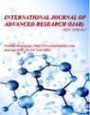

***Journal Homepage: -*** [***www.journalijar.com***](http://www.journalijar.com/)

**Article DOI:** 10.21474/IJAR01/13004

**DOI URL:** <http://dx.doi.org/10.21474/IJAR01/13004>

***RESEARCH ARTICLE***

## APPROACHES TO NANO-BASED VACCINES TOWARDS SARS-COV-2 MANAGEMENT

**Jacqueline A. Padilla1,2 and Erwin M. Faller1,2**

1. Centro Escolar University, Manila, Philippines.
2. San Pedro College, Davao City, Philippines.

***…………………………………………………………………………………………………….... Manuscript Info Abstract***

***……………………. ………………………………………………………………***

***Manuscript History***

Received: 10 April 2021

Final Accepted: 14 May 2021

Published: June 2021

***Key words:-***

SARS-CoV-2, Nanotechnology,

Nanoparticles, Nanomaterials, Nanomedicine, Nano-based vaccines

For a year now, since the world began to be struck with the SARS- CoV-2 pandemic, incidents of the outbreak are still increasing at an alarming rate considering that the virus has evolved and new strains have come out. The urgency for treatment of this SARS-CoV-2 has triggered the pharmaceutical companies to produce and manufacture antiviral medications and diagnostic tools. Since 2004, the pharmaceutical companies have been studying and discovering the great potential of nanotechnology for drug therapy. Nano-based drug delivery has gained an edge in disease management and has proven a pronounced and fast therapeutic activity over the traditional dosage form especially on the nanomedicines employed currently for coronavirus treatment. Reviewed in this article are the important characteristic nature of nanoparticles including the various nanomaterials that can be employed for its drug design that delivers optimum therapeutic activity. Also, the mechanism of how nanodecoys work in trapping and inhibiting viral entry as well as nano-based vaccines. Presently, nano-based vaccines have been formulated which showed a great extent of activity towards eliciting enhanced immunity. And now, these vaccines have been distributed worldwide after undergoing Phase II and Phase III clinical trials. Statistics showed that millions of the individuals worldwide have received the vaccination against SARS-CoV-2 from the different pharmaceutical companies. With the recent positive advancements on nanomedicine therapies, the possibility of complete eradication of any diseases most particularly the current SARS-CoV-2 scare will be materialized. Hence, nanoparticles truly plays a huge contribution in the possible success for the complete treatment of coronavirus infection. In this article, the important contributions and advantages of the use of nanotechnology in the formulation of vaccines are highlighted as a promising medication to help fight against the attack of SARS-CoV-2.

*Copy Right, IJAR, 2021,. All rights reserved.*

***……………………………………………………………………………………………………....***

# Introduction:-

Coronaviruses (CoVs) are named for the crown-like spikes on their surface. They are RNA, enveloped viruses grouped into four main sub-groupings of coronaviruses, known as alpha, beta, gamma, and delta. Among the groups of corona viruses, β-CoVs is the one that infect mammals, with SARS-CoV-1 and MERS-CoV as the known species

225

**Corresponding Author:- Jacqueline Padilla and Erwin M. Faller**

Address**:-** Blk 4, Lot 12, Daffodil Street., Roseville Subd., Phase 1, Lanang, Davao City, Philippines.

able to infect humans. Recently, a new species of SARS-CoV, named SARS-CoV-2 appeared which is currently causing the COVID-19 pandemic [Palestino and Chen, 2020]. Upon contact with the SARS-CoV-2, the incubation period is 3-6 days, with the maximum being 14 days. Once the patients are infected they may exhibit signs and symptoms of upper respiratory tract infection, such as sore throat and rhinorrhea. However, clinical signs may include low-to-high fever, non-productive cough, myalgia, dyspnea, fatigue, standard or decreased leukocyte counts, and confirmed evidence of pneumonia on chest radiography [Chakraborty et al., 2020].

According to the worldometers for covid-19 cases, as of May 25, 2021, the cases has reached to 168,000,188 with deaths of 3,487,572 and recovered cases of 149,342,508 [Worldometers, 2021]. As of this moment, efforts are being put forth on a global scale to find new drug product formulations that can combat SARS-CoV-2 infection using nanotechnology. Currently, the Covid-19 therapeutic management include antivirals, anti-inflammatory drugs, monoclonal antibodies (mAb), antibiotics and immune modulators, activators of toll-like receptors (TLR) and vaccines [Florindo et. al., 2020]. In most countries, Covid-19 cases are managed with antiviral drugs such as Remdesivir. Other drugs included in the therapy are Piptazobactam, Dexamethasone, Enoxaparin and Azithromycin. However, these medicines do not guarantee complete recovery to every patient infected with the Covid-19 virus. Hence, scientists from the pharmaceutical companies keep on doing research for medicines that can completely halt the spread of the infection worldwide.

Undeniably, the Covid-19 outbreak has created global demand for a fast and complete cure as well as control from the spread of the infection. It is on this level that nano-based vaccines have been formulated by the different pharmaceutical companies in the desire to put an end to this economically debilitating coronavirus pandemic. These nano-based vaccines are engineered to offer a number of approaches to deal with this health emergency [Weiss et. al., 2020]. Nanotechnology is an emerging industry in the scientific field and has rapidly expanded in the last years. It has had a good impact in changing the landscape of modern treatment [Valdiglesias and Laffon, 2020]. Being a greatly multi-faceted drug product formulation, nanotechnology has gained an edge in the realm of matchless drug design approaches and solutions that can be beneficial for the pandemic crisis that the world is facing [Talebian and Conde, 2020].

Truly, nanotechnology finds its niche in our current situation because viruses like SARS-CoV-2 similarly grafts the same measure of work as Nanoparticles. The physicochemical properties of these nanoparticles could yield to a very auspicious therapeutic remedy for SARS-CoV-2 because these nanoparticles are filled with viral antigens or antibodies which could be utilized against SARS-CoV-2 and any new emerging strain of CoV [AbdEllah (2020)]. Hence, formulation of nano-vaccines can be an excellent way to greatly reduce Covid-19 cases globally. Vaccination can be generally considered as the most economical option to inhibit, regulate, and combat against infections. Currently, nano-based vaccine formulations include inactivated or weakened virus vaccines, protein- based vaccines, viral vector vaccines and RNA and DNA vaccines, which can prompt an antigen-specific immune response [Nasrollahzadeh (2020)].

In this review, we focus on the properties of nanoparticles and how nanomaterials work in order to trap and inactivate the virus. Nano-based drug formulation and vaccines, which are among the most promising approaches for countering outbreaks of emerging viral infections are also dealt with including the different therapeutic approaches for SARS-CoV-2, focusing on the implementation of nano-vaccines.

# Methods:-

This article review uses recovered studies and peer-reviewed articles from the different journal databases like Pubmed, Google Scholar, Elsevier, and Research Gate. It also includes updated data from World Health Organization and Worldometer. The search started in February 15, 2021 which has a direct focus on the following,

1. properties of nanoparticles (2) how nanoparticles help combat Covid-19 (3) use of nanotechnology in the formulation of nanomedicines for the treatment of SARS-CoV-2 inlcudingnanovaccine formulation (4) different brands of vaccines and its level of clinical trials attained (5) update on the vaccination program campaign highlighting the number of vaccinated population per country with the intent to completely vaccinate and eradicate the global pandemic caused by the coronavirus [Carvalho (2021)].

## Significant Properties of the Nanoparticles

Nanoparticles are very minute, hence their capacity to be absorbed on the target site and exert its antiviral property has varied mechanisms. First exceptional characteristic of nanoparticles is (1) nano-size particles – in which drug

particles can easily squeeze-in delivery into the target sites [Parboosing et. al., 2012], (2) nanoparticles have huge surface area to distribution ratios - which warrants wide distribution due to its nanosize particles [McNeil (2011)] and (3) tunable surface charge – which allow ionic navigation across cellular membrane [Caron (2010)]. These properties of nanoparticles can be an effective tool as an antiviral specifically against SARS-CoV-2. Second, nanoparticles can possibly possess intrinsic antiviral properties that directly restricts viral replication and assembly, thereby rendering a cell non-permissive to a specific class or species of viruses [Gagliardi (2017)]. A good example of which include silver nanoparticles and dendrimers. Third, the likelihood of nano-drug encapsulation, stable functionalization, or any alterations (with the nanocarriers like polyethylene glycol), can significantly improve drug dosing and enhance stability and drug retention time. Lastly, nanoparticles have improved drug delivery by targeting specific moieties to enhance therapeutic activity on the target tissues [Singh (2017)].

## How nanomaterials help combat Covid-19 Virus?

With the advent of Nanotechnology, finding remedies to fight against viruses have greatly increased the success rate for hindering a myriad of human viral pathogens [Weiss et. al., 2020]. With this, nanomaterials help in combating virus by the following mechanisms:

### *Trapping effect of the nanodecoys*

First, the virus attacks itself to the host cell membranes creating the way for invasion. However, nanodecoys which are broad-spectrum anti-infection nanomaterials act to compete with the invasion to the host cell membranes by providing cell-surface receptors that are recognized by the virus and in turn traps them [Rao, et. al 2020]. Figure 1 shows how nanodecoys are prepared.

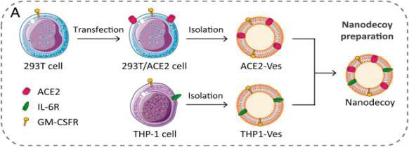

**Figure 1:-** Preparation of Nanodecoy.

Source: ―Decoy nanoparticles protect against Covid-19 by concurrently adsorbing viruses and inflammatory cytokines,‖ by Lang Rao, Shuai Xia, Wei Xu, RuiTian, Guocan Yu, ChenjianGu, Pan Pan, Qian-Fang Meng, Xia Cai, Di Qu, Lu Lu, YouhuaXie, Shibo Jiang, and Xiaoyuan Chen, Copyright 2020, PNAS 117 (44) 27141-27147

The course of inactivating SARS-CoV-2 by utilizing nanodecoys follow a two-step neutralization process, namely: Viral neutralization and then followed by Cytokine neutralization. Nanodecoys are equipped to contain angiotensin converting enzyme II (ACE-2) receptors on its membranes. These ACE-2 enzymes act to compete binding with the virus on the host cells. The mechanism in which nanodecoys act to compete invasion on the host cells can lead the pseudoviruses and the genuine SARS-CoV-2 viruses to attach on nanodecoys instead because of similarity in receptor binding sites. Such scenarios can lead the viruses to be neutralized. Additionally, due to the ample amount of cytokine receptors found in the surrounding environment of the host cells, the nanodecoys powerfully bind and neutralize inflammatory cytokines (IL-6 = Interleukin 6 and GM-CSF = Granulocyte−Macrophage Colony- Stimulating Factor), and significantly subdue disorder in the immune system including any lung damage associated in an acute pneumonia [Thamphiwatana, 2017; Hirotani, 2005; Hu, 2011]. Figure 2 shows the two-step neutralization process of SARS-CoV-2 by Nanodecoys.

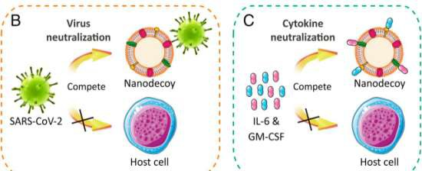

**Figure 2:-** Two-step neutralization activity of Nanodecoys against SARS-CoV-2.

Source: ―Decoy nanoparticles protect against Covid-19 by concurrently adsorbing viruses and inflammatory cytokines,‖ by Lang Rao, Shuai Xia, Wei Xu, RuiTian, Guocan Yu, ChenjianGu, Pan Pan, Qian-Fang Meng, Xia Cai, Di Qu, Lu Lu, YouhuaXie, Shibo Jiang, and Xiaoyuan Chen, Copyright 2020, PNAS 117 (44) 27141-27147

### *Inhibition of viral entry by nanomaterials*

One of the most common activities for inhibition of the passage of the virus going to the host cells is by blocking the viral entry at the early stage. This process can prevent further progression of the infection and viral multiplication into the host cells. And, with the advent of nanotechnology, the high surface area to volume ratio of nanomaterials including its composition and tunable surface chemistry has led to its powerful impact on blocking viral entry [Huang et. al., 2021]. Figure 3 shows the mechanism of blocking the virus from contaminating the healthy cells.

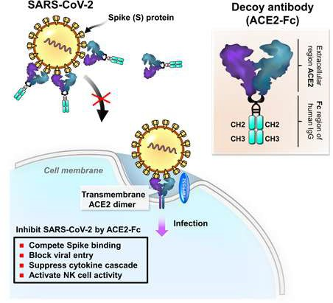

**Figure 3:-** Mechanism of Blocking the Virus.

Source: Humanized COVID-19 decoy antibody effectively blocks viral entry and prevents SARS-CoV-2 infection. Kuo-Yen Huang, Ming-Shiu Lin, et. al., 2021, TheEmbo Journal. Volume 13, Issue 1. Copyright 2020.

However, the entire process of the antiviral action depends on the inactivation of the capsid proteins. In fact, nanomaterials have been utilized for: (1) blocking target proteins for viral entry, (2) capsid protein oxidation, (3) mimicking cell surface, and (4) mechanical breaking of viruses [Giacoma, et. al., 2020]. Figure 4 shows the main mechanism of antiviral action.

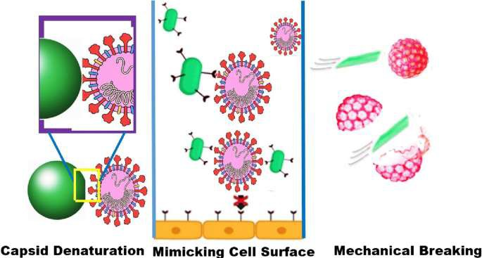

**Figure 4:-** Diagram of the mechanisms of antiviral action.

Source: New insights into application of nanoparticles in the diagnosis and screening of novel coronavirus (SARS- CoV-2). [AbhimanyuTharayil,](https://link.springer.com/article/10.1007/s42247-021-00182-w#auth-Abhimanyu-Tharayil)et. al., Springer Link. Volume 4, pages101–117

## Nano-Drug Delivery Systems

Bioavailability and some other physiologic factors have always been a major concern for the traditional drug delivery system. Several challenges related to this delivery system have been shown such as possible in-vivo drug degradation, which will likely result in poor bioavailability and short half-life including systemic toxicity on some individuals due to patient-to-patient variability. However, with the advent of drug delivery systems utilizing nano- carriers, these challenges have been overcome yielding to a higher extent of bioavailability, including decrease in the size of dose resulting in a lesser extent of systemic toxicity. Moreover, nano-carriers help protect the drug from degradation which will improve the half-life and most specially the ability of the nano-drug to diffuse across the biological membranes of the target site [Kobayashi, 2014 and Jindal, 2020].

What are nanoparticles? These are an extremely small particle size with dimensions measured in nanometres (1 nm

= 10−9metre). We human beings are not aware of our daily exposure to these nanoparticles because they can‘t be seen easily by our naked eye. They exist naturally in the world and are formed as a result of human activities. Due to their sub-microscopic size, they have matchless material features, and are produced in a variety of practical applications in several areas including catalysis, pharmaceutical industry, ecological remediation, and engineering industry [Dobson, et. al., 2019]. At present there are two approaches for the production of nanomaterials, namely: the ―top-down‖ and ―bottom-up‘ approaches. The former approach is characterized by the breaking down of huge pieces of material to produce the needed nanostructures from them. This type of producing a nanomaterial is perfect for making interlocked and assimilated structures such as in electronic circuitry. In the ―bottom-up‖ approach, this involves assembling of single atoms and molecules to form into bigger nanostructures [European Commission (2006)].

There are also three types of nanoparticles, namely: organic, inorganic and virus-like and self-assembly protein nanoparticles. Figure 5 shows the different types of nanoparticles [Itani. et. al., (2020)].

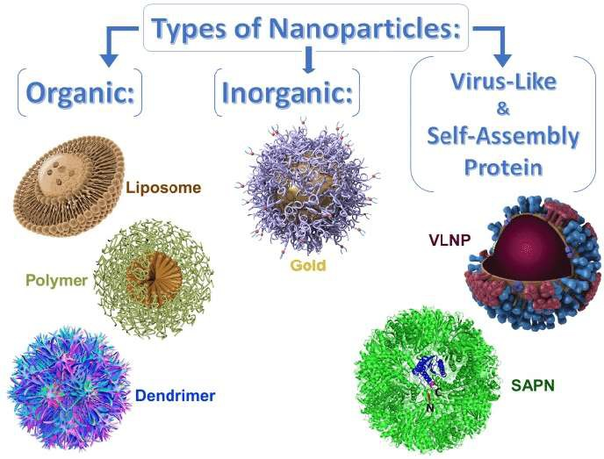

**Figure 5:-** Different Types of Nanoparticles.

Source: Optimizing use of theranostic nanoparticles as a life-saving strategy for treating COVID-19 patients. Rasha Itani, Mansour Tobaiqy, and Achraf Al Faraj. Theranostics. Volume 10.Page 5935. Copyright 2020. Ivyspring International Publisher

Among the three types, organic nanonparticles are considered better because encapsulation of the materials is simpler. Also, organic nanoparticles are made from biodegradable organic materials which make it more impressive in terms of applications in biomedical aspects and drug delivery systems [Romero, et. al., 2012]. Organic NPs are also utilized in many industrial products, mostly in the food and cosmetics industry. They are also used in pharmaceutical product formulations, that is, microspehres, dendrimers, liposomes, micelles, and some other organic nanoparticles. These organic nanoparticles have been fruitfully utilized for a better, direct targeted delivery of different antivirals such as Acyclovir, Zidovudine, Efavirenz, and Dapivirine [Milovanovic (2017)].

## Organic Nanoparticles Lipid Nanoparticles

Nanoparticles like liposomes which are made from lipids are particularly efficient for attracting biological cell membranes due to their lipophilic nature resulting in better biocompatibility. Liposomes are spherically-shaped capsules having a phospholipid bilayer on the outer part and an inner hydrophilic core intended to grip aqueous nature of the active moiety [Kumar, et. al., 2016]. Apart from this, liposomes have a great advantage in terms of its efficiency in encapsulation of the conjugated therapeutic agents together with its added structural changes to further improve their cellular and mucosal uptake resulting in enhanced bioavailability [Khan et. al., 2020]. In terms of the pharmacokinetic profile of liposomes, surface charge plays a significant part. As a matter of fact, there has been some research conducted on the cationic-type and anionic-type of liposomes given the through intranasal route. The result of the study exhibited favourable fate for cationic liposomes in terms of absorption and bioavailability in the mucosal membrane which led to the binding of the positively charged nanoparticles to the target site. In addition, liposomes‘ clearance at the mucosal cilia is also reduced, thereby leading to longer residence time at the target site and better therapeutic activity [Law et. al., 2001]. Moreover, liposomes characteristic nature and property have shown an excellent performance in terms of its retention on the nasal cavity which can possibly result to a tremendous increase in immune activity and formation of higher levels of immunoglobulins [Alpar, et. al., 2012].

## Polymer Nanoparticles

Among the nanoparticles, the polymer-based have shown an excellent performance due to its impressive tailored features of their properties and functions. This type of nanoparticles can easily be enhanced to permit a slow and tapered release of its drug-nanomaterial contents [Kamaly, et. al., 2012] upon the added presence of numerous monomers into the different configurations either linear, branched, or highly branched owing to the 3D networks [Susanna et. al., 2017]. Among the different preparations of polymer nanoparticles, Chitosan has gained much popularity in terms of intranasal route owing to their better bioavailability, harmless characteristic nature, capacity to undergo biodegradation of its non-toxic products in-vivo and their ability to loosened-up the tight junctions between

epithelial cells [Sonaje et. al., 2012], and lastly, its ability to be modified into its desired sizes and shapes [Chua et. al., 2012].

## Dendrimer

Dendrimers as a class of novel polymers have an exceptional well-defined molecular structural-design, which possesses great degree of molecular consistency, low polydispersity and characteristics that make them a perfectly suitable material for the development of nanomedicines. Same with Polymers, Dendrimer Nanoparticles can be produced in greatly branched 3D networks. This makes them better in terms of its capacity to attach functional groups on their surface. Dendrimer also has the ability to encapsulate non-water soluble, hydrophobic therapeutically active moieties in the core [Kono et. al., 2012] making them suitable against tumors and any bacterial and viral infections [Mhlwatika et. al., 2018]. Based on its characteristics and properties, dendrimers have shown to have robust interactions with any viruses making them a good potential as antiviral carriers. Thus, dendrimers became an efficient tool to use in the management of some viral infections particularly HIV and influenza [Kim et. al., 2018].

### *Inorganic Nanoparticles*

Inorganic nanoparticles have fascinated scientists for over a century and are now heavily utilized in biomedical sciences and engineering due to their capability of showing evidence of intrinsic activity (i.e. Magnetic or Gold Nanoparticles) and allowing stimuli-responsive characteristics. Aside from the fact that, it also acts to efficiently distribute the drugs to the target sites using conventional methods of delivery. All of these can be easily monitored by utilizing non-invasive medical imaging [Yoon et. al., 2017]. Moreover, considering the concerns on safe clinical applications on the diagnosis, detection and treatment of many diseases [Bayda et. al., 2018], a research has been conducted on the numerous forms of biocompatible nanomaterials to ensure possible success of both organic and inorganic nanoparticles. Among these inorganic nanoparticles, Gold NP, have gained the most acceptance in vaccine development as they can definitely prompt the immune system through internalization by antigen presenting cells [Gonzales et. al., 2015]. In addition, Gold nanoparticles can be simply adapted and modified for intranasal delivery. Since the mucosal lining is very thin, the extent of diffusion into the lymph nodes is easy thus activating CD8+ (T- killer) cell-mediated immune response [Marques et. al., 2017].

### *Virus-like and Self-assembling Protein Nanoparticles*

*Virus-like NP (VLNP)* contain spherically-shaped sizes of molecules between 20 and 200 nm. When the proteins undergo self-assembly from the viral capsids, virus-like nanoparticles will be formed. They comprise a genetic component however, they possess a capacity to perfectly mimic the real virus or antigen in terms of structure and antigenic determinant(s). Because of this reason, virus-like nanoparticles have gained much attraction to antigen presenting cells which will elicit an immune response [Kushnir et. al., 2012]. Furthermore, VLNP‘s auspicious treatment depends on its ability to simply prevent enzymatic degradation. Also, due to its nanosize particles, penetration into the cellular nucleus is extremely easy [Wang et. al., 2016]. Remarkably, innovation generated in these VLNP can also be accepted in the detection of viral infections by utilizing several noninvasive medical imaging modalities (i.e. MRI and PET). With this, it can possibly result in the establishment of a theranostic platform useful for the identification and management of any viral infections [Shukla et. al, 2015].

*Self-assembling protein nanoparticles (SAPN)* are a novel type of nanoparticles, noted for its molecules with autonomous organization gearing towards a more pronounced structure by using non-covalent bonding mechanisms to reach equilibrium. It is composed of two different oligomerization domains connected by a short linker. These oligomerization of monomeric proteins have a diameter between 20 to 100 nm. The discovery of SAPN has led to the development of a strong and functional NP for myriad applications. One of which is the utilization of biomaterials with peptides [Whitesides et. al., 2002]. The delivery of these nanoparticles (SAPN) into the target site were determined according to its capacity to cross the cellular membrane in order to deliver the drugs, genes and nucleic acids to the nucleus of the cell [Diaz et. al., 2018]. Kanekiyo M. *et al.* described the production of SAPN that prompts a wider and more enhanced protection due to increase immunity than the conventional form of influenza vaccines given after intranasal administration, and therefore, offer an excellent platform for the advancements in vaccine formulation against various existence of increasing variants of viruses and other pathogens [Fan et. al., 2017].

On the other hand, for the different types of nanomaterials utilized in vaccine production, it contains three different parts: (i) *the material(s)* – which consist both natural and synthetic polymers including inorganic substances and

lipids (ii) *immunogen or immunomodulatory agents* for example the antigens, cytokines, siRNA, DNA vaccines, etc. (iii) *targeting and immune-stimulatory ligands* – which are designed to be placed on the surface of the particle to act as an immune specific ligands, tissue-specific ligands, and pathogen-associated molecular patterns (PAMPs) [Hajizade, 2014; Rai 2020]. In the development of a certain nano-drug it is important to consider the extent of the physiological influences which may affect absorption and bioavailability of the nano-drug formulation. These factors involve the role of drug transport into the active site, cellular uptake, and intracellular impacts of the nanoparticle, including its biodegradability and biocompatibility. Similarly, the pharmacokinetic properties of the formulation must be fully established in order to ascertain plasma concentration at therapeutic level which includes discharge rate of the nanoparticle, distribution, and bioavailability of the immunogen. This immunogen, which is the most important component of a nano-based vaccine can be combined with the other nanomaterials in the formulation using three different ways, namely: (i) conjugation (covalent binding), (ii) adsorption (on the surface of the nanoparticles), and (iii) encapsulation (within the nanoparticles). Along with the immunogens are the adjuvants which play a variety of roles in the formulation of vaccines. And, the useful strong adjuvants for nano-based vaccine formulation belong to the Toll-like receptors (TLRs) which include CpG DNA, lipopolysaccharide (LPS), monophosphoryl lipid A, and muramyl peptides [Rai and Poon 2020].

## Emergence of Nano-based Vaccines against SARS-CoV-2

Currently, there is no specific medicine, treatment and vaccine to cure COVID-19 with 100% therapeutic activity and 100% safety to the general population. For now, the basic treatment is provided to enhance the immune system [Kanekiyo (2013)]. In the current situation right now, where the world is facing a pandemic, the use of nanotechnology for the fight against SARS-CoV-2 has increasingly been given much attention in the biomedical practice and pharmaceutical industry. This includes formulation of nano-vaccines using carriers or adjuvants for the encapsulation of the active ingredient [Gagan, 2021; Munoz, 2020]. With the contributions that nanotechnology can offer, this has led to an increase in the rate and extent of bioavailability of a drug since it goes directly to the target site. As a result, size of the dose is lessened and the therapeutic activity has been shown to be enhanced while decreasing its level of toxicity [Weiss, 2020; Rodrigues, 2015; Huang, 2016].

## Types of Vaccines

Vaccines reduce risks of getting a disease by working with your body‘s natural defenses to build protection. Our immune system responds accordingly when we get a vaccine. So, how do we design a vaccine? A vaccine primarily contains an antigen and an adjuvant. Its manufacturing system and delivery mode must also be established (Table 1) [Singh (2021)].

Conventional vaccines originate from viruses or bacteria and can be divided in live attenuated vaccines and non- living vaccines which work by copying the infectious agent. These viruses and bacteria from the vaccines are uniquely designed to protect the body from invading pathogens by stimulating the immune response of the body. So when the body encounters these pathogens, the immune system responds immediately to attack and destroy the pathogens. However, for live attenuated vaccines, there is some danger due to the possibility of reversal of viral virulence. In addition to this disadvantage are related to limited immunogenicity (subunit vaccines) and weak immune response (inactivated viruses). Nonetheless, due to the advent of nanotechnology the world of vaccine formulation has explored more technological advances in terms of its product engineering both chemical and biological which resulted to the development of a nano-based vaccines with powerful immunogenicity and improved antigen presentation [Jindal and Shin, 2020].So, in the past vaccination takes a long time to produce but recent technological developments have made production of vaccines possible at a short period of time especially if the genome and structural information of the virus has been made available like the SARS-CoV-2 [Ahmed, 2020; Wrapp, 2019; Andersen, 2020; Benvenuto, 2019; Yuan, 2020].

**Table 1:-** Components and options in vaccine design.

Nanocarriers synchronize delivery of both, antigen and adjuvant, to target immune cells.

* Viral vector: repurposed mammalian viruses engineered to deliver a gene encoding the antigen (examples include adenoviral vectors derived from chimpanzee and human).
* Proteinaceous nanoparticles: nanoscale

**Antigen: a** foreign material that can induce an immune response within the body—often derived from the pathogen one aims to immunize against. Based on how the antigen is presented, vaccines can be categorized as:

* Live-attenuated vaccine: weakened form of pathogens capable of replication, but not causing illness.
  + Inactivated vaccine: killed form of pathogens incapable of replication or infection.
  + Subunit vaccine: minimal antigenic element of a pathogen, for example, a protein, protein subunit or polysaccharides or VLPs self-assembled from these components. These antigens in purified forms are administered in combination with molecular adjuvants or expressed in vivo using RNA, DNA or viral vectors.
  + Peptide-based vaccines: peptides are fundamental element of a protein subunit recognized by the immune system; all antigens described above contain peptide epitopes.

**Adjuvant:** a stimulatory agent designed to boost immune response toward a co-delivered antigen.

* + Occurs as ‗independent entities‘ in a mixture with antigens.
  + Occurs as ‗conjugate-entities‘ via chemical fusion directly to antigens.

**Nanoparticle/nanocarrier:** The live-attenuated and inactivated viral vaccines can be regarded as nanoparticles themselves. Rather than serving as the vaccine itself, a nanoparticle (viral or non-viral) can be employed as nanocarrier to encapsulate or present the antigen payload or nucleic acid encoding the antigen. Nanocarriers provide stability and targeting of these payloads antigen presenting cells (APCs); nanocarriers can confer innate adjuvant behaviour (see Fig. 6).

biomaterial assemblies with atomic precision and complexity (examples include protein nanocages and non-infectious viruses such as plant viruses or bacteriophages) engineered to present a subunit vaccine or deliver a nucleic acid encoding the antigen.

* + Synthetic nanoparticles: nanoscale assemblies of synthetic materials (examples include polymer, liposomal, or lipid nanoparticles) engineered to present a subunit vaccine or deliver a nucleic acid encoding the antigen.

**Device:** a piece of equipment designed to administer vaccine (Fig. 7).

* + Syringe: hypodermic needle used for intramuscular, subcutaneous or intradermal delivery of vaccine by a healthcare professional (>10 mm length and 0.25–0.5 mm in outer diameter, somewhat invasive)
  + Implant: slow-release device containing vaccine for sustained subcutaneous delivery, administered by a healthcare professional (<10 mm length and <2 mm in width, more invasive).
  + Microneedle patch: array of micrometre-scale needles containing vaccine for slow release, sustained intradermal delivery, administered by a healthcare professional or via self-administration (1 mm in length and 0.1-0.5 mm in width, approximately 1 cm2 patch, minimally invasive.

Source: COVID-19 vaccine development and a potential nanomaterial path forward Matthew D. Shin,Sourabh Shukla, Young Hun Chung, et., al., 2020. Nature Nanotechnology. Copyright Springer Nature Limited 2020

This information data together with the advanced communication of bioinformatics predictions and epitope mapping [Yan, Lucchese, Grifoni, and Baruah 2020], has prompted developments of more vaccine design that is beyond the usual live-attenuated and inactivated vaccines [Ahmed, Walls, Hofmann, Lei, and Wang 2020]. In addition, due to the previous developmental progress of both SARS and MERS vaccines, the formulation of vaccine for SARS-Cov- 2 has been aided efficiently from this previous knowledge on SARS/MERS vaccine candidates [Lan 2020 and Enjuanes 2016]. Moreover, advances in technological platforms of nanoparticles offer significant efficacy in the design of more advanced vaccines and have paved the way to unique and clinically safe vaccine formulations at unparalleled promptness. Presently, together with the conventional inactivated vaccines, a new type of vaccine from mRNA has emerged. Such mRNA vaccine is a form of nanoparticle delivered in liposomal form. Clinical trials on this vaccine have already reached Phase II and III (Table 2) [Song 2019]. The table shows the list of nanovaccine products which are now under pre-clinical phases of testing against SARS-CoV-2 and some have completed the testing phases. Currently, some of the countries in Asia, including the Philippines have been vaccinated already with Novavax, AstraZeneca, Sinopharm, Moderna, Cinovac and Pfizer vaccines. Moreover, other vaccines are available which contain a messenger RNA nanovaccines. This form of nanovaccine encapsulates the messenger RNA with a lipid nanoparticle [Pardi et. al., 2018], and has been investigated for use in numerous other diseases. To note, the 2019-nCoV vaccine (mRNA-1273) developed by Moderna, Inc. is now accessible for pharmaceutical marketing. In fact, several members of the population have been vaccinated with this Moderna vaccine. Moderna, Inc. has also shared their lipid nanoparticle-based mRNA vaccines against H10N8 and H7N9 and have shown a promising safety result and reactogenicity profiles in healthy adults [Feldman et. al., 2019]. They also have confirmed the efficacy of their mRNA-based nano-formulation against chikungunya in mice and macaques [Kose 2019 and Singh 2017].

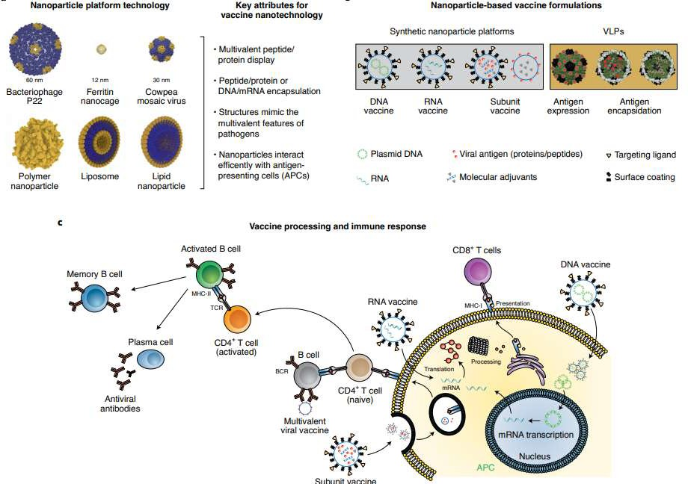

**Fig. 6:-** Different Nanotechnology Platforms for Vaccine Production.

**Source:** Covid-19 vaccine development and a potential nanomaterial path forward. Matthew D. Shin, Souabh Shukla, Young Hun Chung, et. al., 2020. Nature Nanotechnology. Volume 15. Nature Nanotechnology. Copyright Springer Nature Limited 2020

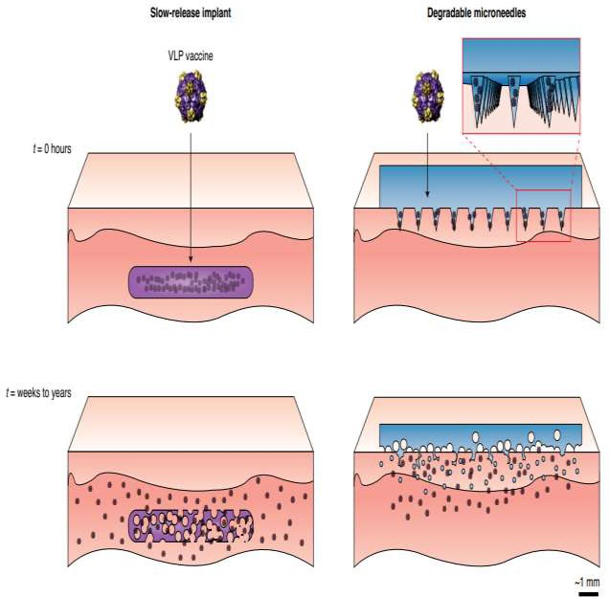

**Fig. 7:-** Comparison of the Application of a Slow-release implant versus Degradable microneedle patch Source: Covid-19 vaccine development and a potential nanomaterial path forward. Matthew D. Shin, Souabh Shukla, Young Hun Chung, et. al., 2020. Nature Nanotechnology. Volume 15. Nature Nanotechnology. Copyright Springer Nature Limited 2020

**Table 2:-** COVID-19 vaccine candidates in the clinical development pipeline.

|  |  |  |  |  |
| --- | --- | --- | --- | --- |
| **Developer** | **Vaccine** | **Status** | **Type** | **Clinical Trials Registry** |
| Sinovac | Formalin inactivating whole virus particles combined with an  alum adjuvant | Phase I/II | Inactivated vaccine | NCT04383574 |
| Beijing Institute of Biological Products -  Sinopharm | Inactivated vaccine of SARS- CoV-2 | Phase I/II | Inactivated vaccine | ChiCTR2000032 459 |
| Wuhan Institute of  Biological Products - Sinopharm | Inactivated vaccine of SARS- CoV-2 | Phase I/II | Inactivated vaccine | ChiCTR2000031 809 |
| Institute of Medical Biology, Chinese Academy of Medical Sciences | Inactivated vaccine of SARS- CoV-2 | Phase I | Inactivated vaccine | https://www.who. int/ who- documents-detail/ draft-landscape- of-covid19- candidate-  vaccines |
| Novavax | Stable, pre-fusion S protein  given with adjuvant, Matrix-M | Phase I/II | Subunit vaccine | NCT04368988 |
| CanSino Biological | Recombinant SARS-CoV-2 | Phase I | Non-replicating | NCT04313127 |

|  |  |  |  |  |
| --- | --- | --- | --- | --- |
| Incorporation, Beijing Institute of  Biotechnology, Canadian Center of Vaccinology | intramuscular vaccine that incorporates the adenovirus type 5 vector (Ad5-nCoV) | Phase II Phase I/II | viral vector vaccine | NCT04341389 NCT04398147 |
| University of Oxford, Astra Zeneca | Chimpanzee adenovirus vaccine vector (ChAdOx1) | Phase I/II Phase II/III | Non-replicating viral vector  vaccine | NCT04324606 NCT04400838 |
| Shenzhen Geno-Immune Medical Institute | Approach 1: modified dendritic cells expressing SARS-CoV-2 minigenes  Approach 2: artificial antigen- presenting cells expressing  SARS-CoV-2 minigenes | Approach 1: Phase I/II  Approach 2: Phase I | Non-replicating viral vector vaccine | NCT04276896 NCT04299724 |
| Inovio Pharmaceuticals | Optimized DNA vaccine given  via electroporation | Phase I | DNA vaccine | NCT04336410 |
| Symvivo | bacTRL-Spike oral DNA vaccine encoding S of SARS-  CoV-2 | Phase I | DNA vaccine | NCT04334980 |
| Moderna | Prefusion stabilized S protein  mRNA vaccine | Phase II | RNA vaccine | NCT04405076 |
| BioNTech, Pfizer,  FosunPharma | Lipid nanoparticle mRNA  vaccines | Phase I/II | RNA vaccine | NCT04368728 |

Source: Covid-19 vaccine development and a potential nanomaterial path forward. Matthew D. Shin, Souabh Shukla, Young Hun Chung, et. al., 2020. Nature Nanotechnology. Volume 15. Nature Nanotechnology. Copyright Springer Nature Limited 2020

## Program for Nano-based Vaccination - Now worldwide

Prompted with the coronavirus pandemic, the pharmaceutical industries have initiated quick response on the need for vaccine formulation. This scenario has led to a more advanced development using nanotechnology in vaccine formulation which gives birth to the term ‗Nanovaccinology‘ or ‗Nano-based vaccines‘ in therapeutics [Mamo et. al., 2012]. Due to its potent immunostimulatory effects, nano-based vaccine formulations have shown to possess better efficacy in comparison to the traditional type of vaccine products [Zaman et. al., 2013].

The advent of nanotechnology in the recent past has paved the way for the development of nanovaccines for Covid- 19 on a fast track mode. These nanoparticles offer an exceptional nanodrug-nanocarriers packing design which are not possible in conventional vaccines [Kanekiyo et. al., 2013].

In a survey conducted by Lazarus et. al., in June 2020 from 19 participating countries regarding a global survey of potential acceptance on Covid-19 vaccines, the result showed that 71.5% of the respondents considered accepting or somewhat likely going to accept the Covid-19 vaccination. Around 61.4% of the respondents would accept if their employers recommend them to get the jab. There are however, differences in acceptance rates ranging from almost 90% (in China) to less than 55% (in Russia) [Lazarus et. al., 2021].

Presently, the worldwide vaccination program has been ongoing with the goal in mind – *to bring the pandemic to an end*. Hence, a large population of the world is required to be immune to SARS-CoV-2. And, the only way to achieve this goal is to have the people vaccinated in order to put down the death toll rate worldwide. Currently, as of May 30, 2021, Our World in Data Covid Vaccination site gives a daily update on the number of people vaccinated worldwide. Table 3 below shows the vaccinated number of people per country [Mathieu et. al., 2021].

**Table 3:-** Vaccinated Population per Country.

|  |  |  |  |
| --- | --- | --- | --- |
| **Country** | **No. of Vaccinated**  **Population** | **Country** | **No. of Vaccinated**  **Population** |
| United States | 292.1 M | Oman | 296,894 |

|  |  |  |  |
| --- | --- | --- | --- |
| India | 203.17 M | Sudan | 290,500 |
| United Kingdom | 63.35 M | Luxembourg | 334,766 |
| Brazil | 66.43 M | Guatemala | 452,100 |
| Germany | 49.26 M | Togo | 304,630 |
| France | 34.94 M | Venezuela | 316,000 |
| Italy | 33.56 M | Moldova | 398,609 |
| Canada | 22.81 M | Mauritius | 220,646 |
| Chile | 18.22 M | Taiwan | 378,277 |
| Israel | 10.58 M | Guinea | 302,356 |
| Hungary | 8.66 M | Iceland | 249,800 |
| Mongolia | 2.96 M | North Macedonia | 290,829 |
| Bahrain | 1.67 M | Paraguay | 175,127 |
| China | 602.99 M | Nicaragua | 167,500 |
| Turkey | 28.73 M | Montenegro | 191,178 |
| Russia | 28.11 M | Jamaica | 164,703 |
| Mexico | 29.24 M | Macao | 162,723 |
| Indonesia | 25.78 M | Seychelles | 134,475 |
| Spain | 26.13 M | Guyana | 245,614 |
| Poland | 19.53 M | Curacao | 150,319 |
| United Arab Emirates | 12.65 M | Northern Cyprus | 129,743 |
| Saudi Arabia | 13.72 M | Somalia | 125,582 |
| Morocco | 14.05 M | Bardabos | 135,082 |
| Argentina | 11.68 M | Zambia | 146,645 |
| Bangladesh | 9.94 M | Libya | 106,559 |
| Colombia | 8.84 M | Bosnia and Herzegovina | 232,706 |
| Netherlands | 8.84 M | Georgia | 151,095 |
| Romania | 7.66 M | Jersey | 103,044 |
| Japan | 11.18M | Fiji | 93,000 |
| Belgium | 6.49 M | Aruba | 113,098 |
| South Korea | 7.37 M | French Polynesia | 95,556 |
| Portugal | 5.5 M | Isle of Man | 89,077 |
| Greece | 5.4 M | New Caledonia | 86,639 |
| Czechia | 5.14 M | Equatorial Guinea | 219,677 |
| Sweden | 5 M | Algeria | 75,000 |
| Austria | 4.98 M | Gibraltar | 77,231 |
| Serbia | 4.44 M | Niger | 159,525 |
| Pakistan | 6.13 M | Cayman Islands | 80,120 |
| Oceania | 4.97 M | Tajikistan | 74,403 |
| Singapore | 3.73 M | Cuba | 70,000 |
| Dominican Republic | 4.12 M | Sierra Leone | 64,996 |
| Australia | 4.04 M | Bermuda | 68,822 |
| Philippines | 4.5 M | Trinidad and Tobago | 86,079 |
| Nepal | 2.76 M | Honduras | 208,843 |
| Denmark | 3.26 M | Guernsey | 63,791 |
| Kazakhstan | 3.1 M | Botswana | 71,500 |
| Peru | 3.56 M | Namibia | 74,662 |
| Myanmar | 2.99 M | Belize | 74,016 |
| Finland | 2.92 M | Suriname | 80.176 |
| Uruguay | 2.74 M | Mali | 49,903 |
| Thailand | 3.5 M | Kosovo | 55,237 |
| Norway | 2.6 M | Cameroon | 64,829 |
| Slovakia | 2.47 M | Comoros | 80,023 |
| Qatar | 2.48 M | Kyrgyzstan | 54,101 |

|  |  |  |  |
| --- | --- | --- | --- |
| Hong Kong | 2.29 M | Turkmenistan | 41,993 |
| Malaysia | 2.93 M | San Marino | 42,476 |
| Ireland | 2.35 M | Congo | 38,268 |
| Nigeria | 1.98 M | Liberia | 55,690 |
| Kuwait | 1.82 M | Bahamas | 50,242 |
| Azerbaijan | 2.17 M | Eswatini | 35,227 |
| Iran | 3.14 M | Dominica | 36,449 |
| Sri Lanka | 1.83 M | Andorra | 32,317 |
| Ecuador | 2.11 M | Antigua and Barduda | 44,230 |
| Ethiopia | 1.8 M | Timor | 63,753 |
| El Salvador | 1.83 M | Faeroe Islands | 32,440 |
| Egypt | 2.13 M | Saint Lucia | 45,986 |
| Croatia | 1.35 M | Monaco | 30,029 |
| Lithuania | 1.59 M | Turks and Cairos Islands | 30.760 |
| Uzbekistan | 1.64 M | Gambia | 28,590 |
| Bulgaria | 1.34 M | Sint Maarten | 27,285 |
| Bolivia | 1.62 M | Cape Verde | 24,382 |
| Costa Rica | 1.46 M | Grenada | 23,553 |
| Jordan | 1.88 M | Yemen | 18,555 |
| Vietnam | 1.03 M | Greenland | 20,910 |
| Ukraine | 1.13 M | Saint Vincent and the Grenadines | 19,463 |
| Kenya | 966,433 | Tonga | 25,970 |
| Ghana | 847,871 | Lesotho | 36,759 |
| Slovenia | 1.03 M | Brunie | 33,850 |
| Panama | 1 M | Liechtenstein | 20,184 |
| Zimbabwe | 976,796 | Mauritania | 28,382 |
| Tunisia | 875,808 | Saint Kitts and Nevis | 25,347 |
| Albania | 759,043 | Djibouti | 14,943 |
| Angola | 859,979 | Gabon | 17,272 |
| Lebanon | 737,328 | Samoa | 28,443 |
| Estonia | 693,331 | Armenia | 26,562 |
| Laos | 750,043 | Benin | 12,934 |
| Latvia | 711,106 | Sao Tome and Principe | 14,509 |
| Afghanistan | 590,454 | Solomon Islands | 16,581 |
| Bhutan | 482,716 | Democratic Republic of Congo | 19,597 |
| South Africa | 700,904 | Bonaire Sint Eustatius and Saba | 7,391 |
| Palestine | 489,698 | Anguilla | 13,325 |
| Iraq | 549,969 | Guinea-Bissau | 5,889 |
| Belarus | 710,922 | Wallis and Futuna | 8,283 |
| Cyprus | 572,426 | South Sudan | 8,606 |
| Maldives | 472,694 | Saint Helena | 7,091 |
| Senegal | 513,332 | Falkland Islands | 4,407 |
| Uganda | 541,569 | Papua New Guinea | 11,537 |
| Malta | 505,100 | Nauru | 7,392 |
| New Zealand | 562,149 | Syria | 2,500 |
| Mozambique | 393,105 | Tuvalu | 2,400 |
| Rwanda | 400,096 | Montserrat | 2,428 |
| Cote d'lvoire | 528,084 | Central Afrian Republic | 667 |
| Malawi | 352,607 | Madagascar | 21,912 |
| Cook Islands | 4,363 | Pitcairn | 47 |
| Switzerland | 4.52 M | Cambodia | 4.33 M |
| Mali | 110,140 | British Virgin Islands | 15,031 |
| Cuba | 803,958 | Paraguay | 340,338 |

Source: A global database of COVID-19 vaccinations. Mathieu, E., Ritchie, H., Ortiz-Ospina, E. et al. Our World in Data. Nat Hum Behav (2021)

Regardless of the uncertainties, the challenges to make the vaccines available to the entire population in the world remains difficult because a certain percentage of the world‘s population do not submit themselves for vaccination. Nevertheless, this next generation of nano-based vaccines must be deployed in order to bring down the number of Covid-19 cases worldwide. These nanotechnology-enabled vaccines will surely deliver the keystone for addressing these global health challenges. Figure 8 below shows the percentage of the total population who received at least one dose of Covid-19 Vaccine [Friedrichs et. al., 2021].

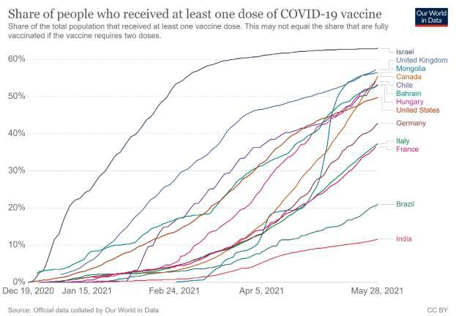

**Figure 8:-** Percentage of the total population who received at least one dose of Covid-19 Vaccine in some Selected Countries.

Source: A global database of COVID-19 vaccinations. Mathieu, E., Ritchie, H., Ortiz-Ospina, E. et al. Our World in Data. Nat Hum Behav (2021)

## Limitation

To date, there is no nano-based vaccine that has been formulated with complete safety and proven efficacy to combat SARS-CoV-2 to the general population especially to the immunocompromised and elderly individuals. Hence, the vulnerable population must seek their doctor‘s advice before getting the jab. The search for the best vaccine that is intended to completely eradicate the spread of the coronavirus is still a work in progress.

# Conclusion:-

The SARS-CoV-2 outbreak which began in December 2019 compelled the researchers and scientists worldwide to embark in finding a quick remedy for the mitigation and cure of SARS-CoV-2 infection. With minimal knowledge on the SARS-CoV-2 at the onset, researchers came with more questions than solutions. Hence, scientists worldwide rapidly address the problem in terms of studying its aetiology, epidemiology, pathogenesis and host immune response to the virus. Such detailed study on the coronavirus aims to develop rapid treatment in order to combat the fast widespread spread of the disease. But the advent of nano-based vaccines has given hope to the people

worldwide. Though some may not have given their submission for vaccination, scientists from the different pharmaceutical companies have proven an impressive efficacy of the nano-based vaccines.

Considering the above mentioned insights, the author would like to consider nanotechnology-based vaccines as an effective instrument to completely eradicate COVID-19 which has given economical and emotional damage as well as loss of the lives of the many worldwide. Nano-based vaccines formulation remains as the best tool to reach our main goal – to a Covid-free world.

# References:-

1. Ahmed, MK., Afifi, M. and Uskoković, V.(2020): Protecting healthcare workers during COVID-19 pandemic with nanotechnology: a protocol for a new device from EgyptJ. Infect. Public Health
2. Ahmed, S. F., Quadeer, A. A. & McKay, M. R. (2020): Preliminary identifcation of potential vaccine targets for the COVID-19 coronavirus (SARS-CoV-2) based on SARS-CoV immunological studies. Viruses 12, 254
3. Alpar, HO., Somavarapu, S., Atuah, KN., Bramwell, VW. (2005): Biodegradable mucoadhesive particulates for nasal and pulmonary antigen and DNA delivery.Adv Drug Deliv Rev. 57: 411-30
4. Andersen, K. G., Rambaut, A., Lipkin, W. I., Holmes, E. C. & Garry, R. F. (2020): The proximal origin of SARS-CoV-2. Nat. Med. 26, 450–452.
5. Baruah, V. & Bose, S. (2020): Immunoinformatics-aided identifcation of T cell and B cell epitopes in the surface glycoprotein of 2019-nCoV. J. Med. Virol. 92, 495–500
6. Bayda, S., Hadla, M., Palazzolo, S., Riello, P., Corona, G., Toffoli, G., et al. (2018): Inorganic nanoparticles for cancer therapy: A transition from lab to clinic. Curr Med Chem. 25: 4269-303.
7. Benvenuto, D. et al. (2020): The 2019-new coronavirus epidemic: Evidence for virus evolution. J. Med. Virol. 92, 455–459
8. Caron, J., Reddy LH., Lepêtre-Mouelhi, S. et al. (2010): Squalenoyl nucleoside monophosphate nanoassemblies: new prodrug strategy for the delivery of nucleotide analogues. Bioorganic Med ChemLett; 20: 2761–2764. DOI: 10.1016/j.bmcl.2010.03.070.
9. Carvalho, A. et. al., (2021): Recent Advances on Nanomaterials to COVID-19 Management: A Systematic Review on Antiviral/Virucidal Agents and Mechanisms of SARS-CoV-2 Inhibition/Inactivation. DOI: 10.1002/gch2.202000115
10. Chakraborty, C., Sharma, A.R., Sharma, G. Bhattacharya, M., Lee, S.S. (2020): SARS-CoV-2 causing pneumonia-associated respiratory disorder (COVID-19): diagnostic and proposed therapeutic options. DOI: 24: 4016-4026
11. Chen Y., Liu Q., and Guo D. (2020): Emerging coronaviruses: genome structure, replication, and pathogenesis. J Med Virol. 92(4):418–423.
12. Chua, BY., Al Kobaisi, M., Zeng, W., Mainwaring, D., Jackson, DC. (2012): Chitosan microparticles and nanoparticles as biocompatible delivery vehicles for peptide and protein-based immunocontraceptive vaccines. Mol Pharm. 9: 81-90
13. Diaz, D., Care, A. andSunna, A. (2018): Bioengineering strategies for protein-based nanoparticles. Genes. 9: 370.
14. Dobson, Peter, King, Stephen and Jarvie, Helen. "Nanoparticle". Encyclopedia Britannica, 14 May. 2019, https://[www.britannica.com/science/nanoparticle.](http://www.britannica.com/science/nanoparticle) Accessed 16 May 2021.
15. Enjuanes, L. et al. (2016): Molecular basis of coronavirus virulence and vaccine development. Adv. Virus Res. 96, 245–286
16. European Commission Health & Consumer Protection Directorate-General: SCENIHR (2006)
17. Fan, T., Yu, X., Shen, B., Sun, L. (2017): Peptide self-assembled nanostructures for drug delivery applications. J Nanomater.
18. Feldman, R. A. et al. (2019): mRNA vaccines against H10N8 and H7N9 infuenza viruses of pandemic
19. potential are immunogenic and well tolerated in healthy adults in phase 1 randomized clinical trials. Vaccine 20. 37, 3326–3334

21. Florindo ,H., Kleiner, R., Koubi, D. et. al., (2020): Immune-mediated approaches against COVID-19 Friedrichs, S. and Bowman, D. (2021): COVID-19 may become nanomedicine‘s finest hour yet. DOI:

22. https://doi.org/10.1038/s41565-021-00901-8

1. Gagliardi, M. (2017): Biomimetic and bioinspired nanoparticles for targeted drug delivery. Therapeutic Delivery, 8(5), 289–299. DOI:10.4155/tde-2017-0013
2. Gonzalez,JA., Ortega, O., Mendoza, S. (2015): Gold nanoparticles and vaccine development. Expert Rev Vaccines. 14: 1197-211.
3. Grifoni, A. et al. A (2020): sequence homology and bioinformatic approach can predict candidate targets for immune responses to SARS-CoV-2. Cell Host Microbe 27, 671–680e2
4. Hajizade, A., Ebrahimi, F., Salmanian, A., et al. (2014): Nanoparticles in vaccine development. J App Biotech Report. 1(4):125–134.
5. Hirotani, T. et al., (2005): The nuclear IkappaB protein IkappaBNS selectively inhibits lipopolysaccharide- induced IL-6 production in macrophages of the colonic lamina propria. J. Immunol. 174, 3650–3657
6. Hofmann, M. et al. (2020): SARS-CoV-2 Cell entry depends on ACE2 and TMPRSS2 and is blocked by a clinically proven protease inhibitor. Cell 181, 271–280
7. Hu, C. et al., (2011): Erythrocyte membrane-camouflaged polymeric nanoparticles as a biomimetic delivery platform. Proc. Natl. Acad. Sci. U.S.A. 108, 10980–10985
8. Huang, J.; Xie, Z.; Xie, Z.; Luo, S.; Xie, L.; Huang, L.; Fan, Q.; Zhang, Y.; Wang, S.; Zeng, T. (2016): Silver Nanoparticles Coated Graphene Electrochemical Sensor for the Ultrasensitive Analysis of Avian Influenza Virus H7. Anal. Chim. Acta. 913, 121−127.
9. Itani, R.et. al. (2020): Optimizing use of theranostic nanoparticles as a life-saving strategy for treating COVID- 19 patients. DOI: 10.7150/thno.46691
10. Jindal, S. and Gopinath, P. (2020): Nanotechnology based approaches for combatting COVID-19 viral infection. DOI: https://doi.org/10.1088/2632-959X/abb714
11. Kamaly, N., Xiao, Z., Valencia, PM., Moreno,AF.,Farokhzad, OC. (2012): Targeted polymeric therapeutic nanoparticles: design, development and clinical translation. ChemSoc Rev. 41: 2971-3010.
12. Kanekiyo, M. et al. (2013): Self-assembling infuenza nanoparticle vaccines elicit broadly neutralizing H1N1 antibodies. Nature 499, 102–106.
13. Khan, AA.,Allemailem, KS., Almatroodi, SA., Almatroudi, A., Rahmani, AH. (2020): Recent strategies towards the surface modification of liposomes: an innovative approach for different clinical applications. 3 Biotech. 10: 163.
14. Kim, Y., Park,EJ., Na, DH. (2018): Recent progress in dendrimer-based nanomedicine development. Arch Pharm Res. 41: 571-82.
15. Kobayashi, K., Wei, J., Iida, R., Ijiro, K. and Niikura, K.(2014): Surface engineering of nanoparticles for therapeutic applications Polym. J. 46 460–8
16. Kono, K. (2012): Dendrimer-based bionanomaterials produced by surface modification, assembly and hybrid formation. Polym J. 44: 531-40.
17. Kose, N. et al. (2019): A lipid-encapsulated mRNA encoding a potently neutralizing human monoclonal antibody protects against chikungunya infection. Sci. Immunol. 4, eaaw6647
18. Kumar, A., Pandey, AN., Jain, SK. (2016): Nasal-nanotechnology: revolution for efficient therapeutics delivery. Drug Deliv. 23: 671-83.
19. Kuo, Y.,Shiu Lin, M. et. al., (2021):Humanized COVID-19 decoy antibody effectively blocks viral entry and prevents SARS-CoV-2 infection. DOI: https://doi.org/10.15252/emmm.202012828
20. Kushnir, N., Streatfield,SJ.,Yusibov, V. (2012): Virus-like particles as a highly efficient vaccine platform: diversity of targets and production systems and advances in clinical development. Vaccine. 31: 58-83
21. Lan, J. et al. (2020): Structure of the SARS-CoV-2 spike receptor-binding domain bound to the ACE2 receptor. Nature 581, 215–220
22. Law, SL., Huang,KJ., Chou, VH., Cherng, JY. (2001): Enhancement of nasal absorption of calcitonin loaded in liposomes. J Liposome Res. 11: 165-74.
23. Lazarus, J. et. al., (2021): A global survey of potential acceptance of a COVID-19 vaccine. DOI: https://doi.org/10.1038/s41591-020-1124-9
24. Lei, C. et al. (2020): Neutralization of SARS-CoV-2 spike pseudotyped virus by recombinant ACE2-Ig. Nat. Commun. 11, 2070
25. Lucchese, G. (2020): Epitopes for a 2019-nCoV vaccine. Cell. Mol. Immunol. 17, 539–540
26. Mahmoud Nasrollahzadeh (2020): Nanomaterials and Nanotechnology-Associated Innovations against Viral Infections with a Focus on Coronaviruses. DOI: 10.3390/nano10061072
27. Mamo, T. and Poland, GA. (2012): Nanovaccinology: the next generation of vaccines meets 21st century materials science and engineering. Vaccine. 30:6609–6611
28. Marques,LM.,Kipnis, A., Kipnis, AP. (2017): Role of metallic nanoparticles in vaccinology: implications for infectious disease vaccine development. Front Immunol. 8: 239.
29. Mathieu, E., Ritchie, H., Ortiz-Ospina, E. et al. (2021): A global database of COVID-19 vaccinations. Nat Hum Behav
30. McNeil SE. (2011): Unique benefits of nanotechnology to drug delivery and diagnostics. Methods MolBiol; 697: 3–8. DOI: 10.1007/978-1-60327-198-1_1
31. Mhlwatika, Z., Aderibigbe, BA. (2018): Application of dendrimers for the treatment of infectious diseases. Molecules. 23: 2205.
32. Milovanovic, M., Arsenijevic, A., Milovanovic, J., Kanjevac, T. and Arsenijevic, N. (2017): Nanoparticles in Antiviral Therapy. Antimicrobial Nanoarchitectonics (United Kingdom: Elsevier) 383–410
33. Munoz, R. and Ribot, J. (2020): Nanotechnology as an Alternative to Reduce the Spread of COVID-19. DOI: 10.3390/challe11020015
34. Noura H AbdEllah (2020): Nanomedicine as a promising approach for diagnosis, treatment and prophylaxis against COVID-19. DOI: 10.2217/nnm-2020-0247
35. Palestino, G., Silva, I., Ortega, O.& Mendoza, S. (2020): Can nanotechnology help in the fight against COVID- 19?, Expert Review of Anti-infective Therapy, DOI: 10.1080/14787210.2020.1776115
36. Parboosing, R., Maguire, GE, Govender P, et al. (2012): Nanotechnology and the treatment of HIV infection. Viruses 2012; 4: 488–520. DOI: 10.3390/v4040488
37. Pardi, N., Hogan, M. J., Porter, F. W. &Weissman, D. (2018): mRNA vaccines — a new era in vaccinology. Nat. Rev. Drug Discov. 17, 261–279
38. Piluso, S., Soultan, AH., and Patterson, J. (2017): Molecularly engineered polymer-based systems in drug delivery and regenerative medicine. Curr Pharm Des. 23: 281-94. DOI: 10.2174/1381612822666161021104239
39. Poon, C. and Patel, A. (2020): Organic and inorganic nanoparticle vaccines for prevention of infectious diseases. Nano Express. 1:012001
40. Rai, M., Bonde, S., Yadav, A., et. al., (2020): Nanotechnology-based promising strategies for the management of COVID-19: current development and constraints, Expert Review of Anti-infective Therapy, DOI: 10.1080/14787210.2021.1836961
41. Rao, L., Xiab, S. and Xub, W. (2020): Decoy nanoparticles protect against COVID-19 by concurrently adsorbing viruses and inflammatory cytokines. DOI: 10.1073/pnas.2014352117/-/DCSupplemental.
42. Reina, G., Peng, S., Jacquemin, L., Andrade, A.F. and Bianco, A. (2020): Hard Nanomaterials in Time of Viral Pandemics. ACS Nano, American Chemical Society, 14 (8), pp.9364-9388. ff10.1021/acsnano.0c04117ff. ffhal- 03001620
43. Rodrigues, S., Cordeiro, C., Seijo, B., López, C. and Grenha, A.(2015): Hybrid nanosystems based on natural polymers as protein carriers for respiratory delivery: stability and toxicological evaluation Carbohydr. Polym. 123 369–80
44. Romero, G. and Moya, S. (2012): Synthesis of Organic Nanoparticles. DOI: 10.1016/B978-0-12-415769- 9.00004-2
45. Shin, Matthew et. al., (2020): COVID-19 vaccine development and a potential nanomaterial path forward. DOI: https://doi.org/10.1038/s41565-020-0737-y
46. Shukla, S. and Steinmetz, NF. (2015): Virus-based nanomaterials as positron emission tomography and magnetic resonance contrast agents: from technology development to translational medicine. Wiley Interdiscip Rev NanomedNanobiotechnol. 7: 708-21.
47. Singh, A. (2021): Eliciting B cell immunity against infectious diseases using nanovaccines. Nat. Nanotechnol. 16, 16–24. https://doi.org/10.1038/s41565-020-00790-3
48. Singh, L. (2017): The role of nanotechnology in the treatment of viral infections. DOI: 10.1177/ 2049936117713593
49. Singh, R.; Hong, S.; Jang, J. (2017): Label-Free Detection of Influenza Viruses using a Reduced Graphene Oxide-based Electrochemical Immunosensor Integrated with a Microfluidic Platform. Sci. Rep. 7, 42771.
50. Sonaje, K., Chuang,EY., Lin, KJ., Yen, TC., Su, FY., Tseng, MT., et al. (2012): Opening of epithelial tight junctions and enhancement of paracellular permeation by chitosan: microscopic, ultrastructural, and computed- tomographic observations. Mol Pharm. 9: 1271-9.
51. Song, Z. et al. (2019): From SARS to MERS, thrusting coronaviruses into the spotlight. Viruses 11, 59
52. Talebian, S. and Conde, J. (2020): Why Go NANO to COVID-19 Pandemic? DOI: https://doi.org/10.1016/j.matt.2020.08.005
53. Thamphiwatana, S. et al., (2017): Macrophage-like nanoparticles concurrently absorbing endotoxins and proinflammatory cytokines for sepsis management. Proc. Natl. Acad. Sci. U.S.A. 114, 11488–11493
54. Tripathi, GK., Rathore, H., Chavali, M. and Rathore, D. (2021): Nanotechnology For Mitigating Impact of COVID-19. https://doi.org/10.35877/454RI.asci151
55. Valdiglesias, V. and Laffon, B. (2020): The impact of nanotechnology in the current universal COVID-19 crisis. Let‘s not forget nanosafety!,Nanotoxicology. DOI: 10.1080/17435390.2020.1780332
56. Walls, A. C. et al. (2020): Structure, function, and antigenicity of the SARS-CoV-2 spike glycoprotein. Cell 181, 281–292
57. Wang, C. et al. (2020): A human monoclonal antibody blocking SARS-CoV-2 infection. Nat. Commun. 11, 2251
58. Wang, Y., Kang, N., Liu, Y., Shan, W., Bi, S., et al. (2016): Construction and immunological evaluation of CpG-Au@HBc Virus-like nanoparticles as a potential vaccine. Nanoscale Res Lett. 11: 338
59. Weiss, C., Carriere, M., Fusco, L. et. al., (2020): Toward Nanotechnology-Enabled Approaches against the Covid-19 Pandemic. ACS Nano. 14 (6), 6383-6406 DOI: 10.1021/acsnano.0c03697
60. Whitesides, GM. andGrzybowski, B. (2002): Self-assembly at all scales. Science. 295: 2418.
61. Worldometer, https://[www.worldometers.info/coronavirus/](http://www.worldometers.info/coronavirus/)
62. Wrapp, D. et al. (2020): Cryo-EM structure of the 2019-nCoV spike in the prefusion conformation. Science 367, 1260–1263.
63. Yan, R. et al. (2020): Structural basis for the recognition of SARS-CoV-2 by full-length human ACE2. Science 367, 1444–1448
64. Yoon, HY.,Jeon, S., You, DG., Park, JH., Kwon, IC., Koo, H, et al. (2017): Inorganic Nanoparticles for Image- Guided Therapy. Bioconjug Chem. 28: 124-34.
65. Yuan, M. et al. (2020): A highly conserved cryptic epitope in the receptor-binding domains of SARS-CoV-2 and SARS-CoV. Science 368, 630–633
66. Zaman, M., Good,MF.,and Toth, I.(2013): Nanovaccines and their mode of action. Methods. 60(3):226–231.