# Agro-Waste Research and Augmentation (AWRA) Phase 2: Carbonization of Rice Husk, Corn Stem and Husk and Giant Taro Peel as Raw Materials for

**Charcoal Briquettes**

***Abstract***

*This study used experimental approach in coming up with substitute material for charcoal briquettes as alternative fuel. Three agricultural waste were utilized and compared in the study, namely* Rice (*Oryza sativa*) husk, Corn (*Zea mays*) Stem and Husk, and Giant Taro (*Alocasia macrorrhizos*) peels*. It was found out that giant taro charcoal briquettes had the shortest duration recorded under the boiling ability test, allowing water to reach boiling point at the shortest amount of time though it was noted that among three alternatives, it burned out easily to ash. No significant differences were noted in terms of burning time and boiling ability. This study showed the potential of agricultural waste for bioconversion, to be specific carbonization as material for charcoal briquettes. It is looking into reusing agricultural waste and turning it for potential income source for the farmers. It could lessen the demand for hard wood charcoals thus minimizing the threat for deforestation. Carbonization can create smokeless fuel which could lessen the damage to the ozone layer further contributing the prevention of global warming. The study could be comprehensive by recalibration of proportion for charcoal briquettes to determine the perfect consistency for maximum effect. Further studies and a more in-depth investigation of alternative sources and reusing agricultural waste is recommended.*

***Keywords:*** *Farmer, Agricultural Waste Management, Alternative Fuel, Charcoal Briquettes*

# Technical Description

* + Rationale

Agricultural waste management has recently received attention among researchers who are interested in understanding its nature and sustainability (Foley et al., 2011). In the past, agricultural waste management researchers focused on the facet of this management variable in areas of understanding the concept (Obi, Ugwuishiwu, & Nwakaire, 2016), generation (Girotto, Alibardi, & Cossu, 2015), production (Chandra, Takeuchi, & Hasegawa, 2012), food bioconversion (Uçkun Kiran, Trzcinski, Ng, & Liu, 2014), utilization (Väisänen, Haapala, Lappalainen, & Tomppo, 2016), biodegradation (Emadian, Onay, & Demirel, 2017), valorization (Tuck, Pérez, Horváth, Sheldon, & Poliakoff, 2012), and profitability (Mel, Yong, Avicenna, Ihsan, & Setyobudi, 2015).

Globally, humans generate 998 million tons of agro-waste annually which makes up 15% of the total waste generation (André, Pauss, & Ribeiro, 2018). The Philippines, in particular, is generating agricultural waste of 0.078 kg/cap/day or 780,000 tons of agro-waste in a year (Agamuthu, 2009). The country is looking into zero waste initiative (Sapuay, 2016) that could lessen the production thus doing less damage to the environment. In Region 8, rice, corn and cassava are the top three crops produced. It posted a 1.11% growth in rice production from 984,017 to 994,972 metric tons or a 98% sufficiency index. Likewise, cassava production

increased by 3.95% from 78,805.43 to 81,918.12 metric tons (Department of Agriculture - Regional Field Unit VIII, 2015).

With all of the information given, it bounces back to the question, why there are so much agro-waste generated? Are there necessary steps taken to solve it? Is there a way to convert agro-waste into something useful? Is bioconversion even possible?

The questions presented motivated the researcher to focus on agricultural waste (rice husk, corn stem and husk, and giant taro peels) carbonization as material for charcoal briquettes. There is a need to look into the acceptability of these materials and how it would fare with the traditional charcoal, hence the conduct of this study.

* + Objectives

# General Objective:

This study opted to carbonize agricultural waste from the utilization of Rice (*Oryza sativa*) husk, Corn (*Zea mays*) Stem and Husk, and Giant Taro (*Alocasia macrorrhizos*) peels as biomass converted to charcoal briquettes.

# Specific Objectives:

1. Find out the potential of agricultural waste from the utilization of Rice (*Oryza sativa*) husk, Corn (*Zea mays*) Stem and Husk, and Giant Taro (*Alocasia macrorrhizos*) peels as alternative materials for charcoal briquettes in terms of its:
   1. Burning Time
   2. Boiling Ability
2. Compare the quality of agricultural waste from the utilization of Rice (*Oryza sativa*) husk, Corn (*Zea mays*) Stem and Husk, and Giant Taro (*Alocasia macrorrhizos*) peels as alternative materials for charcoal briquettes in terms of its:
   1. Burning Time
   2. Boiling Ability
3. Find out which from the three (3) alternative material for charcoal briquettes has the best qualities in terms of its:
   1. Burning Time
   2. Boiling Ability

# Review of Literature

Sixty percent (60%) of the world’s population heats and cooks on charcoal and wood. Making the latter the most important source of energy than oil (Gochicoa-Rangel & Torre-Bouscoult, 2011). This, in turn, poses a disastrous consequence on trees, threats of deforestation (Chidumayo & Gumbo, 2013). Furthermore, such action contributes to the emission of harmful gases, carbon dioxide with emission of 71.20 million tons (Yazdanparast et al., 2013) and methane with 1.3 million tons (Kopetz, 2013).

With such issues of ecological hazards, researches on sustainability (Felix, 2015) and alternative source of substitute fuel (Nunes, Matias, & Catalão, 2016) over conventional fuel, such as wood, charcoal, and coal, is of most importance. In a world where human population is growing at an unprecedented rate, the demand for conventional fuel increases (John, Anisha, Nampoothiri, & Pandey, 2011). Resulting to more trees being cut outfacing the growth of new tress (Phillips et al.,

2010). An increase demand could lead to soaring prices (Gkanoutas-Leventis & Nesvetailova, 2015), which could present dire consequences of wasteful burning of woods and irreversible spread of treeless scenery.

Continuing concerns on energy security (Dolata, 2017) and obvious visibility of climate change and global warming (Foster, 2018), alternative source of energy is coming into prominence and is entering a new chapter of high importance. With the Philippines, generating 780,000 tons of agro-waste in a year, the country is looking into a hot bed of possibilities (Agamuthu, 2009).

Agricultural waste carbonization is an alternative way of producing materials for charcoal briquettes instead of the usual wood (Ronsse, Nachenius, & Prins, 2015). Instead of agricultural waste burning, using it as a fuel source (Fatih Demirbas, Balat, & Balat, 2011) slows deforestation advancement by eliminating the need to cut down trees for wood fuel.

Charcoal briquettes are smokeless advanced fuel and can be stored for longer periods without episodes of degradation (Mwampamba, Owen, & Pigaht, 2013). Repurposing the agricultural waste could not only help in attaining a zero- waste future but could also expand farming potentials and opportunities (Yahya, Al-Qodah, & Ngah, 2015).

# Methodology

* + Materials and Equipment Needed

|  |  |  |
| --- | --- | --- |
| **Quantity** | **Description** | **Source** |
| **Materials** | | |
| 1000 grams | Rice Husk | Agro-waste |
| 1000 grams | Corn Husk and Stem | Agro-waste |
| 1000 grams | Giant Taro Peels | Agro-waste |
| **Equipment** | | |
| 1 box | Disposable Gloves | Local Market |
| 1 piece | Weighing Scale | Residence |
| 1 piece | Food Processor | Residence |
| 2 pieces | Mixing Bowl | Residence |
| 1 piece | Spatula | Residence |
| 1 piece | Improvised Carbonizer | Local Market and  Residence |

* + Process Flowchart

**Collection of Materials**

**Sun and Manual Drying of the Agricultural Waste**

**Grinding of the Dried Agricultural Waste**

**Mixing the Ground Dried Agricultural Waste with**

**Molding the Charcoal Briquettes**

**Sun and Manual Drying of the Charcoal Briquettes**

* + Proportion of Materials per Charcoal Briquettes

|  |  |  |  |
| --- | --- | --- | --- |
| **Proportion A** | **Proportion B** | **Proportion C** | **Proportion D** |
| **Charcoal**  **Briquette A** | **Charcoal**  **Briquette B** | **Charcoal**  **Briquette C** | **Wood Charcoal** |
| 195 grams Rice Husk | 195 grams Corn Husk and Stem | 195 grams Giant Taro Peels | 200 grams Wood Charcoal |
| 5 grams Biomass Binder | 5 grams Biomass Binder | 5 grams Biomass Binder |

* + Research Design

This study utilized a controlled experimental design, specifically quasi- experimental design, of which isolation, augmentation, control, as well as data analysis are conducted under laboratory conditions (Fraenkel & Wallen, 2006).

* + Experimental Phase and Data Analysis

For gauging the effectiveness of the charcoal briquettes, burning time and boiling ability tests were conducted. Testing the burning time simply means from the ignition of the briquette samples as well as the control and measuring the duration or how long will it sustain the flame until it completely turns to ash. Likewise, measuring boiling ability means subjecting each proportion to boiling a 100 ml of water, measuring the time for the water to reach its boiling point.

The variation in time for the two tests were subjected to statistical analysis, both descriptive and inferential statistics, with the aid of Microsoft Excel Data Analysis and SPSS.

# Results and Discussion

The technology generated in the study centers around the utilization of agricultural waste, bioconversion in the form of carbonization and tackling the issues on agricultural waste management, threats of deforestation and alternative fuel sources. This study is brainchild of the Agro-Waste Research and Augmentation (AWRA) Phase 1 study with the same aim of farmer empowerment

and agricultural innovation. It is looking into reusing agricultural waste and turning it for potential income source for the farmers. It could lessen the demand for hard wood charcoals thus minimizing the threat for deforestation. Carbonization can create smokeless fuel which could lessen the damage to the ozone layer further contributing the prevention of global warming.

# Burning Time Test

|  |  |  |  |  |
| --- | --- | --- | --- | --- |
| **Proportions** | **Trials in Time (Minutes)** | | | **Average (Minutes)** |
| **1** | **2** | **3** |
| **Charcoal Briquette A**  **(Rice)** | 38:07.9 | 39:30.1 | 49:58.21 | **42:32.07** |
| **Charcoal Briquette B**  **(Corn)** | 39:57.6 | 48:26.11 | 40:27.6 | **42:70.43** |
| **Charcoal Briquette C**  **(Giant Taro)** | 37:48.7 | 36:31.8 | 39:28.7 | **37:39.73** |
| **Wood Charcoal** | 48:50.27 | 50:16.9 | 49:16.4 | **49:27.85** |

Table showed the result of the burning time test which highlighted that the proportion with the longest duration of burning time or with the highest average is that of the wood charcoal with 49 minutes, 27 seconds. Likewise, it can be gleamed that giant taro proportion had the shortest burning time duration with 37 minutes and 39 seconds. This means that the giant taro briquettes quickly turned to ash. Proportions A and B, rice charcoal briquettes and corn charcoal briquettes manifested an almost the same average burning time.

# Boiling Ability Test

|  |  |  |  |  |
| --- | --- | --- | --- | --- |
| **Proportions** | **Trials in Time (Minutes)** | | | **Average (Minutes)** |
| **1** | **2** | **3** |
| **Charcoal Briquette A**  **(Rice)** | 6:27.53 | 5:31.24 | 4:05.49 | **5:21.42** |
| **Charcoal Briquette B**  **(Corn)** | 5:35.50 | 6:18.14 | 5:10.53 | **5:54.07** |
| **Charcoal Briquette C**  **(Giant Taro)** | 6:09.28 | 4:52.19 | 4:38.65 | **5:00.04** |

|  |  |  |  |  |
| --- | --- | --- | --- | --- |
| **Wood Charcoal** | 5:11.11 | 7:35.44 | 5:22.71 | **6:29.75** |

Table showed the result of the boiling ability test between alternative charcoal briquettes and wood charcoal in three trials. Likewise, it can be noted that giant taro briquettes posted the lowest time for water to reach the boiling point, specifically, 5 minutes. This means that the giant taro briquettes can generate a higher temperature compared to the other three proportions. Wood charcoal posted the lowest average time, 6 minutes and 29 seconds, thus it takes longer for water to reach its boiling point when exposed to wood charcoal.

Upon subjecting the results of both test to statistical analysis, it was found that there was no significant difference in the burning time and boiling ability of the the alternative charcoal briquettes and wood charcoal.

# Summary, Conclusion and Recommendation

* + Summary

It was found out that giant taro charcoal briquettes had the shortest duration recorded under the boiling ability test, allowing water to reach boiling point at the shortest amount of time though it was noted that among three alternatives, it burned out easily to ash. No significant differences were noted in terms of burning time and boiling ability.

* + Conclusion

This study showed the potential of agricultural waste for bioconversion, to be specific carbonization as material for charcoal briquettes. It is looking into reusing agricultural waste and turning it for potential income source for the farmers. It could lessen the demand for hard wood charcoals thus minimizing the threat for deforestation. Carbonization can create smokeless fuel which could lessen the damage to the ozone layer further contributing the prevention of global warming.

* + Recommendations

The study could be comprehensive by recalibration of proportion for charcoal briquettes to determine the perfect consistency for maximum effect. Further studies and a more in-depth investigation of alternative sources and reusing agricultural waste is recommended.

# Literature Cited

André, L., Pauss, A., & Ribeiro, T. (2018). Solid anaerobic digestion: State-of-art, scientific and technological hurdles. *Bioresource Technology*. https://doi.org/10.1016/j.biortech.2017.09.003

Chandra, R., Takeuchi, H., & Hasegawa, T. (2012). Methane production from lignocellulosic agricultural crop wastes: A review in context to second generation of biofuel production. *Renewable and Sustainable Energy Reviews*. https://doi.org/10.1016/j.rser.2011.11.035

Chidumayo, E. N., & Gumbo, D. J. (2013). The environmental impacts of charcoal production in tropical ecosystems of the world: A synthesis. *Energy for Sustainable Development*. https://doi.org/10.1016/j.esd.2012.07.004

Dolata, P. (2017). Energy security. In *The Palgrave Handbook of Security, Risk*

*and Intelligence*. https://doi.org/10.1057/978-1-137-53675-4_3

Emadian, S. M., Onay, T. T., & Demirel, B. (2017). Biodegradation of bioplastics in natural environments. *Waste Management*. https://doi.org/10.1016/j.wasman.2016.10.006

Fatih Demirbas, M., Balat, M., & Balat, H. (2011). Biowastes-to-biofuels. *Energy Conversion and Management*. https://doi.org/10.1016/j.enconman.2010.10.041

Felix, M. (2015). Future prospect and sustainability of wood fuel resources in Tanzania. *Renewable and Sustainable Energy Reviews*. https://doi.org/10.1016/j.rser.2015.06.034

Foley, J. A., Ramankutty, N., Brauman, K. A., Cassidy, E. S., Gerber, J. S., Johnston, M., … Zaks, D. P. M. (2011). Solutions for a cultivated planet. *Nature*. https://doi.org/10.1038/nature10452

Foster, I. (2018). Climate change. In *On the Ecology of Australia’s Arid Zone*. https://doi.org/10.1007/978-3-319-93943-8_14

Fraenkel, J. R., & Wallen, N. E. (2006). The Basic of Educational Research. In

*How to design and evaluate resaerch in education with PowerWeb*.

Girotto, F., Alibardi, L., & Cossu, R. (2015). Food waste generation and industrial uses: A review. *Waste Management*. https://doi.org/10.1016/j.wasman.2015.06.008

Gkanoutas-Leventis, A., & Nesvetailova, A. (2015). Financialisation, oil and the Great Recession. *Energy Policy*. https://doi.org/10.1016/j.enpol.2015.05.006

Gochicoa-Rangel, L., & Torre-Bouscoult, L. (2011). Pollution/biomass fuel exposure and respiratory illness in children. *Paediatric Respiratory Reviews*. https://doi.org/10.1016/s1526-0542(11)70030-6

John, R. P., Anisha, G. S., Nampoothiri, K. M., & Pandey, A. (2011). Micro and macroalgal biomass: A renewable source for bioethanol. *Bioresource Technology*. https://doi.org/10.1016/j.biortech.2010.06.139

Kopetz, H. (2013). Renewable resources: Build a biomass energy market. *Nature*. https://doi.org/10.1038/494029a

Mel, M., Yong, A. S. H., Avicenna, Ihsan, S. I., & Setyobudi, R. H. (2015). Simulation Study for Economic Analysis of Biogas Production from Agricultural Biomass. *Energy Procedia*. https://doi.org/10.1016/j.egypro.2015.01.026

Mwampamba, T. H., Owen, M., & Pigaht, M. (2013). Opportunities, challenges and way forward for the charcoal briquette industry in Sub-Saharan Africa. *Energy for Sustainable Development*. https://doi.org/10.1016/j.esd.2012.10.006

Nunes, L. J. R., Matias, J. C. O., & Catalão, J. P. S. (2016). Wood pellets as a sustainable energy alternative in Portugal. *Renewable Energy*. https://doi.org/10.1016/j.renene.2015.07.065

Obi, F., Ugwuishiwu, B., & Nwakaire, J. (2016). AGRICULTURAL WASTE CONCEPT, GENERATION, UTILIZATION AND MANAGEMENT.

*Nigerian Journal of Technology*. https://doi.org/10.4314/njt.v35i4.34 Phillips, O. L., van der Heijden, G., Lewis, S. L., López-González, G., Aragão, L.

E. O. C., Lloyd, J., … Vilanova, E. (2010). Drought-mortality relationships for tropical forests. *New Phytologist*. https://doi.org/10.1111/j.1469-8137.2010.03359.x

Ronsse, F., Nachenius, R. W., & Prins, W. (2015). Carbonization of Biomass. In

*Recent Advances in Thermochemical Conversion of Biomass*. https://doi.org/10.1016/B978-0-444-63289-0.00011-9

Sapuay, G. P. (2016). Resource Recovery through RDF: Current Trends in Solid Waste Management in the Philippines. *Procedia Environmental Sciences*. https://doi.org/10.1016/j.proenv.2016.07.030

Tuck, C. O., Pérez, E., Horváth, I. T., Sheldon, R. A., & Poliakoff, M. (2012).

Valorization of biomass: Deriving more value from waste. *Science*. https://doi.org/10.1126/science.1218930

Uçkun Kiran, E., Trzcinski, A. P., Ng, W. J., & Liu, Y. (2014). Bioconversion of food waste to energy: A review. *Fuel*. https://doi.org/10.1016/j.fuel.2014.05.074

Väisänen, T., Haapala, A., Lappalainen, R., & Tomppo, L. (2016). Utilization of agricultural and forest industry waste and residues in natural fiber-polymer composites: A review. *Waste Management*. https://doi.org/10.1016/j.wasman.2016.04.037

Yahya, M. A., Al-Qodah, Z., & Ngah, C. W. Z. (2015). Agricultural bio-waste materials as potential sustainable precursors used for activated carbon production: A review. *Renewable and Sustainable Energy Reviews*. https://doi.org/10.1016/j.rser.2015.02.051

Yazdanparast, T., Salehpour, S., Reza Masjedi, M., Mohammad Seyedmehdi, S., Boyes, E., Stanisstreet, M., & Attarchi, M. (2013). Global warming: Knowledge and views of Iranian students. *Acta Medica Iranica*.

1. **Documentation**

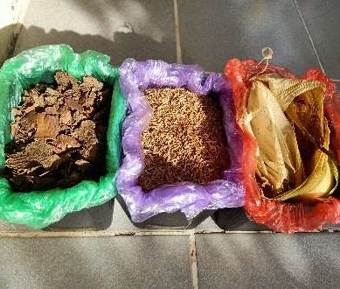

**1. Collection of Materials**

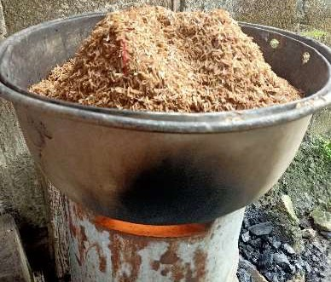

**2. Sun and Manual Drying of the Agricultural Waste**

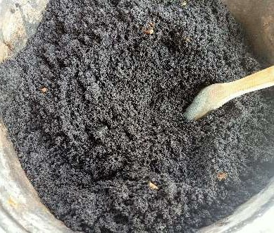

**3. Grinding of the Dried Agricultural Waste**

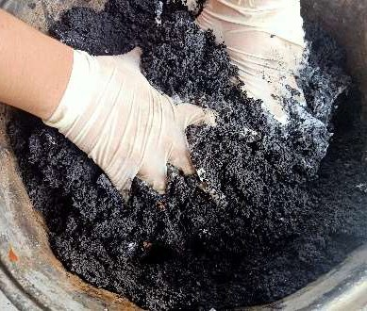

**5. Mixing the Ground Dried Agricultural Waste**

**with Prepared Binder**

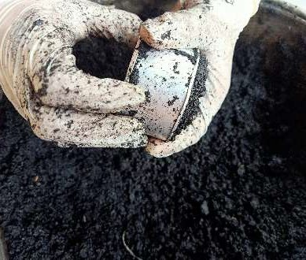

**6. Molding the Charcoal Briquettes**

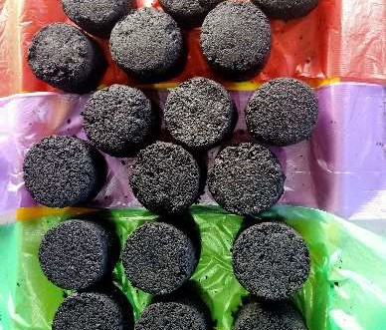

**7. Sun and Manual Drying of the Charcoal Briquettes**

**for 1 Day**

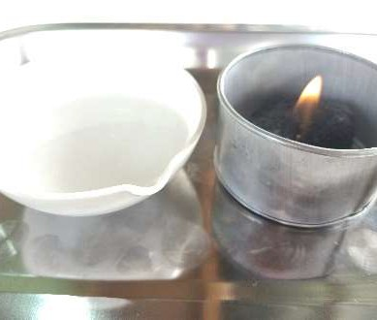

**8. Testing the Charcoal Briquettes for Burning Time and Boiling Ability**

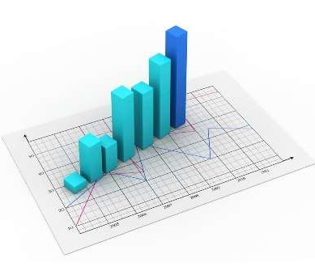

**9. Gathering of Statistical Analysis**