**E-Safety in the Use of Social Networking Application**

**Geliza I. Alcober1, Teodoro F. Revano, Jr2., Manuel B. Garcia3** 1FEU Institute of Technology, Philippines, [gialcober@feutech.edu.ph](mailto:gialcober@feutech.edu.ph) 2FEU Institute of Technology, Philippines, [tfrevanojr@feutech.edu.ph](mailto:tfrevanojr@feutech.edu.ph) 3FEU Institute of Technology, Philippines, [mbgarcia@feutech.edu.ph](mailto:mbgarcia@feutech.edu.ph)

# ABSTRACT

There has been an extensive problem that is connected to various actions such as cyberbullying, exposure to violent content that provokes hatred, online privacy, communicating with strangers online, and coarse languages. This issue involves safety. There has been a recent study about the routine of social networking apps (SNAs) by netizens of different ages and their point of view. Due to the continuous development of usage of the SNAs by individuals of different ages, this paper aimed to observe and examine the activities used from the perspective of the netizens including sharing, habits, and dangers to be able to serve as a guide in developing an e-safety application.

**Key words :** social networking applications, e-safety, shaming, whatsapp, privacy, cyberbullying.

# 1. INTRODUCTION

HE research aimed to examine and analyze the view such as 1. usage of SNA; 2. electronic security of SNA; 3. differences of group such as gender and age; 4. traditional use;

T

5. risks and solutions; and 6. parental control by following the extensive usage of SNA

# SOCIAL NETWORKING APPS (SNAS)

Being safe is one of the foremost matters to the society and to a variety of activities along with cyberbullying, privacy online, violent contents that creates hatred, communicating using expletive languages with strangers online. Cyberbullying is an action intended to harm another person through online via verbal, video, audio, and other online applications [13]. The common examples are flaming, denigration, harassment, exclusion, impersonation, deception, cyber threats, cyber stalking, computer viruses and crashes, website attacks, and many more [13]. People are social creatures thus they want to be part of a social group to be recognized and to be loved by others. Interpersonal relationships are important to meet basic human needs according to [8]. Having friends satisfy psychosocial needs of children and adolescents. Only through having friends can satisfy this need. They also allow

individuals to be intimate, be empathetic, and gain new perspectives in life as well as solving social problems. And also offer emotional support, companionship, affiliation, relatedness and involvement [8]. Social Networking Apps (SNAs), namely Facebook, Twitter, Instagram and WhatsApp, are the trending online applications used by the youth [20]. The structure of our social interactions is now commonly used as a tool for communication and networking to integrate SNAs. [16]. SNAs give individuals a chance to associate to one another and form new relationships [9]. The use online teenagers of social media are 81 percent [23]. Most people today especially the younger generations use social networking sites. Reportedly children spend more than a day per month online [1], and young people are using the internet more for communication than instrumental purposes [27].

By 2006, 9 out of 10 American teenagers use the internet, and half of them use social networking sites [10].

# SATISFYING THE NEED OF CHILDREN AND ADOLESCENT

Does hand-on-hand communication or confrontation bring improvement to the children together with networked communication? According to [8], children that has been invited to compare offline and online means of communication has findings that 50% which are composed of children whose age ranges to 11-16-year-old are users of internet across the continent of Europe, saying that it is a bit or much comfortable to be themselves on the internet rather than having talk or confrontation; 45% have and talk about different issues and topics about the happenings online rather than talking to different individuals on the spot. Another 32% claim that they talk about private issues online in which they do not have the intent to distribute with people face-to-face. Majority of the children either online or offline communication says that these two modes are not that distinct or different from each other but for the latter half, the online world offers opportunities and possibilities for more diverse, confidential and convincing communication – given that some research findings shows that teens are having a hard time to handle confrontations.

Findings of study show that teen friendships are dependable key points of social adjustment, an overall health and confidence [7]. The management and the use of SNAs by different individuals like adolescents, young adults and even children were examined. These are the following that are needed to be examined from (a) usage of social network application and its characteristics; (b) SNA and its internet safety; (c) different habits; (d) solutions and hazards; (e) parental control and discussion.

# METHODOLOGY

The methodology used to gather data is a mixed methodology. The collection of data was done in year 2019.

# SAMPLE

The sample respondents of the study include a totality of 551 respondents from the city of Manila, Philippines, whom consists of female with a percentage of 71.1% and males with a percentage of 28.0%. In line with its aimed goal, the respondents were divided in a groups of three: children (aged 15 years and below; 31%), adolescents (aged 15-18 years; 34%), and lastly young adults (aged 18-24 years; 35%), given a median age value of 18.4 (Standard Deviation – 3.7). A written consent was given to the said individuals who participated in the study while those who did not sign were prohibited to participate, inclusive of the minors without the consent of their parents.

# TOOLS

The study used a quantitative mixed methodology in line to the qualitative element. The study sample of 551 participants answered questionnaires, and total of 110 participants were interviewed. The interviewees were composed of young adults, children, and the preference tools of the media were based on past studies.

**SNA USAGE PATTERN**

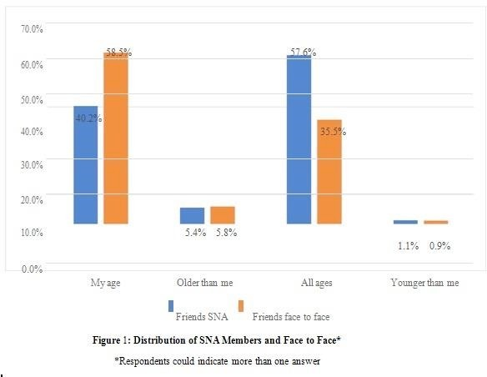In a week, the number of different activities is: Dissemination differences, indices and connections. Five main groups are formed where in each is composed of the different activities listed below.

As shown in table 1, it can infer that the connections in each activity are significant and positive correlations in the middle of the SNAs usage, telephone calls, member meetings, and self-reliant automated activities on the web. The findings imply that the said reinforced activities are interrelated to one another. Combining the volume of 10.2 hours is higher than other activities. The time expended on phone calls with 5.9 hours was not significant difference on meeting friends and self-reliant automated and digital activities.

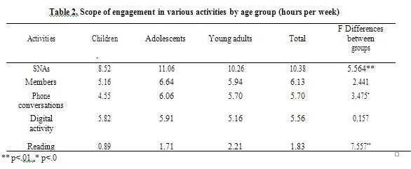

From table 2, the significant difference in use of applications among the children, the adolescents with 5.564. The results show that characteristics of the said respondents were examined in the SNAs given with different percentage to the age differences those children, adolescents and young adults.

Survey shows friends in the SNA were given were given a chance to have multiple answers to make the percentage exact or higher than the 100%.

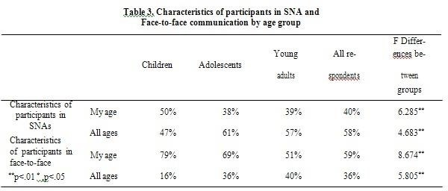

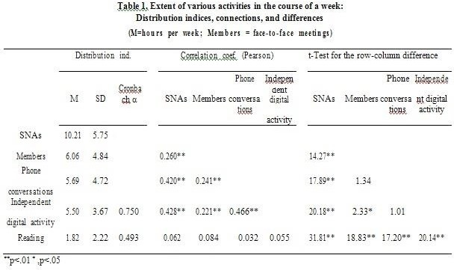

# HAZARDS OF SNA USAGE

The table had shown the outcome of the participants and their answers and opinions intrinsic in the use of SNAs using qualitative analysis.

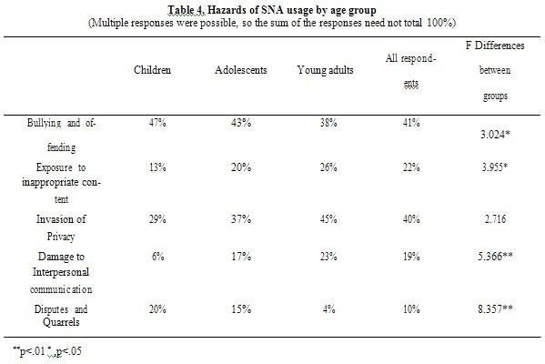

The percentage of children seemingly expose in appropriate content was 13% lower than adolescents with 20% and 26% for young adults. The results believe the possible damage and danger caused by SNAs to interpersonal relationship.

# SOLUTIONS TO SNA-RELATED HAZARDS

The table 5 shows the results made by the respondents on how they will avoid the hazards, risks and dangers naturally occurring in when using SNA. Comparing the percentages, children with a 19% is lower compared to the adolescents who have a 36% same with the young adults with 36%, admitting that one can be in threat or danger in social network app (SNA) can be lessened by having self-discipline and responsibility. Comparing the percentage of adolescents with 5% and young adults with 10% to children with 14%, they have a smaller proportion believing that dangers, risks, and hazards in using SNAs could be avoided when one lessens the use of it. The results show that the 30% of the children speculated that the control and application can fend off the threat of being endangered and the stands and opinions are higher and similar in the use of applications.

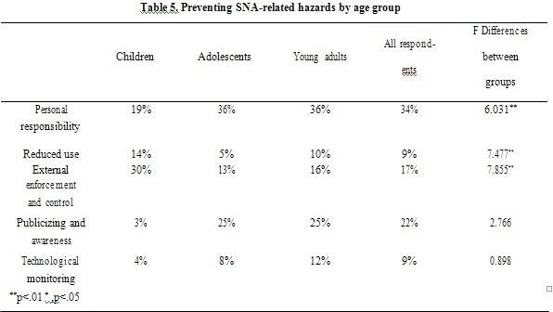

# HAZARDS AND SOLUTIONS IN SNA

The table shows the understanding of threats, dangers and problems in the use of SNAs using qualitative analysis. The respondents have connection to the solutions of SNAs and

suggest different samples of solutions and establish a multiple answer.

# PARENTAL CONTROL

The figure 2 shows that parents are checking their children phone which resulted to mother got 94% and father got 89% use the applications while the rest completely ignores.

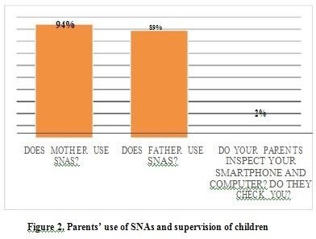

The respondents explained the reason why parents did not check their phone and layout more than one answer.

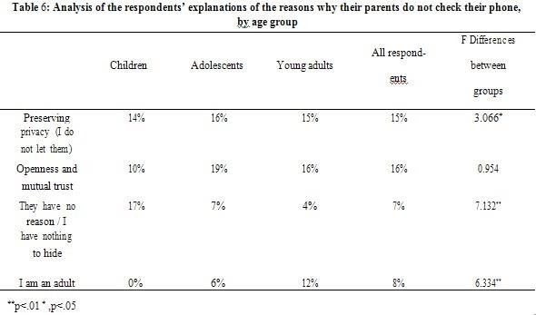

In the openness and mutual trust of parents and children according to age are no differences. The results of the percentage are for the adolescents with 7% and 4% for young adults.

# DISCUSSION

The internet safety issues in the use of SNAs from the perception of individuals of different ages.

# CHARACTERISTICS OF SNA USAGE

The relationships of several activities such as bonding and assembly of friends, mobile incoming and outgoing call, and independent digital activities on the network indicate the connections and positive use of SNAs. These relationships are consistent and largely enhance with each other. A comparable finding was reported by [11]. The researchers of the study utilized the concept of “interdependence”: the higher the

number of children who uses applications, the broader they are exposed to higher risks than those who do not use SNAs.

The application membership reveals in figure 1 have said that peers in the SNAs belong to group of ages. The respondents indicate the offline or face-to-face communication can be counter parted that resulted to discourse and does not show many differences.

# SNA-RELATED HAZARDS

The results in table 4 shows that bullying, shaming and harming others are the hazards, risks and threats encountered by the respondents. The offensive and exposure content also mentioned got 41%. The group of all ages believe that bullying and some injuries to others are the two of the main reasons in the use of SNAs. These two dangers suggested to install visible network to privacy associated problems.

# PARENTAL CONTROL

From the perception of the respondents, 2% of respondents said that their parent frequently checks their smartphone and computer and monitor them. While 15% of respondents said that their parents are not allowed to look and check personal belongings such as gadgets, smartphones and computer with the reason of privacy. On the other hand, 16% stated they have mutual trust among the children and parents and children are open to their parents. The respondents agreed that exposing and sharing of the issues regarding the usage of social media are good and giving them awareness to themselves and for the others. Some parents are having limited of accessing and monitoring of use of SNAs that resulted to exercise ethical control and emphasizing their trust in their children’s. There were no age gaps regarding the mutual trust and honesty between children and parents during the procedure of SNAs usage of parental supervision. With the results that the researchers have gathered, monitoring was perceived as an invasion of their privacy but there was no parental control.

# CONCLUSION

Dealing with such shame is necessary, both in offline and online communication. Therefore, the efforts and intentions must be made in extent to determine a resolution for the subject matter including the problems of humiliation of individuals in certain group, and to point out the value of protecting an individual’s privacy and dignity. Generally, SNAs are an essential part of today’s young generation’s daily system of life, in a way that SNAs are also somewhat a component of the problem or issue because it results to the development of humiliation. On the contrary, they can also be a solution and answer. Communications are exactly detailed, unlike in a physical confrontation in which individuals are put up to the challenge like to observe events, to retain the exact words that an individual spoke, to point out the sequence of events, etc. In this point of time it is feasible and a must to find the solutions on shaming and humiliation in offline

communication and online communication (SNA). It is solely based on the perspective of the young-aged group given that this is their natural environment. The information gathered on this study served as a guide in developing an e-safety application.

# REFERENCES

1. E.B. Dowdell, A. w. Burgess & J.R. Flores, J. R. **Online Social Networking Patterns Among Adolescents, Young Adults, and Sexual Offenders.** AJN, American Journal of Nursing, 111(7), 28–36. doi:10.1097/01.naj.0000399310.83160.73 , 2011.
2. A. Lenhart, et.al. **Social Media and Mobile Internet Use among Teens and Young Adult**, retrieved January 2018, from https://files.eric.ed.gov/fulltext/ED525056.pdf

,2010.

1. M. Madden, et. al. **Teens and Social Media**, retrieved January 2018, from

https://[www.pewinternet.org/wp-content/uploads/sites/9/](http://www.pewinternet.org/wp-content/uploads/sites/9/) media/Files/Reports/2007/PIP_Teens_Social_Media_Fina l.pdf.pdf , 2007.

1. Alexa Internet Incorporation. **Alex Top 500 Global Sites**, 2011
2. N. Ellison, C. Steinfield & Lampe C. **The benefitss of Facebook, Social Capital and College Students’ Use of Online Social Network Sites**, Journal of Computer-Mediated Communication, Volume 12, Issue 4, 1 July 2007, Pages 1143–1168, https://doi.org/10.1111/j.1083-6101.2007.00367.x 2007
3. R. Baumeister & M Leary. **The Need to Belong: Desire for Interpersonal Attachements as a Fundamental human Motivation,** Psychological Bulletin, 117(3), 497–529. https://doi.org/10.1037/0033-2909.117.3.497 1995
4. W. Sartup. **Friendships and their developmental Significance**, Child Development Vol. 67, No. 1 Society for Research in Child Development, DOI: 10.2307/1131681, pp. 1-13 1992
5. S. Lim, S. **Through The Tablet Glass: Transcendent Parenting in an Era of mobile media and cloud computing,** Journal of Children and Media, 10:1, 21-29, DOI: 10.1080/17482798.2015.1121896 , 2016
6. J. Ringrose, L. Harvey, R. Gill, R., & S. Livingstone. **Teen girls, sexual double standards and ‘sexting’: Gendered value in digital image exchange,** retrieved Januray 2018 from https://journals.sagepub.com/doi/10.1177/146470011349 985, https://doi.org/10.1177/1464700113499853, **2016**
7. A. Lenhart, K. Purcell, A. Smith, & K. Zickuhr. **Social media & mobile internet use among teens and young adults. Washington: Pew Internet and American Life Project,** retrieved January 2018 from https://eric.ed.gov/?id=ED525056, 2010
8. S. Lim. **Through the tablet glass: Transcendent parenting in an era of mobile media and cloud computing,** Journal of Children and Media, 10:1, 21-29,

DOI: 10.1080/17482798.2015.1121896 2016

1. S. Livingstone. **Taking risky opportunities in youthful content creation: Teenagers’ use of social networking sites for intimacy, privacy and self-expression**,Retrieved Jannuary 2018 from https://journals.sagepub.com/doi/10.1177/146144480808 9415, https://doi.org/10.1177/1461444808089415, 2008
2. T. Berndt. **Exploring the effects of friendship quality on social development**, n W. M. Bukowski, A. F. Newcomb, & W. W. Hartup (Eds.), Cambridge studies in social and emotional development. The company they keep: Friendship in childhood and adolescence (p. 346–365). Cambridge University Press 1996.
3. S. Livingstone & A. Görzig **When adolescents receive sexual messages on the Internet: Explaining experiences of risk and harm,** Computers in Human Behavior, Volume 33,Pages 8-15, ISSN 0747-5632, https://doi.org/10.1016/j.chb.2013.12.021. 2014
4. S., Haddon & A. Görzig, **Children, risk and safety on the internet: Research and policychallenges in comparative perspective,** Bristol University Press, Policy Press DOI: 10.2307/j.ctt9qgt5z, Pages: 408 2012.
5. M. Madden A. Lenhart, S. Cortesi, U. Gasser, M. Duggan, A. Smith, & M. Beaton.**Teens, social media, and privacy**, Retrieved January 2018 from https://[www.pewresearch.org/internet/2013/05/21/teens-](http://www.pewresearch.org/internet/2013/05/21/teens-) social-media-and-privacy/ 2010.
6. T. McGonagle, T. **Media literacy: No longer the shrinking violet of European audiovisual media regulation?,** In S. Nikoltchev (Ed.), --- Media literacy --- (IRIS plus, 2011/3) (pp. 7-27). Strasbourg: European Audiovisual Observatory2010