

See discussions, stats, and author profiles for this publication at: [https://www.researchgate.net/publication/316782557](https://www.researchgate.net/publication/316782557_Assessing_the_Performance_of_a_Transportation_Lifeline_in_the_Philippines_the_Light_Rail_Transit_LRT_System_Under_a_Large_Magnitude_Earthquake?enrichId=rgreq-53a93cc38638329432a65a2ef97bbe95-XXX&enrichSource=Y292ZXJQYWdlOzMxNjc4MjU1NztBUzo0OTE5NjY5OTI5MjQ2NzJAMTQ5NDMwNTQ3OTE2Ng%3D%3D&el=1_x_2&_esc=publicationCoverPdf)

[Assessing the Performance of a Transportation Lifeline in the Philippines, the Light Rail Transit (LRT) System, Under a Large Magnitude Earthquake](https://www.researchgate.net/publication/316782557_Assessing_the_Performance_of_a_Transportation_Lifeline_in_the_Philippines_the_Light_Rail_Transit_LRT_System_Under_a_Large_Magnitude_Earthquake?enrichId=rgreq-53a93cc38638329432a65a2ef97bbe95-XXX&enrichSource=Y292ZXJQYWdlOzMxNjc4MjU1NztBUzo0OTE5NjY5OTI5MjQ2NzJAMTQ5NDMwNTQ3OTE2Ng%3D%3D&el=1_x_3&_esc=publicationCoverPdf)

**Conference Paper** · September 2012

CITATIONS

4

READS

104

**3 authors**, including:

[Michael Bautista Baylon](https://www.researchgate.net/profile/Michael_Baylon?enrichId=rgreq-53a93cc38638329432a65a2ef97bbe95-XXX&enrichSource=Y292ZXJQYWdlOzMxNjc4MjU1NztBUzo0OTE5NjY5OTI5MjQ2NzJAMTQ5NDMwNTQ3OTE2Ng%3D%3D&el=1_x_5&_esc=publicationCoverPdf)

USHER Technologies Incorporated

**84** PUBLICATIONS **36** CITATIONS

[Lessandro Estelito O. Garciano](https://www.researchgate.net/profile/Lessandro_Garciano?enrichId=rgreq-53a93cc38638329432a65a2ef97bbe95-XXX&enrichSource=Y292ZXJQYWdlOzMxNjc4MjU1NztBUzo0OTE5NjY5OTI5MjQ2NzJAMTQ5NDMwNTQ3OTE2Ng%3D%3D&el=1_x_5&_esc=publicationCoverPdf) [De La Salle University](https://www.researchgate.net/institution/De_La_Salle_University?enrichId=rgreq-53a93cc38638329432a65a2ef97bbe95-XXX&enrichSource=Y292ZXJQYWdlOzMxNjc4MjU1NztBUzo0OTE5NjY5OTI5MjQ2NzJAMTQ5NDMwNTQ3OTE2Ng%3D%3D&el=1_x_6&_esc=publicationCoverPdf)

**33** PUBLICATIONS **52** CITATIONS

[SEE PROFILE](https://www.researchgate.net/profile/Michael_Baylon?enrichId=rgreq-53a93cc38638329432a65a2ef97bbe95-XXX&enrichSource=Y292ZXJQYWdlOzMxNjc4MjU1NztBUzo0OTE5NjY5OTI5MjQ2NzJAMTQ5NDMwNTQ3OTE2Ng%3D%3D&el=1_x_7&_esc=publicationCoverPdf)

[SEE PROFILE](https://www.researchgate.net/profile/Lessandro_Garciano?enrichId=rgreq-53a93cc38638329432a65a2ef97bbe95-XXX&enrichSource=Y292ZXJQYWdlOzMxNjc4MjU1NztBUzo0OTE5NjY5OTI5MjQ2NzJAMTQ5NDMwNTQ3OTE2Ng%3D%3D&el=1_x_7&_esc=publicationCoverPdf)

**Some of the authors of this publication are also working on these related projects:**

Philippine PSHA Studies [View project](https://www.researchgate.net/project/Philippine-PSHA-Studies?enrichId=rgreq-53a93cc38638329432a65a2ef97bbe95-XXX&enrichSource=Y292ZXJQYWdlOzMxNjc4MjU1NztBUzo0OTE5NjY5OTI5MjQ2NzJAMTQ5NDMwNTQ3OTE2Ng%3D%3D&el=1_x_9&_esc=publicationCoverPdf)



Structural Engineering [View project](https://www.researchgate.net/project/Structural-Engineering-24?enrichId=rgreq-53a93cc38638329432a65a2ef97bbe95-XXX&enrichSource=Y292ZXJQYWdlOzMxNjc4MjU1NztBUzo0OTE5NjY5OTI5MjQ2NzJAMTQ5NDMwNTQ3OTE2Ng%3D%3D&el=1_x_9&_esc=publicationCoverPdf)

All content following this page was uploaded by [Michael Bautista Baylon](https://www.researchgate.net/profile/Michael_Baylon?enrichId=rgreq-53a93cc38638329432a65a2ef97bbe95-XXX&enrichSource=Y292ZXJQYWdlOzMxNjc4MjU1NztBUzo0OTE5NjY5OTI5MjQ2NzJAMTQ5NDMwNTQ3OTE2Ng%3D%3D&el=1_x_10&_esc=publicationCoverPdf) on 09 May 2017.

The user has requested enhancement of the downloaded file.

**Assessing the performance of a transportation lifeline in the Philippines, the Light Rail Transit (LRT) System, under a large magnitude earthquake**

**Michael B. BAYLON**

Graduate Student

De La Salle University 2401 Taft Avenue, Manila, Philippines

[*michael*](mailto:michael_baylon@dlsu.ph)[*_baylon@dlsu.ph*](mailto:_baylon@dlsu.ph)

Michael Baylon, born 1976, received his civil engineering degree from De La Salle University - Manila, Philippines. He is currently a graduate student, majoring in Structural Engineering

**Lessandro Estelito 0. GARCIANO**

Associate Professor De La Salle University

2401 Taft Avenue, Manila, Philippines

[*lessandro.garciano@dlsu.edu.ph*](mailto:lessandro.garciano@dlsu.edu.ph)

Lessandro Estelito Garciano, born 1968, is an associate professor of De La Salle University, Manila, Philippines

**Takeshi KOIKE**

Professor

Kyoto University

C cluster, Kyotodaigaku­ katsura, Nishikyo-ku, Kyoto, 615-8540, Japan

[*koike.takeshi.*](mailto:koike.takeshi.7n@kyoto-u.ac.jp)[*7n@kyoto-u.ac.jp*](mailto:7n@kyoto-u.ac.jp)

Takeshi Koike, born 1947, is a Professor atthe Dept. of Civil and Earth Resources Engineering, Faculty of Engineering, Graduate School of Engineering, Kyoto University



**Summary**

This paper therefore investigates the reliability index of the columns of the LRT under a Level 1 (El Centro) earthquake andLevel 2 (Tohoku-Kanta) earthquake using ordinary Monte Carlo Simulation. Based from the maiden structural plans of LRT, the slenderness ratio of columns based from the ACI 318 was observed and checked for buckling failure.The reliability indices of the light railway transit, specifically in one of its reinforced concrete pier, is 3.06 (unconfined, NSCP 2010) and 3.67 (confined, NSCP 2001) when it was simulated under a Tohoku-Kanta Earthquake. A similar scenario was also computed for the simulation of El Centro Earthquake, that is, 3.50 (unconfined, NSCP 2010) and 4.10 (confined, NSCP 2010). This can be attributed to the effectiveness of the confinement model used in this simulation, that is, a maximum of 92% improvement of confinement in the reinforced concrete pier.

**Keywords:light** rail transit system, Tohoku-Kanta earthquake, reliability index, Monte Carlo simulation

**Introduction**

The Philippines' capital has its mass transit, the Light Rail Transit System (LRT), constructed in the 1980s as part of the government's modernization efforts in the field of transportation. Over the past thirty years the LRT has withstood a number of natural hazards including a strong earthquake in July of 1990. Due to this event, the Philippine government initiated the earthquake reconstruction project and made recommendations to retrofit important bridges.

The assessment of a mass railway transit is to ensure its serviceability despite of the absence of significant structural retrofitting. By using reliability study [3], it is the first of its kind in the country. This paper aims to conduct primarily an assessment of a transportation lifeline in Manila through the applicability of a method known as reliability index by ordinary monte carlo simulation. Specifically, a typical pier of the light railway system was subjected to seismic forces brought by the ground acceleration of Level l (El Centro Earthquake) and Level 2 (Tohoku-Kanta Earthquake) magnitudes, and analyzed as a single degree of freedom, lumped mass model using Newmark Beta Method to compute for the structural response.

**Methodology**

*Figure 1. Flow of Methodology*

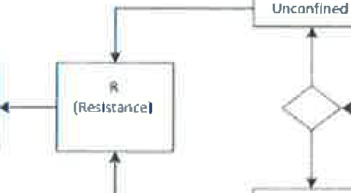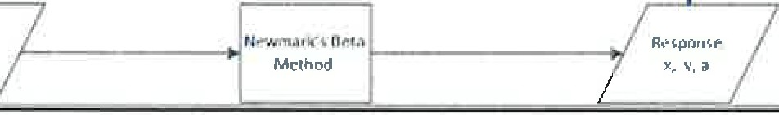

ORDINARY MONTE CARLO SIMULATION

$ (Load)

m",l

Confined J

GfOIJrw:.I

Motion

Based from Figure 1, ground motion acceleration from two levels of earthquake magnitudes, i.e. the El Centro of 1940 and Tohoku-Kanta of 2011 were the inputs in a MatLab script that computes the structural response of single-degree-of­ freedom lumped mass

model of a typical pier of the LRT. This typical reinforced concrete column was based from the maiden plans of LRT, thirty years ago, as reproduced from Figures 2 and 3. The computed properties which were used to compute necessary parameters later, were summarized in Table 1. It can be observed from this structural plan the confinement of the rebars.



*Table 1. Summary of Computed Parameters of Concrete Pier*

|  |  |  |  |  |  |  |  |  |  |
| --- | --- | --- | --- | --- | --- | --- | --- | --- | --- |
|  | weight | plan area | height | volume | weight | mass | stiffness | Elastic |  |
| density  {kN/m3! | (m2) | (m) | (m3) | (kN) | **(kg)** | (kN/m) | Modulus  {MPa} |  |
|  | 24 | 2.38 | 7.75 | 18.445 | 442.7 | 8165232.6 | 366.2 | 24781 |  |

Referring to

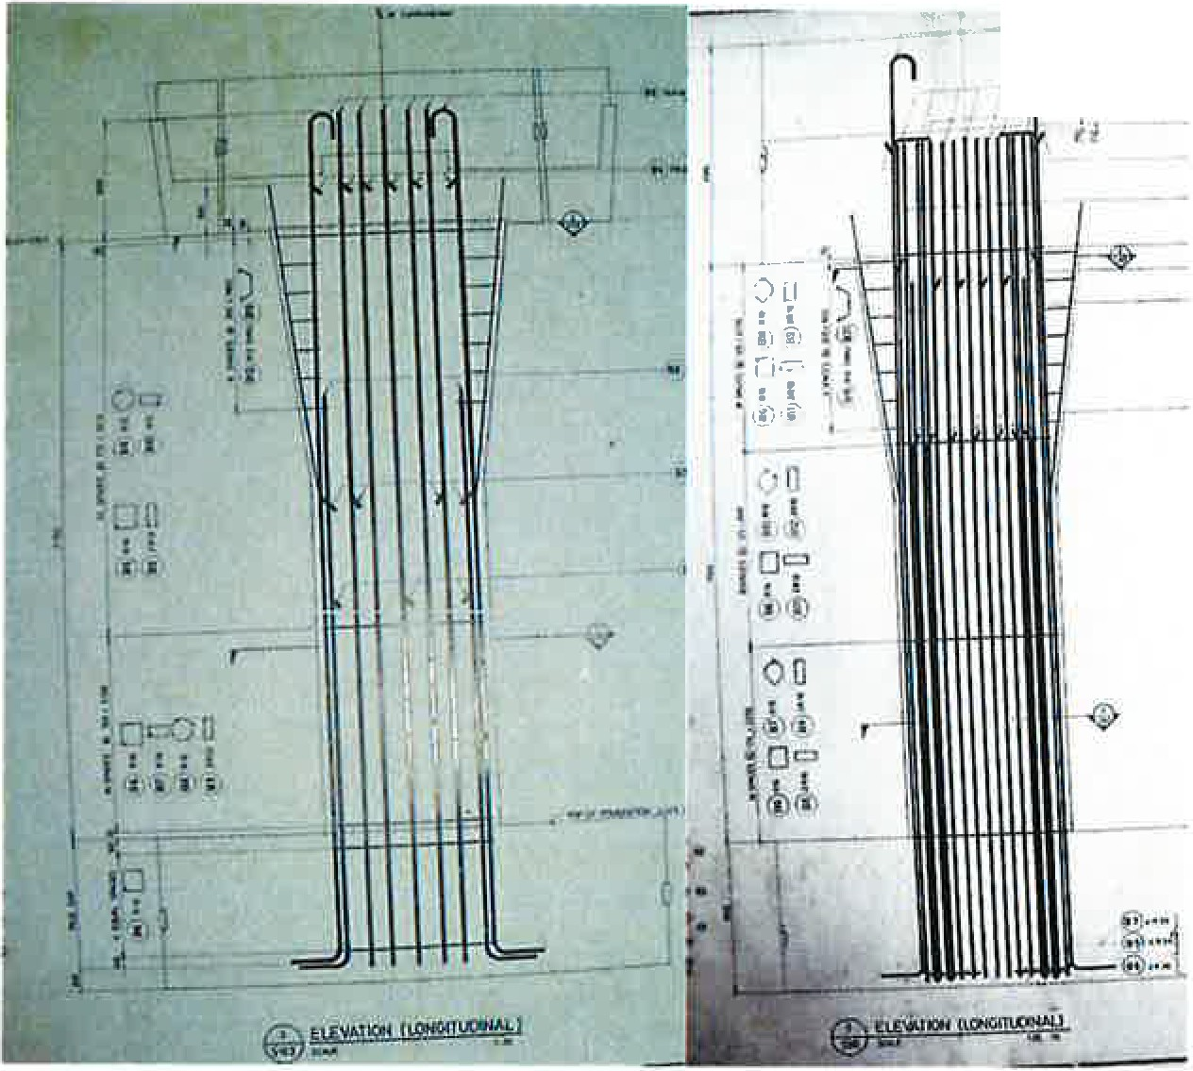

.·1

transcription of structural plans,

the the the



*Figure 2. A Typical Elevation View of LRT I Pier*

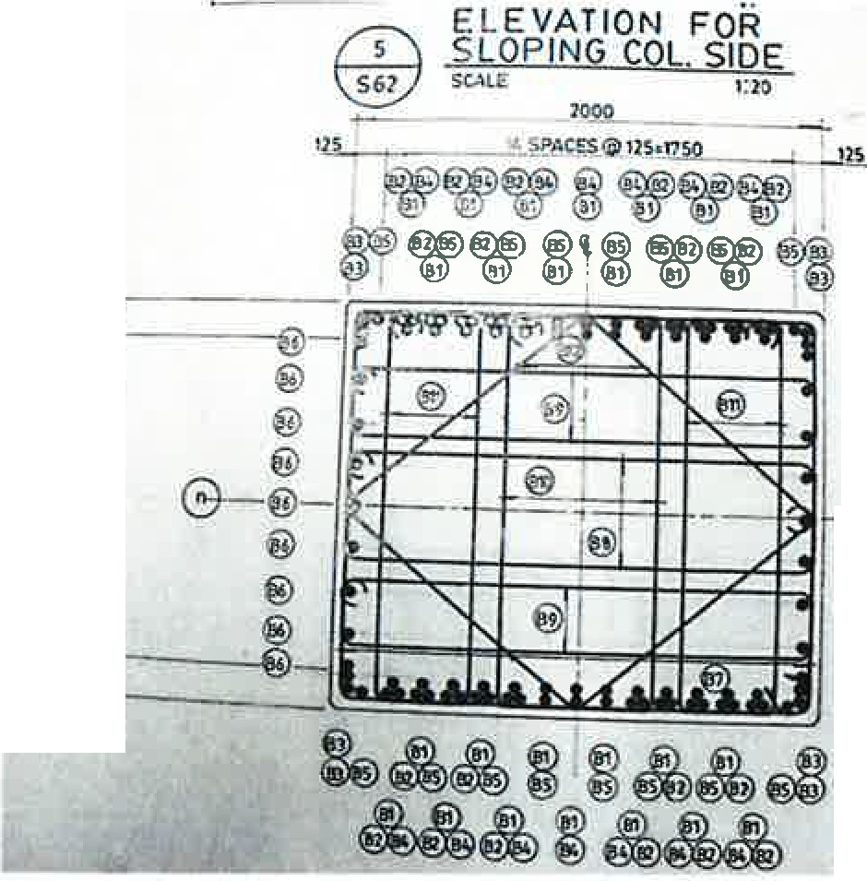

17-1

l

©

.

!.

13

u

®

@

®

**-"MIii-@-**

@

@

I

*Figure3. A Typical Section View of LRT I Pier*

compressive strength of unconfined concrete, fco, 1s 280 kg/cm2 (27.468 MPa) and transverse steel yield strength, fyh, is 2800 kg/cm2 (274.68 MPa). Based from these data, a linear interpolation was used to compute for the corresponding parameters of variables -see Table 3- in accordance to Table 2 [2]. The mass of the concrete pier of 8,165,232.6 kg was computed based from a unit weight of 24 kN/m3

and a dimension of 1.4 m x 1.7 m x

7.75 m of the pier. A volume of

18.445 m3 of concrete alone was computed. Based from these, the computed weight of the concrete pier was 442.68 kN and from the NSCP 2010 computation of concrete modulus of elasticity, a 24,781 MPa was computed. The larger moment of inertia was calculated to be 0.5731 m4.

Table 2. Statistical parameters of material properties and dimensions

Property Mean coef£of

value variation Concrete compressive strength

fc' = 3 ksi 2.760 ksi 0.18

fc' = 4 ksi 3.390 ksi 0.18

fc' = 5 ksi 4.028 ksi 0.15

1 ksi = 6900 Pa; 1 in= 25.4 mm

A range of values is presented in some instances because data from multiple sources were used. Source: Adapted fromEllingwood, Galambos,

After obtaining the structural response, specifically the acceleration, it is now a parameter used to the inertial force as the Load function, S. It is noted that the structural response is probabilistic in nature, as it can be reflected from Table 3 that summarizes the parameters of variables used in the ordinary MCS. The Load function is expressed in one of the NSCP 2001 Section 409.3.3 and NSCP 2010 Section 409.3 factored loads [21], i.e. (where Dis the dead load,

and E for seismic load)

*S* = 0.99D + 1.1E

*S* = 0.90D + *1.0E* + *1.6H*

*Table3. Summa,y of parameters of variables*

Variable Distribution Mean Standard

Deviation RESISTANCE

|  |  |  |  |
| --- | --- | --- | --- |
| fco | Lognormal | 23.734 MPa | 4.272 MPa |
| fyh | Lognormal | 312.33 MPa | 36.542 MPa |
| Ps | Lognormal | I. I 71E-03 | IE-06 |
| LOAD  1PEQ | Lognormal | 4580 kN | 4001 kN |
| 2PEo | Lognormal | 2442 kN | 2440 kN |

'Using Newmark Beta Method for Tohoku-Kanto Earthquake 'Using Newmark Beta Method for El Centro Earthquake

*i' 1gure4. :)tress-:)tratn u1agram of conJtnea ana*

*Unconfined Concrete Column. (Source: Miller, 2006)*

(la)

(lb) This Load Function,S, is then compared to the Resistance Function, **R.** The resistance (a.k.a. capacity) function by nature is probabilistic (refer to Table 3) with parameters divided into two sets: the unconfined and confined strength of the reinforced concrete column [6]. The unconfined model used was based from [7]. For the purposes of comparison of unconfined and confined concrete columns, it can be shown in Figure 4 that significant change in the stress-strain diagram occurs.

The confinement model used was based from the research of Sakai in 2001 [l], [IO].

*fde* = fco'(0.94 + 4.7C) where:

***C***= ***Ks*** *[Psf yh]*

2fco1

***K*** [1 - *_s_]* >0

=

*5 d* tan3o.-J -

(2)

(3)

(4)

For non-prestressed members with existing steel-tie reinforcement, the nominal compressive force is calculated as (from [7] ):

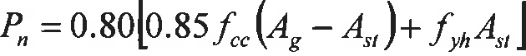 (5)

where:

*feo=* the concrete's specified strength *fee=* the confined concrete strength *p5=* the steel ratio, *Ast I bh*



*b,h* = pier's cross-sectional area dimensions

s=confinement ties spacing

*d=the* pier's effective depth

*[yh=* the steel longitudinal reinforcement yield strength

The resistance function variables used are summarized in Table 4. Using the performance function, *g,* i.e. the difference of resistance function to the load function, the probability of

failure is now calculated using the formula in [2].

I.

|  |  |  |
| --- | --- | --- |
| Buckling | 1s a critical | issue for |
| structural | stability m | structural |

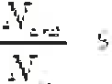

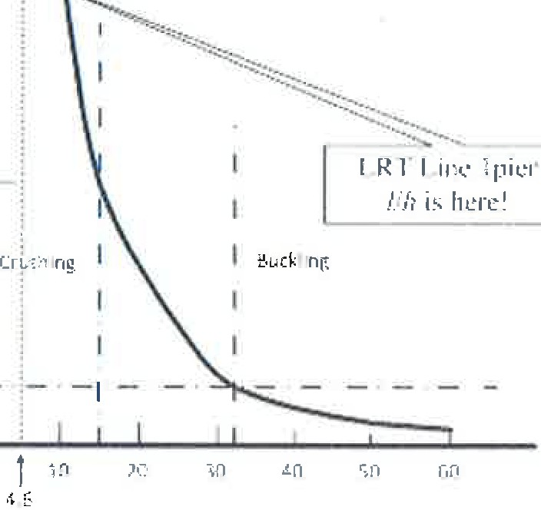*h*

*Figure5. The graph of the ratio of critical load to the crushing load versus the length to width ratio. (Source: Miller, 2006)*

design[4], [14], [15]. In most of the buckling analyses, applied loads, structural and material properties are considered certain. But in the case of this research, the ratio of the unsupported length, /, to the largest dimension, *h,* is less than a critical value of 15, that is, it is believed that the column pier will fail in crushing. See Figure 5.

**Results**

Based from the ordinary MCS using a MatLab script, a summary of the

results can be seen from Table 4, showing only the 1,000,000 iterations.



*Table 4. Summary of Results of Ordinary Monte Carlo Simulation*

Tohoku-Kanto Earthquake 2011 El Centro Earthquake of 1940

|  |  |  |  |  |  |  |
| --- | --- | --- | --- | --- | --- | --- |
|  | Unconfined | Confined | o/odiff | Unconfined | Confined | o/odiff |
|  | Based from | NSCP 2001 |  |  |  |  |
| *P1* | 0.00146 | 0.00012 | -92% | 0.00029 | 0.00013 | -55% |
| *p* | 2.97 | 3.67 | 0 | 3.44 | 3.65 | 6% |

Based from NSCP 2010

|  |  |  |  |  |  |  |
| --- | --- | --- | --- | --- | --- | --- |
| *P1*  *p* |  | 0.00109  3.06 | 0.00039 -64%  3.34 9% | 0.00023  3.5 | 0.00002  4.11 | -91%  17% |
| % | *P1* | -0.00037 | 0.00027 | -0.00006 | -0.00011 | |

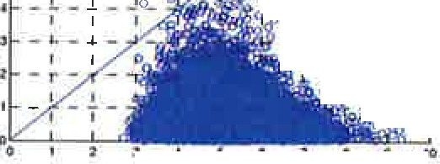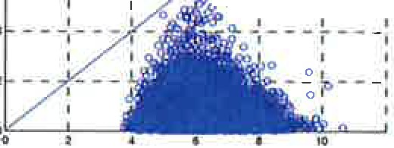

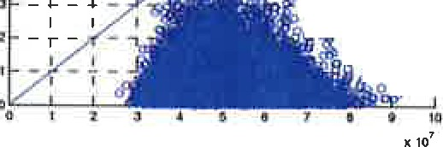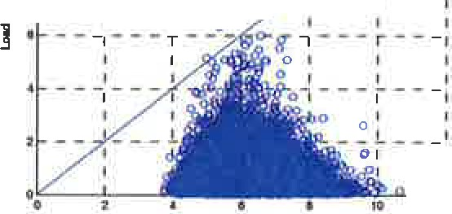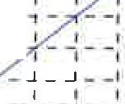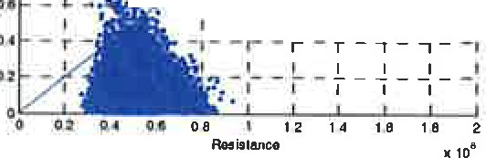

|  |  |
| --- | --- |
| :it:I07  10 - - - - - - .._ -- -•-o- - - - - - - - -  I I I lo I I I I I   * -r--r-1--(1--1--r--r---r 1 * - rI - 1 - 1 - --,,- -,o- ;- - i - , - I 1   I I I I I I I I I  7 _ L _ .1 - _J _ -1g ""b- L _ _ J. ..,J I  - -! - -: -+o-I - - - - _:  I I I ot *g* I Qho I I I I  ] 1 - r - T - 7 -0..,,,g Ci!, e- r - T - 7 - -,  _ L _ *l* _ ..I **-<>,a'.[N,-91 -** L _ *l* _ J I  r I I i>_9 o :  I Cb I I t  'T- 7 1  0 *J* i  I I  RNitlllnce  *Figure 6. Result of MCS (Unconfined, El Centro, NSCP 2001):* | I),_o.io,'... |
| o I |
| 10 ----1---+-.--1►-o-, -t 1  I |
| I |
|  |
| I - - -1- - - _To-e*00* <80_ - - - t" - - -1 |
| I I 100 I |
| I I |
| x10"1 |
| *Figure* 7. *Result of MCS (Confined, El Centro, NSCP 200/):* |
| *P =0.000/30, =3.652203* |
| *P =0*·*.*.*000290, =3.440799*  10- - - - - - - - - - - - - - - -  I I I I oI I I I t I  -t -r-1-1--1--1--r--1--r- --1  =:I=I :]I=I =:t =I =I =I • I I I  =*l* = *=:*  I• - !- - - --:fbI - - - - _;  ] 11 - Ir - I I · "el I I I I I I  T - I - r:, - *f;* - r - T- 7- -1  '- _ f _ *l* - *.1* _ -1  I I I I  "Q:o..,,..-' - - -•  a _ *2*-:  . O O DI I  **-,a;** - -,  **0**  RNl914nce xto'  *Figure 8. Resull of MCS (Unconfined, El Centro, NSCP 2010): P =0.000230, =3.503029* | , |
| If - t" - ,- - 1- -1- -1- - r - T - -t - ' . - -It |
| I I I I I I t I I t |
|  |
| 14 - *L*- - _J I I L _ - .J - J _-1 |
| ! f I I |
| t:I - - t- - -+ - -1 - -1- -11- - - +- -t - -1- -I |
| ] I - - -7·--:-- - - - - --: |
|  |
| *Figure 9. Result of MCS (Confined, El Centro, NSCP 20/0):* |
| *P =0.000020, 4./07480* |
| *:*»10-· --------------------  I I I I I I  u -r- --,--1--1--r-r--  1. -: - :- :--:-- --: - ; -  11 -L-J.!.J-.,.1--L-L_  I I I I ! I  = =-;•:-:1-:-0 -·::-.-_=- =-p=-1=-1=- =:  I f. 1 I f I I I I I  ] 0:  I ,•"$. •-, I I I I I I I  ... , , I-- ,._ _ ....- -1- _,  I I I 1 I I I  *Figure IO. Result of MCS (Unconfined, Tohoku-Kania, NSCP 2001 : P =0.001460, =2.976037* | •10'  "u-------•-------I :---;--I-----·-:I -------I: I :  1 I o 01 I I !  I - - '"1-- - T- - -4- - - - - - r I  I I Cl 08 0 I I I  ] • - - - - -_q_o,_o -- --- ---:  O *§* I I I  RMislaneo .10"'  *Figure 1* /. *Resull of MCS (Confined, Tohoku-Kanta, NSCP 2001: P =0.000120, =3.672701* |
| ? 1 I I I I I I I I  11 -r-T-1--1--1--r--1-1- --1  I I I I I I I I  '!I- I- I - I - -I- - I - I - I - 1 - -I - - l  14 _ L l _J _, _ I L .J_.J f  I *I* .1 I I I I  - t---t -"'.'1 --,- -,--  ]1 - I I..-•7I--,I- I - I I - I I -1  r- .,.-r ,-7-  0.1 -t--fJ.i.r 1--:-- -t !  o.a - - • -•-1--1-_..,. ,.._ --1- -•  o., - Ir • J I J I  I  1....2 t.A t.a 1 a  *Figure I 2. Result of MCS (Unconfined, Tohoku-Kanta, NSCP 20/0: P =0.001090, =3.064547* | *:* .:11->' - - - --- - - - - - - -  ' I  11 - r - T - --i - -,- -,- - *r-* - T" - , - - -1  I I l I t I I I I I  ,t - I - I - I - I...,-. t- - I - I - I - I- -I  J,'I - 1. - .1 _ _J I L _ L _ - .J - J - _ I    -t---+---t--1--1-- --t---1 ,  I I I I I I I  ] I - - :- *I* - -}- - --:  oe _1_1 -L-!-l l •  1 I I I I I  OI -1- -a...-J..-----l 1  I I I r I  04 - r - ·r - 1 - , 1  02 *o.l* ... 0.1 11 IA If 1A  .10'  *Figure I 3. Result of MCS (Confined, Tohoku-Kanta, NSCP 20/0: P =0.000390, =3.359796* |

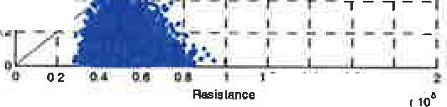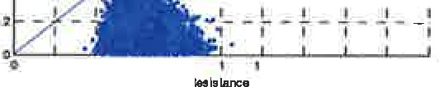**Analysis**

Referring to Table 4, based from NSCP 2010 for the minimum design load combination, there is a significant decrease of probability failure, from 0.109% to 0.039%, with a per cent difference



of 64%, when the confinement to the pier was incorporated while subjecting it toTohoku-Kanto Earthquake simulation. A similar scenario can be observed that of El Cenro Earthquake simulation, but with a higher per cent difference of 91% in the probability of failure decrease.

Comparing this to NSCP 2001, there is a significant decrease of probability of failure, from 0.146% to 0.012%, with a per cent difference of 92%, when the confinement to the pier was incorporated while subjecting it to Tohoku-Kanto Earthquake simulation. A similar scenario can be observed that of El Centro Earthquake simulation, but with a lower per cent difference of 55% in the probability of failure decrease.

Comparing the probability of failure of RC column for the Tohoku-Kanta Earthquake simulation, there is a decrease in per cent difference of 28% from NSCP 2001 to NSCP 2010 minimum design load combinations. But in the case of the El Centro Earthqukae simulation, there is an increase in per cent difference of36%.

Comparing the probability of failure of unconfined RC column (to both simulated earthquakes) for the load combinations with respect to NSCP, there is maximum of 0.00037 (the other is 0.00006) decrease of *P1from* that ofNSCP 2001 to NSCP 2010. In the case of the confined RC column, there is a maximum of 0.00027 increase of *P1from* that ofNSCP 2001 to NSCP 2010, after simulating it to Tohoku-Kanta earthquake. But for the case of El Centro earthquake simulation, there is a decrease of 0.00011 *Pf*

**Discussion, Conclusion, and Recommendation**

The reliability indices of the light railway transit, specifically in one of its reinforced concrete pier, is 3.06 (unconfined, NSCP 2010) and 3.67 (confined, NSCP 2001) when it was simulated under a Tohoku-Kanto Earthquake. A similar scenario was also computed for the simulation of El Centro Earthquake, that is, 3.50 (unconfined, NSCP 2010) and 4.10 (confined, NSCP 2010). This can be attributed to the effectiveness of the confinement model used in this simulation, that is, a maximum of 92% improvement of confinement in the reinforced concrete pier.Based from the ordinary Monte Carlo Simulation, the light railway transit, in its maiden structural form, can withstand seismic forces, given that a confinement model must be chosen for the design of the

reinforced concrete pier. A decrease of *P1from* NSCP 2001 to NSCP 2010 can be attributed to a more conservative load combination for a Level 2 simulated earthquake, but with a Level 1

simulated earthquake, NSCP 2001 load combination is more conservative than the current local code.

To further strengthen this claim, the researcher proposes the following for future findings:

* Consider other failure modes, e.g. foundation uplift, shear failure.
* Update the strength of the structure using data from Non-destructive Test. In tum, these data would be used in a method of structural reliability to obtain the value of reliability index or probability of failure of the structure. Since this research dealt with a stead state condition, it is suggested to refer to[18], [19], and [20].



**s**

**18TH CONGRESS OF IABSE, SEOUL, 2012**

* A senes of known ground motion data, specifically ground acceleration taking into account the soil type, must be used to compute for the reliability index. See [8].
* Instead of a simple SDOF lumped mass model, structural modeling thru the use of finite element methods must be used for an accurate account of the physical properties of one of the LRT's reinforced concrete pier. Numerous commercially available software package can be used for the implementation of FEM, but still MatLab is a powerful tool for a seasoned structured programming trained researcher. See[17], [11] and [18].
* Since this research dealt with a structural component reliability, a systemreliability study can be implemented using the as-built plans of a certain line of the LRT System.

**References**

[l] ORETA A.W.C. and KAWASHIMA K., "Neural Network Modeling of confinedCompressive Strength and Strain of Circular Concrete Columns", *ASCE Journal of*

*Structural Engineering,* Vol. 129, No. 4, April 2003.

1. NOWAK, A.S. and COLLINS, K.R., *Reliability of Structures,* McGraw-Hill International Editions, New York, 2000.
2. ANG, A.H-S. and TANG, W.H., *Probability Concepts in Engineering: Emphasis on*

*Applications in Civil & Environmental Engineering (2nd ed.),* John Wiley & Sons, Inc.,New York, 2007.

1. JIN-KEUN KIM and JOO-KYOUNG YANG, "Buckling Behaviour of Slender High-Strength Concrete Columns",

*Engineering Structures,* Vol 17, No. I, November 1993, pp 39- 51.

1. SZERSZEN, M.M. and NOWAK, A.S., "Reliability-Based Sensitivity Analysis of RC Columns Resistance", *ICOSSAR 2005,* Millpress, Rotterdam, ISBN 90 5966 040 4, pp 2525 to 2530.
2. AMERICAN CONCRETE INSTITUTE 318 COMMITTEE, STRUCTURAL BUILDING CODE, "Building Code Requirements For Structural Concrete (AC! 318-02) and Commentary (ACI 3 I 8R-02)", *AC!,* (c) 2002
3. SADEGHI, K. and NOUBAN, F., "A New Stress-Strain Law For Confined Concrete Under Cyclic Loading", *International Journal of Academic Research,* Vol. 2, No. 4, July 2010, pp 6-15.
4. MICHAEL, A.P., HAMILTON, H.R., and ANSLEY, M.H., "Concrete Confinement Using Carbon Fiber Reinforced Polymer Grid", pp 991 - 1009.
5. MILLER, E.A., "Experimental Research of Reinforced Concrete Column Retrofit Methods", *Master's Thesis,* The Ohio State University, 2006.

[II] YAMAZAKI, F. and SHINOZUKA, M., "Safety Analysis of Stochastic Finite Element Systems By Monte Carlo Simulation", *Proceedings of Japan Society of Civil Engineers, Structural Engineering I Earthquake Engineering,* Vol. 5, No. 2, October 1988, pp 313-323.

1. PAULTRE, P. and LEGERON, F., "Confinement Reinforcement Design for Reinforced Concrete Columns", *Journal of Structural Engineering,* (c) ASCE, May 2008, pp 738-749.
2. CHUNG, W.Y-M, LAM, E.S-S, and WONG, Y-L, "Confinement Action of Reinforced Concrete Columns With Non­ Seismic Detailing", *4th International Conference on Earthquake Engineering, Taipei, Taiwan, Paper No. 304.*
3. FRANGOPOL, D.M., IDE, Y., SPACONE, E., and IWAKI, I., "A New Look At Reliability of Reinforced Concrete Columns", *Structural Safety,* Vol. 18, No.2/3, Elsevier Sciece Ltd., (c) 1996, pp 123 - 150
4. MITROPOULOU, CH.CH., LAGAROS, N.D., and PAPADRAKAKIS, M., "Life-Cycle Cost Assessment of Optimally Designed Reinforced Concrete Buildings Under Seismic Actions", *Reliability Engineering and System Safety,* 2011, pp 1311- 1331.
5. TORREGOSA, R., SUGITO, M., and NOJIMA, N., "Assessment of Seismic Hazard and Microzoning in the Philippines",

*Journal of Structural Mechanics and Earthquake Engineering,*

1. RIEDERER, K.A., "Assessment of Confinement Models For Reinforced Concrete Columns Subjected To Seismic Loading", *Master's Thesis,* University of British Columbia, (c) 2006.
2. DER KIUREGHIAN, A., HAUKAAS, T., and FUJIMURA, K., "Structural Reliability Software At The University of California, Berkeley", *Structural Safety 28,* (c) 2006, pp 44-67.
3. GARCIANO, L. E. and YOSHIDA, I., "Reliability analysis of a brittle fracture due to crack instability using sequential Monte Carlo simulation", *Proceedings of the lnlernationl Conference on the Applications of Statistics and Probability,* pp 2949 - 2956, 2011.
4. GARCIANO, L. E. and YOSHIDA, I., "Estimating the limit state exceeding probability of a deteriorating structure using KF, EKF, UKF and the SMCS", *Proceedings of the 15th ASEP International Conference,* 2011.
5. Association of Structural Engineers of the Philippines, *National Structural Code of the Philippines (2001) and (2010),* (c) 2001 and 2010.

[View publication stats](https://www.researchgate.net/publication/316782557)