Emergency Remote Teaching Experiences of Basic Education Teachers in the Philippines

Celina P. Sarmiento*

Philippine Normal University, [sarmiento.cp@pnu.edu.ph](mailto:sarmiento.cp@pnu.edu.ph)

Marie Paz E. Morales

Philippine Normal University, [morales.mpe@pnu.edu.ph](mailto:morales.mpe@pnu.edu.ph)

Rodney T. Cajimat

Nueva Vizcaya State University, [rtcajimat@nvsu.edu.ph](mailto:rtcajimat@nvsu.edu.ph)

Minie Rose C. Lapinid

De La Salle University, [minie.lapinid@dlsu.edu.ph](mailto:minie.lapinid@dlsu.edu.ph)

Maricar S. Prudente

De La Salle University, [maricar.prudente@dlsu.edu.ph](mailto:maricar.prudente@dlsu.edu.ph)

Rochelle Irene G. Lucas

De La Salle University, [rochelle.lucas@dlsu.edu.ph](mailto:rochelle.lucas@dlsu.edu.ph)

Jayson A. Peñafiel

Department of Education, [jayson.penafiel@deped.gov.ph](mailto:jayson.penafiel@deped.gov.ph)

Ruel A. Avilla

Philippine Normal University, [avilla.ra@pnu.edu.ph](mailto:avilla.ra@pnu.edu.ph)

Josephine Luz D. Pineda

Don Honorio Ventura State University, [jlsdeleon@dhvsu.edu.ph](mailto:jlsdeleon@dhvsu.edu.ph)

Voltaire M. Mistades

De La Salle University, [voltaire.mistades@dlsu.edu.ph](mailto:voltaire.mistades@dlsu.edu.ph)

Socorro E. Aguja

De La Salle Araneta University, [socorro.aguja@dlsau.edu.ph](mailto:socorro.aguja@dlsau.edu.ph)

Honelly Mae S. Cascolan

Pangasinan State University, [honellymae@gmail.com](mailto:honellymae@gmail.com)

Richard DLC. Gonzales

Inno-Change International Consultants, Inc., [r-gonzales@consultant.com](mailto:r-gonzales@consultant.com)

Celia M. Ilanan

Philippine Normal University, [ilanan.cm@pnu.edu.ph](mailto:ilanan.cm@pnu.edu.ph)

Lovely Airein D. Albania

Philippine Normal University, [deguzman.lam@pnu.edu.ph](mailto:deguzman.lam@pnu.edu.ph)

Maria Ruth M. Regalado

Philippine Normal University, [regalado.mrm@pnu.edu.ph](mailto:regalado.mrm@pnu.edu.ph)

* Corresponding author

# Abstract

The COVID-19 worldwide outbreak drove all educational institutions to enforce school closures and sought alternative ways to sustain education. In response, the Philippine Department of Education initiated measures for social distancing and health protocols in the basic education; equipped for Emergency Remote Teaching (ERT) following the curriculum transition to the Most Essential Learning Competencies (MELCs). However, the shift occurred abruptly with insufficient preparation and teachers were obliged to deliver education in an unfamiliar environment, requiring additional skills and resources. Thus, in this study, we investigated the experiences of teachers who had to endure sudden changes and be exposed in a new teaching and learning environment. A nationwide survey in April 2021 was participated by 28,859 public basic education teachers in all levels and descriptive statistics was done to analyze the data gathered. Our findings suggest that most teachers utilize printed modules as the modality for remote teaching. This is probably because stable internet access is still a challenge in many areas of the country. As a result, teachers implement less interactive forms of activities. Facebook also emerged as widely used means for communication with students and colleagues. Teachers also learned how to use several applications to cope with the demands of the new work environment. With these findings, the education sector is enjoined to conceptualize modifications that could improve remote teaching implementation in the country.

Keywords: COVID-19; teachers’ experience, basic education, emergency remote teaching

# Introduction

The United Nations (2020) estimated that the COVID-19 pandemic affected 190 countries and 1.6 billion learners worldwide, creating the largest disruption of education systems in history. School closures affected 94% of the global student population, more so in low and lower-middle income countries where disturbance is up to 99%. Emergency remote teaching (Hodges et al., 2020) (ERT) modalities emerged as a solution to ensure education continuity. However, despite the numerous efforts to alleviate the pandemic’s impact on schooling, the broadening gap in access to quality education became an area of concern. Schools systems are

unprepared and do not possess the infrastructure to deliver education remotely. Additionally, teachers were coerced to rapidly adjust to the demands of remote teaching with little training and without the proper technology (Chuah & Mohamad, 2020).

Emergency remote teaching is described as a quick temporary change of instructional delivery because the traditional classroom setup is not permitted, contrary to a well-planned distance learning scheme which is indeed intended and designed to be delivered remotely (Hodges et al., 2020). ERT necessitates the utilization of available resources for delivering the curriculum and attaining set educational standards amidst unconventional scenarios (Misirli & Ergulec, 2021). These resources might not be originally intended for remote teaching and oftentimes are not optimized for delivering education without face-to-face meeting. However, due to the urgency of the situation, providing a make-shift educational environment is more efficient than developing a refined educational ecosystem for remote learning (Chuah & Mohamad, 2020). Nonetheless, once favorable conditions arise and conventional schooling becomes feasible, it is expected that instructional delivery will revert to its regular arrangement.

Because of the COVID-19 pandemic, several ERT models were implemented by schools and universities worldwide to mitigate the spread of the virus. For instance, Egypt encourages teachers to utilize free communication platforms and to maximize the use of social media (Sobaih et al., 2020). On a similar note, the Ministry of Education of Cyprus authorized the use of Microsoft Teams as the official platform for online education in public school even though many teachers have never used it in the past (Sofianidis et al., 2021). Other studies on ERT investigated teachers’ preparedness to address the demands and challenges of the new learning modality in urban areas where online learning became prevalent (Mailizar et al., 2020; Sandars et al., 2020; Trust & Whalen, 2020). Additionally, reports indicate that teachers were greatly unaccustomed with the instructional methods and tools introduced during the pandemic period.

Results of previous studies oftentimes describe ERT modalities that are online in nature. However, the Philippines had to be creative in ERT delivery since internet access and speed is a challenge in many areas of the country (Esquire Philippines, 2020). Actually, the Philippines ranks low in terms of internet affordability index and internet quality index, placing it among the countries with expensive, slow, and least stable internet (Esquire Philippines, 2020). In fact, a nationwide survey by the Department of Education (DepEd) among its stakeholders shows that 41%

do not have internet access and 10% answered that internet signal is not available in their area (Department of Education, 2020c). It is thus good to understand the situation of Philippine Education with the implementation of ERT from the perspective of all its stakeholders, most especially from the viewpoint of teachers.

Correspondingly, this study reports the result of a nationwide cross-sectional survey that aimed to understand the experiences of teachers in the ERT environment brought by COVID-19. In particular, the voices of public school teachers shed light on the issues and challenges that they had to face in delivering instruction. This investigation might help the basic education sector in devising guidelines and protocols that could potentially address identified teachers’ needs. Moreover, the results can also be used to influence the decision of policy makers towards favorable legislation for teachers. Lastly, it will help education stakeholders prepare in advance and conceptualize modifications that will help bridge the gaps caused by ERT.

# Philippine Basic Education Amidst COVID-19

Following the quarantine directives of the national government, the DepEd was coerced to suspend all scheduled events and prematurely ended the school year 2019-2020. Foreseeing that the effect of the pandemic in the educational setting might last until 2021, which prevents the opening of schools and face-to-face classes for at least one year, the DepEd geared towards ERT modalities to ensure continuity of learning. Immediately on March 15, 2020, the Department released Memorandum 043 s. 2020, that stipulates the guidelines on the alternative work arrangements of school personnel and social distancing measures. The agency strengthened its *Sulong EduKalidad* movement, originally conceptualized to innovate the Philippine education to be resilient to a ‘world drastically changing,’ to devise new ways to teach learners, upgrade the capacity of teachers, and improve its facilities for distance learning (Department of Education, 2020d). As a result, the Basic Education Learning Continuity Plan (BE-LCP) was developed, stipulating necessary adjustments in the curriculum, development of learning materials, and relevant support to teachers and students (Department of Education, 2020b). The K to 12 curriculum was adjusted to focus on the Most Essential Learning Competencies (MELCs) and Self-Learning Modules (SLM) were prepared and distributed. Emergency remote learning spaces were set into place and various modalities to facilitate the teaching and learning process were offered (Department of Education, 2020a). Furthermore, the opening of classes which was

supposed to take place in June 2020 was pushed to October 2020 to give all stakeholders time to prepare for the new learning and work environment.

However, the delivery of education in the new normal entails certain mechanisms and skills that take time and practice to develop (Nambiar, 2020). Teachers were abruptly tasked to implement ERT modalities and shift towards a flexible work environment with insufficient guidance, training, and resources (Nambiar, 2020). Teachers were largely unprepared for a remote teaching environment. Their new tasks became highly dependent on certain technological affordances and digital skills that many educators still lack (Safi et al., 2020). Internet connectivity became a necessity, which is still limited and unstable in many areas in the country (Department of Information and Communications Technology, 2020).

Teaching under usual circumstances is already a demanding job, more so under an unprecedented worldwide health risk (Baker et al., 2021). Teachers had to face an uncharted educational territory through ERT. The many facets of this new school environment remain unknown and of great concern to education stakeholders, especially in the public school system that shares 81.28% of basic education enrollment and hosts 847,487 teaching positions (Department of Education, 2020c). In this regard, this study was conducted to unravel the ERT experiences brought by COVID-19 in the basic education. This paper offers results that address the following objectives from the perspective of public school teachers.

1. Describe the emergency remote teaching experiences brought by COVID- 19 in the Philippine basic education.
2. Determine the issues and challenges faced by basic education teachers in the emergency remote teaching brought by the COVID-19 pandemic.

# Methods

The data used for this study was lifted from the database of a National Research Council of the Philippines (NRCP)-funded research project “*Bridging the Gap in Remote Teaching and Learning*.” The project’s research team includes multidisciplinary educational experts and researchers, who investigated several facets of the ERT environment in the public school system from the perspective of the teachers. A cross-sectional survey research design was initiated, through an English version remote teaching survey instrument, which was designed by the team based on meticulous literature review and DepEd available documents and

information. Most of the questions were close-ended, necessitating either multiple-choice, checklist, or Likert-type ratings. Several open-ended questions that allow respondents to explain and expound ideas better were also included.

Table 1. Distribution of Samples

|  |  |  |  |  |
| --- | --- | --- | --- | --- |
| **Region** Kinder to Grade 6 | | Grade 7 to 10 | Grade 11 to 12 |  |
|  | (Elementary) | (Junior High School) | (Senior High School) | Total |
| Region I | 3303 | 1125 | 427 | 4855 |
| Region II | 3347 | 1240 | 458 | 5045 |
| Region III | 3067 | 1621 | 394 | 5082 |
| Region IV-A | 322 | 403 | 57 | 782 |
| Region IV-B | 164 | 151 | 24 | 339 |
| Region V | 87 | 35 | 34 | 156 |
| Region VI | 303 | 117 | 128 | 548 |
| Region VII | 1852 | 775 | 178 | 2805 |
| Region VIII | 7 | 1 | 6 | 14 |
| Region IX | 4424 | 1857 | 509 | 6790 |
| Region X | 42 | 20 | 4 | 66 |
| Region XI | 906 | 73 | 20 | 999 |
| Region XII | 45 | 14 | 2 | 61 |
| NCR | 25 | 33 | 15 | 73 |
| BARMM | 1 | 0 | 0 | 1 |
| CAR | 937 | 235 | 65 | 1237 |
| CARAGA | 1 | 2 | 3 | 6 |
| Total | 18833 | 7702 | 2324 | 28859 |

Four DepEd teachers with varying age, length of service, educational attainment, specialization, and location were invited in a Focus Group Discussion (FGD) to qualitatively evaluate the initial draft of the instrument. Their suggestions were accounted for, and the instrument was revised accordingly. The revised survey was evaluated by another four DepEd teachers with varying academic backgrounds using the survey instrument validation rating scale of Oducado (2021). The mean validity rating is 4.5962 with a standard deviation of .5998, which indicates a high face and content validity of the instrument. Moreover, a significantly good reliability was found between the four ratings using a two-way random Intraclass Correlation Coefficient (ICC) for consistency based on the scale of Koo and Li (2016). The average ICC was .840 with a 95% confidence interval from .628 to .945 (F(12,36) = 6.265, p<.001). The final version of the instrument was loaded on Google Forms and pilot tested before administration to DepEd

teachers. The online survey, where an informed consent form is also embedded, took about 15 minutes to complete.

After obtaining the approval of the concerned agency, the link to the remote teaching and learning survey was distributed through the help of field researchers. It was also distributed through the different public school divisions. Participation in the online survey was voluntary and was done from April 13, 2021 to April 21, 2021. The online form gathered 34,182 valid responses. However, only those who willingly declared their official Gmail were considered to ensure the authenticity of responses. Moreover, to secure uniqueness of responses, a clean-up process was done to remove any duplicates. This procedure trimmed the sample to 28,859; distributed as shown in Table 1. Since the survey is voluntary, as displayed in the table, the samples are uneven according to region. However, it is proportional in terms of level. The sample gathered represents provinces or more rural regions, which constitutes the larger area of the country and more prone to income inequality (Zamora & Dorado, 2015). Correspondingly, a Focus Group Discussion (FGD) with several public school teachers and an interview with a DepEd officer was also conducted to clarify and provide more insights about the results of the survey. The information they provided was used to offer additional explanation and enrich the analysis of the current study.

The data gathered from the survey was organized into three sections: Teaching and Learning, Challenges and Coping, and Remote Teaching Perceptions. Pertinent items that would address the objectives stipulated in this paper were lifted and analyzed mostly using descriptive quantitative methods. Text-based and qualitative responses were also considered and were mainly used to support the quantitative results to provide complementary information and paint a better picture of teachers’ ERT experiences.

# Results and Discussion

The findings of this study reflect data collected from public school teachers in April 2021. At this point, the teachers who participated had at least taught for five months in a remote teaching environment. The results are presented in the following subsections.

## *Teachers’ Emergency Remote Teaching Experiences*

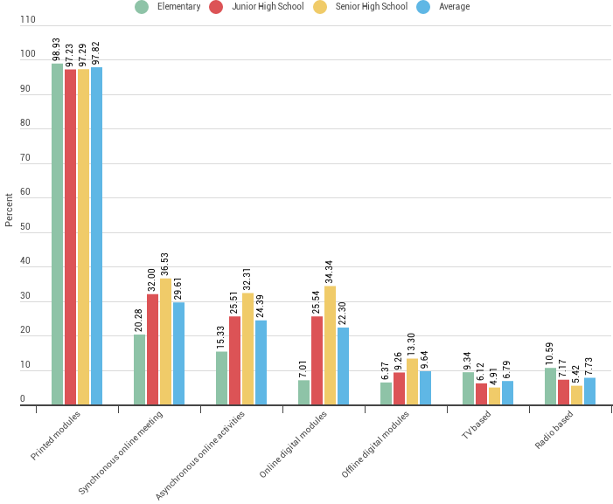Figure 1 presents the ERT modalities experienced by public school teachers. As shown in the bar graph, printed modules (above 97% in all levels) dominate the modality experienced in the basic education. It seems that this modality emerged as the most viable option chosen by parents and students since a stable internet connectivity is still limited in most areas in the country (Department of Education, 2020c). The Self Learning Modules (SLM)

Figure 1. Remote teaching modalities experienced by teachers

developed by DepEd were distributed to all school

divisions, who were tasked to plan and implement a process of printing and distributing the modules to reach the target students. The divisions can modify the modules to contextualize the SLM to the needs of their respective areas. Additionally, teachers supplement these modules with “*learning activity sheets na pinapasagutan sa mga estudyante*” [learning activity sheets that students are asked to answer].

In October 2020, the Inter-Agency Task Force (IATF) for the Management of Infectious Diseases issued a resolution recommending that “*any person below fifteen (15) years old, those who are over sixty-five years (65) years of age, those with immunodeficiency, comorbidity or other health risks, and pregnant women, shall be required to remain in their residences at all times*” (*Resolution No. 79 Series of 2020: Inter-Agency Task Force for the Management of Emerging Infectious Diseases*, 2020). This resolution prohibited most basic education students from going to school to claim their SLM. For this reason, the help of parents/guardians was solicited to assume this task. Teachers had to take a new role, as they must physically deliver or distribute modules to parents/guardians. Teachers set timetables for module distribution in their respective schools, and

parents/guardians must come on the designated schedule to get the modules. There were also schools who sought the help of Barangay Officials to minimize physical contact. Consequently, teachers are also tasked to physically retrieve the modules and the learning activity sheets. As a result, although not daily, most teachers still have to physically report to school (on average, 43.55% report thrice a week,

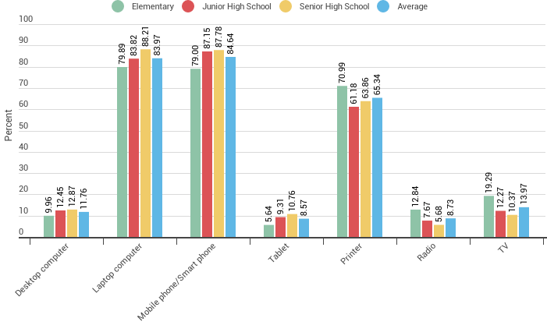

Figure 2. Devices that teachers use for remote teaching

19.11% report twice a week, and 18.23% report every school day). Approximately 5.14% report when called for, while only an average of 1.84% answered that they don’t report to school at all. Moreover, as shown in Figure 3, a mean 39.01% teacher respondents had conducted home visitation. There are instances when teachers are propelled to personally drop by the home of students “*na hindi kinukuha ng parents ang module*” [whose parents do not go to school to get the module]. Some teachers had difficulty reaching out to students from socially disadvantaged homes as indicated by an average of 51.81% of survey respondents (Figure 5).

Teachers either select or are given alternative work arrangements (AWA). When in school, social distancing measures and health protocols are strictly observed and implemented. Most teachers were also provided supplies and items needed for compliance with minimum health standards. Actually, the survey revealed that an average of 61.80% of teachers received health kits that contain face masks, face shields, alcohol, vitamins, and similar items from the DepEd or other organizations. On a similar note, school supplies donation (72.55% on average) is the most common form of support teachers receive. Free webinars (68.57% on average) were also provided by various educational agencies and organizations. On the other hand, only a small percentage of teachers surveyed received monetary allowance (4.93% on average), communication allowance (13.58% on average), and electronic gadgets (12.39%).

Since the use of printed modules is the dominant remote teaching modality, as shown in Figure 3, the activities that teachers were able to administer are less

interactive and mostly asynchronous. In fact, only an average of 26.67% was able to experience a video conference with the class. The number is even lower at the elementary level, where only 14.44% was able to experience this synchronous class activity. Whereas 37.82% senior high school public school teachers and 27.76% junior high school teachers were able to conduct video conferencing with their students. Consequently, merely 20.67% on average was able to use an online platform to post assignment activities. At the elementary level, this was only 6.82%. While the figures are 21.76% and 33.43% in the junior high school and senior high school respectively.

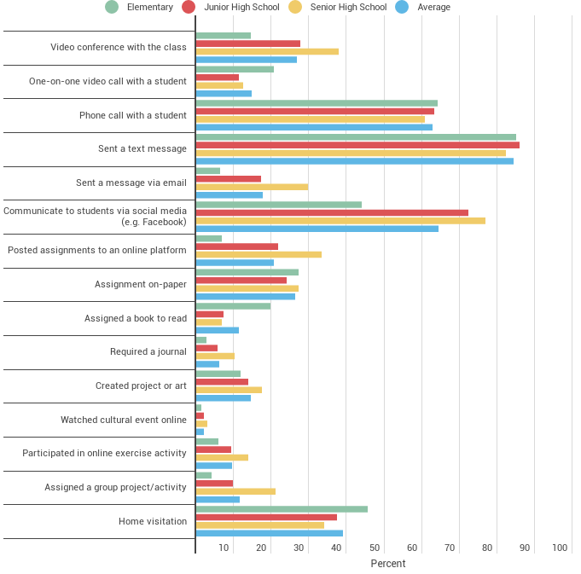

Figure 3. Teacher-student interactions/activities

Providing students with opportunities to interact with peers is considered a best practice. However, facilitating activities like those that involve collaborative learning to trigger peer interaction is a challenge for many teachers (Jacobs & Ivone, 2020), most especially when they can only depend on printed modules. Our survey indicates that only an average of 11.58% was able to conduct a group project/activity. Expectedly, only 3.98% of teachers in the elementary level and 9.76% in the junior high school were able to assign group tasks. This implies that there is lack of social interaction among

students and less chance to improve social skills, which is imperative especially in young students (Slavin, 2015). On the flip side, 21% of the senior high school teachers were able to administer such undertakings. This is probably because older students are more independent and can access more ways to communicate with peers (Gillies, 2016).

As mentioned, the use of printed modules is the prevailing remote teaching modality. Clearly, this mechanism has certain limitations in terms of teaching and

learning. For one, students cannot immediately clarify unclear concepts in the module. Furthermore, teachers are not able to provide immediate feedback to misconceptions. For this reason, teachers innovate by exhausting different means to communicate. As shown in Figure 3, the type of interaction most frequently experienced by teachers involves sending a text message (84.42% on average), communicating with students through social media (64.46% on average), and calling students through phone (62.78% average). It appears that teachers use these communication platforms to provide the support that students need in understanding the modules they received. If students have questions, they reach out to teachers using these platforms. For young students, the teachers use these platforms to communicate with parents or guardians.

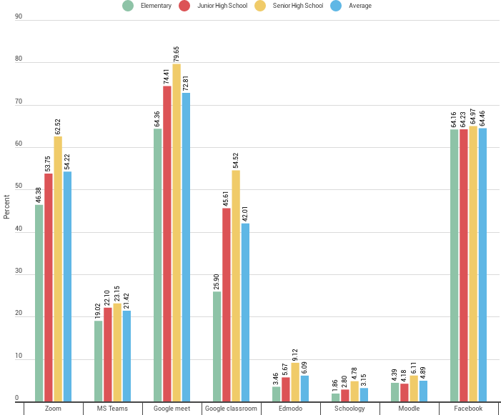Teachers also coped by learning how to use digital tools. While the delivery of instruction is through printed modules supported by communication through call, messaging, or text; other teacher functions and responsibilities shifted to online modality. In particular, teacher professional development opportunities were moved online through virtual training and webinar. Meetings with colleagues and assemblies became web-based

through online conferencing applications. Teachers had to update their technological

Figure 4. Applications that teachers learned how to use during the pandemic

knowledge and learn how to use new applications (Marshall et al., 2020). Figure 4 presents the applications that teachers learned how to use during the pandemic. As shown in the graph, an average of 72.81% teacher respondents learned how to use Google Meet, an online conferencing application. While Zoom, likewise a conferencing application, was learnt by 54.22% on average. Zoom is mostly used for webinars and online conferences. On the other hand, Google Meet is used for online meetings with colleagues. Additionally, an average 42.01% learned how to use Google Classroom, which is a Learning Management System (LMS). Some

learning modules for teachers are made available through Google Classroom, thus encouraging them to study how to use it. Teachers who are able to conduct online classes also use this application to manage their activities. Although significantly less, 21.42% of teachers learned Microsoft Teams, another LMS. It appears that some schools prefer MS Teams over Google Classroom as LMS because they prefer some of its functionalities.

Surprisingly, an average of 64.46% teachers indicated that they learned how to use Facebook (Figure 4), although the application is already popular and widely used (Garzon et al., 2019) even before the pandemic hit. To explain, a teacher who was a part of our FGD mentioned that previously, Facebook was usually used for “*non- school related purposes*.” However, the pandemic drove teachers “*na humanap ng madaling way to communicate at mag-share*” [to find an easier way to communicate and share], and as it appears, this is Facebook. The said application has a lite version, which is commonly “*free sa mga network*” [free on networks]. Also, the teacher voice that “*halos lahat may Facebook*” [almost everyone has a Facebook account] and “*hindi na kailangan aralin*” [users do not have to study how to use it anymore]. Hence, the high percent ratings indicate that teachers extended the use of Facebook as a social media for academic purposes. In fact, Faceboook Messenger became the most widely used application by teachers to communicate and exchange information with students (93.41% on average) and DepEd colleagues (95.55% on average) during the pandemic.

## *Issues and Challenges Faced by Teachers*

The challenges experienced by public school teachers are presented in Figure 5. Evidently, teachers’ access to technology is the most pressing issue that teachers had to face in the shift to remote teaching and learning (81.20% on average). In fact, the survey reveals that most teachers spent personal funds to avail internet connectivity (73.07% on average). Additionally, due to limited infrastructure for wired internet access, most teachers utilize mobile data connectivity (71.87% on average). Since most of the respondents are part of the 53% rural population of the country, this means that most of them have no fixed broadband, and wireless connectivity is the only means that they connect to the internet (Nedescu, 2019). Moreover, internet experience in these areas is greatly influenced by 3G speeds only, which is considerably slower and more unstable compared to 4G. As such, analysis reveals that internet access (78.52%) and speed (65.10%) is a source of difficulty in the new school environment (Figure 6).

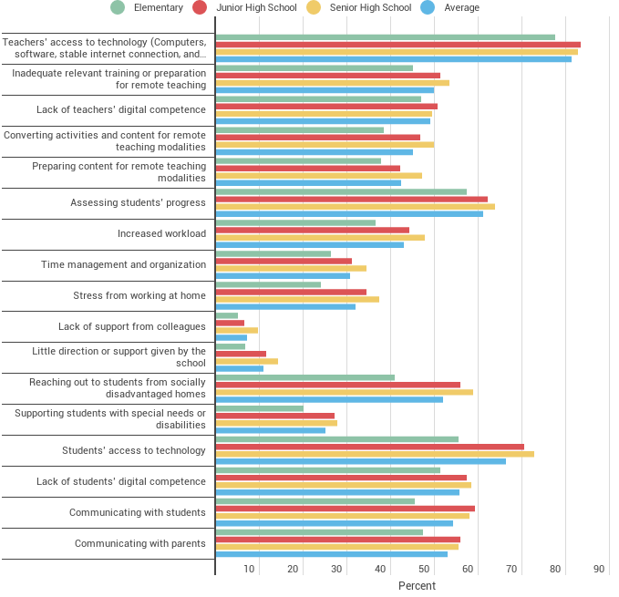

Figure 5. Challenges experienced by teachers in ERT

This internet adversities could also explain why communicating with students (54.16% on average) and parents (52.89% on average) is a challenge for teachers (Figure 5). Intermittent signal issues in the country (Nedescu, 2019) and difficulty in students’ access to technology (66.17% on average) might also contribute to this dilemma. Even if teachers innovate and use personal resources to reach out to students and parents, the lack of face- to-face interaction still makes it difficult to have

effective communication since real time interaction is reduced.

Additionally, an average of 72.67% of teachers responded that “*it is more difficult to ensure that students are engaged and learning*” (Figure 6). Clearly, the challenges in technological affordances of teachers and students reflect the delivery of instruction. On average, 44.90% of teachers find it difficult to convert their instructional materials for remote teaching modalities and an average of 42.28% finds it difficult to prepare content for remote delivery (Figure 5). In terms of teaching and learning, Figure 5 indicates that assessing students’ progress emerges as the most difficult for teachers (61.02%). Whether formative or summative, assessment seems to be a struggle for teachers since “*hindi namin nakikita kung paano nagsasagot ang mga bata*” [we cannot monitor how students answer] their learning activity sheets. There are even issues about the authenticity of submission since “*hindi naman ma-verify kung sino ang nagsagot ng exercises*” [teachers cannot verify who actually answered exercises]. As a result, 53.72% of our respondents believe that students are learning somewhat less and another 37.47% believe that students are learning much less in the new school environment. Only 5.67% believe that students are learning about the same, while

3.14% assumes that students learn more. Hence, it is no surprise that 88.58% of the respondents deem that student remediation is necessary.

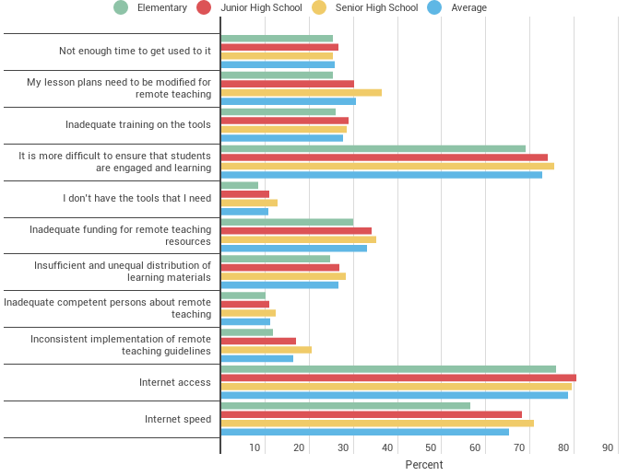

Figure 6. Teachers' difficulties in ERT

Lack of teachers’ digital competence appears to be a difficulty for an average of 48.99% respondents (Figure 5). Such is expected since 49.87% responded that they had inadequate relevant training or preparation for remote teaching (Figure 6). Data also reveals that 40.29% of teachers only had one to two training in remote teaching, and 14.08% had none. These figures are surprising considering

that various educational organizations have provided numerous webinars that are available for free. The low number of training sessions attended is probably because online access is needed to participate in the training, and since the internet is a struggle for many teachers, attending training is a difficulty for most of them. Details on Figure 5 also reveal that the pandemic might have brought increased workload to some teachers (42.84%). This makes it difficult for some to manage and organize their time (30.58%). Others also find it stressful to work at home (31.90%).

# Conclusions and Implications

The COVID-19 pandemic brought a worldwide shift to all sectors of the state, most especially educational units. The circumstances were unprecedented and novel for all education stakeholders. ERT emerged as the most sensical means to ensure that education continues amidst a global health crisis. Teachers had to prematurely engage in foreign instructional delivery with a very short preparation and insufficient training. They are likewise tasked to perform academic functions and handle students who most likely do not possess the aptitude and the independence

required for such educational delivery. Unlike a carefully executed distance learning experience, the ERT experienced by the nation can be considered as a damage control strategy. That being so, it is anticipated and understandable to have shortcomings and issues along the way. It is expected that the education community will encounter difficulties, especially the teachers. Nonetheless, it is imperative to investigate the experiences of teachers and the challenges they faced to determine the support they need and to plan for ways forward. In this regard, this empirical study aimed to understand the experiences of public school teachers’ including the issues and challenges they had to face in ERT; through a national survey participated by 28,859 teachers, mostly from rural regions.

By and large, printed modules in the form of SLMs supported by learning activity sheets was the most dominant modality experienced by teachers during ERT since internet connectivity is still a challenge in many areas of the country. Even if AWA was set for, many teachers had to physically report to school to distribute and retrieve modules and other activities. Most of the activities and interactions between teacher and students are less interactive forms and were mainly used for communication to provide a medium for clarification and feedback. On another note, the other academic function of teachers shifted to online modality. For example, faculty meetings and webinars are held through online conferencing applications. To participate, teachers had to learn how to use new applications like Google Meet and Zoom. Similarly, teachers innovated and utilized Facebook and Facebook Messenger as a make-shift learning management system and communication channel for academic exchange.

Both teachers’ and students’ access to technology resonated as a challenge in ERT. Similarly, internet access and speed are also major concerns. This makes it difficult for teachers to communicate with students and parents. They also struggle with teaching and learning discourse due to inadequate relevant training. Reaching out to students from socially disadvantaged homes is also an issue. Moreover, since teachers cannot physically monitor students, they reported that it is more difficult to ensure that students are engaged and learning. Most teachers believe that students are learning less in the new learning environment and recommend remediation for learning losses that occurred due to the pandemic.

The result of this investigation may expound the kind of support and resources that teachers need to thrive better in a remote environment. Additionally, this study could also assist teacher training institutions and other educational organizations to craft programs that would capacitate teachers with the skills they

need for a non-face-to-face learning modality. This could also guide teacher education institutions and educational designers in developing a remote education ready teacher education curriculum and remote teaching programs. Furthermore, this could enlighten policy makers and officials about the reforms that must be done to empower teachers in a remote teaching environment. Lastly, the DepEd may utilize the finding of this report the scaffold guidelines that could improve the delivery of remote teaching and learning.

Although this research has a good sample size, it is not without limitations. For one, the analysis done on this venture is mainly from the result of a survey, using descriptive methods. A further study using inferential exploration might be necessary to determine and relate factors that would have an effect to remote teaching might be necessary. Furthermore, the data collected is only from the viewpoint of DepEd teachers and does not confirm the results from the perspective of students and parents. Hence, future research should also look into other education stakeholders, most especially the students. The experiences of private school teachers must also be taken into account. Similar studies must also be done in higher education to paint a better picture of ERT in the country. Additionally, studies, both short- and long-term, that would investigate the proper adaptation of remote teaching in the Philippine Education system must be done to come up with a viable plan of action that could harness the potentials of remote teaching in improving the delivery and quality of education in the country.

**Acknowledgements:** This research project was funded by the National Research Council of the Philippines (NRCP) through the *Kapakanan ng Tao sa Oras ng Pandemya - COVID* (KTOP-COVID) program.

# References

Baker, C. N., Peele, H., Daniels, M., Saybe, M., Whalen, K., Overstreet, S., & The New Orleans, T.-I. S. L. C. (2021). The experience of COVID-19 and its Impact on teachers’ mental health, coping, and teaching. *School Psychology Review*, 1– 14. https://doi.org/10.1080/2372966X.2020.1855473

Chuah, K. M., & Mohamad, F. S. (2020). Emergency remote teaching scenarios, struggles and soundboxes: A case study on Malaysian teachers. *Interaction Design and Architecture(S)*, *46*, 13–28.

Department of Education. (2020a). *Ano ang pwedeng learning delivery modality?* https://[www.deped.gov.ph/2020/07/22/ano-ang-pwedeng-learning-](http://www.deped.gov.ph/2020/07/22/ano-ang-pwedeng-learning-) delivery-modality/

Department of Education. (2020b). *DO 012, 2020 – Adoption of the basic education learning continuity plan for school year 2020-2021 in the light of the COVID- 19 public health emergency*. https://[www.deped.gov.ph/2020/06/19/june-](http://www.deped.gov.ph/2020/06/19/june-) 19-2020-do-012-2020-adoption-of-the-basic-education-learning-

continuity-plan-for-school-year-2020-2021-in-the-light-of-the-covid-19- public-health-emergency/

Department of Education. (2020c). *The basic education learning continuity plan in the time of COVID-19*. https://[www.deped.gov.ph/wp-](http://www.deped.gov.ph/wp-) content/uploads/2020/07/DepEd_LCP_July3.pdf

Department of Education. (2020d). *Unity statement of the Department of Education (DepEd)*. https://[www.deped.gov.ph/2020/05/01/unity-](http://www.deped.gov.ph/2020/05/01/unity-) statement-of-the-department-of-education-deped/

Department of Information and Communications Technology. (2020). *Data says PH internet improved; DICT says it could do better*. https://dict.gov.ph/data- says-ph-internet-improved-dict-says-it-could-do-better/

Esquire Philippines. (2020). *So, yeah, the Philippines has expensive turtle internet, according to a new study*. https://[www.esquiremag.ph/culture/tech/philippines-internet-a00203-](http://www.esquiremag.ph/culture/tech/philippines-internet-a00203-) 20200820

Garzon, J. D., Kim, N., & Kim, C. H. (2019). Relationship of Facebook use and scholastic performance: The case of Filipino Senior High School students. *Asian Journal of Education and E-Learning*, *7*(1). https://doi.org/10.24203/ajeel.v7i1.5742

Gillies, R. M. (2016). Cooperative learning: Review of research and practice.

*Australian Journal of Teacher Education*, *41*(3), 41. https://doi.org/10.14221/ajte.2016v41n3.3

Hodges, C., Moore, S., Lockee, B., Trust, T., & Bond, A. (2020). The difference between emergency remote teaching and online learning. *EDUCAUSE Review*, 1–15. https://er.educause.edu/articles/2020/3/the-difference- between-emergency-remote-teaching-and-online-learning

*Resolution No. 79 Series of 2020: Inter-agency task force for the management of emerging infectious diseases*, (2020) (testimony of Inter-Agency Task Force).

Jacobs, G. M., & Ivone, F. M. (2020). Infusing cooperative learning in distance education a perspective on student-student and student-teacher interaction. *Jacobs & Ivone 1 The Electronic Journal for English as a Second Language*, *1*(1).

Koo, T. K., & Li, M. Y. (2016). A guideline of selecting and reporting intraclass correlation coefficients for reliability research. *Journal of Chiropractic Medicine*, *15*(2), 155. https://doi.org/10.1016/J.JCM.2016.02.012

Mailizar, Almanthari, A., Maulina, S., & Bruce, S. (2020). Secondary school mathematics teachers’ views on e-learning implementation barriers during the COVID-19 pandemic: The case of Indonesia. *Eurasia Journal of Mathematics, Science and Technology Education*, *16*(7). https://doi.org/10.29333/EJMSTE/8240

Marshall, D. T., Shannon, D. M., & Love, S. M. (2020). How teachers experienced the COVID-19 transition to remote instruction. *Phi Delta Kappan*, *102*(3), 46–50. https://doi.org/10.1177/0031721720970702

Misirli, O., & Ergulec, F. (2021). Emergency remote teaching during the COVID-19 pandemic: Parents experiences and perspectives. *Education and Information Technologies 2021*, 1–20. https://doi.org/10.1007/S10639-021-10520-4

Nambiar, D. (2020). The impact of online learning during COVID-19: Students’ and teachers’ perspective. *The International Journal of Indian Psychology*, *8*(2), 783–793. https://doi.org/DOI:10.25215/0802.094

Nedescu, D. (2019). *In the Philippines, the urban-rural 4G availability divide varies by region*. Opensignal. https://[www.opensignal.com/2019/10/29/in-the-](http://www.opensignal.com/2019/10/29/in-the-) philippines-the-urban-rural-4g-availability-divide-varies-by-region

Oducado, R. M. (2021). Survey instrument validation rating scale. *SSRN Electronic Journal*. https://doi.org/10.2139/ssrn.3789575

Safi, F., Wenzel, T., & Spalding, L.-A. T. (2020). Remote learning community: Supporting teacher educators during unprecedented times. *Journal of Technology and Teacher Education*, *28*(2), 211–222.

Sandars, J., Correia, R., Dankbaar, M., de Jong, P., Goh, P. S., Hege, I., Masters, K., Oh, S.-Y., Patel, R., Premkumar, K., Webb, A., & Pusic, M. (2020). Twelve tips for rapidly migrating to online learning during the COVID-19 pandemic.

*MedEdPublish*, *9*(1). https://doi.org/10.15694/mep.2020.000082.1

Slavin, R. E. (2015). Cooperative learning in elementary schools.

*Https://Doi.Org/10.1080/03004279.2015.963370*, *43*(1), 5–14.

https://doi.org/10.1080/03004279.2015.963370

Sobaih, A. E. E., Hasanein, A. M., & Elnasr, A. E. A. (2020). Responses to COVID-19 in higher education: Social media usage for sustaining formal academic communication in developing countries. *Sustainability (Switzerland)*, *12*(16), 1–18. https://doi.org/10.3390/su12166520

Sofianidis, A., Meletiou-Mavrotheris, M., Konstantinou, P., Stylianidou, N., & Katzis, K. (2021). Let students talk about emergency remote teaching experience: Secondary students’ perceptions on their experience during the COVID-19 pandemic. *Education Sciences*, *11*(6). https://doi.org/10.3390/educsci11060268

Trust, T., & Whalen, J. (2020). Should teachers be trained in emergency remote teaching? Lessons learned from the COVID-19 pandemic. In *Jl. of Technology and Teacher Education* (Vol. 28, Issue 2).

United Nations. (2020). *Education during COVID-19 and beyond*. https://[www.un.org/development/desa/dspd/wp-](http://www.un.org/development/desa/dspd/wp-) content/uploads/sites/22/2020/08/sg_policy_brief_covid- 19_and_education_august_2020.pdf

Zamora, C. M., & Dorado, R. (2015). Rural-urban education inequality in the Philippines using decomposition analysis. *Journal of Economics, Management, and Agricultural Development*, *1*(1), 63–71.