STUDENTS’ REFLECTIVE JOURNAL ANALYSIS IN THE TIME OF PANDEMIC

# Abstract

***Education, in this unprecedented time, takes on a new landscape and therefore students face new challenges. The purpose of this action research is to propose an action plan based on the profile of 77 Grade 8 students in Sorsogon State University Laboratory High School and the issues revealed in their survey responses and reflective journals utilizing quantitative and qualitative method. The quantitative data shows that most of them are from a small or medium family which mostly belong to poor or low-income family. Almost half of the respondents are the eldest and only child in the family. Twenty of them are only using smartphone for online classes. The qualitative section revealed that the issues mostly revolve around their struggle in adjusting to online classes. The major problem encountered by a significant number of students is poor signal or internet connection. Other notable concerns are the amount of activities and projects given and poor social life. An action plan is proposed based on the result of the study with the goal of giving recommendations to the students, area chairman, subject teachers, parents, and school officials on how to help the Grade 8 students cope and learn well in their online classes. Mainly, they need help to improve in their time management skills and relational life. Hence, the teachers, parents, school officials, and other stakeholders are encouraged to take appropriate actions to address the concerns and suggestions expressed by the students regarding online classes to promote quality education amidst the Covid19 pandemic.***

**Keywords:** Distance education, reflective journal, action research, online classes

# Introduction

The on-set of the Covid-19 crisis in the Philippines led President Rodrigo Duterte to implement the Luzon-wide lockdown starting March 16, 2020. By then, the school year in all levels has not yet ended; therefore, distance learning has become the new norm. In the case of the Sorsogon State University Laboratory High School (SSU-LHS), the school year 2019-2020 ended by the end of May 2020. Hence, the students had a two-month break from school (June-July); but due to the challenges in preparing for the new normal in education and all the health protocols and restrictions, the present school year for basic education in public schools in the country was moved from August to October, allowing for an additional two-month break from academics. SSU-LHS started the school year 2020-2021 on October 5 adopting online learning.

With this new set-up brought about by the pandemic, students are expected to encounter problems and challenges. Some students may possibly lack proper guidance and attention from their parents or guardians. They may show behavioral problems which may affect their academic performance. Embedded in Ambisyon Natin 2040 of the National Economic and Development Authority (NEDA) is the goal for “children to receive quality education so that they realize their full potentials and become productive members of society”. Also, parents should provide the “care, guidance, health and education services” to their children which entails preparing well to have a family. In addition, educators are expected not just to help students “obtain competencies but also develop character qualities” among the learners which may require adjustment in the “mode of delivery” of instruction (National Economic and Development Authority, 2016).

These parental and instructional responsibilities take on a new landscape especially due to the new normal of education. This new set up leads to challenges for the parents and teachers, particularly to students. According to Muilenburg and Berge (2005), there are eight factors of student barriers to online learning which are as follows: “(a) administrative issues, (b) social interaction, (c) academic skills, (d) technical skills, (e) learner motivation, (f) time and support for studies, (g) cost and access to the Internet, and (h) technical problems”.

In a survey conducted to students in Turkey and Denmark during the pandemic, Seyahi, Ozcan, Sut, Mayer, and Poyraz (2020), found that a considerable portion of the students in both countries “expressed loneliness, boredom and anxiety towards the future”. Other complaints that they have noted are “decreased physical activity, sleep problems, eating disorders and domestic abuse”.

Ellis, Dumas, and Forbes (2020) conducted a study “to examine stress associated with the initial COVID-19 crisis and the role of recommended coping strategies on mental health

indicators among mid-to-late adolescents”. They emphasized that the factors which alleviate loneliness during the pandemic are the time spent with family and connecting to friends virtually, as well as physical activity. Emphasis was also given on the importance of helping adolescents cope especially in this time of crisis.

Niemi and Kousa (2020) of the University of Helsinki, Finland conducted a “case study of students’ and teachers’ perceptions in a Finnish high school during the COVID pandemic”. Based on their findings, motivation is a key ingredient to empower students’ capacity for online learning alongside “life management skills - how they themselves organize their days, balance distance school and leisure time, and learn to maintain their own wellbeing.” (p. 368)

A qualitative research conducted by Rahiem (2021) in Indonesia explored on selected state university students’ learning motivation during the Covid-19 pandemic. The results show that the students were able to remain motivated due to their “mental fortitude”, encouragement from their social groups especially from their families and friends, and their learning atmosphere and facilities.

With the need to address issues concerning distance learning, this study focused on identifying and describing the situation of SSU-LHS Grade 8 students whose ages range from 13 to 14 years old. Needless to say, it is a crucial stage of development especially as they adjust to a higher level of schooling. Consequently, teachers should be more intentional in dealing with these students well especially to those who are struggling at home and in their online classes in order to help them reach their potential as learners despite the pandemic.

This will be beneficial to the following: to educators since they can have an objective knowledge about students’ issues which may affect their behavior, to the students’ well-being for improved academic performance and social life, and to the guardians or parents for they will be helped in raising their children well especially during this time of pandemic in which students are forced to stay at home.

# Objectives/purpose of the Study

The goal of this study is to propose an action plan for SSU-LHS Grade 8 students with problems explicitly expressed through their reflective journal. The specific objectives are as follows: a. identify and describe the profile of Grade 8 students; b. identify the revealed issues of the students according to themes; and c. propose an action plan based on the result of the study.

# Methodology

This study is an action research. It is defined as a wide variety of evaluative, investigative, and analytical research methods designed to diagnose problems or weaknesses—whether organizational, academic, or instructional—and help educators develop practical solutions to address them quickly and efficiently (Edglossary, 2015).

SSU-LHS offers Junior High School (Grade 7 to 10) and Senior High School (Grade 11 and 12). Grade 8 and Grade 12 are composed of two classes, the rest have one class. The researcher purposefully chosen the Grade 8 students in order to focus on a particular grade level and have a qualitative approach through students’ reflective journal entries. In addition, they will be staying in SSU-LHS for 2 to 4 years more if they decide to pursue their senior high school there taking the STEM (Science, Technology, Engineering, and Mathematics) strand. Hence, it is ideal to know their academic concerns in order to address them early on and help them reach their potentials. The Grade 8 students of SSU-LHS are composed of 77 students (33 boys and 44 girls). Mixed method or quantitative and qualitative methods of research were utilized in this study. A survey questionnaire created through google forms was used to identify and describe the profile of the Grade 8 students. It was sent to the FB messenger group chats of Grade 8 A and B respectively. This provided information especially regarding their family background. As a supplementary source of data, the researcher also referred to the results of the enrolment and survey form for SSU-LHS students. Frequency count and percentage were the statistical tools used in the study. Furthermore, the students were asked to write a reflective journal entry in the month of November 2020. Guide questions were given which revolve around their experience with online learning, instructional support from family members, relational life, and emotions felt associated with the pandemic. This is the major part of the study. The contents of the students’ reflective journals were analyzed and organized into themes and/or codes using a software

(Quirkos).

Based on the students’ reflective journal entries, the revealed issues of the students were identified. Finally, an action plan is then proposed based on the result of the study.

# Findings

**Profile of Grade 8 Students**

In identifying and describing the profile of Grade 8 students, data has been collected through a google form containing the survey questionnaire which sought to collect information about the students’ family background. Out of the 77 Grade 8 students, 67 were able to fill out the google form. The following are some of the salient points from the data gathered:

# Figure 1. Number of Siblings of SSU-LHS Grade 8 Students S.Y. 2020-2021

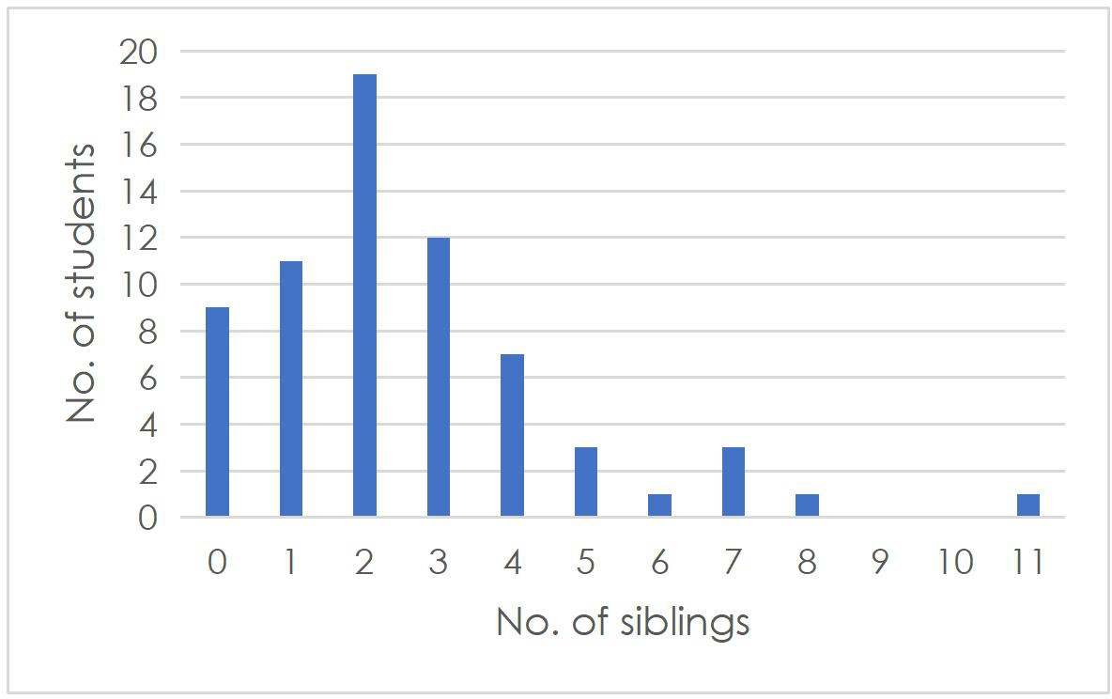

Figure 1 shows the number of siblings that the Grade 8 students have. It is noteworthy that out of 67 respondents, 19 or 28.4% have two siblings; 12 of them (17.9%) have 3 siblings, 11

(16.4%) have only one sibling, 9 of them (13.4%) do not have a sibling, 7 (10.4%) have 4, 3

(4.5%) have 5 and another 3 (4.5%) with 7 siblings, and 1 (1.5%) with 6, another 1 (1.5%) with 8,

and 1 (1.5%) other student with 11 siblings respectively.

According to the Philippine Statistics Authority (2016), the average household size in the Philippines was 4.4 persons in 2015. Mangahas (2012) elaborated that *“*Filipino families come in various sizes, here called Extra Small, Small, Medium, Large, and Very Large, or XS, S, M, L, and XL for short”. XS is composed of 1 or 2 persons, S has 3 to 4, M has 5 to 6, L has 7 to 8, and XL has 9 or more persons in the household.

Based on the findings, 58 out of 67 Grade 8 respondents or 86.6% have a small to medium family. Only 9 or 13.4% belong to a large or extra large family having 7 or more family members. Larger families usually suffer more from economic deprivation compared to smaller ones (Mangahas, 2012). This is worthy of consideration especially during a pandemic in which the economy suffers due to the health protocols and restrictions. In the case of the students having online classes, students need to be provided with a gadget and internet connection or at least mobile data for distance learning. This brings us to the next chart which shows the family income bracket of the Grade 8 students.

# Figure 2. Family Income Bracket of SSU-LHS Grade 8 Students S.Y. 2020-2021

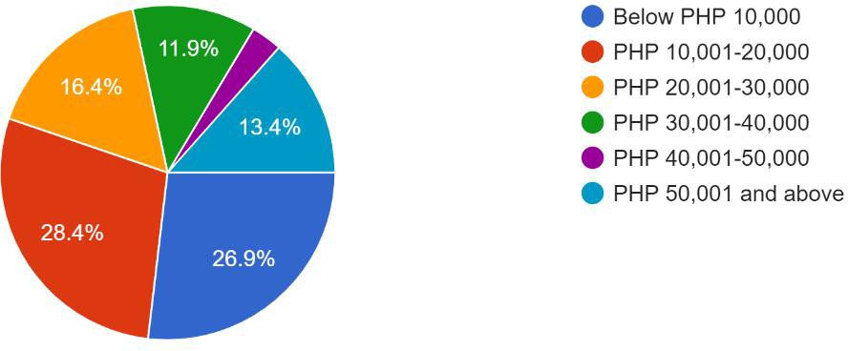

This figure shows the average monthly household income bracket of the Grade 8 students including cash earnings of all family members who are working or gainfully employed. It

reveals that out of the 67 respondents, 28.4% or 19 students have a family income of Php 10,0001-20,000; 26.9% (18) have below Php 10,000 household income, 16.4% (11) have Php

20,001-30,000, 13.4% (9) have Php 50,0001 or more, 11.9% (8) have 30,0001-40,000, and only

3% (2) with a family income of Php 40,001-50,000.

Philippine Institute for Development Studies (PIDS), as cited by Domingo (2020), released an “income class brackets in the country, which government uses to categorize families into social classes”. Domingo (2020) stated that as of 2018, the PIDS identified social classes according to the following income brackets in terms of monthly income:

# Table 1. Income Class Brackets of SSU-LHS Grade 8 Students S.Y. 2020-2021

|  |  |  |
| --- | --- | --- |
| **Social Class** | **Family Monthly Income** | **F** |
| Poor | Below P10,957 | 18 |
| Low-income but not poor | P10,957 to P21,914 | 19 |
| Lower middle | P21,914 to P43,828 | 19 |
| Middle | P43,828 to P76,66 | 11 |
| Upper middle | P76,669 to P131,484 | 0 |
| Upper middle but not rich | P131,483 to P219,140 | 0 |
| Rich | P219,140 and above | 0 |

In the case of the Grade 8 students, 18 out of the 67 respondents (26.9%) belong to a poor family; 19 (28.4%) students belong to families with low-income; 19 (28.4%) are in the lower middle class, and 11 (16.4%) are in the middle class. Going back to the first figure, data shows that most of the Grade 8 students belong to a small to medium size family. Though this is a good indicator, it should be noted that based on the second figure and Table 1, a significant number of these students belong to a poor or low-income families. One of the implications of this concerning online classes is that a number of parents may have difficulty in providing gadgets for the students which are appropriate for distance learning.

Based on the results of the enrolment and survey form for SSU-LHS students, out of the 77 Grade 8 students, 55 (71.4%) have two or more gadgets to use for online classes which may include smartphone, laptop, desktop computer, or tablet; while 20 (26%) of them are only using smartphone, 1 (1.3%) student uses laptop, and another 1 (1.3%) uses a tablet for distance learning. Needless to say, it is more appropriate to use a laptop or desktop computer for online learning for they are more convenient to use especially in terms of reading texts and creating documents to be submitted in compliance with the activities and assignments given by their teachers. According to UTEP Connect (n.d), one of the major problems in using smartphones for online classes is the element of distraction specifically due to popping messages or incoming calls. Also, it is helpful to use a “word-processing program on a laptop or desktop computer when finalizing an assignment” especially those with prescribed formats (UTEP Connect, n.d.).

# Figure 3. Position in the Family of SSU-LHS Grade 8 Students S.Y. 2020-2021

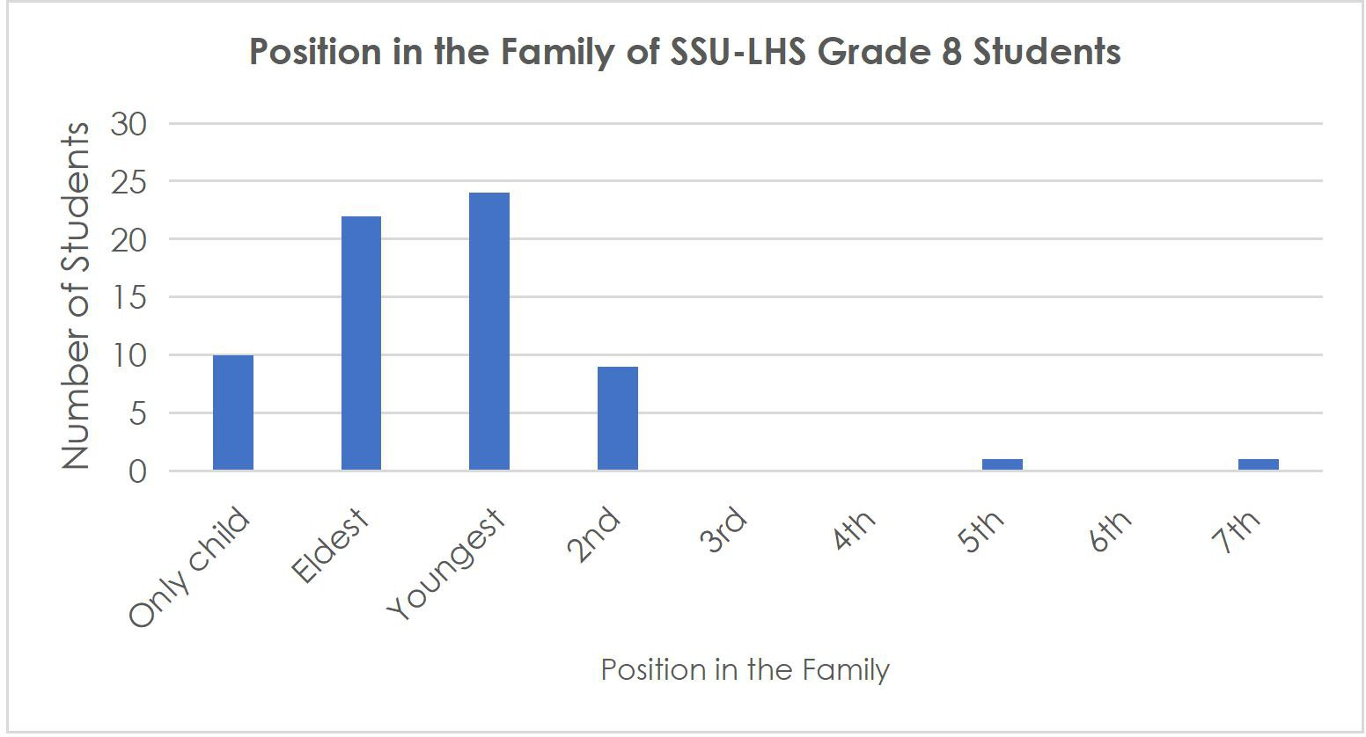

Another factor to be considered is the student’s position in the family. Figure 3 shows that out of the 67 Grade 8 respondents, 24 or 35.8% are the youngest in the family; 22 (33%) are the

eldest, 10 (15%) are the only child in the family, 9 (13.4%) are the 2nd, 1 student (1.5%) is the 5th child and another one (1.5%) is the 7th child respectively. The implication of this especially in terms of online classes is that the eldest and those who are the only child in the family (48%) could only rely on their parents or guardians for instructional support; while the others who have elder siblings could be taught or helped by their older brother/s or sister/s particularly in understanding the teachers’ instructions or some difficult concepts.

# Issues or Problems Encountered by Students

Data has been collected from the students’ reflective journals in which they were given six

1. guide questions which revolve around the following themes: 1.) online classes, 2.) instructional support, 3.) relational life, and 4.) emotions felt amidst the pandemic. Quirkos, a simple data analysis software, was used in coding and theming the students reflective journal entries. Out of the 77 Grade 8 students, 57 were able to submit their reflective journal. The following are the findings:

# Online Classes

Sorsogon State University adopted online learning this school year including its Laboratory High School, with a Learning Management System set in place. In SSU-LHS, synchronous and asynchronous sessions are held following a class schedule. In a week, four (4) subject teachers hold at least one virtual meeting with the class and give assignments to be accomplished for the week, while the other four (4) subject teachers give activities which students can accomplish asynchronously.

Based on the reflective journal entries, most of the Grade 8 students are having a hard time adjusting with online classes. The following statements are from some of the students who found distance learning difficult.

*“To be honest I think [its] kinda hard since [I’m] used to face to face instead of online… I can do the work the teachers gave me but even though [I’m] doing it [I’m] still not learning anything…”*

*“I’m one of those students who are having a hard time learning online... [Distance] and modular learning are not really effective. The moment that our school announced that the modality of learning will be online or also known as [distance] learning, I got depressed. [It’s] because I know myself that I’m a slow learner and prefers human interaction (face to face).”*

Generally, a significant number of Grade 8 students indicated that one of the main challenges that they are encountering in online classes is poor signal or internet connection which leads to unclear lessons during synchronous sessions and difficulty in accessing online applications and submitting files on time during asynchronous sessions.

Another major challenge that they face is the amount of activities and projects to comply with and the lack of time to accomplish them. A student noted that sometimes they were only given a day to comply with the activity. Some of them also expressed that they can hardly learn well since there are a lot of things to do; such is the case of these students who noted that:

*“I expected online classes won’t be that easy, but I never expected it to be this hard. First few weeks was fine, last week was too hard for me. We had fewer synchronous classes than the usual but the amount of activities and projects given were overwhelming.”*

*“[Because] of so many activities, I don’t have more time to study the lessons well because I need to move on to other subjects to pass right on time.”*

The other challenges that the Grade 8 students expressed are the following: distractions at home, lack of a conducive place to study, housechores, power outage, procrastination, poor time management, anxiety during recitation, difficulty in self-studying, having to use smartphone in online learning, sharing smartphone with a sibling for online classes, hanging phone or laptop and/or malfunctioning gadget, lack of materials for projects, and unclear instructions in some activities.

A student also expressed some concerns regarding their virtual meeting:

*“In synchronous classes, some of our [teachers] did not [send] the code in [our] group chat, [it was sent] through direct messages resulting for most of my classmates to be late. Synchronous classes [are] absolutely fine except if we have problems connecting to the internet and if the teacher [isn’t] really teaching.”*

A concern was also raised regarding the accessibility of materials sent by teachers:

*“I sometimes have a problem when the teacher only gives an activity in messenger because of my other classmates who are active that time they keep on adding chats that [make] the given activity hard to find and sometimes I didn’t notice if there is a given activity.”*

Two of the students who use smartphone for online classes expressed the difficulty in accomplishing some tasks.

*“I find experiencing synchronous and asynchronous sessions a bit hard because there are times that there are a lot of things to type and sometimes it's hard to type it on my phone.”*

*“My experience [in] online class so far has been very stressful because [I’m] new to Microsoft making documents and [it’s] very hard in mobile cell phone.”*

Some students also complained about headaches due to long exposure to gadgets. Such is the case of these students who expressed that:

*“I often experience headaches too [because I] have been on screen for too long and my parents get angry about it. I can’t do anything [because] all of the tasks are online. I am [nearsighted] and I am worried [because] I don’t want it to get worse.”*

*“The bad things about getting online in class are that you are not learning and your eyes and head are still hurting because of radiation and the online class for me is that you can just pass, not the same as before that you really learned something.”*

Comments and suggestions about online classes were also noted:

*“Synchronous sessions demand participation from students and that challenges those who are shy and quiet. From what I observed in my synchronous classes, only a few answer and participate in the discussion leaving an awkward silence when no one answers. Anyways I suggest that in synchronous sessions we may comment down our answers in this way the "quieter" students can participate as well.”*

*“I do hope that there’s less activities in the future because all of the activities that are given right now are piled up and we still have projects that we need to do that are due in a couple of weeks.”*

*“In spite of this pandemic, I also expect that we'll be enabled to work independently and also maybe collaboratively with my fellow classmates. Moreover, as an online student, I foresee that we will be given the chance to have enough time for us to complete all our requirements/activities. And as to our teachers, I hope that you will be more understanding particularly considering that we are all new to this new normal, be more approachable, and can teach in such a way that we as students will be more motivated to participate.”*

On the other hand, a few students find online classes okay, engaging, and/or fun as shown in the following statements:

*“It's going great so far some people may say they assign [too] many activities but for me [it’s] moderate.”*

*“My experience in having synchronous and asynchronous sessions is okay because I don't really have any problems with it and [I’m] totally fine with how it turned out, I do miss school but that’s okay because I get to learn stuff and [I] can be more efficient with school and [I] can also do my hobbies more often now that I’m always at home.”*

*“My online learning experience is engaging. It gives joy of learning that enhances my skills, abilities and knowledge. It helped me learn independently… by working from the comfort of our home. I also learn how to manage family time and school work. Online classes become an opportunity to gain new skills and experiences since we are connecting with others in a personal, creative and human way through computers and devices.”*

In general, the highlights or good things that the students noted regarding online classes are the following: learning in the comfort of their own home, class schedule, ensuring everyone’s safety, not having to wake up early to go to school and spend money and time to commute, learning new things, doing fun activities and projects, meeting classmates virtually after a long break, being able to see and listen to teachers and classmates, flexible time to study, easy access to learning materials, and more time with family.

Some students expressed their appreciation to their teachers.

*“One of the good things that I've experienced during online class is I've met new dedicated and hard-working teachers that are willing to help you and teach you [despite ] the circumstances.”*

*“There are good things that I experience in my online classes like the teachers are kind, hardworking and smart. They help us [when] we don’t understand some parts of [the lesson], they ask us if we have questions, they allow us to speak [Filipino] so we can recite comfortably, and they listen to our opinions.”*

*“Moreover, my teachers are committed to help everyone in our class and provide positive learning experiences. I am grateful for their tireless service in ensuring quality education.”*

A student also noted that online classes help them in improving themselves.

*“The students will be more independent and self-disciplined, improve or learn new skills like technical and communication skills.”*

Online classes, according to a student, are a good way to redirect their focus in this time of pandemic.

*“I guess that it’s the fact that even [we’re] in a pandemic, the education system is still doing its best on making sure kids are well educated and not just lying there not doing anything. The other good thing is that online class distracts students from the whole global pandemic thing.”*

# Instructional Support

With the new normal in teaching and learning, students also need instructional support from their family members, either from their parents/guardians or from their older siblings or extended family. In moments when students are having a hard time understanding instructions and concepts, it would be helpful if they would receive such a support. Based on the findings of this study, most of the Grade 8 students receive instructional support from at least one of their family members (parent/guardian, grandparent, older sibling/cousin, etc). However, there are some who receive little to no instructional support especially those who are the eldest in the

family, or an only child whose parents are both working. Here are some statements which express students’ difficulty of having to cope with online classes at home on their own:

*“My family doesn't really give me instructional support for online classes. But they do help me for my projects if they can. I don't really ask for their help because they have their own tasks to do. I don't want them to be distracted. My mom and dad [have] work to do, so they are out of the house at [8:00 AM]. My siblings have school tasks to do, my other sibling has online classes just like me and the other has so many modules to finish.”*

*“When it comes to school work, I don't often ask for help from my parents because they're busy and that doubled since the pandemic. Also because they're helping my younger sisters study because they need it more and I understand that.”*

*“Sometimes, because they are also busy in their work so I’m just alone in the house for the whole day.”*

Another reason for lack of instructional support is the fact that students may not be that close to their family.

*“I don’t usually ask for help especially to my family because [I’m] not close to them, but they are giving me moral and financial support.”*

In addition, some of the students’ parents are not able to give instructional support due to their educational background.

*“My mother is having trouble understanding some lessons and my father is not a college graduate. They aren’t able to help me, [it’s] hard for them especially English language. We are just a small family in the house and my cousins [live] far away.”*

Being worried about what the family members would say is also one factor for a student who expressed the following statement:

*“I hardly ask or even mention anything about my classes to my family because I fear they might say ‘I am not doing good enough’ or I am not ‘I’m not listening well’.”*

# Relational Life

Based on the students’ reflective journal entries, most of them are connected to their friends through chats/texts and/or video calls. In addition, most of them have been closer to their family during this time of pandemic that they are forced to stay at home for almost 9 months now. Only one of them explicitly expressed the lack of significant growth in terms of relationship within the family.

*“Nothing actually changed, my relationship with my family particularly to my parents didn't grow. The wall between me and my parents is still there, maybe because I’m too afraid to talk to them or open my problems. Even my guardians don't know how my life is going.”*

In addition, there are some of them who expressed that they are not so connected with their friends and classmates online as elaborated in the following statements.

*“Friends? I rarely even talk to them.”*

*“In terms of interacting with friends is where [I] find problematic. It just doesn't feel the same in screen than real life. Although [I] can still message or call them*

* 1. *still find it better to interact with them face to face.”*

*“Lately, I have not been able to talk or chat with my friends. I do not really like talking or chatting with other people online.”*

Poor signal and internet connection or the lack thereof is also one factor affecting communication and relational life.

*“My parents and my friends connect when we are chatting and having a video call. I really miss my parents, our house does not have a wifi so it's hard when I'm not with them.”*

*“It’s also hard to connect to other people in the midst of pandemic when you’re in an area that doesn’t have strong internet connection. And it is really depressing [too] when you needed someone to talk online because you’re not that close to any of your family member, the internet or signal won’t cooperate.”*

A struggle in having a conversation with relatives was expressed by a student.

*“I don’t really communicate that much with my relatives since it’s sometimes awkward and hard to start and keep a conversation going because my interests [differ] from what they talk about as a topic.”*

Difficulty in making friends with new classmates online was also noted.

*“Making friends or getting close to my new classmates scares me a lot and is quite challenging for me. I'm a friendly type of person but [I’m] also shy, like some of my classmates are intimidating, [I’m] afraid that they would snob me or what, so [I choose] to be silent and just go with the flow.”*

Social interaction is one of the factors of student barriers to online learning (Muilenburg & Berge, 2005). Therefore, there should be avenues in which students develop their social skills by having meaningful interactions with other people particularly with their classmates.

# Emotions Associated with the Pandemic

In the student’s reflective journal entries, the negative emotions expressed which are associated with the effects of the pandemic to their lives in general are the following: sad, isolated, lonely, bored, frustrated, depressed, stressed, pressured, nervous, anxious, afraid, and tired. On the other hand, some expressed positive emotions such as thankful, happy, and hopeful which they have attributed to their family and loved ones’ safety, spending more time with their families, being able to learn new things and to do their hobbies, and having faith in God that this pandemic shall pass. One neutral feeling was expressed which is that of being stoic noting that the pandemic is something that is quite expected.

Generally, the negative feelings that they have are caused by common stressors such as: restriction to go outside and meet people especially their friends, fear that they or their loved ones would get infected by the virus, adjusting to the new normal especially to online classes, having too many tasks to accomplish, distractions while having online classes, lack of instructional support from family, poor signal or internet connection, news about those who were infected and died due to corona virus and about the negative effects of the pandemic in terms of employment, etc; and the effects of the consecutive typhoons. The following are some of the statements showing their emotions in this time of pandemic:

*“This is [my] first time experiencing [a] pandemic so [I am] really scared and even paranoid sometimes. When [I] found out what this virus can do, [I] got scared like any other people.”*

*“Public health actions, such as social distancing, surely are necessary to reduce the spread but [I] can't help [but] feel isolated, lonely and [have increased] stress and anxiety.”*

*“It is normal to [feel] fearful and anxious during this time of pandemic and I realize as the coronavirus outbreak has shown, life can change very quickly and*

*[it is] very unpredictable… You may be anxious about when the pandemic will end or if the world will ever return to normal.”*

A student shared an unfortunate incident which led to feelings of frustration:

*“I got robbed while sleeping. The phone that I personally use to attend online classes, on making activities, etc. All my files that are related to school and other important things. After that incident, I cannot sleep very [well] anymore, couldn’t finish a complete meal, frustrated to think of fancy words, construct sentences for essay.”*

Some students expressed that they are struggling with online classes which caused feelings of depression, and anxiety.

*“The moment that our school announced that the modality of learning will be online or also known as [distance] learning, I got depressed. [It’s] because I know myself that I’m a slow learner and prefers human interaction (face to face).”*

*“I do not like synchronous classes because everyone can see my face which is something I do not like for it makes me anxious. I also do not like speaking during synchronous sessions because, I feel anxious whenever a lot of people that I do not even know are listening to me.”*

These findings show some similarity with what Seyahi et. al (2020) found in their survey in which they concluded that a considerable portion of the students in Turkey and Denmark expressed feelings of loneliness, boredom, and anxiety towards the future in this time of pandemic. Although there are a lot of factors affecting one’s human emotions, it should be taken into consideration how educational institutions could help lessen the extent to which these emotions are felt especially due to academic factors. In addition, Ellis et. al (2020) emphasized that helping adolescents cope especially in this time of crisis is highly essential.

# Conclusions

SSU-LHS Grade 8 students mostly belong to a small or medium family. In addition, a significant number of these students belong to a poor or low-income families. Out of the 67 respondents, 48% constitute the eldest and only child in the family. Also, 20 students only use a smartphone for online classes.

In the light of the findings of the study, the revealed issues mostly revolve around their struggle in adjusting to online classes. The major problem encountered by a significant number of students is poor signal or internet connection. Another notable concern is the amount of activities and projects given. Some students have little to no instructional support from their family members. Some of them also find it hard to connect with their classmates, friends, family members, and relatives.

An action plan is proposed based on the result of the study. The general objective is to inform and give recommendations to the students, area chairman, subject teachers, parents, and school administration on how to help the Grade 8 students cope and learn well in their online classes.

# Recommendations Action Plan

Based on the findings of this study, the researcher proposed an action plan to address the

concerns of the Grade 8 students. Generally, the action plan aims to give recommendations to the students, area chairman, advisers, subject teachers, parents, and school administration in order to help the students to adjust and learn well in the online classes.

# ACTION PLAN FOR THE SSU-LHS GRADE 8 STUDENTS S.Y. 2020-2021

|  |  |  |
| --- | --- | --- |
| **Objectives** | **Tasks** | **Success Criteria** |
| Give recommendations to the students based on the findings of the study | -Teach them about time management and tips to cope with online classes  -Recommend the following:   1. Have a written or printed class schedule/personal schedule posted in their study area 2. Regularly check their class group chats, Google Classroom or LMS for new assignments 3. Avoid procrastinating 4. Connect to at least one of their classmates to update each other about their progress in online   classes or to check on each other as friends | The students were informed about the findings of the study and how they can improve in their online classes and relational life. |
| Give recommendations to the area chairman, advisers, and  subject teachers  based on the findings of the study | - Inform the area chairman and subject teachers about the students’ concerns regarding online classes  -Propose the following:   1. lessen the weight of projects so that students would be able to focus on the Most Essential Learning Competencies 2. post materials on LMS or Google classroom instead of sending them solely in messenger 3. allow students to contribute in the discussion during the synchronous sessions by typing their answer/s on the chat box 4. give a longer time for students to submit their works 5. send the link to a google meet on the class group chat 6. give clear and detailed instructions for the activities 7. intentionally create an avenue for them to know one another better and be more comfortable with one   another | The area chairman and subject  teachers were  informed about the concerns of the Grade 8 students based on the findings of the study. |
| Give recommendations to parents based on the findings of the study | -Ask for permission from the area chairman to share the findings of this study to the parents of the Grade 8 students during the first PTA meeting  -Recommend the following to the parents:   1. check if their child has a written or printed class schedule or personal schedule 2. help their child to have a conducive place to learn at home 3. (if they are able) provide instructional support to their child; if not, at least check on their progress in their online classes 4. help them unwind especially during weekends | The parents were informed about the concerns of their children based on the findings of the study. |
| Give recommendations to the school  administration | The result of the study and the action plan shall be forwarded to the school administration thru the dean and campus administrator.  -Recommend the following to the school administration:  a. find ways to help impoverished students not to get left behind in the online classes set up by providing gadgets or implementing blended  learning (combination of online and modular learning) | The school administration was informed about the plight of the students  amidst distance learning. |

|  |  |  |
| --- | --- | --- |
|  | b. consider modular learning especially for the students with no appropriate gadget, poor signal,  and/or internet connectivity. |  |

In terms of giving recommendations to the students, the researcher - being one of their subject teachers, taught them about time management and tips to cope with online classes. First, they were encouraged to have a written or printed class schedule/personal schedule posted in their study area. This will help them in managing their time well and avoiding tardiness or absences especially during synchronous sessions. Motivation is a key ingredient to empower students’ capacity for online learning alongside “life management skills - how they themselves organize their days, balance distance school and leisure time, and learn to maintain their own wellbeing” (Niemi and Kousa, 2020, p. 368). Second, they should regularly check their class group chats, Google Classroom or LMS for new assignments. Third is to avoid procrastinating. Having to deal with piled up assignments would certainly cause unnecessary stress and anxiety. Fourth is to connect to at least one of their classmates to update each other about their progress in online classes or to check on each other as friends. Connecting to friends virtually is one of the factors which alleviate loneliness (Ellis, Dumas, & Forbes, 2020; Muilenburg and Berge, 2005; Rahiem, 2021). Generally, the students were informed about the findings of the study and how they can improve in their online classes and relational life.

With regard to the area chairman and subject teachers, they were informed about the concerns of the Grade 8 students based on the findings of the study. In the action plan, the researcher proposed the following: a. lesson the weight of projects so that students would be able to focus on the Most Essential Learning Competencies (they may be required in some subjects but not in all); b. post materials on LMS or Google classroom instead of sending them solely in messenger; c. allow students to contribute in the discussion during the synchronous sessions by typing their answer/s on the chat box (especially for those who are shy to speak); d. give a longer time for students to submit their work; e. send the link to a google meet on the class group chat; f. give clear and detailed instructions for the activities; and g. intentionally create an avenue for them to know one another better and be more comfortable with one another. Aside from helping them learn well together, they would be able to engage with others online. As mandated, educators are expected not just to help students “obtain competencies but also develop character qualities” among the learners including the social aspect of their growth (National Economic and Development Authority, 2016).

Moreover, these are the recommendations addressed to the parents: a. check if their child has a written or printed class schedule or personal schedule (should be posted within their study area); b. help their child to have a conducive place to learn at home (at least a quiet area); Rahiem (2021) found that the learning atmosphere is one of the factors that help keep students motivated in their studies; c. (if they are able) provide instructional support to their child; if not, at least check on their progress in their online classes; d. help them unwind especially during weekends. As emphasized by Ellis, Dumas, and Forbes (2020) and Rahiem (2021), the factors which alleviate loneliness is the time spent with family, connecting to friends online, as well as physical activity especially in this time of pandemic.

Lastly, the following are recommendations which were forwarded to the school administration: a. find ways to help impoverished students not to get left behind in the online classes set up by providing gadgets or implementing blended learning (combination of online and modular learning); and b. consider modular learning especially for the students with no appropriate gadget, poor signal, and/or internet connectivity. With this, the students will be helped to remain motivated with the “learning atmosphere and facilities” which are provided for them (Rahiem, 2021).

This action plan was developed to help improve the learning conditions of the students especially in the next school year with the cooperation of the stakeholders especially the faculty members, parents, school administration, and even the learners themselves. In addition, it is recommended that further study on students’ concerns about online learning should be done with a wider scope in order to address the problems and cater to the students’ needs to ensure quality education amidst the pandemic.

1. **Acknowledgement**

The researcher wants to extend her heartfelt gratitude to everyone who participated in this action research especially to the students, area chair, faculty members, parents, and school administration. Also to her family particularly her mother for being her number

one supporter. Most of all, to Almighty God for the wisdom, guidance, and sustaining grace in accomplishing this worthwhile task.

# References

Action Research. Retrieved from <https://www.edglossary.org/action-research/>

Domingo, K. (2020). Who are identified rich, poor? Gov't shows income class brackets in PH. Retrieved from <https://news.abs-cbn.com/news/09/17/20/who-are-identified-rich->poor-

govt-shows-income-class-brackets-in- ph#:~:text=Low%2Dincome%20but%20not%20poor,to%20P131%2C484%20 monthly%20income

Ellis, W. E., Dumas, T. M., & Forbes, L. M. (2020). Physically isolated but socially connected: Psychological adjustment and stress among adolescents during the initial

COVID- 19 crisis. *Canadian Journal of Behavioural Science/Revue*

*canadienne des sciences du comportement*, *52*(3), 177.

Mangahas, M. (2012). Economic deprivation and family size. Retrieved from https://opinion.inquirer.net/22811/economic-deprivation-and-family-size

Muilenburg, L. Y., & Berge, Z. L. (2005). Student barriers to online learning: A factor analytic study. *Distance education*, *26*(1), 29-48.

National Economic and Development Authority. (2016). *Ambisyon Natin 2040.* Pasig City: NEDA. Retrieved March 6, 2020, from <http://2040.neda.gov.ph/wp->

content/uploads/2016/04/A-Long-Term-Vision-for-the-Philippines.pdf Niemi, H. M., & Kousa, P. (2020). A case study of students’ and teachers’ perceptions in a

Finnish high school during the COVID pandemic. International Journal of Technology in Education and Science (IJTES), 4(4), 352-369.

Press Academia. (2020, March 13). *Definition of Case Study.* Retrieved from https://[www.pressacademia.org/definition-of-case-study/](http://www.pressacademia.org/definition-of-case-study/)

Rahiem, M. D. (2021). Remaining motivated despite the limitations: University students’ learning propensity during the COVID-19 pandemic. *Children and Youth Services*

*Review*, *120*,105802. <https://doi.org/10.1016/j.childyouth.2020.105802>

Seyahi, L. S., Ozcan, S. G., Sut, N., Mayer, A., & Poyraz, B. C. (2020). Social and Psychiatric Effects of COVID-19 Pandemic and Distance Learning on High School Students:

A Cross-Sectional Web-Based Survey Comparing Turkey and Denmark. *medRxiv*.

UTEP Connect. (n.d.). 5 Pitfalls to avoid when using your smartphone for school. Retrieved from [https://www.utep.edu/extendeduniversity/utepconnect/blog/september-](https://www.utep.edu/extendeduniversity/utepconnect/blog/september-2017/5-pitfalls-to-avoid-when-)

2017/5-pitfalls-to-avoid-when- using-your-smartphone-for-school.html