ISSN: 2502-4752, DOI: 10.11591/ijeecs.v15.i3. ppxx-xx 

1

ONLINE QR CODE DIGITAL CONTACT TRACING USING ORACLE – CLOUD COMPUTING

|  |  |  |
| --- | --- | --- |
| **Article Info** |  | **ABSTRACT** |
| ***Article history:*** |  | While the cure is yet to discover, one of the approaches to preventing the virus spread is Contact Tracing. A systematic Contact Tracing protocol should identify, assess, and manage people who are positive or exposed to the virus to break the transmission chain, thereby preventing the disease's onward transmission. The current manual approach of gathering data, whereby people who needed to go inside banks, malls, government offices had to line up, waiting for their turn to write their necessary personal data on a security guards' logbook. The researchers developed the system using Information Technology, various trends, QR codes, Cloud computing, Data Analytics, Smartphone, and Big Data. The QR code system eliminates the long queues when entering the establishments. Using a designated smartphone connected to the internet, the scanning officer only needs two (2) to five (5) seconds to scan the QR code of the person who is about to enter the office or building. The scanned QR code would give the scanning officer the necessary personal information and information relative to the person's exposure or non-exposure to the virus. All captured information would send to the cloud that the command center can access the report at any time for a possible analysis of contact tracing of known COVID-19 positive. Any quarantine violator would detect—the methodology used in the Rapid Application Development model. The researcher has anchored each module as a guide during the system's development using Oracle front-end and back-end. The development tools used on scripting for the forms and reports are Oracle's native scripts, including Oracle plug-ins. The system was already tested its purpose and functionality for contact and quarantine tracing solutions. It is already available using the Oracle infra and Oracle platform suitable to carry BIG DATA in nationwide implementation. |
| Received Oct 1, 2019  Revised Dec 10, 2019  Accepted Jan 25, 2020 |
| ***Keywords:*** |
| Big Data  Cloud Computing Contact Tracing Oracle Infrastructure QR Code |
|  |  | *This is an open access article under the* [*CC BY-SA*](https://creativecommons.org/licenses/by-sa/4.0/) *license.* |
| ***Corresponding Author:*** |  |  |

## 1. INTRODUCTION

light of the pandemic [6] that the world is experiencing now, different types of preventive measures

[8] have been implements vis-à-vis the unrelenting efforts of health professionals to come up with a cure for this virus.[4]

While the cure is yet to discover, one of the approaches to preventing the virus's spread is Contact Tracing [3]. A systematic Contact Tracing protocol should identify [11], assess, and manage people who are found to be positive or exposed to the virus [17], to break the chain of transmission, thereby preventing the onward transmission of the disease [9].

***Journal homepage****:* [*http://ijeecs.iaescore.com*](http://ijeecs.iaescore.com/)

#### ISSN: 2502-4752

The current manual approach is a redundant gathering of data. People who needed to go inside banks, malls, and government offices had to line up, waiting for their turn to write their necessary personal data on a security guards' logbook.

In this scenario, people are very prone to the virus's contamination because of the frequently used ball pens and logbooks during the manual registration process that defeats the purpose of preventing spreading the viruses.

Other methods that the department stores implement are they have their QR code at the mall entrance. The person who wants to enter the mall must scan the QR code for their smartphone to access the forms to fill- up the required parameters of the person's whereabouts before entering the mall.

Many contact tracing applications exist [10] in the country, but the application only traces the infected virus's possible contact. All of them cannot acquire accurate data because of the issue that the name of the person is not validated its integrity. However, they required a text validation before they can continue to acquire the QR code. However, the person's name is not properly validated; in other words, anybody can register without using his/her real name. [28][29][30][31][32][33][34][35]

The researchers developed the contact and quarantine tracing software using a quick response (QR) code system that eliminates [7] the long queues when entering the establishments. It is a cloud-based domain application using the Oracle infrastructure, Oracle platform, Oracle front-end, and a back-end that the smartphone, laptop, tablet, and Personal computer can use as the scanner gadget connected to the internet to access the cloud server [1].

For the checkpoints, any smartphone connected to the internet, the scanning officer only needs two

1. to five (5) seconds to scan the QR code of the person who is about to enter the office or building and even crossing the borders.

The system requires a massive registration of all the Cebu City residents to secure a one-time QR code thru an on-site designated area by accessing a domain for on-site registrations that requires a valid ID or barangay clearance as a minimum requirement before the registration will continue. Furthermore, accessing the internet domain for online registration requires two (2) layers of validation. First, sending a good ID picture. Second, the selfie captured carries the valid ID for a strict verification of data or person to register the system to ensure that the data gathered is correct and accurate. Then equivalent QR code would email to the registrants by the command center personnel after the validation process.

This study is an innovative approach to acquiring personal information of Cebu City residents and nearby provinces in a verified and accurate way because this is important for contact and quarantine tracing. Other innovative solutions are not considered the accuracy of the gathered data as their primary concern. After all, their system can register using any name and address as long as a cellphone number can receive the validation code as the main requirement to release the QR code.

The residents must carry their QR code, either printout or screenshots on their smartphone every time they go out to markets and malls in the city. After the registration process, the proper implementation is a need at the barangay level. Security assigns a scanning officer to scan the person outside of their residents to determine that they are under home quarantine restrictions or allowed to go outside of their residents they belong to PUI and PUM status.

The malls and establishments' security acts as a scanning officer to scan the person's QR code that enters the mall or establishments. The police officers work as a scanning officer to inspect the vehicle for the checkpoints, passing to the checkpoints or borders. All the data captured in the QR code would send directly to the cloud for possible data reporting and possible virus carriers' data analysis during the scanning process.

All the contact tracers must position the command center for the possible contact tracing analysis by accessing the command center domain. The command center is equipped with unbreakable user authentication to ensure that only an authorized person can access the command center.

The command center can update the record given by the Department of Hearth (DOH) for the alert of a possible infected person, quarantine restriction for persons under investigation (PUI)[25], or a person with COVID-19 infected and cured, and persons under monitoring (PUM). The health department can access the domain for updating the residents' records for any restrictions or heal patients if they have user rights to access the updated internet domain. If, just in case of losing the QR code for those on-site registrations, they can ask for a copy to the designated on-site registration office. Figure 1 shows the concept of the study.

Indonesian J Elec Eng & Comp Sci, Vol. 15, No. 3, September 2020 : xx - xx

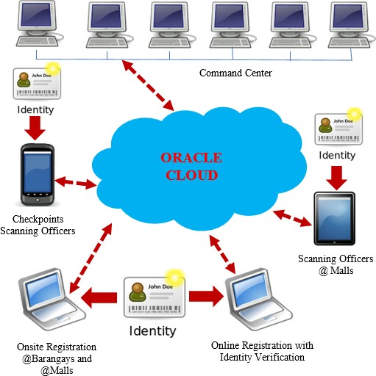

# Figure 1. Concept of the study

**Objective of the Study**

The main objectives of the study are to support the Cebu City government in managing the COVID- 19 virus and other health emergencies affecting the community thru:

* 1. Contact and Quarantine tracing software using QR code technology to monitor the allowed persons outside their residence for a possible contact tracing.
  2. A gadget or smartphone that is capable of accessing cloud server using the internet browser with internet connectivity that can access the application for scanning:
     1. Checkpoints
     2. Malls
     3. Public Markets
     4. Establishments
     5. Barangay Outpost
     6. Inter-City Border
  3. Cloud computing-based independent Software Vendor Oracle and Oracle infrastructure that caters entire Cebu province as one database.
  4. A fully managed technology solution with an approach that is secure without infringing on individuals' privacy.
  5. Application software that is suitable for the DOH action plan for the COVID-19 reduction mechanism.

## RESEARCH METHODOLOGY

The researcher's decision to use the Rapid Application Development (RAD) model for the methodology as a basis in developing a useful and accurate solution for this contact and quarantine tracing

*Online QR Code Contact and Quarantine Tracing Using Independent Software Vendor Oracle, J.I. Teleron*

independent software vendor oracle (ISVO) [14] to mitigate the fast spreading of the virus in the city of Cebu in particular and in the province of Cebu in general. Figure 2 shows the RAD model.

Indonesian J Elec Eng & Comp Sci, Vol. 15, No. 3, September 2020 : xx - xx

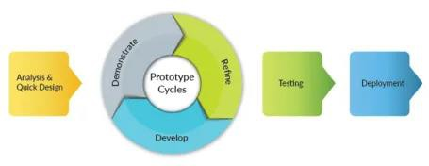

Figure 2. Rapid Application Development Model

### Project Planning Phase

There are many factors that the researchers have considered before starting the development of the

solution:

* 1. The possible bloating of data captured day by day by the end-users.
  2. The infrastructure that supports wide-area networks easily.
  3. The front end and back end of the system that used.
  4. The platform and the application of the method used.

The researchers decided that cloud computing is the best solution to implement the solution. Figure 3 shows the concept of cloud computing as being identified as all the requirements to proceed with the answer. The Oracle Platform, Oracle Infrastructure, and Oracle Application needed to implement so that the system became Safety, Accurate, Fast, and Easy solution based on the Oracle Enterprise Solution provider's characteristics.

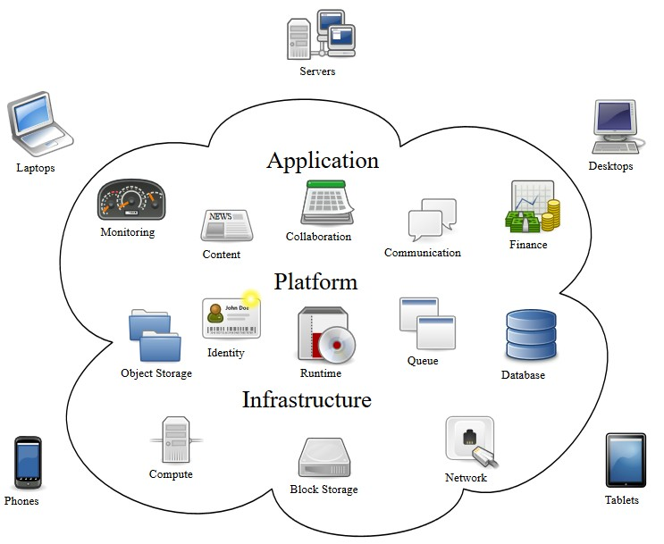

*Online QR Code Contact and Quarantine Tracing Using Independent Software Vendor Oracle, J.I.*

Figure 3. Cloud Computing Concepts

### Analysis and Design Phase

The researchers then assigned the system development for the back-end side's internal policies before making the codes/script from the native Oracle scripting of the database as identified during the design phase of the researcher's methodology. The researchers secure the action plan workflow of the Inter-Agency Task Force (IATF) to automate the flow instead of developing something that is not compliant with the action plan of IATF. Figure 4 shows the contact tracing workflow against COVID-19 below.

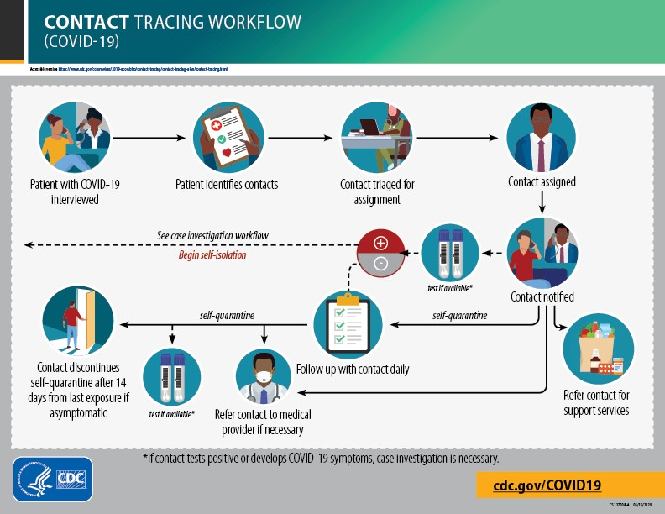

Figure 4. Contact Tracing Workflow

The forms and GUI were created in the Oracle native scripting in an Oracle application to make the application more friendly and concise to the end-user. The researchers developed a dashboard representing the content's visual data analytics registered per barangays with bar and pie graphs. Figure 5 shows the dashboard of the command center.

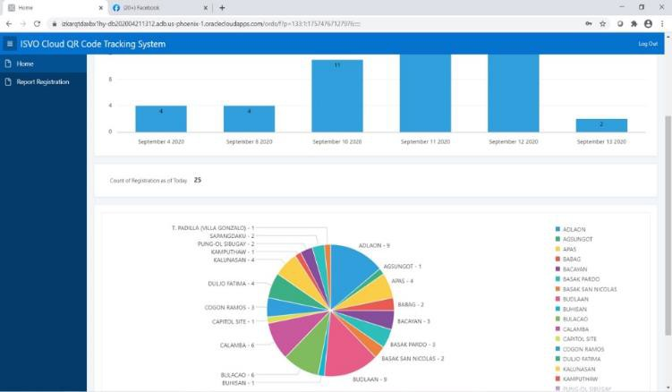

*Teleron*

Figure 5. Command Center Dashboard

### Data Analytics

The data analytics is an essential function of the system because the contact tracing officer can view the number of registered residents, the infected individual per barangays of possible PUI, PUM, and cured patients in pie and bar charts.

### Graphical User Interface Design

The researchers analyzed the workflow of the government's requirement for the basis of their action plan nationwide. They were formulating the user interface based on the IATF (Inter-Agency Task Force) format for data gathering upon entering the person to the establishment or public areas for contact tracing records. Figure 6 shows the user-interface design for the smartphone view.

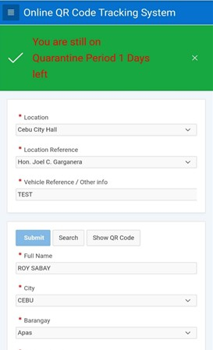

Figure 6. User interface for Scanning officer at Mall area

# There were six (6) user interfaces developed:

1. A registration form for barangays and other designated areas.
2. An online registration entry.
3. Scanning officer for checkpoints.
4. Scanning officer for malls and other establishments.
5. Command Center.
6. Update record for positive and person under investigation patient to identify her/her status to trace easily his/her possible future contacts.

### Prototype Cycles Phase

In this stage of the study, the researchers identify the cloud infrastructure requirements for the Central Processing Unit (CPU) Core, Random Access Memory (RAM) storage, Hard disk storage as the initial setup for the oracle cloud provider. One of the researcher’s members is a gold partner of Oracle Enterprise, in which everything accessible because all the resources were ready for wide-area implementation.

### Testing Phase

Indonesian J Elec Eng & Comp Sci, Vol. 15, No. 3, September 2020 : xx - xx

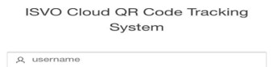

*Online QR Co*

*racle, J.I. Teleron*

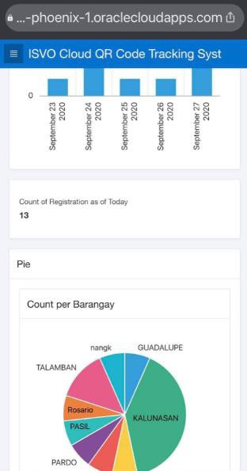In testing, the researchers test the system's integrity by enabling the database to the cloud server at Phoenix, Texas, the United States of America as the cloud service provider's location. Upon testing, the database record had stored thousands of information to tests its process time and response time while other users were accessing the database. Hence, the Oracle database tested reliable and secure Worldwide. Additional inputs from a possible end-user were acknowledged during the testing proceedings and consider the researcher's revision. It was essential for the accuracy of giving an alert when patients under quarantine were visiting the mall, wherein the quarantine period was still ongoing. An alert screen displays one of the screens of the scanner as deflected in Figure 6. While in Figure 7 shows the Oracle database record with data analytics below.

Figure 7. Oracle Database Record with Data Analytics

### System Deployment

The researchers developed a solution that is ready to deploy the entire system because, in the testing process, the system already enables the proper testing of the software in the cloud. The system's final implementation is to sign up and acquire a domain name system (DNS) to easily access the system with the application's desired name in the universal resource locator (URL) of the internet browser. The entire system needs six (6) domain names to complete the whole package of the system with the following application names:

1. scanning officer for checkpoints
2. scanning officer for malls and establishments
3. online registration
4. barangay level registration
5. update patients' status
6. Command Center database access

## RESULTS AND DISCUSSION

After the complex algorithms and analysis of the system's architectural structure, including the contact and quarantine tracing software's internal policies, the researcher's sign-up for hosting the system to Oracle cloud service provider to make the system accessible on the web. The researchers gradually unfold finally, the results based on the desired function of the system. Figure 8 shows the database login screen below.

When the login is complete and the password is correct, Figure 9 shows the dashboard display of the database's content in a Pie graph, and Figure 10 is a Bar Graph that displays on the screen representing the content of data with legends, including the data analytics of records in a database.

*de Contact and Quarantine Tracing Using Independent Software Vendor O*

Indonesian J Elec Eng & Comp Sci, Vol. 15, No. 3, September 2020 : xx - xx

Figure 8. Database Login

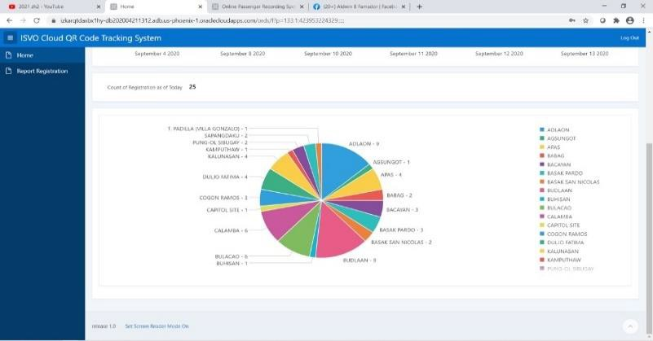

Figure 9. Report Pie Graph with Data Analytics

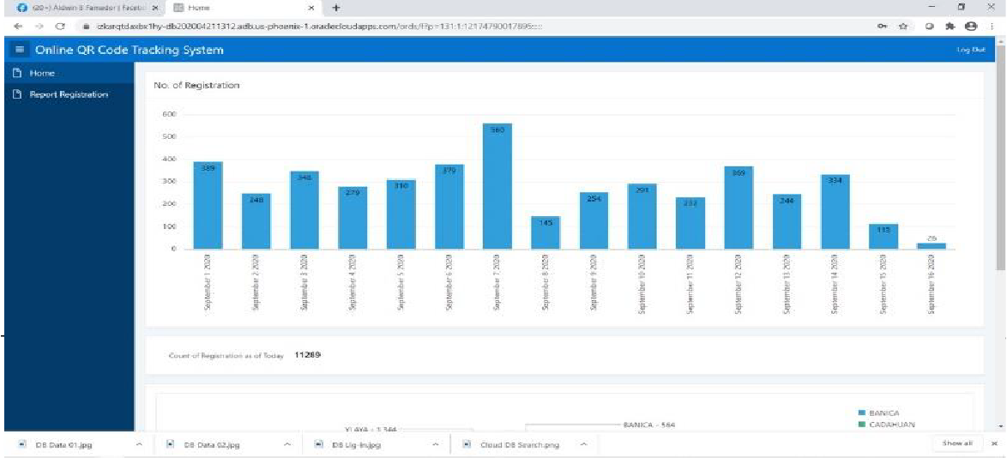

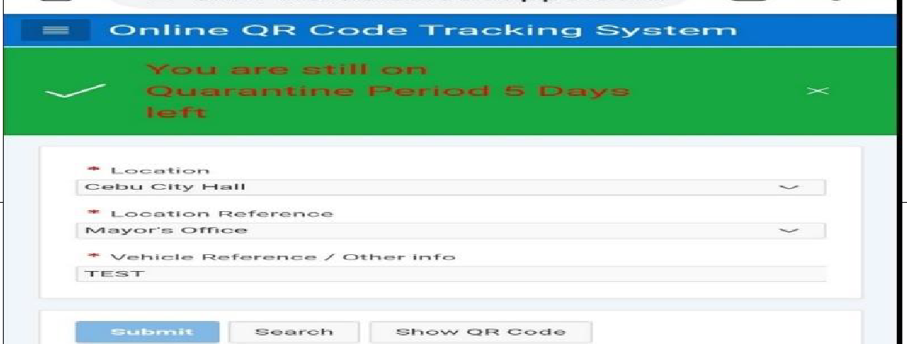

*Online QR Code Contact and Quarantine Tracing Using Independent Software Vendor Oracle, J.I. Teleron*

Figure 10. Report Bar Graph with Data Analytics

The command center controls this database server because the contact tracing personnel can analyze, trace, and update the possible COVID positive based on the DOH (Department of Health) report. Presently, the information is given to the command center to correct the patient's record for a possible alert when going outside the residence or in the quarantine facilities

.

Figure 11 shows the updated record of a specific person. This domain can be access by the Department of Health for updating the patients. Presently, all the DOH reports will send the contact tracer to the command center to tracing possible positive patient contacts. Here, they can set a person under quarantine for a variable day, depending on the desired quarantine period per PUI and PUM person. It is also possible to put an alert for PUI and PUM and Cured COVID-19 patients.

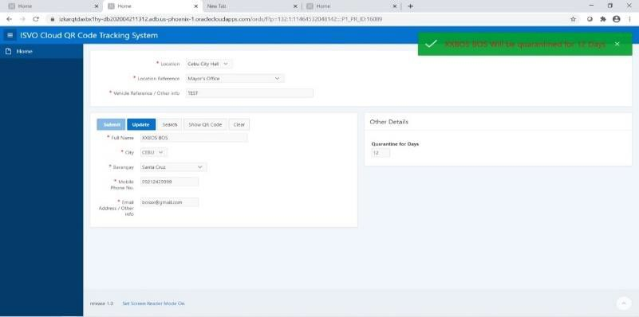

Figure 11. Update Patient Record Form

In an update entry, the command center can input the number of days quarantine period to monitor if he/she goes/went outside the quarantine area. By the time that his/her QR code scans, the screen will display that the person is under quarantine with days remaining prompted on the screen of the scanning officer for the mall and establishments applications. Then, automatically send the information to the command center to alert that one person violates the quarantine rules that can impose immediate sanctions on the violator. Figure 12 shows the display of the smartphone of the scanning officer in the mall.

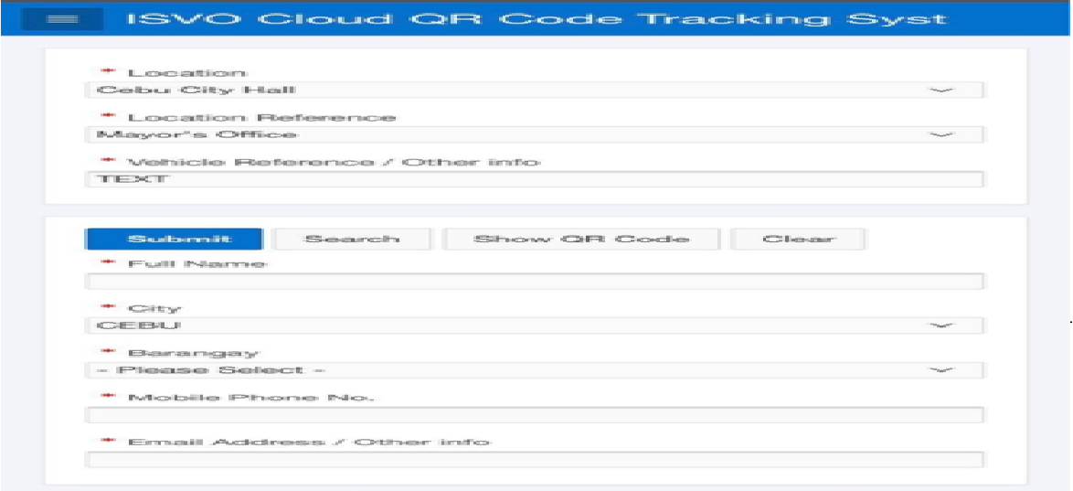

Indonesian J Elec Eng & Comp Sci, Vol. 15, No. 3, September 2020 : xx - xx

Figure 12. Scanning officer smartphone display for malls

The Cebu City residents and neighboring cities and provinces can register and secure the QR codes in two ways. First, barangay registration. After encoding necessary information and validating ID and the person's presence in a barangay level registration, the system automatically generates the QR code and takes screenshots by the registrants. It's up to them if he/she printout the QR code or leaves it as is in his/her phone for future scanning when he/she leaves the house or going to the market or anywhere. Figure 13 shows the registration procedure at the barangay level area.

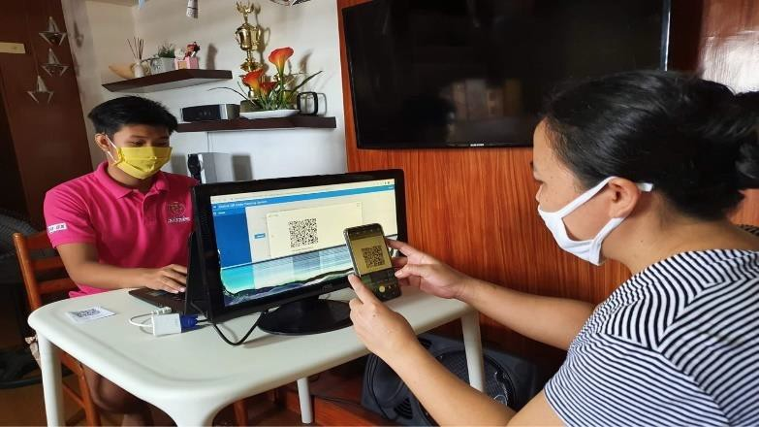

Figure 13. Barangay Registration

While in Figure 14 shows the registration form of the barangay level. And Figure 15 is the additional information that needs to follow the IATF mandate to fill-up the required information. Finally, in Figure 16 is the equivalent QR code of the registrants.

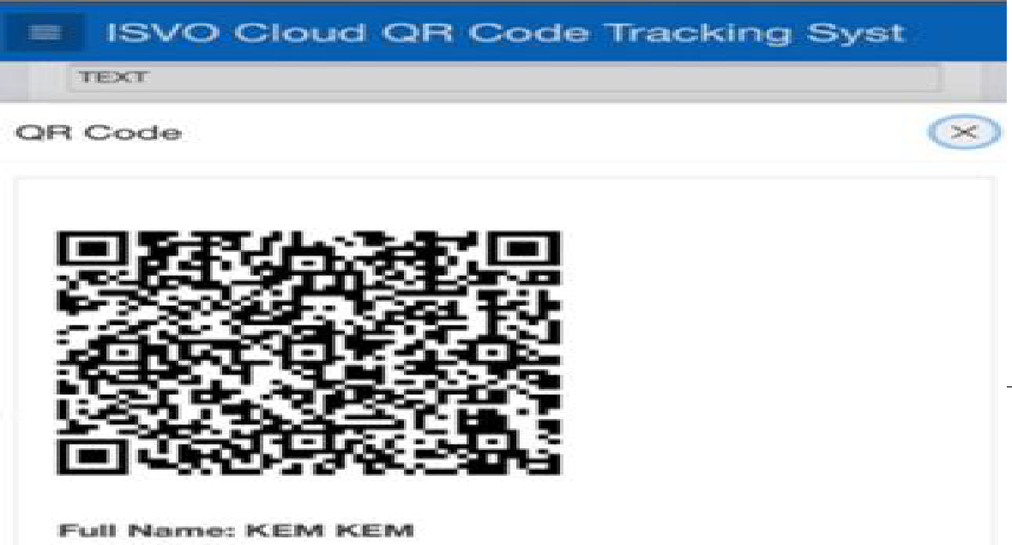

*Online QR Code Contact and Quarantine Tracing Using Independent Software Vendor Oracle, J.I. Teleron*

Figure 14. Registration Form

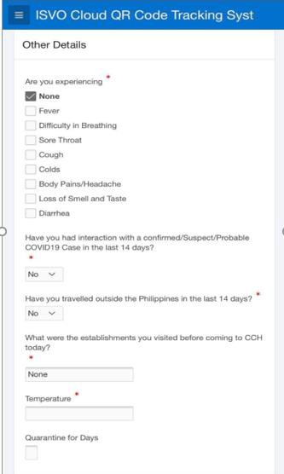

Figure 15. Registration Form Other Details

Comp Sci, Vol. 15, No. 3, September 2020 : xx - xx

Figure 16. Equivalent QR Code

Second, Online registration. Here, the registrants would have an email account before registering the system. It needs a valid ID to validate the person who will write if it is credible and a Cebu City resident and Cebu province. The registrants will access the website for the online registration page and fill-up the registration form, either PC, Tablet, or smartphone, as long as there is an Internet connection. After submitting the registration, the command center will verify the integrity of the registrants' ID. The approved unique QR code will be sent through email by the command center after the validation. Figure 17 deflected the online registration on desktop PC or Laptop.

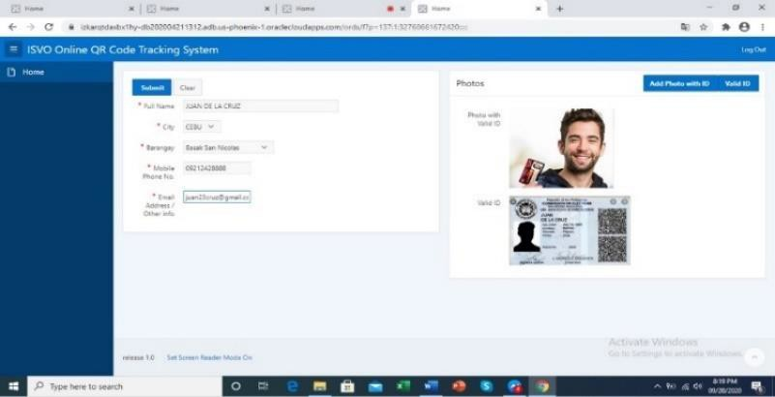

Figure 17. Online Registration Screen for PC

However, it is also possible to register using a smartphone or Tablet, particularly the android operating system, for better performance. Figure 18 shows the registration screen utilizing an android smartphone.

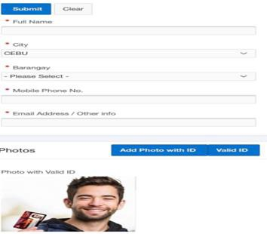

Indonesian J Elec Eng &

Figure 18. Online Registration using android smartphone

The researchers had developed two modules for contact and quarantine tracing; first, application for mall purposes and establishments based on the IATF recommendation that the person who will enter the establishments must fill-up the needed information before entering the establishments. After the scanning officer finishes scanning the QR code, a thermal scanner also checks the person and encoded it to a form displayed during QR scanning. Simultaneously, other details set the default as none to ensure the speed of accepting a person and click the submit button to send the information to the cloud. Figure 19 shows the scanning screen for malls and establishments.

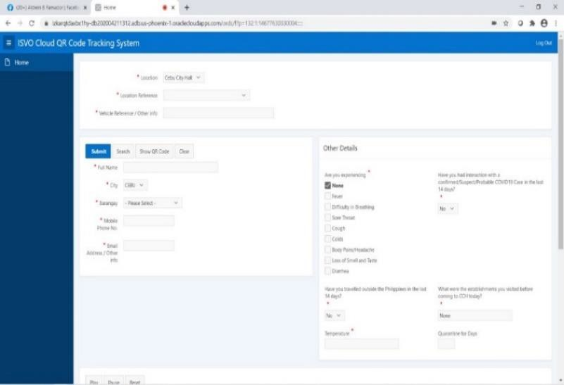

Figure 19. Mall and Establishments Scanning officer Screen

Second, the scanning officer for checkpoints and other barangay areas or designated installation for deputized scanning officers are different scanner applications. It needs a faster scanning process to avoid the car's congestion passing to the border or the significant thoroughfares with police/scanning officers on vital installations. Figure 20 shows the smartphone application screen of the scanning officer for checkpoints.

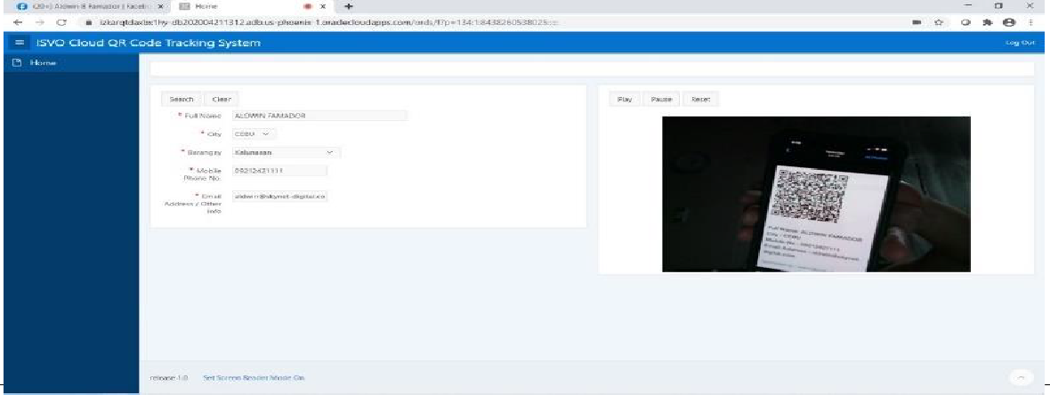*Online QR Code Contact and Quarantine Tracing Using Independent Software Vendor Oracle, J.I. Teleron*

Figure 20. Checkpoints Scanning officer Screen

After scanning the QR code, the system automatically sends the information to the cloud without touching any buttons to submit the scanned data to avoid traffic. When the system detects the violator automatically displays to the scanning officer's screen, similar to Figure 21, as reflected below.

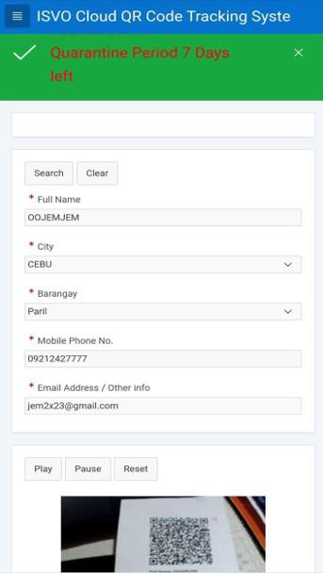

Figure 21. Violators detected Screen

The command center is the in-charge of all contact tracing jobs because all the data would send to the database, and the only ones authorized to access the database are those who have access to database admin. The contact tracer will analyze the data anytime if there are COVID-19 people positive. The researchers developed an unlimited multi-layer field search to ensure the easy detection and filtering of possible infected viruses. Figure 22 shows the multi-layer search of the oracle database.

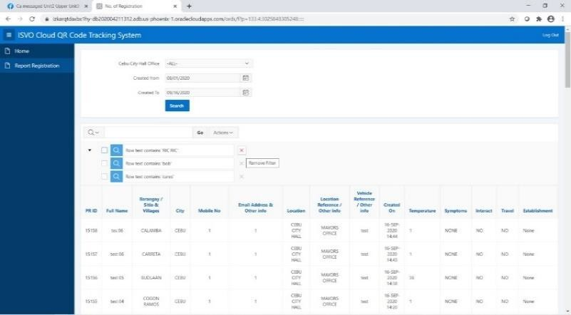

Indonesian J Elec Eng & Comp Sci, Vol. 15, No. 3, September 2020 : xx - xx

Figure 22. Multi-layer database record search

In a search engine field, the contact tracing officer can type the name of a COVID-19 positive person; by clicking search, all the possible whereabouts of the person inputted in the search engine field will display in a matrix format as shown in Figure 22. Backtracking the days of the whereabouts of the person can also check its close contact during those days before he/she detected as positive. During the analysis, the system automatically determines the PUI and PUM through a small space area that the patient caught, like the plate number of the vehicle, small stores, and other establishments that are very close to a positive person. While looking for a possible PUI and PUM, the contact tracer can load another field in the search engine until they can conclude the possible PUI and PUM in a much lesser time of tracing a positive person's contact.

To take a closer look at the database record reflected in Figure 23 below. Notice that all the table columns can be searchable to ensure that the analysis made it easy for the contact tracer.

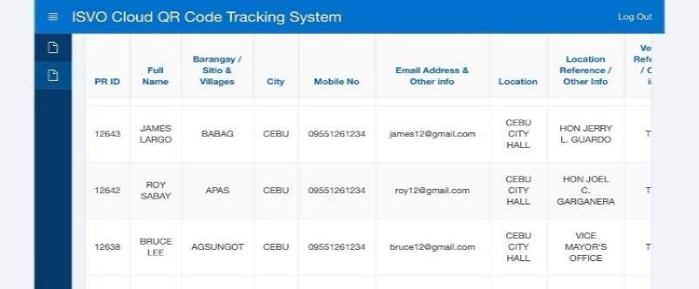

Figure 23. Closer look of Database Record

### Summary

The researchers had developed the contact and quarantine tracing based on the action plan imposed by IATF to mitigate COVID-19 infected virus to track and trace the possible contact of infected virus easily using the Cloud QR code contact and quarantine tracing software. Upon writing this paper, the researchers were continuously convincing Cebu and neighboring cities' City government to implement this system because the researchers believe that it can reduce the spreading of COVID-19 viruses. After all, the system can monitor the person's whereabouts without infringing their privacy.

The researchers offer this software for free to the City government of Cebu as Software as a Service. Still, the Infrastructure as a Service and Platform as a Service needed to pay by the City government to run the system as the Cebu City and Cebu province's data center that can carry BIG DATA. The idea of Infrastructure as a Service and Platform as Service is that the private establishment will pay monthly Cloud service provider used.

In this way, the application can sustain its availability to the Cloud while still struggling for this pandemic to cater to the whole of Cebu City and Cebu province and the entire country if needed.

## CONCLUSION

The researchers concluded that if the system implements appropriately in Cebu City or the entire Country, the system is ready to handle BIG DATA because the oracle platform is a trusted database enterprise vendor. The contact tracing implies made easy because the individual's whereabouts will be trace through the device used by the scanning officers in any strategic location. Similarly, the home quarantine will possibly solve the congestion of our quarantine facilities for those diagnosed as COVID-19 with positive but mild

*Online QR Code Contact and Quarantine Tracing Using Independent Software Vendor Oracle, J.I. Teleron*

symptoms or asymptomatic patients because he/she can trace at barangay checkpoints or to any police checkpoint installations. As to social responsibility, the researchers seek the IT solution to trace easily using the existing technology like data analytics, cloud computing, quantum computing, and Big Data to help the government mitigate spreading COVID-19 viruses to humanity. Lastly, at the end of this pandemic, the researchers can share their families and friends for their effort to develop this one-of-a-kind solution. It is opposite to other contact tracing software that used Android apps with no restrictions of locations and no verifications of integrity as to the person who will register and download the apps. Lastly, this solution did not use GPRS and Bluetooth technology to protect the privacy of an individual.

## RECOMMENDATION

The researcher’s primary recommendations for this one-of-a-kind Information Technology solution using QR code, Cloud Computing, Data Analytics, Quantum Computing, and Big Data are the following:

* 1. Implement the system in a nationwide setting so that the government can trace easily to those who are law-abiding for the COVID-19 rules and regulations tailored by IATF.
  2. Invest in an extensive Cloud infrastructure suitable for nationwide implementation that can carry BIG DATA.
  3. Concerning the software and platform, it is an Independent Software Vendor Oracle (ISVO). The researchers open to further improvement and modification of the system suitable for broad applications.
  4. This system is ready to adopt a nationwide ID system for the second phase if the government utilizes this to distribute any government activities efficiently.

## ACKNOWLEDGMENT

As we draw our strength and our knowledge from God, once again, we thank the Almighty Father for enabling us to come up with this journal.

We likewise thank the City Government of Cebu for their support. Our appreciation and wishes for the best of health to the Honorable Cebu City Mayor, Attorney Edgardo Labella.

To the City Administrator, Atty. Floro Casas and CENRO Chief, Atty. Junine Aragones for their inputs in the applicability of the system to the program of the government.

To the man who has shared with us the passion of helping out the community, he shared his vision of integrating Information Technology into the Cebu City Government’s system—for giving us the guidance and time whenever we need it. Thank you very much, Councilor Renato “Junjun” Osmena, Jr.

And, Love and thanks to our family for being supportive of all our endeavors in life.

And last but not least, our appreciation to our friends who have one way or another given their inputs.

## REFERENCES

1. P. Amonkar. **Independent software vendors of all sizes are digital first responders for Asia Pacific**, September 2020. Retrieved from https://news.microsoft.com/apac/2020/09/18/independent-software-vendors-of-all-sizes-are- digital-first-responders-for-asia-pacific/
2. G. Berman, K. Carter, M. Herranz, and V. Sekara. **Digital contact tracing and surveillance during COVID-19 - General and Child-specific Ethical Issues, Innocenti Working Paper**, UNICEF Office of Research – Innocenti, Florence, June 2020.
3. I. Braithwaite, T. Callender, M. Bullock, and R. Aldridge. A**utomated and partly automated contact tracing: a systematic review to inform the control of COVID-19**, August 2020. doi: https://doi.org/10.1016/S2589- 7500(20)30184-9
4. I. Chakraborty and P. Maity. **COVID-19 outbreak: Migration, effects on society, global environment and prevention**, *Science of the Total Environment*, Vol. 728, pp. 138882, April 2020.
5. European Centre for Disease Prevention and Control. **Contact tracing for COVID-19: current evidence, options for scale-up and an assessment of resources needed**, April 2020. Retrieved from https://[www.ecdc.europa.eu/sites/default/files/documents/COVID-19-Contract-tracing-scale-up.pdf](http://www.ecdc.europa.eu/sites/default/files/documents/COVID-19-Contract-tracing-scale-up.pdf)

Indonesian J Elec Eng & Comp Sci, Vol. 15, No. 3, September 2020 : xx - xx

1. A. Haleem, M. Javaid, and R. Vaishya. **Effects of COVID-19 pandemic in daily life**, *Current Medicine Research and Practice*, vol. 10, no. 2, pp. 78-79, April 2020.
2. A. Hern. **Arrival of NHS contact-tracing app heralds return of QR codes**, September 2020. Retrieved from https://[www.theguardian.com/technology/2020/sep/24/arrival-of-nhs-contact-tracing-app-heralds-return-of-qr-codes](http://www.theguardian.com/technology/2020/sep/24/arrival-of-nhs-contact-tracing-app-heralds-return-of-qr-codes)
3. Y. Huang, M. Sun, and Y. Sui. **How Digital Contact Tracing Slowed Covid-19 in East Asia**, May 2020. Retrieved from <https://hbr.org/2020/04/how-digital-contact-tracing-slowed-covid-19-in-east-asia>
4. C. Juneau, A. Briand, T. Pueyo, P. Collazzo, and L. Potvin. **Effective Contact Tracing for COVID-19: A Systematic Review**, July 2020. doi:https://doi.org/10.1101/2020.07.23.20160234
5. L. Kabagani. **Valenzuela creates contact tracing app via QR code system**, September 2020. Retrieved from [https://www.health.govt.nz/our-work/diseases-and-conditions/covid-19-novel-coronavirus/covid-19-resources-and-](https://www.health.govt.nz/our-work/diseases-and-conditions/covid-19-novel-coronavirus/covid-19-resources-and-tools/nz-covid-tracer-app) [tools/nz-covid-tracer-app](https://www.health.govt.nz/our-work/diseases-and-conditions/covid-19-novel-coronavirus/covid-19-resources-and-tools/nz-covid-tracer-app)
6. M. Keeling, T. Hoolingswroth, and J. Read. **Efficacy of contact tracing for the containment of the 2019 novel coronavirus (COVID-19)**, June 2020. doi: <http://dx.doi.org/10.1136/jech-2020-214051>
7. Ministry of Health. **NZ COVID tracer app**, September 2020. Retrieved from <https://www.pna.gov.ph/articles/1115247>
8. C. Quevado, G. Scarpetti, and E. Webb. **How do countries structure contact tracing operations and what is the role of apps?**, June 2020. Retrieved from https://analysis.covid19healthsystem.org/index.php/2020/06/18/how-do- countries-structure-contact-tracing-operations-and-what-is-the-role-of-apps/
9. M. Rouse. **ISV (independent software vendor)**, October 2018. Retrieved from https://searchitchannel.techtarget.com/definition/ISV
10. M. Ryan. **In defense of digital contact-tracing: human rights, South Korea and Covid-19**, *Science of the Total Environment*, International Journal of Pervasive Computing and Communications, vol. 16, no. 4, pp. 383-407, August 2020.
11. K. Servick. **COVID-19 contact tracing apps are coming to a phone near you. How will we know whether they work?**, May 2020. Retrieved from https://[www.sciencemag.org/news/2020/05/countries-around-world-are-rolling-](http://www.sciencemag.org/news/2020/05/countries-around-world-are-rolling-) out-contact-tracing-apps-contain-coronavirus-how
12. World Health Organization, Center for Disease Control. **Implementation and management of contact tracing for Ebola virus disease**, USA, 2015, pp. 5.
13. M.Li,Z.Zhang,W.Cao,etal. **Identifying novel factors associated with COVID-19 transmission and fatality using the machine learning approach,** *Science of the Total Environment,* September (2020). Retrieved from https://doi.org/10.1016/j.scitotenv.2020

[19]T Hale, S Webster, A Petherick, T Phillips, B Kira. **Oxford COVID-19 government response tracker,**

Blavatnik School of Government, Oxford (2020). Retrieved from [https://www.bsg.ox.ac.uk/research/research-](https://www.bsg.ox.ac.uk/research/research-projects/coronavirus-government-response-tracker) [projects/coronavirus-government-response-tracker](https://www.bsg.ox.ac.uk/research/research-projects/coronavirus-government-response-tracker)

1. VJ Lee, CJ Chiew, WX Khong. **Interrupting transmission of COVID-19: lessons from containment efforts in Singapore,** *Journal of Travel Medicine,* Article taaa039, March 2020
2. European Centre for Disease Control. **Contact tracing: public health management of persons, including healthcare workers, having had contact with COVID-19 cases in the European Union—second update**. *European Centre for Disease Control, Stockholm (2020)*. Retrieved from [https://www.ecdc.europa.eu/en/covid-19-](https://www.ecdc.europa.eu/en/covid-19-contact-tracing-public-health-management) [contact-tracing-public-health-management](https://www.ecdc.europa.eu/en/covid-19-contact-tracing-public-health-management)
3. I Braithwaite, T Callender, M Bullock, R Aldridge. **Automated and semi-automated contact tracing: protocol for a rapid review of available evidence and current challenges to inform the control of COVID-19,** April 2020. Doi: <https://doi.org/10.1101/2020.04.14.20063636>
4. **ATF-EID-BRINGS-HOME-FILIPINOS-FROM-WUHAN-CHINA**. Department of Health, February 10, 2020. Retrieved from [https://www.doh.gov.ph/IATF-EID-BRINGS-HOME-FILIPINOS-FROM-WUHAN-CHINA,](https://www.doh.gov.ph/IATF-EID-BRINGS-HOME-FILIPINOS-FROM-WUHAN-CHINA)
5. **DOH REPORTS 34 NEW COVID-19 CASES; SEEKS PUBLIC COOPERATION**. Department of Health, March 14, 2020. Retrieved from [https://www.doh.gov.ph/doh-press-release/doh-reports-34-new-covid-19-cases-seeks-](https://www.doh.gov.ph/doh-press-release/doh-reports-34-new-covid-19-cases-seeks-public-cooperation) [public-cooperation](https://www.doh.gov.ph/doh-press-release/doh-reports-34-new-covid-19-cases-seeks-public-cooperation)
6. **GUIDELINES ON THE STANDARDS OF AIRBORNE INFECTION ISOLATION ROOM AND CONVERSION OF PRIVATE ROOMS AND/OR WARDS INTO TEMPORARY ISOLATION ROOMS FOR THE MANAGEMENT OF PATIENTS UNDER INVESTIGATION (PUI) FOR 2019 NOVEL CORONAVIRUS (NCOV). (n.d.).** Department of Health, February 4, 2020. Retrieved from <https://www.doh.gov.ph/node/21238>
7. **Coronavirus disease (COVID-19): #HealthyAtHome campaign,** World Health Organization, 2020. Retrieved from <https://www.who.int/news-room/campaigns/connecting-the-world-to-combat-coronavirus/healthyathome>
8. **WHO, UNICEF BACK DOH IN FIGHT AGAINST COVID-19,** Department of Health, May 27, 2020. Retrieved from <https://www.doh.gov.ph/press-release/WHO-UNICEF-BACK-DOH-IN-FIGHT-AGAINST-COVID-19>
9. Saavedra, J. R. S. **Cebuano IT expert offers app for Covid-19 contact tracing,** Philippine News Agency**, March 23, 2020.** Retrieved from <https://www.pna.gov.ph/articles/1097512>
10. **Safe Ormoc,** Safe Ormoc Contact Tracing, 2020. Retrieved from <http://www.ormoc.gov.ph/safeormoc/>
11. **Globe powers Red Cross’ COVID-19 response mobile app.,** Telecompaper, May 20, 2020. Retrieved from <https://www.telecompaper.com/news/globe-powers-red-cross-covid-19-response-mobile-app--1339196>

*Online QR Code Contact and Quarantine Tracing Using Independent Software Vendor Oracle, J.I. Teleron*

1. N. Ahmed et al., **"A Survey of COVID-19 Contact Tracing Apps,",** IEEE Access, vol. 8, pp. 134577-134601, 2020, doi: 10.1109/ACCESS.2020.3010226

ndonesian J Elec Eng



1. P. H. O’Neill, T. Ryan-Mosley and B. Johnson, **A Flood of Coronavirus Apps are Tracking Us. Now it’s Time to Keep Track of Them**, 2020. Retrieved from [https://www.technologyreview.com/2020/05/07/1000961/launching-](https://www.technologyreview.com/2020/05/07/1000961/launching-mittr-cov%25id-tracing-tracker/) [mittr-cov%id-tracing-tracker/](https://www.technologyreview.com/2020/05/07/1000961/launching-mittr-cov%25id-tracing-tracker/)
2. C. Criddle and L. Kelion, **Coronavirus Contact-Tracing: World Split Between Two Types of App,** 2020, Retrieved from <https://www.bbc.com/news/technology-52355028>
3. P. Farrell, **Experts Raise Concerns About Security of Coronavirus Tracing App Covidsafe**, 2020, Retrieved from [https://www.abc.net.au/news/2020-05-14/experts-concerned-about-coronavi%rus-tracingcovidsafe-](https://www.abc.net.au/news/2020-05-14/experts-concerned-about-coronavi%25rus-tracingcovidsafe-security/12245122) [security/12245122](https://www.abc.net.au/news/2020-05-14/experts-concerned-about-coronavi%25rus-tracingcovidsafe-security/12245122)
4. L. Reichert, S. Brack and B. Scheuermann, **"A survey of automatic contact tracing approaches"**, 2020, Retrieved from <https://eprint.iacr.org/2020/672>

## BIOGRAPHIES OF AUTHORS

|  |  |
| --- | --- |
| ) | **JERRY INCIERTO TELERON**  He is an experienced technopreneur. The maker of an educational training module for BS in Electrical Engineering, BS in Electronics and Communication Engineering, BS in Computer Engineering, and BS in Information Technology laboratory equipment sold-out most well-known universities nationwide for almost two decades, an academician, Certified Mikrotik Network Consultant, and an international journal author. Presently, he is now concentrating his business on hardware design and development in various applications. He is a graduate of Bachelor of Science in Computer Engineering, Bachelor of Science in Electronics and Communication Engineering, Masters of Engineering, and Doctor of Philosophy in Technology  Management and received recognition as the most functional dissertation of class 2003 |
|  |  |
|  | **ALDWIN BONTILAO FAMADOR**  He is a founder and president of SkyNet Digital Systems Inc., an independent software vendor on oracle systems platforms, for the past 23 years. He also participates in servicing clients (both and private) about IT business for the past two decades and counting. He graduated with a Bachelor of Science in Industrial Technology Major in Electronics at Cebu State College of Science and Technology (CSCST) and a graduate BS in Computer Engineering at the University of Cebu (UC). He and the company that manages offers system integration and automation to Local Government Units (LGU) such as the Cebu City Government and other provinces, and private companies, like Timex Philippines and Tuneishi Heavy Industries. At present, he strives to adapt to the continually changing digital transformation trends in the IT business. |
|  |  |
| C:\Users\USER\Downloads\MORITE.jpg | **ANALYN SAY MORITE**  She is a graduate of Bachelor of Science in Computer Engineering, Masters of Industrial Education, Doctor of Philosophy in Technology Management, a professional computer engineer, and a licensed professional teacher. She is currently an Associate Professor, program chair, research & OJT coordinator of BS in Computer Engineering, and an ICT Quality Assurance In charge of Surigao State College of Technology. Presently, she is the Vice-President for External. Affairs of Institute of Computer Engineers of the Philippines (ICpEP) - Caraga Chapter. For the most recent years, she presented and published papers as follows: Cleaner Production: The Key to Waste, Water and Energy Reduction in an Educational Institution, Philippines; Automated Energy Meter and Controller for Rural Residential Structures and Level of Satisfaction and Performance in Laboratory Subjects. She values competence, integrity, perseverance, and loyalty,  among other virtues. |
|  |  |
|  | **CHERYL M TARRE**  She is currently the Dean of the College of ICT & Engineering of Western Leyte College of Ormoc City, Inc. for 14 years. A graduate of Bachelor of Science in Computer Science, Master in |
| I & Comp Sci, Vol. 15, No. 3, September 2020 : xx - xx | |

|  |  |
| --- | --- |
|  | Science Teaching Computer Science, Master in Science in Computer Science and Doctor in Business Administration; and a member of different Computing Organizations. |
|  |  |
|  | **ALTHEA RODRIGUEZ-ARENAJO**  Is a registered Pharmacist, she is the former Dean of College of Pharmacy at Southwestern University and recently retired as Dean College of Pharmacy at University of Southern Philippines Foundation. She finished her Doctor of Education in Educational Management at the University of Southern Philippines Inc. She is active in research and published researches in science journals, both national and international fora. She has been in the academe for 34 years. |
|  |  |
|  | **GREGORIO Z. GAMBOA, JR.**  He is the incumbent College President of Surigao State College of Technology. He previously held academic appointments at Cebu Technological University as Program Director of Extension and Community Development in the College of Industrial Technology and Engineering, Chairman of the Bids and Awards Committee, OIC Campus Director-CTU-San Fernando, and CTU-Naga Campus and University Director of the Extension Services.  He is formerly an Associate Professor V and a distinguished graduate of Cebu Technological University. He finished his Doctor of Education major in Educational Management at the University of Southern Philippines in Cebu City.  He also received several awards and recognitions from different organizations. Also, he produced publications and papers presented to various fora that received an Honor Award for Exemplary and Unselfish Leadership in 2014. An award of Recognition for Extension Services, and Outstanding Achievement in providing technical knowledge in converting radiator lubricating oil  cooler into a plate type cooling system for caterpillar generator unit. |

*Online QR Code Contact and Quarantine Tracing Using Independent Software Vendor Oracle, J.I. Teleron*