## Philippine Journal of Science

150 (4): 643-655, August 2021

### ISSN 0031 - 7683

Date Received: 09 Nov 2020

Leaf Traits of *Calophyllum inophyllum* L. (Calophyllaceae) in Different Locations Suggest Suitability for Planting Outside of Natural Habitat

## Ma. Kristina T. Calibo, Crusty E. Tinio, Marilyn S. Combalicer, and Lerma S.J. Maldia*

Department of Forest Biological Sciences, College of Forestry and Natural Resources University of the Philippines Los Baños, College, Laguna, Philippines

## *Calophyllum inophyllum* L. (*bitaog*), a native tree species in the Philippines that can be found growing in different locations (urban, coastal, and forest areas) with varying climatic conditions, were studied to compare the morphological and anatomical characters in relation to climatic factors. Nine leaf morphological characters (arrangement, apex, base, margin, shape, venation, texture, length, and width) were observed. The thicknesses of the epidermis, vascular tissues, and mesophyll were measured. One-way analysis of variance (ANOVA) was used to show significant differences in morphological and anatomical characters among locations. The linear mixed model was used to determine if leaf characters were affected by precipitation (PPT) and temperature (Temp) in each location. A significant difference in the quantitative morphological characters of *C. inophyllum* leaves was observed only in leaf length (LL), which was found negatively correlated with leaf width (LW) across locations. Palisade mesophyll (PM) and spongy mesophyll (SM) were found to have significant differences among locations. Leaves in the coastal area, which is the natural habitat of the species, had the thickest mesophyll. It was found out that *C. inophyllum* grows best in the coastal area and least in the urban area based on the quantitative measurement of leaf morphological characters such as LL and LW. On one hand, trees in the urban area have smaller LL, LW, PM, and SM as affected by the climatic variables. We, therefore, conclude that morphological and anatomical characteristics of *C. inophyllum* are altered once the species is grown outside of its natural habitat.

Keywords**:** climatic factors, coastal area, forest area, linear mixed model, mesophyll, urban area

# INTRODUCTION

Phenotypic plasticity together with genetic determination is important in understanding how plants respond to environmental change (Royer *et al.* 2009; Rozendaal *et al.* 2006; Fritz *et al.* 2018). Phenotypic plasticity acts to increase the performance of plants under stress (Xu *et al.* 2008). *Calophyllum inophyllum* of Family Calophyllaceae is a native species among Southeast Asian countries

*Corresponding Author: [lsmaldia@up.edu.ph](mailto:lsmaldia@up.edu.ph)

(Allen 2002). It grows in a wide variety of habitats, but it naturally occurs in coastal areas (Orwa *et al.* 2009). The capability of the species to withstand poor soil conditions and water availability and resist strong winds makes it suitable in the coastal area (Gilman and Watson 1993). Due to its long, broad, and evergreen leaves, dense crown, and horizontal branches (Allen 2002; Kainuma *et al.* 2016), it has become a common ornamental plant in urban settings like parking lots and street sides. Commonly, it is used for aesthetics and shade (Prabakaran and Britto

2012). In the Philippines, the Department of Environment and Natural Resources (DENR) considers *C. inophyllum* as an ideal forest tree species to promote reforestation and biological diversity. It has been planted in watershed areas and various reforestation sites.

Although *C. inophyllum* is widely planted in the Philippines, the possible variation in characters of the species in different locations in relation to varying temperature, relative humidity (RH), rainfall, light intensity, and other environmental factors has not been extensively studied. A comparative study of the leaf traits (morphological and anatomical) of *C. inophyllum* from different locations is helpful to determine its suitability to thrive in varying environmental conditions. Furthermore, correlating the species characteristics such as leaf characters to various climatic factors such as temperature, light intensity, RH, and rainfall will determine the differences in their growth responses in terms of morphological, physiological, and other parameters when planted in various locations. The physiognomy (sizes and shapes) of the leaves has been shown to have a strong correlation with temperature and moisture from global to local scales (reviewed in Peppe *et al.* 2011). Specifically, the site-mean leaf size typically is proportional with water availability and, to a lesser extent, temperature. In urban areas, the effects of environmental factors in relation to morphology (primarily leaf size/area) and anatomy of leaves of urban trees show significant differences. The study of Xu *et al.* (2006) showed that the main meteorological factors affecting the growth and development rhythms of main tree species leaves in the urban forest of Shenyang in Liaoning Province of China were temperature of its phenological period. Plants located in the area with high RH have larger, narrower, and thicker leaves compared to those with low RH (Hovenden *et al*. 2012). Therefore, the objective of this study was to determine the morphological and anatomical characteristics of the *C. inophyllum* growing in different locations and climatic variables over a certain period.

# MATERIALS AND METHODS

**Location of the Study Sites and Sample Collection** There are three locations included in this study (Figure 1). First, the Mt. Makiling Forest Reserve (MMFR) in the University of the Philippines Los Baños (UPLB), Laguna (14° 8’ 6.8064’’ N, 121° 11’ 40.0272’’ E; 115 masl)

represented the forested area. MMFR is a biodiversity-rich mature secondary tropical forest. Although *C. inophyllum* trees are growing naturally in the MMFR, based on our survey, there were very limited adult trees (around 10 potential mother trees) and others are already planted for the campus landscape. Second, the Bonifacio Global City

(BGC) in Taguig City (14° 33’ 15.8652’’ N, 121° 3’ 32.4’’

E; 16 masl) represented the urban area. BGC is a financial and business hub that sits within the busy city of Metro Manila. Different tree species, including *C. inophyllum*, are planted in the BGC for landscape. Based on the record of the Joseph Server Associates, Inc. (JSA, Inc.) – the contracted grounds maintenance, tree servicing, and landscape management of the BGC – the *C. inophyllum trees* in the BGC were planted in 2003 using earth-balled saplings from Batangas and measured around 10 cm diameter at breast height (June B. Micosa, JSA, Inc.’s resident forester-arborist of BGC; pers. comm.). Third, Barangay Simlong in Batangas City (13° 40’ 35.76’’ N,

121° 3’ 32.4’’E; 13.8 masl) represented the coastal area, which is the ideal natural habitat of the species.

For each location, the morphological characters were estimated from six adult trees of *C. inophyllum*. From each tree, six samples of matured leaves (third leaf from the top) from each of the three portions of the tree crown (lower, middle, and upper) were used, while one leaf from each portion (lower, middle, upper) of the individual sampled tree was used in the analysis of anatomical characters.

By the number of observations, the average of each morphological parameter was taken from a total of 18 leaves per tree, bringing a total of 108 observations (36 average observations per location). For the anatomical characteristics, the average measurement per character was taken from a total of three leaves per tree replicated 10 times each leaf, bringing a total of 180 observations (six average observations per location).

The number of samples, particularly in the urban area, was assumed enough to represent the effects of environmental variables on the morphology and anatomy of the leaves over the period considered in the study since the sampled trees in BGC have the same length (years) of exposure to the new environment after transplanting. As mentioned,

*C. inophyllum* trees in the BGC were hauled from similar natural habitats. Hence, the assumption that trees in BGC will have large variability (*i.e.* genotype variation) in their response to the environmental variables considered in the study was assumed to be less likely. It is more of the average response that is expected given the time it was removed from its original habitat and had been exposed to a new condition, which was similarly considered for the other two sites. Some publications mentioned in the Results and Discussion sections (*e.g*. Li *et al*. 2015; Oggero *et al*. 2016; Arimy *et al*. 2017; Muniz *et al*. 2018, and others) also made use of limited leaf samples and able to detect morpho-anatomical responses to environmental variables.

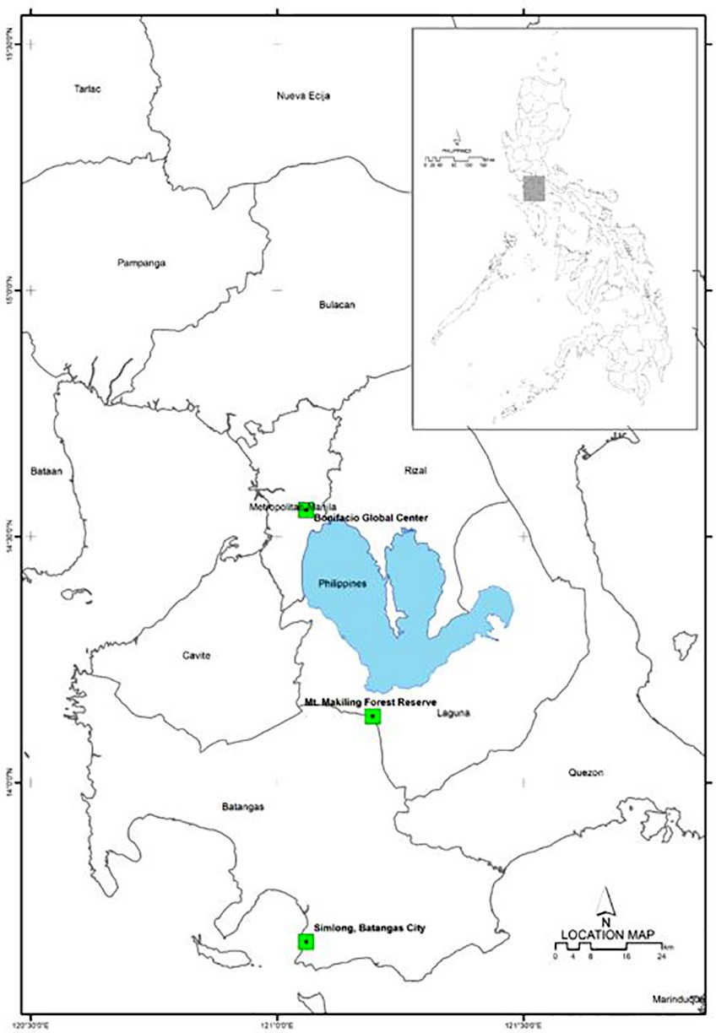

**Figure 1.** Location of the three study sites in Luzon, Philippines.

**Morphological Characteristics of *Calophyllum inophyllum***

Nine (9) morphological characters were measured in the three locations. Qualitative characters such as leaf arrangement (LAR), leaf apex (LAP), leaf base (LB), leaf margin (LM), leaf shape (LS), leaf venation pattern (LVS), and leaf texture (LT) were assessed based on the modified works of Radford *et al.* (1974) and Simpson (2006). Quantitative parameters such as LL and LW were measured using a ruler (cm).

**Anatomical Characteristics of *Calophyllum inophyllum***

Anatomical sections of the mid-lamina region were observed from the specimens. Transverse sections of leaf were obtained following the procedures of Johansen (1940). Samples were fixed in FAA (formalin: acetic acid: alcohol) (Hernandez *et al.* 2016). Afterward, the samples were dehydrated in ethanol series and embedded into melted paraffin wax (Appendix Table I).

Sections were cut with a thickness of 10–15 μm by the rotary microtome (American Optical 820). Sections were stained with safranin and counter-stained with fast green dye solution. After staining, specimens were coated with Entelan® solution. The slides were air-dried for anatomical examination.

Microscopic examination was done using a compound microscope at the Microtechnique Laboratory of the Department of Forest Biological Sciences (DFBS), College of Forestry and Natural Resources (CFNR), UPLB. Anatomical structures were identified using the manuals on the anatomy of dicot plants (Haupt 1953; Fahn 1967; Bell 2008; Shipunov 2020). Photomicrographs were obtained in the microscope under 400X magnification. The mean thickness of the upper and lower epidermis, mean vascular tissue area (xylem and phloem), and the mean thickness of mesophyll tissues (palisade and spongy) were observed and measured using the Image J software (Schneider *et al.* 2012). The traits were compared among locations.

## Climatic Factors

The data for Temp, RH, and PPT for Los Baños, Laguna, Taguig, Metro Manila, and Barangay Simlong, Batangas City were taken from the World Weather Online database available at [https://www.worldweatheronline.com/.](http://www.worldweatheronline.com/) Average monthly values of each environmental variable for the years 2009–2018 were taken as these were the longest period with complete climatic data available in the database. As mentioned since the sampled trees in BGC were planted in 2003, the 10-year climatic data from 2009–2018 may be sufficient to demonstrate climatic influence on the growth of these trees. The 10-year means

of the RH, PPT, and Temp varied significantly among the three locations (Figures 6a, b, and c, respectively). The mean RH was lowest in urban compared to forested and coastal areas. The mean PPT was lowest in the coastal and highest in the forest area, while the urban area seemed to experience a few isolated cases of heavy rainfall as seen from the many outlying values. The mean Temp was lowest in the forest and highest in the coastal area. These three climatic variables are among the major environmental factors that were observed to cause significant effects, positively or negatively, on the morphological and anatomical characters of a plant. Each species has a specific need of all factors combined to perform well in their environment. Excessive or insufficient exposure from one or more of these factors can cause damage to the plant.

## Statistical Analysis

One-way ANOVA was done to determine variation in morphometric and anatomical characters among sites using the QI Macros for Excel (KnowWare 1997–2020). The significant difference among locations for each climatic factor was tested using one-way ANOVA. Tukey’s honestly significant difference (HSD) *post hoc* test was selected to compare the means of leaf characters between locations.

To determine the leaf morphological and anatomical responses of *C. inophyllum* in different locations to each of the climatic variable (Temp, RH, and PPT) and to the interaction of the three for 10 years, the effects were analyzed using the linear mixed models (REML) implemented in the R Studio version 4.0. Because of the high multicollinearity with temperature and RH, only Temp and PPT were considered in all analyses performed.

# RESULTS

**Morphological Characteristics of *Calophyllum inophyllum***

*Calophyllum inophyllum* has opposite leaf arrangement, retuse apex, rounded base, entire margin, oblong shape, pinnate venation, and leathery texture. These traits were consistent with the literature published about *Calophyllum* and Family Clusiaceae (now Callophyllaceae) (Allen 2002; Friday and Okano 2006; Stevens 2006; Orwa *et al.* 2009; Díaz 2013; Kainuma *et al.* 2016). This indicates that environmental factors in each location did not alter the distinctive physical attributes typical of *C. inophyllum*.

Measurements of *C. inophyllum* leaves across locations showed that LL varied from 8–20 cm and LW from 6–9 cm, which are consistent with the previous studies of *C. inophyllum* (*e.g*. Allen 2002; Orwa *et al.* 2009).

The variances of averages of LL and LW are 0.4–0.5 and 0.5–0.9, respectively, across sites. With these variances range, it can be asserted that the sample size may already be a relatively good number in determining the differences between locations. Significant variation among locations was observed for the LL (Figure 2a). The LL was significantly reduced in the urban area (average

= 7.90 cm; 16.0–19.0; Figure 2b) while largest in the coastal area (average = 18.22 cm; 18.0–20.5; 3c). When the relationship between LL and LW in all locations was observed in detail, their relationship was consistent across locations to show a weak, negative significant correlation (Figure 3). The tendency of decreasing LW with increasing LL was most evident in the forested site, as shown by the value of *R*2 (0.0433; *P* < 0.001; Figure 3a), but the leaf blade in the urban area (3b) had the tendency to become smaller compared to those in the forested and urban areas (Figures 3a and c, respectively).

In a review article on plant phenotypic plasticity in response to environmental factors (Gratani 2014), sets of evidence were accounted for that “morphological and anatomical plasticity play secondary role to physiological plasticity in terms of plant acclimatization to adverse environments, and plants growing in stress conditions tend to have conservative leaf morphological pattern to avoid the production of structures too expensive to be sustained.” The observed subtle morphological differences appear to follow this observed tendency. Thus, sampling for anatomical characteristics need not be over large amounts of samples, at least for this study.

Some publications on the effects of the environment on morpho-anatomy of leaves had also considered a relatively fewer number of samples and had shown significant results. In the study of Li *et al*. (2015) on the influences of environmental factors on the leaf morphology of 116 varieties of Chinese jujubes (*Ziziphus jujuba* Mill.) from 33 locations, the average of measurements per variety was taken from only 3–5 mid-leaves per variety. With this sample size, three distinct clusters of varieties were observed. The morpho-anatomy of *Aldama grandiflora* (Asteraceae) across its wide distribution in Brazil (Muniz *et al*. 2018) with 10 sampled plants per location (6) and, despite showing small morpho-anatomical differences among individuals of the different populations, was reflected in the varying soil conditions in which the populations were grown.

**Anatomical Characteristics of *Calophyllum inophyllum***

*Calophyllum* species are known for their “V-shaped” vascular bundles (Díaz 2013). The position of its xylem is adjacent to the upper epidermis while the phloem is near towards the lower epidermis (Figure 4A). Its adaxial surface composed of parenchyma cells is flat while the abaxial surface forms a convex shape (D’Arcy and Keating 1979; Zabaleta-Mancera *et al.* 2011). *C. inophyllum* has two layers of palisade mesophyll and a loosely arranged spongy mesophyll (Somaratne and Heart 2001). These observations were found to be similar in all samples from three locations (Figures 4D–F).

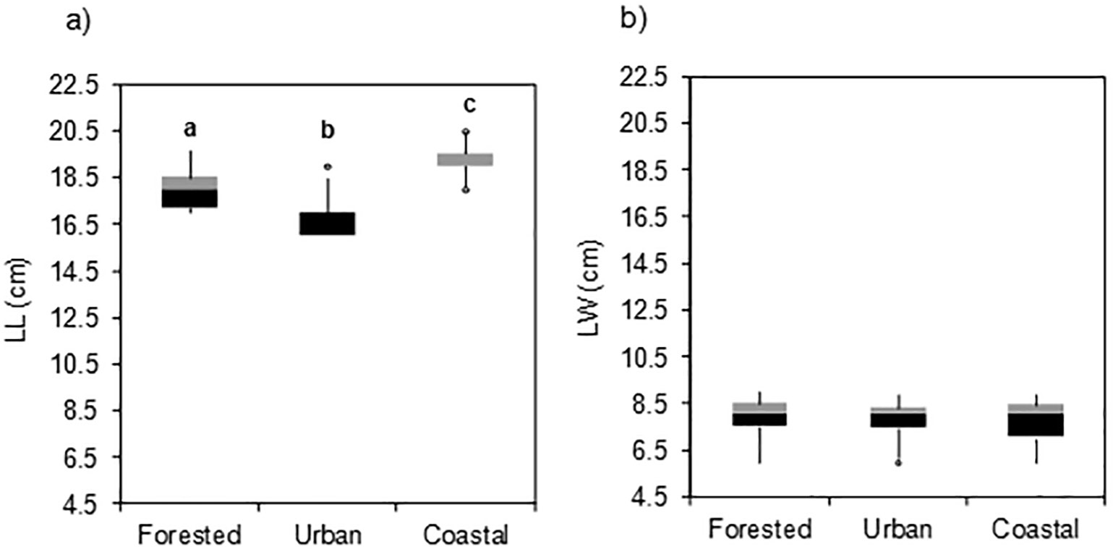

**Figure 2.** Mean values of LL and LW of *Calophyllum inophyllum* in the three study sites; columns with the same letter are not significantly different from each other based on one-way ANOVA with post hoc tests using HSD.

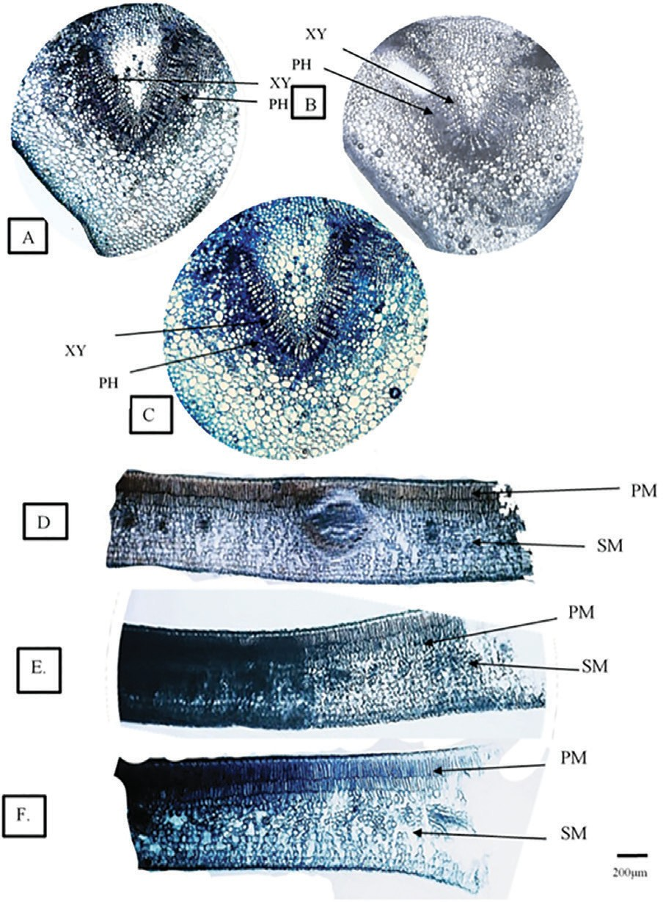

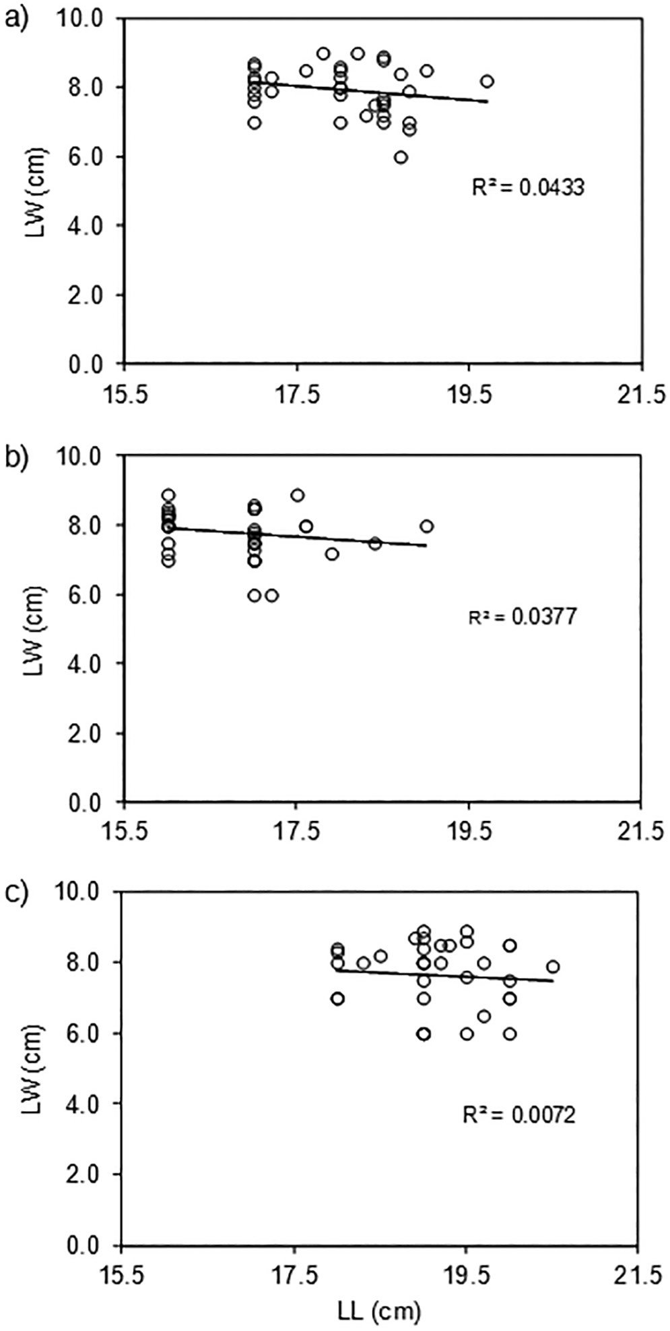**Figure 3.** Relationship of leaf length (LL) and leaf width (LW) of *Calophyllum inophyllum* in a) forested, b) urban, and c) coastal areas.

Figure 5 shows the measurements of the six anatomical characters. *C. inophyllum* showed comparatively thicker (about twice) upper epidermis (UE) compared to the lower epidermis (LE) across locations (Figures 5a and b, respectively), but significant variation among locations was only observed in LE. The mean LE was significantly larger in the urban area than in the forested and coastal areas, which were not significantly different from each other. As mentioned, *C. inophyllum* has two layers of palisade and a loosely arranged spongy mesophyll. The palisade layer (PM) was thinner compared to the spongy (SM) across locations (Figure 5), but only SM had significant variation among locations. The mean SM was smaller in the forested and urban areas compared to the coastal area. In terms of the vascular tissues, the phloem

**Figure 4.** Anatomical structure of *Calophyllum inophyllum* sampled from the forest (A, D), urban (B, E), and coastal areas (C, F). Abbreviation: XY – xylem; PH – phloem; PM

– palisade mesophyll; SM – spongy mesophyll; bar

represents 200 μm.

mean area was smaller than the xylem across locations (Figures 6e and f, respectively). However, significant variation among locations was observed only for the RH. The mean phloem area was higher in the coastal area compared to the forested and urban.

# DISCUSSION

## Morphological and Anatomical Responses of *C. inophyllum* across Locations in Relation to Climatic Variables

Since *C. inophyllum* is naturally found along seashores and coastal areas, the prevailing environmental conditions are expected to favor the growth of the plant in its natural habitat. *C. inophyllum* thrives in full sun or partial shade on any well-drained soil (Gilman and Watson 1993) and was observed tolerant to drought conditions. It was reported that *C. inophyllum* can tolerate a temperature of 22–37 °C (maximum) and 12–17 °C (minimum).

However, as *C. inophyllum* has been grown widely outside of its natural habitat, it is important to clarify whether

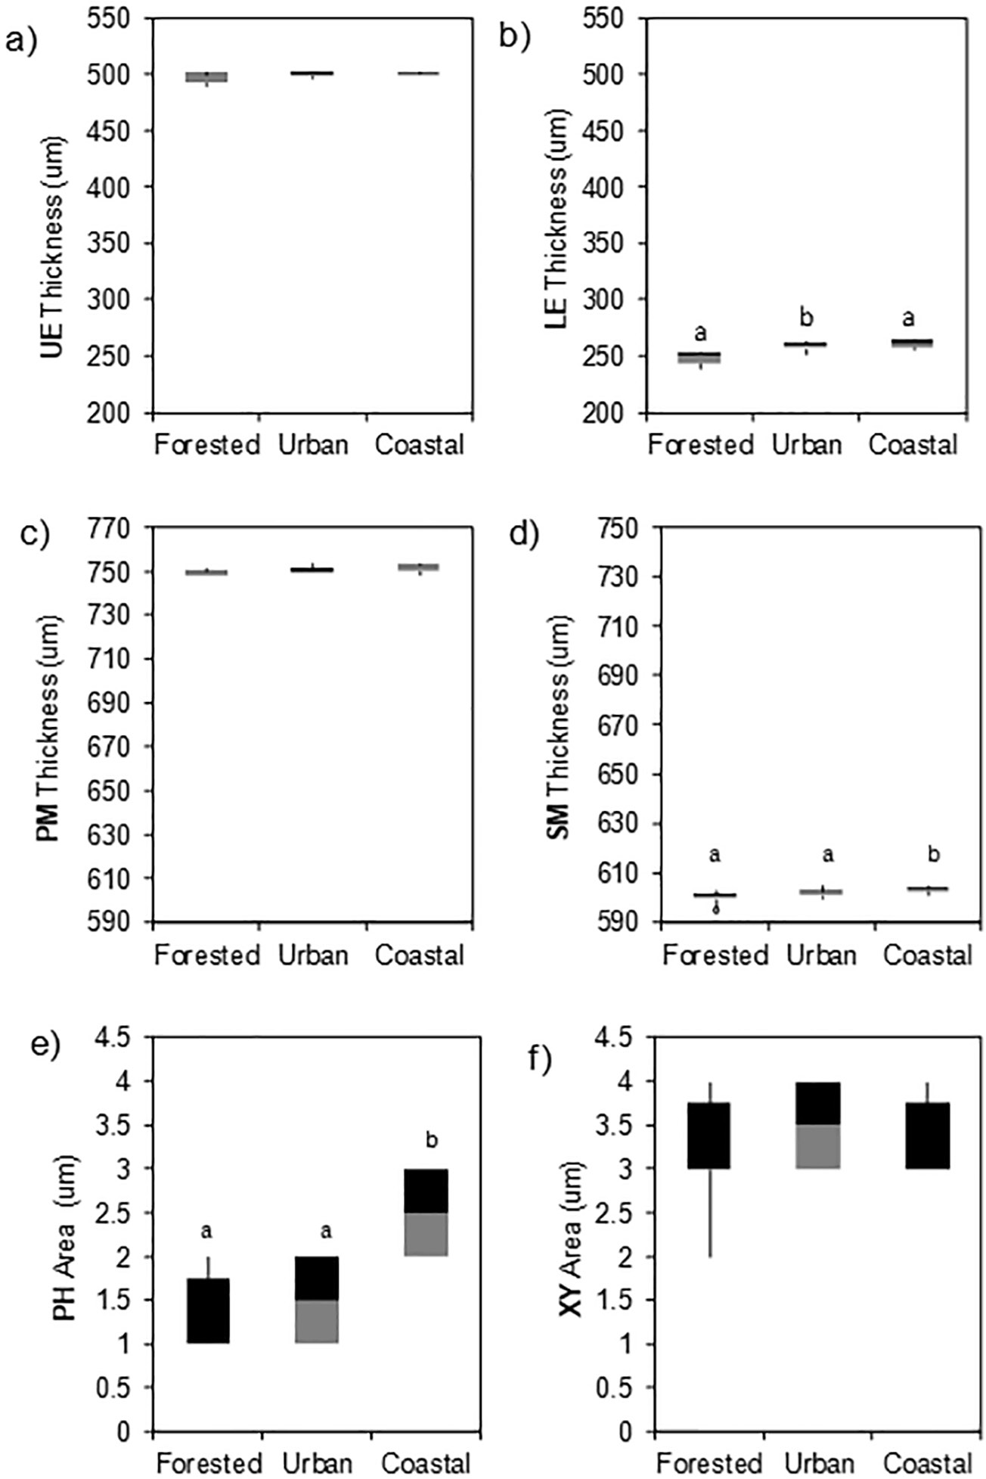

**Figure 5.** Mean values of anatomical characters of *Calophyllum inophyllum*: a) upper epidermis (UE), b) lower epidermis (LE), c) palisade mesophyll (PM), d) spongy mesophyll (SM), e) phloem (PH), and f) xylem (XY), with Tukey’s post hoc HSD test to compare differences among sites.

the difference in the locations of the species as affected by the prevailing climatic conditions have significantly rendered structural changes in the leaf morphology and anatomy. As mentioned in the methodology, due to the high multicollinearity of Temp and RH, the RH was dropped in the model. The effects of the two remaining climatic variables on the morphological and anatomical characters of *C. inophyllum* in the three studied areas are shown in Table 1. In Dataset 1 – using the means of observations for each of the six anatomical characters, means of LL and LW, and mean annual climatic variables from 2009–2018 – the PPT and Temp, individually and in combination, had significant effects on LL and thickness of the LE in the urban area. In Dataset 2 – using the means of observations for each of the six anatomical characters and the individual LL and LW values, and taking only measurements of climatic variables of four representative months (March, Jun, September, and December) of each year from 2009–2018 – the effects of PPT and Temp, individually and in combination, had significant effects

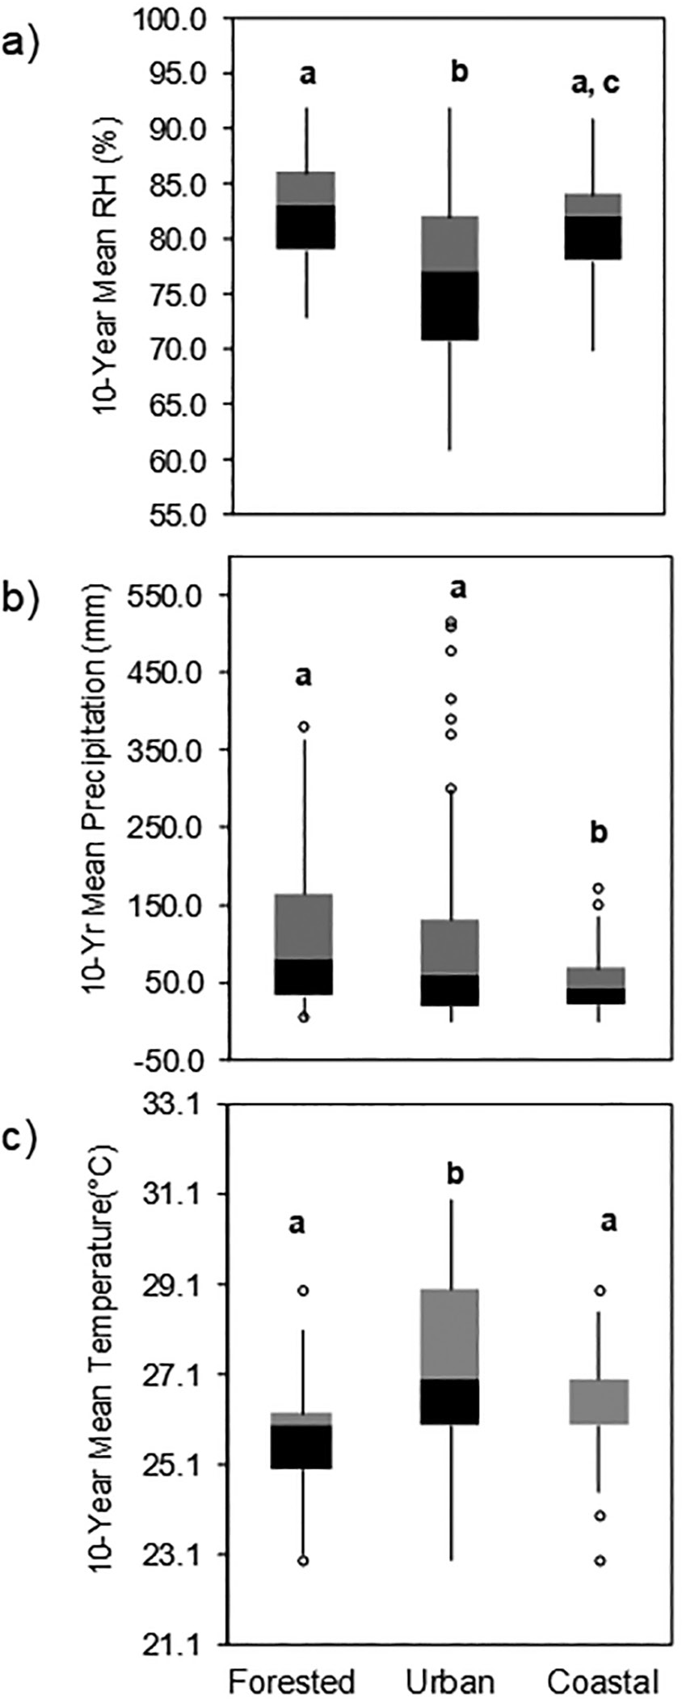**Figure 6.** Ten-year mean values of climatic variables: a) relative humidity (RH), b) precipitation, and c) temperature in forest (Los Baños), urban (Taguig), and coastal (Batangas) areas in Luzon, with Tukey’s *post hoc* HSD test to determine differences among various factors.

on SM in forested and UE in the urban area. In Dataset 3 – using the means of observations for each of the six anatomical characters and the individual LL and LW values, and the monthly average of climatic variables from 2009–2018 – the effects of PPT and Temp, individually and in combination, had significant effects on LW and the leaf blade surface area in the coastal area. In all these datasets, the model generally detected significant effects of climatic variables on LL. In Figure 2 it is apparent that

|  |  |  |  |
| --- | --- | --- | --- |
| **Table 1.** Summary results of linear mixed model used to determine the effects of climatic variables on morphological and anatomical characters of *C. inophyllum*. | | | |
| **Area** | **Dataset_1 (*p* < 0.05)** | **Dataset_2 (*p* < 0.05)** | **Dataset_3 (*p* < 0.05)** |
| Forested | NS | SM (P, T, P:T) | NS |
| Urban | LL (P, T, P:T)  LE (P, T, P:T) | UE (P, T, P:T) | NS |
| Coastal | NS | NS | LW (P, T, P:T)  LL*LW (P, T, P:T) |
| P – precipitation; T – temperature; P:T – combined effects of precipitation and temperature NS – not significant | | | |
| In Dataset 1, the model considered the means of observations for six trees for each of the six anatomical characters and means of LL and LW of six trees in each location, and annual average of climatic variables from 2009–2018.  In Dataset 2, the model considered the means of observations for six trees for each of the six anatomical characters and the individual sample LL and LW values of six trees in each location and taking only measurements of climatic variables of four representative months (March, Jun, September, and December) of each year from 2009–2018.  In Dataset 3, the model considered the means of observations for six trees for each of the six anatomical characters and the individual 36 LL and LW values of six trees in each location, taking only four representative months (March, Jun, September, and December) of each year from 2009–2018. | | | |

there is a distinct difference among locations in terms of LL, with the smallest mean LL in the urban and highest in the coastal area.

In some species like *Quercus acutissima* Carruth. (Xu *et al.* 2009), *Ziziphus jujuba* Mill. (Liu *et al.* 2015), *Betula papyrifera* Marshall (Wang 2014), and *Berberis microphylla* G.Forst. (Radice and Arena 2015) leaves were found smaller with low temperature and low light intensity as a form of plant adaptation to survive in cold environments. Smaller and thinner leaf prevents the plant from a large amount of transpiration. Although temperature and light intensity requirement specifically differs among species, studies show that the leaf morphology is negatively affected by high temperature and light intensity.

In this study, it appears that the *C. inophyllum* adapts with the higher temperatures in the urban area by having smaller LL and thicker upper and lower epidermal layers, and these morphological and anatomical responses were found significantly affected by the temperature – either independently or in interaction with the PPT. This thick epidermal development had been observed also by the two xeric *Zanthoxylum* species (Rutaceae) in central Argentina (Oggero *et al.* 2016). Comparison of leaf anatomy of *Nepenthes* species between lowland and highlands habitats from Borneo and Sumatra (Arimy *et al*. 2017), despite using limited samples (three adult leaves of 1–3 individual plants), also showed that highland *Nepenthes* had thicker and larger hypodermis and cuticular layer, with bigger and fewer stomata than the lowland species. Although the observations were attributed mainly to altitudinal differences, the associated varying temperature along gradients – specifically the fall in mean temperature in high altitudes – was mentioned.

In addition, studies show that the thickness of the mesophyll increases with increasing Temp and light intensity, as well as PPT and RH [*e.g*. *Tradescantia pallida* (Rose) D.R. Hunt (Paiva *et al.* 2003), *Plantago major* L. (Onoda *et al.* 2008), *Tanacetum vulgare* L. (Stevović *et al.* 2010), *Acacia koa* A. Gray (Craven *et al.* 2010) *Hibiscus rosasinensis* L. (Noman *et al.* 2014), *Platanus orientalis* L. (Arena *et al.* 2016), *Zanthalum coco* (Oggero *et al*. 2016), and *Thalassia hemprichii* (Ehrenb. ex Solms) Asch. (Purnama *et al.* 2015)], and this is also well demonstrated in this study. *C. inophyllum* leaves in the urban areas, with significantly higher 10-year mean temperatures than the coastal and forested areas, had thicker palisade and spongy mesophyll. This response of the mesophyll specifically the SM was found correlated to climatic variables (based on Dataset 2). However, as light intensity is also one important environmental factor that has a potential relationship with the responses of the leaf epidermal and mesophyll tissues, the study also considers that this factor, if analyzed over a sufficient period, may have shed more light on the above results.

The three climatic variables also have important effects on the initiation and differentiation of the vascular cambium, specifically the rate of cambial cell division (xylem development), which is correlated with these variables (Köcher *et al*. 2012; Patel *et al.* 2014, as reviewed in Caderi *et al.* 2019). Water deficiency or drought inhibits cell division of the vascular cambium, which leads to reduced plant growth, by delaying or reducing the turgor of the cambial cells (Patel *et al.* 2014). Although there was significantly reduced PPT in the coastal area over ten years compared to the forested and urban areas, the mean xylem thickness did not vary across locations. It was the phloem in the coastal area that had a striking

difference from the other locations by having the largest mean thickness, although this response could also not be significantly attributed to any of the two climatic variables considered in this study. The effects of PPT may be easily rendered on vascular tissues in stems, as shown in Caderi *et al.* (2019) for some species like *Pinus kesiya*, but not on vascular tissues extending through the leaves. In a number of studies related to the characters of the vascular system, such as those that determine the efficiency of water and resistance, vascular tissues may exhibit variation in response to changes in the RH and temperature, as well as salinity; hence, they are crucial to be maintained in their habitat (reviewed in Muniz *et al*. 2018). Phloem may have a similar tendency but studies on phloem tissue formation in response to changes in environmental conditions such as temperature, RH, and light seem relatively less explored compared to the xylem. Drought stress, on one hand, was found to cause a delay in the formation of phloem (Qaderi *et al*. 2019). Vascular-specific effects of salt stress have also been theorized. Molecular-level analysis has also shown the possibility that salt stress has a role in phloem tissue formation (reviewed in López-Salmerón *et al*. 2019). Water availability and natural exposure to the salinity of

*C. inophyllum* trees in its natural habitat – coastal areas

– may have larger roles in phloem development in the species and merit an investigation in the future.

Furthermore, as urban trees are potentially more exposed to dust pollution or other particulate matters from vehicular and industrial releases, some of the changes in the anatomical structures observed in *C. inophyllum* leaves in the urban area may be partly attributed to this reason. Although the BGC in Taguig City is fairly vegetated compared to the other cities and business districts in the Metro Manila (National Capital Region), the particulate matters in the surrounding cities have been reported to have exceeded the amount for a desirable air quality index; specifically, PM10 is high in Metro Manila (DENR-EMB 2015). The leaf surface is the most important receptor of atmospheric pollutants. Several structural and functional changes happen in the leaves when particulate-laden air strikes them (Rai *et al.* 2010). Large-leaved species such

*C. inophyllum* is a popular tree for urban greening and may provide effective particulate matter barriers. However, large particulate matter can block the passage of sunlight and curtail photosynthesis (Rahul and Jain 2014). Several studies also reported a number of negative effects of particulate matters on the morphology and physiological activities in the leaves, especially of sensitive plant species. The *Ricinus communis* (castor bean) plants along the roadside in a polluted area in Kathmandu, Nepal, for example, showed reduced leaf area, petiole length, and thickness of palisade layer and spongy parenchyma but had thicker cuticle and size of epidermal cells (Suwal *et*

*al.* 2019). Dust deposition on the leaves also affects the net assimilation efficiency, and long-term deposition of the dust causes changes in the phytochemistry, which leads to retarded leaf growth (Kameswaran *et al.* 2019). Apparently, the reduction in the leaf area was a common conspicuous effect on plants in polluted areas [*e.g.* Jahan and Iqbal (1992); Dineva (2004); Tiwari *et al*. (2006); Sayyednejad *et al.* (2009a, 2009b), as reviewed in Seyyednejad *et al*. (2011) and Kameswaran *et al*. (2019)]. Hence, air pollution as a contributing factor on the significant changes in leaf characters needs further investigation.

# CONCLUSION

In this study, a few readily apparent changes in the morphological and anatomical characteristics of the *C. inophyllum* growing in different locations (coastal, forest, and urban) and climatic variables were observed. This suggests that the species has a strong potential to adapt to various areas and environmental conditions, rendering a warrant for its popular use in reforestation and similar activities. Nevertheless, the observed tendency to develop smaller leaf size, thinner mesophyll and phloem area, and thicker lower epidermal layer in an urban environment suggest its less suitability for purposes that require the ideal large leaf size as in its natural habitat, such as for urban landscape and for ecological and physiological functions.

# ACKNOWLEDGMENTS

The authors thank the DFBS and the Makiling Center for Mountain Ecosystems of CFNR in UPLB for allowing the use of its facilities for the conduct of this study. The authors also acknowledge JSA, Inc. through its resident arborist Forester June B. Micosa for assisting us in the sample collection and tree measurement in BGC. This study was supported partly by the DOST-PCAARRD (Department of Science and Technology through the Philippine Council for Agriculture, Aquatic, and Natural Resources Research and Development) through the project “Germplasm Conservation of Select Indigenous Forest Trees in Mount Makiling Forest Reserve (MMFR).”

# REFERENCES

ALLEN JA. 2002. *Calophyllum inophyllum* L. In: Tropical Tree Seed Manual: Part II, Species Descriptions. Vozzo J ed. US Department of Agriculture, Washington, DC. 712p.

ARENA C, TSONEV T, DONEVA D, MICHELOZZI M, BRUNETTI C, CENTRITTO M, FINESCHI S, VELIKOVA V, LORETTO F. 2016. The effect of

light quality on growth, photosynthesis, leaf anatomy and volatile isoprenoids of a monoterpene-emitting herbaceous species (*Solanum lycopersicum* L.) and an isoprene-emitting tree (*Platanus orientalis* L.). Environmental and Experimental Botany 130: 122–

132. doi: 10.1016/j.envexpbot.2016.05.014

### ARIMY NQ, NISYAWATI, METUSALA D. 2017.

Comparison of leaf anatomy on some *Nepenthes* spp. (Nepenthaceae) from highland and lowland habitat in Indonesia. AIP Conference Proceedings 1862: 030111. https://doi.org/10.1061/1.4991215

BELL AD. 2008. Plant Form: An Illustrated Guide to Flowering Plant Morphology. London: Oxford University Press. 393p.

### CRAVEN D, GULAMHUSSEIN S, BERLYN GP. 2010.

Physiological and anatomical responses of *Acacia koa* (Gray) seedlings to varying light and drought conditions. Environmental and Experimental Botany 69: 205–213.

D’ARCY WG, KEATING RC. 1979. Anatomical support for the taxonomy of *Calophyllum* (Guttiferae) in Panama. Annals of the Missouri Botanical Garden 557–571.

[DENR-EMB] Department of Environment and Natural Resources–Environmental Management Bureau. 2015. National Air Quality Status Report 2008– 2015. Retrieved from emb.gov.ph/wp-content/ uploads/2015/09/1-Air-Quality-1.8-National-Air- Quality-Status-Report-2008-2015

DÍAZ DMV. 2013. Multivariate analysis of morphological and anatomical characters of *Calophyllum* (Calophyllaceae) in South America*.* Botanical Journal of the Linnean Society 171(3): 587–626.

DINEVA SD. 2004. Comparative studies of the leaf morphology and structure of white ash *Fraxinus americana* L. and London plane tree *Platanus acerifolia* Willd. growing in polluted area. Dendrobiology 52: 3–8.

FAHN A. 1967. Plant Anatomy. Oxford: Pergamon Press Ltd. 541p.

FRIDAY JB, OKANO D. 2006. *Calophyllum inophyllum* (kamani). Species Profiles for Pacific Island Agroforestry 2(1): 1–17.

FRITZ MA, ROSA S, SICARD A. 2018. Mechanisms

underlying the environmentally induced plasticity of leaf morphology. Frontiers in Genetics 9(478): 1–25.

GILMAN EF, WATSON DG. 1993. *Calophyllum*

*inophyllum*: Beauty Leaf. Fact Sheet ST-115. US Forest Service Department of Agriculture. Retrieved from <http://hort.ufl.edu/database/documents/pdf/> tree_fact_sheets/calinoa.pdf

GRATANI L. 2014. Plant phenotypic plasticity in response to environmental factors. Advances in Botany (Article ID 208747, 17 pages). [http://dx.doi.](http://dx.doi/) org/10.1155/2014/208747

HAUPT AW. 1953. Plant Morphology. McGraw-Hill, University of Michigan, USA. 464p.

HERNANDEZ JO, FERNANDO ES, MALABRIGO PL, QUIMADO MO, MALDIA LSJ. 2016. Xerophytic

characteristics of *Tectona philippinensis* Benth. & Hook. f. Philippine Journal of Science 145(3): 259–269.

### HOVENDEN M, VANDER SCHOOR JK, OSANAI

Y. 2012. Relative humidity has dramatic impacts on leaf morphology but little effect on stomatal index or density in *Nothofagus cunninghamii* (Nothofagaceae). Australian Journal of Botany 60(8): 700–706. DOI: 10.1071/bt12110

JAHAN S, IQBAL MZ. 1992. Morphological and anatomical studies on leaves of different plants affected by motor vehicle exhausted. Journal of Islamic Academy of Science 5: 21–23.

JOHANSEN. 1940. Plant Microtechnique. New York: McGraw-Hill. 523p.

### KAINUMA M, BABA S, CHAN HT, INOUE T,

TANGAH J, CHAN EWC. 2016. Medicinal plants of sandy shores: a short review on *Calophyllum inophyllum* and *Thespesia populnea*. Int J Pharmacogn Phytochem Res 8: 2056–2062.

### KAMESWARAN S, GUNAVATHI Y, GOPI KRISHNA P.

2019. Dust pollutions and its influence on vegetation – a critical analysis. Research Journal of Life Sciences, Bioinformatics, Pharmaceutical and Chemical Sciences 5(1): 341–363.

### KÖCHER P, HORNA V, LEUSCHNER C. 2012.

Environmental control of daily stem growth patterns in five temperate broad-leaved tree species. Tree Physiology 32: 1021–1032.

LI X, LI Y, ZHANG Z, LI X. 2015. Influences of Environmental Factors on Leaf Morphology of Chinese Jujubes. PLoS ONE 10(5): e0127825. doi:10.1371/

journal.pone.0127825

### LIU M, WANG J, LIU P, ZHAO J, ZHAO Z, LI D, LI

X, LIU Z. 2015. Historical achievements and frontier advances in the production and research of Chinese

jujube (*Ziziphus jujube*) in China (in Chinese) Acta Horticulturae Sinica 42: 1683–1689. doi:10.1007/ s10114-015-4669-7

### LÓPEZ-SALMERÓN V, CHO H, TONN N. GREB

T. 2019. The phloem as a mediator of plant growth plasticity. Current Biology 29: R173–R181.

### MUNIZ LF, BOMBO AB, FILARTIGAAL, APPEZATO-

DA-GLÓRIA B. 2018. Can climate and soil conditions change the morpho-anatomy among individuals from different localities? A case study in *Aldama grandiflora* (Asteraceae). Brazilian Journal of Biology 78(4): 706–717.

### NOMAN A, ALI Q, HAMEED M, MEHMOOD T,

IFTIKHAR T. 2014. Comparison of leaf anatomical characteristics of *Hibiscus rosasinensis* grown in Faisalabad region. Pakistan Journal of Botany 469(1): 199–206.

### OGGERO AJ, ARANA MD, REINOSO HE. 2016.

Comparative morphology and anatomy of the leaf and stem of species of *Zanthoxyllum* (Rutaceae) from central Argentina. Polibotanica 42: 121–136. doi:10.188387.polibotanica.42.6

ONODA Y, SCHIEVING F, ANTEN NPR. 2008. Effects

of light and nutrient availability on leaf mechanical properties of *Plantago major*: a conceptual approach. Annals of Botany 101(5): 727–736. DOI: 10.1093/ aob/mcn013

### ORWA C, MUTUA A, KINDT R, JAMNADASS R,

ANTHONY S. 2009. Agroforestry Database: a tree reference and selection guide version 4.0. World Agroforestry Centre, Kenya.

### PAIVA EAS, ISAIAS RMDS, VALE FHDA, DE

SENNA QCG. 2003. The influence of light intensity on anatomical structure and pigment contents of *Tradescantia pallida* (Rose) Hunt. cv. *urpurea* Boom (Commelinaceae) leaves. Brazillian Archives of Biology and Technology 46(4). DOI: 10.1590/S1516- 89132003000400017.

PATEL VR, PRAMOD S, RAO KS. 2014. Cambial

activity, annual rhythm of xylem production in relation to phenology and climatic factors and lignification pattern during xylogenesis in drum-stick tree (Moringaoleifera). Flora 209: 556–566.

### PEPPE DJ, ROYER DL, CARIGLINO B, OLIVER SY, NEWMAN S, LEIGH E, ENIKOLOPOV G, FERNANDEZ-BURGOS M, HERRERA F, ADAMS JM, CORREA E, CURRANO ED, ERICKSON JM, HINIJOSA LF, HOGANSON JW, IGLESIAS A, JARAMILLO CA, JOHNSON KR, JORDAN, GJ, KRAFT NJB, LOVELOCK EC, LUSK CH,

NIINEMETS U, PEŇUELAS J, RAPSON G, WING

SL, WRIGHT IJ. 2011. Sensitivity of leaf size and shape to climate: global patterns and paleoclimatic applications. New Phytologist 190: 724–739. https:// doi.org/10.1111/j.1469-8137.2010.03615.x

PRABAKARAN K, BRITTO SJ. 2012. Biology,

agroforestry and medicinal value of *Callophyllum inophyllum* L. (Clusiaceae): a review. International Journal of Natural Products Research 1(2): 24–33.

### PURNAMA PR, SOEDARTI T, PURNOBASUKI H.

2015. The effects of lead [Pb(NO3)2] on the growth and chlorophyll content of sea grass [*Thalassia hemprichii* (ehrenb.) Aschers.] *ex situ*. Vegetos 28(1): 9–15.

### QADERI MM, MARTEL AB, DIXON SL. 2019.

Environmental factors Influence vascular system and water regulation. Plants 8(65). doi:10.3390/ plants8030065

### RADFORD AE, DIKISON WC, MASSEY JR, BELL

CR. 1974. Vascular Plants Systematics. New York: Harper and Row.

RADICE S, ARENA M. 2015. Environmental effect on the leaf morphology and anatomy of *Berberis microphylla*

G. Forst. International Journal of Plant Biology 6(1). https://doi.org/10.4081/pb.2015.5677

### RAI A, KULSHRESHTHA K, SRI VASTAVA

PK. 2010. Leaf surface structure alterations due to particulate pollution in some common Plants. Environmentalist 30: 18–23. https://doi. org/10.1007/s10669-009-9238-0

RAHUL J, JAIN MK. 2014. An investigation into the impact of particulate matter on vegetation along the national highway: a review. Research Journal of Environmental Sciences 8(7): 356–372.

### ROYER DL, MEYERSON L, ROBERTSON KM,

ADAMS JM. 2009. Phenotypic plasticity of leaf shape along a temperature gradient in *Acer rubrum*. PLoS ONE 4(10): e7653.

### ROZENDAAL DMA, HURTADO VH, POORTER L.

2006. Plasticity in leaf traits of 38 tropical tree species in response to light; relationships with light demand and adult stature. Functional Ecology 20(2): 191–412.

### SCHNEIDER CA, RASBAND WS, ELICEIRI KW. 2012.

NIH Image to ImageJ: 25 years of image analysis. Nature Methods 9: 671–675.

SEYYEDNEJAD SM, NIKNEJAD M, YUSEFI M. 2009a.

The effect of air pollution on some morphological and biochemical factors of *Callistemon citrinus* in petrochemical zone in South of Iran. Asian Journal of Plant Science 8: 562–565.

### SEYYEDNEJAD SM, NIKNEJAD M, YUSEFI M.

2009b. Study on the air pollution effects on some morphological and biochemical factors of *Albizzia lebbeck* in high temperature condition in Khuzestan. Journal of Plant Science 8: 562–565.

### SEYYEDNEJAD SM, NIKNEJAD M, KOOCHAK H.

2011. A review of some different effects of air pollution on plants. Research Journal of Environmental Sciences 5(4): 302–309.

SHIPUNOV A. 2020. Introduction to Botany. Minot State University, North Dakota, USA. 192p.

SIMPSON MG. 2006. Plant Systematics. Amsterdam, Netherlands: Elsevier Academic Press. 590p.

SOMARATNE S, HEART TR. 2001. A comparative vegetative anatomical study of the genus *Calophyllum* in Sri Lanka. Ceylon Journal of Science (Biological Sciences) 28: 51–80.

STEVENS PF. 2006. An end to all things? — plants and their names. Australian Systematic Botany 19(2): 115–133.

### STEVOVIĆ S, MIKOVILOVIĆ VS, ĆALIĆ D. 2009.

Environmental adaptability of tansy (*Tanacetum vulgare* L.). African Journal of Biotechnology 8(22): 6290–6294. DOI: 10.5897/AJB09.1267

### SUWAL BMS, GAUTAM RS, MANANDHAR D.

2019. Environmental impact on morphological and anatomical structure of *Ricinus communis* L. leaves growing in Kathmandu, Nepal. 2019. International Journal of Applied Sciences and Biotechnology 7(2): 274–278.

### TIWARI SM, AGRAWAL M, MARSHALL FM. 2006.

Evaluation of ambient air pollution impact on carrot plants as a sub urban site using open top chambers. Environmental Monitoring Assessment 119: 15–30.

### WANG Z, SUN F, WANG J, DONG J, XIE S, SUN M,

SUN B. 2014. The diversity and paleoenvironmental significance of *Calophyllum* (Clusiaceae) from the Miocene of southeastern China. Historical Biology. p. 1–15.

WEATHER UNDERGROUND. n/d. Weather Forecast & Reports – Long Range & Local. Retrieved on 12 Apr 2020 from [https://www.worldweatheronline.com/](http://www.worldweatheronline.com/)

XU F, GUO W, XU W, WANG R. 2008. Habitat efffects on leaf morphological plasticity in *Quercus acutissima*. Acta Biologica Cracoviensia: Series Botanica 50(2): 19–26.

XU F, GUO W, XU W, WEI Y, WANG R. 2009. Leaf

morphology correlates with water and light availability: what consequences for simple and compound leaves? Progress in Natural Science 19(12): 1789–1798. https:// doi.org/10.1016/j.pnsc.2009.10.001

XU W, HE X, CHEN W, WEN H. 2006. Morphological- ecological characters and growth patterns of main tree species leaves in urban forest of Shenyang. Ying Yong Sheng Tai Xue Bao 17(11): 1999–2005.

### ZABALETA-MANCERA HA, REYES-CHILPA R,

GARCIA-ZEBADÚA. 2011. Leaf structure of two chemotypes of *Calophyllum brasiliense* from Mexico. Microscopy and Microanalysis 17(S2): 340–341. DOI: 10.1017/S1431927611002571

655

|  |  |  |  |
| --- | --- | --- | --- |
| APPENDIX  **Table I.** Schedule of fixing and dehydration of samples for anatomical study. | | | |
| **Fixing and dehydration series** | **Chemical composition** | **Concentration (ml)** | **Duration** |
|  | Formalin | 12 |  |
|  | 95% ethanol | 88 |  |
| FAA |  |  | 7 d |
|  | Glacial acetic acid | 10 |  |
|  | Water | 90 |  |
|  | 50% ethanol |  | Change every hour for 4 h |
|  | Water | 30 |  |
| J1 | 95% ethanol | 24 | 3 h |
|  | TBA | 6 |  |
|  | Water | 18 |  |
| J2 | 95% ethanol | 30 | 17 h |
|  | TBA | 12 |  |
|  | Water | 9 |  |
| J3 | 95% ethanol | 30 | 3 h |
|  | TBA | 21 |  |
|  | 95% ethanol | 27 |  |
| J4 |  |  | 3 h |
|  | TBA | 33 |  |
|  | 100% ethanol | 45 |  |
| J5 |  |  | 3 h |
|  | TBA | 15 |  |
| J6 | TBA |  | 15 h; uncovered inside laminar hood |
|  | TBA | 15 | Uncovered at room temperature for 4 h |
| J7 |  |  |  |
|  | Mineral oil | 15 | Uncovered inside the oven  for 3 h |