 

*Article* 1

**Short-term Cumulative Exposure to Ambient Traffic-Related** 2

**Black Carbon and Blood Pressure: MMDA Traffic Enforcers’** 3

**Health Study** 4

5

6

7

8

9

10

11

12

13

**Citation:**

Academic Editor:

Received: date Accepted: date Published: date

**Publisher’s Note:** MDPI stays neu- tral with regard to jurisdictional claims in published maps and institu- tional affiliations.



**Copyright:** © 2021 by the authors. Submitted for possible open access publication under the terms and conditions of the Creative Commons Attribution (CC BY) license (https://creativecommons.org/license s/by/4.0/).

**Abstract:** Exposure to traffic-related air pollution is linked with acute alterations in blood pressure 14 (BP). We examined the cumulative short-term effect of black carbon (BC) exposure on systolic (SBP) 15 and diastolic (DBP) BP and assessed effect modification by participant characteristics. SBP and DBP 16 were repeatedly measured on 152 traffic enforcers. Using a linear mixed-effects model with random 17 intercepts, quadratic (QCDL) and cubic (CCDL) constrained distributed lag models were fitted to 18 estimate the cumulative effect of BC concentration on SBP and DBP during the 10-hours (daily ex- 19 posure) and 7-days (weekly exposure) before the BP measurement. Ambient BC was related to in- 20 creased BP with QCDL models. An interquartile range change in BC cumulative during the 7-days 21 before the BP measurement was associated with increased BP [1.2% change in mean SBP, 95% con- 22 fidence interval (CI), 0.1 to 2.3; and 0.5% change in mean DBP, 95% CI, –0.8 to 1.7]. Moreover, the 23 association between the 10-hours cumulative BC exposure and SBP was stronger for females (4.0% 24 change, 95% CI: 2.1–5.9) versus males and for obese (2.9% change, 95% CI: 1.0–4.8) vs. non-obese 25 traffic enforcers. Short-term cumulative exposure to ambient traffic-related BC could bring about 26 cardiovascular diseases through mechanisms involving increased BP. 27

**Keywords:** *black carbon, diastolic blood pressure, MMDA traffic enforcers, obesity, sex, systolic blood* 28

*pressure* 29

30

# Introduction 31

It is estimated that about 4.2 million people yearly across the world die from air pol- 32

lution, according to the World Health Organization (WHO), and over 90% of people 33

breathe air containing high levels of pollutants [1,2]. Exposure reduction to air pollution 34

has an essential impact on global public health since the adverse health effects of air pol- 35 lution are usually driven through their detrimental impact on cardiovascular health [3]. 36 Counties are now confronting significant public health and climate crises brought about 37

by air pollution, which prompted the WHO to update the existing guidelines on air pol- 38

lution in September 2021. WHO provided more robust evidence to demonstrate how air 39

pollution affects different aspects of health at even lower concentrations than previously 40

known [4]. 41

*Int. J. Environ. Res. Public Health* **2021**, *18*, x. https://doi.org/10.3390/xxxxx [www.mdpi.com/journal/ijerph](http://www.mdpi.com/journal/ijerph)

Black Carbon (BC) is a measured component of fine particulate matter (PM2.5) in the 42 air [5]. BC usually exists in submicron particles from combustion-related sources, includ- 43 ing transportation, fossil fuel burning, residential heating, and industry [6]. Numerous 44 epidemiological studies have provided evidence that BC exposure is linked to detrimental 45 health effects [5,7-9]. It was emphasized by various researches the potential role of BC in 46 influencing the variability of toxicologically active components of PM2.5 [10,11]. BC in 47 urban environments is often related to adverse respiratory and cardiovascular effects, 48 including an increase in blood pressure (BP) [12], increased cases of asthma, and 49 premature deaths [13]. Unsustainable urbanization and outdated environmental 50 protection legislation, which resulted in severe degradation of urban air quality in terms 51 of BC emission, exacerbate these problems in developing megacities in South-East Asia, 52 Latin America, and Africa [14]. There remain regional differences in BC-related health 53 effects described in some epidemiological researches that cannot be fully explained by 54 geographical variations in ambient concentrations of BC [6]. 55

Several studies concluded that exposure to BC is associated with cardiovascular ef- 56

fects [6,15,16]. Although the evidence linking BC to subclinical cardiovascular endpoints 57

is more limited than that for PM2.5, BC is of interest from a health perspective because 58

multiple studies report associations between combustion-related air pollution and health 59

effects [17-20]. In addition, acute and chronic BC exposures contribute to cardiovascular 60

morbidity and mortality [21,22]. Physiological events happen to mediate these cardiovas- 61

cular effects, such as an altered autonomic function of the heart, changes in micro- and 62

macrovascular reactivity, induction of systemic inflammation, endothelial dysfunction, 63

and altered peripheral resistance of the blood vessels [23-26]. Moreover, elevation in BP 64

and an increased risk for developing hypertension usually result from microcirculation, 65

which determines the overall peripheral resistance and microvascular alterations [12]. 66 One study in Beijing, China, demonstrated the impact of short-term variation in high lev- 67 els of ambient air pollution metrics on health outcomes. Results showed that both PM2.5 68

and BC are linked to BP increase and insulin resistance, even among at-risk individuals 69

who have been living for long periods in these conditions [27]. The study also demon- 70

strated that personal exposure to BC elevates blood pressure and heart rate within a few 71

hours [27]. 72

In less developed and developing countries, megacities endure high levels of traffic- 73

related air pollution and its health effects due to rapid urbanization, modernization, and 74

economic growth [13]. Metro Manila, Philippines, is one of those megacities and home to 75

approximately 13 million people. The air quality situation in Metro Manila is frequently 76

hazardous due to various sources of pollution, and the residents intermingle in condensed 77

limited spaces [14]. Furthermore, Metro Manila is reported to have the highest number of 78

registered motor vehicles compared with other cities in the Philippines. Based on the Na- 79 tional Emissions Inventory by source conducted in 2015, the majority (65%) of air pollu- 80 tants in the Philippines came from mobile sources such as cars, motorcycles, diesel trucks, 81

and buses. Moreover, almost 21% were contributed by stationary sources such as power 82

plants and factories, and the rest (14%) were from area sources such as construction activ- 83

ities and open burning of solid wastes. Conversely, Metro Manila inventory in the same 84

year revealed that mobile sources contributed 88% to total air pollution in the area com- 85

pared to 10% from stationary sources and a mere 2% from area sources [28]. 86

There is a need to understand better the association between air pollution and health 87

outcomes, including BC and BP levels. Our study examined the association between acute 88

cumulative exposure to BC and BP, particularly systolic (SBP) and diastolic (DBP) BP, 89

among urban traffic enforcers stationed along a major circumferential highway in Metro 90

Manila. Moreover, we evaluated effect modification by the characteristics of the traffic 91

enforcers. 92

# Materials and Methods 93

# Study Population and Study Site 94

The study population involved 152 traffic enforcers who were actively employed and 95

working for the Metropolitan Manila Development Authority (MMDA). Traffic enforcers 96

stationed along the Epifanio de Los Santos Avenue (EDSA) were randomly selected from 97

the list given by MMDA management. Recruitment was voluntary on the traffic enforcers 98

and included 19 – 65 years old traffic enforcers working the 5:00 am to 2:00 pm shift from 99

May 2014 to April 2015. In addition, traffic enforcers working on secondary roads and 100

other highways, pregnant, and clinically diagnosed with pulmonary tuberculosis were 101

excluded from the study. The study received ethics approval from an independent Ethics 102

Review Committee. 103

# Data Collection 104

* + 1. *Health Assessment and Self-Administered Questionnaire* 105

As part of the baseline health assessment, weight and height measurements, and col- 106 lection of serum samples, were done on all eligible traffic enforcers, including a self–ad- 107 ministered questionnaire containing data on medical history, medication usage, alcohol 108

consumption, smoking history, and other factors that could affect health. These measure- 109 ments were done the day before the start of the workweek of the traffic enforcers. Further- 110 more, the traffic enforcers were asked to report four more visits to the MMDA command 111

center clinic for additional BP measurements and blood extractions after their daily duty. 112

* + 1. *Blood Pressure Measurement* 113

For the health outcome assessment, sitting SBP and DBP measurements of the traffic 114

enforcers were recorded. The research team assessed the SBP and DBP of the traffic en- 115

forcers at the end of their scheduled duty at the MMDA command center clinic. Traffic 116

enforcers were seated for 5 min with arms at the level of the heart before the SBP and DBP 117

measurements. The average of three readings of SBP and DBP was used in the analysis. If 118

the traffic enforcer was agitated, upset, or excited, an additional 10-15 min of sitting before 119

the measurement of SBP and DBP was done. In addition, the participants were advised to 120

avoid food, alcohol, caffeine, and tobacco for 30–60 min before measuring their SBP and 121

DBP. 122

* + 1. *Black Carbon and Meteorological Measurement* 123

Ambient BC levels were measured daily using a real-time, pocket-sized BC aerosol 124

monitor (microAeth® Model AE51, AethLabs, Inc.). The monitor operated continuously 125

for 24 hrs and was positioned on the rooftop of the Metro Base Ver. 2.0 MMDA station 126

command center at Orense Guadalupe, Makati, Philippines. For quality assurance of BC 127

measurements, a second BC aerosol monitor was co-located at the rooftop site. Relative 128

humidity (RH) and ambient temperature (AT) measurements were obtained from the 129

Philippine Atmospheric, Geophysical, and Astronomical Services Administration – De- 130 partment of Science and Technology (PAGASA–DOST) weather stations located in Sci- 131 ence Garden, Quezon City. Moreover, the study had 570 valid BC exposure and BP out- 132 come measurements of the 152 traffic enforcers who had one (n = 15), two (n = 23), three 133

(n = 25), four (n = 11), or five (n = 78) measurements. 134

135

# Data Analysis 136

Descriptive statistics and correlation coefficients were calculated to describe and 137

evaluate the relationships among BC, SBP, DBP, and covariates. Associations between BC 138

and the change in the mean of both systolic BP (SBP) and diastolic BP (DBP) were esti- 139 mated using linear mixed-effects with random subject-specific intercepts regression mod- 140 els with an unstructured covariate matrix structure. It is a standard approach required to 141

capture and account for the residual correlation among measurements within the same 142

traffic enforcer and to take into account the heterogeneity in the traffic enforcer’s overall 143

BP measurements for the repeated measures data [29,30]. 144

Two BC-pollutant models were assessed. First, to examine the workday and 1-week 145

exposure windows of traffic enforcers to BC, and to minimize multiple comparisons, the 146

study fitted quadratic constrained distributed lag (QCDL), and cubic constrained distrib- 147

uted lag (CCDL), BC-pollutant models, to estimate the cumulative effect of BC during a 148

10-hour and a 7-day time window before the visit for the measurement of blood pressure 149

[31]. The linear mixed-effects regression models for the cumulative effect of BC on BP take 150

the general equation: 151

Quadratic Constrained Distributed Lag Linear Mixed-Effects Model (QCDL): 152

%'#

%'#

!"

𝐸"𝑌!"$ = 𝑏#! + 𝛽# + 𝛼#"∑&

%'#

𝑘#𝐵𝐶!"$%$ + 𝛼("∑&

𝑘(𝐵𝐶!"$%$ + 𝛼)"∑&

𝑘)𝐵𝐶!"$%$ + 𝑓"𝑠!"$ + 𝑋* 𝛽 (1) 153

𝐸"𝑌!"$ = 𝑏#! + 𝛽# + 𝛼#𝑣#!" + 𝛼(𝑣(!" + 𝛼)𝑣)!" + 𝑓"𝑠!"$ + 𝑋* 𝛽 (2) 154

!"

Cubic Constrained Distributed Lag Linear Mixed-Effects Model (CCDL): 155

𝐸"𝑌!"$ = 𝑏#! + 𝛽# + 𝛼#"∑&

%'#

𝑘#𝐵𝐶!"$%$ + 𝛼("∑&

𝑘(𝐵𝐶!"$%$ + 𝛼)"∑&

𝑘)𝐵𝐶!"$%$ + 𝛼)"∑&

𝑘+𝐵𝐶!"$%$ + 𝑓"𝑠!"$ + 𝑋* 𝛽 (3) 156

𝐸"𝑌!"$ = 𝑏#! + 𝛽# + 𝛼#𝑣#!" + 𝛼(𝑣(!" + 𝛼)𝑣)!" + 𝛼+𝑣+!" + 𝑓"𝑠!"$ + 𝑋* 𝛽 (4) 157

%'#

%'#

%'#

!"

!"

where *Yij* is the BP (SBP or DBP) measurement of traffic enforcer *i* at time *j*, *β0* is the overall 158 intercept, *b0i* is the random intercept for traffic enforcer *i*, *νmij* is a linear combination of the 159 current and lagged values of BC pollution *BCij* (q = 1 to 10 hours, or q = 1 to 7 days), *f(sij)* is 160 the smooth function of calendar date (natural spline with 4 degrees of freedom), and *X1ij*,…, 161 *Xrij* are the parametric fixed effects covariate terms from 1 to r identified *a priori* and 162 measured at each visit in which the SBP and DBP measurements were taken. Based on the 163 established relationship between BP and BC [32], the following covariates were controlled 164 *a priori* in all the models: age, sex, body mass index (BMI), fasting blood glucose level, 165 cholesterol level, hypertensive status (yes, no), cigarette smoking status (never, ever), 166 alcohol drinking status (never, ever), years of work experience. [33-35]. In addition, we 167 included the graduate of a 4-year degree (Yes/No) variable in the model to control for the 168 socioeconomic status. Furthermore, we used a natural spline of calendar date with 4 169 degrees of freedom in the model to account for the variation in season and other possible 170 long-term time trends in blood pressure. Moreover, we also modeled traffic enforcer's duty 171 post effects with indicator variables and controlled 1-hour mean relative humidity and 172 temperature using linear terms. The Akaike Information Criterion was used to determine 173 the best model fit for the cumulative effect of BC on BP. 174

For effect modification by participant characteristics, traffic enforcers were classified 175 into two groups according to the following characteristics: sex (male; female), obesity 176 status (obese, BMI ≥ 30 kg/m2; non-obese, BMI < 30 kg/m2), smoking status (ever smoker, 177 never smoker), and drinking status (ever drinker, never drinker). Interaction terms 178 between BC and the dichotomized effect modifier were included in the models. We 179 reported the effect size estimates with a 95% confidence interval (95% CI) as percent 180 change in mean BP (SBP or DBP) per interquartile range (IQR) change of BC. R Studio 181 (Version 1.1.463 – © 2009-2018 RStudio, Inc.) was used in the analyses. 182

1. **Results** 183

# Demographic Profile and Health Assessment 184

Five hundred seventy valid BP and BC measurements available for analysis were 185

collected from 152 eligible MMDA traffic enforcer participants. The traffic enforcers were 186

middle-aged men with a mean age (± SD) of 37.2 years ± 8.7 years who were generally 187

slightly overweight with a mean BMI (± SD) of 25.9 ± 4.2 kg/m2. In addition, approximately 188

3 out of 4 traffic enforcers were drinkers, and 3 out of 20 were hypertensive. The mean 189

SBP of the traffic enforcers was slightly elevated (128.2 mmHg ± 16.2 SD) than the stand- 190

ard average SBP of 120.0 mmHg, while the mean DBP of the traffic enforcers was less than 191

(78.1 mmHg ± 11.1 SD) the acceptable normal DBP of 80 mmHg. Table 1 shows the other 192

characteristics of the study participants. 193

194

**Table 1.** Characteristics of the study population (N=152). 195

# Characteristics Mean ± SD, %

Age, years 37.2 ± 8.7

Male 90.1

Cholesterol level, mg/dL 203.5 ± 38.4

Glucose fasting, mg/dL 102.6 ± 47.5

Body mass index, kg/m2 25.9 ± 4.2

Obese (BMI ≥ 30 kg/m2) 16.4

Hypertensive 15.8

Ever cigarette smoker 44.1

Ever drinker 76.3

College graduate 36.2

Work experience, years 9.7 ± 8.6

Systolic blood pressure, mmHg 128.2 ± 16.2

Diastolic blood pressure, mmHg 78.1 ± 11.1

196

Table 2 summarizes the exposure and meteorological variable measurements, in- 197

cluding descriptive statistics of ambient BC, AT, and RH measurements. Ambient BC 198

mean concentrations during the current measurement (0-hr lag), 10-hour lag, and 7-day 199

lag prior to health measurements were 10.6 µg/m3 ± 10.4 SD, 8.1 µg/m3 ± 5.1 SD, and 9.3 200

µg/m3 ± 8.6 SD, respectively. 201

202

**Table 2.** Concentration of temperature, relative humidity, and black carbon during (0- 203

hr), 10-hr, or 7-d before blood pressure monitoring. 204

|  |  |  |  |  |
| --- | --- | --- | --- | --- |
| **Variable** | **Lag** | **Mean ± SD** | **Median** | **IQR** |
| Black Carbon, μg/m3 | 0-hr | 10.6 ± 10.4 | 6.1 | 10.8 |
|  | 10-hr | 8.1 ± 5.1 | 7.3 | 7.1 |
|  | 7-d | 9.3 ± 8.6 | 5.8 | 8.5 |
| Temperature, °Ca |  | 32.0 ± 2.6 | 32.1 | 3.4 |
| Relative humidity, %b |  | 55.8 ± 11.7 | 54.4 | 15.7 |

a Current 1-hr mean temperature; b Current 1-hr mean relative humidity 205

# Effect of Black Carbon on Blood Pressure 206

Fig. 1 compares the estimates for the cumulative BC exposure for both the 10-hr and 207

the 7-day time window lag models. The results from both QCDL and CCDL models pro- 208

duced almost similar adjusted effect estimates and 95% confidence intervals, with QCDL 209

models exhibiting better Akaike Information Criterion model fit than the CCDL models. 210

In the QCDL model, ambient BC was positively associated with both SBP and DBP for the 211

7-days cumulative exposure before the BP measurement [SBP: 1.2 percent change in mean 212

SBP per IQR increase in cumulative BC exposure; 95% confidence interval (CI), 0.1 to 2.3; 213

DBP: 0.5% change in mean DBP per IQR increase in cumulative BC exposure; 95% CI, – 214

0.8 to 1.7;]. In contrast, for the 10-hours cumulative exposure, we found null associations 215

between ambient BC and blood pressure (SBP: -0.4 % change in mean SBP per IQR in- 216

crease in cumulative BC exposure; 95% CI, -1.1 to 0.3; DBP: -0.6 % change in mean DBP 217

per 10% increase in cumulative BC exposure; 95% CI, -1.4 to 0.2, see Table S1 for more 218

details). 219

Fig. 2 compares the pollutant model plots for the 10-hr and 7-day cumulative BC 220

exposure time windows using QCDL and CCDL with hourly and daily lags. In addition, 221

we found wider confidence intervals in the 7-day exposure time window as compared 222

with the 10-hr exposure time window for both the QCDL and CCDL models. 223

224

225

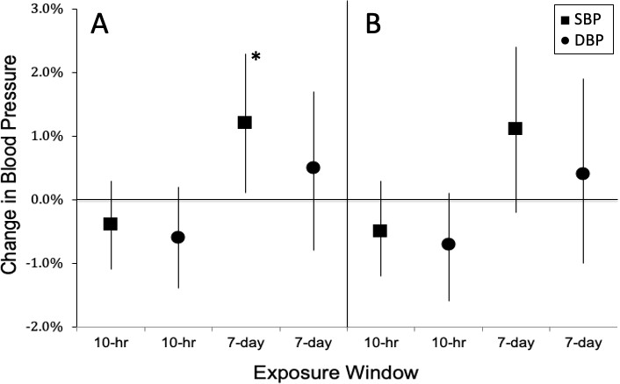

226

**FIGURE 1.** Adjusted effect estimates of percent change in systolic (SBP) and diastolic (DBP) blood pressure per inter- 227 quartile range (IQR) change in cumulative exposure to black carbon during the 10 hours and 7 days before SBP and 228 DBP measurements: pollutant model with random intercept using quadratic constrained distributed lags (A) and cubic 229 constrained distributed lags (B). All models were adjusted for age; sex; body mass index; fasting blood glucose level; 230 cholesterol level; hypertension status (yes, no); cigarette smoking status (never, ever); alcohol drinking status (never, 231 ever); traffic enforcer's duty post; work experience; graduate of a 4-year degree (yes, no); temperature; relative humidity; 232

and a natural spline for long–term time trend (date). Error bars indicate 95% CI. 233

234

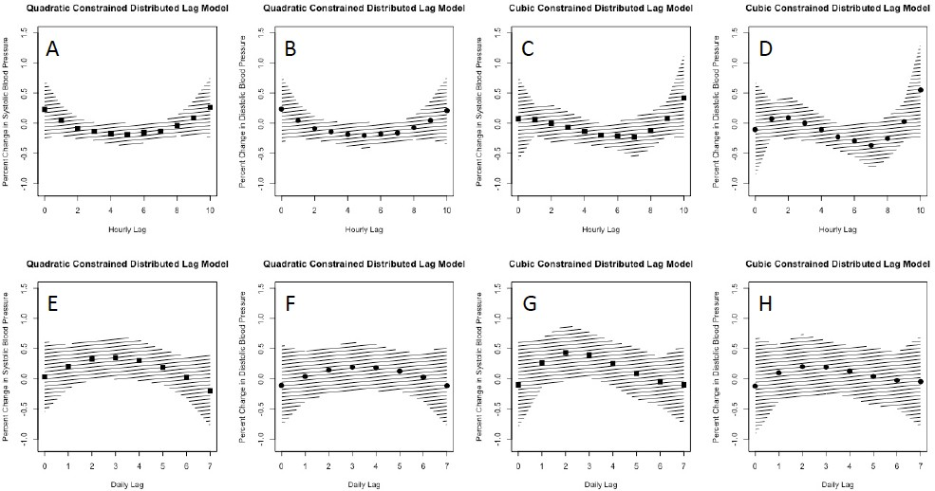

235

236

FIGURE 2. Adjusted effect estimates of percent change in systolic (SBP) and diastolic (DBP) blood pressure per 237

interquartile range (IQR) change of traffic-related black carbon. (A–D) Pollutant model of cumulative exposure for a 10- 238

hr time window with random intercept using quadratic constrained distributed lag (QCDL) with hourly lags [SBP (A), 239

and DBP (B)] and cubic constrained distributed lag (CCDL) with hourly lags [SBP (C), and DBP (D)]. (E–H) Pollutant 240

model of cumulative exposure for a 7-day time window with random intercept using QCDL with daily lags [SBP (E), 241

and DBP (F)] and CCDL with daily lags [SBP (G), and DBP (H)]. Hatch-marked regions indicate 95% CI. 242

# 3.3. Effect Modification by Participant Characteristics 243

We assessed whether being a drinker, obese, smoker, or male or female modified the 244

effect of BC on SBP and DBP. Fig. 3 shows the results of effect modification by participant 245

characteristics for the QCDL model for the cumulative BC exposure during the 10-hours 246

before BP measurement. BC was positively associated with SBP with a 4.0 % (95% CI: 2.1 247

to 5.9) change in mean SBP among female traffic enforcers but was negatively associated 248

(-0.8 % change; 95% CI: -1.5 to 0.0) for male traffic enforcers. In addition, the association 249

between BC and SBP was also stronger for obese (2.9 % change, 95% CI: 1.0 to 4.8) versus 250

non-obese (-0.8 % change, 95% CI: -1.5 to 0.0) traffic enforcers. No effect modification by 251

smoking and drinking was observed for the effect of BC on both SBP and DBP (see Table 252

S2 for more details). 253

Fig. 4 shows the results of effect modification by sex, obesity, drinking, and smoking 254

status for the cumulative BC exposure during the 7-days before BP measurement using 255

QCDL models. The association between the BC and SBP was more robust among females 256

(3.3% change, 95% CI: 0.4 to 6.3) than males (0.9% change, 95% CI: -0.2 to 2.1), and never 257

drinking (2.4% change, 95% 0.5 to 4.4) versus ever drinking (1.1% change, 95% CI: -0.1 to 258

2.4) traffic enforcers (Table S3 for more details). 259

1. **Discussion** 260

Our study provides a significant suggestion that acute cumulative exposure for 261

seven days to traffic-related BC is associated with increased SBP, a risk factor for stroke 262

and heart attack. In contrast, null associations were found between BC and both SBP and 263

DBP for a 10-hr cumulative exposure window. Moreover, results from our study also sug- 264

gest that females, obese, and hypertensive traffic enforcers remain predominantly at risk 265

from traffic-related BC exposure. 266

As a by-product of the incomplete combustion of fossil fuels, BC is among the prev- 267

alent ambient particles in the world. Exposure to traffic-related BC has a well-documented 268

association with numerous adverse health outcomes, and the association of BC with in- 269

creased systemic BP is among the most extensively studied [36-38]. Research reported that 270

the emission in Manila is dominated by ultrafine particles comprising about 90% of the 271

total ambient air pollution. In addition, BC emission shared up to 70% of the calculated 272

emission factors of particle number. This finding implies that the urban air in Manila com- 273

prises high concentrations of ultrafine particles and BC particles, which are highly toxic 274

[39]. EDSA is considered the busiest highway in Metro Manila. According to MMDA data 275

in 2013, 156,000 vehicles, including diesel buses, provincial and local, represent a large 276

part of EDSA traffic. This observation results in low profitability, excessive BC air pollu- 277

tion levels, and mediocre consideration for passengers [40]. Furthermore, our findings 278

suggest an acute 1-week cumulative effect of ambient BC exposure on SBP. The strong 279

association between traffic enforcers and ambient BC implies that ambient BC effects are 280

linked to background levels of traffic-related BC pollution in Metro Manila, particularly 281

to traffic enforcers' occupational health-related exposure**.** 282

**FIGURE 4.** Adjusted change in mean systolic blood pressure per IQR change of traffic–related black carbon: cumulative exposure during 7–days before blood pressure measurement, by participant characteristics [sex (male, female), obesity status (obese: body mass index ≥ 30, non-obese: body mass index < 30), smoking status (ever smoker, never smoker), and drinking status (ever drinker, never drinker)]. Error bars indicate 95% CI.

**5. Conclusions**

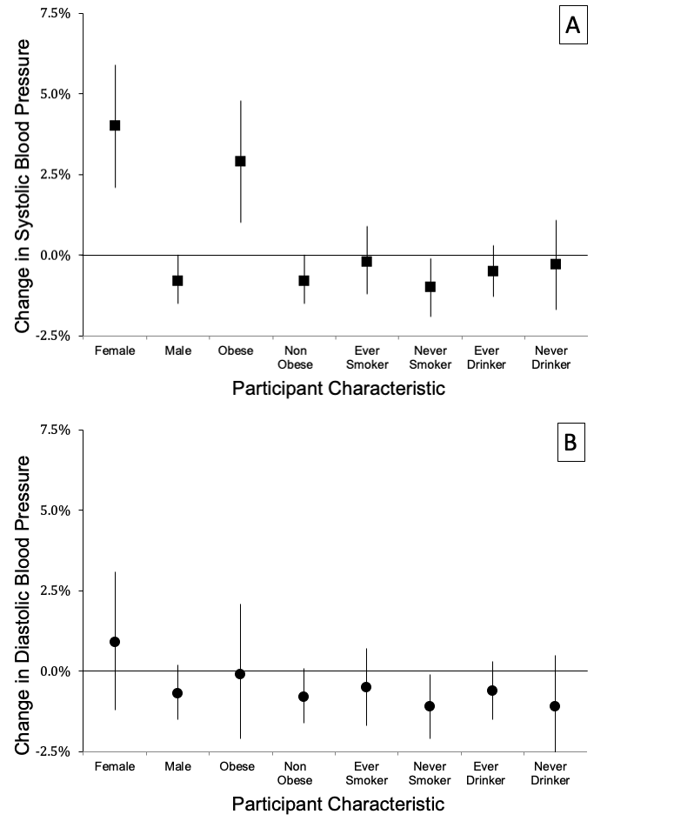

**FIGURE 3.** Adjusted change in mean systolic blood pressure per IQR change of traffic–related black carbon: cumulative exposure during 10–hours before blood pressure measurement, by participant characteristics [sex (male, female), obesity status (obese: body mass index ≥ 30, non-obese: body mass index < 30), smoking status (ever smoker, never smoker), and drinking status (ever drinker, never drinker)]. Error bars indicate 95% CI.

Our findings were consistently in agreement with previous studies that also exam- ined the acute exposure effect of BC on BP [23,27,35,41-47]. For example, the 7-day cumu- lative exposure to ambient BC and its positive effect on SBP and DBP findings from our study of traffic enforcers were supported by those from an aging cohort study of older men [23,35], a cohort of participants with metabolic syndrome [27], a panel study of sub- jects with Type 2 Diabetes Mellitus [43], and a study on hypertensive patients [47]. In ad- dition, our results of null associations between a 10-hour cumulative exposure window to ambient BC and both SBP and DBP were comparable to a cross-over study of women [42] and a cohort of community dwellers living near major highways [41]. These studies showed null effects in SBP and DBP for a 3-hr [42] and 24-hr [41] prior exposure windows. However, some studies did not concur with our findings, including a controlled cross- over study of healthy nonsmoking adults [44] and a non-smoking elderly cohort [46], which both studies reported positive associations on SBP and DBP.

Elevated BP has been considered worldwide as the most substantial modifiable risk factor for cardiovascular disease and related disability [48]. In 2016, air pollution was the fifth leading risk factor for the global burden of disease, with ambient BC pollution as the

283

284

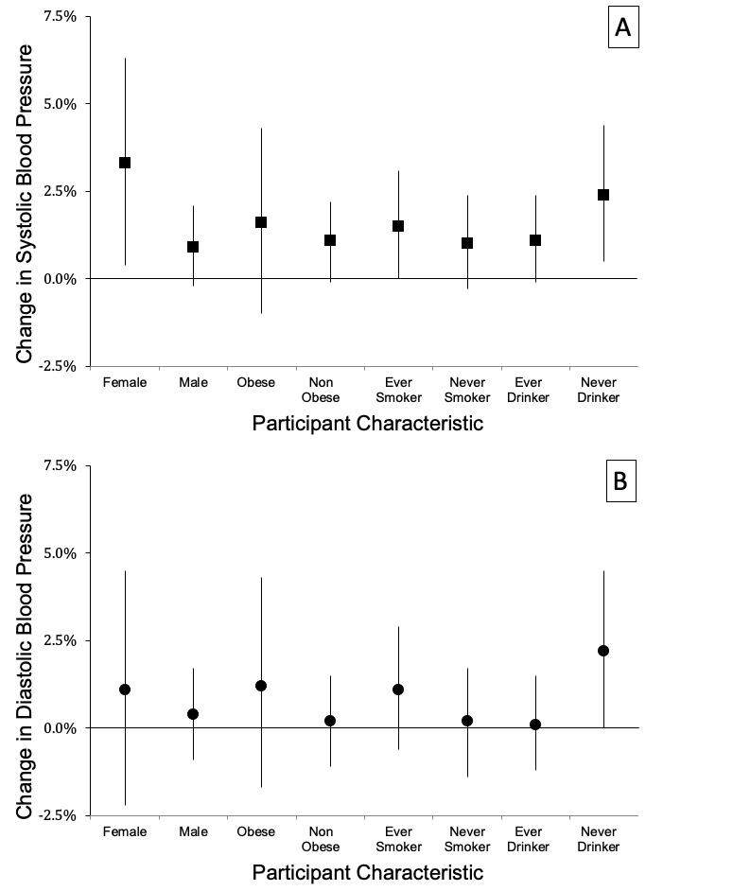

285

286

287

288

289

290

291

292

293

294

295

296

297

298

299

300

301

302

303

304

305

306

most important cause of illness among environmental risk factors. It led to 4.0 million 307 deaths and 105.7 million disability-adjusted life years [49]. Elevated BP levels or less vas- 308 odilatation were found in humans experimentally exposed to concentrated ambient air 309 pollution. [50]. Components of particles, especially ultrafine particles, induce oxidative 310 stress responses [51], an important mechanism underlying hypertension [52]. 311

Analysis of the effect modification by sex in our study indicated that the associations 312

between the cumulative ambient BC exposure windows of 10-hrs and 7-days and elevated 313

SBP were more robust for female than male traffic enforcers. Our findings did not agree 314

with a cross-sectional study of police officers that reported men to have a significantly 315

higher SBP than women in pre- and post-shift. The SBP of women was considerably 316

higher post-shift than pre-shift [53]. Furthermore, males predominately have higher SBP 317

than females in developing populations [54]. However, women may be more susceptible 318

than men to the particulate matter-induced health effects; robust risk estimates have been 319

reported for studies that found an increase in fatal coronary heart disease and cardiovas- 320

cular events [55-57]. Our observed effect modification by sex needs to be verified in future 321

studies. 322

Evidence of effect modification by obesity was observed on the association between 323

10 hours before BP measurement cumulative BC exposure and elevated SBP. In one study, 324

obesity and blood pressure are associated; an increase in BMI is related to an increase in 325

systolic blood pressure [58]. This study may support our finding of a stronger association 326

between ambient BC and SBP among obese compared with non-obese traffic enforcers. 327

Nonetheless, our results suggest that traffic enforcers who are female or obese may be 328

more responsive to traffic-related ambient BC compared with traffic enforcers who are 329

male or not obese. 330

Several studies have delved into exposure assessment and characterization of partic- 331 ulate matter, including black carbon in Metro Manila; however, the health effects of am- 332 bient black carbon exposure on susceptible populations in Metro Manila were never ex- 333 amined [39,59,60]. Similar to our health effects study of airborne heavy metals on BP [61], 334

this study is the first study that looked at the association between acute ambient BC expo- 335

sure and BP in the Philippines. Using a linear mixed model with random subject-specific 336

intercept means that contrasts were both within and between subjects; therefore, bias due 337

to confounding factors should be less than that observed in cross-sectional study design. 338 However, bias as a result of unmeasured or residual confounding can never be disre- 339 garded. 340

Another limitation of our study is the BC exposure monitoring. We used a single site 341

as a surrogate for acute ambient black carbon exposure that will not pick up the spatial 342

variation in BC concentrations. With the traffic enforcers stationed ~5 km on a median 343

straight-line distance from our ambient monitoring site, adequate spatial variation in BC 344

concentrations may be observed. Consequently, this spatial variation may lead to expo- 345

sure misclassification that would likely be nondifferential and could bias our estimates 346

toward the null [62]. Furthermore, our study utilized Filipino traffic enforcers as the study 347

population who were young and predominantly healthy. Thus, the results of this study 348

may not be generalizable to older people, children, or other ethnic and racial groups. Fu- 349 ture studies on the health effect of ambient BC on BP on these at-risk populations should 350 be considered. 351

352

1. **Conclusion** 353

Our study supports the health effects of elevated short-term cumulative exposure to 354

ambient BC on increased SBP, a cardiovascular risk marker among urban traffic enforcers 355

in Metro Manila, Philippines. In addition, male traffic enforcers appear to be better pro- 356 tected from SBP elevation with ambient BC exposure than female traffic enforcers. More- 357 over, when cumulatively exposed to ambient BC, even in shorter exposure windows, non- 358 obese traffic enforcers tend to be protected against increased SBP compared with obese 359

traffic enforcers. The findings of our study further suggest that short-term cumulative ex- 360 posure to ambient BC could bring about cardiovascular diseases through mechanisms in- 361 volving increased BP. 362

363

**Supplementary Materials:** The following are available online at [www.mdpi.com/xxx/s1,](http://www.mdpi.com/xxx/s1) **Table S1:** 364

Adjusted effect estimates of percent change in systolic (SBP) and diastolic (DBP) blood pressure per 365

interquartile range (IQR) change in cumulative exposure to black carbon during the 10 hours and 7 366

days before SBP and DBP measurements: pollutant model with random intercept using QCDL or 367

CCDL. All models were adjusted for age; sex; BMI; cholesterol; hypertensive (yes, no); cigarette 368

smoker (never, ever); alcohol drinker (yes, no); fasting blood glucose (FBG) level; years of service; 369

graduate of a 4-year degree (yes, no); traffic enforcer's duty post; temperature; relative humidity; 370

and a natural spline for long–term time trend (date, degrees of freedom = 4), **Table S2:** Adjusted 371

effect estimates of percent change in systolic (SBP) and diastolic (DBP) blood pressure per interquar- 372

tile range (IQR) change in cumulative exposure to black carbon during the 10 hours before SBP and 373

DBP measurements, by participant characteristics [sex (male, female), smoking (ever, never), obesity 374

(obese (+): body mass index ≥ 30, obese (-): body mass index < 30), smoking status (ever smoker, 375

never smoker), drinking status (drinker (+): yes, drinker (-): no), and hypertension status (hyper (+): 376

yes, hyper (-): no)], and **Table S3**: Adjusted effect estimates of percent change in systolic (SBP) and 377

diastolic (DBP) blood pressure per interquartile range (IQR) change in cumulative exposure to black 378

carbon during the 7 days before SBP and DBP measurements, by participant characteristics [sex 379

(male, female), smoking (ever, never), obesity (obese (+): body mass index ≥ 30, obese (-): body mass 380

index < 30), smoking status (ever smoker, never smoker), drinking status (drinker (+): yes, drinker 381

(-): no), and hypertension status (hyper (+): yes, hyper (-): no)]. 382

**Funding:** The authors received a research grant (Grant # FP-140002) from the Philippine Council 383

for Health Research and Development (PCHRD) of the Department of Science and Technology 384

(DOST), Philippines. 385

**Institutional Review Board Statement:** All procedures performed in studies involving human 386

participants were in accordance with the ethical standards of the institutional research committee 387

(Asian Eye Institute – Ethics Review Committee: ERC# 2014-004) and with the 1964 Helsinki 388

declaration and its later amendments or comparable ethical standards. 389

**Informed Consent Statement:** All participants provided their informed consent to participate in 390

this study. 391

**Data Availability Statement:** The data are not publicly available due to privacy or ethical 392

restrictions. 393

**Acknowledgement:** The authors would like to thank the Philippine Council for Health Research 394

and Development (PCHRD) of the Department of Science and Technology (DOST) for the funding 395

the study, Former Chairman and now Senator Francis N. Tolentino, the Metropolitan Manila 396

Development Authority management, Director Josie Faulan, Dr. Annabelle R. Ombina, and clinic 397

staff for permitting and supporting the research team to conduct the study among their traffic 398

enforcers, our research assistants, Don Paulo Guevarra, Billy Gorospe, Abby Quiroz, Dr. Abigail 399

Santos, Dr. Ruby So-Hao, and Nover Edward P. Duarte for making it easy for the study to collect 400

the specimens and measurements needed by the study, and the volunteer traffic enforcers who 401

participated in the study. 402

**Conflicts of Interest:** The authors declare no conflict of interest. The funders had no role in the 403

design of the study; in the collection, analyses, or interpretation of data; in the writing of the 404

manuscript, or in the decision to publish the results. 405

**References** 406

1. Stanaway, J.D.; Afshin, A.; Gakidou, E.; Lim, S.S.; Abate, D.; Abate, K.H.; Abbafati, C.; Abbasi, N.; Abbastabar, H.; Abd- 407

Allah, F. Global, regional, and national comparative risk assessment of 84 behavioural, environmental and occupational, 408

and metabolic risks or clusters of risks for 195 countries and territories, 1990–2017: a systematic analysis for the Global 409

Burden of Disease Study 2017. *The Lancet* **2018**, *392*, 1923-1994. 410

1. Organization, W.H. *Air quality guidelines: global update 2005: particulate matter, ozone, nitrogen dioxide, and sulfur dioxide*; World 411

Health Organization: 2006. 412

1. Forouzanfar, M.H.; Afshin, A.; Alexander, L.T.; Anderson, H.R.; Bhutta, Z.A.; Biryukov, S.; Brauer, M.; Burnett, R.; Cercy, 413

K.; Charlson, F.J. Global, regional, and national comparative risk assessment of 79 behavioural, environmental and 414

occupational, and metabolic risks or clusters of risks, 1990–2015: a systematic analysis for the Global Burden of Disease 415

Study 2015. *The lancet* **2016**, *388*, 1659-1724. 416

1. World Health, O. *WHO global air quality guidelines: particulate matter (PM2.5 and PM10), ozone, nitrogen dioxide, sulfur dioxide* 417

*and carbon monoxide*; World Health Organization: Geneva, 2021. 418

1. EPA, U. Integrated science assessment for particulate matter. **2009**. 419
2. Luben, T.J.; Nichols, J.L.; Dutton, S.J.; Kirrane, E.; Owens, E.O.; Datko-Williams, L.; Madden, M.; Sacks, J.D. A systematic 420

review of cardiovascular emergency department visits, hospital admissions and mortality associated with ambient black 421

carbon. *Environment international* **2017**, *107*, 154-162. 422

1. Rabito, F.A.; Yang, Q.; Zhang, H.; Werthmann, D.; Shankar, A.; Chillrud, S. The association between short‐term residential 423

black carbon concentration on blood pressure in a general population sample. *Indoor air* **2020**, *30*, 767-775. 424

1. Magalhaes, S.; Baumgartner, J.; Weichenthal, S. Impacts of exposure to black carbon, elemental carbon, and ultrafine 425

particles from indoor and outdoor sources on blood pressure in adults: a review of epidemiological evidence. *Environmental* 426

*research* **2018**, *161*, 345-353. 427

1. Segersson, D.; Eneroth, K.; Gidhagen, L.; Johansson, C.; Omstedt, G.; Nylén, A.E.; Forsberg, B. Health impact of PM10, PM2. 428

5 and black carbon exposure due to different source sectors in Stockholm, Gothenburg and Umea, Sweden. *International* 429

*journal of environmental research and public health* **2017**, *14*, 742. 430

1. Bell, M.L.; Dominici, F.; Ebisu, K.; Zeger, S.L.; Samet, J.M. Spatial and temporal variation in PM2. 5 chemical composition in 431

the United States for health effects studies. *Environmental health perspectives* **2007**, *115*, 989-995. 432

1. Janssen, N.A.; Hoek, G.; Simic-Lawson, M.; Fischer, P.; Van Bree, L.; Ten Brink, H.; Keuken, M.; Atkinson, R.W.; Anderson, 433

H.R.; Brunekreef, B. Black carbon as an additional indicator of the adverse health effects of airborne particles compared with 434

PM10 and PM2. 5. *Environmental health perspectives* **2011**, *119*, 1691-1699. 435

1. Louwies, T.; Nawrot, T.; Cox, B.; Dons, E.; Penders, J.; Provost, E.; Panis, L.I.; De Boever, P. Blood pressure changes in 436

association with black carbon exposure in a panel of healthy adults are independent of retinal microcirculation. *Environment* 437

*international* **2015**, *75*, 81-86. 438

1. Alas, H.D.; Müller, T.; Birmili, W.; Kecorius, S.; Cambaliza, M.O.; Simpas, J.B.B.; Cayetano, M.; Weinhold, K.; Vallar, E.; 439

Galvez, M.C. Spatial characterization of black carbon mass concentration in the atmosphere of a Southeast Asian megacity: 440

An air quality case study for Metro Manila, Philippines. *Aerosol and Air Quality Research* **2018**, *18*, 2301-2317+ ap2301. 441

1. Kecorius, S.; Madueño, L.; Vallar, E.; Alas, H.; Betito, G.; Birmili, W.; Cambaliza, M.O.; Catipay, G.; Gonzaga-Cayetano, M.; 442

Galvez, M.C.; et al. Aerosol particle mixing state, refractory particle number size distributions and emission factors in a 443

polluted urban environment: Case study of Metro Manila, Philippines. *Atmospheric Environment* **2017**, *170*, 169-183, 444

doi:https://doi.org/10.1016/j.atmosenv.2017.09.037. 445

1. Kirrane, E.F.; Luben, T.; Benson, A.; Owens, E.; Sacks, J.; Dutton, S.; Madden, M.; Nichols, J. A systematic review of 446

cardiovascular responses associated with ambient black carbon and fine particulate matter. *Environment international* **2019**, 447

*127*, 305-316. 448

1. Biel, R.; Danieli, C.; Shekarrizfard, M.; Minet, L.; Abrahamowicz, M.; Baumgartner, J.; Liu, R.; Hatzopoulou, M.; Weichenthal, 449

S. Acute cardiovascular health effects in a panel study of personal exposure to traffic-related air pollutants and noise in 450

Toronto, Canada. *Scientific reports* **2020**, *10*, 1-12. 451

1. Kirrane, E.; Luben, T.; Benson, A.; Owens, E.; Sacks, J.; Dutton, S.; Madden, M.; Nichols, J. A systematic review of 452

cardiovascular responses associated with ambient black carbon and fine particulate matter. *Environment international* **2019**, 453

*127*, 305-316. 454

1. Baumgartner, J.; Zhang, Y.; Schauer, J.J.; Huang, W.; Wang, Y.; Ezzati, M. Highway proximity and black carbon from 455

cookstoves as a risk factor for higher blood pressure in rural China. *Proceedings of the National academy of sciences* **2014**, *111*, 456

13229-13234. 457

1. Witters, K.; Dockx, Y.; Op't Roodt, J.; Lefebvre, W.; Vanpoucke, C.; Plusquin, M.; Vangronsveld, J.; Janssen, B.G.; Nawrot, 458

T.S. Dynamics of skin microvascular blood flow in 4–6-year-old children in association with pre-and postnatal black carbon 459

and particulate air pollution exposure. *Environment International* **2021**, *157*, 106799. 460

1. Lin, C.; Hu, D.; Jia, X.; Chen, J.; Deng, F.; Guo, X.; Heal, M.R.; Cowie, H.; Wilkinson, P.; Miller, M.R. The relationship between 461

personal exposure and ambient PM2. 5 and black carbon in Beijing. *Science of The Total Environment* **2020**, *737*, 139801. 462

1. Yang, J.; Sakhvidi, M.J.Z.; de Hoogh, K.; Vienneau, D.; Siemiatyck, J.; Zins, M.; Goldberg, M.; Chen, J.; Lequy, E.; Jacquemin, 463

B. Long-term exposure to black carbon and mortality: A 28-year follow-up of the GAZEL cohort. *Environment International* 464

**2021**, *157*, 106805. 465

1. Tao, S.; Xu, Y.; Chen, M.; Zhang, H.; Huang, X.; Li, Z.; Pan, B.; Peng, R.; Zhu, Y.; Kan, H. Exposure to different fractions of 466

diesel exhaust PM2. 5 induces different levels of pulmonary inflammation and acute phase response. *Ecotoxicology and* 467

*environmental safety* **2021**, *210*, 111871. 468

1. Mordukhovich, I.; Wilker, E.; Suh, H.; Wright, R.; Sparrow, D.; Vokonas, P.S.; Schwartz, J. Black carbon exposure, oxidative 469

stress genes, and blood pressure in a repeated-measures study. *Environmental health perspectives* **2009**, *117*, 1767-1772. 470

1. Dubowsky, S.D.; Suh, H.; Schwartz, J.; Coull, B.A.; Gold, D.R. Diabetes, obesity, and hypertension may enhance associations 471

between air pollution and markers of systemic inflammation. *Environmental health perspectives* **2006**, *114*, 992-998. 472

|  |  |  |
| --- | --- | --- |
| 25. | Rückerl, R.; Ibald-Mulli, A.; Koenig, W.; Schneider, A. Air pollution and markers of inflammation and coagulation in | 473 |
|  | patients with coronary heart disease. *American journal of respiratory and critical care medicine* **2006**, *173*, 432. | 474 |
| 26. | Park, S.K.; O’Neill, M.S.; Vokonas, P.S.; Sparrow, D.; Schwartz, J. Effects of air pollution on heart rate variability: the VA | 475 |
|  | normative aging study. *Environmental health perspectives* **2005**, *113*, 304-309. | 476 |
| 27. | Brook, R.D.; Sun, Z.; Brook, J.R.; Zhao, X.; Ruan, Y.; Yan, J.; Mukherjee, B.; Rao, X.; Duan, F.; Sun, L. Extreme air pollution | 477 |
|  | conditions adversely affect blood pressure and insulin resistance: the air pollution and cardiometabolic disease study. | 478 |
|  | *Hypertension* **2016**, *67*, 77-85. | 479 |
| 28. | Environmental Management Bureau, E. *Air Quality*; Department of Environment and Natural Resources: Manila, | 480 |
|  | Philippines, 2015. | 481 |
| 29. | Pearl, J. Causal diagrams for empirical research. *Biometrika* **1995**, *82*, 669-688. | 482 |
| 30. | Fitzmaurice, G.M.; Laird, N.M.; Ware, J.H. *Applied longitudinal analysis*; John Wiley & Sons: 2012; Volume 998. | 483 |
| 31. | Baja, E.S.; Schwartz, J.D.; Wellenius, G.A.; Coull, B.A.; Zanobetti, A.; Vokonas, P.S.; Suh, H.H. Traffic-related air pollution | 484 |
|  | and QT interval: modification by diabetes, obesity, and oxidative stress gene polymorphisms in the normative aging study. | 485 |
|  | *Environmental health perspectives* **2010**, *118*, 840-846. | 486 |
| 32. | Brook, R.D.; Rajagopalan, S. Particulate matter, air pollution, and blood pressure. *Journal of the American Society of* | 487 |
|  | *Hypertension* **2009**, *3*, 332-350. | 488 |
| 33. | Ding, N.; Wang, X.; Weisskopf, M.G.; Sparrow, D.; Schwartz, J.; Hu, H.; Park, S.K. Lead-related genetic loci, cumulative lead | 489 |
|  | exposure and incident coronary heart disease: The normative aging study. *PloS one* **2016**, *11*. | 490 |
| 34. | Rapisarda, V.; Ledda, C.; Ferrante, M.; Fiore, M.; Cocuzza, S.; Bracci, M.; Fenga, C. Blood pressure and occupational exposure | 491 |
|  | to noise and lead (Pb) A cross-sectional study. *Toxicology and industrial health* **2016**, *32*, 1729-1736. | 492 |
| 35. | Wilker, E.H.; Baccarelli, A.; Suh, H.; Vokonas, P.; Wright, R.O.; Schwartz, J. Black carbon exposures, blood pressure, and | 493 |
|  | interactions with single nucleotide polymorphisms in MicroRNA processing genes. *Environmental health perspectives* **2010**, | 494 |
|  | *118*, 943-948. | 495 |
| 36. | Nwanaji-Enwerem, J.C.; Wang, W.; Nwanaji-Enwerem, O.; Vokonas, P.; Baccarelli, A.; Weisskopf, M.; Herndon, L.W.; | 496 |
|  | Wiggs, J.L.; Park, S.K.; Schwartz, J. Association of Long-term Ambient Black Carbon Exposure and Oxidative Stress Allelic | 497 |
|  | Variants With Intraocular Pressure in Older Men. *JAMA Ophthalmol* **2019**, *137*, 129-137, | 498 |
|  | doi:10.1001/jamaophthalmol.2018.5313. | 499 |
| 37. | Hudda, N.; Eliasziw, M.; Hersey, S.O.; Reisner, E.; Brook, R.D.; Zamore, W.; Durant, J.L.; Brugge, D. Effect of Reducing | 500 |
|  | Ambient Traffic-Related Air Pollution on Blood Pressure: A Randomized Crossover Trial. *Hypertension* **2021**, *77*, 823-832. | 501 |
| 38. | Mann, J.K.; Lutzker, L.; Holm, S.M.; Margolis, H.G.; Neophytou, A.M.; Eisen, E.A.; Costello, S.; Tyner, T.; Holland, N.; | 502 |
|  | Tindula, G. Traffic-related air pollution is associated with glucose dysregulation, blood pressure, and oxidative stress in | 503 |
|  | children. *Environmental Research* **2021**, *195*, 110870. | 504 |
| 39. | Madueño, L.; Kecorius, S.; Birmili, W.; Müller, T.; Simpas, J.; Vallar, E.; Galvez, M.C.; Cayetano, M.; Wiedensohler, A. | 505 |
|  | Aerosol Particle and Black Carbon Emission Factors of Vehicular Fleet in Manila, Philippines. *Atmosphere* **2019**, *10*, 603. | 506 |
| 40. | Boquet, Y. Battling congestion in Manila: the EDSA problem. *Transport and Communications Bulletin for Asia and the Pacific* | 507 |
|  | **2013**, *82*, 45-69. | 508 |
| 41. | Chung, M.; Wang, D.D.; Rizzo, A.M.; Gachette, D.; Delnord, M.; Parambi, R.; Kang, C.-M.; Brugge, D. Association of PNC, | 509 |
|  | BC, and PM2. 5 measured at a central monitoring site with blood pressure in a predominantly near highway population. | 510 |
|  | *International journal of environmental research and public health* **2015**, *12*, 2765-2780. | 511 |
| 42. | Weichenthal, S.; Hatzopoulou, M.; Goldberg, M.S. Exposure to traffic-related air pollution during physical activity and acute | 512 |
|  | changes in blood pressure, autonomic and micro-vascular function in women: a cross-over study. *Particle and fibre toxicology* | 513 |
|  | **2014**, *11*, 70. | 514 |

1. Hoffmann, B.; Luttmann-Gibson, H.; Cohen, A.; Zanobetti, A.; de Souza, C.; Foley, C.; Suh, H.H.; Coull, B.A.; Schwartz, J.; 515 Mittleman, M. Opposing effects of particle pollution, ozone, and ambient temperature on arterial blood pressure. 516 *Environmental health perspectives* **2012**, *120*, 241-246. 517
2. Kubesch, N.; De Nazelle, A.; Guerra, S.; Westerdahl, D.; Martínez, D.; Bouso, L.; Carrasco-Turigas, G.; Hoffmann, B.; 518

Nieuwenhuijsen, M. Arterial blood pressure responses to short-term exposure to low and high traffic-related air pollution 519

with and without moderate physical activity. *European Journal of Preventive Cardiology* **2015**, *22*, 548-557. 520

1. Zhao, X.; Sun, Z.; Ruan, Y.; Yan, J.; Mukherjee, B.; Yang, F.; Duan, F.; Sun, L.; Liang, R.; Lian, H. Personal black carbon 521

exposure influences ambulatory blood pressure: air pollution and cardiometabolic disease (AIRCMD-China) study. 522

*Hypertension* **2014**, *63*, 871-877. 523

1. Liu, L.; Ruddy, T.; Dalipaj, M.; Poon, R.; Szyszkowicz, M.; You, H.; Dales, R.E.; Wheeler, A.J. Effects of indoor, outdoor, and 524

personal exposure to particulate air pollution on cardiovascular physiology and systemic mediators in seniors. *Journal of* 525

*Occupational and Environmental Medicine* **2009**, *51*, 1088-1098. 526

1. Lin, Z.; Wang, X.; Liu, F.; Yang, X.; Liu, Q.; Xing, X.; Cao, J.; Li, J.; Huang, K.; Yan, W. Impacts of Short-Term Fine Particulate 527

Matter Exposure on Blood Pressure Were Modified by Control Status and Treatment in Hypertensive Patients. *Hypertension* 528

**2021**, HYPERTENSIONAHA. 120.16611. 529

1. Olsen, M.H.; Angell, S.Y.; Asma, S.; Boutouyrie, P.; Burger, D.; Chirinos, J.A.; Damasceno, A.; Delles, C.; Gimenez-Roqueplo, 530

A.-P.; Hering, D. A call to action and a lifecourse strategy to address the global burden of raised blood pressure on current 531

and future generations: the Lancet Commission on hypertension. *The Lancet* **2016**, *388*, 2665-2712. 532

1. Collaborators, G.R.F. Global, regional, and national comparative risk assessment of 79 behavioural, environmental and 533

occupational, and metabolic risks or clusters of risks, 1990–2015: a systematic analysis for the Global Burden of Disease 534

Study 2015. *Lancet (London, England)* **2016**, *388*, 1659. 535

1. Brook, R.D.; Urch, B.; Dvonch, J.T.; Bard, R.L.; Speck, M.; Keeler, G.; Morishita, M.; Marsik, F.J.; Kamal, A.S.; Kaciroti, N. 536

Insights into the mechanisms and mediators of the effects of air pollution exposure on blood pressure and vascular function 537

in healthy humans. *Hypertension* **2009**, *54*, 659-667. 538

1. Li, N.; Sioutas, C.; Cho, A.; Schmitz, D.; Misra, C.; Sempf, J.; Wang, M.; Oberley, T.; Froines, J.; Nel, A. Ultrafine particulate 539

pollutants induce oxidative stress and mitochondrial damage. *Environmental health perspectives* **2003**, *111*, 455-460. 540

1. Rafee, L.; Abedini, M.; Javanmard, S.H.; Sarrafzadegan, N.; Mansourian, M. Association of GSTT1 and GSTM1 541

polymorphisms with blood pressure: A Bayesian modeling of continuous data. *Journal of Research in Medical Sciences: The* 542

*Official Journal of Isfahan University of Medical Sciences* **2014**, *19*, 200. 543

1. Elliott, J.L.; Lal, S. Blood pressure, sleep quality and fatigue in shift working police officers: effects of a twelve hour roster 544

system on cardiovascular and sleep health. *International journal of environmental research and public health* **2016**, *13*, 172. 545

1. Tesfaye, F.; Nawi, N.; Van Minh, H.; Byass, P.; Berhane, Y.; Bonita, R.; Wall, S. Association between body mass index and 546

blood pressure across three populations in Africa and Asia. *Journal of human hypertension* **2007**, *21*, 28-37. 547

1. Hamanaka, R.B.; Mutlu, G.M. Particulate Matter Air Pollution: Effects on the Cardiovascular System. *Front Endocrinol* 548

*(Lausanne)* **2018**, *9*, 680-680, doi:10.3389/fendo.2018.00680. 549

1. Miller, K.A.; Siscovick, D.S.; Sheppard, L.; Shepherd, K.; Sullivan, J.H.; Anderson, G.L.; Kaufman, J.D. Long-term exposure 550

to air pollution and incidence of cardiovascular events in women. *New England Journal of Medicine* **2007**, *356*, 447-458. 551

1. Puett, R.C.; Hart, J.E.; Yanosky, J.D.; Paciorek, C.; Schwartz, J.; Suh, H.; Speizer, F.E.; Laden, F. Chronic fine and coarse 552

particulate exposure, mortality, and coronary heart disease in the Nurses’ Health Study. *Environmental health perspectives* 553

**2009**, *117*, 1697-1701. 554

1. Linderman, G.C.; Lu, J.; Lu, Y.; Sun, X.; Xu, W.; Nasir, K.; Schulz, W.; Jiang, L.; Krumholz, H.M. Association of body mass 555

index with blood pressure among 1.7 million Chinese adults. *JAMA network open* **2018**, *1*, e181271-e181271. 556

1. Kecorius, S.; Madueño, L.; Vxallar, E.; Alas, H.; Betito, G.; Birmili, W.; Cambaliza, M.O.; Catipay, G.; Gonzaga-Cayetano, M.; 557 Galvez, M.C. Aerosol particle mixing state, refractory particle number size distributions and emission factors in a polluted 558 urban environment: Case study of Metro Manila, Philippines. *Atmospheric environment* **2017**, *170*, 169-183. 559
2. Bagtasa, G.; Chung-Shin, Y. Influence of local meteorology on the chemical characteristics of fine particulates in 560

Metropolitan Manila in the Philippines. *Atmospheric Pollution Research* **2020**. 561

1. Regencia, Z.J.G.; Dalmacion, G.V.; Quizon, D.B.; Quizon, K.B.; Duarte, N.E.P.; Baja, E.S. Airborne heavy metals and blood 562

pressure: Modification by sex and obesity in the MMDA traffic enforcers’ health study. *Atmospheric Pollution Research* **2020**. 563

1. Sarnat, J.A.; Brown, K.W.; Schwartz, J.; Coull, B.A.; Koutrakis, P. Ambient gas concentrations and personal particulate matter 564

exposures: implications for studying the health effects of particles. *Epidemiology* **2005**, 385-395. 565

566