Knowledge, Attitudes, Risk Perceptions, and Intention towards COVID-19 and COVID-19 Vaccination Among Adults in the City of Manila, Philippines

# Ernesto R. Gregorio, Jr.*

Department of Health Promotion and Education, College of Public Health, University of the Philippines Manila. 625 Pedro Gil St. Ermita 1000 Manila, Philippines

Email: [ergregorio@up.edu.ph](mailto:ergregorio@up.edu.ph)

*corresponding author

# Crystal Amiel M. Estrada

Department of Environmental and Occupational Health, College of Public Health, University of the Philippines Manila

Email: [cmestrada@up.edu.ph](mailto:cmestrada@up.edu.ph)

# Marian Fe Theresa C. Lomboy

Department of Environmental and Occupational Health, College of Public Health, University of the Philippines Manila

Email: [mclomboy@up.edu.ph](mailto:mclomboy@up.edu.ph)

# Evalyn A. Roxas

Department of Medical Microbiology, College of Public Health, University of the Philippines Manila

Email: [earoxas1@up.edu.ph](mailto:earoxas1@up.edu.ph)

# Buenalyn Teresita M. Ramos-Mortel

Department of Health Promotion and Education, College of Public Health, University of the Philippines Manila

Email: [bmramosmortel@up.edu.ph](mailto:bmramosmortel@up.edu.ph)

# Maylin C. Palatino

Department of Epidemiology and Biostatistics, College of Public Health, University of the Philippines Manila

Email: [maylin_palatino@alumni.brown.edu](mailto:maylin_palatino@alumni.brown.edu)

Abstract: Vaccination is a crucial strategy to prevent new COVID-19 infections; however, it will only be optimally effective if people, especially those who are at a higher risk of COVID-19 infection, will not hesitate to receive the vaccines once they become available. The current study utilized a sequential mixed methods study design to measure the knowledge, attitudes, risk perceptions, and intention towards COVID-19 and vaccination among adult residents of the city of Manila, Philippines. A self-administered questionnaire was used to measure the study variables of interest. Frequencies and proportions were calculated to describe the level of COVID-related knowledge, attitude, risk perception and intention to receive the COVID-19 vaccination. Logistic regression analyses were done to determine the factors associated with outcome variables. Majority of the respondents had good knowledge about COVID-19, with news media as the main source of COVID- related information. Around 40% expressed hesitancy and concerns over the safety of the vaccines. Catholics, those with at least a monthly income of 5,000 pesos, had good knowledge of prevention, positive behavioral intention, and positive perceived benefits of COVID-19 vaccination were more likely to have the intention to get vaccinated. The study highlights the importance of correct information that is easy to understand and access so that individuals can make informed choices about their health, especially during the COVID-19 pandemic. Stakeholders must collaborate in developing effective strategies focused on addressing the public’s hesitancy and building trust towards COVID-19 vaccines and the government’s vaccination program.

*Keywords: COVID-19, vaccine, risk perception, knowledge, attitudes, Philippines*

# Introduction

The world has experienced a number of pandemics in the past but none can parallel the speed of spread as well as the health, social, economic, and development impact brought about by the novel Coronavirus disease 2019 (COVID-19). As of May 2021, the World Health Organization (WHO) has reported a total of 167,492,769 confirmed cases of COVID- 19 with 3,482,907 deaths globally. The United States of America, India, and Brazil top the list of countries with the highest number of cases [1]. Meanwhile, the Philippines has logged a cumulative total of 1,193,976 cases and 20,169 deaths [2].

Vaccination is a crucial strategy to prevent new COVID-19 infections, hence, countries around the world are racing to vaccinate as many people as possible. However, vaccines will only be optimally effective if people, especially those who are at a higher risk to COVID- 19 infection, will not hesitate to receive the vaccines once they become available and the target herd immunity is attained. Unfortunately, with the proliferation of fake news about the questionable efficacy and safety of possible COVID-19 vaccines, full compliance to vaccination will remain a challenge and an elusive goal. There is a rich body of evidence that describes the knowledge, attitudes, perceptions, and practices of certain groups of people related to COVID-19 transmission and prevention [3,4]. However, there is dearth of information about the factors that influence compliance to COVID-19 vaccines once they become available, including studies on intention to comply to COVID-19 vaccination.

Therefore, there is a need to determine the knowledge, attitudes, risk perceptions, and intention towards COVID-19 vaccination. This study aims to generate knowledge, attitudes, risk perceptions and intention of the people towards COVID-19 and vaccination. The results of the study will be used to design a risk communication intervention that will improve the perceptions and behavioral intention of the target beneficiaries towards the COVID-19 vaccine.

# Methodology

*Study design*

Analytical cross-sectional study design was used to determine knowledge, attitudes, risk perceptions, and intention of the general population towards COVID-19 and vaccination.

*Study setting and participants*

The study was conducted in the city of Manila due to its high COVID-19 transmission rates and the strong political will and resources of its local government to procure COVID-19 vaccines. Residents of the city of Manila, Philippines who were at least 18 years of age and who have been living in the city for the past 12 months were selected. Adults who did not consent to participate, unable to read and write, displayed symptoms of COVID-19 and who were reported to be in immunocompromised conditions (e.g. on asthma medication) were excluded from the study. Permission to conduct the study was granted by the local government. The study was reviewed and approved by the University of the Philippines Manila Research Ethics Board (UPMREB-2021-016-01).

The sample size for the survey was computed assuming a proportion of adults with good knowledge, attitudes, risk perceptions, and intention towards COVID-19 vaccination of around 50%, a 95% confidence level and 5% margin of error. Based on these parameters, at least 385 participants were needed. Adjusting for a 20% non-response rate, a minimum sample size of 482 adults were invited to participate in the study. The study utilized a two- stage stratified sampling design to systematically select 49 households from each of the 10 randomly selected barangays. One adult selected using convenience sampling, that is, presently at home at the time of data collection who satisfies the inclusion-exclusion criteria was asked to participate. No replacement was done for households with adults who were present and eligible for the study but did not give consent.

*Data collection and analysis*

Data collection was done through a self-administered questionnaire aided by trained data enumerators. The survey tool was drafted based on the tools that have been used by similar

research from China [5], Malaysia [6], the Philippines [3,7], and the United States [8,9]. The questionnaire is composed of 56 questions divided into the following sections: 1) sociodemographic characteristics; 2) experience of COVID-19; 3) knowledge of COVID-19 and COVID-19 vaccine; 4) attitudes towards COVID-19 vaccine; and 5) perceptions and intentions towards COVID-19 vaccine and vaccination. The members of the study team who are experts on infectious diseases, health promotion and risk communication, biostatistics, and public health research reviewed the survey tool. The survey tool was translated to Tagalog and then back translated into English to further improve clarity and the study team deliberated on the accuracy of the translation and back translation. The draft survey tool was pretested with at least 10 adults that represented the general population. The pretesting focused on the duration of the interview, clarity, and cultural sensitivity of the instructions, questions, and the response options. The pretesting also gathered possible response options to open-ended questions. The survey tool was revised according to the findings of the pretest.

Frequencies and proportions were calculated to describe the level of COVID-related knowledge, attitude, risk perception and intention to receive the COVID-19 vaccination. Logistic regression analyses were done to determine the factors associated with outcome variables (risk perception and intention). The unadjusted and adjusted odds ratios and their corresponding 95% confidence interval were recorded. A 0.05 level of significance was used. The R software was utilized in the analyses of data.

# Results

*Characteristics of the participants*

While 383 residents agreed to participate in the study, seven decided not to respond to any questions, thus, the study only had 376 respondents. Their average age was 43.6 years old. Table 1 presents the demographic characteristics of the participants. The majority of the respondents were female (78.5%), married (53.5%), Roman Catholic (91.2%), and had reached high school level of education (63.0%). About 45% were either unemployed, students or retirees and about half reported a family income of less than 5,000 pesos.

Table 1: Characteristics of the participants, Manila, April 2021 (n = 376)

|  |  |  |
| --- | --- | --- |
| Characteristic | Frequency | Percent |
| **Sex**  Female | 295 | 78.5 |
| Male | 81 | 21.5 |
| **Marital status**  Living with a partner | 43 | 11.4 |
| Married | 201 | 53.5 |
| Separated/divorced | 14 | 3.7 |
| Single | 77 | 20.5 |
| Widowed | 38 | 10.1 |
| No data | 3 | 0.8 |
| **Religion**  Other | 33 | 8.8 |
| Roman Catholic | 343 | 91.2 |
| **Educational attainment**  Elementary level | 36 | 9.6 |
| High school level/Vocational | 237 | 63.0 |
| At least college level | 103 | 27.4 |
| Employment **status**  Employed | 67 | 17.8 |
| Self employed | 137 | 36.4 |
| Unemployed/student/retired | 172 | 45.7 |
| **Monthly family income**  <5,000 | 176 | 46.8 |
| 5,001 - 15,000 | 129 | 34.3 |
| >15,000 | 66 | 17.6 |
| missing | 5 | 1.3 |

*Experience of COVID-19 infection*

Two participants reported having been exposed to somebody with known COVID-19 infection in the past month prior to data collection while 98% reported no exposure (Table 2). Five (1.3%) were said to have experienced some symptoms in the past month; all of them have had cough, four had cold, while two experienced difficulty breathing, loss of taste, and loss of smell.

About one in four participants (26%) did not think that COVID-19 infection is severe at all while 16% thought the infection is a little serious. Only 12.5% said that the infection is very serious. As regards their susceptibility to the COVID-19 infection, 42.8% and 14.6% said

that there is no chance and low chance, respectively, that they would get the infection. About 3% said that they have a high chance of being infected with the COVID-19 virus (Table 2).

Table 2: Distribution of the participants according to experience of COVID-19 (n = 376)

|  |  |  |  |
| --- | --- | --- | --- |
| Characteristic | Frequency | | Percent |
| **Had been exposed to a person with infection** | | | |
| No | 369 | | 98.1 |
| Unsure | 5 | | 1.3 |
| Yes | 2 | | 0.5 |
| **Experienced signs and symptoms of COVID-19**  No | | 351 | 93.4 |
| Unsure | 20 | | 5.3 |
| Yes | 5 | | 1.3 |
| **Experienced COVID-19 symptoms\***  cough | | 5 | 100.0 |
| cold | 4 | | 80.0 |
| Difficulty breathing | 2 | | 40.0 |
| Loss of taste | 2 | | 40.0 |
| Loss of smell | 2 | | 40.0 |
| Diarrhea | 2 | | 40.0 |
| Muscle aches | 1 | | 20.0 |
| Sore throat | 1 | | 20.0 |
| Headache | 1 | | 20.0 |
| Fatigue | 1 | | 20.0 |
| **Perceived severity of COVID-19 infection**  Not at all | | 98 | 26.1 |
| A little serious | 59 | | 15.7 |
| Moderately serious | 28 | | 7.4 |
| Very serious | 47 | | 12.5 |
| Don’t know/unsure | 144 | | 38.3 |
| **Perceived susceptibility to COVID-19 infection** | | | |
| No chance | 161 | | 42.8 |
| Low chance | 55 | | 14.6 |
| Moderate chance | 21 | | 5.6 |
| High chance | 10 | | 2.7 |
| Don’t know/unsure | 129 | | 34.3 |

*Knowledge of the participants about COVID-19*

The majority of the participants (93%) said that they get their information about COVID-19 from news media (Figure 1) and 39% get their information from social media. Only at most 20% reported getting their information from official government websites and health workers.

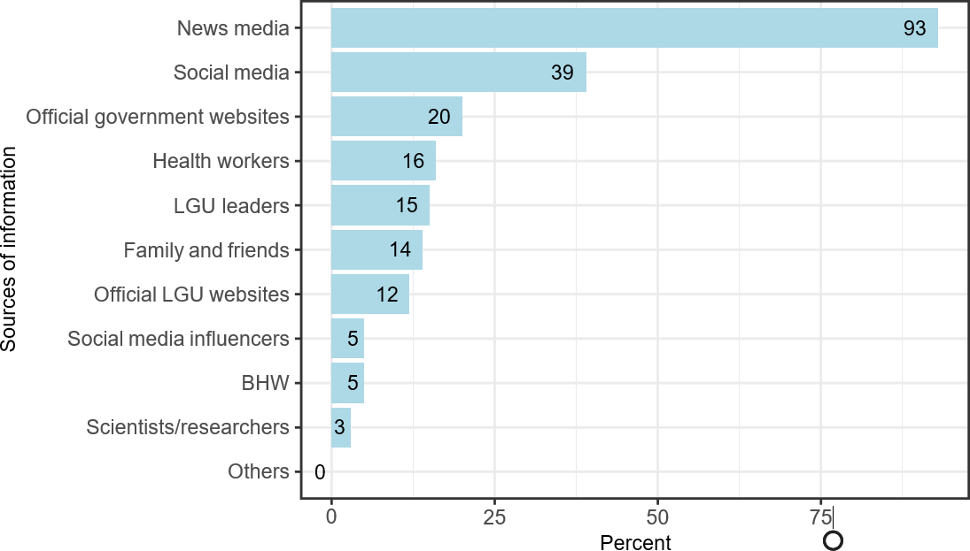

Figure 1: Source of information about COVID-19 infection, (n = 376)

Table 3 presents the proportion of participants who had correct answers on each knowledge item. About 90% knew that the COVID-19 virus spreads via respiratory droplets of infected individuals, that isolating and treating the people who are infected with the COVID-19 virus are effective ways to reduce its spread, and one should avoid crowded places and public transportation to prevent getting infected. However, three out of four respondents incorrectly thought that eating or touching wild animals would result in the infection by COVID-19 virus.

About 15% correctly answered all six knowledge questions while almost half (48.4%) got five out of six items correctly (Table 4). Six participants did not have any correct answers (1.6%). Overall, 63.6% (95% confidence interval: 58.7−68.4%) had correctly answered at least 75% of the knowledge items, thus, have good knowledge about COVID-19 virus infection.

Table 3: Proportion of participants with correct answers on knowledge questions (n = 376)

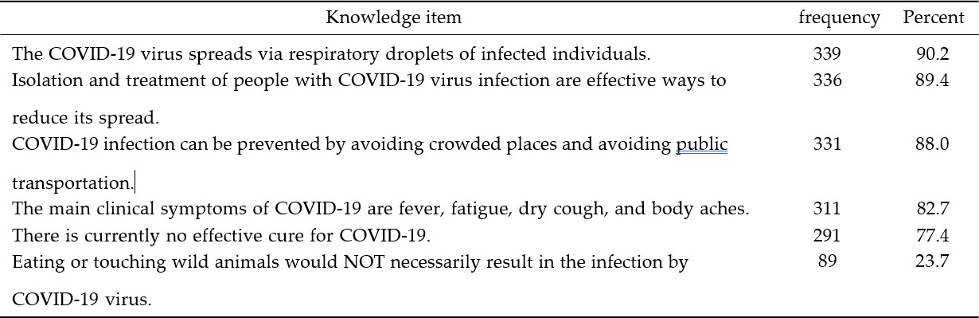

Table 4: Proportion of participants according to number of correct answers (n = 376)

|  |  |  |
| --- | --- | --- |
| No. of correct answers | frequency | Percent |
| 0 | 6 | 1.6 |
| 1 | 10 | 2.7 |
| 2 | 8 | 2.1 |
| 3 | 33 | 8.8 |
| 4 | 80 | 21.3 |
| 5 | 182 | 48.4 |
| 6 | 57 | 15.2 |

*Knowledge of the participants about COVID-19 vaccine*

M ore than half (58.2%) of the respondents said that they know a little about the COVID- 19 vaccine. Only six (6) said that they know a lot about the COVID-19 vaccine (Table 5). Two-thirds reported that they would see or hear conflicting information on the COVID-19 vaccine from different sources. One in five participants believed that none of the information that they get about the COVID-19 vaccine seemed fake or made up and half said that only a little of these information on the COVID-19 vaccine seemed fake or made up. About one- fifth believed that the information that the vaccine is safe and has no adverse effects on one’s body is fake (Table 5).

Table 5: Distribution of the participants according to perception on COVID-19 vaccine (n = 376)

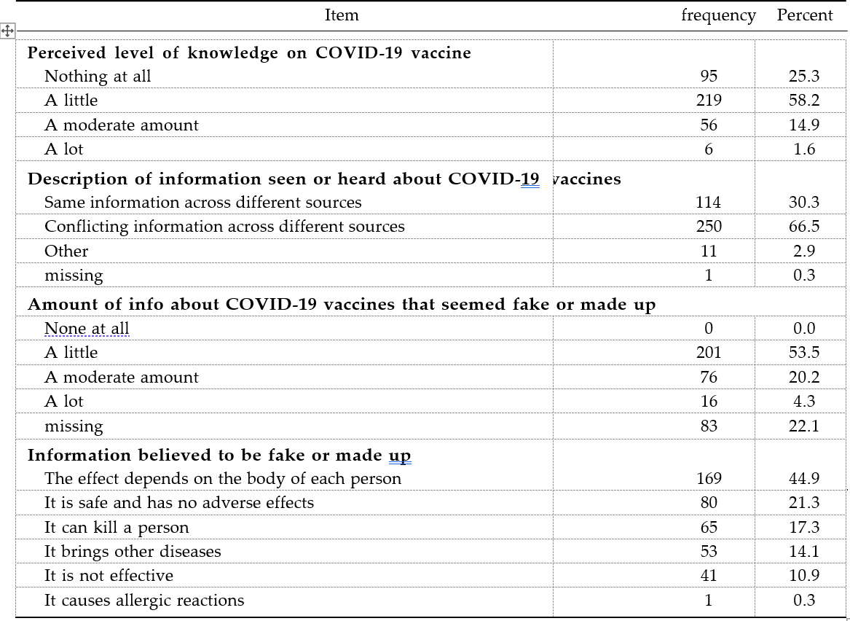

As shown in Figure 2, 67% of the participants reported that the news media are trustworthy source of information about the COVID-19 vaccine. Only about 25% thought that social media and health workers are trustworthy sources of information. Meanwhile, less than 10% said that LGU leaders, scientists and researchers, the LGU websites, and barangay health workers (BHWs) are trustworthy sources of information.

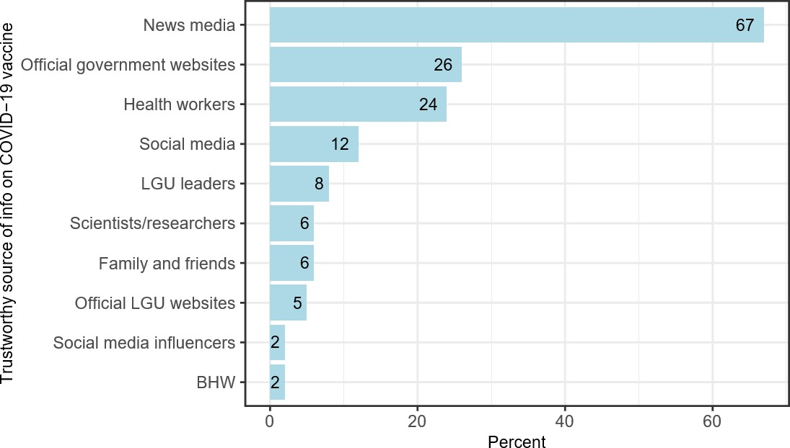

Figure 2: Trustworthy source of information about COVID-19 Vaccine (n = 376)

*Attitudes toward COVID-19 vaccine*

Table 6 presents the responses of the participants on several attitudes items on the COVID- 19 vaccine. Only 16.7% said that they trust the information they hear about the COVID-19 vaccine. About 40% said that they are concerned that they might have a serious side effect from a COVID-19 vaccine and that the vaccine may not be safe. Forty-three percent were hesitant about the vaccine.

Less than 10% said that getting the COVID-19 vaccine is against the teachings of their religion while 36% were unsure. As regards self-efficacy, only 21% said that they are confident that they will get the vaccine for COVID-19 even if they must go to a health center or hospital (Table 6).

About 23% and 28% said that they are willing to receive the COVID-19 vaccine when it becomes available and that they are willing to receive the COVID-19 vaccine if it is free and covered by health insurance, respectively. Only 12% were willing to participate in a clinical trial (Table 6).

Table 6: Attitude of the participants on getting a COVID-19 vaccine (n = 376)

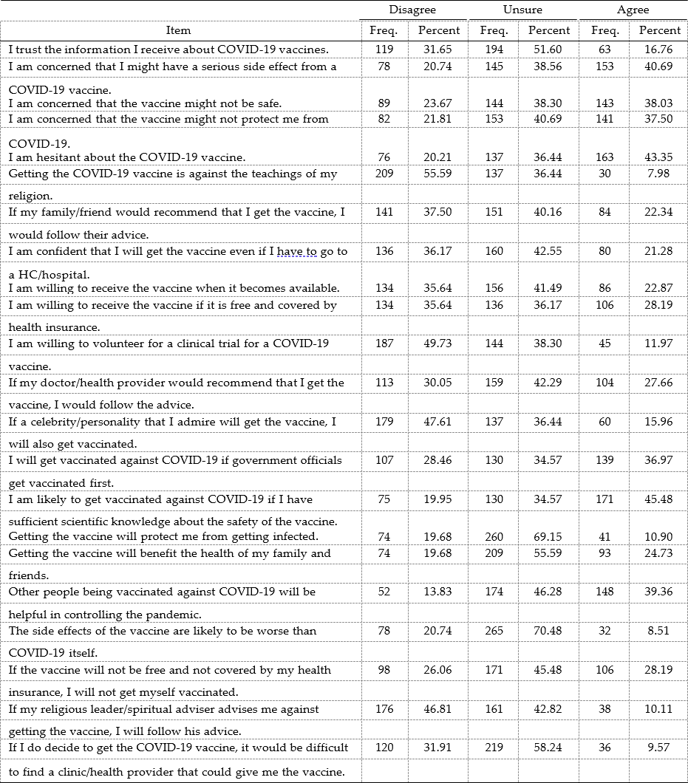

As regards external cues to action, 37% reported that they are likely to get vaccinated if government officials get vaccinated first (Table 6). Sixty-eight percent said that they want to see government officials get vaccinated first before they get vaccinated followed by LGU officials (36%) (Figure 3).

Only 11% agreed that the COVID-19 vaccine will protect them from getting infected while 25% agreed that getting the vaccine for COVID-19 will benefit the health of their family and friends. As regards perceived efficacy, about two in every five (39.4%) said that other people being vaccinated against COVID-19 will be helpful in controlling the pandemic. One in every five (20.7%) did not agree that the side effects of the vaccine are likely to be worse than COVID-19 itself while 70% were unsure (Table 6).

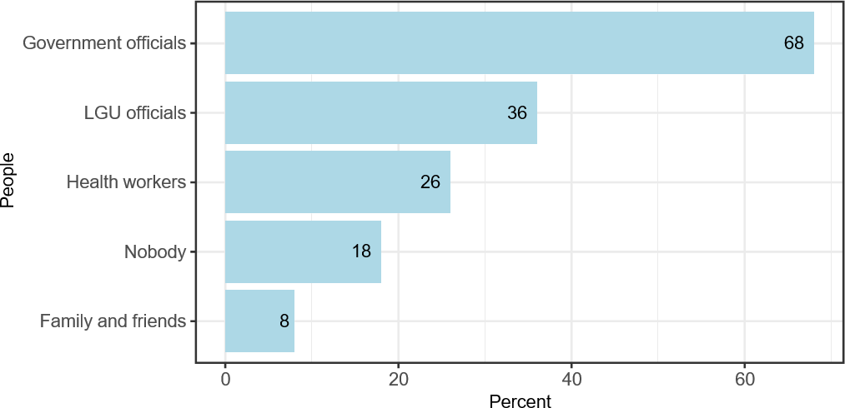

Figure 3: People the participants wanted to see get the vaccine first before they get vaccinated (n = 376)

*Intentions towards COVID-19 vaccination*

Two participants reported to have been vaccinated. For the rest of the participants, 25% (95% confidence interval: 20.7% − 29.5%) said that they plan to get vaccinated against COVID-19 infection. Some of the reasons given why they plan to get vaccinated were: 1) to keep them and their family safe and protected against the virus, 2) so that they can go back to work, and 3) to end the pandemic and things go back to normal. As regards timing of getting vaccinated, the responses given were as follows: 1) right away, 2) once it is available,

1. once it is sure that the vaccine is safe, and 4) once a vaccine with higher efficacy becomes available. Among those who did not plan to get vaccinated, some of the reasons given are the following: 1) afraid of the side effects, 2) afraid to die because of the vaccine, 3) does

not trust vaccines, 4) not experiencing any sickness, and 5) afraid of what will happen because of what happened with Dengvaxia.

*Factors associated with intention to get vaccinated*

Table 7 presents the results of the logistic regression analyses that were performed to determine the factors associated with intention to get vaccinated. Without controlling for any variables, males were more likely to have intention to get vaccinated than females. Similarly, those with higher education had higher odds of having intention to get vaccinated than those who only reached elementary level of education. Those who were self-employed or unemployed had lesser odds of having intention to get vaccinated than the employed. Moreover, those with good knowledge on prevention of COVID-19 infection had higher odds of having intention to get vaccinated. As regards attitudes toward COVID-19 vaccine, those with positive social norms, perceived self-efficacy, behavioral intention, external cues to action, perceived benefit and perceived efficacy had higher odds of having intention to get vaccinated than those with negative or unsure attitudes.

Putting all these covariates in one model, several variables were found to be statistically associated with intention to get vaccinated. Controlling for the other variables, the Roman Catholics had 10.79 times the odds of having intention to get vaccinated compared to those with other religion (95% CI: 1.78% − 65.54%). Those whose families were said to earn at least 5,000 pesos monthly had at least 2.41 times the odds of having intention to get vaccinated than those who earn lower. Those who had good knowledge on prevention had about 23 times the odds of having intention to get vaccinated compared to those with poor knowledge (95% CI: 3.52% − 149.72%). Those with positive behavioral intention as well as positive perceived benefits of COVID-19 vaccination had 9.88 and 12.25 times the odds of having intention to get vaccinated, respectively, compared to those with negative or unsure attitudes. It is interesting to note that, controlling for the other variables, those with good knowledge on treatment had 89% lower odds of having intention to get vaccinated than those with poor knowledge. Similarly, those with positive attitude towards perceived barriers had 66% lower odds of having intention to get vaccinated than those with negative attitudes (Table 7).

Table 7: Results of logistic regression on the factors associated with intention to get the COVID-19 vaccine

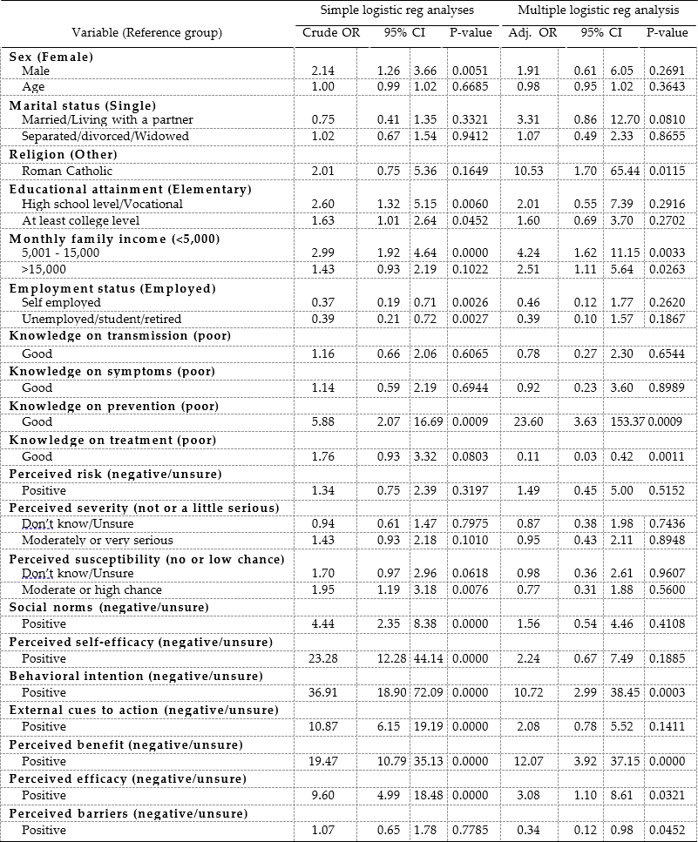

# Discussion

The current study aimed to determine the knowledge, attitudes, risk perceptions, and intention of people towards COVID-19 and vaccination. Majority of the respondents had good knowledge about COVID-19, with almost all citing news media as their source of COVID-related information. However, two-thirds also reported hearing or seeing conflicting information on COVID-19 vaccines. Around 40% expressed concerns over the safety of the vaccines, and a similar proportion also reported feeling hesitant about the vaccine. This is also reflected by the low proportion of respondents with intent to receive the vaccine. Logistic regression analysis also revealed that Catholics, those with at least a monthly income of 5,000 pesos, had good knowledge of prevention, positive behavioral intention, and positive perceived benefits of COVID-19 vaccination were more likely to have the intention to get vaccinated.

The good knowledge about COVID-19 demonstrated by the respondents is consistent with the findings of previous studies that were conducted in Nigeria [10], Malaysia [11], China [12], Vietnam [13], and Ecuador [14]. People’s knowledge, attitude, and practices in relation to COVID-19 are significant predictors of disease-specific preventive behaviors. According to Lau et al.[3], a greater number of COVID-19 prevention measures were practiced by those with a higher level of knowledge. These findings indicate that good knowledge, combined with attitudes and practices, can contribute to the suppression and mitigation of COVID-19.

News and social media as the most common sources of COVID-related information were also consistent with literature [10,15]. In terms of trustworthiness, news media was also ranked as the highest, but what is concerning is that only a small proportion of the respondents believed that health workers and scientists were trustworthy. It is also important to note that two-thirds of the participants reported hearing or seeing conflicting information on COVID-19 vaccines. A study among American adults reported inconsistent messages from public health experts and elected government officials as determinants for reduced vaccine uptake [16]. These findings emphasize the important role of collaboration between

news and social media and the scientific community in disseminating correct information, mitigating disinformation, and responsible reporting of COVID-related news.

Contrary to the findings of Neumann-Böhme, et al. [17], Biasio et al. [18], Ahmed et al., [19] and Elhadi et al. [20], the intention to receive the vaccine among the participants was low. The findings also indicate that vaccine hesitancy remains a major challenge to the country’s vaccination program, with a large proportion of the respondents citing safety concerns as a major factor for their hesitation to receive the vaccine. These findings were consistent with Bono et al’s study [21], wherein fear of vaccine side effects and lack of confidence in the effectiveness of the vaccines were the most cited reasons for refusing vaccination. Farha et al. [22] also reported similar results, with adverse effects of the vaccine being reported by 61% of the respondents as their reason for refusal. Concerns with vaccine safety and distrust towards health professionals are recurring concerns across several studies, as these factors were also cited as common reasons for poor compliance among the general population and even among healthcare workers [23,24,25,26]. The first step in vaccine communication and addressing vaccine hesitancy is to identify the target audience and establish trust with them [27,28]. Transparency and honesty in the information being delivered is important, and this can be addressed by presenting both the benefits and risks of getting vaccinated. The World Health Organization [29] also stressed the need to listen to and engage with stakeholders and members of the target population and obtain their feedback as one of the ways forward for vaccine safety communication.

The present study also found that Catholics, those with at least a monthly income of 5,000 pesos, had good knowledge of prevention, positive behavioral intention, and positive perceived benefits of COVID-19 vaccination were more likely to have the intention to get vaccinated. The higher intention to get vaccinated that was observed among Catholics in the study can be explained by the bishops and clergy who were reported to have been infected by COVID-19 and the promotion of the Catholic Church among its followers to get the vaccination. The relationship between low socioeconomic status and refusal of vaccination has also been documented among French adults [30]. In terms of good knowledge of prevention and the perceived benefits of the COVID-19 vaccination, these

findings were congruent with the results of an online survey conducted in Malaysia, Thailand, Bangladesh, Democratic Republic of Congo, Benin, Uganda, Malawi, Mali, and Brazil [21].

The results reported in this study should be considered in light of some limitations. The study employed an analytic cross-sectional design and thus cannot establish causation between the variables measured.

# Conclusion

The findings of the study point towards the importance of health literacy during the COVID- 19 pandemic. It is important that individuals are provided with the correct information that is easy to understand and access so that they can make informed choices about their health, especially during the COVID-19 pandemic. Government agencies, the scientific community, the media, and community stakeholders must collaborate in developing effective strategies focused on addressing the public’s hesitancy and building trust towards COVID-19 vaccines and the government’s vaccination program.

# Acknowledgements

We would like to express our gratitude to the National Research Council of the Philippines, Department of Science and Technology for providing funds for this study, the city government and residents of Manila for their support and cooperation. We would also like to thank Mark Jun Alcantara, Kristhel Grace Gregorio, Amelia Santiago, Eriza Grace Gregorio, Abegail Ochoa, Marites Mayagma for their assistance during the conduct of the study.

# References

* 1. World Health Organization. WHO Coronavirus disease (COVID-19) Dashboard [Internet]. World Health Organization [updated 26 May 2021; cited 27 May 2021]. Available from: https://covid19.who.int/.
  2. Department of Health. COVID-19 Tracker [Internet]. Department of Health [updated 26 May 2021; cited 27 May 2021]. Available from: https://[www.doh.gov.ph/covid19tracker.](http://www.doh.gov.ph/covid19tracker)
  3. Lau LL, Hung N, Go DJ, Ferma J, Choi M, Dodd W, Wei X. Knowledge, attitudes and practices of COVID-19 among income-poor households in the Philippines: a cross-sectional study. Journal of global health. 2020 Jun;10(1).
  4. Adela N, Nkengazong L, Ambe LA, Ebogo JT, Mba FM, Goni HO, Nyunai N, Ngonde MC, Oyono JL. Knowledge, attitudes, practices of/towards COVID 19 preventive measures and symptoms: A cross-sectional study during the exponential rise of the outbreak in Cameroon. PLoS neglected tropical diseases. 2020 Sep 4;14(9):e0008700.
  5. Li ZH, Zhang XR, Zhong WF, Song WQ, Wang ZH, Chen Q, Liu D, Huang QM, Shen D, Chen PL, Mao A. Knowledge, attitudes, and practices related to Coronavirus disease 2019 during the outbreak among workers in China: A large cross-sectional study. PLoS neglected tropical diseases. 2020 Sep 17;14(9):e0008584.
  6. Bhagavathula AS, Aldhaleei WA, Rahmani J, Mahabadi MA, Bandari DK. Knowledge and perceptions of COVID-19 among health care workers: cross- sectional study. JMIR public health and surveillance. 2020;6(2):e19160.
  7. Gregorio Jr ER, Medina JR, Lomboy MF, Talaga AD, Hernandez PM, Kodama M, Kobayashi J. Knowledge, attitudes, and practices of public secondary school teachers on Zika Virus Disease: A basis for the development of evidence-based Zika educational materials for schools in the Philippines. PloS one. 2019 Mar 28;14(3):e0214515.
  8. Reiter PL, Pennell ML, Katz ML. Acceptability of a COVID-19 vaccine among adults in the United States: How many people would get vaccinated?. Vaccine. 2020 Sep 29;38(42):6500-7.
  9. Pogue K, Jensen JL, Stancil CK, Ferguson DG, Hughes SJ, Mello EJ, Burgess R, Berges BK, Quaye A, Poole BD. Influences on attitudes regarding potential COVID- 19 vaccination in the United States. Vaccines. 2020 Dec;8(4):582.
  10. Reuben RC, Danladi MM, Saleh DA, Ejembi PE. Knowledge, attitudes and practices towards COVID-19: an epidemiological survey in North-Central Nigeria. Journal of community health. 2020 Jul 7:1-4.
  11. Azlan AA, Hamzah MR, Sern TJ, Ayub SH, Mohamad E. Public knowledge, attitudes and practices towards COVID-19: A cross-sectional study in Malaysia. Plos one. 2020 May 21;15(5):e0233668.
  12. Yue S, Zhang J, Cao M, Chen B. Knowledge, attitudes and practices of COVID-19 among urban and rural residents in China: a cross-sectional study. Journal of community health. 2021 Apr;46(2):286-91.
  13. Van Nhu H, Tuyet-Hanh TT, Van NT, Linh TN, Tien TQ. Knowledge, attitudes, and practices of the Vietnamese as key factors in controlling COVID-19. Journal of Community Health. 2020 Dec;45(6):1263-9.
  14. Bates BR, Moncayo AL, Costales JA, Herrera-Cespedes CA, Grijalva MJ. Knowledge, attitudes, and practices towards COVID-19 among Ecuadorians during the outbreak: an online cross-sectional survey. Journal of Community Health. 2020 Dec;45(6):1158-67.
  15. Honarvar B, Lankarani KB, Kharmandar A, Shaygani F, Zahedroozgar M, Haghighi MR, Ghahramani S, Honarvar H, Daryabadi MM, Salavati Z, Hashemi SM. Knowledge, attitudes, risk perceptions, and practices of adults toward COVID-19: a population and field-based study from Iran. International journal of public health. 2020 Jul;65(6):731-9.
  16. Thunstrom L, Ashworth M, Finnoff D, Newbold S. Hesitancy towards a COVID-19 vaccine and prospects for herd immunity. Available at SSRN 3593098. 2020 May 6.
  17. Neumann-Böhme S, Varghese NE, Sabat I, Barros PP, Brouwer W, van Exel J, Schreyögg J, Stargardt T. Once we have it, will we use it? A European survey on willingness to be vaccinated against COVID-19.
  18. Biasio LR, Bonaccorsi G, Lorini C, Pecorelli S. Assessing COVID-19 vaccine literacy: a preliminary online survey. Human vaccines & immunotherapeutics. 2021 May 4;17(5):1304-12.
  19. Ahmed MA, Colebunders R, Gele AA, Farah AA, Osman S, Guled IA, Abdullahi AA, Hussein AM, Ali AM, Siewe Fodjo JN. COVID-19 Vaccine Acceptability and

Adherence to Preventive Measures in Somalia: Results of an Online Survey. Vaccines. 2021 Jun;9(6):543.

* 1. Elhadi M, Alsoufi A, Alhadi A, Hmeida A, Alshareea E, Dokali M, Abodabos S, Alsadiq O, Abdelkabir M, Ashini A, Shaban A. Knowledge, attitude, and acceptance of healthcare workers and the public regarding the COVID-19 vaccine: a cross- sectional study. BMC Public Health. 2021 Dec;21(1):1-21.
  2. Bono SA, Faria de Moura Villela E, Siau CS, Chen WS, Pengpid S, Hasan MT, Sessou P, Ditekemena JD, Amodan BO, Hosseinipour MC, Dolo H. Factors Affecting COVID-19 Vaccine Acceptance: An International Survey among Low-and Middle- Income Countries. Vaccines. 2021 May;9(5):515.
  3. Abu Farha RK, Alzoubi KH, Khabour OF, Alfaqih MA. Exploring perception and hesitancy toward COVID-19 vaccine: A study from Jordan. Human Vaccines & Immunotherapeutics. 2021 May 21:1-6.
  4. Falagas ME, Zarkadoulia E. Factors associated with suboptimal compliance to vaccinations in children in developed countries: a systematic review. Current medical research and opinion. 2008 Jun 1;24(6):1719-41.
  5. Blasi F, Aliberti S, Mantero M, Centanni S. Compliance with anti‐H1N1 vaccine among healthcare workers and general population. Clinical Microbiology and Infection. 2012 Oct;18:37-41.
  6. Ventola CL. Immunization in the United States: recommendations, barriers, and measures to improve compliance: part 1: childhood vaccinations. Pharmacy and Therapeutics. 2016 Jul;41(7):426.
  7. Knowler P, Barrett M, Watson DA. Attitudes of healthcare workers to influenza vaccination. Infection, Disease & Health. 2018 Sep 1;23(3):156-62.
  8. Dubé E, Gagnon D, Vivion M. Public Health Network: Optimizing communication material to address vaccine hesitancy. Canada Communicable Disease Report. 2020 Feb 6;46(2-3):48.
  9. Thomas TM, Pollard AJ. Vaccine communication in a digital society. Nature materials. 2020 Apr;19(4):476-.
  10. World Health Organization. Vaccine safety communication in the digital age. 2018 meeting report, Veyrier-du-Lac, France, 4–5 June 2018 [Internet]. Geneva: World

Health Organization; 2019. Available from: https://apps.who.int/iris/bitstream/handle/10665/311961/WHO-MVP-EMP-SAV- 2019.02-eng.pdf.

* 1. Peretti-Watel P, Seror V, Cortaredona S, Launay O, Raude J, Verger P, Fressard L, Beck F, Legleye S, l'Haridon O, Léger D. A future vaccination campaign against COVID-19 at risk of vaccine hesitancy and politicisation. The Lancet Infectious Diseases. 2020 Jul 1;20(7):769-70.