IAC-18,D4,2,13,x48287

**TOWARDS A SUSTAINABLE PRODUCTION OF PROTEINS IN SPACE: A PROPOSED SOLUTION**

**AND ROADMAP**

**Francesco Spinaa**\***, Catherine Raisa Kimberly P. Mandigmab, Kensuke Wadac, Roberto Aguilard,**

**Ryunosuke Yokoyae, Mami Sugayaf, Koshi Kimurag, Chuanzelong Guoh**

a *Department of Space Engineering, Luleå University of Technology, Rymdcampus E10, 98128 Kiruna, Sweden*, [aerospina@gmail.com](mailto:aerospina@gmail.com)

b *Department of Food Science and Nutrition, University of the Philippines, Quirino Avenue, 1101 Diliman Quezon City, The Philippines*, [crkp.mandigma@gmail.com](mailto:crkp.mandigma@gmail.com)

c *Department of Physics, Tokyo Institute of Technology, 152-8550 Tokyo, Japan*, [dkbnw@gmail.com](mailto:dkbnw@gmail.com)

d *Department of Space and Engineering Systems, Skolkovo Institute of Science and Technology, 143026 Moscow,*

*Russian Federation*, [roberto.aguilar@ditspacecr.com](mailto:roberto.aguilar@ditspacecr.com)

e *Sony Corporation, Minato-ku, 108-0075 Tokyo, Japan*, [ryunosuke.yokoya@sony.com](mailto:ryunosuke.yokoya@sony.com)

f *Remote Sensing Technology Center of Japan, Minato-ku, 105-0001 Tokyo, Japan*, [sugaya_mami@restec.or.jp](mailto:sugaya_mami@restec.or.jp)

g *Seibu Holdings Inc., 1-11-1 Kusunokidai, Tokorozama, Saitama 359-8510, Japan*, [koshi0220@gmail.com](mailto:koshi0220@gmail.com)

h *Auckland University of Technology, 55 Wellesley St. E, 1010 Auckland, New Zealand*, [longee_guo@hotmail.com](mailto:longee_guo@hotmail.com)

* Corresponding Author

# Abstract

Nutrition is elementary for human existence and it poses numerous challenges for deep-space exploration. The food currently used during space missions, despite its promises to deliver nutritious value to the astronaut’s diet, will become unsuitable and unsustainable during longer expeditions. Nowadays, soil-less techniques are regularly used to grow vegetables on the International Space Station. Sustainable production of proteins remains an unsolved issue both in space and on Earth. This paper introduces a novel approach to this issue, proposing the production of proteins from fungi in space. Reasons and advantages of this approach are detailed and will demonstrate how the proposed solution can be self-sustainable in space. Furthermore, the properties of fungi can also provide solutions for water filtering and waste management, as well as other emerging applications. A roadmap is proposed, which aims to ac- celerate the development of the related technologies needed in space, while using them to solve pressing global chal- lenges on Earth.

**Keywords:** Protein, Nutrition, Space Food, Fungi, Mycomeat, Sustainability

# Acronyms/Abbreviations

BNF - British Nutrition Foundation

ECLSS - Environmental Control and Life Support System FAO - Food and Agriculture Organization

ISS - International Space Station

ISSFS - International Space Station Food Systems JAXA - Japan Aerospace Exploration Agency

NASA - National Aeronautics and Space Administration PU - Polyester Polyurethane

RDA - Recommended Dietary Allowance RHM - Rank Hovis McDougall

SDG - Sustainable Development Goals SPSS - Sustainable Protein Supply System UN - United Nations

WRS - Water Recovery System

# Introduction

Less than 400 people have travelled into space since the beginning of manned space exploration. This will continue to be the reality for the coming decades. Space agencies around the world send astronauts constantly into Earth’s orbit to the ISS. One of the long-term goals

of these agencies includes National Aeronautics and Space Administration’s (NASA) effort towards manned-exploration of Mars by 2050. With this comes an overall need to maintain good health among astro- nauts, especially during long-term space missions. It is necessary to determine what optimum nutrition is nec- essary to support these missions, not only to maintain life but also to mitigate the negative effects of the space environment during extended missions. Exposed to harsh conditions, astronauts routinely experience weight loss and this loss is exacerbated during extended mis- sions of six months and longer [1]. Concern for food sustainability during long term explorations has necessi- tated research in this area, since the significance of nutrition in space is magnified over its significance on Earth.

Good nutrition is comprised of quality food in ade- quate amounts with all the essential nutrients for the body to sustain itself. Maintaining optimum nutrition is critical during short and medium-term missions, and even more during long-term missions. During short and

medium-term missions diet intake is suppressed to 60– 75% of a normal intake [1], and this 25-30% inadequacy will be more pronounced for longer space missions, i.e. inter-planetary missions. Without a balanced diet, astro- naut’s performance will decline and subsistence will be endangered. Food fatigue is the main reason for intake below the Recommended Dietary Allowance (RDA) and the limited source of fresh food rations is the root cause. It is noteworthy that the cost of sending fresh food and water to the International Space Station (ISS) is about $10,000 per pound [1].

The semi-closed food system of the ISS is a limita- tion for longer space missions, therefore, sustainable approaches must be carefully studied and experimented. Production of food in the ISS will open doors to varied selections from the usual dehydrated menus. Unlike carbohydrates that can be produced by cultivation of vegetables in the ISS, production of good quality pro- teins has not been thought of.

This paper suggests the possibility of producing pro- teins from fungi in a sustainable way. Also, it explores some of the ways in which fungi could be of help in many other human-related activities in setting up com- munities on the Moon, Mars or asteroids. Reasons and advantages of this approach are detailed and it is demonstrated how the proposed solution can be self- sustainable in the space environment.

# State of the art of food in space

Food requirement varies according to the length of the mission. Arquiza, a proponent of zero-gravity cook- ing, states that dehydrated food is only good for short term space missions. It must scale up to cooking in space for medium term while, for long term, food must be grown [2]. In a paper about NASA Advanced Food Technology, Cooper mentions that food must provide the nutrients to sustain crew health and performance, must be acceptable throughout the course of the mis- sion, must be safe after cooking, processing, formulated and packaged in such a way that mass and volume are not restrictive to mission viability [3]. The International Space Station Food Systems (ISSFS) provides a menu with a cycle of 8-16 days of mostly dehydrated, vacuum packed food. This food type is shelf stable and good for short-term space missions, but most astronauts suffer food fatigue as they become more and more familiar with the menu offered in this semi-closed food system. During a personal interview with the authors, Japan Aerospace Exploration Agency’s (JAXA) astronaut Takuya Onishi mentioned that during a mission he pre- fers to consume his fresh food rations first and then consume the ISS food. This came with a remark that “in the ISS the food is healthy, but healthy does not neces- sarily mean good to eat” [4].

Long term food production in space has been made possible since the NASA’s Veggie Project [5]. Veggie’s

goal is to provide astronauts with a sustainable food supplement [6] while providing psychological support to astronauts [7]. Multiple salad and herb species have been cultivated in Veggie, both on the ISS and on Earth. The Veggie space hardware on Earth simulates the light level, temperature, water delivery, and relative humidity of the ISS. The first cultivated produce in the ISS was red romaine lettuce, while analogue studies on Earth included the cultivation of cherry bomb radish, Chinese cabbage, chard, and snow pea. All of them grew in an acceptable way in the Veggie space hardware, including the red romaine lettuce in the ISS. It was found that aeration and water have been the most important param- eters in growing these vegetables. Microgravity impact has yet to be determined, but the use of wicking surface (that works with capillary action) helped in water ab- sorption [8]. Zinnia flower was the second vegetable cultivated in space [9]. It was chosen to check how flowers grow in space, since fruit-bearing plants, such as tomatoes, flower before bearing the fruit. In 2018, dwarf tomatoes were sent to the ISS [9].

As for the taste of vegetables grown in space, the let- tuce tastes fresh, yet it resembles the taste of Arugula (which is more bitter than lettuce). The reason might be attributed to stress that led to the formation of bitter compounds, for example water stress [9].

The Veggie experiment, though, produces food items that are limited to small salad crops. In the ISS, protein sources are limited to the meats that are dehy- drated or irradiated. While Petri dish cultivated meat could be an option in the future, nowadays the cost of producing a meat patty is about $2,400, and the produc- tion requires a very long time [10].

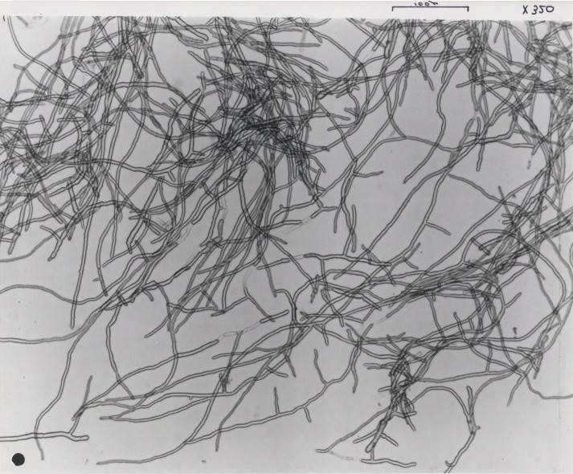

Figure 1 - The appearance of Fusarium Venenatum A3/5 (protein strands) as collected from the outlet of the

Quorn™ fermenter [11]

# Fungi as a source of proteins in space

With long-term missions towards the Moon, Mars and asteroids being on the horizon, NASA has started to perfect the Martian Growth Chamber with the aim of providing healthier and sustainable crops into the diet of astronauts such as tomatoes, potatoes and lettuce, but

not meat. Animals cannot be herded in space because they too will require essential resources like food and water. Cattle in outer space are just not practical. Fungi on the other hand could represent a possible sustainable source of proteins in space.

Fungi, in many of their forms, have played an im- portant role in mankind’s food chain for over a thousand years. Many variants can be eaten as is, like mushrooms in pastas and cloud ear fungus in Chinese cuisines. Fungi are not foreign in mankind’s diet.

A fungus, selected among 3000 types, called Fusari- um Venenatum A3/5, is one of the most promising candidates as possible source of proteins in space (Fig- ure 1). This fungus was initially intended as protein alternative for countries that has experienced protein shortage. F. Venenatum has undergone intensive devel- opment as a source of proteins (“mycoproteins”) fit for human consumption. After 12 years of intensive testing,

F. Venenatum A3/5 was approved for sale by the Minis- try of Agriculture, Fisheries and Food in the United Kingdom, making it the most carefully tested food product in the European market, and the strain used, ATCC PTA-2648, passed toxicity tests [12].

Another type of fungi, Pleurotus Ostreatus, com- monly known as the oyster mushroom, has also been part of several investigations related to its ecological and nutritional benefits. In 2016, a group of students from Ryerson University in Canada sent oyster mush- rooms to the ISS, aiming to analyse their ability to grow in space to become a product that could be harvested and eaten there. Oyster mushrooms were chosen be- cause they are edible, have a high source of fibre, a high source of protein, are low in fat and have a small growth period [13].

Besides representing an excellent protein source, fungi have peculiar characteristics that make them the ideal candidates for a space travel. Fungal growth has been observed in the International Space Station [5], which means that they can well survive in the harsh space environment. They are known to survive anaero- bic conditions and do not require photosynthesis, which means they could potentially be grown in shaded areas on the Moon or asteroids. Since they are microorgan- isms, they are lightweight and can be cultivated and replicated easily, in mass quantities, just by carrying their spores in space. The payload cost for carrying them in space is negligible, compared to the one for carrying dehydrated meat.

# A closer look at mycoproteins

Mycoprotein (or Mycomeat - meat from fungi) holds the promise as a safe, sustainable source of proteins in space. Genetically, fungi resemble more of animals than plants. The hyphae resembles fibre muscles in meats of beef, chicken, duck, fish and pork (Figure 1). It is firm in the bite and can absorb flavour (Figure 2). Because of

this, food fatigue can be minimized due to its flexibility to be used in different dishes.

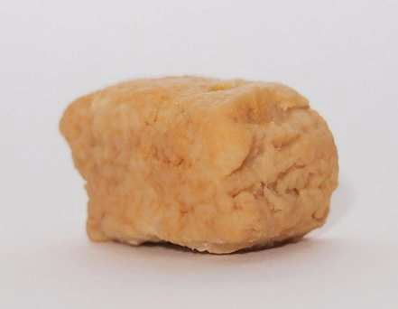

Figure 2 - A sample of Mycoprotein with dough-like texture [14]

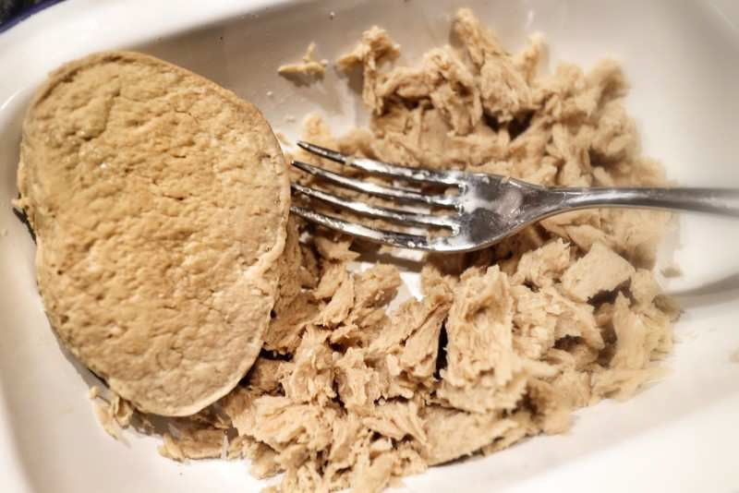

Figure 3 - Mycoprotein dough develops even more meat strands after freezing [15]

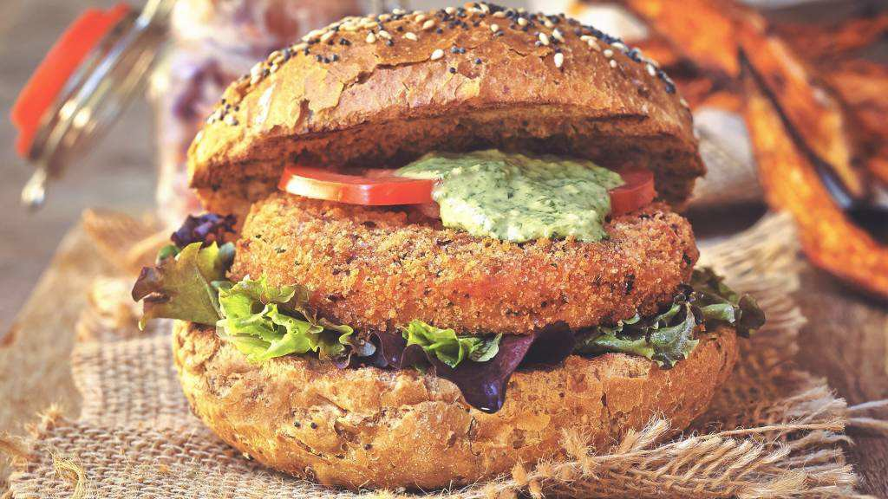

Figure 4 - Mycomeat burger [16]

Mycoprotein is grown in a fermenter where it is aseptically filled with a sterile broth of glucose, to which a starter culture of F. Venenatum is added. More glucose is added as well as ammonia as a source of nitrogen for fungus to produce amino acids – the build- ing blocks of proteins. During the six-week period, the fungus grows the hyphae, a long structure of proteins, doubling its biomass every five hours. After this period, the biomass is harvested and purified by heat and cen- trifugation. A yellow solid mass is then obtained, which gets flavoured and shaped into different products (Fig- ure 3 and 4).

Mycomeat is high in proteins as well as fibre, low in saturated fats, has zero cholesterol, and is soy free [12].

According to the British Nutrition Foundation (BNF) Mycomeat may help maintain normal blood cholesterol levels and may even lower LDL cholesterol levels. It can contribute to satiety, which leads to lesser caloric intake, and help control blood glucose levels [17]. My- coprotein contains all essential amino acids necessary for RDA. It has almost the same protein content with ground beef and has zero (0 mg) cholesterol compared to lean beef. Much like vegetables, it can also deliver fibre as much as 4.8 grams.

Ground mycoprotein uses less than 1/8th of the amount of land needed for ground beef [18]. The water footprint is up to 10 times less than producing beef. Carbon footprint of Mycomeat production is more than 90% lower than beef production and 70% lower than chicken production [12]. This clean and green “meat” is both advantageous for health and the environment.

Further improvements on production should take place to produce protein anaerobically. Currently, ef- forts have been made to turn the production process into a more cyclical one, utilising waste water and reusing some of the waste streams (such as the ‘broth’ left over from fermentation). These waste sources have the po- tential to be of some value, as well as reducing the eco- logical footprint of mycoprotein [19].

# Other potential uses of fungi in space

Apart from their applications in human nutrition, several studies have been conducted to assess the poten- tial use of fungi in very diverse applications on Earth. Fungi-based technologies represent a green and effec- tive solution that holds the promise to help solving pressing environmental problems, including waste and water treatment, production of biodegradable packaging and greener batteries. The following subsections will explore the state of the art of these new applications.

* 1. *Water filtering*

Water is a precious resource in space. Nowadays, the water in the ISS is recovered thanks to the Water Recovery System (WRS). The water that comes from human waste is recovered, purified and made available again to the crew. However, the WRS is heavy and prone to break.

Fungi can represent an alternative solution. In his re- cent study, P. Stamets reports that the mycelium, the underground part of fungi, can clean up water [20]. The technology, called “Mycofiltration”, is a biological active filter made from mycelium that can remove con- taminants from water [20]. Mycelium can effectively break the carbon-hydrogen bond and remanufacture hydrocarbon to carbohydrate. Moreover, he found out that oyster mushrooms can absorb a lot of oil and break it down. In another experiment, The Ocean Blue Project reports that oyster mushrooms can clean up their local waterways and reduce E. Coli contaminants [21]. Fungi

are therefore a very useful material when used for water filtering.

Looking further to interplanetary missions, fungi can represent a reliable and cost-effective solution to water filtering. For example, spare mycelium-made filters can be manufactured easily from locally grown fungi on the Moon or Mars.

* 1. *Waste treatment*

During recent years, the need of finding alternative and more sustainable ways to treat waste has led to some interesting experiments in this field. Several of these experiments have repeatedly demonstrated the ability of fungi in treating and reducing waste.

Food waste generally includes high starch content. Fungal hydrolysis in submerged fermentation by Asper- gillus Awamori and Aspergillus Oryzae can degrade 80- 90% of this starch into glucose, free amino nitrogen, and phosphate [22]. A. Awamori can produce glucoam- ylase which is one of enzymes to produce glucose from starch. Glucoamylase were obtained at the end of the fermentation by fungal mash and it was directly used to hydrolyse food waste [22].

Agaricus Bisporus (White mushrooms) can grow on substrate prepared with waste cellulose [23]. Vegetables grown in space generate residuals that could be used as substrate for this type of fungus.

A type of soil fungus, Aspergillus Tubingensis, has been discovered to break down plastics such as Polyes- ter Polyurethane (PU) in a matter of weeks. The fungus was found in a garbage dump in Sector H-10 in Islama- bad, Pakistan [24]. Aspergillus Tubingensis is generally found growing in soil, but researchers found that it could also colonize and thrive on plastic surfaces. The fungus breaks plastic down by secreting enzymes which weaken the chemical bonds between individual mole- cules and uses the mechanical force of its thread-like hyphae to break them apart. This process takes only a few weeks.

The Fungi Mutarium concept shows that oyster mushrooms can use previously sterilized plastic as sub- strate for growth [24]. Trash from packed astronaut’s food (or other plastic waste produced during the mis- sion) could be treated instead of just being thrown away, representing a fundamental component of a substrate where edible mushrooms could grow on.

Fungi also have the potential to clean up soil con- taminated by radioactive waste. Rhodotorula Taiwanen- sis can form biofilms which can help absorb toxins and heavy metals in waste, removing them from soil [25].

* 1. *Greener batteries*

Energy storage is critical during space missions. Batteries are heavily used into all types of spacecrafts, and they represent a critical element of the power sub- system. Since the number of charge/discharge cycles of

a battery is limited, it is necessary to replace the battery with a certain frequency.

The material which the electrode is made of is a key component that determines the electric efficiency of the battery [26]. Recent developments have made possible use of porous carbon material as an electrode of a bat- tery. Electrodes based on carbon material can be made from fungi [27].

Campbell created Li-ion battery anodes from the skin of Portobello mushrooms [28]. Heat-treatment was used to form a hierarchically porous structure that cre- ates more room for the storage and transfer of energy. The anodes achieved over 260 mAh/g after a heat- treatment at the temperature of 1100 °C, without the use of materials harmful to the environment. In the future, biomass-derived anodes may replace the ones made from synthetic graphite, which is the current industry standard for rechargeable Li-ion battery anodes and uses harmful materials in the production process.

In-space production of batteries could be key in the development of a future self-sustainable human settle- ment on another celestial body.

* 1. *Mycoplastic production*

It is difficult to get organic materials like plastic on the Moon or Mars without transporting them from Earth. Several prototypes of building and packing material were made from fungi [29]. Ecovative, a U.S-based company, is already producing packages for wine bot- tles from fungi [30].

One of the advantages of mycoplastic materials is mechanical strength. Fungi’s mycelium forms entan- gled networks of branching fibres. The filaments of the fibrous mycelium consist of elongated cells. These cells are separated from each other by internal porous cross walls, and are all enclosed within a tubular cell wall. The cell wall plays a fundamental role in providing mechanical strength to the whole mycelium [31].

Fungi can represent a very cost-effective solution for in-space mycoplastic production in the future. They can allow the production of alternatives to plastic materials like Styrofoam, Polyurethane foam and Polyvinyl Chlo- ride [29].

# The Sustainable Protein Supply System (SPSS)

In this section, we propose a novel solution that ena- bles a self-sustainable production of proteins in space from fungi. Following what has been shown in the pre- vious sections, it is possible to ideate a closed loop system (Figure 5), having fungi as central fundamental enabling element, that can be engineered as part of the Environmental Control and Life Support System (ECLSS) for future deep-space missions. We called this system the *Sustainable Protein Supply System* (SPSS).

The closed loop at the base of the SPSS is imple- mented as follows. First, mycomeat is produced from fungi as primary protein source.

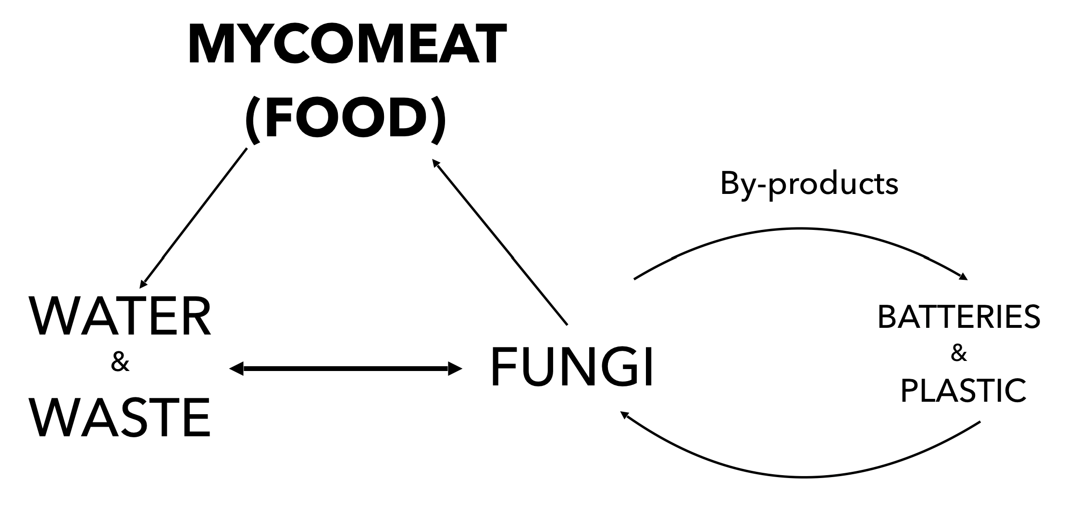

Figure 5 - Closed loop at the base of the proposed Sustainable Protein Supply System (SPSS)

F. Venenatum A3/5 and Oyster mushroom can be sources of proteins fit for human consumption (see Section 3 and Section 4). As a result of human con- sumption of mycomeat, the precious water coming from human waste is collected, as well as the food waste and plastic wrapping waste. Fungi are then used for water filtering and waste disposal. The processed water and waste are used to cultivate other fungi. The technology, called mycofiltration, is a biological active filter made from mycelium that can remove contaminants from water. Oyster mushrooms can clean up water by absorb- ing a lot of oil and breaking it down. Aspergillus Tubingensis can colonize and thrive on plastic surfaces by breaking them down. Oyster mushrooms can also use previously sterilized plastic as substrate for growth (see Section 5). At this point, batteries components and my- coplastic can be produced from fungi as by-products. Li-ion battery anodes can be created from the skin of Portobello mushrooms, while several packing materials can be made from fungi (See Section 5). Batteries and plastic derived from fungi can be used to sustain the cycle itself, with batteries storing the necessary energy and mycoplastic used create new wraps and to act as substrate for new fungi when disposed. In this way, the cycle can be considered closed and completely self- sustainable.

# A strategic roadmap to achieve a sustainable pro- duction of proteins in space

Beyond environmental and sustainability advantages, fungi’s role in producing healthier meat substitutes can create a shift in dietary patterns among millennials and the next generations. This establishes a target market that may act not only as consumer, but also as advocate. According to this scenario, a certain hope for business sustainability can be held. Rank Hovis McDougall (RHM), the £500 worth company producer of mycopro- tein Quorn™, is expanding in 19 countries with the aim of becoming a billion-dollar business in the next ten years [19].

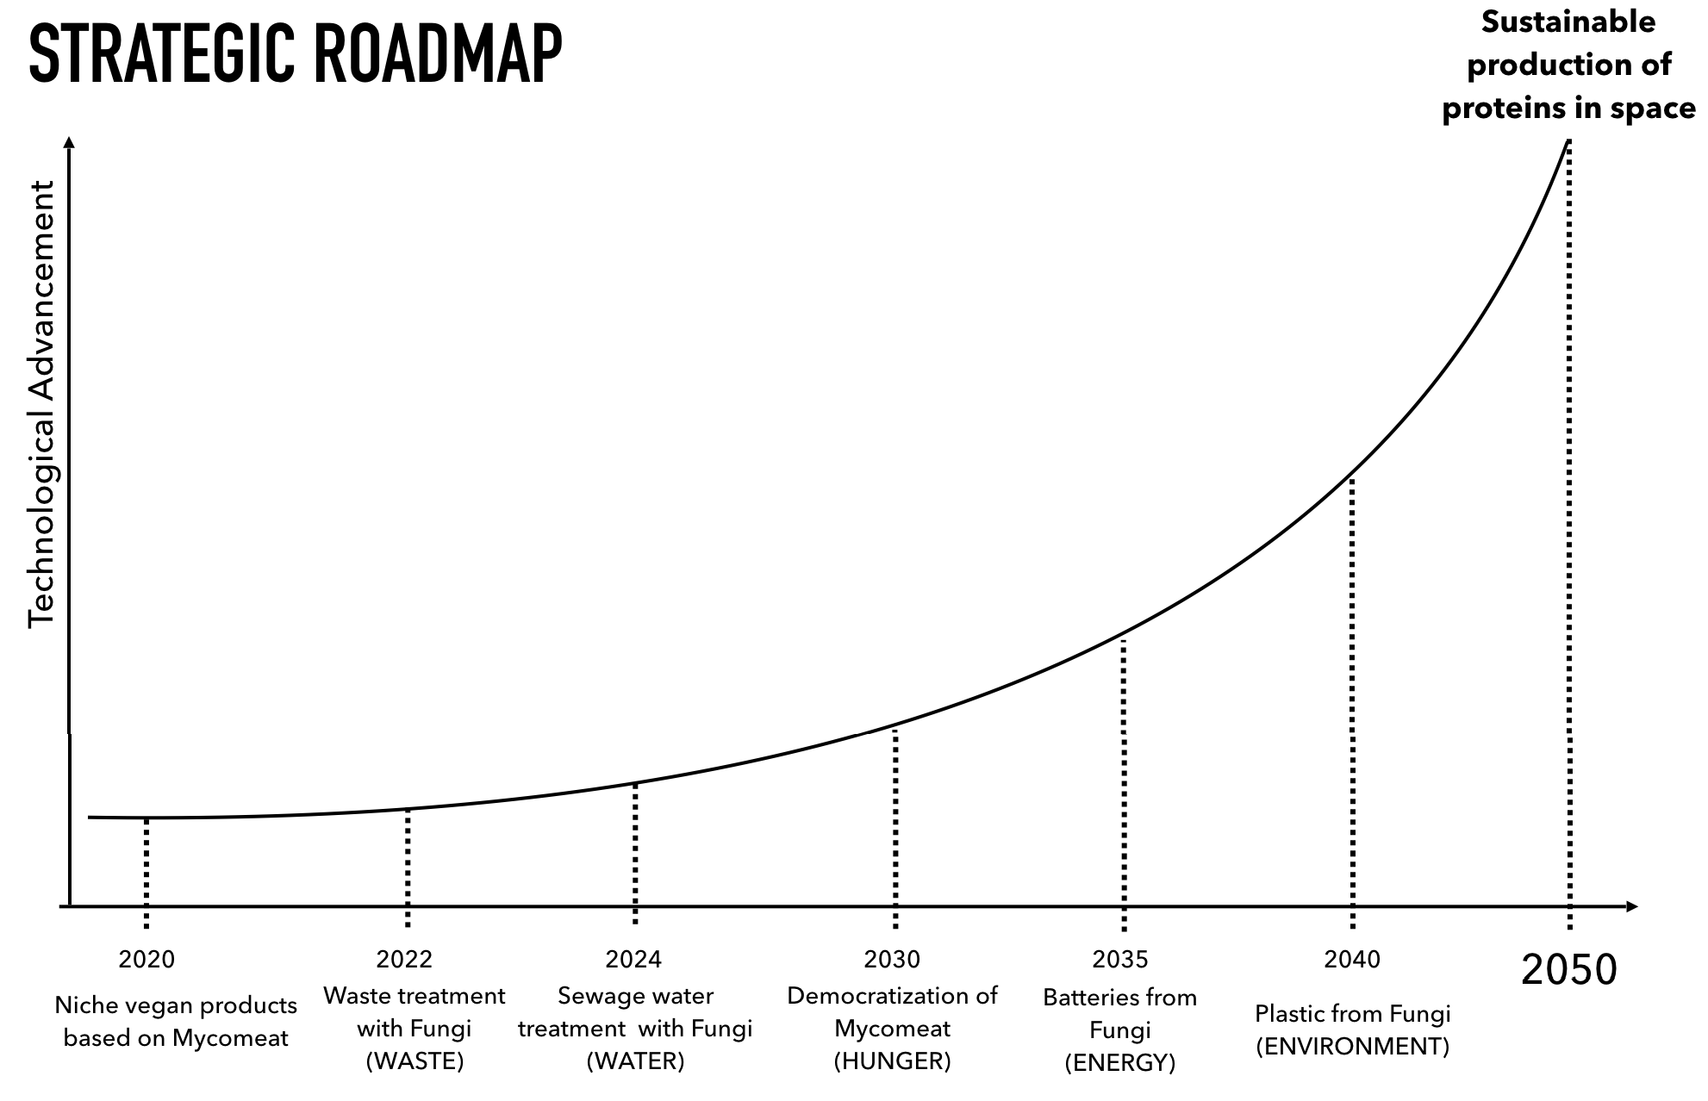

Figure 6 - Strategic roadmap to achieve a sustainable production of

proteins in space

Beyond profit, business producers of these fungi- based products may work with government agencies, national research institutions for environmental protec- tion advocacies, health program promotions, and other collaborative work that is complementary to the Sus- tainable Development Goals of United Nations (UN SDGs) such as UN SDG 2 - Zero Hunger, UN SDG 3 - Good Health and Well Being, UN SDG 6 - Clean Water and Sanitation, UN SDG 12 - Responsible Consumption and Production and UN SDG 13 - Climate Action.

Anything beneficial and workable in outer space should be relevant to planet Earth first-hand. This ap- proach would encourage worldwide cooperation among institutions and enterprises, promoting a more circular and sustainable economy. At first, testing of these sys- tems may be done within Earth communities and may leverage this experience to sustain future communities in outer space.

Figure 6 shows a strategic roadmap proposed by the authors of this paper. The roadmap conceptualizes an exponential advancement of the technologies needed during time to hit the goal of having a sustainable pro- duction of proteins in space by 2050, which is about the same time NASA intends to send people to Mars. Each stepping stone is technologically more challenging, and it will require more time to be developed. Moreover, each of them will help solve some of the global chal- lenges that Earth is facing today such as water treatment, waste management, energy utilization and storage, and hunger. Once commercialization of one technology is achieved, it becomes an economical booster and enabler of the subsequent technological milestone. These tech- nologies, by 2050, will concur to create the proposed closed loop system shown in Figure 5.

The first and easiest milestone should consist in the establishment of a series of niche vegan products based on mycomeat. With exponential improvements of tech-

nology, the cost of mycomeat will gradually drop until it reaches democratization presumably by 2030. Technol- ogies for waste and water treatment, energy storage and plastic production from fungi will improve over time, reaching a point in which all these technologies will be ready to sustain a closed loop during an interplanetary mission around 2050. A proposed roadmap to develop the space hardware required to build the Sustainable Protein Supply System (SPSS) is presented in Figure 7.

# 9. Conclusions

With the world’s population growing, the biggest challenge of the future lies in the protein needs of the entire planet. Animal proteins production costs 45% of worldwide lands for animal grazing. Another 33% of land is used to grow livestock food, dependent on com- modity products like soy and corn that are devastating the planet. The Food and Agriculture Organization (FAO) estimates that livestock production is responsible for 18% global greenhouse gas, but WorldWatch states that livestock and their by-products accounts for at least 51% of annual worldwide CO2 emissions [32]. Our planet's resources are pushed to their absolute limits for the sake of creating proteins from animals. Despite of all this, almost one billion people still suffer from hun- ger worldwide.

If malnutrition is evident on Earth, it is more pro- nounced amongst astronauts in space. For over a decade, space agencies are at the forefront of the development of technologies to ensure that space voyagers are well- nourished. Shelf-stable and nutritious are the hallmarks of space food, but space food may become unpalatable over time. Eating dehydrated food for several weeks is not healthy, both on Earth and in space. That is why food production in space remains the only approach possible for long-term manned missions. Research has been done on the ability of lettuce to grow in micrograv-

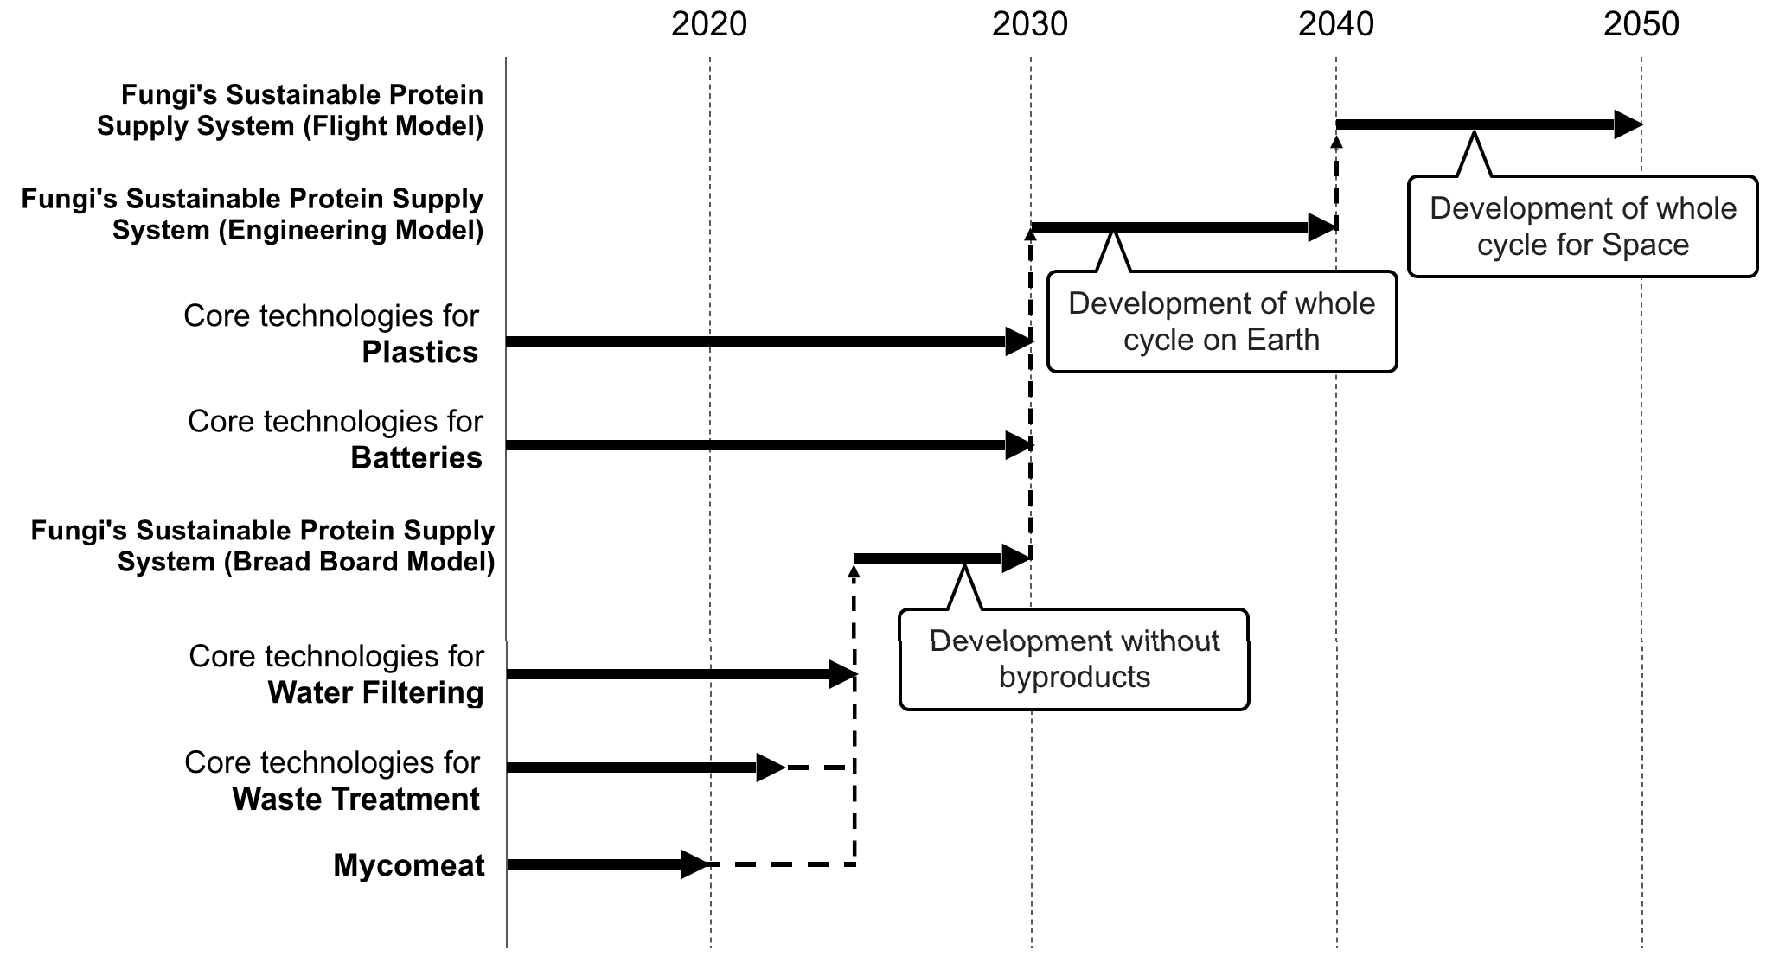

Figure 7 - Roadmap for the development of the Sustainable Protein

Supply System (SPSS)

ity, but protein sources, which make up 20% of a healthy diet, have not yet been grown. Production of proteins from fungi in outer space may solve this gap since fungi can create protein-rich products even with- out photosynthetic action, are lightweight and easy to carry in space.

Thanks to their peculiar structure, beyond the fact that they can be a protein source, fungi can be also har- nessed for some other potential uses. Several studies show that, once the related technologies are fully devel- oped, fungi can be used to address fundamental prob- lems like materials production, energy storage and waste and water treatment. All these characteristics of fungi can be exploited to create a closed-loop system at the base of the proposed SPSS. Once these technologies are perfected and the SPSS is in place, it may help in achieving some of the Sustainable Development Goals set by the United Nations. If successfully tested on Earth communities, the SPSS may represent a future strategy in setting up self-sustained communities in outer space.

# Acknowledgements

This concept was the 1st Grand Prize winner, Real Tech Fund Prize winner and Shiseido Ginza Prize winner for the JAXA Young-International Space Exploration Fo- rum (Y-ISEF) Ideation Hackathon held in Tokyo, Japan, 28th February-3rd March 2018.

# References

1. Smith S., Zwart S., Heer, M., *Human Adaptation to Spaceflight: The role of Nutrition*. NASA, USA (2014).
2. Arquiza, A., Personal Interview, University of the Philippines, Diliman, 10th February 2018.
3. Cooper, M., Douglas, G., Perchonok, M., *Develop- ing the NASA Food System for Long Duration Mis- sions*, Journal of Food Science, 76:2, 2011.
4. Onishi. T., Personal Interview, JAXA Tsukuba Space Center, Japan, 28th February 2018.
5. NASA, *Vegetable Production System (Veggie),* 2018, https://[www.nasa.gov/mission_pages/station/researc](http://www.nasa.gov/mission_pages/station/researc) h/experiments/383.html, (accessed July 14th, 2018).
6. Pearlman, R.Z., *Astronauts Take the First Bites of Lettuce Grown in Space*, Scientific American, 2015, https://[www.scientificamerican.com/article/astronaut](http://www.scientificamerican.com/article/astronaut) s-take-first-bites-of-lettuce-grown-in-space/.
7. Lori Meggs, *Growing plants and vegetables in a space garden*, NASA Marshall Space Flight Center, https://[www.nasa.gov/mission_pages/station/researc](http://www.nasa.gov/mission_pages/station/researc) h/10-074.html, (accessed July 18th, 2018).
8. Masaa, G., Newsham, G. Hummerick, M., Caro, J., Stutte, G., Morrow, R., Wheeler, R., *Preliminary Species and Media Selection for the Veggie Space Hardware,* Gravitational and Space Research, 1 (1): 95 – 106, 2013.
9. Linda Herridge, *Veggie Plant Growth System Acti- vated on International Space Station,* 2017, https://[www.nasa.gov/content/veggie-plant-growth-](http://www.nasa.gov/content/veggie-plant-growth-) system-activated-on-international-space-station, (ac- cessed July 20th, 2018).
10. Bhat, Z.F., Kumar, S., Fayaz, H., *In Vitro Meat production: Challenges and benefits over conven- tional meat production*, Journal of Integrative Agri- culture, 14:2 241-248, 2015.
11. *The appearance of Fusarium Venenatum A3/5 as collected from the outlet of the Quorn™ fermenter, Digital image,* 2002,

https://[www.researchgate.net/figure/The-](http://www.researchgate.net/figure/The-) appearance-of-Fusarium-venenatum-A3-5-as- collected-from-the-outlet-of-the- Quorn_fig2_228813798, (accessed July 20th, 2018).

1. Wiebie, M.G., *Mycoprotein from Fusarium Ven- enatum: a well-established product for Human con- sumption*, 58:421–427, 2002.
2. Ward, L., *Ryerson students launch mushrooms into space*, CBC News, 28th July 2016, https://[www.cbc.ca/news/canada/toronto/space-](http://www.cbc.ca/news/canada/toronto/space-) mushrooms-ryerson-1.3698559, (accessed July 20th, 2018).
3. *Tasty Mould: Quorn, Tempeh, and Huitlacoche*, Digital image, 2014, <http://openurbanism.blogspot.com/2014/01/tasty-> mould-quorn-tempeh-and-huitlacoche.html, (ac- cessed July 20th, 2018).
4. Morley, C., *North Carolina style vegetarian vine- gar pulled pork with coleslaw*, Digital image, 2015, https://[www.cutoutandkeep.net/projects/pulled-](http://www.cutoutandkeep.net/projects/pulled-) quorn-pork-burgers, (accessed July 20th, 2018).
5. Quorn, *Burgers*, Digital image, 2017, https://[www.quorn.us/products/burgers,](http://www.quorn.us/products/burgers) (accessed July 20th, 2018).
6. Denny, A., Aisbitt, B., Lunn, J., *Mycoprotein and Health*, Nutrition Bulletin, 33(4):298–310, 2008.
7. National Audit Office, *Carbon Trust: Accelerating the move to a low carbon economy,* United Kingdom: Comptroller & Auditor General, 2004.
8. Harrison, R., Johnson, R., *Mycoprotein production and food sustainability,* Microbiology Society, 2018, https://microbiologysociety.org/publication/current- issue/microbes-and-food/article/mycoprotein- production-and-food-sustainability.html, (accessed July 4th, 2018).
9. Stamets, P., *Comprehensive Assessment of Mycofil- tration Biotechnology to Remove Pathogens from Urban Stormwater*, Environmental Protection Agen- cy, USA, 2012.
10. Apps, R., *Using Fungi to Clean Up Pollutants,* Permaculture, 2015, https://[www.permaculture.co.uk/readers-](http://www.permaculture.co.uk/readers-) solutions/using-fungi-clean-pollutants, (accessed Ju- ly 4th, 2018).
11. Pleissner, D. Kwan, T., Sze Ki Lin, C., *Fungal hydrolysis in submerged fermentation for food waste treatment and fermentation feedstock preparation,* Bioresource Technology, 158, 48-54, 2014).
12. Kamenik, I., Marecek, J., *The use of waste cellu- lose in production of white mushroom substrate,* 59(5):131-136, 2011.
13. Sarwar, M., *The Future of Plastic Waste Disposal Could Be a Fungus*, MIT Technology Review Paki- stan, 2017, <http://www.technologyreview.pk/future-> plastic-waste-disposal-fungus/, (accessed July 7th, 2018).
14. Wosten, H., *Prestigious BraunPrize for converting plastic into food*, Utrecht University News, 2015, https://[www.uu.nl/en/news/prestigious-braunprize-](http://www.uu.nl/en/news/prestigious-braunprize-) for-converting-plastic-into-food, (accessed August 5th, 2018).
15. Wang, C., Xiong, Y., Wang, H.,Jin, C., Sun, Q., *Naturally three-dimensional laminated porous car- bon network structured short nano-chains bridging nanospheres for energy storage*, Journal of Materials Chemistry, 5, 15759–15770, 2017.
16. Kiran, E. & Trzcinski, *Optimizing the conversion of Food Waste to Sugars using Fungal Enzymes*, A.EC Microbiology, Singapore, 2017.
17. Campbell, B., Ionescu, R., Favors, Z., Ozkan, C. S., Ozkan, *M. Bio-Derived, Binderless, Hierarchically Porous Carbon Anodes for Li-ion Batteries*, Scien- tific Reports, 5, 14575, 2015.
18. Flores, R., *Plastic Alternatives: Exploring Myceli- um as a Medium,* New York, 2015.
19. Strom, S., *Packaging Food with Food to Reduce Waste*, The New York Times, 2017, https://[www.nytimes.com/2017/05/30/dining/packag](http://www.nytimes.com/2017/05/30/dining/packag) ing-materials-food-waste.html?_r=1, (accessed Au- gust 7th, 2018).
20. Muhammad, H., Canale, C., Ceserraciu, L., Atha- nassiou, A., *Advanced Materials from Fungal Myce- lium: Fabrication and Tuning of Physical Properties*, Scientific Reports, 7:41292, 2017.
21. Mastny, L., McKeown, A., Moomaw, W., Scherr, S., Sthapit, S., Starke, L., *State of the World: Into a Warming World*, Worldwatch Institute, USA, 2009.