ASSESSMENT OF METRO CEBU’S GROUNDWATER VULNERABILITY TO SEAWATER INTRUSION USING THE GALDIT INDEX

# ABSTRACT

Groundwater is an essential source of freshwater in the Philippines. However, this resource is vulnerable to deterioration if not properly managed due to both natural and anthropogenic forces. To overcome this, this study aims to identify and locate areas which exhibit higher tendencies of groundwater contamination using publicly available datasets. Metro Cebu, one of the country’s major economic centers, was chosen as the study area as larger amounts of groundwater extraction and existing seawater intrusions have been observed in the region. For this study, the GALDIT index is introduced to highlight areas with higher vulnerabilities to seawater intrusions based on several parameters. Additionally, several alterations of the original GALDIT method were also implemented to provide better insights as to how the investigated parameters influence the vulnerability of the area. Lastly, the outputs of this study are intended to be used as decision support tools by different stakeholders and water resource managers.

***Keywords:*** groundwater, vulnerability, GIS, GALDIT, Cebu

# INTRODUCTION

Groundwater plays an essential role in meeting the rising global demand for freshwater. It is estimated that around 30% of the world’s freshwater resources are located underground and are not readily accessible for use [1]. Currently, the total volumetric estimates of global groundwater ranges from 16 to 30 million cubic kilometers. However, the resource is unevenly distributed throughout the globe with some countries having scarce amounts of groundwater [2]. As population continues to increase at an alarming pace, excessive extraction is expected to occur to sustain the growth of municipal, industrial, and agricultural sectors. This rapid increase in the rate of consumption may not allow enough time for sufficient recharge of groundwater aquifers which may lead to a premature depletion of the natural resource. This emphasizes the urgent need for monitoring systems which can aid in the proper assessment and management of both local and regional groundwater resources [3]. While the true quantity and status of global subsurface freshwater still remains uncertain, it is clear that this resource will have a significant part in addressing the need for clean water especially in water-stressed regions worldwide.

Countries located in arid regions of the world still struggle to locate and produce water from their groundwater resources. This has led to advancements in the field of groundwater management in water-stressed regions such as the management of transboundary aquifers shared by multiple countries in Africa. These leaps in management have made substantial influence in protecting the groundwater resources in arid regions; however, this also highlights the lagging efforts in research for other vulnerable aquifers such as those near the coastlines. Around 40% of the world’s population is clustered within or near coastal areas. The coastal aquifers located in these areas that supply the communities and cities are considered susceptible to contamination by seawater which may render the groundwater unusable or require additional measures before it may be considered usable [4]. Moreover, coastal aquifers have also been found to be vulnerable to the impending effects of climate change.

In the case of the Philippines, an archipelago that has one of the longest coastlines, the country houses a significant portion of its cities and municipalities’ population near its coasts. The islets and large island groups that comprise the country are surrounded by several straits, seas and open ocean [5]. Depending on the region, the groundwater produced via deep wells is used for various purposes across different sectors such as agriculture, municipal, and industrial sectors. Excessive and unmonitored extraction of groundwater may potentially harm a number of the country’s most important hydrogeologic systems due to hastened seawater intrusions. The country currently has three metropolitan areas which are agglomerations of highly-urbanized municipalities and cities. These metropolitan centers are areas of high economic growth and are central to both local and international commerce and logistics [6]. In one of these densely populated areas, Metropolitan Cebu, groundwater extraction has far exceeded the prescribed limits for sustainable production [7]. Furthermore, the country’s coastal aquifers are more exposed to the effects of climate change as the country frequently encounters typhoons, experiences storm surges, and sea level rises greater than the global average [5].

To monitor this anticipated influence of both human and environmental factors to the overall quality of groundwater supply, consistent sampling and data gathering from monitoring wells are being conducted. This establishes a baseline statistic and identifies possible trends in groundwater quality [8]. However, identifying priority areas for monitoring provides a difficult challenge for groundwater management planners due to the (a) large costs associated with establishing monitoring wells, (b) a scarcity of information about the locations of both abandoned and functional wells, and (c) the lack of a system that identifies the optimal locations of wells for

monitoring groundwater quality. This work sets its sights on aiding the selection of priority areas for monitoring the coastal aquifers of Cebu based on their vulnerability to seawater intrusions.

The vulnerability of an aquifer refers to its likelihood of contamination due to either anthropogenic or natural forces. It’s considered an intrinsic property of the aquifer which depends on several contributing factors that highly depend on the identified possible sources of contamination for the groundwater system. Because contamination might come from different and multiple sources, several methodologies have been developed specifically targeting the aquifer’s vulnerability to certain contaminants. In most vulnerability studies, popular index-based methods such as DRASTIC, GOD, and SINTACS are being implemented to classify areas of the aquifer with different vulnerabilities [9]. However, these methods do not mainly address the aquifer’s vulnerability to seawater intrusions but rather focus on the tendency of contamination from sources aboveground. In coastal aquifers, such as those found in this presented study, the concept of an index-based groundwater vulnerability method called GALDIT and some of its derivative hybrid methodologies are used to identify the vulnerability of the aquifer to seawater intrusion [10]. For this work, methods such as GALDIT-AHP and GALDIT-SUSI were tested against the classic method to determine the differences in their classification of vulnerable areas.

In summary, this study aims to implement several index-based methods for the assessment of groundwater vulnerability in the Metro Cebu area. The maps were constructed using publicly available datasets and open-source tools for geospatial information systems (GIS). The results of this study are to be used as decision support tools for local authorities for the protection and monitoring of the region’s groundwater resource as well as for future research and development work.

# METHODOLOGY

## Study Area

Metropolitan Cebu refers to a collection of 9 urbanized cities and municipalities in the island province of Cebu, Philippines. According to the region’s Mines and Geosciences Bureau, Cebu is composed of 11 geological formations which are namely: Talavera group, Naga group, quartz diorite, largely intra-Miocene quartz diorite, Mananga group, Carcar Limestone, keratophyre and andesite flows, Barili formation, basement complex, ultramafic and mafic plutonic rocks, and quaternary alluvium.

The metropolitan area extends from longitudes 123.5˚ to 124.6˚ E and latitudes 9.9˚ and 10.8˚ N and has an area of approximately 786 km2. It is considered as the second largest urbanized metro in the country. The different municipalities and cities comprising the study area are stretched along the eastern coastline of the island province. These include Danao, Compostela, Liloan, Consolacion, Mandaue City, Cebu City, Minglanilla, Talisay City, and Naga City. Figure 1 shows the location and extent of the study area. Latest reports project the population of metro Cebu to reach 3.8 million by 2030. The aquifers which provide the needed groundwater supply for the growing region are classified as coastal aquifers and may be considered vulnerable to saltwater intrusions if not properly monitored and managed.

The administrative boundaries of metro Cebu are further delegated into smaller government units called barangays. To streamline the government’s efforts, the barangays have been entrusted with administering their constituents. These include responsibilities such as health services, public security, and in some cases environmental and natural resources protection [11]. The

administrative boundaries of the 270 barangays comprising metro Cebu were used to divide the study area into smaller units of interest which will be used throughout the study in determining the prioritized areas based on the GALDIT index.

## GALDIT Methodology

The GALDIT method is a groundwater management tool which uses a numerical ranking system to assess groundwater vulnerability to sea water intrusion [12]. The method considers six parameters which include groundwater occurrence, aquifer hydraulic conductivity, height of groundwater above sea level, distance from the shore, impact of existing status of seawater intrusion, and thickness of aquifer. To calculate the GALDIT index, the values and classifications associated with the aforementioned indicators must be identified together with their corresponding rating [13].

Eq.1 shows the formula for calculating the GALDIT index (Gi) where Wi and Ri correspond to the weight and rating of the ith parameter, respectively. Table 1 shows the different ranges of the parameters with their corresponding weights and rating scores. Using the datasets collected from different sources, several thematic maps were generated which represent the geospatial distribution of the vulnerability ratings for each parameter. Groundwater quality data was collected from the country’s National Water Resources Board. Maps for Cebu's geology were sourced from the region’s Mines and Geosciences Bureau. Digital elevation models and administrative boundaries were provided by the different mapping agencies in the area. After the maps for each layer were created, the overall GALDIT index map was constructed using Eq.1.

After establishing a GALDIT index map, a zonal statistics analysis for each barangay with the GALDIT index used as the parameter of interest was conducted. The mean GALDIT index values were then used to classify which barangays showed low, moderate, and high vulnerability to sea water intrusions. Shapefiles of the administrative boundary for the 270 barangays were retrieved from the country’s mapping agency, NAMRIA. The steps in generating the GALDIT index map were repeated with minor alterations to produce the GALDIT-AHP and GALDIT-SUSI index maps. In the case of the GALDIT-SUSI index, the production of additional layers was required as it considers factors such as rivers, torrents, lagoons, and wetlands in its computation.

# RESULTS AND DISCUSSION

## Groundwater Occurrence

Groundwater occurrence refers to the type or types of aquifer located in the study area. The 4 types of aquifers classified for the GALDIT method include confined, unconfined, leaky, and bounded. The coastal aquifers of metro Cebu are composed of unconfined and semi-confined aquifers where limestone is overlain by unconsolidated and alternating sediments near the coast. The aquifer exhibits a transmissivity of 2,000 to 3,000 m2/d, a storage coefficient of 0.01 and 0.05, a specific yield of 3% to 27%, and a resistivity of 360 to 640 ohm-m [14]. As shown on Figure 2a, around 60% of the study area has an unconfined aquifer while the remaining area is considered leaky or semi- confined aquifer. The leaky aquifer that lies nearest to the coastline stretches from 1.3 to 10 km inland.

## Aquifer Hydraulic Conductivity

The aquifer hydraulic conductivity data is estimated from the geology of the study area as further explained by Basilan et al. [15]. The important geological formations found in metro Cebu consist of

Carcar limestone, quaternary alluvium, Barili formation, Mananga group, and Largely intra-Miocene quartz diorite. The quaternary alluvium and Carcar limestone which lie nearest to the coasts exhibit moderate to high hydraulic conductivities which suggests saltwater vulnerability. Moving further inland, the rest of the formations show low conductivity and, therefore, lower vulnerability to seawater intrusions. Figure 2b shows the geospatial distribution of the hydraulic conductivity rating for the study area. The majority of the aquifer (57%) located within the metro Cebu area show low vulnerability; however, 18% of the total land area shows a GALDIT rating of 10 which are attributed to the Carcar limestone located near the coastline.

## Height of Water above Sea Level

The data for the static water level was retrieved from the Philippine National Water Resource Board database and interpolated through inverse distance weighting. A total of 94 data points were used to generate the water level map. The static water level raster layer was then deducted to a digital elevation model map of metro Cebu to generate a contour map which represents the height of the water table relative to the mean sea level. See Figure 2c. In general, the height of the water above sea level is lower near the coasts and rises further inland. Some areas have depressions on their water table heights of up to 20 meters below sea level which indicate excessive extraction in its vicinity. These areas are considered highly vulnerable to saltwater intrusions. Areas with a height of groundwater level above mean sea level of less than 1m represents 16% of the study area and are generally located at areas with lower elevations and closer to the coasts.

## Distance from the Shore

The distance from the shore layer was generated using a proximity analysis of metro Cebu’s natural coastline. According to the GALDIT index ratings, areas nearer to the coasts exhibit greater vulnerability to seawater intrusions. The vulnerability to seawater intrusions decreases further inland. Around 88% of the area exhibits the lowest rating for vulnerability attributed to distance from the shore line as seen on Figure 2d. In the case of Cebu, the presence of large land reclamation projects has altered the coastline of the study area. Moreover, as the island province experiences higher rates of coastal sea level rise which may, in the future, alter the distance from the shore data that will likely influence the groundwater vulnerability of the area [12].

## Impacts of Existing Status of Seawater Intrusion

Originally, the metric used to rate the impacts of existing seawater intrusions are based on the chloride and carbonate components of the sampled groundwater in the study area. However, it has been found out that the groundwater’s electrical conductivity can also be used as an alternative to estimate seawater intrusions in groundwater aquifers [16]. This concept was applied to this study and showed that seawater intrusions are apparent in some areas near the coasts. A total of 186 locations with electrical conductivity data were used to produce the thematic layer (Figure 2e) for this parameter. Most of the area (95%) being investigated exhibited low scores for this parameter with only less than 1% of the area showing existing seawater intrusions.

## Thickness of Aquifer

Several previous research efforts in the study area have reported the coastal aquifers of metro Cebu to be from 20m to 80m. For this study, the entire study area was assigned a high vulnerability rating for aquifer thickness, as seen on Figure 2f, as minimum thickness recorded for the coastal aquifers located within metro Cebu are greater than 10m [17,18].

## GALDIT Scores

Some previous reports have demonstrated the viability of using overlain index methods using GIS to determine groundwater vulnerability in other parts of the Philippines. This procedure, DRASTIC, has been the most used groundwater vulnerability index used due to the easily accessible dataset requirements. The layers or parameters considered for these mapping efforts include depth to water table, recharge, aquifer material, soil and vadose zone material, topography, and hydraulic conductivity [15,19]. While these parameters do exhibit the area of interest’s vulnerability to contamination from sources located on the surface, they are unable to estimate the tendency of horizontal movement of seawater moving inland [20]. To specifically look at potential seawater intrusions on coastal aquifers, a more adequate index such as GALDIT is being commonly implemented [21].

The GALDIT method was applied for the entire extent of study area to evaluate the vulnerability of the area’s coastal aquifers to seawater intrusion. Figure 3a shows the geospatial distribution of vulnerability to seawater intrusions in metro Cebu. The vulnerability of the areas was classified based on their calculated decision criteria or its GALDIT score. A GALDIT score of greater than 7.5 is considered highly vulnerable to seawater intrusion, scores in between 7.5 and 5.0 are considered moderately vulnerable, and values with less than 5.0 exhibit low vulnerability. The results of this study suggest that areas lying near the coastlines exhibit very high vulnerabilities to groundwater contamination with GALDIT values greater than 7.5. Highly vulnerable areas extend as far as 1km inland and cover around 52 sq. km area which is 7% of the entire of the study area. The high index scores found at these areas are attributed to their high ratings for the height of water above sea level and distance from shore criteria. Both the L and D layers have weights of 4 which are the highest among the different criteria covered by the GALDIT index.

Moving further inland, the vulnerability to seawater decreases to moderate levels. The areas lying immediately after the high vulnerability zones have higher aquifer hydraulic conductivity levels as they lie on Carcar limestone. Despite having high vulnerability scores for the A layer due to the innately high hydraulic conductivity of limestone, this middle area still lies further from the coastlines and has elevated water levels relative to the main sea level. Most areas in this region present GALDIT index values of around 5 to 7.5 which are considered moderate scores for seawater intrusion. The farthest points from the coastline received low scores for vulnerability. This area is characterized by aquifers with low hydraulic conductivity, high levels for the water table, and has no signs of existing seawater intrusions.

Out of 270 barangays in metro Cebu, only 229 barangays were covered by the final GALDIT index layer generated. Around 46% of the barangays present low vulnerability to seawater intrusions, 31% showed moderate vulnerability scores, and 23% are classified as highly vulnerable areas. These results can aid in the selection of specific barangays for locating possible monitoring wells. However, a noteworthy shortcoming for this prioritization process could be the uneven areas for barangays.

While the classic GALDIT index does provide the needed insights to help manage groundwater sources based on their vulnerability using cheap and available data, the subjectiveness of the weights and ratings of these numerical ranking systems has always been a major downside. To overcome this obstacle, advancements and alterations of the classical GALDIT methodology have been achieved using techniques such as machine learning and more complex concepts [22,23]. In this study, the weights of a GALDIT index improved by the analytical hierarchy process, GALDIT- AHP, was also used to show the sensitivity of the assessment when parameter weights are changed

[24]. The procedure suggested by Mirzavand et al. was implemented and was compared to the original GALDIT scores achieved in this study.

In general, the GALDIT-AHP index classified lesser areas as moderately vulnerable when compared to the classic GALDIT scores. The percentage of areas classified with moderate vulnerability by the GALDIT-AHP was 15% less than the original index method. However, the areas with high vulnerability scores were, more or less, the same with a difference of less than 1%. This disparity in labeling moderately vulnerable areas was due to the classic GALDIT method placing a greater importance on the aquifer hydraulic conductivity factor than its GALDIT-AHP counterpart. This can be observed in the map generated, Figure 3b, using the GALDIT-AHP, where there has been an exclusion of the areas covered with Carcar limestone from the moderately vulnerable classified regions.

Recent improvements of the GALDIT scores have also leaned towards the inclusion of new parameters. Additional parameters that have been considered include natural features and built-up areas [25,26]. For this work, a variation of the GALDIT index that considers superficial seawater intrusion, GALDIT-SUSI, was also implemented. In the case of metro Cebu where rivers, wetlands, lagoons, and streams are located, this procedure would provide a much needed insight as to how these features might influence the groundwater vulnerability of the area. For the computation of this index, six new thematic layers were created which represent elevation, vadose zone, rivers, torrents, lagoons, and wetlands. The additional maps are shown on Figure 4.

The scores for the GALDIT-SUSI method reveal that only 1% of the entire study area is classified as highly vulnerable. This is a noticeable decrease from the GALDIT and GALDIT-AHP scores which are 7% and 6% of the study area, respectively. The generally lower scores returned from the GALDIT- SUSI method are attributed to the greater number of parameters that are being considered by this index. Only a small portion of the study area shows high vulnerability caused by the new parameters introduced using this method. As shown in Figure 3c, most highly vulnerable areas labeled by this methodology are clustered around wetlands and lagoons which are parameters that are not considered by the previous GALDIT variations studied in this work. Table 2 shows the summary of vulnerable areas when using GALDIT, GALDIT-AHP, and GALDIT-SUSI.

The study has successfully mapped out the different parameters that are considered important in estimating the likelihood of seawater intrusion to the groundwater resources of metro Cebu. Moreover, areas that may require prioritized attention have been identified in this study through the use of the GALDIT index. The application of different variations of the index has revealed important insights into the robustness of this method as the classification of vulnerable areas rely heavily on the parameters and their corresponding weights assigned by the GALDIT method. Ultimately, the results of this study can serve as important tools for decision makers for the effective protection and conservation of metro Cebu’s groundwater resources.

# REFERENCES

1. Amanambu AC, Obarein OA, Mossa J, Li L, Ayeni SS, Balogun O, et al. Groundwater system and climate change: Present status and future considerations. J Hydrol [Internet]. Elsevier; 2020;589:125163. Available from: https://doi.org/10.1016/j.jhydrol.2020.125163
2. Gleeson T, Befus KM, Jasechko S, Luijendijk E, Cardenas MB. The global volume and distribution of modern groundwater. Nat Geosci. 2016;9:161–4.
3. Green TR, Taniguchi M, Kooi H, Gurdak JJ, Allen DM, Hiscock KM, et al. Beneath the surface of global change: Impacts of climate change on groundwater. J Hydrol [Internet]. Elsevier B.V.; 2011;405:532–60. Available from: <http://dx.doi.org/10.1016/j.jhydrol.2011.05.002>
4. Prusty P, Farooq SH. Seawater intrusion in the coastal aquifers of India - A review. HydroResearch [Internet]. The Authors; 2020;3:61–74. Available from: https://doi.org/10.1016/j.hydres.2020.06.001
5. Licuanan WY, Cabreira RW, Aliño PM. The Philippines [Internet]. Second Edi. World Seas An Environ. Eval. Vol. II Indian Ocean to Pacific. Elsevier Ltd.; 2018. Available from: https://doi.org/10.1016/B978-0-08-100853-9.00051-8
6. NEDA. Philippine Development Plan 2017-2022. Chapter 3: Overlay of Economic Growth, Demographic Trends, and Physical Characteristics. pp 30-52. 2017;30–52.
7. Cristina C, Arlene B, Roberto S, Ramon P, Guillermo Q. Metro Manila and Metro Cebu Groundwater Assessment. PIDS Discuss Pap Ser. 2001;
8. Uddin MG, Nash S, Olbert AI. A review of water quality index models and their use for assessing surface water quality. Ecol Indic [Internet]. Elsevier Ltd; 2021;122:107218. Available from: https://doi.org/10.1016/j.ecolind.2020.107218
9. Machiwal D, Jha MK, Singh VP, Mohan C. Assessment and mapping of groundwater vulnerability to pollution: Current status and challenges. Earth-Science Rev [Internet]. Elsevier; 2018;185:901–

27. Available from: https://doi.org/10.1016/j.earscirev.2018.08.009

1. Parizi E, Hosseini SM, Ataie-Ashtiani B, Simmons CT. Vulnerability mapping of coastal aquifers to seawater intrusion: Review, development and application. J Hydrol [Internet]. Elsevier; 2019;570:555–73. Available from: https://doi.org/10.1016/j.jhydrol.2018.12.021
2. Bañas JCC, Subade RF, Salaum DN, Posa CT. Valuing vanishing coasts: The case of Miagao coastline in Southern Iloilo, Philippines. Ocean Coast Manag. 2020;184.
3. Ferreira JPL, Chachadi AG, Diamantino C, Henriques MJ. Assessing aquifer vulnerability to seawater intrusion using the GALDIT method: Part 1-application to the Portuguese Monte Gordo aquifer. IAHS-AISH Publ. 2007;161–71.
4. Chachadi AG, Ferreira JPL. Assessing aquifer vulnerability to seawater intrusion using GALDIT method: Part 2 - GALDIT Indicators Description. IAHS-AISH Publ. 2007;172–80.
5. David S, Larano L. AN OVERVIEW ON THE CRITICAL IMPACT OF GROUNDWATER DEVELOPMENT AND EFFECTS ON METRO CEBU AND COASTAL AQUIFERS.
6. Basilan EG, Dayao AE. ASSESSMENT OF AQUIFER VULNERABILITY USING GIS-AIDED DRASTIC INDEX-OVERLAY METHOD AND MAPPING OF SALINE WATER INTRUSION USING ELECTRICAL RESISTIVITY SOUNDING METHOD: A CASE STUDY OF MASBATE CITY, MASBATE. 2019;
7. Chang SW, Chung IM, Kim MG, Tolera M, Koh GW. Application of GALDIT in assessing the seawater intrusion vulnerability of Jeju Island, South Korea. Water (Switzerland). 2019;11.
8. Japan International Cooperation Agency, Metro Cebu Water District. The Study for Improvement

of Water Supply and Sanitation in Metro Cebu, Main Report Ch 3. 2010;1–50.

1. Scholze, O , Hillmer G , Schneider W. Protection of the Groundwater Resources of Metropolis Cebu ( Philippines ) in Consideration of Saltwater Intrusion Into the Coastal. 17th Salt Water Intrusion Meet. 2002;1:489.
2. Linan EL, Ella VB, Florece LM. GIS-based assessment of groundwater vulnerability to contamination in Boracay island using DRASTIC model. J Environ Sci Manag. 2013;16:19–27.
3. Barbulescu A. Assessing groundwater vulnerability: DRASTIC and DRASTIC-like methods: A review. Water (Switzerland). 2020;12.
4. Allouche N, Maanan M, Gontara M, Rollo N, Jmal I, Bouri S. A global risk approach to assessing groundwater vulnerability. Environ Model Softw [Internet]. Elsevier Ltd; 2017;88:168–82. Available from: <http://dx.doi.org/10.1016/j.envsoft.2016.11.023>
5. Bordbar M, Neshat A, Javadi S, Pradhan B, Aghamohammadi H. Meta-heuristic algorithms in optimizing GALDIT framework: A comparative study for coastal aquifer vulnerability assessment. J Hydrol [Internet]. Elsevier; 2020;585:124768. Available from: https://doi.org/10.1016/j.jhydrol.2020.124768
6. Barzegar R, Razzagh S, Quilty J, Adamowski J, Kheyrollah Pour H, Booij MJ. Improving GALDIT- based groundwater vulnerability predictive mapping using coupled resampling algorithms and machine learning models. J Hydrol [Internet]. Elsevier B.V.; 2021;598:126370. Available from: https://doi.org/10.1016/j.jhydrol.2021.126370
7. Mirzavand M, Ghasemieh H, Sadatinejad SJ, Bagheri R, Clark ID. Saltwater intrusion vulnerability assessment using AHP-GALDIT model in Kashan plain aquifer as critical aquifer in a semi-arid region. Desert. 2018;32:255–64.
8. Kazakis N, Busico G, Colombani N, Mastrocicco M, Pavlou A, Voudouris K. GALDIT-SUSI a modified method to account for surface water bodies in the assessment of aquifer vulnerability to seawater intrusion. J Environ Manage [Internet]. Elsevier; 2019;235:257–65. Available from: https://doi.org/10.1016/j.jenvman.2019.01.069
9. Kazakis N, Spiliotis M, Voudouris K, Pliakas FK, Papadopoulos B. A fuzzy multicriteria categorization of the GALDIT method to assess seawater intrusion vulnerability of coastal aquifers. Sci Total Environ [Internet]. Elsevier B.V.; 2018;621:524–34. Available from: https://doi.org/10.1016/j.scitotenv.2017.11.235

**Table 1.** GALDIT parameters, weights, ranges, and rating

|  |  |  |  |  |  |
| --- | --- | --- | --- | --- | --- |
| **Parameter** | **GALDIT – SUSI**  **Weights** | **GALDIT - AHP**  **Weights** | **GALDIT**  **Weight** | **Indicator Ranges** | **Importance Rating** |
| Groundwater Occurrence (aquifer type) | 0.134 | 0.024 | 1 | Confined | 10 |
| Unconfined | 7.5 |
| Leaky | 5 |
| Bounded | 2.5 |
| Aquifer hydraulic conductivity (m/day) | 0.041 | 0.145 | 3 | >40 | 10 |
| 10 to 40 | 7.5 |
| 5 to 10 | 5 |
| <5 | 2.5 |
| Groundwater level above sea level (m) | 0.258 | 0.253 | 4 | <1 | 10 |
| 1 to 1.5 | 7.5 |
| 1.5 to 2.0 | 5 |
| >2.0 | 2.5 |
| Distance from the shore (m) | 0.101 | 0.448 | 4 | <500 | 10 |
| 500 to 750 | 7.5 |
| 750 to 1000 | 5 |
| >1000 | 2.5 |
| Impact of the existing status of seawater intrusion (uS/m) | 0.015 | 0.08 | 1 | >3000 | 10 |
| 2000 to 3000 | 7.5 |
| 1000 to 2000 | 5 |
| <1000 | 2.5 |
| Thickness of the aquifer (m) | 0.032 | 0.044 | 2 | >10 | 10 |
| 7.5 to 10 | 7.5 |
| 5 to 7.5 | 5 |
| <5 | 2.5 |
| Vadose zone hydraulic conductivity (m/day) | 0.101 |  |  | >40 | 10 |
| 10 to 40 | 7.5 |
| 5 to 10 | 5 |
| <5 | 2.5 |
| Elevation (m) | 0.165 |  |  | <2 | 10 |
| 2 to 4 | 7.5 |
| 4 to 10 | 5 |
| >10 | 2.5 |
| Torrent (m) | 0.012 |  |  | <75 | 10 |
| 75 to 150 | 7.5 |
| 150 to 300 | 5 |
| >300 | 2.5 |
| River (m) | 0.014 |  |  | <75 | 10 |

|  |  |  |  |  |  |
| --- | --- | --- | --- | --- | --- |
|  |  |  |  | 75 to 150 | 7.5 |
| 150 to 300 | 5 |
| >300 | 2.5 |
| Wetland (m) | 0.035 |  |  | <75 | 10 |
| 75 to 150 | 7.5 |
| 150 to 300 | 5 |
| >300 | 2.5 |
| Lagoon (m) | 0.092 |  |  | <75 | 10 |
| 75 to 150 | 7.5 |
| 150 to 300 | 5 |
| >300 | 2.5 |

**Table 2.** Summary of results when using GALDIT, GALDIT-AHP, and GALDI-SUSI

|  |  |  |  |  |  |  |
| --- | --- | --- | --- | --- | --- | --- |
|  | **GALDIT** | | **GALDIT-AHP** | | **GALDIT-SUSI** | |
| **Vulnerability** | **Area (km2)** | **%** | **Area (km2)** | **%** | **Area (km2)** | **%** |
| LOW | 533.79 | 69% | 652.22 | 84% | 656.94 | 85% |
| MODERATE | 190.60 | 25% | 75.05 | 10% | 110.04 | 14% |
| HIGH | 52.49 | 7% | 49.60 | 6% | 9.67 | 1% |

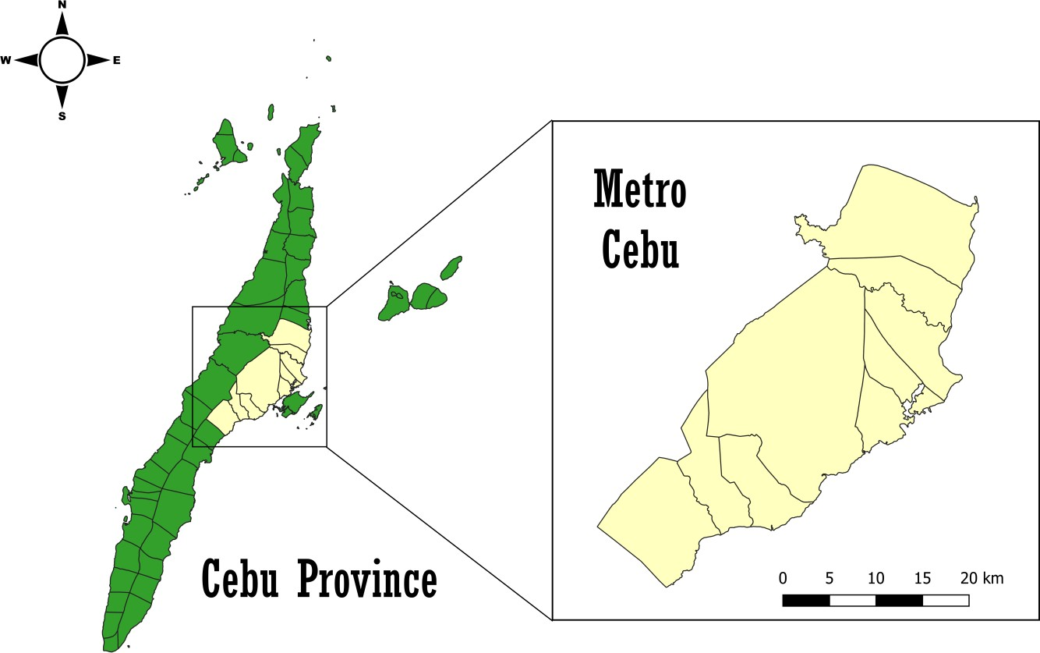

**Figure 1.** Location map of the study area.

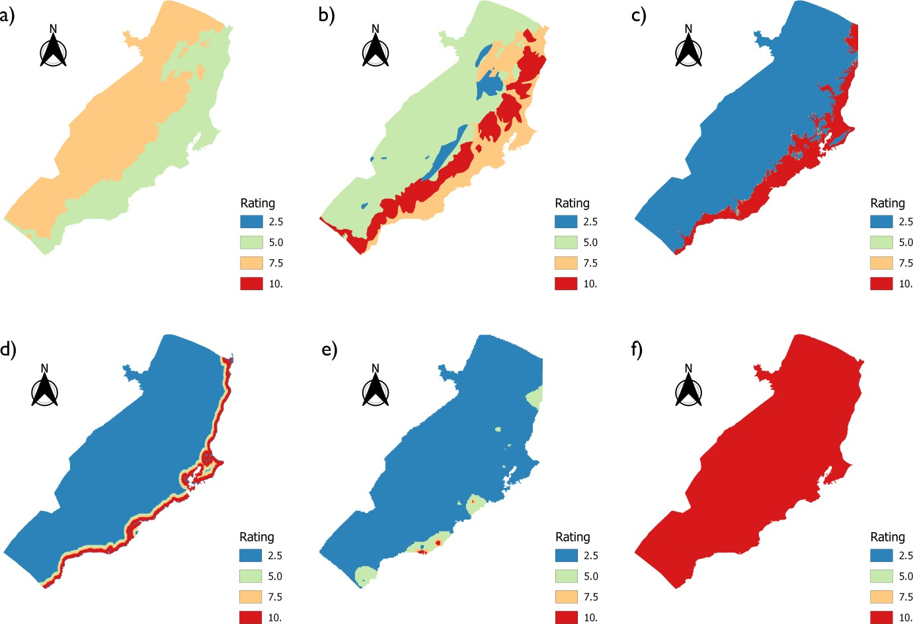

**Figure 2.** GALDIT rating spatial distribution maps for a) groundwater occurrence, b) aquifer hydraulic conductivity, c) height of water above sea level, d) distance from the shore, e) impact of existing seawater intrusion, and f) aquifer thickness

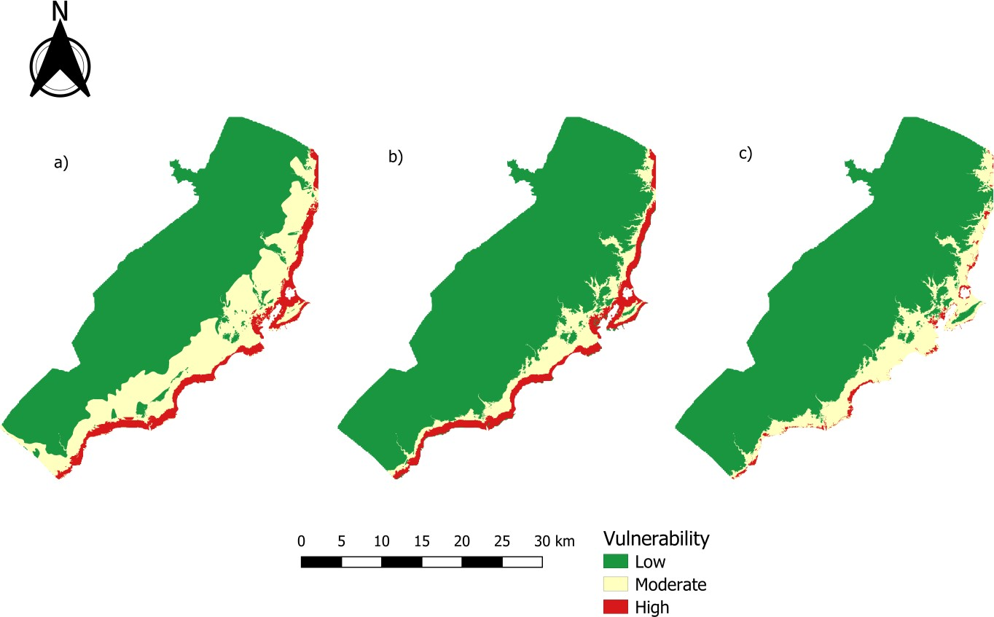

**Figure 3.** a) GALDIT, b) GALDIT-AHP, and c) GALDIT-SUSI index for Metro Cebu

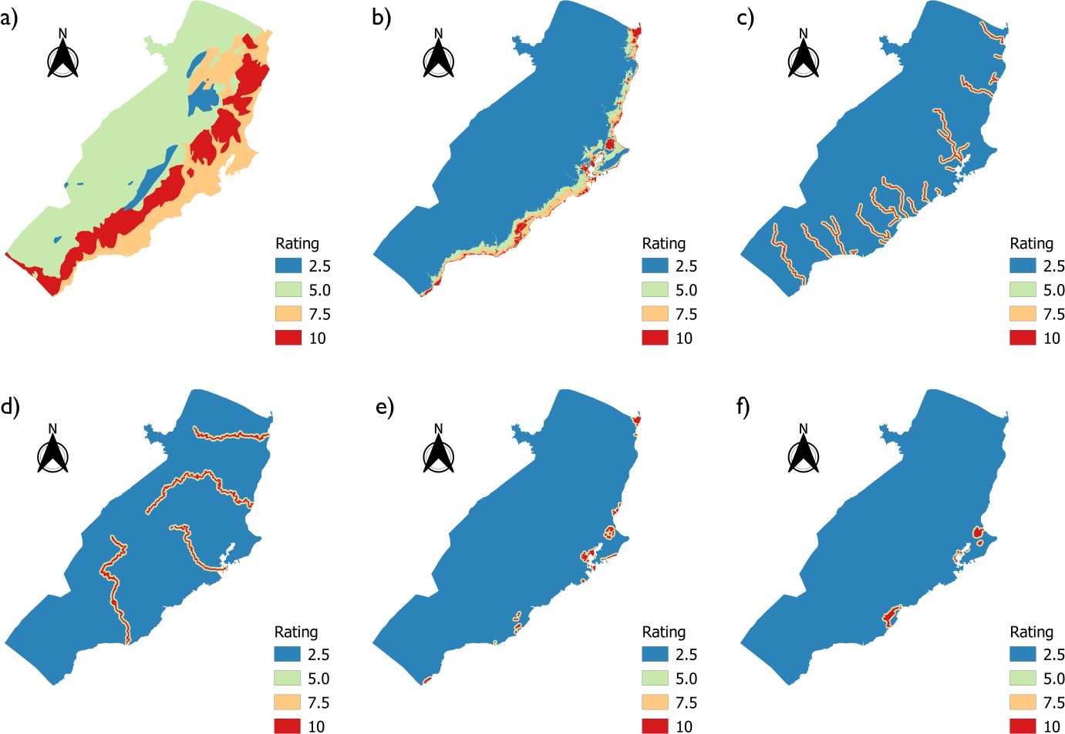

**Figure 4.** GALDIT-SUSI rating spatial distribution maps for a) vadose zone hydraulic conductivity,

b) elevation, c) torrents, d) river, e) wetlands, and f) lagoons