**Gender Audit as Basis in Developing Modules for GAD Focal Persons in Mati, Davao Oriental, Philippines**

# ABSTRACT

Many countries across the globe, including the Philippines, have implemented Gender and Development (GAD) policies to reduce gender biases and promote equality. However, mainstreaming efforts have been challenging due to the scarce availability of learning resources in the local context. This study is an initiative to provide the GAD Focal Point System (GFPS) in the Department of Education – City of Mati with a primary reference in training their GAD Focal Persons on Gender Sensitivity, GAD Planning, and Budgeting (GPB). The coverage is based on their learning needs and gaps determined through participatory strategies involving the school administrators, teachers, students, and parents. Also, the results of the gender audit using the Gender Mainstreaming Evaluation Framework (GMEF) are used as a baseline in module development. The framework presents strategic directions that agencies need to follow to advance across stages. It was found that Mati’s primary and secondary schools are in the initial stages of gender mainstreaming. As such, GAD’s basic concepts and definitions are introduced, along with various forms of gender- based violence and the appropriate mechanisms to address them aptly. The essential steps in planning and budgeting are also detailed, providing an active experience among the participants. It is imperative to sustain GAD capacity-building initiatives to catalyze a more directed and engaged policy framework.

*Keywords:* Gender and Development, Training Module, Basic Education, City of Mati

# INTRODUCTION

The Philippines is at the forefront in closing gender gaps compared to other Asian Countries (Philippine Commission on Women, 2021). Attaining gender equality and women’s empowerment has become more deliberate through apt gender mainstreaming initiatives in various human agencies. However, there remains a need to enhance support and monitoring mechanisms to effectively normalize gender and development in sub-national settings, particularly in the education sector (Sumadsad & Tuazon, 2016; Villegas et al., 2021).

Gender and Development (GAD) is an integral part of the basic education system. It is mainstreamed through the focal persons placed in various bureaucratic stances at the school, regional, and national levels (Department of Education, 2017; Sacro et al., 2021). The schools are mandated to assign people, formulate policies, enable mechanisms, and implement gender- related PPAs.

However, a significant gap necessitates translating gender policies into actions to catalyze visible impacts to the community. Gender responsiveness must be embedded in the curriculum to widen the access of different gender groups and improve academic performance (Hernandez & Cudiamat, 2018). Organizational support is also fundamental to the success of GAD implementation (Valencia, 2017; Sumasad & Tuazon, 2016). As such, a systemic approach to GAD is deemed urgent and compulsory.

In the City of Mati, devolving GAD programs remain a challenge. The focal persons have insufficient theoretical and experiential training, making it difficult to identify issues, plans, and implementation strategies. This study attempts to assess the gender mainstreaming

efforts of basic education institutions and consequently develop a training module to address learning needs and gaps in gender sensitivity, planning, and budgeting.

# METHODOLOGY

## Research Locale

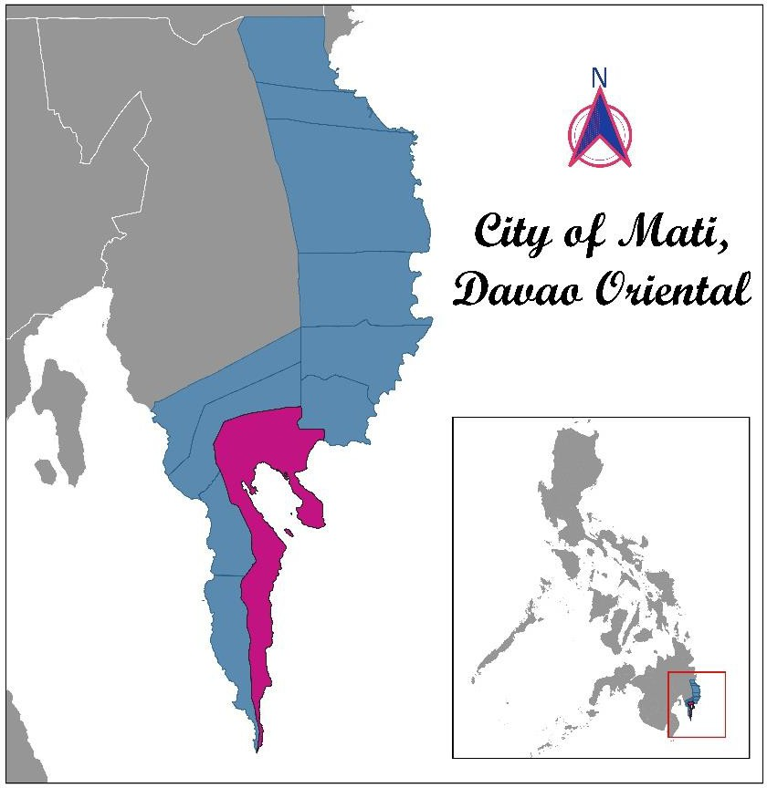

**Figure 1.** Coordinates map of the surveyed sites in the City of Mati, Davao Oriental, Philippines. (Cartographer: Verzosa, 2021).

The study was conducted in Mati, Davao Oriental, Philippines (6.9522° N, 126.2173° E), involving 43 basic education institutions under the Schools Division of Mati. More specifically, this project surveyed 29 primary and 15 secondary schools. The City is known for its agritourism industry. It is home to the Mt. Hamiguitan Wildlife Range Sanctuary (MHWRS), a UNESCO World Heritage Site, and Dahican and Pujada Bay, The Most Beautiful Bays in the World.

## Entry Protocol

The Davao Oriental State University (DOrSU) is home to Davao Oriental’s only Gender and Development (GAD) Center. Its primary mandates include integrating gender in the university’s curriculum, research, and extension initiatives. On this premise, the Center led a research and extension project to assess and assist the Department of Education (DepEd) Schools Division of Mati in their gender mainstreaming efforts. A Memorandum of Agreement (MOA) was inked to formalize the partnership between the two agencies, stipulating research- based technical assistance.

## Gender Audit

The Philippine Commission on Women’s (PCW) (2016) Gender Mainstreaming and Evaluation Framework (GMEF) was utilized in determining the significant milestones and gaps in GAD implementation among 43 primary and secondary schools in the City of Mati, Davao Oriental. It is a tool to evaluate the gender mainstreaming efforts of an organization in an attempt to assess the GAD Focal Point Systems (GFPS) in the improvement of their initiatives.

Four key result areas (KRAs) were examined, including the people, policy, enabling mechanisms, and programs, projects, and activities (PPAs). The first KRA necessitates the designation and capacitation of GAD champions, advocates, program implementers, and experts to lead various GAD initiatives. Meanwhile, the issuance of GAD policies and their integration and continuous enhancement in school mandates is another critical aspect that the tool evaluates. The schools are expected to set up essential GAD mechanisms, structures, and systems on enabling mechanisms. Lastly, the PPAs refer to the initiatives to facilitate, establish commitment, apply, and institutionalize GAD mainstreaming.

## Module Development

Expert resource persons in biology, psychology, and criminology were pooled to develop the training modules. Their varied field of expertise encompasses the interdisciplinary nature of GAD, thus providing a more comprehensive approach to understanding its fundamental concepts and normative practices in the Philippines. Based on the previously mentioned specializations, the module tackles the nexus among the biological, environmental, social influences on gender. It also emphasizes the legal perspectives, rationalizing gender- based violence and their corresponding penalties in the Philippine context. As such, the module presents a multi-faceted comprehension of gender beyond the traditional notions through a social lens.

## GAD Training Series

Numerous training on gender sensitivity, planning, and budgeting among the primary and secondary schools under the DepEd Mati was conducted from 2018 until 2021. The participants were school administrators, teachers, students, parents, and other stakeholders. Most of the training sessions were conducted face-to-face, although some are held online using Zoom or Google Meet given the physical restrictions during the COVID-19 pandemic.

Through a participatory training approach, the contents were purposefully developed by a pool of experts, incorporating the knowledge gaps, frequently asked questions, and least learned competencies in GAD. The long-standing partnership between DOrSU and DepEd Mati has informed both the content experts and participants. This strategy in module development, the user-centered usability test, contextualizes the learning needs of the target communities.

## Expert Review

Expert review, otherwise known as expert analysis, employs multiple experts to review the module independently. Three content experts were invited from DOrSU and DepEd Mati to examine the contents of the material using heuristic evaluation techniques. A more in-depth content assessment was also conducted through qualitative interactions between the module

developer and reviewer. Results of the review process were incorporated in the final version of the training module.

# RESULTS AND DISCUSSION

## Gender Mainstreaming

Table 1. Levels of Gender Mainstreaming in the Primary Schools in the City of Mati, Davao Oriental

|  |  |  |  |
| --- | --- | --- | --- |
| **Key Result Areas** | **Score** | **Stage** | **Remarks** |
| People | 1.5431 | 2 | Installation of strategic mechanisms |
| Policy | 0.8966 | 1 | Foundation formation |
| Enabling Mechanisms | 0.2897 | 1 | Foundation formation |
| Programs, Projects, and Activities | 1.2880 | 2 | Installation of strategic mechanisms |
| **OVERALL** | **1.0044** | **2** | **Installation of strategic**  **mechanisms** |

Table 2. Levels of Gender Mainstreaming in the Secondary Schools in the City of Mati, Davao Oriental

|  |  |  |  |
| --- | --- | --- | --- |
| **Key Result Areas** | **Score** | **Level** | **Remarks** |
| People | 0.1367 | 1 | Foundation formation |
| Policy | 0.6667 | 1 | Foundation formation |
| Enabling Mechanisms | 0.4400 | 1 | Foundation formation |
| Programs, Projects, and Activities | 1.2444 | 2 | Installation of strategic mechanisms |
| **OVERALL** | **0.9294** | **1** | **Foundation formation** |

The Gender Mainstreaming Evaluation Framework (GMEF) revealed that the primary schools are in the installation of strategic mechanisms (Stage 2), while the secondary schools are in the foundation formation (Stage 1) of GAD implementation. These stages are indicative of the different developmental needs in the surveyed schools.

Primary schools in the City of Mati are now in a transition towards gender mainstreaming. The Philippine Commission on Women (2016) has outlined the essential steps that need to be undertaken in four areas: people, policy, enabling mechanisms, and PPAs. Strategic mechanisms are put in place in primary schools, but more efforts are needed to attain GAD application. It is recommended that schools institutionalize a GAD focal system, spell out the school’s visions and goals on gender mainstreaming, identify institutional mechanisms such as funding and staff, and issue various policies and guidelines.

On the one hand, secondary schools are found to be in the initial stage of GAD implementation. At the onset is the need for people to understand, appreciate, and imbibe gender sensitivity. It is fundamental to incorporate RA 7192, otherwise known as the Women in Nation Building Act, in the school operations. As such, the schools must issue broad statements to support GAD, review existing policies, allocate budget, and evaluate and analyze the school’s potentials to incorporate GAD.

The results underscored that mastery of the GAD concepts is fundamental for its successful implementation at the school level. There is a need to appoint a focal person, who shall undergo a rigorous capacity-building to be equipped with an understanding of GAD, gender-related issues, and DepEd’s framework of gender-responsive basic education. In this way, the focal person may critically identify gender issues and plan initiatives to address each appropriately.

Meanwhile, monitoring schemes at the division level must be established to put pressure on the school implementers. The division’s focal person shall be in charge of GAD implementation of the entire division under the leadership of the Schools Division Superintendent. In addition to this function is the continuous assessment and monitoring of gender mainstreaming to ensure sustainability (Sacro et al., 2021). The issuance of policies to formalize and enable these mechanisms is also needed as a legal basis for implementing GAD PPAs.

## On the Development of a Training Module

The Gender and Development (GAD) Training Module is intended for the GAD Focal Persons in the basic education schools in Mati, Davao Oriental. The contents were contextualized to fit their learning needs, as revealed in the GAD mainstreaming evaluation. In hindsight, this module contains important topics in gender sensitivity, planning, and budgeting. Romero et al. (2020) and Arellano-Hernandez (2018) ideated that training and seminars effectively raise awareness about GAD.

Table 3 details the different lessons and topics covered in the training module. Emphasis is put into the GAD basic concepts and definitions towards resolving gender issues and promoting gender-responsiveness in the school setting.

Table 3. Content Outline of the Training Module for GAD Focal Persons in DepEd City of Mati

|  |  |
| --- | --- |
| **Lesson** | **Topic** |
| Understanding Gender and Development | Differences between Sex and Gender, The Biology of Sex, Humans and the Concept of Gender |
| Resolving Gender-Based Violence in Basic Education | Defining Gender-Based Violence, Gender- based Violence at School, Response to  School-Related Gender-Based Violence |
| Towards a Gender-Responsive Basic Education | Identifying Gender Issues inside the School, Gender-Responsive Teaching Design, GAD  Planning and Budgeting |

## Understanding Gender and Development (GAD)

The Governance and Social Development Resource Centre (GSDRC) (2015) asserted that gender is an integral development component. The GAD focal persons must have a concrete understanding of the nexus between gender and development on this premise. Hence, the training shall start with gender sensitivity, tackling the definitions of and differences between sex and gender from the biological and sociological perspectives (Jahn et al., 2017). The overarching goal is to inculcate the values of respect for individuals regardless of sex and

gender (United Nations Educational, Scientific and Cultural Organization (UNESCO), 2004). This lesson also expounds on the biology of sex, particularly the genotypic and phenotypic characters that distinguish females and males. In the last part, the transition from biological to social viewpoints is presented, recognizing the influence of the environment in the expression of sex and gender.

## Resolving Gender-Based Violence in Basic Education

Gender-based violence (GBV) is a perennial problem globally, which appeared to have worsened during the COVID-19 pandemic (Mittal & Singh, 2020). Residence, parental behavior, substance abuse, civil status, and educational attainment are the significant influences of the persistence of violence (Beyene et al., 2019). As such, the need to resolve GBV in the school setting is emphasized. In this lesson, the definition and various forms of GBV are thoroughly discussed, providing significant insights on its successful resolution. The identification of GBV is fundamental in planning and designing programs, projects, and activities. Several Philippine legislation, such as the Magna Carta of Women (RA 9710), Anti- violence Against Women and their Children (RA 9262), Anti-sexual Harassment Act (RA 7877), and Safe Spaces Act (RA 11313) are introduced to orient the GAD focal persons about the legal undertakings to address school-related GBV.

## Towards a Gender-Responsive Basic Education

In the last part of the module, the essential steps towards a gender-responsive basic education are outlined. The development of gender-responsive teachers is tantamount to creating safe spaces for school children (United Nations Children’s Fund (UNICEF), 2020). In this context, gender responsiveness entails identifying gender-related issues, curriculum integration, and an informed planning and budgeting process. It is anchored on the gender- responsive basic education policy promulgated under DO 32 s. 2017 (Department of Education, 2017).

More emphasis is given to GAD planning and budgeting (GPB), a detailed process of identifying gender issues, PPAs, and allocating the budget needed to address the issues raised effectively. This initiative is anchored on the need to equip the focal persons with technical know-how in complying with the minimum GAD expenditure requirements, at least 5% of the agency’s total budget appropriation under Republic Act No. 9710 (Department of Budget and Management, 2019). Actual expenditures for GAD PPAs and the attributed values must be per the monitoring mechanisms of the Philippine Commission on Women (PCW), Commission on Audit (COA), Department of Budget Management (DBM), and other relevant government agencies.

## International Relevance

The present study provides a platform for international scholars to exchange knowledge and practices in gender advocacy. While this describes module development for local use in the Philippines, foreign institutions may learn from the experience of the Philippines, being a forerunner of gender and development work in Asia, especially in contextualizing learning materials. This may lead to the re-designing and re-inventing of local strategies in capacitating local actors of gender and development.

# CONCLUSION

The primary and secondary schools in Mati are in the first two stages of gender mainstreaming. This evaluation underscores the need to intensify mainstreaming efforts in four key result areas: people, policy, enabling mechanisms, and programs, projects, and activities. It is integral to capacitate a pool of focal persons who shall serve as GAD champions at the school level with close monitoring by a division coordinator. This study presents three crucial topics to be covered, including Understanding Gender and Development, Resolving Gender- Based Violence in Basic Education, and Towards a Gender-Responsive Basic Education. The module needs to be quantitatively evaluated upon rollout to identify learning gaps and re-design strategies towards a more comprehensive capacity-building program for the basic education sector.

# ACKNOWLEDGMENT

This work was supported by the research fund of Davao Oriental State University (DOrSU), in collaboration with the Department of Education – Schools Division of Mati. The researchers want to thank Ms. Niña Jay M. Lapac, Ms. Evan Mae P. Villegas, Mr. Jireh R. Rosales, and Ms. Firdausa A. Jaljis for their generous contributions to the success of this project.

# REFERENCES

Arellano-Hernandez, M. H. 2018. Training Needs Assessment of The Gender Focal Point System: Basis for A Capability Building Program. *International Journal of Advanced Research and Publications*, *2*(11), 42-46. [http://www.ijarp.org/published-research-](http://www.ijarp.org/published-research-papers/nov2018/Training-Needs-Assessment-Of-The-Gender-Focal-Point-System-Basis-For-A-Capability-Building-Program-.pdf) [papers/nov2018/Training-Needs-Assessment-Of-The-Gender-Focal-Point-System-](http://www.ijarp.org/published-research-papers/nov2018/Training-Needs-Assessment-Of-The-Gender-Focal-Point-System-Basis-For-A-Capability-Building-Program-.pdf) [Basis-For-A-Capability-Building-Program-.pdf](http://www.ijarp.org/published-research-papers/nov2018/Training-Needs-Assessment-Of-The-Gender-Focal-Point-System-Basis-For-A-Capability-Building-Program-.pdf)

Beyene, A. S., Chojenta, C., Roba, H. S., Melka, A. S., & Loxton, D. 2019. Gender-based violence among female youths in educational institutions of sub-Saharan Africa: A systematic review and meta-analysis. *Systematic Reviews*, *8*(1). <https://doi.org/10.1186/s13643-019-0969-9>

Department of Budget and Management. 2019. FY 2019 General Appropriations Act. Retrieved on June 7, 2021 at DBM: https://[www.dbm.gov.ph/index.php/bud](http://www.dbm.gov.ph/index.php/bud) getdocuments/2019/general-appropriations-act-fy-2019/gaa-volume-ib-2019

Department of Education. 2017. Gender-Responsive Basic Education Policy. *DepEd Order No. 32 series 2017.* [*https://www.deped.gov.ph/wp-*](https://www.deped.gov.ph/wp-content/uploads/2017/06/DO_s2017_032.pdf)[*content/uploads/2017/06/DO_s2017_032.pdf*](https://www.deped.gov.ph/wp-content/uploads/2017/06/DO_s2017_032.pdf)

Governance and Social Development Resource Centre (GSRDC). 2015. *Understanding gender*. GSDRC. Retrieved June 30, 2021, from [https://gsdrc.org/topic-](https://gsdrc.org/topic-guides/gender/understanding-gender/) [guides/gender/understanding-gender/](https://gsdrc.org/topic-guides/gender/understanding-gender/)

Hernandez, T. A., & Cudiamat, M. A. 2018. Integrating gender and development (GAD) in the classroom: The case of Lucsuhin national high school, Department of Education- Philippines. *KnE Social Sciences*, *3*(6), 1135. <https://doi.org/10.18502/kss.v3i6.2430>

Jahn, I., Börnhorst, C., Günther, F., & Brand, T. 2017. Examples of sex/gender sensitivity in epidemiological research: Results of an evaluation of original articles published in JECH 2006–2014. *Health Research Policy and Systems*, *15*(1). <https://doi.org/10.1186/s12961-017-0174-z>

Mittal, S., & Singh, T. 2020. Gender-based violence during COVID-19 pandemic: A mini- review. *Frontiers in Global Women’s Health*, *1*. <https://doi.org/10.3389/fgwh.2020.00004>

Philippine Commission on Women. 2016. *A handbook on the application of the enhanced gender mainstreaming evaluation framework*.

Romero, E. R., Abulencia, M. T., Asia, M. A., Alvarez, R. A., Hidalgo, M. M., Santos, J. L., & Tan, A. C. 2020. Awareness on Gender and Development (GAD) of Local Government Officials. *Journal of Business and Management Studies*, *2*(3), 64-

69. <https://al-kindipublisher.com/index.php/jbms/article/view/858>

Sacro, J. H., Bauyot, M. M., Villegas, J. P., & Leorisyl, S. D. In press. Gender Mainstreaming in Basic Education, City of Mati, Southern Mindanao, Philippines (in press). *Davao Research Journal*.

Sumadsad, C., & Tuazon, A. 2016. Gender and Development (GAD) Awareness in a Higher Education Institution. *International Journal of Educational Science and Research*, *6*(3), 75-86. <https://papers.ssrn.com/sol3/papers.cfm?abstract_id=2838156>

United Nations Children Fund (UNICEF). 2020. *Gender-responsive Education in the Context of COVID19*. [https://inee.org/system/files/resources/Gender-](https://inee.org/system/files/resources/Gender-responsive%20Education%20in%20the%20Context%20of%20COVID-19.pdf) [responsive%20Education%20in%20the%20Context%20of%20COVID-19.pdf](https://inee.org/system/files/resources/Gender-responsive%20Education%20in%20the%20Context%20of%20COVID-19.pdf)

United Nations Educational, Scientific and Cultural Organization (UNESCO).

(2004). *Gender sensitivity: A training manual for sensitizing educational managers, curriculum and material developers and media professionals to gender concerns*.

Valencia, M. C. 2017. Gender Mainstreaming in a Teacher Education Institution in the Philippines. *EDUCARE: International Journal for Educational Studies*, *9*(2), 85-

94. <https://journals.mindamas.com/index.php/educare/article/view/801/764>

Villegas, J.P., Biol, R.C. Dacullo, J.E., & Simbajon, J.S. In press. Gender, Numbers, and Beyond: The Case of Criminology Program in DOSCST, City of Mati, Philippines. *Davao Research Journal.*