Bacterial Populations in the Surface Sediments
of Lake Lanao

ABSTRACT

Bacteria are among the major decomposers that maintain stability of any ecosystem, thus this study was conducted to determine the abundance of bacteria in the surface sediments of Lake Lanao. Bacteria were grown and isolated in nutrient broth yeast extract agar using Spread Plate method. Results showed spatio-temporal variations in the abundance of bacteria being highest in the eastern side of Lake Lanao along Tampararan with mean CFUs of 5.33 x 10⁴ followed by 4.70 x 10⁴ in Taraka. Bacterial abundance in the western side of Lake Lanao was relatively lower at 4.45 x 10⁴, 4.11 x 10⁴, and 3.61 x 10⁴ CFUs in Tugaya, Wato-Balindong, and Bacolod-Kalawi, respectively. Abundance of bacteria showed a decrease from shore up to 25 meters lakeward direction. Bacteria were most abundant on January 2017 (5.29 x 10⁴), followed by March 2017 (5.14 x 10⁴), June 2016 (4.67 x 10⁴), September 2016 (3.30 x 10⁴), October 2016 (2.69 x 10⁴), and lowest on February 2017 (1.10 x 10⁴). Most bacterial species were Gram-negative bacilli although Gram-negative cocci were also present. Gram-positive cocci and bacilli also formed a part of the bacterial populations in the surface sediments of Lake Lanao,

Keywords: Microbial Ecology, limnology, Spread Plate method, bacteria, Gram-negative, Lake Lanao

INTRODUCTION

Along with fungi, bacteria are among the important decomposers in the littoral zones in aquatic ecosystems such as Lake Lanao. The food web would be incomplete without microorganisms that decompose organic matter. Among the microorganisms with vital role in decomposition are the bacteria, which include aerobic to facultative anaerobic species from the surface water to the deep sediments. There are multiple genera of bacteria found ubiquitously in the aquatic environment where they feed saprophytically on dead and decaying organic matter. As heterotrophs, some bacteria have evolved locomotory structures and spores for long-range dispersal making them efficient decomposers.

Lake Lanao is not only a home for these microorganisms but primarily a traditional home of the Meranaw, one of several Muslim ethno-linguistic groups in Mindanao. The lake provides a valuable life support system to the communities that depend on the bounty of the Lake Lanao River Basin. It is surrounded by 19 municipalities of Lanao del Sur. Lake Lanao was proclaimed a watershed reserve by virtue of Proclamation 871 on February 26, 1992. Considered as an important biodiversity site in the Philippines, it is one of the priority sites for conservation [1]. And this conservation should include the unseen decomposers of the lake particularly the bacteria. As Lake Lanao is known as home for endemic fishes, mollusks, and crustaceans; it could also be a home for endemic microorganisms as well. For this reason, there is a possible discovery of new species of bacteria from Lake Lanao. As there is a continuing call for a responsive and responsible local community, this study is a simple response to such call.

An inventory of bacteria is beneficial to the scientific community as it provides baseline information of these ecologically important biotic components of Lake Lanao. No single published article yet was found on these bacterial populations in the lake. Culture collection of bacteria will also provide a pool of microorganisms that can be screened for bioactive components, which may provide potential benefit in biotechnology. This study will also advance the knowledge-based of the science of tropical limnology as well as encourage the younger scientists to pursue further studies on Lake Lanao.

METHODOLOGY

Five sampling sites (Figure 1) were established along the shorelines of Lake Lanao particularly Bacolod-Kalawi (2388 ft E 124◦12.228' N 07◦53.281'), Tugaya (2360 ft E 124◦10.639' N 07◦52.795'), and Wato (2388 ft. E 124◦12.228' N 07◦53.281') on the western bank as well as Tamparan (2345 ft E124◦19.240' N 07◦52.097') and Taraka (2382 ft E 124◦19.349' N 07◦53.963') on the eastern bank where river tributaries drain into the lake basin. Sampling was done on June, September and October 2016 and the following year on January, February, and March 2017.

Samples were aseptically collected from surface sediments in Lake Lanao. Samples were obtained from the shoreline moving towards the middle of the lake. Station 1 was established at the bank of Lake Lanao about five meters away from the shore, followed by Station 2 up to Station 5, which were five meters apart. About 100 grams of surface sediment samples were collected into sterile bags. Samples were kept in an icebox with ice and transported to the Microbiology Laboratory at Mindanao State University, Marawi City for immediate processing and plating.

For enumeration of bacteria from surface sediments of Lake Lanao, Nutrient Broth Yeast Extract (NBYE) Agar was used. NBYE agar was prepared by combining and dissolving eight grams nutrient broth, two grams yeast extract and 15 grams plain agar powder in 1000 ml distilled water aided with the use of water bath. Prepared NBYE agar was then autoclaved at 121ºC, 15 psi for 30 minutes. After sterilization, it was allowed to cool to 55 degrees Celsius, added with 0.04 microliter of an antifungal, Nystatin, then poured onto sterile Petri dishes and allowed to solidify.

Each of the sediment samples were diluted only once by transferring one gram of the sediment sample into a test tube containing 9 ml sterile 0.9% saline solution. The tube was then rotated in between palms for even distribution of sample. From the 1:10 tube, 0.1 ml of diluted sample was pipetted onto previously prepared NBYE agar plate and spread using an L-rod. This set up was prepared in duplicates.

Serial Dilution Spread Plate Method was employed to obtain data on bacterial abundance from sediment samples collected from Lake Lanao. This procedure was applied to quantify microorganisms based on the principle that a complete detachment and dispersion of cells from the sediment will give rise to discrete colonies when incubated in Petri plates containing appropriate culture medium. The inoculated plates were incubated for 24-72 hours at 28 degrees Celsius. After incubation, bacterial growth were counted, coded and initially characterized.

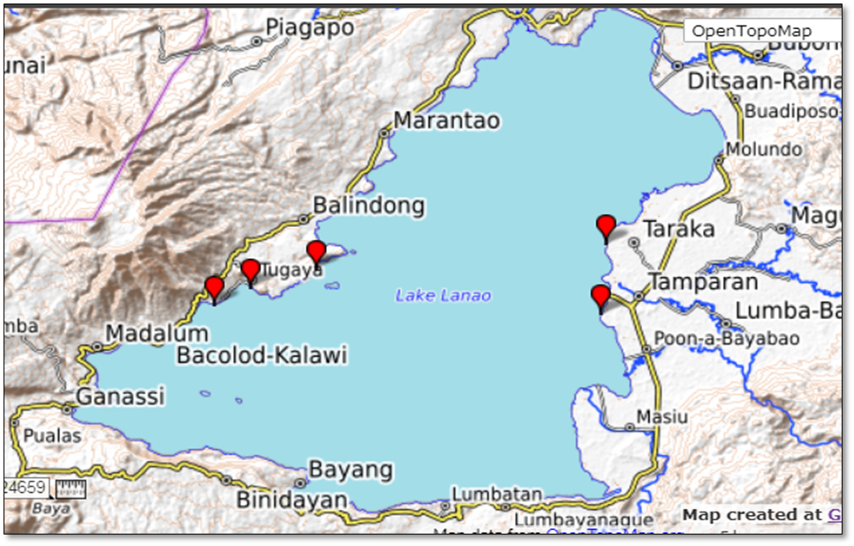

Figure 1. Topographic view of Lake Lanao in Lanao del Sur showing the five
sampling sites (in red) [2].

After the incubation period, the number of bacterial colonies was counted. The mean of the CFUs was obtained. The colony forming units (CFU) of bacteria present per ml of the plated sample was calculated using this formula:

CFU = average no. of colonies x dilution factor
volume plated in ml

Where: CFU= colony forming units
Dilution factor = reciprocal of the final dilution
Characterization of bacterial isolates followed the conventional standard methods. The bacterial colonies grown on plates were initially characterized and coded based on the colony characteristics. Colonies were aseptically streaked from the mixed culture and into sterile culture plates. Characterization of bacterial colonies grown in NBYEA plates included observation of their colony form, color, shape, margin, texture, and size. Gram staining and microscopic examination was also done to confirm growth of pure culture and to classify the isolates as either Gram positive or Gram negative and as to cocci, bacilli or vibrio.

Data on the CFUs of bacteria among the stations in the five selected sites during the six sampling periods were subjected to Multiple Analysis of Variance (MANOVA) and post hoc test to analyze the differences among group means on the data of bacterial abundance. Photographs were taken for documentation. Each bacterial isolate was examined using a Phase Contrast microscope with built-in camera that projects images to a linked computer.

RESULTS AND DISCUSSION

Abundance of Bacterial Populations among the Five Selected Sites

Bacteria are ubiquitous in distribution yet they vary in density as affected by the interplay of the environmental factors in their microhabitat. Figure 2 shows the mean abundance of bacteria in the surface sediments of Lake Lanao along five selected sites. Results show that there were more bacteria in the relatively disturbed surface sediments of the western side of Lake Lanao particularly along Tamparan and Taraka with mean CFUs of 5.33 x 10⁴ and 4.70 x 10⁴, respectively. Tugaya, Wato, and Bacolod, on the other hand, showed lower mean bacterial CFUs of 4.45 x 10⁴, 4.11 x 10⁴, and 3.61 x 10⁴, respectively.

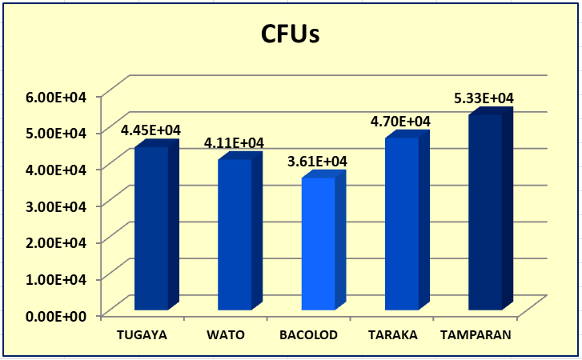
Figure 2. Mean abundance of bacteria in surface sediments of Lake
Lanao along five selected sites expressed in colony-
forming units (CFUs).

The higher bacterial populations in Lake Lanao along Tamparan (Figure 2) and Taraka (Figure 2) could be attributed to the presence of dense local community along its lakeshore. In addition, river tributaries such as Gata, Masiu, Ramain, and Taraka rivers (Figure 3) drain water and other allochthonous materials (both biotic and abiotic) from upstream and into the lake [3].

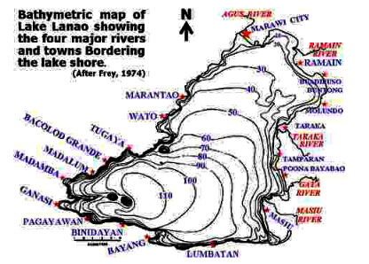
Figure 3. River tributaries (Gata, Masiu, Ramain, and Taraka rivers) shown
in a bathymetric map of Lake Lanao [3].

Bacterial populations, however, were lower in density in Lake Lanao along the western side of Tugaya, Wato, and Bacolod (Figure 3). These lakeshore areas were observed to be relatively less disturbed and more remote from the residences of the local communities.

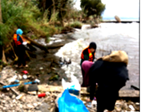

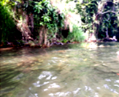


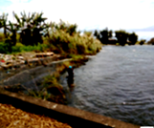
a
b
c
d
e
f
Figure 4. Grab sampling of Lake Lanao surface sediments (a) in Tamparan (b), Taraka (c), Tugaya (d), Bacolod-Grande (e), and Wato (f).

Abundance of Bacterial Populations among the Five Stations in the Littoral Zone

Comparison on the populations of bacteria from the surface sediments shows a decreasing abundance from the shore up to 25 meters lakeward direction (Figure 5), which was established as the five stations. Bacteria dominate next to fungi in the shallow portions of the lake sediment where organic particulate matters are most abundant. Bacteria range from being aerobic to facultative anaerobes, thus, present in littoral, pelagic, and deeper portions of lakes. Sediments serve as seedbanks for resting spores of not only aquatic bacteria but also of various terrestrial species. Therefore, the abundance of bacteria depends greatly on the quantity of particulate organic matter. The lower abundance of bacteria in the lakeward area as compared to the lakeshore populations could be attributed to the lesser amount of particulate organic matter where they attach and obtain as food sources. These bacteria-particulate organic matter assemblies can be easily carried into the open pelagic zone of the lake. The lesser amount of coarse particulate organic matter in the deeper portion of a lake could be one primary factor of the decreased abundance of the bacterial populations [4].

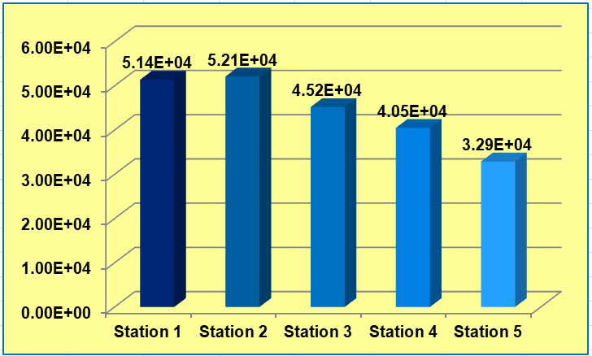
Figure 5. Mean abundance of bacteria (in CFUs) of surface sediments
of Lake Lanao among the five stations.

Abundance of Bacteria in Lake Sediments during the Six Sampling Periods

Temporal variations in the abundance of bacteria were observed during the six sampling periods (Figure 6), being highest on January 2017 (5.29 x 10⁴) and then March 2017 (5.14 x 10⁴). January is a period of mixing of tropical lakes such as Lake Lanao. This vertical circulation or overturn is due to cooling process that increases the density of surface waters sufficiently causing them to sink. Lakes that do not cool to below 4 °C undergo overturn only once per year and are called warm monomictic [5]. During circulation, the nutrient-loaded bottom waters and surface sediments move up to the surface bringing particulate organic matter more available to bacteria, thus, leading to increased abundance. Another peak in bacterial abundance on March 2017 may be attributed to the warmer temperature that favors increased metabolism and reproduction of the bacterial populations.

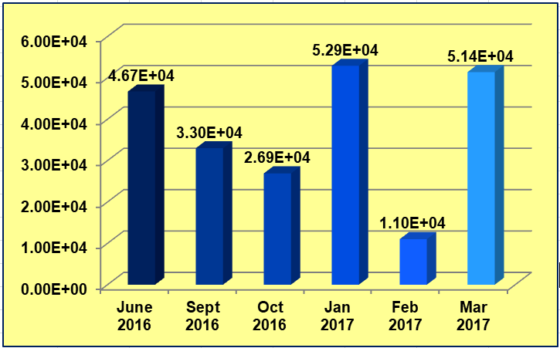
Figure 6. Mean abundance of bacteria (in CFUs) in the surface sediments
of Lake Lanao during the six sampling periods (June 2016-March 2017).

High bacterial abundance on June 2016 could be due to the onset of rainy season which followed after a long period of drought which affected Mindanao and Visayas regions from the first quarter of 2015 to 2016 [6]. Rain brought nutrient-laden runoff water from both the terrestrial and river tributaries, thus, the increase in the abundance of bacteria.

The above bacterial populations, however, were not identified and were considered as the total heterotrophic count that can be grown in nutrient broth-yeast extract agar. Heterotrophic bacteria are a group of microorganisms that utilize organic compounds as sources of energy and carbon. They include both aerobic and facultative anaerobic species that take active part in the natural cycling of substances and even the degradation of cellulose, lignin, chitin, keratin, hydrocarbons, phenol, and other substances [7].

A previous study showed heterotrophic bacterial counts between 33 × 10⁵ and 161 × 10⁵ CFUs/ mL in a lagoon was considered high [7] as compared to the bacterial abundance in this study with CFUs of 110 x 10² – 529 x 10² CFUs/gram only. The relatively lower bacterial count conforms to the recent findings on the physico-chemical status of Lake Lanao which is oligotrophic [8], that is, characterized by a low accumulation of dissolved nutrient salts, supporting but a sparse growth of algae and other organisms, and having a high oxygen content owing to the low organic content. Peaks in bacterial counts on January 2017, March 2017, and June 2016 may be attributed to the occurrence of lake overturn and heavy rain which both contributed in the increased heterotrophic count through increased input of organic matter as well as bacteria from the sediments and terrestrial sources. High bacterial count is indicative of the sanitary status especially when coliform count is also high. Such counts are highly undesirable and indicate fecal pollution, hence the possible presence of human pathogens [7].

Colony and Microscopic Features of Some Bacterial Isolates from Lake Lanao

Bacterial populations were generally slow-growing in the nutrient broth-yeast extract agar (NBYEA) with colonies appearing beyond 48 hours of incubation. There were 142 kinds of bacterial colonies grown in NBYE agar. Colonies vary with mostly irregular, filamentous, and arborescent but there were also circular, punctiform, and spindle in form. Color varies from dirty white, paper white, bluish white, cream, brownish, pale yellow, bright yellow, golden yellow, pink, orange, yellow orange, red, and almost colorless. Bacterial isolates have transparent, translucent and opaque opacity (Figures 7 and 8). Majority were odorless, however, few had distinctive odor.




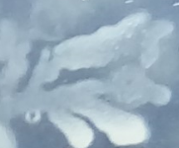

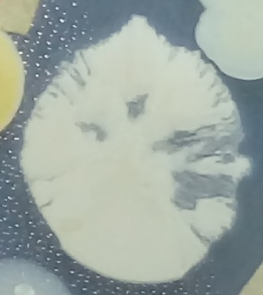

Figure 7. Some colonies of bacteria from the surface sediments of Lake Lanao. Most colonies were irregular in form although circular colonies were also present.

Bacterial colonies also showed different margins as smooth, irregular, lobed, arborescent, diffuse, and others; texture was smooth, dry, granular, glossy, diffuse, or rough. Elevation was mostly flat, and embedded although there were also elevated, convex, and umbonate. Pure culture of these bacterial isolates were periodically sub-cultured and maintained in the Microbiology laboratory prior to the Marawi City siege.

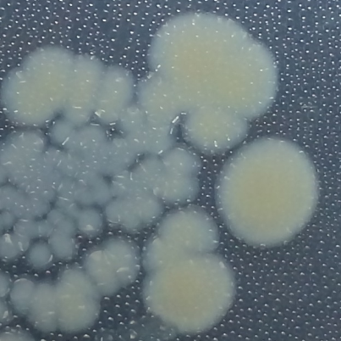
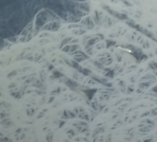
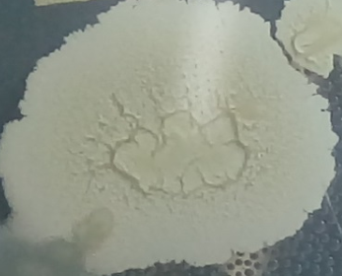
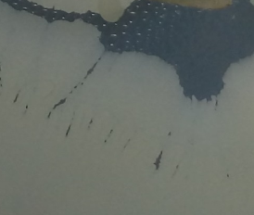
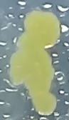
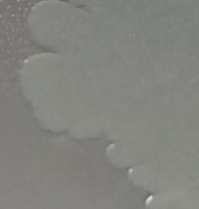
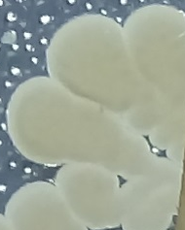
Figure 8. Some other colonies of bacteria from the surface sediments of Lake Lanao
showing circular form, filamentous growth, membranous texture, lobed margin,
as well as yellowish, milky white, and off-white colonies.

Gram-staining and microscopic examination showed that most bacterial populations in the surface sediments of the littoral zone of Lake Lanao were mostly Gram-negative bacilli. There were also Gram-negative by cocci (Figure 9) although Gram-positive bacilli and cocci were also present (Figures 10).

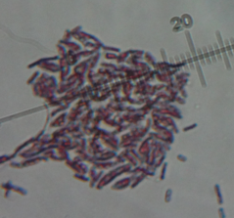
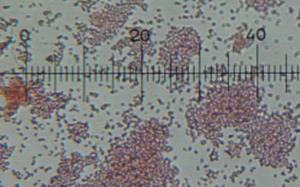
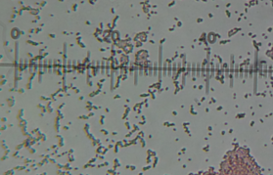
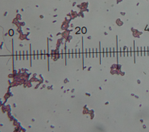
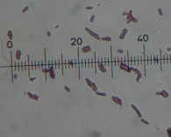
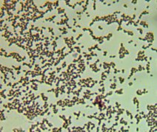
Figure 9. Some Gram-negative bacilli and cocci bacteria from the surface sediments of
Lake Lanao at 1,000x magnification.

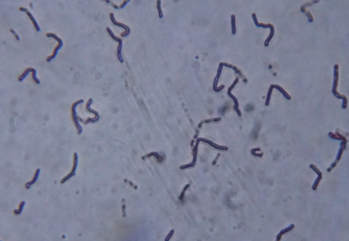
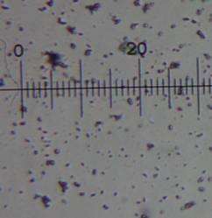
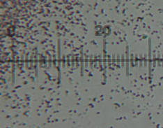
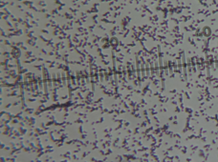
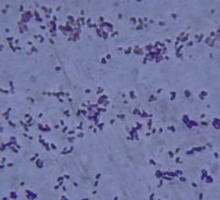
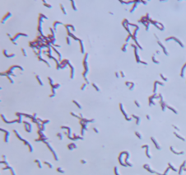
Figure 10. Some Gram-positive bacilli and cocci bacteria from the surface sediments of
Lake Lanao at 1,000 x magnification.

CONCLUSION AND RECOMMENDATIONS

Spatio-temporal variations in the abundance of bacterial populations were recorded along the shorelines of Lake Lanao at Tamparan (5.33 x 10⁴), Taraka (4.70 x 10⁴), Tugaya (4.45 x 10⁴), Wato-Balindong (4.11 x 10⁴), and Bacolod-Grande (3.61 x 10⁴) with respective number of colony-forming units (CFUs) per gram of surface sediments. There was a decreasing bacterial count from the lakeshore extending 25 meters lakeward direction. Vertical mixing of Lake Lanao on January 2017 marked a peak in bacterial abundance and the warmer waters on March 2017. Influx of rain on June 2016 also caused an increase in the bacterial count. This study shows that bacterial populations were greatly influenced by the changes in physico-chemical profile of an otherwise stable lake ecosystem.

A more comprehensive study of microbial community structure in Lake Lanao must be done using culture-independent molecular approaches such as bacterial 16S ribosomal DNA region amplification by polymerase chain reaction to determine the number of bacterial clone sequences that represent bacterial strains. The conventional culture method used in this study limits growth and inventory of not even half of the actual populations of bacteria in a lake ecosystem.

ACKNOWLEDGEMENT

Sincere appreciation to the National Research Council of the Philippines (NRCP) of the Department of Science and Technology (DOST) as the funding agency, MSU-Iligan Institute of Technology as the implementing agency, and Mindanao State University, Marawi City as the supporting agency. Special thanks to my two project staff, Prof. Mariam C. Kabirun and Prof. Nourshamsia C. Barosa whose passion for research enable them to endure and surmount all the hard work and sacrifices. Ladies, am blessed to have you as my co-researchers. And to our “Microbio Ladies”, Anisah M. Bustamen, Lailah A. Dumpao, Rosaidah L. Gampong, Irrania Aleah R. Langco, Hafsah M. Macadadaya, Rufaisah D. Macalabo, Saleja Merhana M. Macapodi, Sittie Asral C. Magomnang, and Nor Aica D. Moner. Ladies, I owe you a treat.

REFERENCE LIST

[1] Mayuga, Jonathan L. Lake Lanao in Peril. https://businessmirror.com.ph/2019/09/02/ lake-lanao-in-peril/, 2019. Accessed February 25, 2020.

[2] Villanueva, Carl. Lake Lanao. https://carlvillanueva012210.wordpress.com/2013/08/20/ lake lanao. 2013.

[3] Naga, P.O. Lake Lanao: An Ancient Lake in Distress. Integrated Ecosystem Management Program Province o fLanaodelSur, MarawiCity 9700, http://rcse.edu.shiga-u.ac.jp/gov-pro/plan/2009list/lbm_expert_group_meeting /wlc13 _papers/ 16_nagapaper.pdf. 2009.

[4] Wurzbacher, C.M., Bärlocher, F., Grossart, H. P. Fungi in lake ecosystems [Review].
Aquatic Microbial Ecology, 59: 125–149, 2010.

[5] Encyclopedia Britannica. Vertical Mixing and Overturn of Lakes. https://www.britannica.
com/science/lake/Vertical-mixing-and-overturn. Accessed February 2020.

[6] International Federation of Red Cross. Philippines: Drought & Dry Spells-Information
Bulletin n°1. April 29.2016. https://reliefweb.int/report/philippines/philippines-drought-
and-dry-spells-information-bulletin-n-1 Accessed February 28, 2020.

[7] Akoachere, J.TK; P. M. Oben; B.S. Mbivnjo; L.M. Ndip; G. Nkwelang; and R.N. Ndip.
Bacterial indicators of pollution of the Douala lagoon, Cameroon: Public health
Implications. African Health Sciences. Vol 8 (2) : 85-89, 2008.

[8] Hansel, Carmelita G. Physical and Chemical Characterization of Lake Lanao. A
Personal Communication. Mindanao State University, Marawi City, 2019.

