Lake Lanao Fishes: Relative Abundance Based on Fish Catch

Abstract
Lake Lanao has been known for its species flock of 18 endemic species of cyprinids which used to be the dominant species caught in the Lake. Surveys in the past indicated a slow decline in the number endemic species and being slowly displaced by introduced species. The present study documents the relative abundance of fishes caught and landed in the four landing areas of Lake Lanao. Results showed that the dominant species landed is the introduced Giuris margaritacea, along with its fries, constitute more than 80% relative abundance in most months. The Tilapia has a moderate abundance while the other introduced species have exhibited a low abundance. No endemic species was recorded, except for Barbodes tumba which is not a usual inhabitant of Lake Lanao itself.

Keywords : Lake Lanao, fish abundance, fish catch, Barbodes tumba, Giuris margaritacea, Cyprinids

Introduction
Managing the fisheries and aquatic resources is currently faced with overriding issues such as decreasing catch volume; degrading aquatic habitats; increasing demand for fish protein due to population explosion; and illegal, unregulated and unreported fishing issues, among others (Sinclair and Murawski, 1997). These issues are relevant on what type of management interventions is applicable in order to sustain the global demand for fish and other aquatic resources (Evans, 2002).

In 2014, the global total capture fishery production was 93.14 million tons, of which 81.5 million tons are from marine waters while the remaining comes from inland water production (SOFIA, 2016). The relative contribution of inland fisheries to a country’s food and economic security is dependent on its level of economic development and social context. This is higher in the developing world and emerging economies, such as the Philippines, where 90% of global inland capture fisheries production is used for human consumption (Welcomme et al., 2011). Despite the demonstrably large contribution of inland capture fisheries in terms of livelihood development; public support and political will are often difficult to obtain, and generally receive little consideration in water resource allocation decisions (Cooke et al., 2013). One factor that is considerably affecting poor inland fish resources management is the lack of research-based information about the present status of a particular inland fishery (Taylor et al., 2016).

Lake Lanao is a large freshwater lake whose water has been used by the Maranaws in their various day to day activities including in the practice of their religion. But perhaps, its biggest role however, is its use as a fishing ground: a source of livelihood for fishermen. Lake Lanao is at the heart of the Lake Lanao Watershed, which is the second largest lake in the Philippines and the largest in Mindanao. The Lake Lanao Watershed is located in the province of Lanao de Sur, Philippines. It is with an estimated area of 186,640 hectares and is a protected area (Proclamation No. 87, February 1992). This environment provide home for some rare and endemic species of plants and animals some of which may be ecologically threatened. In any environment there is always a correlation between human activities and the degree of environmental disturbance in that environment. Lake Lanao environment is not an exception. It is not what it used to be. Many of the original forest surrounding the lake been cleared and used for agriculture. In the mid 1980’s a dam was constructed along Agus River in the municipality of Baloi, creating an artificial lake now known as Lake Nangka. Another dam right at the opening of the lake to Agus River, became operation in the 1990s. Lake Lanao itself, in fact, has showed signs of ecological disturbance as manifested by persistent reports of unusual greening of the water in the lake during certain seasons of the year (Lagmay, et. al. 2006). Sometime in the 1960 and early 70s and eleotrid fish, Hypseleotris agilis (= Giuris margaritaceae), as well as the White Goby, Glossogobius giuris started appearing among the fishes caught in the lake, these were hypothesized by Escudero (1983) to have been accidentally introduced into the Lake together with the stocking of tilapia fries by the BFAR in the 1960s.
This present paper deals with the relative abundance Lake Lanao fishes based on fish catch to determine the present status of the fishes in the Lake, where the data derived, hopefully, would be of use to local officials to better manage the fisheries in the Lake.

Review

Lakes have been likened to island environments where endemism is high and where the introduction of non-native species would have a drastic consequence on the native population (Kornfield, 1984). The introduction for example of the Lamprey Eel (Petromyzon marinus) into the St. Lawrence Great Lake has wreaked havoc in its native population (Frey, 1974). Recent survey of the Lake’s endemic fish has shown a reduction in the total number of species from 18 (Herre, 1924) to only two (Ismael, 2011)
At various times several species of fish were known to be caught in the Lake. Some are native others endemic and others still are introduced, and were reported in fish market surveys. Ismael, (2011) reported 12 introduced species two native species and two endemic species Some of them failed to established a viable population like the milkfish (Chanos chanos), which was introduced several times starting in 1955, and the Black Bass (Micropterus salmoides), introduced in 1945, and disappeared from the Lake altogether. One native species locally called “Kasili” (Anguilla celebensis) totally disappeared. On the other hand, some introduced species, clearly have proliferated and are well established, like the “Katulong” (Giuris margaritaceae), to the point of being a nuisance, being hypothesized as one of the reasons for the demise of endemic and native species.
Surveys on the fish abundance in the Lake include those of Villaluz (1966), who conducted fish landing surveys in 1963- 64 and showed that the total fish catch was dominated by the endemic cyprinids (50%), followed by the native and introduced species (25%). Escudero (1994) in 1990-91 survey showed the decline of the endemic cyprinids at 9% of the total catch, and the Tilapia at 28%, while the “Katulong” (Giuris margaritaceae (=Hypseleotris agilis) started appearing at 31% of the total fish catch. Ismail (2011), on the other, hand showed that the endemic cyprinids have declined, two species Barbodes (=Puntius) tumba and B. lindog were recorded, while the introduced Giuris margaritaceae dominated the fish catch.
Methods
- Study site

Lake Lanao is located at the southern island of Mindanao, Philippines, in the province of Lanao del Sur, Autonomous Region in Muslim Mindanao, with a latitude of 7º51’22.19” N, longitude of 124º14’59.33” E, and an elevation of 702 meters above sea level (Naga, 2010). Lake Lanao has a total area of 357 square kilometers with a minimum depth of 10 meters and a maximum depth of 112 meters. The entire province of Lanao del Sur has a Type III tropical climate, with a dry season lasting only from 1 to 3 months (March-May). It has a mean monthly temperature of 23°C, providing the lake with cool climate (Rosagaron, 2011). The lake’s major river tributaries are Ramain, Taraka, Gata, Masiu and Bacayawan rivers with a major outlet which is the Agus river in the north (Rosagaron, 2011). It is the largest (surface area 357 km²; volume 21.5 km³) and deepest (maximum and mean depth of 112 m and 60.3 m) freshwater lake in the Philippines. Lake Lanao is being bordered by 18 lakeshore municipalities including the province’s capital- Marawi City Based on its origin, it is a tectonic-volcanic lake with the deeper portion located somewhere at its southern part.
From the 18 lakeshore municipalities, four were initially chosen to be the sampling sites- Marantao, Ramain, Taraka and Ganassi. The prioritization of the said municipalities was based on its strategic location to represent the northern, eastern, western and southern fishing areas of the lake, and at the same time cover both the major and minor fish landing areas.
- Data collection
Data collection in the study area was conducted from April 2016 to March 2017 by field enumerators. The frequency of sampling was every two days, including Saturdays, Sundays and holidays. All fishing boats, of whatever fishing gear, unloading their catch during the daytime were sampled for total catch and species. Data that were collected during sampling include name of fisherman, fishing boat classification, time of landing, landing site, fishing area, gears used, total catch, catch data per species, fishing duration, expenses incurred and marketing arrangement/s through a structured survey form.

RESULTS AND DISCUSSION

- Fishing Area
A total of 88 fishing areas were identified by the fishermen in Lake Lanao. These fishing areas were plotted in a grid map (Figure 3). Out of the 88 recorded fishing areas, 45 were identified by Taraka fishermen as represented by yellow dots.
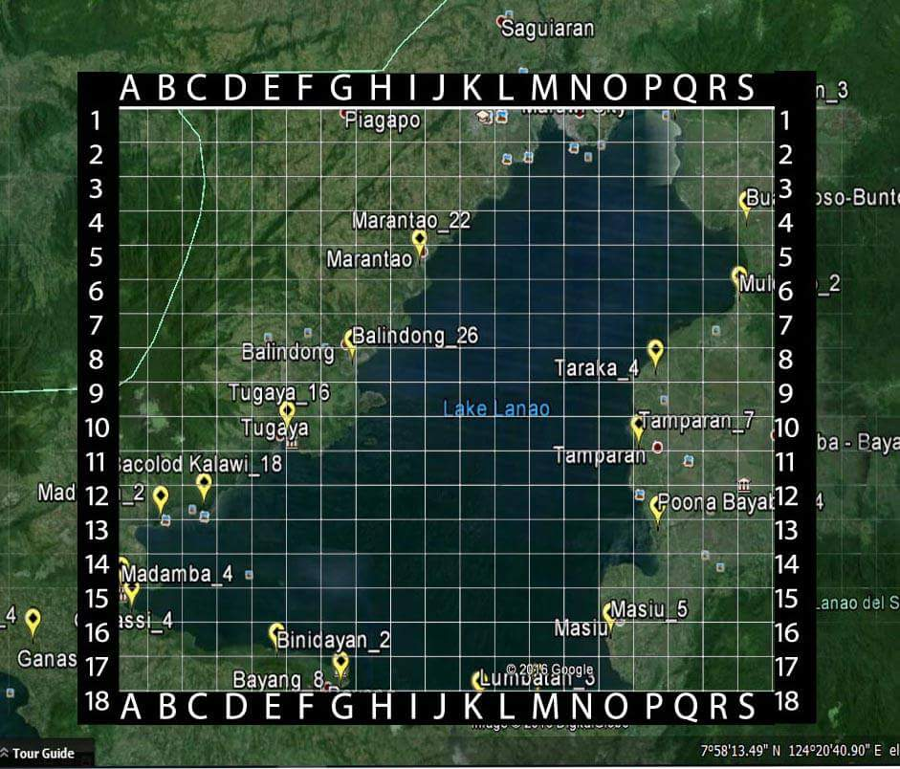
Figure 1. Fishing areas as identified by fishermen within Lake Lanao. Yellow dots as identified by Taraka fishermen, Blue from Marantao, Red from Ramain and White dots from Ganassi fishermen.

Thirty-five were identified by Marantao fishermen, represented by blue dots. While there were only four areas identified by Ramain (red dots) and Ganassi (white dots) fishermen. Of the four fish landing ares, Ganassi is the largest with a major port immediately beside a large the market area. So much so that fishermen from other nearby municipalities choose to land their catches in Ganassi straight to the market
Although most of the fishermen prefer to fish near the lakeshore, it can be noted that there are some fishing areas with overlapping fishermen (e.g. Marantao and Taraka fishermen). This suggests that the lake is accessible to all Maranao fishermen, regardless of the municipality of origin. It can also be noted that the whole lake is not yet delineated to specific LGUs, as to determine the extent of use and management interventions.
- Fish Data Analysis
- Catch composition
Of the four fish landing areas, Ganassi, contributes 45% of the total fish-catch throughout the sampling months (Figure 2). As noted earlier, compared to the other three areas, Ganassi is the largest with a major port immediately beside a large market area
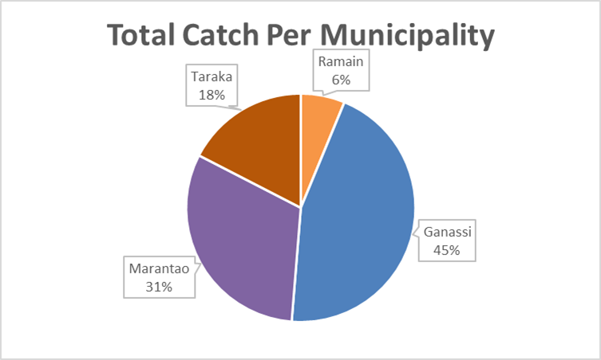
Figure 2. Relative proportion of fish-catch per municipality throughout the sampling months
The eleven months survey has only recorded 11 major species groups: Chana striata, Glossogobius giuris, Clarias batrachus, Giuris margaritacea, G. margaritacea fry, Shrimp spp and Tilapia spp. are shown in Table s1 and Table 2. The entire study recorded a total of 38, 247.47 kg by weight (Table 1). The highest contributor to the total catch was the Giuris margaritacea with 19, 880.80 kg, followed by G. margaritacea fry spp. with 12, 035.50 kg, Tilapia spp. with 4,181.95 kg, Chana striata with 1,013.34 kg, Glossogobius giuris with 923.71 kg, Shrimp spp with 195.90 kg, Clarias batrachus with 8.88 kg, and lastly, the other species combined (7.39kg). It should be noted that all of the introduced species (Glossogobius giuris, Clarias batrachus, Cyprinus carpio, Anabas testudineus, and Trichogaster pectoralis) exhibit a low abundance, except for G. margaritacea, which dominates the the fish-catch throughout the survey period.
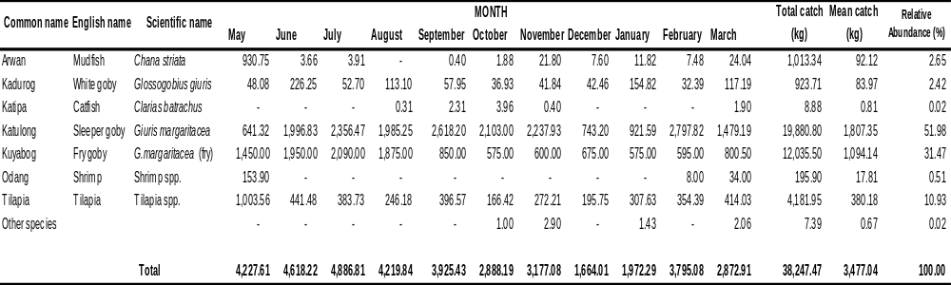
Table 1. Monthly catch weight of fish species from the four landing sites of Lake Lanao from May 2016 to March 2017

This catch composition shows a big difference with the previously conducted survey by Ismail in 2011. Many species that were present in the past survey are barely recorded in this survey such as Barbodes tumba, Cyprinus carpio, Anabas testudineus, and Trichogaster pectoralis. Minor species that were not included due to lack of weight data, are shown in separate table (Table 2). It should be noted, that of the four species listed in table 2, all are introduced, except B. tumba which is an endemic. Herre (1924) noted that the species was never collected from the lake itself but from the various streams and rivers which are tributaries of the Lake. Its presence in the waters of the Lake is never really expected. Specimens caught in the waters of the Lake could be just vagrant individuals washed downstream from the rivers or streams draining into the lake. Locals in the areas have testified that the fish can still be collected in the various streams and rivers although rare in the lake itself.
Table 2. Summary of Other Species Recorded During the Entire Sampling Period
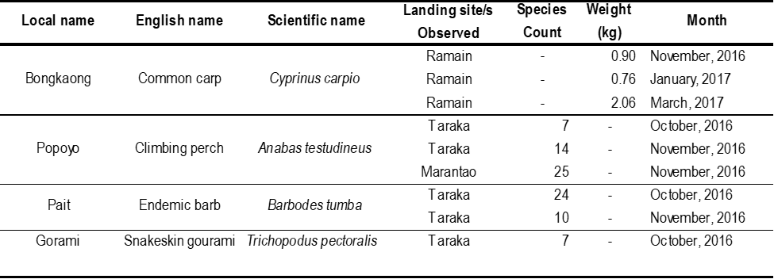
In terms of weight composition, the fish species recorded for both surveys are still being dominated by Giuris margaritacea. The Tilapia spp. which was recorded to be the second dominant species in the previous survey is now being replaced by G.margaritacea fries, locally known as “kuyabog”. These kuyabog, which is largely being landed in Ganassi markets, were not explicitly quantified by Ismail’s study. While the Chana striata which ranked third in the survey of Ismail has recorded only 2.65% of the total catch or 1,013.34 kg out of 38,247.47 kg from this recent survey. It might be of interest to note that the total combined percentage of the G. margaritacea fry and adults (Fig 3) would result into a dominance of about 80% of the total fish catch.
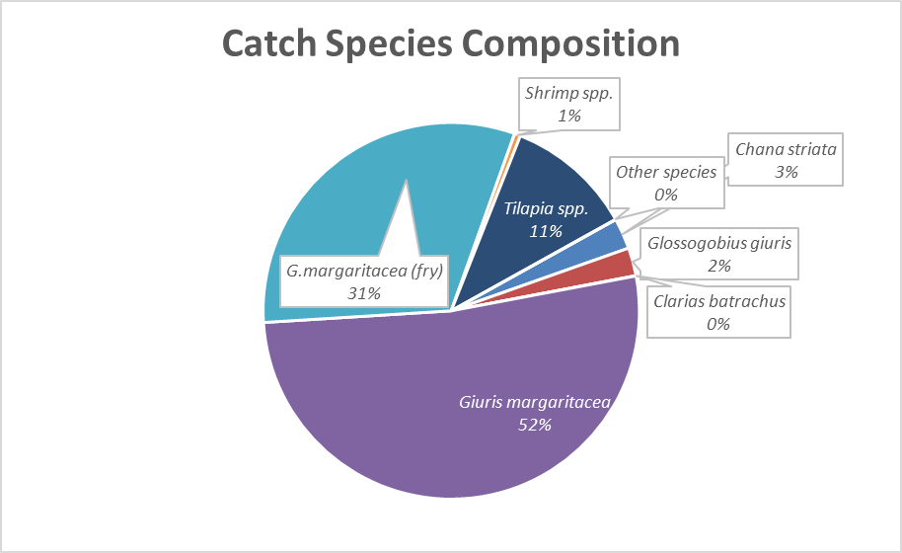
Figure 3. Relative abundance of the catch composition from all landing sites during the entire
sampling period. Combining the percentage abundance of G. margaritacea fry and adults would result into a high dominance of 83% for the species

It would also result into Tilapia being still the second most dominant fish caught in Lake Lanao. It should be noted, however, that Tilapia fingerlings have been and still is regularly seeded into the Lake by the MSU College of Fisheries as part of its extension program. Combining the two tables (Tables 1 and 2) using minimum weights of less than1 kg (for overall presentation of the result in bar graph) for each species in table two and plotting the values in a bar graph would show a monthly abundance for each species (Fig 4)
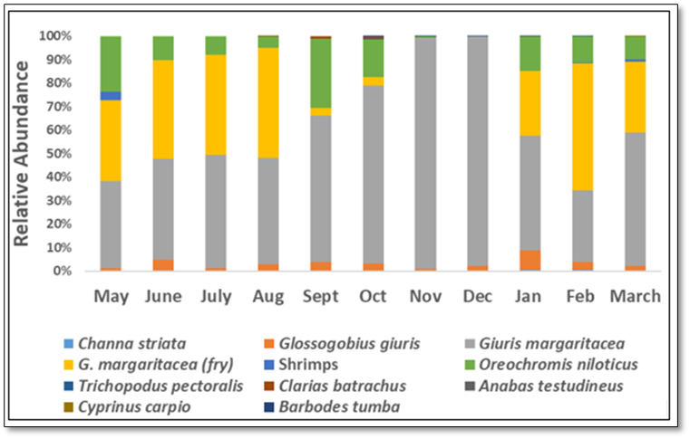Figure 4. Bar graph of relative abundance data of fish species recorded from the fish landing zones of the four municipalities bordering the lake from May 2016 to March 2017. A total of 11 species/groups were recorded with the fries and adults of Giuris magaritacea in separate entries to emphasize the months when fries are abundant. It shows the dominance of G. margaritacea and its fries approaching 80% in most months except for the months of November and December where fries were absent.

Figure 3 would show that in most months the fries are abundant, but for the months of September until December where relative abundance is low, and disappeared altogether in the months of November and December. It would be tempting to conclude, that peak months of reproduction for the species would be from January until August as evidenced by the abundance of their fries, however, errors may have been introduced when some of our raw data sheets were damaged when we left our laboratories, in haste at the start of the “Marawi siege” that lasted four months before we were allowed to go back to MSU. Escudero (1983), though, reported the presence of fries throughout his year-round study on the biology of the species.
The reduction and /or absence of endemic cyprinids from Lake Lanao were already noticed in previous studies (Villaluz, 1966; Escudero,1983; Ismael, 2011). Endemic cyprinids of Lake Lanao have evolved for hundreds of the thousands of years in a very unique, isolated, and pristine environment of the Lake. Isolated from the influence of the marine environment and other freshwater habitats, they have evolved specific characteristics which are fined -tuned to the narrow requirement of the pristine environment. Any change in that habitat, may lead to their demise. The physical environment of Lake Lanao has undergone changes and along with the introduction of several species of fish provides a challenge to the existence of the endemic cyprinids.
One of the introduced species is Giuris margaritacea. The species is not a desirable food fish because of its small size and its bony characteristic. It has been hypothesized to be the cause of the disappearance of the endemic species from Lake Lanao. The species in Lake Lanao has been characterized as a voracious omnivore by Escudero (1983), and is known to feed on the young of other species including its own (Guerrero 2002). De Guzman et al. (2009) considered species as carnivorous. This species from Tondano Lake in Indonesia has been known to breed throughout the year with a fecundity of between 36,000 to 90,000 (Makmur, 2019). All these characteristics would point to it as a generalist species and has the potential to outcompete any species. The species is the most abundant species recorded in this survey of fish catch in Lake Lanao.
Recent initiatives by local officials of massive fishing of Giuris margaritacea to reduce its population to improve the population of the other desirable food fishes like the tilapia (Oreochromis spp.) might still produce desirable results. But if the objective is to give way to the re-introduction of the endemic cyprinids; would be a big question mark considering that of the cyprinids only B. tumba is still extant. The species is recorded not to be present in the waters of the Lake itself but in the streams and river tributaries.
Summary and Conclusion
- Eleven species/groups were recorded from the four municipalities throughout the duration of the survey.
- The fish catch is dominated by “Katolong” (Giuris margaritacea), and its fries “Kuyabog.”
- The native species “Arowan” (Channa striata) and “Katipa” (Clarias spp.) has a very low relative abundance as indicated by the fish catch.
- The introduced fish “Tilapia” (Oreochromis spp.), whose fingerlings are seeded into Lake Lanao regularly the College of Fisheries of MSU-Marawi, has a moderately high abundance.
- Only one endemic species (B. tumba) was recorded in the months of October and November. The species was not recorded to be present in waters of the Lake but rather in the triburtaries.
- The introduced species with its broad food and feeding habits has the potential to outcompete any species with benign habits.
- The initiative of massive fishing of G. margaritacea should be properly examined as to its purpose.
Acknowledgement :
We wish acknowledge the local officials of the municipalities of Marantao, Ganassi, Taraka, and Ramain who extended to us valuable help in doing the fish-catch survey in their municipalities. We wish to acknowledge also our research enumerators in the four municipalities who did the survey and recording of the fish catch in their respective areas.
This research project is funded by the National Research Council of the Philippines (NRCP)

References
Collar, N.J., N.A.D. Mallari, and B.R. Tabaranza Jr. 1999. Threatened Birds of the Philippines: The Haribon foundation/Birdlife International Red Data Book in Collaboration with the DENR aand the Environment Agency of Japan. Bookmark. Makati City
De Guzman, A.B., W.H. Uy, J.G. Gorospe. A.E. Openiano, R.E. Acuna, R.L. Roa, J.P. Garcia, M.M. Ologiun and J.R. Santamina. 2009. Sustainable Fisheries Management Program for Lake Mainit. Phase II: Comprehensive Resource Assessment. Final Report. MSU at Naawan Foundation for Science and Technology Development, Inc. Funded by the International Fund for Agricultural Development-Northern Mindanao Community Initiatives in Resource Management (IFAD-NMCIREMP), Department of Agrarian Reform 13, Lake Mainit Development Alliance (LMDA) and PCAMRDDOST. 73p.
Escudero, P.T., O.M. Gripaldo and N.M. Sahay. 1980. Biological studies of the Glossogobius giurus and the Puntius sirang in Lake Lanao. Journal of Fisheries and Aquaculture. 1(1):1-154
Escudero, P.T., O.M. Gripaldo and N.M. Sahay. 1980. Biological studies of the Glossogobius giurus (Hamilton & Buchanan) and the Puntius sirang (Herre) in Lake Lanao. Journal of Fisheries and Aquaculture 1(1): 11-154.
Escudero, P.T. and M.A. Demoral. 1983. Preliminary studies on the biology and fishery of Hypseleotris agilis, Herre (Eleotridae). Journal of Fisheries and Aquaculture. 4(1-2):3-84.
Escudero, P.T. 1994. Lake Lanao Fisheries: Problems and Recommendations. The Philippine Biota 27(1):8-18.
Escudero, P.T. 1994. Lake Lanao fisheries: problems and recommendations. The Philippine Biota 27(1): 8-18.
Frey, D.G. 1974. A Limnological reconnaissance of Lake Lanao. Mindanao Journal, 1:81-101.
Guerrero, R. III. 2002. Invasive Aquatic Animals in the Philippines. ASEAN Biodiversity Special Report, 12-15.
Herre, A.W.C.T. 1924. Distribution of true freshwater fishes in the Philippines. The Philippine Journal of Science. T.F.H. Publication, Inc., New Jersey, USA. Vol. 24, No. 3. pp. 249-307.
Herre, A.W.C.T. 1927. Gobies of the Philippines and the China Sea. Monographs of the Bureau of Science. Manila Bureau of Printing. Philippine Islands
Herre, A.W.C.T. 1933. The fishes of Lake Lanao: A problem in evolution. Amer. Natur. 67:154-162
ICLARM. Fish Base 2000. International Center for Living Aquatic Resources Management. Penang, Malaysia
Ismael, G. 2011. The Status and Life History traits of Endemic, Native and Introduced Species in Lake Lanao, Philippines. Master of Science in Fisheries Science. An MS thesis submitted to Oregon State University.
Kornfield, I. 1982. Report from Mindanao. Copeia 1982(2):493-495.
Kornfield, I. and K. Carpenter. 1984. The cyprinids of Lake Lanao, Philippines: taxonomic validity, evolutionary rates and speciation scenarios. In: Echelle AE, Kornfield I (eds) Evolution of fish species flocks. University of Maine Press, Orono. 69-84.
Lagmay, J.P., C.G. Hansel, P.T. Escudero, N. Autor, D. Dagot, R.V. Estoista, L. Lopez, D. Mero and S.S. Nacua. 2006. Hydrobiological assessment of Lake Lanao subsequent to its unusual greening in 2006. Mindanao Journal, 24:85-99.
Makmu, S. R., Dina Muthmainnah and Subagdja. 2019. Biological Characters of Snakehead Gudgeon (Giuris margaritacea Valenciennes, 1837). Biovalentia: Biological Research Journal e-ISSN: 2477-1392 vo.5 No. 2
Rabor, D.S. and L.F. Rabor. 1975. Ecological source of life and progress. In: Mamitua Saber and Abdullah T. Madale (eds). The Maranao, Solidaridad Publishing House. Manila, Philippines.
Rosagaron, R.P. 2001. Lake Lanao: its past and present status, p. 29-39 In: C.B. Santiago, M.L. Cuvin-Aralar and Z.U. Basiao (eds.) Conservation and Ecological Management of Philippine Lakes in Relation of Fisheries and Aquaculture, Southeast Asian Fisheries and Development Center, Aquaculture Department, Iloilo, Philippines.
Sanguila, W.M., A. Rosales, B. Tabaranza Jr., and S. Mohamad. 1975. Notes on the Foods Habits of Puntius sirang and Glossogobius giurus. The Mindanao Journal 1:3-11.
Villaluz, D.K. 1966. The Lake Lanao fisheries and their conservation. Bureau of Printing, Manila
WCSP. 1997. Philippines Red Data Book. Wildlife Conservation Society of the Philippines and Bookmark Inc., Makati City, Philippines.
Villaluz, D.K. 1966. The Lake Lanao fisheries and their conservation. Bureau of Printing, Manila

