**EXERCISE - 11**

**(i) Upload files using Multer in Node JS**

**CODE:**

**HTML:**

<!DOCTYPE html>

<html>

<head>

<title>File Upload</title>

<link rel = "stylesheet" href = "index.css">

</head>

<body>

<h2>Select File</h2>

<form action="http://localhost:3000/upload" method="post" enctype="multipart/form-data" >

<input type="file" name="myFile"/>

<br>

<br>

<button type="submit">Upload</button>

</form>

</body>

</html>

**CSS:**

body{ justify-content: center; display: flex; align-items: center; flex-direction: column; background-color: antiquewhite; height: 50vh;

}

**index.js:**

const express = require('express'); const multer = require('multer'); const path = require('path');

const app = express();

const storage = multer.diskStorage({ destination: function (req, file, cb) { cb(null, 'uploads/');

},

filename: function (req, file, cb) { cb(null, Date.now() + path.extname(file.originalname));

}

});

const upload = multer({ storage: storage });

app.use('/uploads', express.static('uploads'));

app.post('/upload', upload.single('myFile'), (req, res) => { if (!req.file) {

return res.status(400).send('No file uploaded.');

}

res.send({ message: 'File uploaded successfully!', filePath: `/uploads/${req.file.filename}`

});

});

app.listen(3000, () => { console.log('Server started on http://localhost:3000');

});

**OUTPUT:**

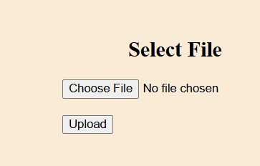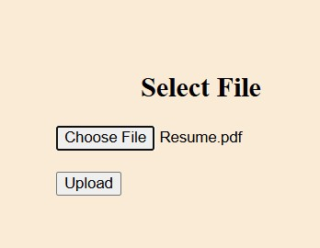

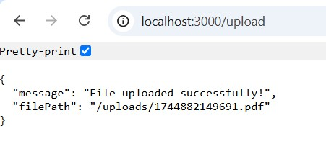

**(ii) Create Registration form with profile photo and display in the right panel**

**CODE:**

**HTML:**

<!DOCTYPE html>

<html lang="en">

<head>

<meta charset="UTF-8">

<title>Register</title>

<link rel = “stylesheet” hred = “style.css”>

</head>

<body>

<div class="form-container">

<h2>Registration Form</h2>

<form action="/register" method="POST" enctype="multipart/form-data">

<label for="fullName">Full Name:</label><br>

<input type="text" name="fullName" required><br>

<label for="email">Email:</label><br>

<input type="email" name="email" required><br>

<label for="profilePhoto">Profile Photo:</label><br>

<input type="file" name="profilePhoto" accept="image/*" required><br><br>

<button type="submit">Register</button>

</form>

</div>

</body>

</html>

**CSS:**

body { display: flex; justify-content: space-between; padding: 40px;

font-family: Arial, sans-serif;

}

Input { width: 100%; padding: 10px; margin: 10px 0;

}

button { padding: 10px 20px; cursor: pointer;

}

**index.js:**

const express = require('express'); const multer = require('multer'); const path = require('path'); const app = express();

app.use(express.static('public')); app.use('/uploads', express.static('uploads')); app.use(express.urlencoded({ extended: true }));

const storage = multer.diskStorage({ destination: function (req, file, cb) { cb(null, 'uploads/');

},

filename: function (req, file, cb) { cb(null, Date.now() + path.extname(file.originalname));

}

});

const upload = multer({ storage: storage });

app.post('/register', upload.single('profilePhoto'), (req, res) => { const { fullName, email } = req.body;

const profilePhoto = req.file ? `/uploads/${req.file.filename}` : '';

res.send(` <html>

<head> <style> body { display: flex; padding: 40px; font-family: sans-serif; }

.form, .preview { width: 50%; padding: 20px; }

.preview img { width: 150px; height: 150px; border-radius: 50%; object-fit: cover; }

</style>

</head>

<body>

<div class="form">

<h2> Registration Successful</h2>

<p><strong>Name:</strong> ${fullName}</p>

<p><strong>Email:</strong> ${email}</p>

<a href="/"> Go Back</a>

</div>

<div class="preview">

<h2>Profile Preview</h2>

<img src="${profilePhoto}" alt="Profile Photo" />

</div>

</body>

</html>

`);

});

const PORT = 3000; app.listen(PORT, () => { console.log(`Server started on http://localhost:${PORT}`);

});

**OUTPUT:**

