

**FRONTEND PROJECT**

**REPORT**

**Instructor: Mr. Lovish Arora**

**Prince Gupta**

**2110992024**

**G5**

# Table Of Contents

|  |  |  |
| --- | --- | --- |
| S.no | Title | Page |
| 1 | Introduction | 3 |
| 2 | Why Choose Us? | 4 |
| 3 | Goals and Challenges | 5-9 |
| 4 | Screenshots and Explanation | 9-10 |
| 5 | Future Scope | 10 |

# Project Overview and Introduction

Overview:

* Website Name :Chitkara University ●TIME TAKEN: 15 days
* TECHNOLOGIES USED: HTML,CSS,JAVASCRIPT.
* No of Pages:20

**Introduction:**

In an age marked by the digital revolution, e-commerce has not just become a convenient choice for shoppers; it has evolved into a way of life. As the lines between the online and offline worlds blur, the success of e-commerce platforms hinges on their ability to offer a seamless, personalised, and secure shopping experience. In this report, we delve into the realm of e-commerce excellence through the lens of Anything.com, an innovative and game-changing online shopping destination.Anything.com stands as a testament to the potential of e-commerce when powered by visionary thinking, user-centric design, and a commitment to staying at the forefront of technological advancements. This report aims to provide an in-depth analysis of Anything.com, exploring its history, growth, key features, and the strategies that have propelled it to the forefront of the e-commerce industry.it's a transformative platform that redefines the way people shop online. It showcases the power of e-commerce to create endless possibilities for consumers and opportunities for businesses.

**Why Choose Us?**

* **Academic Excellence**: Chitkara University is renowned for its commitment to academic excellence. It offers a wide range of undergraduate, postgraduate, and doctoral programs across various disciplines.
* **Qualified Faculty:** The university boasts a highly qualified and experienced faculty who are experts in their respective fields. Their dedication to teaching and research enriches the academic experience.
* **State-of-the-Art Facilities:** Chitkara University is equipped with modern infrastructure, cutting-edge laboratories, and well-stocked libraries, providing an optimal environment for learning and research.
* **Innovative Pedagogy:** Chitkara incorporates innovative teaching methods, including e-learning platforms, simulations, and practical assignments to enhance the learning process.
* **Placement Support:** Chitkara University has a dedicated placement cell that assists students in securing internships and job placements with top companies.

**Goals**

**Information Dissemination:**

* Provide comprehensive and up-to-date information about academic programs.Share details on admissions, eligibility criteria, and application procedures.Offer information on faculty and staff members.

**Student Engagement:**

* Facilitate student-teacher interactions and engagement.Showcase student achievements, activities, and events.Provide access to academic resources, such as course material commitment to providing a seamless and enticing user experience that encourages customer engagement and transactions.
  + **Community Building:**

Foster a sense of community among current students, faculty, and alumni.Promote networking and collaboration among various university stakeholders.

**Promotion and Outreach:**

Attract prospective students by showcasing the university's strengths and unique selling points.Promote research and academic achievements.Highlight the university's social impact and contributions to the community.Foster a sense of community among current students, faculty, and alumni.Promote networking and collaboration among various university stakeholders

* + **Transparency and Accountability:**

Publish information on governance, policies, and regulations. Maintain transparency in financial matters and budget allocation.

* + **Challenges:**
* **User Experience (UX) Design:**
  + User Experience (UX) Design is the practice of creating digital interfaces that prioritise user satisfaction and ease of interaction. It involves understanding user behaviour, preferences, and needs to design websites, apps, or products that are intuitive and enjoyable to use. UX designers focus on optimising layout, navigation, content presentation, and visual elements to provide a seamless and meaningful user journey. Effective UX design improves user engagement, reduces friction, and enhances accessibility, ultimately leading to higher customer satisfaction

and better business outcomes. It combines research, empathy, and design principles to create a harmonious and efficient user experience that aligns with the goals of the product or platform.

**Performance Optimization:**

* + Performance optimization refers to the process of enhancing the speed and efficiency of a website, application, or system. It involves various techniques, such as code optimization, image compression, and minimising HTTP requests, to ensure swift load times and responsive user interactions. By reducing loading delays, improving server response times, and managing resource utilisation, performance optimization enhances the user experience. It is crucial for retaining visitors, improving search engine rankings, and increasing customer engagement. High-performance systems also decrease bounce rates, boost conversions, and lower operational costs, making it a key focus ordevelopers and organisations looking to deliver.
* **Browser Updates**
  + Browser updates refer to the periodic releases of new versions or patches for web browsers like Google Chrome, Mozilla Firefox, and Microsoft Edge. These updates are essential for enhancing browser performance, fixing security vulnerabilities, and introducing new features or standards compliance. They also enable users to access the latest web technologies and ensure a secure and efficient browsing experience. However, they can pose challenges for web developers, as new updates may introduce changes in rendering, standards support, or features that affect a website's compatibility. Staying updated with browser changes is crucial to maintain a website's functionality and user experience across different browser versions.
* **Content Management:**
  + Content management is the process of creating, organising, and maintaining digital content, such as text, images, and multimedia, within a structured system or platform. This facilitates efficient content creation, editing, and publication. Content management systems (CMS) like WordPress and Drupal simplify this process, allowing users to manage web content without extensive technical expertise. CMS tools streamline content updates, version control, and collaboration among content creators. This practice is fundamental for websites, blogs, and digital platforms, ensuring content remains relevant, up-to-date.
  + **Main Pages**

**Landing Page**

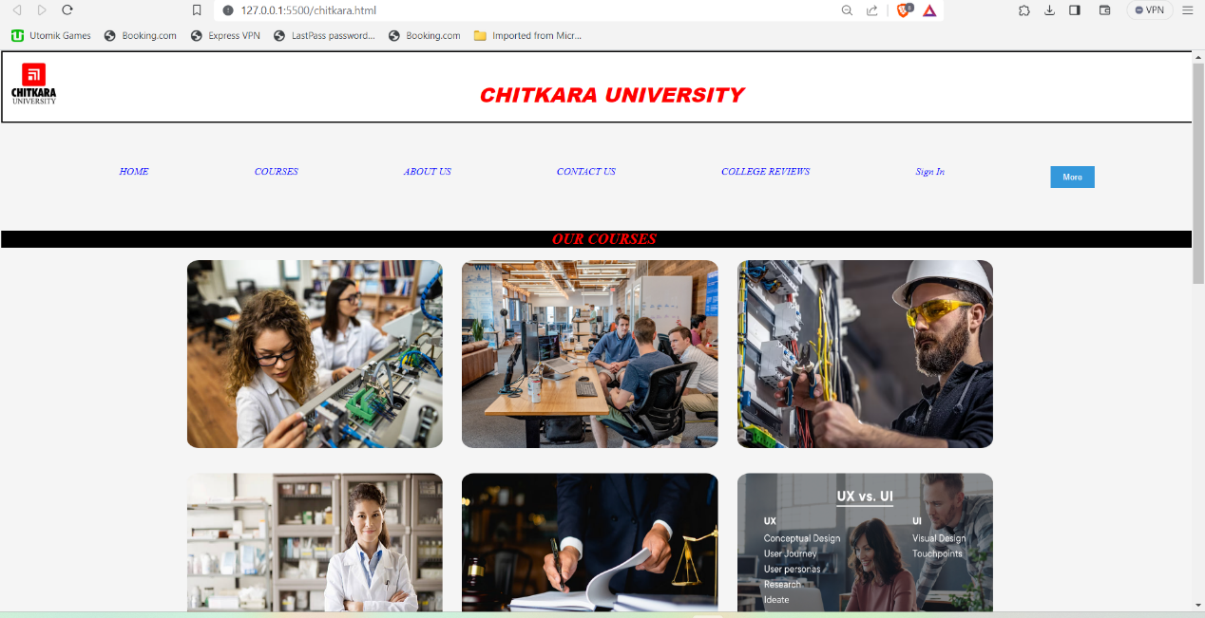

# Courses

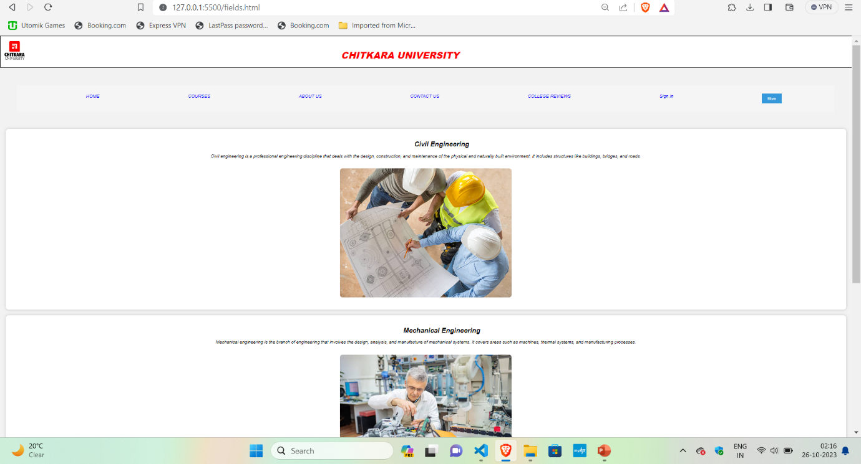

# About Us

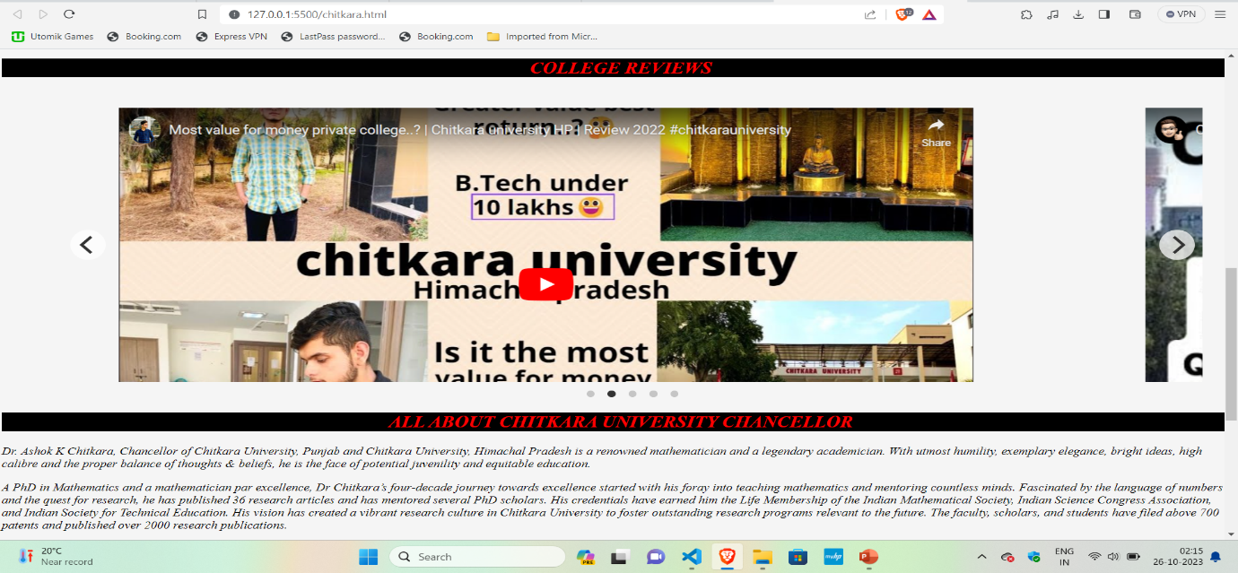

**SignIn**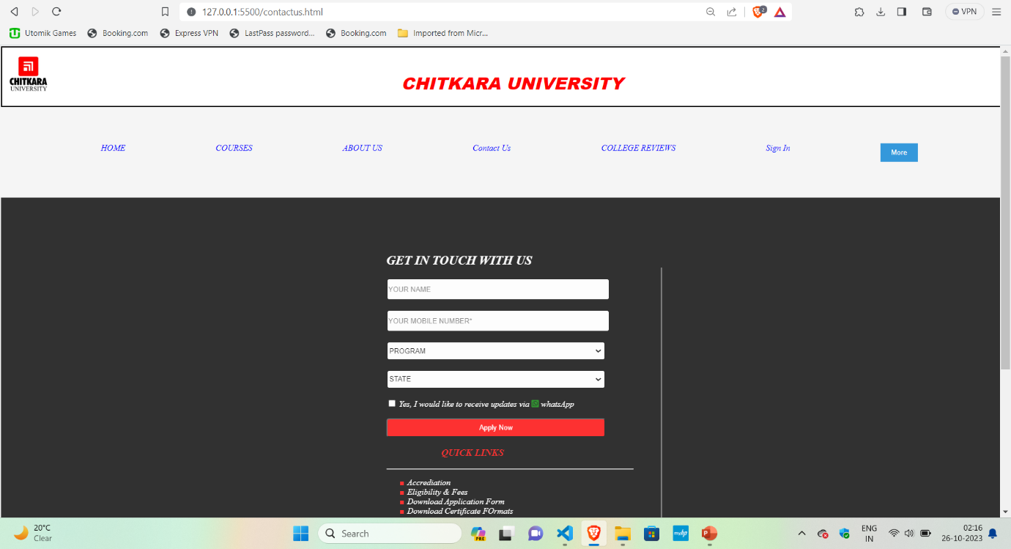

**Future Scope**

**Achieving Responsiveness:**

One of the main challenges we faced during the project was making sure the webpage looked good and worked well on all types of screens, like phones, tablets, and computers. Some of the things on the webpage moved around when we changed the screen size, and we needed to fix that**.**

**• Improving User-Friendliness:**

We also focused on making the webpage more user-friendly, meaning we wanted to make it easier for people to use. We worked on optimizing the User Experience, which is all about how people feel and interact with the webpage. We wanted it to be a smooth and enjoyable experience for everyone.

**• Using Bootstrap for Redesign:**

To help with these goals, we decided to use a tool called Bootstrap. It's a set of pre-made design elements and features that make it easier to create responsive and user-friendly webpages. We used Bootstrap to redesign certain parts of the webpage to make them work better and look nicer.

**• Making Comparison page:**

Thinking about a way which would make the comparison page work was a challenge for me as it required a good knowledge of JavaScript and overcoming this hurdle was really exciting for me.

**• Displaying info on Hover:**

Displaying information about core team members was a challenge and I solved it by creating 3 different datasets for the members and the person on whom the cursor is hovering, the dataset of that person gets displayed.

THANK YOU