Vacuum Chamber Monitoring And Control System
A
SUMMER INTERNSHIP REPORT

Submitted in partial fulfillment of the requirements for the successful completion of the 45-Day Summer Internship
at
CSIR – Central Electronics Engineering Research Institute (CSIR–CEERI), Pilani

Submitted By:
PRINCE
23EBKEC034
Under the Guidance
Of
Dr. Jai Gopal Pandey
Senior Principal Scientist
CSIR–Central Electronics Engineering Research Institute (CSIR–CEERI), Pilani


Submitted to
CSIR–Central Electronics Engineering Research Institute, Pilani
Duration: 45 Days (Summer Internship)
(June-July, 2026)

DECLARATION

I hereby declare that the project entitled “Vacuum Chamber Monitoring And Control System” submitted in partial fulfillment of the requirements for the award of the “Bachelor of Technology (B.Tech)” degree is an original work carried out by us under the guidance and supervision of our project guide.

We further declare that this project has not been submitted, either in whole or in part, to any other university or institution for the award of any degree, diploma, or certificate. The work presented in this report is based on our own efforts, and all sources of information and references used have been properly acknowledged.

We take full responsibility for the authenticity and originality of the work presented in this project report.

Submitted By:

Prince
Roll No:- 23EBKEC034

Ankit Kumar
Roll No:- 23EBKEC003

Date: 15/07/2026

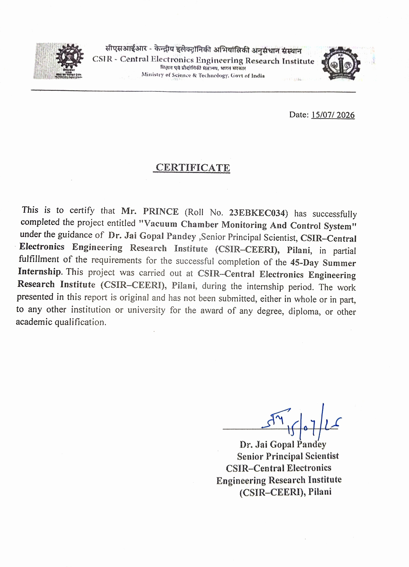

Acknowledgement
I would like to express my sincere gratitude to my project guide, Dr. Jai Gopal Pandey Sir, for his valuable guidance, continuous encouragement, and technical support throughout the development of this project. His suggestions and motivation helped us successfully complete this work.
We are also thankful to the Department of Electronics & Communication Engineering, BK. Birla Institute of Engineering & Technology, for providing the necessary facilities and resources required for this project.
We would like to express our heartfelt thanks to all the faculty members, laboratory staff, and our classmates for their cooperation and support during the project work.
Finally, we are deeply grateful to our parents and family members for their constant encouragement, patience, and moral support throughout our academic journey.
Student
Prince

Abstract
The Standalone ATmega328P Based Vacuum Chamber Monitoring and Control System is an embedded system designed to monitor and automatically control the operating conditions inside a vacuum box. The system is developed using a standalone ATmega328P microcontroller, making it compact, economical, and suitable for industrial as well as laboratory applications.
The system continuously monitors three important environmental parameters: temperature, humidity, and pressure. The LM35 temperature sensor is used to measure the temperature, the DHT22 sensor measures the humidity, and the pressure sensor monitors the vacuum level inside the chamber. The sensor data is continuously processed by the ATmega328P microcontroller.
Based on the programmed pressure limits, the controller automatically operates the Single Channel Relay and Solid State Relay (SSR) to control the vacuum pump. This automatic operation minimizes human intervention, improves process accuracy, reduces power consumption, and enhances the overall efficiency of the vacuum system.
The hardware consists of a standalone ATmega328P minimum system including a 16 MHz crystal oscillator, 22 pF capacitors, 100 nF decoupling capacitor, 10 kΩ reset pull-up resistor, 1 kΩ resistor, and a push-button reset switch. The embedded software is developed using the Arduino IDE and uploaded to the microcontroller through an ISP programmer.
Experimental testing confirmed that the system operates reliably under different conditions and successfully performs automatic monitoring and control of the vacuum process. The developed system is low-cost, reliable, modular, and can be further enhanced with features such as IoT connectivity, data logging, wireless communication, and advanced control algorithms.

Chapter No. | Title | Page No.
Declaration | Declaration | 2
Certificate | Certificate | 3
Acknowledgement | Acknowledgement | 4
Abstract | Abstract | 5
Table of Contents | Table of Contents | 6-9
Chapter 1 | Introduction | 11
1.1 | Introduction | 11
1.2 | Problem Statement | 14
1.3 | Proposed Solution | 14
1.4 | Scope of the Project | 14
1.5 | Organization of the Report | 14
Chapter 2 | Objectives and Literature Review | 15
2.1 | Objectives of the Project | 15
2.2 | Need of the Project | 15
2.3 | Literature Review | 16
2.4 | Existing System | 17
2.5 | Proposed System | 17
2.6 | Summary | 17-19
Chapter 3 | Hardware Description | 20
3.1 | Introduction | 20
3.2 | ATmega328P Microcontroller | 20
3.3 | Minimum System of ATmega328P | 21
3.4 | LM35 Temperature Sensor | 22
3.5 | DHT22 Humidity Sensor | 23
3.6 | Pressure Sensor | 23
3.7 | Single Channel Relay | 24
3.8 | Solid State Relay (SSR) | 24
3.9 | Crystal Oscillator | 25
3.10 | Push Button Switch | 25
3.11 | Resistors | 25
3.12 | Capacitors | 25
3.13 | Regulated Power Supply | 26
3.14 | Summary | 26
Chapter 4 | System Design and Circuit Description | 29
4.1 | Introduction | 29
4.2 | Input Section | 29
4.3 | Processing Section | 30
4.4 | Output Section | 30
4.5 | Circuit Description | 30
4.6 | System Operation | 31
4.7 | Summary | 31
Chapter 5 | Software Design and Control Algorithm | 35
5.1 | Introduction | 35
5.2 | Software Development Tools | 35
5.3 | Program Structure | 35
5.4 | Control Algorithm | 36
5.5 | Sensor Data Processing | 36
5.6 | Relay and SSR Control Logic | 37
5.7 | Error Handling | 37
5.8 | Advantages of Software Design | 37
5.9 | Summary | 38
Chapter 6 | Program Implementation and Code Explanation | 42
6.1 | Introduction | 42
6.2 | Program Development Methodology | 42
6.3 | Program Initialization | 43
6.4 | Sensor Data Acquisition | 43
6.5 | Decision Making Process | 44
6.6 | Relay and SSR Operation | 44
6.7 | Main Program Logic | 45
6.8 | Advantages of Implemented Program | 45
6.9 | Program Testing | 46
6.10 | Summary | 46
Chapter 7 | Testing, Results, Advantages, Applications and Future Scope | 49
7.1 | Introduction | 49
7.2 | Testing Procedure | 49
7.3 | Observation Table | 50
7.4 | Experimental Results | 50
7.5 | Advantages | 51
7.6 | Applications | 51
7.7 | Future Scope | 52
7.8 | Limitations | 53
7.9 | Summary | 53
Chapter 8 | Conclusion and References | 57
8.1 | Conclusion | 57
8.2 | Project Achievements | 58
8.3 | References | 58
8.4 | Final Summary | 59
Advantages | Advantages | 60
Applications | Applications | 61
Future Scope | Future Scope | 62
Conclusion | Conclusion | 63
References | References | 64

CHAPTER 1

Introduction
1.1 Introduction
Vacuum technology plays an important role in modern industrial and laboratory applications. A vacuum box is used to create a low-pressure environment inside a sealed chamber for various industrial processes such as vacuum drying, leak testing, electronic component manufacturing, food packaging, pharmaceutical processing, and research applications. Maintaining the required vacuum level is essential to achieve consistent process quality, improve efficiency, and ensure product reliability.
Traditionally, vacuum systems are operated manually, where the operator continuously monitors pressure and environmental conditions before switching the vacuum pump ON or OFF. Manual operation may lead to inaccurate readings, delayed response, increased power consumption, and human errors. To overcome these limitations, an automatic monitoring and control system is required.
This project presents the design and development of a Standalone ATmega328P Based Vacuum Box Monitoring and Control System. Unlike development boards such as Arduino Nano or Arduino Uno, this project uses a standalone ATmega328P microcontroller, making the system compact, cost-effective, and suitable for dedicated industrial applications.
The proposed system continuously monitors important environmental parameters inside the vacuum chamber using suitable sensors. The LM35 sensor is used to measure temperature, while the DHT22 sensor measures humidity. A pressure sensor continuously measures the pressure inside the vacuum box. The sensor data is processed by the ATmega328P microcontroller to determine the operating condition of the vacuum chamber.
Based on the programmed pressure limits, the controller automatically operates the vacuum pump through a Single Channel Relay and a Solid State Relay (SSR). This automatic control minimizes human intervention and ensures that the desired vacuum level is maintained throughout the operation.
The hardware of the system includes a standalone ATmega328P minimum system consisting of a 16 MHz crystal oscillator, two 22 pF capacitors, a 10 kΩ reset pull-up resistor, a push button for reset, a 100 nF decoupling capacitor, and a 1 kΩ resistor used in the control circuitry. These components ensure stable operation of the microcontroller and improve overall system reliability.
One of the major advantages of this project is its modular design. Additional sensors, data logging systems, communication modules, or display units can be integrated in the future without major hardware modifications. Therefore, the proposed system provides a flexible platform for future industrial automation applications.
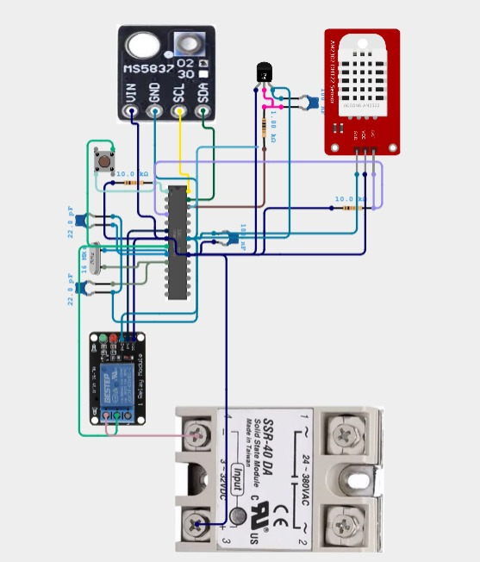

Circuit Description
The complete hardware circuit of the proposed Standalone ATmega328P Based Vacuum Box Monitoring and Control System is shown in Figure. The ATmega328P microcontroller acts as the central processing unit and is responsible for acquiring sensor data and controlling the output devices.
A 16 MHz crystal oscillator together with two 22 pF capacitors is connected to the XTAL1 and XTAL2 pins of the ATmega328P to provide a stable clock signal for accurate program execution. A 10 kΩ pull-up resistor is connected between the RESET pin and the +5 V supply to ensure reliable startup, while a push-button switch is provided for manual reset. A 100 nF decoupling capacitor is connected across the power supply pins to suppress electrical noise and improve system stability.
The LM35 temperature sensor is connected to one of the analog input pins of the microcontroller. It generates an analog voltage proportional to the surrounding temperature, which is converted into a digital value using the internal 10-bit ADC of the ATmega328P.
The DHT22 humidity sensor is interfaced through a digital input pin using a single-wire communication protocol. It continuously provides humidity data to the controller for environmental monitoring.
The MS5837 pressure sensor is connected through the I²C communication interface, where the SDA and SCL lines are connected to the corresponding I²C pins of the ATmega328P. This sensor continuously measures the pressure inside the vacuum chamber and provides real-time pressure data to the controller.
The controller processes all sensor readings and compares the measured pressure with the predefined operating limits. According to the control algorithm, the controller activates a Single Channel Relay Module to switch the vacuum pump ON or OFF. Additionally, a Solid State Relay (SSR-40DA) is connected to another output pin for controlling a high-power load with electrical isolation, fast switching, and improved reliability.
The complete system operates from a regulated 5 V DC power supply, ensuring stable operation of the microcontroller and all connected sensors. The hardware design provides accurate monitoring, automatic control of the vacuum pump, low power consumption, and reliable performance suitable for laboratory and industrial automation applications.

1.2 Problem Statement
Manual vacuum box operation requires continuous human supervision for monitoring pressure and environmental conditions. Manual switching of the vacuum pump may result in unstable vacuum levels, higher energy consumption, delayed response, and process inconsistency. Therefore, there is a need for an intelligent embedded system capable of automatically monitoring and controlling the vacuum box using a standalone microcontroller.

1.3 Proposed Solution
The proposed solution is a standalone ATmega328P-based embedded control system capable of continuously monitoring temperature, humidity, and pressure inside the vacuum chamber. Based on predefined pressure limits, the controller automatically controls the vacuum pump using a relay and SSR, thereby maintaining the required operating conditions with minimal human intervention.

1.4 Scope of the Project
The developed system can be used in:
- Laboratory Vacuum Chambers
- Vacuum Drying Systems
- Food Packaging Industries
- Pharmaceutical Industries
- Research Laboratories
- Electronic Component Manufacturing
- Leak Testing Systems
- Small Industrial Vacuum Processes

1.5 Organization of the Report
This report consists of several chapters describing different aspects of the project. The introduction explains the project background and objectives. The literature review discusses previous work related to vacuum monitoring systems. The hardware chapter explains all electronic components used in the project.

Objectives

CHAPTER 2
2.1 Objectives of the Project
The primary objective of this project is to design and develop a standalone ATmega328P based embedded system capable of monitoring and controlling a vacuum box automatically. The system continuously measures important environmental parameters and controls the vacuum process with minimum human intervention.
The specific objectives of the project are as follows:
- To design a compact standalone embedded controller using the ATmega328P microcontroller.
- To measure the temperature inside the vacuum box using the LM35 temperature sensor.
- To monitor humidity using the DHT22 digital humidity sensor.
- To continuously monitor the pressure inside the vacuum chamber using the pressure sensor.
- To automatically control the vacuum pump using a Single Channel Relay and a Solid State Relay (SSR).
- To improve the accuracy and stability of the vacuum generation process.
- To reduce manual operation and human errors during vacuum monitoring.
- To develop a low-cost and reliable monitoring system suitable for industrial and laboratory applications.
- To provide a modular hardware platform that can be upgraded in the future with additional sensors or communication modules.

2.2 Need of the Project
In many small-scale industries and laboratory setups, vacuum systems are still operated manually. The operator has to monitor the pressure continuously and switch the vacuum pump ON or OFF according to the required vacuum level. This manual operation has several disadvantages such as delayed response, inconsistent vacuum levels, increased power consumption, and the possibility of human error.

2.3 Literature Review
Automation has become an important part of modern industrial systems. Microcontroller-based monitoring and control systems are widely used because they provide accurate measurements, fast response, and flexible programming capabilities.
Several researchers have developed embedded systems for environmental monitoring using sensors such as temperature, humidity, and pressure sensors. Most existing systems use development boards like Arduino Uno or Arduino Nano because they simplify hardware development. However, these boards are generally intended for prototyping and educational purposes.
For industrial applications, a standalone ATmega328P microcontroller offers several advantages. It reduces the size of the hardware, lowers the overall cost, improves reliability, and allows the designer to develop a customized PCB according to the application requirements.
Temperature monitoring is one of the most important parameters in vacuum-based processes. The LM35 temperature sensor is commonly used because of its linear output voltage, good accuracy, and simple interfacing with microcontrollers.
Humidity also affects many industrial and laboratory processes. The DHT22 sensor is widely used because it provides both humidity and temperature information in digital form with good accuracy and long-term stability.
Pressure monitoring is the most critical part of any vacuum control system. A pressure sensor continuously measures the vacuum level inside the chamber and provides feedback to the controller. The controller compares the measured pressure with predefined limits and automatically operates the vacuum pump using relay circuits.
Relay modules and Solid State Relays (SSR) are widely used in industrial automation because they provide electrical isolation between the controller and high-power electrical loads. SSRs offer silent operation, faster switching speed, longer service life, and improved reliability compared to conventional mechanical relays in many applications.
The combination of these technologies enables the development of a compact, low-cost, and reliable vacuum monitoring and control system suitable for educational laboratories, research centers, and industrial environments.

2.4 Existing System
Traditional vacuum boxes are generally operated manually. The operator checks the pressure level using analog gauges and manually controls the vacuum pump. Such systems require constant supervision and may produce inconsistent results due to human error.
Limitations of Existing System
- Continuous manual monitoring is required.
- Higher possibility of human error.
- Delayed switching of the vacuum pump.
- Increased power consumption.
- Less reliable operation.
- Difficulty in maintaining a constant vacuum level.
- Limited automation capability.

2.5 Proposed System
The proposed system uses a standalone ATmega328P microcontroller as the main controller. The controller continuously receives data from the LM35 temperature sensor, DHT22 humidity sensor, and the pressure sensor. Based on the programmed pressure limits, it automatically controls the vacuum pump through a Single Channel Relay and SSR.
The proposed system offers better accuracy, lower cost, compact hardware, improved reliability, reduced human intervention, and easier maintenance. It also provides flexibility for future expansion by adding communication modules, displays, or data logging systems.

2.6 Summary
This chapter discussed the objectives, necessity, existing techniques, and proposed solution for the development of the Standalone ATmega328P Based Vacuum Box Monitoring and Control System. The next chapter presents the detailed hardware components used in the project along with their specifications and working principles.

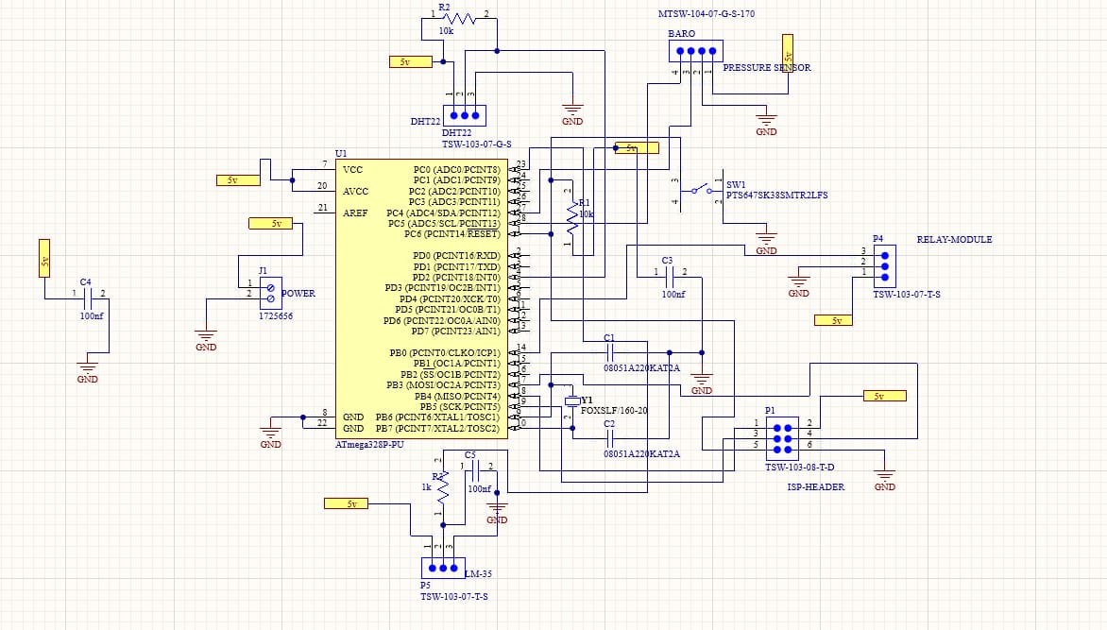

Circuit Description
Figure shows the complete schematic diagram of the proposed Standalone ATmega328P Based Vacuum Box Monitoring and Control System designed using Proteus Design Suite. The ATmega328P-PU microcontroller serves as the central processing unit of the system and controls all sensing and switching operations.
The ATmega328P operates from a regulated 5 V DC power supply. Both the VCC and AVCC pins are connected to the 5 V supply, while the GND pins are connected to the common ground. A 100 nF decoupling capacitor (C4) is connected across the power supply to eliminate electrical noise and improve voltage stability.
A 16 MHz crystal oscillator (Y1) is connected between the XTAL1 and XTAL2 pins of the ATmega328P. Two 22 pF capacitors (C1 and C2) are connected from the crystal terminals to ground to provide stable clock oscillation required for reliable execution of the embedded program.
The RESET pin of the ATmega328P is connected to a 10 kΩ pull-up resistor (R1), which keeps the controller in the normal operating state. A push-button switch (SW1) is connected to the RESET line, allowing manual restarting of the microcontroller whenever required.
The LM35 temperature sensor is connected to one of the analog input pins of the ATmega328P. It generates an analog output voltage proportional to the surrounding temperature, which is converted into a digital value using the internal Analog-to-Digital Converter (ADC) of the microcontroller.
The DHT22 temperature and humidity sensor is interfaced with a digital input pin of the ATmega328P using a single-wire communication protocol. A 10 kΩ pull-up resistor (R2) is connected between the data pin and the 5 V supply to ensure reliable digital communication between the sensor and the microcontroller.
The pressure sensor is connected to the controller through its dedicated interface pins. The microcontroller continuously receives pressure information from the sensor and compares it with the predefined pressure limits stored in the program.
A Single Channel Relay Module is connected to one of the digital output pins of the ATmega328P. The relay controls the external vacuum pump by switching it ON or OFF according to the measured pressure conditions. This automatic control reduces manual intervention and maintains the desired vacuum level inside the chamber.
An ISP (In-System Programming) Header is provided in the circuit for programming the ATmega328P using an external USBasp programmer. This allows the embedded program to be uploaded directly to the microcontroller without removing it from the circuit.
The complete system integrates temperature sensing, humidity sensing, pressure monitoring, and automatic relay control into a compact embedded platform.

Hardware Description
CHAPTER 3
3.1 Introduction
The performance of any embedded system depends on the proper selection of hardware components. In the proposed Standalone ATmega328P Based Vacuum Box Monitoring and Control System, reliable electronic components have been selected to ensure accurate sensing, stable operation, and efficient control of the vacuum process. This chapter explains the specifications, working principle, and role of each hardware component used in the project.
The controller continuously receives input from the LM35 temperature sensor, DHT22 humidity sensor, and the pressure sensor. Based on the programmed logic, the ATmega328P processes these inputs and controls the output devices through a Single Channel Relay and a Solid State Relay (SSR). A regulated power supply provides stable voltage to all electronic components.

3.2 ATmega328P Microcontroller
The ATmega328P is an 8-bit AVR microcontroller manufactured by Microchip Technology. It is the main controller used in this project. Instead of using an Arduino Nano development board, a standalone ATmega328P has been used to reduce cost, minimize circuit size, and improve hardware flexibility.
The microcontroller executes the embedded program, reads sensor data, performs decision making, and controls the output devices.
Features of ATmega328P
- 8-bit AVR Architecture
- 32 KB Flash Memory
- 2 KB SRAM
- 1 KB EEPROM
- Operating Voltage: 1.8 V to 5.5 V
- Clock Frequency: Up to 20 MHz
- 23 Programmable I/O Pins
- 6 Analog Input Channels
- SPI, I²C and UART Communication
Role in the Project
- Reads the LM35 temperature sensor.
- Reads humidity data from the DHT22 sensor.
- Reads pressure sensor output.
- Processes all sensor data.
- Controls the Single Channel Relay.
- Controls the Solid State Relay (SSR).
- Executes the complete control algorithm.

3.3 Minimum System of ATmega328P
Since a standalone ATmega328P is used, the minimum supporting circuit is required for stable operation.
The minimum system consists of:
- ATmega328P-PU Microcontroller
- 16 MHz Crystal Oscillator
- Two 22 pF Capacitors
- 10 kΩ Reset Pull-up Resistor
- Push Button Reset Switch
- 100 nF Decoupling Capacitor
- 5 V Regulated Power Supply
This circuit provides a stable clock signal and ensures reliable operation of the microcontroller.

3.4 LM35 Temperature Sensor
The LM35 is a precision analog temperature sensor that provides an output voltage linearly proportional to temperature in degrees Celsius. It is simple to interface with the analog input of the ATmega328P and does not require external calibration.
Specifications
- Supply Voltage: 4 V to 30 V
- Temperature Range: −55°C to +150°C
- Output: 10 mV/°C
- Accuracy: ±0.5°C (Typical)
- Low Power Consumption
Working Principle
The sensor produces an analog voltage proportional to the measured temperature. The ATmega328P converts this analog voltage into digital values using its built-in Analog-to-Digital Converter (ADC). The software then calculates the corresponding temperature in degrees Celsius.
Advantages
- Simple interfacing
- Low cost
- Good accuracy
- No external calibration required
- Low power consumption

3.5 DHT22 Humidity Sensor
The DHT22 is a digital sensor capable of measuring both humidity and temperature. In this project, it is used primarily for humidity measurement inside the vacuum chamber.
Specifications
- Supply Voltage: 3.3 V to 6 V
- Humidity Range: 0–100% RH
- Humidity Accuracy: ±2% RH
- Digital Single-Wire Communication
- Long-Term Stability
Working Principle
The DHT22 contains a humidity sensing element and an internal microcontroller. It measures humidity and transmits digital data directly to the ATmega328P through a single communication pin, eliminating the need for external ADC conversion.
Advantages
- High accuracy
- Digital output
- Easy interfacing
- Stable performance
- Low maintenance

3.6 Pressure Sensor
The pressure sensor continuously monitors the pressure inside the vacuum chamber. It provides feedback to the ATmega328P, enabling automatic control of the vacuum process.
Functions
- Measures vacuum pressure.
- Provides real-time pressure data.
- Helps maintain the required vacuum level.
- Improves process stability

3.7 Single Channel Relay Module
A relay is an electrically operated switch used to control high-power electrical loads using low-voltage control signals.
Features
- 5 V Coil Voltage
- Electrical Isolation
- High Load Switching Capability
- Easy Interfacing
Role in the Project
The relay switches the vacuum pump according to commands generated by the ATmega328P.

3.8 Solid State Relay (SSR)
The Solid State Relay is an electronic switching device used to control AC or DC loads without mechanical contacts.
Advantages
- Silent Operation
- High Switching Speed
- Long Service Life
- No Mechanical Wear
- High Reliability
The SSR improves switching performance and increases the overall reliability of the vacuum control system.

3.9 Crystal Oscillator
A 16 MHz crystal oscillator provides the clock signal required by the ATmega328P for program execution and accurate timing.
Two 22 pF capacitors are connected with the crystal to ensure stable oscillation.

3.10 Push Button Switch
A push button is connected to the RESET pin of the microcontroller. It is used to restart the system whenever required during testing or operation.

3.11 Resistors
Two resistors are used in the hardware design.
10 kΩ Resistor
- Connected to RESET pin.
- Pulls the RESET pin HIGH.
- Prevents unwanted reset.
1 kΩ Resistor
- Used in the control circuit.
- Limits current.
- Protects electronic components.

3.12 Capacitors
22 pF Capacitors
- Connected with the crystal oscillator.
- Stabilize the clock signal.
100 nF Capacitor
- Used as a decoupling capacitor.
- Filters electrical noise.

3.13 Regulated Power Supply
A regulated 5 V power supply provides stable voltage to the ATmega328P and all peripheral components. A stable power source is essential for accurate sensor readings and reliable controller operation.

3.14 Summary
This chapter discussed the hardware components used in the proposed vacuum box monitoring and control system. Each component has been selected based on reliability, cost, simplicity, and ease of interfacing. The next chapter explains the complete system architecture, block diagram, and circuit connections used in the project.

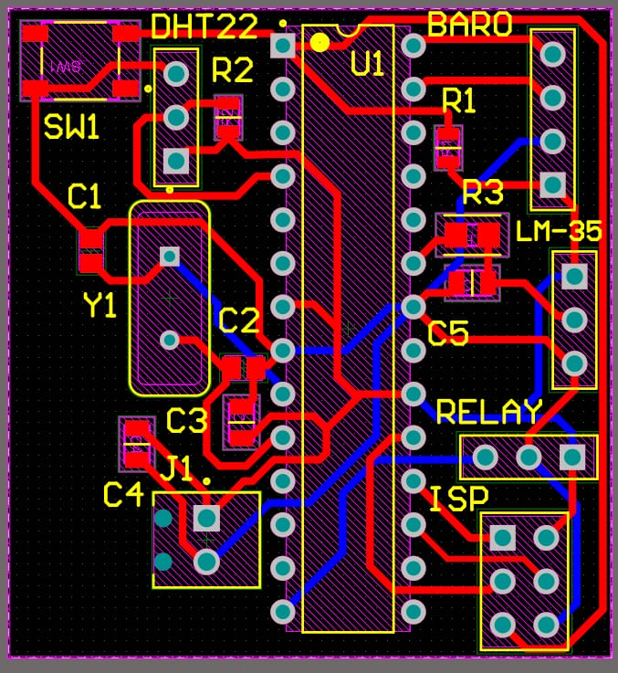

From this Figure illustrates the Printed Circuit Board (PCB) layout of the proposed Standalone ATmega328P Based Vacuum Box Monitoring and Control System. The PCB was designed using Proteus ARES software with the objective of developing a compact, reliable, and easy-to-fabricate hardware platform.
The ATmega328P-PU microcontroller (U1) is placed at the center of the PCB to minimize routing complexity and reduce signal path lengths between the controller and peripheral devices. This placement improves signal integrity and simplifies the PCB design.
The LM35 temperature sensor, DHT22 humidity sensor, and pressure sensor connector (BARO) are positioned near the edge of the PCB to allow convenient external sensor connections. The relay module connector is also placed on the PCB boundary so that the external vacuum pump can be connected easily without affecting the internal circuitry.
The PCB incorporates a 16 MHz crystal oscillator (Y1) with two 22 pF capacitors (C1 and C2) positioned close to the microcontroller to ensure stable clock generation. The 10 kΩ pull-up resistor for the reset circuit and the push-button reset switch (SW1) are located near the RESET pin to provide reliable system initialization and manual reset functionality.
An ISP (In-System Programming) header is provided on the PCB to allow direct programming of the ATmega328P using a USB asp programmer without removing the microcontroller from the board. This feature simplifies firmware updates and debugging during development.
The PCB layout uses single-board construction with properly routed power and signal tracks to minimize electrical noise and voltage drops. Adequate spacing has been maintained between tracks to improve manufacturing reliability and reduce the possibility of short circuits. Component placement has been optimized to reduce PCB size while maintaining easy accessibility for assembly and maintenance.
Overall, the designed PCB provides a compact, organized, and efficient hardware platform for integrating the microcontroller, sensors, relay interface, and programming connector into a single embedded system. The layout supports reliable monitoring of temperature, humidity, and pressure while enabling automatic control of the vacuum pump.
PCB Design Features:-
Designed using Proteus ARES PCB Designer.
Compact single-board layout for reduced size.
Central placement of the ATmega328P for efficient routing.
Dedicated connectors for LM35, DHT22, and Pressure Sensor.
On-board 16 MHz crystal oscillator with 22 pF capacitors.

CHAPTER 4
4.1 Introduction
The system design is one of the most important stages in the development of any embedded system. It defines the interaction between hardware components, sensors, controller, and output devices. In this project, a standalone ATmega328P microcontroller is used as the central processing unit to monitor environmental conditions inside the vacuum box and control the vacuum pump automatically.
The complete system consists of three major sections:
- Input Section
- Processing Section
- Output Section
All sensor information is collected by the ATmega328P microcontroller. After processing the input data, the controller generates suitable output signals to operate the relay and Solid State Relay (SSR), thereby controlling the vacuum pump.

4.2 Input Section
The input section consists of three sensors connected to the ATmega328P microcontroller.
LM35 Temperature Sensor
The LM35 continuously measures the temperature inside the vacuum chamber. The analog output voltage is converted into a digital value using the internal ADC of the ATmega328P.
DHT22 Humidity Sensor
The DHT22 measures the humidity level inside the vacuum chamber. The digital data is transferred directly to the microcontroller through a single communication line.
Pressure Sensor
The pressure sensor continuously measures the vacuum pressure inside the chamber. This value is the primary control parameter used for automatic operation of the vacuum pump.

4.3 Processing Section
The processing section is based on the standalone ATmega328P microcontroller.
The controller performs the following tasks:
- Initializes all hardware components.
- Reads sensor values periodically.
- Converts analog data into digital values.
- Compares pressure values with predefined limits.
- Executes the control algorithm.
- Generates output signals for relay and SSR.
- Repeats the monitoring process continuously.
The embedded software is developed using the Arduino IDE and uploaded into the ATmega328P through an ISP programmer.
4.4 Output Section
The output section contains:
Single Channel Relay
The relay provides electrical isolation between the microcontroller and the vacuum pump control circuit. It switches the pump ON and OFF according to the controller output.
Solid State Relay (SSR)
The SSR is used for reliable and high-speed switching of the load. Since it has no moving mechanical parts, it offers silent operation, higher durability, and longer operational life.
4.5 Circuit Description
The complete hardware circuit consists of a standalone ATmega328P minimum system and sensor interface circuits.
The ATmega328P is powered by a regulated 5 V supply. A 16 MHz crystal oscillator, together with two 22 pF capacitors, provides the clock signal required for program execution.
A 10 kΩ resistor is connected between the RESET pin and the +5 V supply to keep the microcontroller in the normal operating state. A push button switch is connected to the RESET pin for manual system reset.A 100 nF capacitor is placed across the power supply pins of the microcontroller to remove high-frequency electrical noise and improve power stability.The LM35 output is connected to one of the analog input pins of the ATmega328P. The DHT22 communicates through a digital I/O pin using a single-wire communication protocol. The pressure sensor is connected according to its output type (analog or digital), allowing the controller to continuously monitor the vacuum level.
The output pins of the ATmega328P are connected to the Single Channel Relay and SSR through suitable interfacing circuitry. These output devices control the operation of the vacuum pump based on the embedded program.

4.6 System Operation
The complete system operates according to the following sequence:
- Power is applied to the controller.
- ATmega328P initializes all peripherals.
- Temperature, humidity, and pressure sensors are read.
- Pressure value is compared with the programmed set point.
- If vacuum level is below the required value, the relay and SSR activate the vacuum pump.
- When the desired pressure is achieved, the controller switches the pump OFF.
- The monitoring process continues continuously.

4.7 Summary
This chapter explained the overall system architecture, block diagram, hardware organization, and circuit description of the Standalone ATmega328P Based Vacuum Box Monitoring and Control System. The next chapter presents the software design, control algorithm, and flowchart used for automatic system operation.

3D PCB View

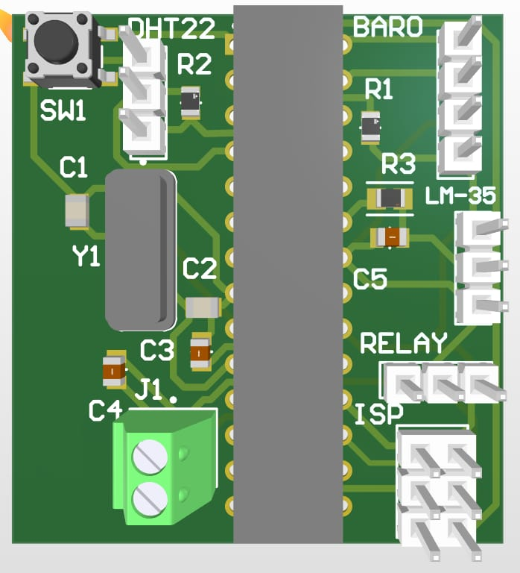

3D PCB View
From this Figure shows the 3D model of the Printed Circuit Board (PCB) developed for the proposed Standalone ATmega328P Based Vacuum Box Monitoring and Control System. The 3D PCB model was generated using Proteus ARES software to verify the physical placement of components before PCB fabrication.
The ATmega328P-PU microcontroller is mounted at the center of the PCB, providing a compact and organized layout for all peripheral connections. Placing the controller at the center minimizes routing complexity and shortens the signal paths between the microcontroller and connected sensors.
A 16 MHz crystal oscillator (Y1) with its associated capacitors is placed close to the microcontroller to provide a stable clock source. The push-button reset switch (SW1) and the reset pull-up resistor are positioned near the RESET pin, allowing convenient manual reset during programming and testing.
Dedicated connectors are provided for the DHT22 humidity sensor, LM35 temperature sensor, and the pressure sensor (BARO). These connectors are located along the edges of the PCB, making sensor installation and replacement simple and convenient.
A separate connector is provided for the relay module, which controls the vacuum pump according to the programmed control logic. An ISP (In-System Programming) header is also included to allow direct programming of the ATmega328P using a USBasp programmer without removing the microcontroller from the PCB.
The PCB layout is designed with proper spacing between components and tracks to ensure reliable electrical performance, easy soldering, and simplified maintenance. The compact arrangement reduces wiring complexity while improving overall mechanical strength and circuit reliability.
The 3D visualization confirms that all components are correctly positioned without mechanical interference. It also helps in identifying assembly issues before manufacturing the PCB, thereby reducing fabrication errors and development time.
Overall, the developed PCB provides a compact, reliable, and cost-effective hardware platform for monitoring temperature, humidity, and pressure while automatically controlling the vacuum pump.

Key Features of the 3D PCB
Compact PCB designed using Proteus ARES.
Central placement of the ATmega328P microcontroller.
Dedicated connectors for LM35, DHT22, and Pressure Sensor.
16 MHz crystal oscillator for stable microcontroller operation.
Push-button reset switch for manual reset.
Relay connector for automatic vacuum pump control.
ISP programming header for firmware uploading.
Optimized component placement for easy assembly and maintenance.
Compact size with organized routing for reliable operation.

Circuit Description
CHAPTER 5
5.1 Introduction
The software plays a vital role in the operation of the Standalone ATmega328P Based Vacuum Box Monitoring and Control System. It is responsible for initializing the hardware, reading sensor data, processing the information, making control decisions, and operating the relay and Solid State Relay (SSR).
The software for this project was developed using the Arduino IDE. After writing and testing the program, the compiled firmware was uploaded to the standalone ATmega328P microcontroller using an ISP programmer. The program executes continuously in an infinite loop, ensuring real-time monitoring and control of the vacuum box.

5.2 Software Development Tools
The following software tools were used during the development of this project:
Software | Purpose
Arduino IDE | Program development and compilation
Embedded C/C++ | Programming language
AVR Board Package | Support for ATmega328P
ISP Programmer | Uploading firmware to ATmega328P

5.3 Program Structure
The embedded program is divided into the following major sections:
- Library Initialization
- Variable Declaration
- Pin Configuration
- Sensor Initialization
- Reading Sensor Data
- Decision Making

5.4 Control Algorithm
The control algorithm continuously monitors the operating conditions of the vacuum box.
The following sequence is executed repeatedly:
- Power ON the controller.
- Initialize all peripherals.
- Configure input and output pins.
- Read LM35 temperature value.
- Read DHT22 humidity value.
- Read pressure sensor value.
- Compare pressure with programmed threshold.
- If pressure is higher than the set value, activate the relay and SSR to start the vacuum pump.
- Continue monitoring until the required vacuum level is achieved.

5.5 Sensor Data Processing
LM35
The LM35 provides an analog voltage proportional to temperature. The ATmega328P converts this analog voltage into a digital value using its built-in 10-bit ADC. The software calculates the corresponding temperature in degrees Celsius.
DHT22
The DHT22 sends humidity data digitally through a single-wire communication protocol. The controller decodes the received data and extracts the humidity value.
Pressure Sensor
The pressure sensor continuously measures the vacuum pressure inside the chamber. The measured value is compared with the predefined operating limits stored in the program.

5.6 Relay and SSR Control Logic
The output control section is responsible for operating the vacuum pump.
The controller continuously evaluates the pressure level.
- If the pressure is above the desired limit, the relay and SSR are switched ON.
- When the required vacuum level is achieved, both outputs are switched OFF.
- This automatic control minimizes energy consumption and maintains stable vacuum conditions.

5.7 Error Handling
To improve system reliability, the software includes basic error handling features.
- Continuous sensor monitoring.
- Stable initialization after power-up.
- Reliable program execution inside the main loop.
- Automatic restart after manual reset.
- Noise reduction through software filtering where required.

5.8 Advantages of the Software Design
The software developed for this project offers several advantages:
- Simple and modular program structure.
- Easy debugging and maintenance.
- Reliable sensor interfacing.
- Fast response to pressure changes.
- Automatic control without human intervention.
- Low memory utilization.
- Easy future modification and expansion.

5.9 Summary
This chapter explained the software architecture, program flow, sensor data processing, control algorithm, and relay operation used in the Standalone ATmega328P Based Vacuum Box Monitoring and Control System. The software continuously monitors environmental parameters and automatically controls the vacuum pump based on the programmed operating conditions. The next chapter presents the implementation, testing procedure, and experimental results of the developed system.

Sensor Schmatic:-

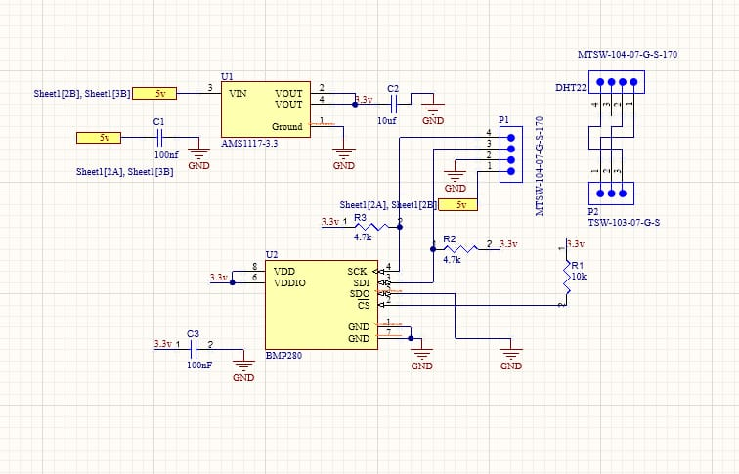

Circuit Description
Figure this figure illustrates the interface circuit of the DPP101A000 pressure sensor and DHT22 humidity sensor used in the proposed vacuum box monitoring system. Since the DPP101A000 sensor operates at 3.3 V, an AMS1117-3.3 voltage regulator is used to convert the available 5 V DC supply into a stable 3.3 V output.
The input of the AMS1117 regulator is connected to the 5 V supply, while the output provides a regulated 3.3 V required by the DPP101A000 sensor. A 100 nF capacitor (C1) is connected at the regulator input, and a 10 µF capacitor (C2) is connected at the output to filter voltage fluctuations and ensure a stable power supply.
The DPP101A000 pressure sensor (U2) is powered by the regulated 3.3 V supply. The sensor communicates with the ATmega328P microcontroller through the I²C communication interface, using the SDA (Serial Data) and SCL (Serial Clock) lines. Two 4.7 kΩ pull-up resistors (R2 and R3) are connected to the I²C bus, ensuring reliable communication by maintaining the logic HIGH level when the bus is idle.
The DHT22 temperature and humidity sensor connector is also provided in the circuit. A 10 kΩ pull-up resistor (R1) is connected between the data line and the supply voltage to maintain stable digital communication between the sensor and the microcontroller.
A connector (P1) is included for interfacing the sensor module with the main controller board, allowing easy installation and maintenance. Proper decoupling capacitors and pull-up resistors improve signal quality, reduce electrical noise, and enhance the overall reliability of the sensing system.
The sensor interface circuit continuously provides accurate pressure, temperature, and humidity data to the ATmega328P microcontroller. These measurements are processed by the controller to monitor the vacuum box conditions and automatically control the relay-operated vacuum pump according to the programmed control logic.

Main Components Used
AMS1117-3.3 Voltage Regulator – Converts 5 V to 3.3 V for the BMP280 sensor.
DPP101A000 Pressure Sensor – Measures pressure for vacuum monitoring.
DHT22 Sensor Connector – Provides humidity and temperature measurement.
4.7 kΩ Pull-up Resistors – Required for reliable I²C communication.
10 kΩ Pull-up Resistor – Used for the DHT22 data line.
100 nF and 10 µF Capacitors – Provide power supply filtering and voltage stabilization.
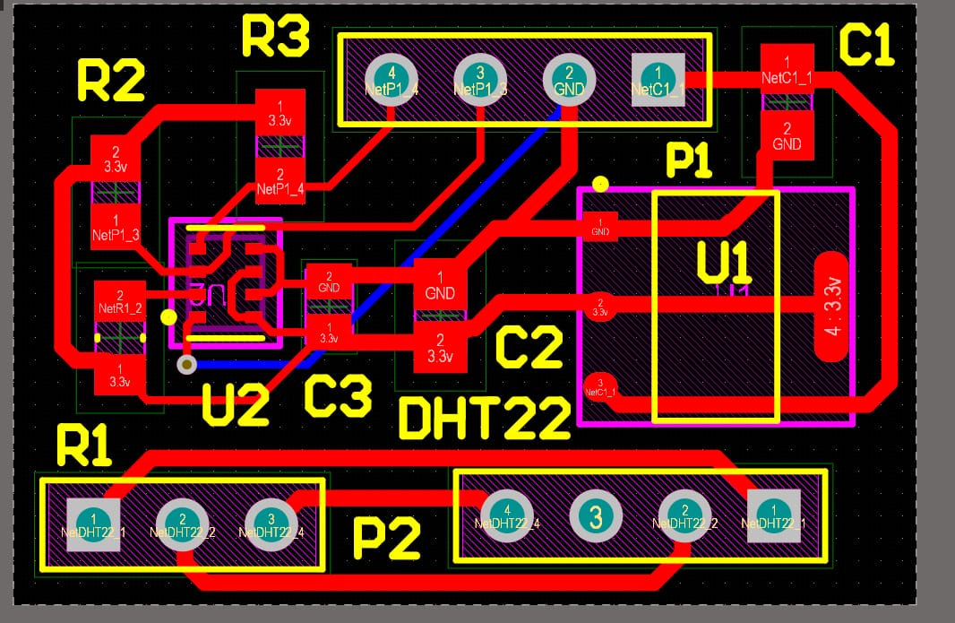

PCB Layout Description
Figure shows the 2D PCB layout of the sensor interface module designed for the proposed Standalone ATmega328P Based Vacuum Box Monitoring and Control System. The PCB was developed using Proteus ARES software to provide a compact and reliable interface for the pressure sensor and humidity sensor.
The PCB includes an AMS1117-3.3 voltage regulator (U1), which converts the available 5 V DC supply into a stable 3.3 V output required for the pressure sensor. Proper input and output filter capacitors (C1 and C2) are placed close to the regulator to ensure voltage stability and minimize electrical noise.
The BMP280 pressure sensor (U2) is positioned on the left side of the PCB to reduce signal routing complexity. The sensor communicates with the main controller through the I²C interface, while R2 and R3 (4.7 kΩ pull-up resistors) maintain the SDA and SCL lines at the required logic level for reliable communication.
A 10 kΩ pull-up resistor (R1) is provided for the DHT22 sensor data line, ensuring stable single-wire communication with the microcontroller. The P2 connector is used for connecting the DHT22 sensor, whereas the P1 connector provides the interface between the sensor module and the main controller board.
The PCB routing has been carefully optimized to reduce track length, improve signal integrity, and minimize electrical interference. Separate power and ground tracks have been provided to ensure stable operation of the sensors. Adequate spacing between copper tracks helps prevent short circuits and improves manufacturing reliability.
The compact PCB layout simplifies assembly, reduces external wiring, and enhances the overall reliability of the sensor interface module. The designed board can be easily integrated with the main ATmega328P controller board for accurate monitoring of pressure, temperature, and humidity inside the vacuum box.

PCB Design Features
Designed using Proteus ARES PCB Designer.
Compact single-layer PCB layout.
Integrated AMS1117-3.3 V voltage regulator.
Dedicated connector for the BMP280 pressure sensor.
Dedicated connector for the DHT22 humidity sensor.
4.7 kΩ pull-up resistors for reliable I²C communication.

Working Principle
CHAPTER 6
6.1 Introduction
The software developed for the Standalone ATmega328P Based Vacuum Box Monitoring and Control System is responsible for acquiring sensor data, processing the measured values, making control decisions, and operating the relay and Solid State Relay (SSR). The firmware has been developed using Embedded C/C++ in the Arduino IDE and uploaded to the standalone ATmega328P microcontroller using an ISP programmer.
The software follows a continuous monitoring approach in which all sensors are read repeatedly, and the vacuum pump is controlled automatically according to the programmed pressure limits.

6.2 Program Development Methodology
The software development process was divided into the following stages:
- Hardware initialization
- Port configuration
- Sensor initialization
- Temperature acquisition
- Humidity acquisition
- Pressure monitoring
- Decision making
- Relay and SSR control
- Continuous execution
This modular approach improves readability, simplifies debugging, and allows future modifications.

6.3 Program Initialization
When power is applied, the ATmega328P initializes all hardware peripherals.
The initialization process includes:
- Configuring input and output pins
- Initializing the Analog-to-Digital Converter (ADC)
- Initializing the DHT22 communication interface
- Configuring relay and SSR output pins
- Preparing program variables for execution
After successful initialization, the controller enters the main loop.

6.4 Sensor Data Acquisition
LM35 Temperature Sensor
The LM35 produces an analog output voltage proportional to temperature.
The ATmega328P reads this voltage through one of its ADC channels and converts it into a digital value. The software then calculates the corresponding temperature in degrees Celsius.
The temperature value is updated continuously throughout the operation.

DHT22 Humidity Sensor
The DHT22 communicates digitally with the controller.
Whenever the controller requests data, the sensor transmits humidity information using its single-wire communication protocol.
The received data is verified and stored for further processing.

Pressure Sensor
The pressure sensor continuously measures the pressure inside the vacuum chamber.
The measured pressure value is used as the primary parameter for automatic control of the vacuum pump.

6.5 Decision Making Process
The ATmega328P continuously analyses all sensor values.
The pressure value is given the highest priority because it directly affects the operation of the vacuum pump.
The controller follows the following sequence:
- Read all sensors.
- Validate the received values.
- Compare pressure with the desired operating limit.
- Decide whether the vacuum pump should be switched ON or OFF.
- Update the relay and SSR outputs.
- Repeat the process continuously.
This method ensures stable and automatic operation of the system.

6.6 Relay and SSR Operation
The relay and Solid State Relay (SSR) are controlled through digital output pins of the ATmega328P.
When the controller detects that the pressure has not yet reached the required vacuum level, it activates the relay and SSR.
Once the desired pressure is achieved, both outputs are deactivated automatically.
This automatic switching improves energy efficiency and reduces unnecessary operation of the vacuum pump.

6.7 Main Program Logic
The software operates in an infinite loop.
The sequence followed is:
- Start the controller.
- Initialize all hardware.
- Read LM35 temperature.
- Read DHT22 humidity.
- Read pressure sensor.
- Process all sensor data.
- Compare pressure with the programmed threshold.
- Control relay and SSR.
- Repeat continuously.
This loop allows real-time monitoring of the vacuum chamber.

6.8 Advantages of the Implemented Program
The developed software offers several advantages:
- Continuous monitoring of environmental parameters.
- Fast response to pressure variations.
- Automatic operation of the vacuum pump.
- Simple program structure.
- Easy debugging and maintenance.
- Low memory requirement.
- Reliable operation using the standalone ATmega328P.

6.9 Program Testing
The software was tested under different operating conditions.
The following parameters were verified:
- Correct initialization after power-up.
- Proper communication with the DHT22 sensor.
- Accurate temperature acquisition from the LM35.
- Stable pressure monitoring.
- Correct switching of the relay.
- Reliable operation of the SSR.
- Continuous execution without program interruption.
The software performed satisfactorily during all experimental tests.

6.10 Summary
This chapter presented the implementation of the embedded software used in the proposed vacuum box monitoring and control system. The developed firmware continuously acquires sensor data, processes the measured values, and automatically controls the vacuum pump using the relay and Solid State Relay. The modular software structure improves reliability, simplifies maintenance, and provides flexibility for future upgrades.

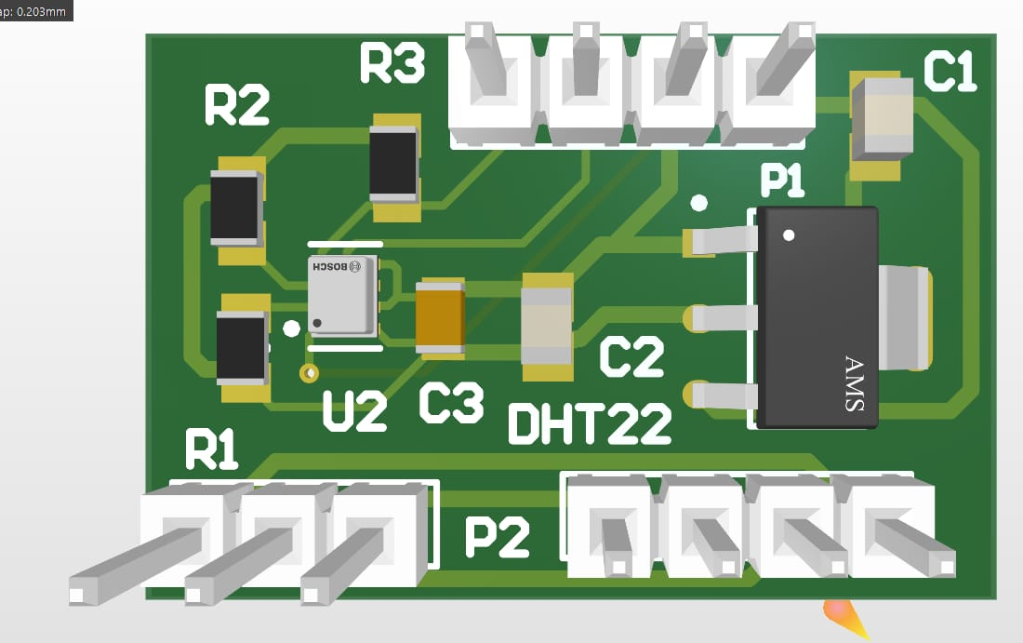

PCB Layout Description
Figure 4.X shows the 2D PCB layout of the sensor interface module designed for the proposed Standalone ATmega328P Based Vacuum Box Monitoring and Control System. The PCB was developed using Proteus ARES software to provide a compact and reliable interface for the pressure sensor and humidity sensor.
The PCB includes an AMS1117-3.3 voltage regulator (U1), which converts the available 5 V DC supply into a stable 3.3 V output required for the pressure sensor. Proper input and output filter capacitors (C1 and C2) are placed close to the regulator to ensure voltage stability and minimize electrical noise.
The BMP280 pressure sensor (U2) is positioned on the left side of the PCB to reduce signal routing complexity. The sensor communicates with the main controller through the I²C interface, while R2 and R3 (4.7 kΩ pull-up resistors) maintain the SDA and SCL lines at the required logic level for reliable communication.
A 10 kΩ pull-up resistor (R1) is provided for the DHT22 sensor data line, ensuring stable single-wire communication with the microcontroller. The P2 connector is used for connecting the DHT22 sensor, whereas the P1 connector provides the interface between the sensor module and the main controller board.
The PCB routing has been carefully optimized to reduce track length, improve signal integrity, and minimize electrical interference. Separate power and ground tracks have been provided to ensure stable operation of the sensors. Adequate spacing between copper tracks helps prevent short circuits and improves manufacturing reliability.
The compact PCB layout simplifies assembly, reduces external wiring, and enhances the overall reliability of the sensor interface module. The designed board can be easily integrated with the main ATmega328P controller board for accurate monitoring of pressure, temperature, and humidity inside the vacuum box.

PCB Design Features
Designed using Proteus ARES PCB Designer.
Compact single-layer PCB layout.
Integrated AMS1117-3.3 V voltage regulator.
Dedicated connector for the BMP280 pressure sensor.
Dedicated connector for the DHT22 humidity sensor.
4.7 kΩ pull-up resistors for reliable I²C communication.

Software Design
CHAPTER 7
7.1 Introduction
After the completion of hardware assembly and software development, the proposed Standalone ATmega328P Based Vacuum Box Monitoring and Control System was tested under different operating conditions. The objective of testing was to verify the correct operation of sensors, relay outputs, Solid State Relay (SSR), and the overall control algorithm.
The system was tested by observing the response of the microcontroller to changes in temperature, humidity, and pressure. The relay and SSR switching were also verified according to the programmed pressure limits.

7.2 Testing Procedure
The following testing procedure was adopted during the implementation of the project:
- The regulated 5 V power supply was connected to the controller circuit.
- Proper operation of the standalone ATmega328P minimum system was verified.
- The LM35 sensor was tested by measuring temperature variations.
- The DHT22 sensor was tested under different humidity conditions.
- The pressure sensor was connected and its response was observed during vacuum generation.
- Relay switching was verified by changing the pressure value.
- The SSR operation was checked with the connected load.
- Continuous operation of the system was observed for an extended period.
The complete system operated successfully without any abnormal behavior.

7.3 Observation Table
Parameter | Observation
Controller Start-Up | Successful
LM35 Temperature Reading | Stable
DHT22 Humidity Reading | Stable
Pressure Sensor Response | Accurate
Relay Switching | Correct
SSR Switching | Correct
Vacuum Pump Operation | Automatic
System Stability | Good

7.4 Experimental Results
The experimental results confirmed that the developed system successfully monitored temperature, humidity, and pressure inside the vacuum chamber.
The controller continuously processed sensor data and automatically controlled the vacuum pump according to the programmed pressure conditions. The relay and SSR responded correctly without unnecessary switching. The standalone ATmega328P operated reliably throughout the testing period.
The developed system achieved the desired objectives of automatic monitoring and vacuum control.

7.5 Advantages of the Proposed System
The developed system offers several advantages over conventional manual vacuum systems.
- Automatic monitoring of environmental conditions.
- Compact standalone controller.
- Low hardware cost.
- Reliable operation.
- Low power consumption.
- Easy maintenance.
- Simple circuit design.
- Reduced human intervention.
- High operational accuracy.
- Modular design for future upgrades.
- Fast response to pressure changes.
- Improved process efficiency.

7.6 Applications
The proposed system can be used in various industrial and laboratory applications.
Industrial Applications
- Vacuum drying systems
- Food packaging industries
- Pharmaceutical manufacturing
- Plastic processing industries
- Chemical laboratories
- Electronic component manufacturing

Laboratory Applications
- Vacuum chamber experiments
- Leak testing systems
- Material testing laboratories
- Research and development laboratories
- Educational laboratories

7.7 Future Scope
The developed system can be further improved by adding advanced features.
Possible future improvements include:
- LCD or OLED display for real-time monitoring.
- Wi-Fi based remote monitoring.
- GSM notification system.
- IoT cloud connectivity.
- Data logging using SD card.
- Mobile application control.
- Touchscreen Human Machine Interface (HMI).
- PID-based automatic pressure control.
- Password-protected operating modes.
- Battery backup system.
- Alarm and fault indication system.
- Remote firmware update.
These improvements can increase the efficiency, usability, and industrial applicability of the proposed system.

7.8 Limitations
Although the developed system performs satisfactorily, some limitations still exist.
- Limited processing capability of the 8-bit controller.
- Manual programming required for parameter changes.
- No built-in graphical display.
- No wireless communication in the current design.
- Limited onboard memory for advanced applications.
These limitations can be overcome in future versions of the project.

7.9 Summary
The developed Standalone ATmega328P Based Vacuum Box Monitoring and Control System was successfully tested under different operating conditions. The controller accurately monitored environmental parameters and automatically controlled the vacuum pump using the relay and Solid State Relay. The experimental results confirmed the reliability, stability, and effectiveness of the proposed system. Future enhancements can further improve the performance and functionality of the system for industrial automation applications.

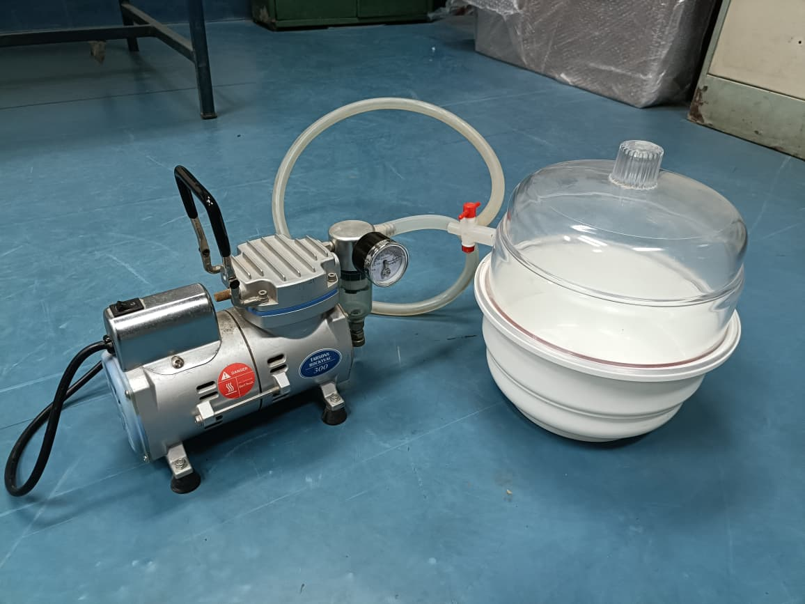

Hardware Implementation of the Proposed System
Hardware Prototype Description
Figure shows the actual hardware prototype of the proposed Standalone ATmega328P Based Vacuum Box Monitoring and Control System. The system consists of a vacuum pump, a sealed vacuum chamber, connecting tubes, a pressure gauge, and the embedded controller circuit developed using the ATmega328P microcontroller.
The vacuum pump is connected to the vacuum chamber through a flexible air tube. When the controller activates the relay, the pump starts operating and removes air from the chamber, thereby creating a vacuum environment. The pressure sensor continuously measures the pressure inside the chamber and sends the measured values to the ATmega328P controller for processing.
The LM35 temperature sensor monitors the temperature inside the vacuum chamber, while the DHT22 sensor measures the humidity level. These sensor values are continuously processed by the microcontroller to ensure that the operating conditions remain within the desired range.
A pressure gauge is installed between the pump and the vacuum chamber to provide a visual indication of the vacuum level during operation. This gauge is also useful for comparing the pressure readings obtained from the electronic pressure sensor during testing and calibration.
The vacuum chamber is constructed using a transparent acrylic dome with an airtight sealing ring, allowing the internal process to be observed while maintaining the required vacuum conditions. The transparent cover also helps in inspecting the test samples without opening the chamber.
The controller automatically switches the vacuum pump ON or OFF through the relay and Solid State Relay (SSR) according to the programmed pressure limits. This automatic control reduces manual intervention, improves operational accuracy, and protects the vacuum pump from unnecessary continuous operation.
The complete hardware prototype demonstrates reliable monitoring of temperature, humidity, and pressure, along with automatic vacuum control. The developed system is compact, cost-effective, and suitable for laboratory experiments, research applications, educational purposes, and small-scale industrial automation.

Hardware Components Used
Vacuum Pump
Vacuum Chamber (Acrylic Vacuum Box)
ATmega328P Standalone Controller Board
LM35 Temperature Sensor
DHT22 Humidity Sensor
DPP101A000 Pressure Sensor
Single Channel Relay Module
Solid State Relay (SSR)
Pressure Gauge
Flexible Vacuum Pipe
5 V DC Power Supply

Program Explanation
CHAPTER 8
8.1 Conclusion
The Standalone ATmega328P Based Vacuum Box Monitoring and Control System was successfully designed, developed, and tested. The primary objective of this project was to develop a compact, low-cost, and reliable embedded system capable of monitoring the operating conditions inside a vacuum box and automatically controlling the vacuum pump.
The developed system uses a standalone ATmega328P microcontroller as the central controller instead of a development board. This approach reduces the overall system cost, minimizes hardware size, and provides flexibility for designing a customized embedded control system.
The LM35 temperature sensor accurately measures the temperature inside the vacuum chamber, while the DHT22 sensor continuously monitors the humidity level. The pressure sensor provides real-time pressure information required for automatic vacuum control. These sensor values are continuously processed by the ATmega328P to make control decisions.
The vacuum pump is controlled through a Single Channel Relay and a Solid State Relay (SSR). Based on the programmed pressure limits, the controller automatically switches the vacuum pump ON and OFF. This automatic operation eliminates continuous manual monitoring, reduces human error, improves system efficiency, and helps maintain a stable vacuum level.
The hardware design includes a standalone ATmega328P minimum system consisting of a 16 MHz crystal oscillator, 22 pF capacitors, 100 nF decoupling capacitor, 10 kΩ reset pull-up resistor, 1 kΩ resistor, and a push-button reset switch. These components ensure reliable operation and stable performance of the controller.
The embedded software was developed using the Arduino IDE and successfully tested under different operating conditions. The software continuously reads sensor values, processes the data, and controls the relay outputs according to the programmed control algorithm. Experimental testing confirmed stable sensor operation, reliable relay switching, and proper automatic control of the vacuum pump.
Overall, the developed system satisfies the project objectives and demonstrates that a standalone ATmega328P can be effectively used for vacuum box monitoring and control. The proposed design is economical, reliable, easy to maintain, and suitable for laboratory experiments, educational institutions, research facilities, and small industrial automation applications.

8.2 Project Achievements
The following objectives were successfully achieved during the implementation of the project:
- Designed a standalone ATmega328P-based embedded controller.
- Successfully interfaced the LM35 temperature sensor.
- Successfully interfaced the DHT22 humidity sensor.
- Successfully integrated the pressure sensor for vacuum monitoring.
- Implemented automatic vacuum pump control using a relay and SSR.
- Developed stable embedded software using the Arduino IDE.
- Achieved reliable automatic monitoring and control of the vacuum box.
- Reduced manual operation and improved process efficiency.
- Designed a compact and cost-effective hardware system.
- Developed a modular system suitable for future upgrades.

8.3 References
The following technical documents and reference materials were consulted during the development of this project:
- Microchip Technology Inc., ATmega328P Datasheet, Microchip.
- Texas Instruments, LM35 Precision Temperature Sensor Datasheet.
- Aosong Electronics, DHT22 Digital Temperature and Humidity Sensor Datasheet.
- Arduino Documentation – Embedded Programming and Development Environment.
- AVR Microcontroller Programming Manual.
- Embedded Systems Design – Raj Kamal.
- Muhammad Ali Mazidi, Janice Gillispie Mazidi, AVR Microcontroller and Embedded Systems.
- John Morton, The AVR Microcontroller and Embedded Systems.
- IEEE Research Papers on Embedded Monitoring and Control Systems.

8.4 Final Summary
The developed Standalone ATmega328P Based Vacuum Box Monitoring and Control System provides an efficient solution for automatic monitoring of temperature, humidity, and pressure in a vacuum chamber. By combining embedded control techniques with reliable sensing and automatic relay operation, the project demonstrates a practical approach to industrial and laboratory automation.
The project successfully meets its design objectives and provides a strong foundation for future enhancements such as wireless communication, IoT integration, data logging, graphical user interfaces, and advanced control algorithms.

Advantages
The proposed Standalone ATmega328P Based Vacuum Box Monitoring and Control System provides several advantages over conventional manually operated vacuum systems. The system is compact, economical, and easy to maintain because it uses a standalone ATmega328P microcontroller instead of a complete development board. Automatic monitoring of temperature, humidity, and pressure reduces the need for continuous human supervision and minimizes the possibility of human error.
The automatic operation of the relay and Solid State Relay (SSR) improves the efficiency of the vacuum pump by switching it only when required, thereby reducing unnecessary power consumption. The hardware design is modular, allowing additional sensors, displays, or communication modules to be integrated in future without major hardware modifications. The overall system provides reliable performance, stable operation, faster response, and improved process accuracy, making it suitable for laboratory and industrial applications.
1. Low-cost embedded system with affordable electronic components.
2. Compact and lightweight hardware design.
3. Standalone operation without requiring an Arduino Nano board.
4. Accurate monitoring of temperature, humidity, and pressure.
5. Automatic control of the vacuum pump using relay and SSR.
6. Fast response to changes in environmental conditions.
7. Reliable and stable operation using the ATmega328P microcontroller.
8. Low power consumption, making it energy efficient.
9. Easy installation, maintenance, and troubleshooting.
10. Modular design allows easy replacement or upgrading of sensors.
11. High reliability for continuous monitoring applications.
12. Suitable for laboratory, industrial, and research environments.
13. Reduces manual monitoring and improves operational efficiency.
14. Provides stable performance under varying operating conditions.
15. Easy to program and modify according to application requirements.

Applications
The developed system can be used in a wide range of industrial and research applications where automatic vacuum monitoring and control are required. It is suitable for laboratory vacuum chambers used for scientific experiments and material testing. The system can also be implemented in vacuum drying units, food packaging industries, pharmaceutical manufacturing plants, and electronic component production where maintaining a controlled vacuum environment is essential.
In addition, the project can be used in leak testing equipment, chemical laboratories, educational institutions, research centers, and small-scale industrial automation systems. Because of its compact design and low cost, it is also suitable for prototype development and embedded system learning.
- Vacuum box monitoring and control systems.
- Laboratory vacuum chambers.
- Industrial vacuum processing units.
- Research and development laboratories.
- Vacuum drying and heating systems.
- Environmental monitoring applications.
- Temperature and humidity monitoring systems.
- Pressure monitoring and control systems.
- Industrial automation and process control.
- Electronic testing and calibration laboratories.
- Packaging and sealing industries.
- Educational and embedded system research projects.

Future Scope
1. Low-cost embedded system with affordable electronic components.
2. Compact and lightweight hardware design.
3. Standalone operation without requiring an Arduino Nano board.
4. Accurate monitoring of temperature, humidity, and pressure.
5. Automatic control of the vacuum pump using relay and SSR.
6. Fast response to changes in environmental conditions.
7. Reliable and stable operation using the ATmega328P microcontroller.
8. Low power consumption, making it energy efficient.
9. Easy installation, maintenance, and troubleshooting.
10. Modular design allows easy replacement or upgrading of sensors.
11. High reliability for continuous monitoring applications.
12. Suitable for laboratory, industrial, and research environments.
13. Reduces manual monitoring and improves operational efficiency.
14. Provides stable performance under varying operating conditions.
15. Easy to program and modify according to application requirements.

Conclusion
The Standalone ATmega328P Based Vacuum Box Monitoring and Control System has been successfully designed, developed, and tested. The project demonstrates an efficient embedded solution for monitoring temperature, humidity, and pressure inside a vacuum chamber while automatically controlling the vacuum pump using a relay and Solid State Relay.
The use of a standalone ATmega328P microcontroller reduces the overall hardware cost and provides flexibility for customized circuit design. The LM35 temperature sensor, DHT22 humidity sensor, and pressure sensor continuously monitor environmental conditions and provide reliable data to the controller.
Based on the programmed pressure limits, the controller automatically operates the vacuum pump without requiring manual intervention. Experimental testing confirmed stable sensor performance, reliable relay operation, and effective vacuum control. The developed system is economical, compact, reliable, and suitable for laboratory experiments, educational purposes, and small-scale industrial automation. The modular design also allows future expansion by integrating additional sensors, communication modules, and intelligent control techniques.

References
1. Microchip Technology Inc., ATmega328P 8-bit AVR Microcontroller Datasheet, Microchip Technology, USA.
2. Texas Instruments, LM35 Precision Centigrade Temperature Sensor Datasheet, Texas Instruments Incorporated.
3. Aosong Electronics Co., Ltd., DHT22 (AM2302) Digital Temperature and Humidity Sensor Datasheet, China.
4. Arduino, Arduino IDE Documentation, Arduino Official Documentation.
5. Atmel Corporation, AVR Microcontroller Programming Manual, Atmel Application Notes.
6. Raj Kamal, Embedded Systems: Architecture, Programming and Design, 3rd Edition, McGraw-Hill Education.
7. Muhammad Ali Mazidi, Sarmad Naimi and Sepehr Naimi, AVR Microcontroller and Embedded Systems: Using Assembly and C, Pearson Education.
8. John Morton, The AVR Microcontroller: Embedded Systems Using Assembly and C, Prentice Hall.
9. Frank Vahid and Tony Givargis, Embedded System Design: A Unified Hardware/Software Introduction, Wiley India.
10. David A. Patterson and John L. Hennessy, Computer Organization and Design, Morgan Kaufmann Publishers.
11. R. S. Sedha, A Textbook of Applied Electronics, S. Chand Publishing.
12. IEEE Xplore Digital Library, Research Papers on Embedded Monitoring and Industrial Automation Systems.
13. National Instruments (NI), Sensor Measurement Fundamentals and Industrial Automation Manuals.
14. Proteus Design Suite, Proteus ISIS and ARES User Manual, Labcenter Electronics Ltd.
15. USBasp Programmer Documentation, AVR ISP Programming Guide.
16. Technical Manuals of Single Channel Relay Module and Solid State Relay (SSR).
17. AVR Freaks Community, Technical Articles on ATmega328P Embedded System Development.
18. Technical literature on Vacuum Monitoring and Industrial Control Systems.

