ASSINGMENT-3
Flask & MongoDB
Task 1: JSON API Route
- Create a Flask application with an /api route. When this route is accessed, it should return a JSON list. The data should be stored in a backend file, read from it, and sent as a response.
Objective
Create a Flask application with an /api route that reads data from a JSON file and returns it as a JSON response.
Project Structure
project/
├── app.py
├── data.json
└── templates/
└── index.html
Main Components
- app.py – Contains the Flask application and routes.
- data.json – Stores backend data.
- index.html – Provides a styled home page with a link to the API.
Routes
- / – Displays the home page.
- /api – Reads data.json and returns the data in JSON format.
Technologies
- Python
- Flask
- JSON
- HTML
- CSS
Result
The Flask application successfully displays a styled home page and provides backend data through the /api JSON endpoint.
.
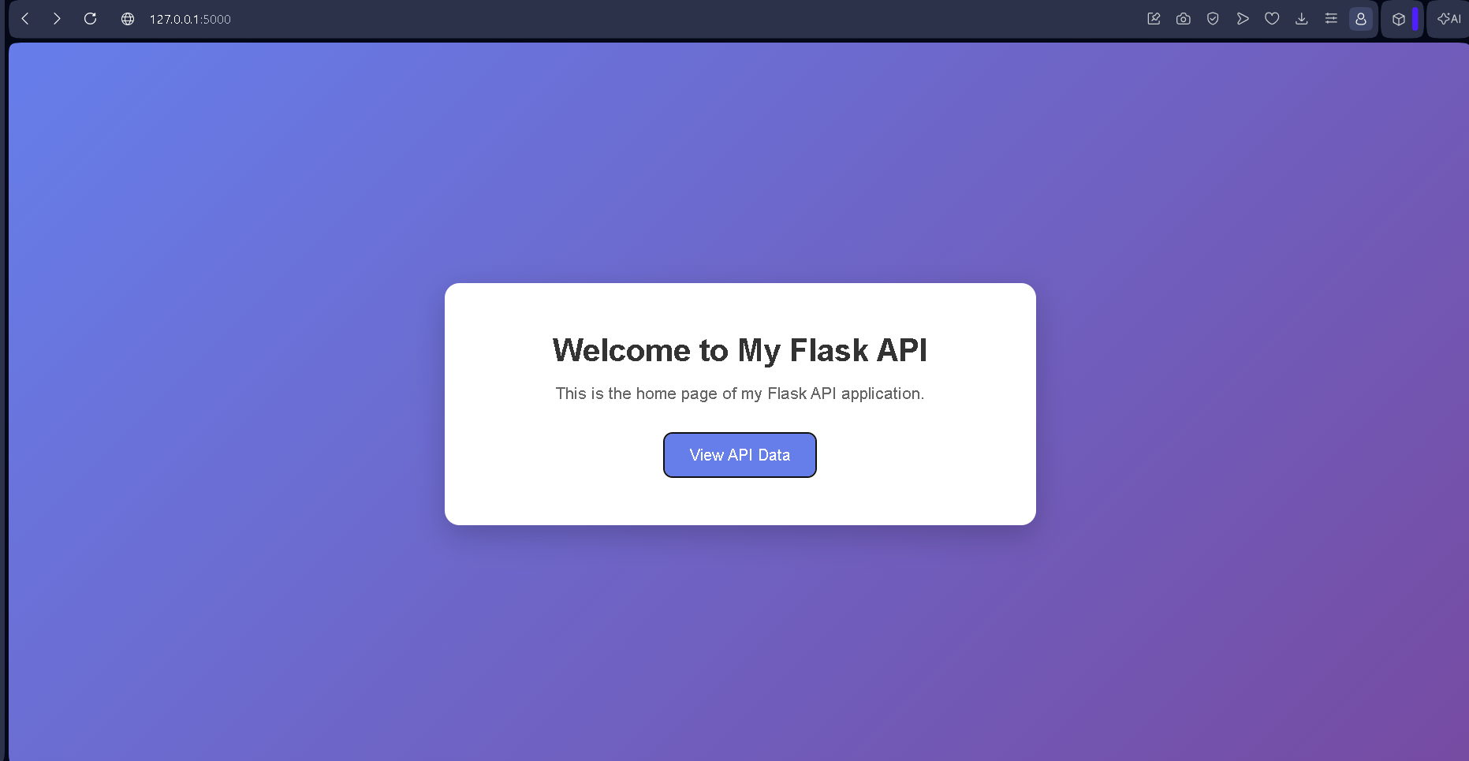
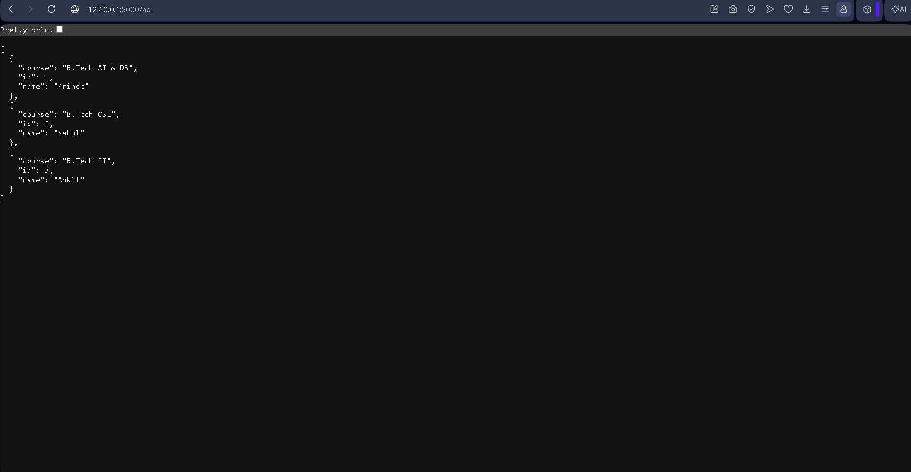

Task 2: Frontend Form with MongoDB Atlas
- Create a form on the frontend that, when submitted, inserts data into MongoDB Atlas.
- On success: the user should be redirected to another page displaying the message “Data submitted successfully”.
- On error: display the error on the same page without redirection.
Objective
Create a frontend form that accepts user data and stores it in MongoDB Atlas using Flask.
Project Structure
project/
├── app.py
├── .env
└── templates/
├── index.html
└── success.html
Technologies
- Python
- Flask
- HTML & CSS
- MongoDB Atlas
- PyMongo
- python-dotenv
Working
Frontend Form
↓
POST /submit
↓
Flask
↓
Validate Data
↓
MongoDB Atlas
Success Case
- Form data is inserted into MongoDB Atlas.
- User is redirected to /success.
- The page displays:
"Data submitted successfully"
Error Case
- If validation or database insertion fails, the user remains on the same form page.
- The error message is displayed on the form.
MongoDB Collection
Database: student_database
Collection: students
Data stored:
name
email
course

