EX.No:1 | Create a responsive web page with a registration  form using HTMLS, CSS3, and Bootstrap grid  system.

AIM:
To create a responsive web page with a registration form using HTMLS, CSS3, and Bootstrap grid system.

ALGORITHM:
Step 1: Start
Step 2: Load Webpage
- Initialize HTML document
- Load Bootstrap CSS for styling
- Apply background image and custom styles
Step 3: Display Form Layout
- Create a container for the form
- Display header with:
  - Title: IPL Player Registration
  - Player image
Step 4: Accept User Inputs
- Get the following details from the user:
  - Full Name (text)
  - Age (number)
  - Date of Birth (date)
  - Email (email format)
  - Contact Details (phone number)
  - Gender (radio buttons)
  - City (text)
  - Fielding Option (dropdown: Batter/Bowler)
  - Batting Style (dropdown: Left/Right handed)
Step 5: Validate Inputs
- Check all fields are filled (required validation)
- Ensure:
  - Email is in correct format
  - Contact number is valid
  - Age is a positive number
Step 6: Submit Action
- When user clicks Submit:
  - Validate all inputs
  - If valid → form is submitted successfully
  - If invalid → show error messages
Step 7: Reset Action
- When user clicks Reset:
  - Clear all input fields
  - Restore default values
Step 8: End

SOURCE CODE:
<!DOCTYPE html>
<html lang="en">
<head>
<meta charset="UTF-8">
<meta name="viewport" content="width=device-width, initial-scale=1.0">
<title>IPL Player Registration</title>
<!-- Bootstrap -->
<link href="https://cdn.jsdelivr.net/npm/bootstrap@5.3.2/dist/css/bootstrap.min.css" rel="stylesheet">
<!-- Google Font -->
<link href="https://fonts.googleapis.com/css2?family=Poppins:wght@600&display=swap" rel="stylesheet">
<style>
body{
background:#f2f2f2;
}
.form-box{
background:white;
padding:30px;
border-radius:10px;
box-shadow:0 0 10px rgba(0,0,0,0.1);
}
.logo-img{
width:120px;
height:120px;
object-fit:cover;
}
.title-font{
font-family:'Poppins', sans-serif;
font-weight:600;
font-size:32px;
letter-spacing:1px;
}
.register-btn{
background: linear-gradient(to right,#5fa8d3,#a95ecb);
border:none;
color:white;
padding:10px;
width:100%;
border-radius:5px;
}
</style>
</head>
<body>
<div class="container mt-5 d-flex justify-content-center">
<div class="col-lg-8">
<div class="form-box">
<!-- Logos + Title -->
<div class="d-flex align-items-center justify-content-between mb-4">
<img src="C:\Users\prince joel\OneDrive\Pictures\ipl.jpg" class="logo-img" alt="IPL Logo">
<h3 class="text-center m-0 flex-grow-1 title-font">IPL Player Registration</h3>
<img src="C:\Users\prince joel\OneDrive\Pictures\ipl2.png" width="100px" height="100px" class="logo-img" alt="Second Logo">
</div>
<form>
<div class="row mb-3">
<div class="col-md-6">
<label class="form-label">Full Name</label>
<input type="text" class="form-control" placeholder="Enter your name">
</div>
<div class="col-md-3">
<label class="form-label">Age</label>
<input type="number" class="form-control" placeholder="Age">
</div>
<div class="col-md-3">
<label class="form-label">DOB</label>
<input type="date" class="form-control">
</div>
</div>
<div class="row mb-3">
<div class="col-md-6">
<label class="form-label">Email</label>
<input type="email" class="form-control" placeholder="Enter your email">
</div>
<div class="col-md-6">
<label class="form-label">Phone Number</label>
<input type="text" class="form-control" placeholder="Enter phone number">
</div>
</div>
<!-- <div class="mb-3">
<label class="form-label">Gender</label>
<div class="form-check form-check-inline">
<input class="form-check-input" type="radio" name="gender">
<label class="form-check-label">Male</label>
</div>
<div class="form-check form-check-inline">
<input class="form-check-input" type="radio" name="gender">
<label class="form-check-label">Female</label>
</div>
</div> -->
<div class="row mb-3">
<div class="col-md-6">
<label class="form-label">Batting Style</label>
<select class="form-select">
<option>Right Hand Bat</option>
<option>Left Hand Bat</option>
</select>
</div>
<div class="col-md-6">
<label class="form-label">Bowling Arm</label>
<select class="form-select">
<option>Right Arm</option>
<option>Left Arm</option>
</select>
</div>
</div>
<div class="mb-3">
<label class="form-label">Player Role</label>
<select class="form-select">
<option>Batsman</option>
<option>Bowler</option>
<option>All-Rounder</option>
<option>Wicketkeeper</option>
<option>Wicketkeeper-Batsman</option>
</select>
</div>
<div class="mb-3">
<label class="form-label">Bio</label>
<textarea class="form-control" rows="3" placeholder="Write about yourself"></textarea>
</div>
<button type="submit" class="register-btn">Register</button>
</form>
</div>
</div>
</div>
</body>
</html>

OUTPUT:
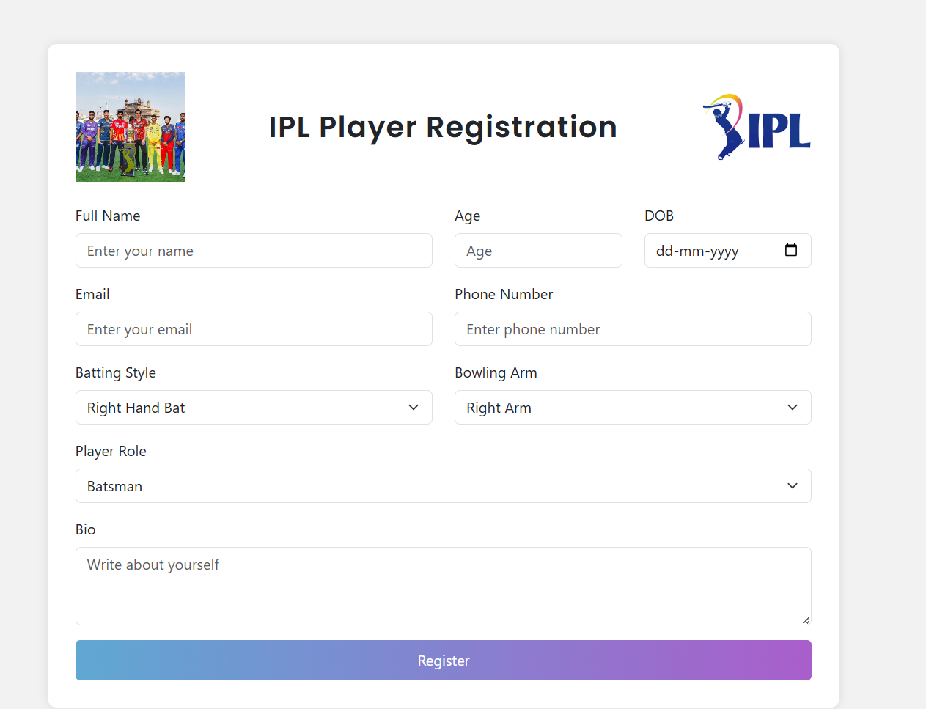

RESULT:
Hence the output for the sample code using HTML, CSS and Bootstrap has been displayed.
EX.No:2 | Enhance web elements with CSS: Shadows,  Rounded Borders, and Multiple Backgrounds.

AIM:
To enhance web elements with CSS: Shadows, Rounded Borders, and Multiple Backgrounds.

ALGORITHM:
Step 1: Start
Step 2: Initialize HTML Document
- Create the basic structure using:
  - <html>
  - <head>
  - <body>
Step 3: Apply CSS Styling
- Add internal CSS inside <style> tag:
  - Set body padding (top, bottom, left, right)
  - Define class .x with:
    - Dashed border
    - Rounded corners
    - Background color (brown)
    - Center alignment
    - Box shadow
    - Font styling
    - Padding
  - Style <h1> with text shadow
  - Style <img> with rounded corners
Step 4: Create Main Container
- Create a <div> with class "x"
- This acts as the main content box
Step 5: Add Heading
- Insert <h1> tag
- Display name: PRINCE JOEL A
- Apply inline color styling (pink)
Step 6: Insert Image
- Add <img> tag
- Set:
  - Source path of image
  - Width = 150px
- Apply border radius using CSS
Step 7: Add Description
- Insert <p> tag
- Add personal details:
  - Education
  - Interests
  - Skills
  - Goals
- Apply text color (aliceblue)
Step 8: Display Output
- Browser renders:
  - Styled container
  - Name heading
  - Profile image
  - Description text
Step 9: End

SOURCE CODE:
<!DOCTYPE HTML>
<html>
<head>
<style>
.xx
{
border-style: double;
border-color:rgb(26, 18, 18);
border-radius:40px;
text-align: center;
box-shadow:3px 3px 40px rgb(17, 110, 127);
font-family:cursive;
margin-left: 300px;
margin-right: 300px;
}
.x
{
text-shadow : 3px 3px 3px rgb(1, 231, 70);
}
</style>
</head>
<body>
<div class="xx">
<div class="x">Prince Joel A</div>
<img src="C:\Users\prince joel\OneDrive\Pictures\Screenshots\photo.jpg" width="50px" height="50px" style="border-radius: 100px;"><br>
I am a first-year student at Sri Krishna College.
<br>I am interested in coding and enjoy solving problems, especially in data structures.
<br>This is my ADP Project.
<br>Thank you.
</div>
</body>
</html>

OUTPUT:
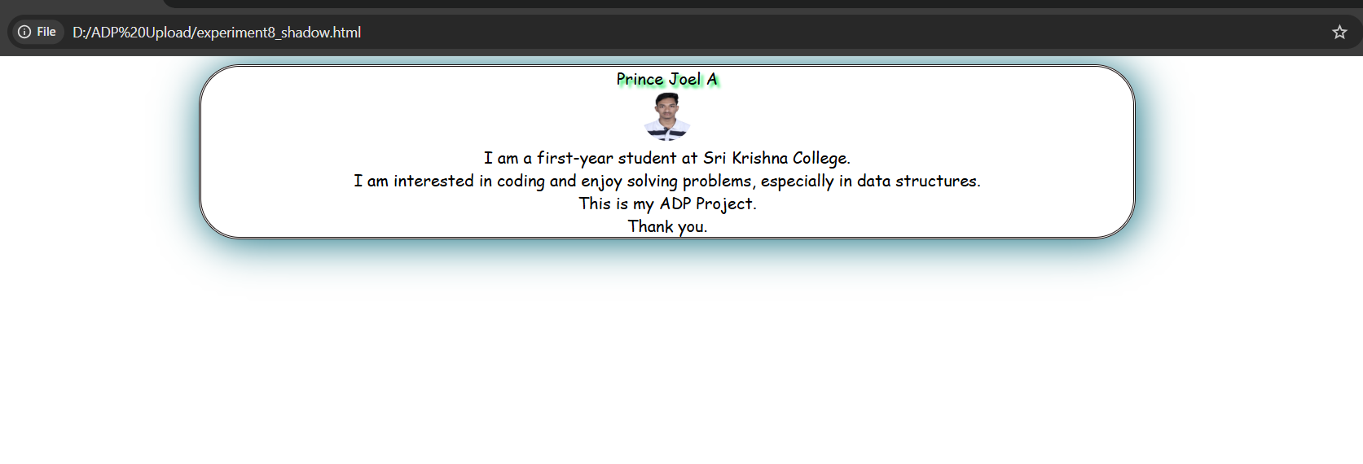

RESULT:
From the source code, the web elements are enhanced using CSS.

EX.No:3 | Implement a CSS grid-based layout to create a  responsive web page.

AIM:
To implement a CSS grid-based layout to create a responsive web page.

ALGORITHM:
Step 1: Start
Step 2: Initialize HTML Structure
- Create basic HTML document using:
  - <html>
  - <head>
  - <body>
Step 3: Link Bootstrap
- Add Bootstrap CSS using CDN link
- This helps in creating responsive layout using grid system
Step 4: Define CSS Styles
- Create class .x:
  - Apply solid blue border
- Create #head:
  - Add border
  - Center align text
  - Add padding
- Create #child:
  - Add border
  - Add padding
- Create #foot:
  - Add border
  - Center align text
  - Add padding
Step 5: Create Main Container
- Use <div class="x">
- This acts as outer wrapper
Step 6: Create Header Section
- Use Bootstrap row:
  - <div class="row">
- Add one column:
  - Display Header text
- Apply styling using #head
Step 7: Create Content Section
- Use Bootstrap row:
  - Divide into 2 columns
Left Column (col-4)
- Add multiple links using <a> tag
Right Column (col-8)
- Add heading (Lorem ipsum)
- Add paragraph content
Step 8: Create Footer Section
- Use another row:
  - Add one column
  - Display Footer text
- Apply styling using #foot
Step 9: Apply Bootstrap Grid System
- Use:
  - row → horizontal layout
  - col-4 and col-8 → column division
  - Ensures responsive design
Step 10: Display Output
- Browser renders:
  - Header at top
  - Content section (links + text)
  - Footer at bottom
Step 11: End

SOURCE CODE:
<!DOCTYPE html>
<html>
<head>
<style>
.container {
display: grid;
grid-template-areas:
"header header"
"sidebar content"
"footer footer";
grid-template-columns: 250px 1fr;
grid-template-rows: 100px 1fr 80px;
height: 100vh;
gap: 5px;
}

.container > div {
border: 3px solid #e30808;
padding: 15px;
background-color: #f2f2f2;
}

.header {
grid-area: header;
text-align: center;
font-size: 24px;
font-weight: bold;
}

.footer {
grid-area: footer;
text-align: center;
font-weight: bold;
}

.sidebar a {
display: block;
color: purple;
margin-bottom: 5px;
}
</style>

</head>
<body>

<div class="container">
<div class="header">Header</div>
<div class="sidebar">
<a href="#">Link 1</a>
<a href="#">Link 2</a>
<a href="#">Link 3</a>
</div>

<div class="content">
<h3>Water Management System</h3>
<p>
A water management system refers to the planning, development, distribution, and<br>
efficient use of water resources. It ensures that water is available for drinking, agriculture, industry,<br>
and environmental needs while preventing wastage and pollution.
</p>
</div>
<div class="footer">Footer</div>
</div>

</body>
</html>

OUTPUT:
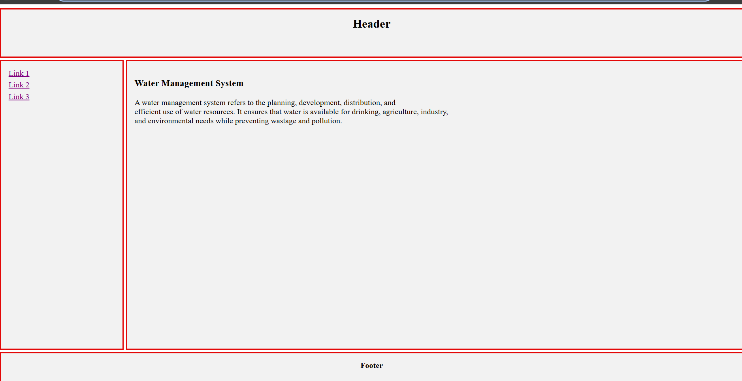

RESULT:
Responsive web page is created by implementing CSS Grid-based layout.
EX.No:4 | Implement a JavaScript-based form validation for  user input fields (email, password, etc.).

AIM:
To implement a JavaScript-based form validation for user input fields (email, password, etc.).

ALGORITHM:
Step 1: Start
Step 2: Initialize HTML Structure
- Create a basic HTML page with:
  - <form>
  - Input fields for:
    - Name
    - Phone Number
    - Email ID
  - Paragraph tags (<p>) to display validation results
Step 3: Apply CSS
- Style all <p> elements:
  - Set text color to brown
Step 4: Define JavaScript Function
- Create a function named validate()
Step 5: Get User Inputs
- Read values using getElementById():
  - n ← Name
  - ph ← Phone number
  - email ← Email
Step 6: Define Validation Patterns
- Create regular expressions:
  - pattern1 → Phone number (10 digits only)
  - pattern2 → Email format
  - pattern3 → Name (alphabets only)
Step 7: Validate Name
- If name matches pattern3:
  - Display "valid name"
- Else:
  - Display "invalid name"
Step 8: Validate Phone Number
- If phone matches pattern1:
  - Display "valid phone number"
- Else:
  - Display "invalid phone number"
Step 9: Validate Email
- If email matches pattern2:
  - Display "valid email id"
- Else:
  - Display "invalid email id"
Step 10: Display Results
- Show validation messages inside:
  - demo3 → Name result
  - demo → Phone result
  - demo2 → Email result
Step 11: Trigger Validation
- When user clicks Validate button:
  - Call validate() function
Step 12: End

SOURCE CODE:
<!DOCTYPE html>
<html>
<head>
<style>
p{
color: brown;
}
</style>
<script>
function validate(){
var n=document.getElementById("name").value;
var ph=document.getElementById("phone").value;
var email=document.getElementById("mail").value;
var pattern1=/^[0-9]{10}$/;
var pattern2=/^[A-Za-z0-9]+@[A-Za-z]+.(com|ac\.in|co\.in)$/;
var pattern3=/^[A-Za-z]+$/;
if(pattern3.test(n))
var res3="valid name";
else
res3="invalid name";
if(pattern1.test(ph))
var res="valid phone number";
else
res="invalid phone number";
if(pattern2.test(email))
var res2="valid email id";
else
res2="invalid email id";
document.getElementById("demo3").innerHTML=res3;
document.getElementById("demo").innerHTML=res;
document.getElementById("demo2").innerHTML=res2;
}
</script>
</head>
<body>
<form>
<label>Name:</label>
<input type="textbox" id="name">
<p id="demo3"> </p>
<label>Phone No:</label>
<input type="textbox" id="phone">
<p id="demo"> </p>
<label>E-mail:</label>
<input type="textbox" id="mail">
<p id="demo2"> </p>
<input type="button" value="validate" onclick="validate()">
</form>
</body>
</html>

OUTPUT:
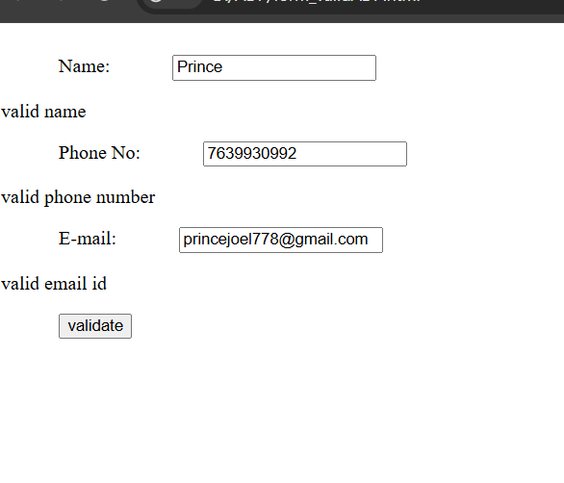
RESULT: Hence a JavaScript-based form validation for user input fields (email, password, etc.) is created.

EX.No:5 | Develop a dynamic webpage using JavaScript  and DOM manipulation.

AIM:
To develop a dynamic webpage using JavaScript and DOM manipulation.

ALGORITHM:
Step 1: Start
Step 2: Initialize HTML Structure
- Create a basic HTML page using:
  - <html>, <head>, <body>
- Add input fields:
  - num1 → First number
  - num2 → Second number
- Add a result field to display output
Step 3: Apply CSS Styling
- Set:
  - Padding (top, bottom, left, right)
  - Background color (burlywood)
  - Center alignment for content
Step 4: Create Buttons
- Add four buttons:
  - ADD → calls sum()
  - SUB → calls sub()
  - MUL → calls mul()
  - DIV → calls div()
Step 5: Define JavaScript Functions
Function 1: Addition (sum)
- Read values of num1 and num2
- Convert them into integers using parseInt()
- Add the numbers
- Display result
Function 2: Subtraction (sub)
- Read inputs
- Convert to integers
- Subtract second number from first
- Display result
Function 3: Multiplication (mul)
- Read inputs
- Convert to integers
- Multiply values
- Display result
Function 4: Division (div)
- Read inputs
- Convert to integers
- Divide first number by second
- Display result
Step 6: Display Result
- Show output in result textbox using:
- document.getElementById("res").value
Step 7: User Interaction
- User enters numbers
- Clicks any operation button
- Corresponding function executes
- Result is displayed
Step 8: End

SOURCE CODE:
<!DOCTYPE html>
<html>
<head>
<style>
.xx{
margin-left: auto;
margin-right: auto;
margin-top: auto;
margin-bottom: auto;
}
</style>
</head>
<body style="background-color: rgb(169, 193, 244);">
<div id="xx">
num1: <input type="text" id="num1">
num2: <input type="text" id="num2"><br>
<input type="button" value="ADD" onclick="sum()">
<input type="button" value="SUBTRACT" onclick="subtract()">
<input type="button" value="MULTIPLY" onclick="multiply()">
<input type="button" value="DIVIDE" onclick="divide()">
<script>
function sum(){
var a=document.getElementById("num1").value;
var b=document.getElementById("num2").value;
document.getElementById("res").value=parseInt(a)+parseInt(b);
}
function subtract(){
var a=document.getElementById("num1").value;
var b=document.getElementById("num2").value;
document.getElementById("res").value=parseInt(a)-parseInt(b);
}
function multiply(){
var a=document.getElementById("num1").value;
var b=document.getElementById("num2").value;
document.getElementById("res").value=parseInt(a)*parseInt(b);
}
function divide(){
var a=document.getElementById("num1").value;
var b=document.getElementById("num2").value;
document.getElementById("res").value=parseInt(a)/parseInt(b);
}
</script>
<br><br>
Result
<input type="text" id="res" value="--ANS--"></p>
</div>
</body>
</html>

OUTPUT:
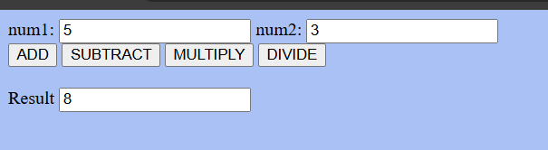

RESULT:
A Dynamic web page is created using JavaScript and DOM manipulation
EX.No:6 | Work with APIs and fetch data asynchronously  using JavaScript.

AIM:
To work with APIs and fetch data asynchronously using JavaScript.

ALGORITHM:
Step 1: Start
Step 2: Initialize HTML Page
- Create basic structure using:
  - <html>, <body>
- Display heading: API INTERFACE PROGRAM
- Add a button labeled DISPLAY
- Add a <p> element with id result to show output
Step 3: Define JavaScript Function
- Create an asynchronous function named display() using async keyword
Step 4: Fetch Data from API
- Use fetch() method to request data from:
- https://jsonplaceholder.typicode.com/users
- Wait for response using await
Step 5: Convert Response to JSON
- Convert fetched data into JSON format:
- let data = await info.json();
Step 6: Initialize Output Variable
- Create a variable output as an empty string
- This will store formatted results
Step 7: Process Data
- Use a loop (for) to iterate through all users:
  - Extract:
    - name
    - city (from address.city)
  - Append to output string in formatted form
Step 8: Display Data
- Insert output into HTML using:
- document.getElementById("result").innerHTML = output;
Step 9: User Interaction
- When user clicks DISPLAY button:
  - display() function is called
  - Data is fetched and shown on screen
Step 10: End

SOURCE CODE:
<!DOCTYPE html>
<html>
<body>
<H1> API INTERFACE PROGRAM</H1>
<br><br>
<button onclick="display()">DISPLAY</button>
<br>
<p id="result"></p>
<script>
async function display()
{
let info=await fetch("https://jsonplaceholder.typicode.com/users");
let data=await info.json();
let output="";
for(let i=0;i<data.length;i++)
{
output+="<br>Name:"+ data[i].name+ "<br>City:"+ data[i].address.city+"<br>";
}
document.getElementById("result").innerHTML=output;
}
</script>
</body>
</html>

OUTPUT:
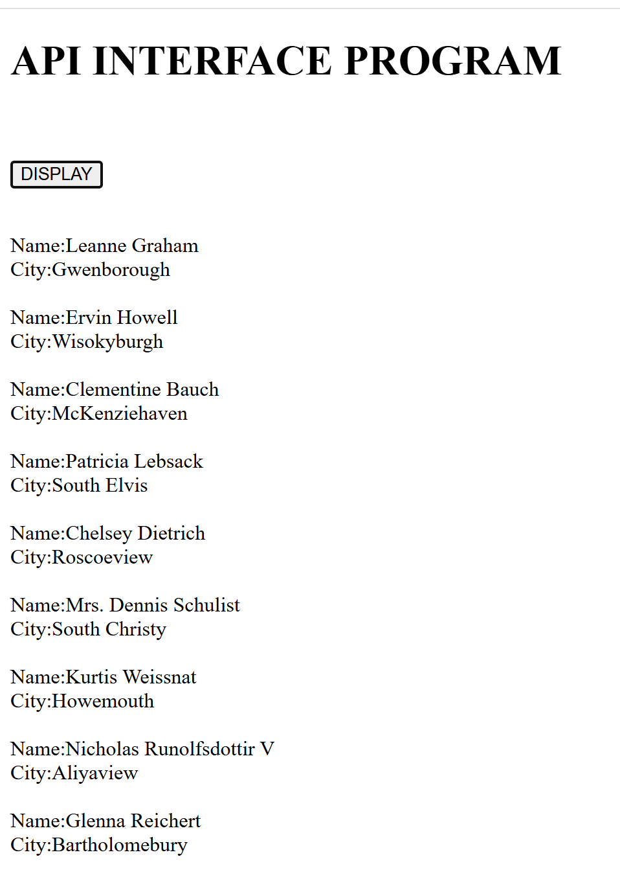

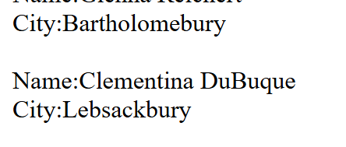

RESULT:
JavaScript enables smooth interaction with APIs through asynchronous data fetching. Using fetch() and promises, data can be retrieved and processed without blocking the UI. This approach enhances responsiveness and demonstrates real-time integration of external data into web applications.
EX.No:7 | Create a TypeScript application demonstrating  object-oriented programming concepts.

AIM:
To create a TypeScript application demonstrating object-oriented programming concepts.

ALGORITHM:
Step 1: Start
Step 2: Define Base Class (Person)
- Create a class named Person
- Declare attributes:
  - name → public
  - age → private
  - city → public
Step 3: Create Constructor for Person
- Initialize values using constructor:
  - Assign name, age, and city using parameters
Step 4: Define Methods in Person Class
- getAge():
  - Return the value of age
- setAge(a):
  - Update the value of age
- display():
  - Print:
    - Name
    - Age
    - City
Step 5: Define Derived Class (Employee)
- Create class Employee that extends Person
Step 6: Declare Employee Properties
- employeeid → public
- salary → public
Step 7: Create Constructor for Employee
- Accept parameters:
  - name, age, city, employeeid, salary
- Call parent constructor using:
- super(n, a, c)
- Assign employee-specific values
Step 8: Override display() Method
- Call parent method using:
- super.display()
- Then display:
  - Employee ID
  - Salary
Step 9: Create Object
- Create object:
- emp = new Employee("sham", 19, "cbe", 1, 300000)
Step 10: Call Method
- Call:
- emp.display()
- Output will display:
  - Name
  - Age
  - City
  - Employee ID
  - Salary
Step 11: End

SOURCE CODE:
var __extends = (this && this.__extends) || (function () {
var extendStatics = function (d, b) {
extendStatics = Object.setPrototypeOf ||
({ __proto__: [] } instanceof Array && function (d, b) { d.__proto__ = b; }) ||
function (d, b) { for (var p in b) if (Object.prototype.hasOwnProperty.call(b, p)) d[p] = b[p]; };
return extendStatics(d, b);
};
return function (d, b) {
if (typeof b !== "function" && b !== null)
throw new TypeError("Class extends value " + String(b) + " is not a constructor or null");
extendStatics(d, b);
function __() { this.constructor = d; }
d.prototype = b === null ? Object.create(b) : (__.prototype = b.prototype, new __());
};
})();
var person = /** @class */ (function () {
function person(n, a, c) {
this.name = n;
this.age = a;
this.city = c;
}
person.prototype.display = function () {
console.log(this.name);
console.log(this.age);
console.log(this.city);
};
person.prototype.getAge = function () {
return this.age;
};
person.prototype.setAge = function (a) {
this.age = a;
};
return person;
}());
var Employee = /** @class */ (function (_super) {
__extends(Employee, _super);
function Employee(n, a, c, i, s) {
var _this = _super.call(this, n, a, c) || this;
_this.empId = i;
_this.salary = s;
return _this;
}
Employee.prototype.display = function () {
_super.prototype.display.call(this);
console.log(this.empId);
console.log(this.salary);
};
return Employee;
}(person));
var emp1 = new Employee("Prince", 18, "erode", 23, 10000);
emp1.display();
OUTPUT:
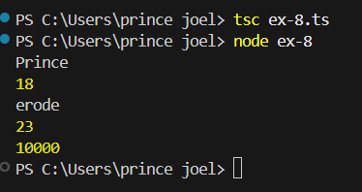

RESULT:
A TypeScript application is created demonstrating object-oriented programming concepts.
RESULT:
This experiment shows that Linux shell commands can efficiently handle directory creation, file editing, permission changes, and file listing.
It confirms that proper execution of commands ensures successful completion of basic file management tasks.

