Experiment No. : 2
28th July 2025

Simple Linear Regression

Prince John
Roll No: 46
S7 AI & ML

PROGRAM

import torch
import torch.nn as nn
import matplotlib.pyplot as plt

# Generate synthetic data: y = 2x + 3 + noise
torch.manual_seed(42)
X = torch.linspace(0, 10, 100).unsqueeze(1)
y = 2 * X + 3 + torch.randn(X.size()) * 2

# Define a simple linear regression model
class LinearRegressionModel(nn.Module):
def __init__(self):
super().__init__()
self.linear = nn.Linear(1, 1)

def forward(self, x):
return self.linear(x)

model = LinearRegressionModel()

# Loss and optimizer
criterion = nn.MSELoss()
optimizer = torch.optim.SGD(model.parameters(), lr=0.01)

# Training loop
epochs = 200
for epoch in range(epochs):
model.train()
outputs = model(X)
loss = criterion(outputs, y)
optimizer.zero_grad()
loss.backward()
optimizer.step()
if (epoch+1) % 40 == 0:
print(f'Epoch [{epoch+1}/{epochs}], Loss: {loss.item():.4f}')

# Plot results
predicted = model(X).detach()
plt.scatter(X.numpy(), y.numpy(), label='Original Data')
plt.plot(X.numpy(), predicted.numpy(), color='red', label='Fitted Line')
plt.legend()
plt.xlabel('X')
plt.ylabel('y')
plt.title('Simple Linear Regression with PyTorch')
plt.show()

OUTPUT

Epoch [40/200], Loss: 6.2077
Epoch [80/200], Loss: 5.4339
Epoch [120/200], Loss: 4.9143
Epoch [160/200], Loss: 4.5653
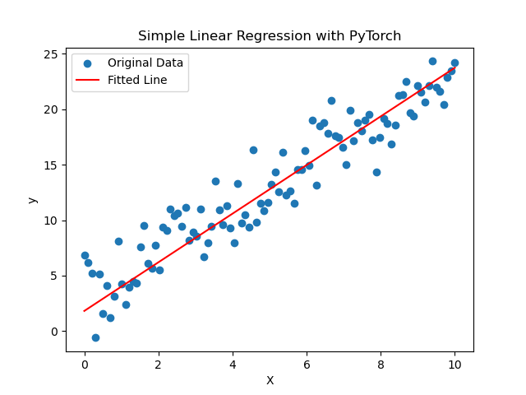
Epoch [200/200], Loss: 4.3309

