Experiment No: 3 28th July 2025

Basic Image Enhancement

Prince John
Roll No: 46
S7 AI & ML

PROGRAM

import torch
import numpy as np
from PIL import Image
import torchvision.transforms.functional as TF
import matplotlib.pyplot as plt

def histogram_equalization(img_tensor):
# Convert to numpy
img_np = img_tensor.squeeze().cpu().numpy()
if img_np.ndim == 3:
# For RGB images, apply HE to each channel
img_eq = np.zeros_like(img_np)
for c in range(3):
img_eq[c] = _equalize_channel(img_np[c])
else:
img_eq = _equalize_channel(img_np)
return torch.from_numpy(img_eq).float().unsqueeze(0)

def _equalize_channel(channel):
# Compute histogram
hist, bins = np.histogram(channel.flatten(), bins=256, range=[0, 1])
cdf = hist.cumsum() # Cumulative distribution function
cdf_normalized = cdf / cdf[-1] # Normalize to [0, 1]
equalized = np.interp(channel.flatten(), bins[:-1], cdf_normalized)
return equalized.reshape(channel.shape)

def morphological_operation(img_tensor, operation='dilate', kernel_size=3):
# Convert to numpy
img_np = img_tensor.squeeze().cpu().numpy()
kernel = np.ones((kernel_size, kernel_size), dtype=bool)
if operation == 'open':
img_morph = _dilate(_erode(img_np, kernel), kernel)
elif operation == 'close':
img_morph = _erode(_dilate(img_np, kernel), kernel)
else:
raise ValueError("Operation must be 'open' or 'close'")
return torch.from_numpy(img_morph).float().unsqueeze(0)

def _dilate(image, kernel):
pad = kernel.shape[0] // 2
padded_image = np.pad(image, pad, mode='constant', constant_values=0)
dilated = np.zeros_like(image)
for i in range(image.shape[0]):
for j in range(image.shape[1]):
dilated[i, j] = np.max(padded_image[i:i+kernel.shape[0], j:j+kernel.shape[1]] * kernel)
return dilated

def _erode(image, kernel):
pad = kernel.shape[0] // 2
padded_image = np.pad(image, pad, mode='constant', constant_values=1)
eroded = np.zeros_like(image)
for i in range(image.shape[0]):
for j in range(image.shape[1]):
eroded[i, j] = np.min(padded_image[i:i+kernel.shape[0], j:j+kernel.shape[1]] * kernel)
return eroded

def load_image(path, grayscale=False):
img = Image.open(path)
if grayscale:
img = img.convert('L')
else:
img = img.convert('RGB')
img_tensor = TF.to_tensor(img)
return img_tensor.unsqueeze(0) # Add batch dimension

def show_image(img_tensor, title='Image'):
img = img_tensor.squeeze().cpu().numpy()
if img.ndim == 3 and img.shape[0] == 3:
img = np.transpose(img, (1, 2, 0))
plt.imshow(img, cmap='gray' if img.ndim == 2 else None)
plt.title(title)
plt.axis('off')
plt.show()

if __name__ == "__main__":
# Example usage
img_path = '/home/cs-ai-21/Prince/DeepLearning-S7-AI-ML-KTU-Lab/code/exp3/input.jpg'
img_tensor = load_image(img_path, grayscale=True)

# Histogram Equalization
img_he = histogram_equalization(img_tensor)
img_open = morphological_operation(img_tensor, operation='open', kernel_size=5)
img_close = morphological_operation(img_tensor, operation='close', kernel_size=5)

# Display all four images together
images = [img_tensor, img_he, img_open, img_close]
titles = ['Original', 'Histogram Equalized', 'Opened', 'Closed']
plt.figure(figsize=(12, 6))
for i, (img, title) in enumerate(zip(images, titles)):
plt.subplot(1, 4, i+1)
arr = img.squeeze().cpu().numpy()
if arr.ndim == 3 and arr.shape[0] == 3:
arr = np.transpose(arr, (1, 2, 0))
plt.imshow(arr, cmap='gray' if arr.ndim == 2 else None)
plt.title(title)
plt.axis('off')
plt.tight_layout()
plt.show()

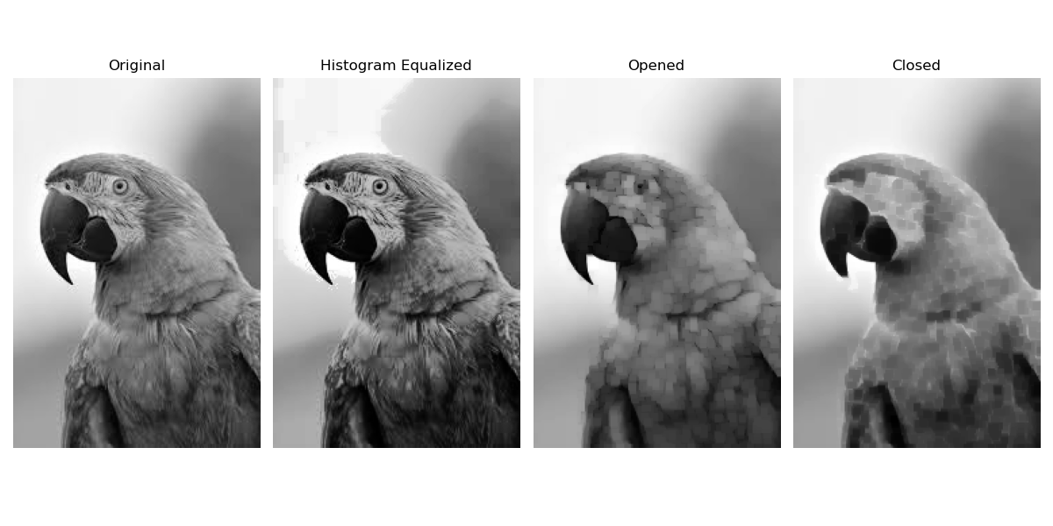
OUTPUT

