Experiment No. : 1.a
14th July 2025

Decision Tree

Prince John
Roll No: 46
S7 AI & ML

PROGRAM

import math
import pandas as pd
import matplotlib.pyplot as plt

# Calculate entropy
def entropy(target_col):
elements, counts = pd.Series(target_col).value_counts().index, pd.Series(target_col).value_counts().values
entropy = 0
for i in range(len(elements)):
probability = counts[i] / sum(counts)
entropy -= probability * math.log2(probability)
return entropy

# Calculate Information Gain
def info_gain(data, split_attribute_name, target_name="PlayTennis"):
total_entropy = entropy(data[target_name])
vals, counts = data[split_attribute_name].value_counts().index, data[split_attribute_name].value_counts().values
weighted_entropy = 0
for i in range(len(vals)):
subset = data[data[split_attribute_name] == vals[i]]
weighted_entropy += (counts[i] / sum(counts)) * entropy(subset[target_name])
gain = total_entropy - weighted_entropy
return gain

# ID3 Algorithm
def ID3(data, original_data, features, target_attribute_name="PlayTennis", parent_node_class=None):
# If all target_values have same value, return that value
if len(data[target_attribute_name].unique()) == 1:
return data[target_attribute_name].iloc[0]

# If dataset is empty
if len(data) == 0:
return parent_node_class

# If no more features, return mode of target
if len(features) == 0:
return data[target_attribute_name].mode()[0]

# Set default value for parent node
parent_node_class = data[target_attribute_name].mode()[0]

# Choose best feature
item_values = [info_gain(data, feature, target_attribute_name) for feature in features]
best_feature_index = item_values.index(max(item_values))
best_feature = features[best_feature_index]

# Build tree
tree = {best_feature: {}}

feature_values = data[best_feature].unique()
for value in feature_values:
sub_data = data[data[best_feature] == value].drop(columns=[best_feature])
subtree = ID3(sub_data, original_data, [f for f in features if f != best_feature], target_attribute_name, parent_node_class)
tree[best_feature][value] = subtree

return tree

# Predict using the decision tree
def predict(query, tree, default='Yes'):
for key in list(query.keys()):
if key in tree:
try:
result = tree[key][query[key]]
except:
return default
if isinstance(result, dict):
return predict(query, result)
else:
return result
return default

# Plot the decision tree using Matplotlib
def plot_tree_with_matplotlib(tree, x=0, y=0, dx=4, dy=2, ax=None, parent_coords=None):
"""Recursively plots the decision tree using Matplotlib."""
if ax is None:
fig, ax = plt.subplots(figsize=(12, 8))
ax.axis('off')
ax.set_xlim(-10, 10)
ax.set_ylim(-10, 5)

for key, value in tree.items():
if isinstance(value, dict):
n = len(value)
start_x = x - dx * (n - 1) / 2
for i, (sub_key, sub_value) in enumerate(value.items()):
child_x = start_x + i * dx
child_y = y - dy
ax.annotate('', xy=(child_x, child_y+0.3), xytext=(x, y-0.3),
arrowprops=dict(arrowstyle='->', lw=1.5))
ax.text(x, y, f"{key}", ha='center', va='center',
bbox=dict(boxstyle='round', facecolor='lightblue', edgecolor='black'))
ax.text((x+child_x)/2, (y+child_y)/2+0.2, f"{sub_key}", ha='center', va='center', fontsize=9, color='brown')
if isinstance(sub_value, dict):
plot_tree_with_matplotlib(sub_value, child_x, child_y, dx/2, dy, ax, (x, y))
else:
ax.text(child_x, child_y, f"{sub_value}", ha='center', va='center',
bbox=dict(boxstyle='round', facecolor='lightgreen', edgecolor='black'))
else:
ax.text(x, y, f"{key}: {value}", ha='center', va='center',
bbox=dict(boxstyle='round', facecolor='lightgreen', edgecolor='black'))
if parent_coords is None:
plt.show()

# Data
data = pd.DataFrame([
['Sunny', 'Hot', 'High', 'Weak', 'No'],
['Sunny', 'Hot', 'High', 'Strong', 'No'],
['Overcast', 'Hot', 'High', 'Weak', 'Yes'],
['Rain', 'Mild', 'High', 'Weak', 'Yes'],
['Rain', 'Cool', 'Normal', 'Weak', 'Yes'],
['Rain', 'Cool', 'Normal', 'Strong', 'No'],
['Overcast', 'Cool', 'Normal', 'Strong', 'Yes'],
['Sunny', 'Mild', 'High', 'Weak', 'No'],
['Sunny', 'Cool', 'Normal', 'Weak', 'Yes'],
['Rain', 'Mild', 'Normal', 'Weak', 'Yes'],
['Sunny', 'Mild', 'Normal', 'Strong', 'Yes'],
['Overcast', 'Mild', 'High', 'Strong', 'Yes'],
['Overcast', 'Hot', 'Normal', 'Weak', 'Yes'],
['Rain', 'Mild', 'High', 'Strong', 'No']
], columns=['Outlook', 'Temperature', 'Humidity', 'Wind', 'PlayTennis'])

features = ['Outlook', 'Temperature', 'Humidity', 'Wind']
target = 'PlayTennis'

# Build Tree
tree = ID3(data, data, features, target)
print("Decision Tree:")
print(tree)

s1="Sunny"
s2="Cool"
s3="High"
s4="Strong"
sample = {'Outlook': s1, 'Temperature': s2, 'Humidity': s3, 'Wind': s4}

# Classify a new sample
#sample = {'Outlook': 'Sunny', 'Temperature': 'Cool', 'Humidity': 'High', 'Wind': 'Strong'}
result = predict(sample, tree)
print("\nPrediction for sample", sample, ":", result)

# Plot the decision tree using Matplotlib
plot_tree_with_matplotlib(tree)

OUTPUT
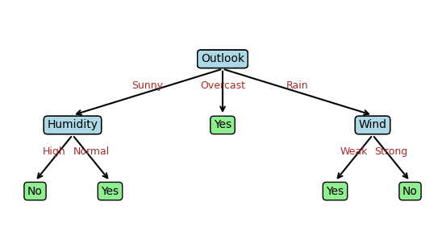

Decision Tree:
{'Outlook': {'Sunny': {'Humidity': {'High': 'No', 'Normal': 'Yes'
}}, 'Overcast': 'Yes', 'Rain': {'Wind': {'Weak': 'Yes', 'Strong':
'No'}}}}

Prediction for sample {'Outlook': 'Sunny', 'Temperature': 'Cool',
'Humidity': 'High', 'Wind': 'Strong'} : No

Experiment No. : 1.b
14th July 2025

SVM

Prince John
Roll No: 46
S7 AI & ML

PROGRAM

from sklearn import datasets
from sklearn.model_selection import train_test_split
from sklearn.preprocessing import StandardScaler
from sklearn.svm import SVC
from sklearn.metrics import accuracy_score, confusion_matrix, classification_report
import seaborn as sns
import matplotlib.pyplot as plt
import numpy as np

# 1. Load the Iris dataset
iris = datasets.load_iris()
X = iris.data
y = iris.target
target_names = iris.target_names

# 2. Split the dataset (80% training, 20% testing)
X_train, X_test, y_train, y_test = train_test_split(X, y, test_size=0.2, random_state=42)

# 3. Feature Scaling (important for SVM)
scaler = StandardScaler()
X_train_scaled = scaler.fit_transform(X_train)
X_test_scaled = scaler.transform(X_test)

# 4. Train the Linear SVM classifier
svm_clf = SVC(kernel='linear', C=1.0, random_state=42)
svm_clf.fit(X_train_scaled, y_train)

# 5. Make predictions
y_pred = svm_clf.predict(X_test_scaled)

# 6. Evaluation
print("Accuracy:", accuracy_score(y_test, y_pred))
print("\nConfusion Matrix:\n", confusion_matrix(y_test, y_pred))
print("\nClassification Report:\n", classification_report(y_test, y_pred, target_names=target_names))

# 7. Visualize the Confusion Matrix
plt.figure(figsize=(12, 5))

plt.subplot(1, 2, 1)
sns.heatmap(confusion_matrix(y_test, y_pred), annot=True, cmap='Reds',
xticklabels=target_names, yticklabels=target_names, fmt='d')
plt.xlabel("Predicted")
plt.ylabel("True")
plt.title("SVM Confusion Matrix (Linear Kernel)")

# 8. Visualize SVM Decision Boundary (using first 2 features)
plt.subplot(1, 2, 2)

# Use only first 2 features for 2D visualization
X_2d = X[:, :2] # sepal length and sepal width
X_train_2d, X_test_2d, y_train_2d, y_test_2d = train_test_split(X_2d, y, test_size=0.2, random_state=42)

# Scale the 2D data
scaler_2d = StandardScaler()
X_train_2d_scaled = scaler_2d.fit_transform(X_train_2d)
X_test_2d_scaled = scaler_2d.transform(X_test_2d)

# Train SVM on 2D data
svm_2d = SVC(kernel='linear', C=1.0, random_state=42)
svm_2d.fit(X_train_2d_scaled, y_train_2d)

# Create a mesh for plotting decision boundary
import numpy as np
h = 0.02 # step size in the mesh
x_min, x_max = X_train_2d_scaled[:, 0].min() - 1, X_train_2d_scaled[:, 0].max() + 1
y_min, y_max = X_train_2d_scaled[:, 1].min() - 1, X_train_2d_scaled[:, 1].max() + 1
xx, yy = np.meshgrid(np.arange(x_min, x_max, h), np.arange(y_min, y_max, h))

# Make predictions on the mesh
Z = svm_2d.predict(np.c_[xx.ravel(), yy.ravel()])
Z = Z.reshape(xx.shape)

# Plot the decision boundary
plt.contourf(xx, yy, Z, alpha=0.8, cmap=plt.cm.RdYlBu)

# Plot the data points
colors = ['white', 'blue', 'orange']
for i, color in enumerate(colors):
idx = np.where(y_train_2d == i)
plt.scatter(X_train_2d_scaled[idx, 0], X_train_2d_scaled[idx, 1],
c=color, marker='o', label=f'{target_names[i]} (train)', s=50, alpha=0.8)

# Plot test points with different markers
for i, color in enumerate(colors):
idx = np.where(y_test_2d == i)
plt.scatter(X_test_2d_scaled[idx, 0], X_test_2d_scaled[idx, 1],
c=color, marker='s', label=f'{target_names[i]} (test)', s=60, alpha=1.0)

plt.xlabel('Sepal Length (scaled)')
plt.ylabel('Sepal Width (scaled)')
plt.title('SVM Decision Boundary (Linear Kernel)')
plt.legend()

plt.tight_layout()
plt.show()

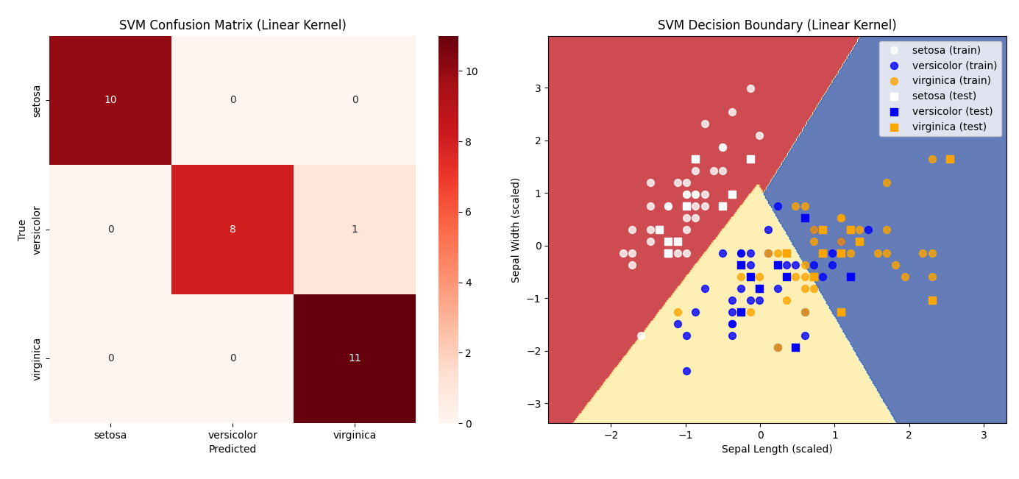
OUTPUT

Accuracy: 0.9666666666666667

Confusion Matrix:
[[10 0 0]
[ 0 8 1]
[ 0 0 11]]

Classification Report:
precision recall f1-score support

setosa 1.00 1.00 1.00 10
versicolor 1.00 0.89 0.94 9
virginica 0.92 1.00 0.96 11

accuracy 0.97 30
macro avg 0.97 0.96 0.97 30
weighted avg 0.97 0.97 0.97 30

Experiment No. : 1.c
14th July 2025

Linear Regression using Gradient Descent

Prince John
Roll No: 46
S7 AI & ML

PROGRAM
import numpy as np
import matplotlib.pyplot as plt

# 1. Generate simple linear data
np.random.seed(42)
X = 2 * np.random.rand(100, 1)
y = 4 + 3 * X + np.random.randn(100, 1)

# Flatten X and y for simplicity
X = X.flatten()
y = y.flatten()

# 2. Initialize parameters
m = 0 # slope
c = 0 # intercept
alpha = 0.1 # learning rate
epochs = 25

n = len(X)
cost_history = []

# 3. Gradient Descent Algorithm
for epoch in range(epochs):
y_pred = m * X + c
error = y_pred - y

cost = (1/n) * np.sum(error**2)
cost_history.append(cost)

dm = (2/n) * np.dot(error, X)
dc = (2/n) * np.sum(error)

m -= alpha * dm
c -= alpha * dc

if epoch % 10 == 0:
print(f"Epoch {epoch}: m={m:.4f}, c={c:.4f}, cost={cost:.4f}")

print(f"\nFinal parameters: m = {m:.4f}, c = {c:.4f}")

# 4. Plot Regression Line
plt.figure(figsize=(14, 5))

plt.subplot(1, 2, 1)
plt.scatter(X, y, color='blue', label='Data points')
plt.plot(X, m * X + c, color='red', label='Fitted line')
plt.xlabel('X')
plt.ylabel('y')
plt.title('Linear Regression Fit using Gradient Descent')
plt.legend()

# 5. Plot Cost Function
plt.subplot(1, 2, 2)
plt.plot(range(epochs), cost_history, color='green')
plt.xlabel('Epoch')
plt.ylabel('Cost (MSE)')
plt.title('Cost Reduction over Iterations')

plt.tight_layout()
plt.show()

OUTPUT
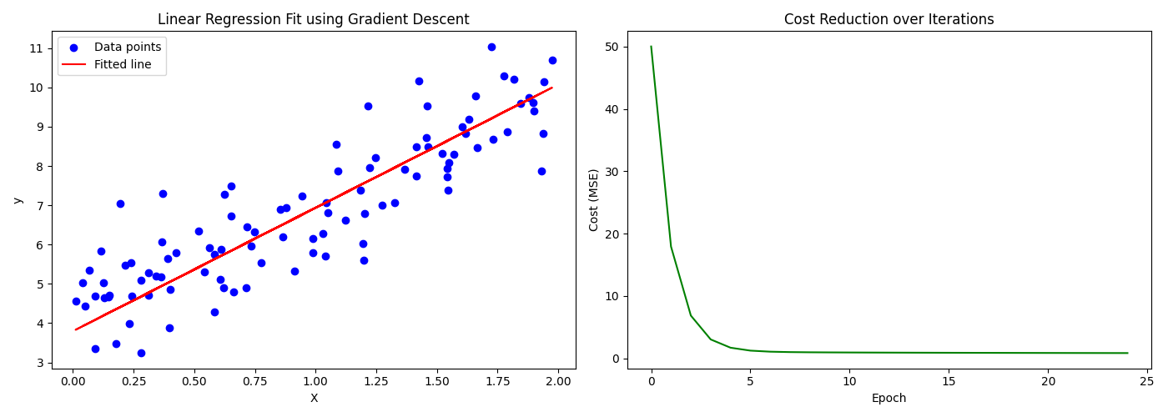
Epoch 0: m=1.4768, c=1.3640, cost=50.0083
Epoch 10: m=3.3601, c=3.5259, cost=0.9574
Epoch 20: m=3.1951, c=3.7336, cost=0.8816

Final parameters: m = 3.1403, c = 3.7958

Experiment No: 2
28th July 2025

Linear Regression using Pytorch

Prince John
Roll No: 46
S7 AI & ML

PROGRAM

PROGRAM

import torch
import torch.nn as nn
import matplotlib.pyplot as plt

# Generate synthetic data: y = 2x + 3 + noise
torch.manual_seed(42)
X = torch.linspace(0, 10, 100).unsqueeze(1)
y = 2 * X + 3 + torch.randn(X.size()) * 2

# Define a simple linear regression model
class LinearRegressionModel(nn.Module):
def __init__(self):
super().__init__()
self.linear = nn.Linear(1, 1)

def forward(self, x):
return self.linear(x)

model = LinearRegressionModel()

# Loss and optimizer
criterion = nn.MSELoss()
optimizer = torch.optim.SGD(model.parameters(), lr=0.01)

# Training loop
epochs = 200
for epoch in range(epochs):
model.train()
outputs = model(X)
loss = criterion(outputs, y)
optimizer.zero_grad()
loss.backward()
optimizer.step()
if (epoch+1) % 40 == 0:
print(f'Epoch [{epoch+1}/{epochs}], Loss: {loss.item():.4f}')

# Plot results
predicted = model(X).detach()
plt.scatter(X.numpy(), y.numpy(), label='Original Data')
plt.plot(X.numpy(), predicted.numpy(), color='red', label='Fitted Line')
plt.legend()
plt.xlabel('X')
plt.ylabel('y')
plt.title('Simple Linear Regression with PyTorch')
plt.show()

OUTPUT

Epoch [40/200], Loss: 6.2077
Epoch [80/200], Loss: 5.4339
Epoch [120/200], Loss: 4.9143
Epoch [160/200], Loss: 4.5653
Epoch [200/200], Loss: 4.3309
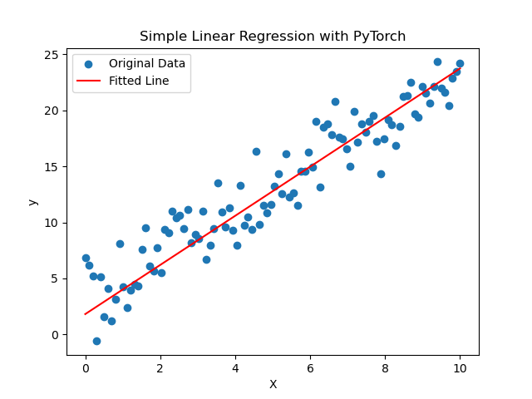

Experiment No: 3
28th July 2025

Basic Image Enhancement

Prince John
Roll No: 46
S7 AI & ML

PROGRAM

def to_grayscale(img_tensor):
img = img_tensor.squeeze().cpu().numpy()
if img.ndim == 3 and img.shape[0] == 3:
# Convert from CHW to HWC
img = np.transpose(img, (1, 2, 0))
img_gray = np.dot(img[..., :3], [0.2989, 0.5870, 0.1140])
return img_gray
return img

def binarise(img_np, threshold=0.5):
return (img_np > threshold).astype(float)
import torch
import numpy as np
from PIL import Image
import torchvision.transforms.functional as TF
import matplotlib.pyplot as plt

def histogram_equalization(img_tensor):
# Convert to numpy
img_np = img_tensor.squeeze().cpu().numpy()
if img_np.ndim == 3:
# For RGB images, apply HE to each channel
img_eq = np.zeros_like(img_np)
for c in range(3):
img_eq[c] = _equalize_channel(img_np[c])
else:
img_eq = _equalize_channel(img_np)
return torch.from_numpy(img_eq).float().unsqueeze(0)

def _equalize_channel(channel):
# Compute histogram
hist, bins = np.histogram(channel.flatten(), bins=256, range=[0, 1])
cdf = hist.cumsum() # Cumulative distribution function
cdf_normalized = cdf / cdf[-1] # Normalize to [0, 1]
equalized = np.interp(channel.flatten(), bins[:-1], cdf_normalized)
return equalized.reshape(channel.shape)

def morphological_operation(img_tensor, operation='dilate', kernel_size=3):
# Convert to numpy
img_np = img_tensor.squeeze().cpu().numpy()
kernel = np.ones((kernel_size, kernel_size), dtype=bool)
if operation == 'open':
img_morph = _dilate(_erode(img_np, kernel), kernel)
elif operation == 'close':
img_morph = _erode(_dilate(img_np, kernel), kernel)
else:
raise ValueError("Operation must be 'open' or 'close'")
return torch.from_numpy(img_morph).float().unsqueeze(0)

def _dilate(image, kernel):
pad = kernel.shape[0] // 2
padded_image = np.pad(image, pad, mode='constant', constant_values=0)
dilated = np.zeros_like(image)
for i in range(image.shape[0]):
for j in range(image.shape[1]):
dilated[i, j] = np.max(padded_image[i:i+kernel.shape[0], j:j+kernel.shape[1]] * kernel)
return dilated

def _erode(image, kernel):
pad = kernel.shape[0] // 2
padded_image = np.pad(image, pad, mode='constant', constant_values=1)
eroded = np.zeros_like(image)
for i in range(image.shape[0]):
for j in range(image.shape[1]):
eroded[i, j] = np.min(padded_image[i:i+kernel.shape[0], j:j+kernel.shape[1]] * kernel)
return eroded

def load_image(path, grayscale=False):
img = Image.open(path)
if grayscale:
img = img.convert('L')
else:
img = img.convert('RGB')
img_tensor = TF.to_tensor(img)
return img_tensor.unsqueeze(0) # Add batch dimension

def show_image(img_tensor, title='Image'):
img = img_tensor.squeeze().cpu().numpy()
if img.ndim == 3 and img.shape[0] == 3:
img = np.transpose(img, (1, 2, 0))
plt.imshow(img, cmap='gray' if img.ndim == 2 else None)
plt.title(title)
plt.axis('off')
plt.show()

if __name__ == "__main__":
# Example usage
img_path = '/home/cs-ai-21/Prince/DeepLearning-S7-AI-ML-KTU-Lab/code/exp3/input.jpg'
img_tensor = load_image(img_path, grayscale=False) # Load as color

# Prepare all images
img_col = img_tensor.squeeze().cpu().numpy()
if img_col.ndim == 3 and img_col.shape[0] == 3:
img_col_disp = np.transpose(img_col, (1, 2, 0))
else:
img_col_disp = img_col

img_gray = to_grayscale(img_tensor)
img_he = histogram_equalization(torch.from_numpy(img_gray).unsqueeze(0))
img_he_np = img_he.squeeze().cpu().numpy()
img_bin = binarise(img_gray)
img_open = morphological_operation(torch.from_numpy(img_bin).unsqueeze(0), operation='open', kernel_size=5)
img_close = morphological_operation(torch.from_numpy(img_bin).unsqueeze(0), operation='close', kernel_size=5)

images = [
img_col_disp,
img_gray,
img_he_np,
img_bin,
img_open.squeeze().cpu().numpy(),
img_close.squeeze().cpu().numpy()
]
titles = ['Original (Color)', 'Grayscale', 'Histogram Equalized', 'Binarised', 'Opened', 'Closed']
plt.figure(figsize=(18, 3))
for i, (img, title) in enumerate(zip(images, titles)):
plt.subplot(1, 6, i+1)
plt.imshow(img, cmap='gray' if img.ndim == 2 else None)
plt.title(title)
plt.axis('off')
plt.tight_layout()
plt.show()

OUTPUT

