

Problem Statement: Microphone array-based direction of arrival for gunshot detection

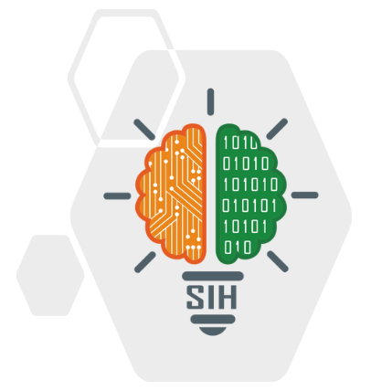

**INDEX**

Problem statement _______1

Proposed Model _______2

Model Overview _______3

Flow Chart _______4

CAD Design _______6



# Problem statement

## Problem description

The system consists of number of omnidirectional microphones preferably six. The output of microphone will be fed to the analog to digital converter and then this signal is fed to the FPGA. Inside FPGA, each channel will be filtered using Bandpass filter so as to limit the band to approx. 3Khz. After this sound classification and localization algorithm will deduce the direction from where the bullet has been fired and display the result on a Graphical LCD.

Organization: - Ministry of Defense

Category: - Software

Domain Bucket: - Defense Management



# Proposed Model

The proposed model for the FPGA-based gunshot detection system can be structured into several key components, combining hardware and software to detect, classify, and localize gunshots. Here’s a step-by-step breakdown of the proposed model.

**1.** **Microphone Array for Sound Capture**

- Components: Use a set of omnidirectional microphones (typically 4-6) placed in a known geometric arrangement.

- Purpose: Capture sound from all directions.

- Output: Analog sound signals.

**2. Analog to Digital Conversion (ADC)**

- Function: The analog sound signals from the microphones are fed to an ADC.

- Output: Digital sound data that can be processed by the FPGA.

**3. FPGA Processing Unit**

- Core Processing Unit: The heart of the system, where all the real-time signal processing happens.

- Key Functions:

1. **Signal Filtering:**

- A bandpass filter is applied to the input signals, isolating gunshot frequencies (around 3 kHz) and filtering out noise.

2. **Sound Classification:**

- A classification algorithm determines whether the detected sound matches gunshot characteristics (e.g., using energy detection, machine learning, or pattern matching).

3. **Sound Localization:**

- The **Time Difference of Arrival (TDOA)** algorithm calculates the direction of the gunshot based on the difference in arrival times of the sound at each microphone.

4. **Echo Reduction:**

- Implement **Acoustic Echo Cancellation (AEC)** or time-windowing techniques to minimize echoes and isolate the direct sound.

**4**. **Direction Calculation and Display**

- **Computation**: The direction (angle or coordinates) of the gunshot is computed based on the time difference and microphone positioning.

- **Graphical LCD**: Displays the direction of the gunshot on a graphical screen in real-time, usually as an arrow or a point on a map.

**Model Overview**

**Input Stage:**

* Microphone Array: Captures sound.
* ADC: Converts analog signals to digital.

**Processing Stage (on FPGA):**

* Bandpass Filtering: Isolates gunshot frequency range.
* Gunshot Detection Algorithm: Determines if the sound is a gunshot.
* Localization Algorithm (TDOA): Calculates the direction of the sound.
* Echo Reduction: Removes unwanted echoes.

**Output Stage:**

* LCD Display: Shows the gunshot direction.
* Optional Alerts: Sends alerts via wireless communication if integrated.

**Flowchart**

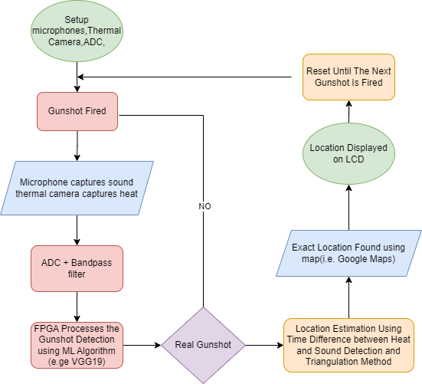

## Detailed version of flowchart

**1. Data Acquisition:**

* Microphones capture sound signals.
* Thermal camera captures heat signatures.
* ADC converts analog sound signals to digital for further processing.

**2. Thermal Camera Event Detection:**

* Heat Signature Detection:
* Thermal camera detects a sudden heat signature (gunshot flash).
* Record the timestamp of the heat signature detection.

**3. Signal Processing (FPGA):**

* Pre-processing:
* Noise filtering (remove background noise from microphone input).
* Normalize signals.
* Gunshot Detection:
* Analyze sound signatures for specific gunshot patterns.
* Record the timestamp of gunshot sound detection.
* Trigger event if gunshot detected.

**4. Time Difference Calculation:**

* Time Difference of Arrival (TDOA):
* Calculate the time difference between the thermal camera detecting the heat signature and the microphones detecting the sound.
* Distance Calculation:
* Multiply the time difference by the speed of sound to calculate the distance of the gunshot from the sensors.
* 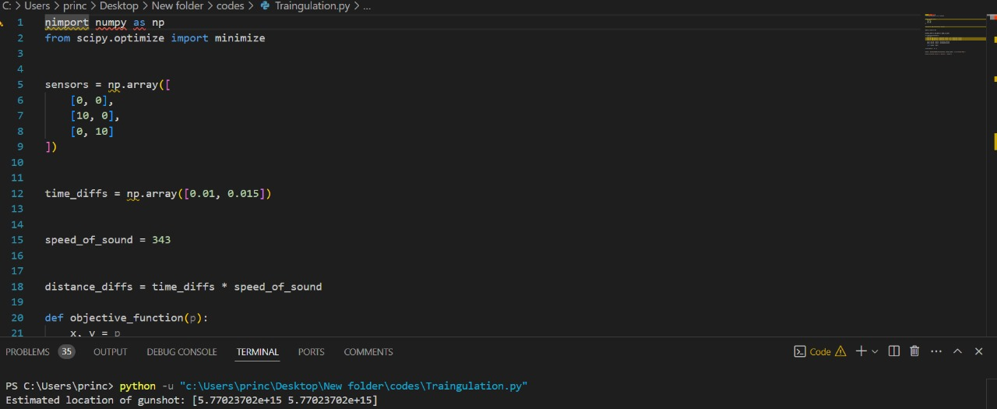Combine results with TDOA across multiple microphones for triangulation.

**5. Location Estimation:**

* Use the time difference calculation along with the thermal camera and microphone data to pinpoint the exact location.
* Apply triangulation/multilateration algorithms for precise location estimation.

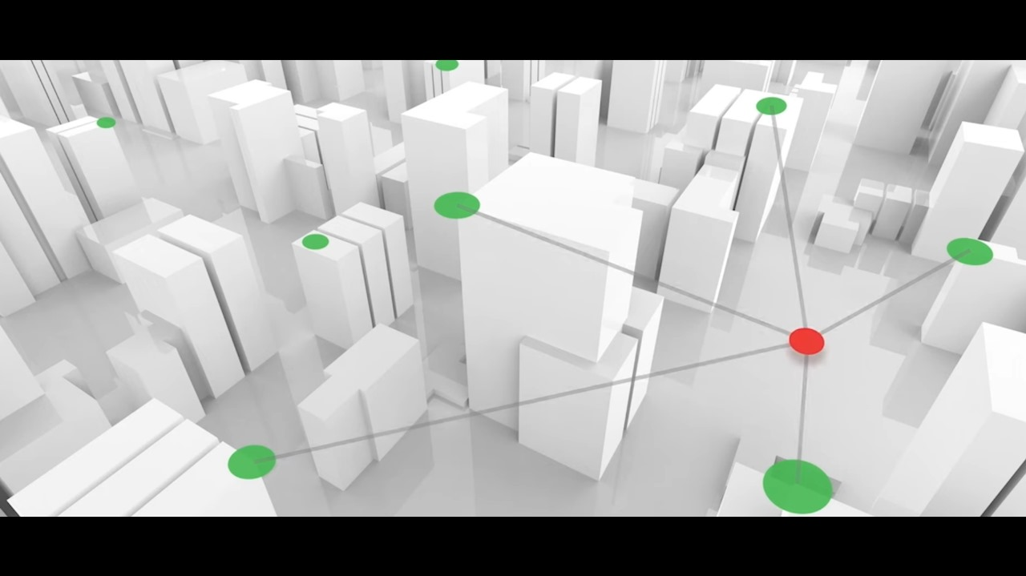

**6. Map Display:**

* Display the calculated gunshot location on a digital map.
* Mark the exact coordinates and provide visual representation on the map (e.g., using a pin or highlighted area).

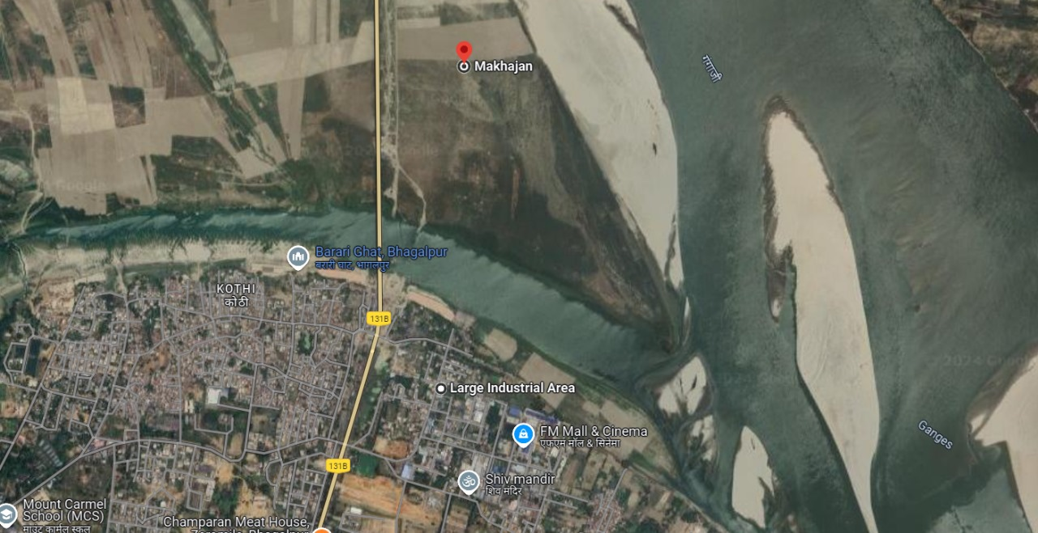

**7. Output/Alarm:**

* Send location data to display systems (including the map).
* Trigger alarm if necessary.

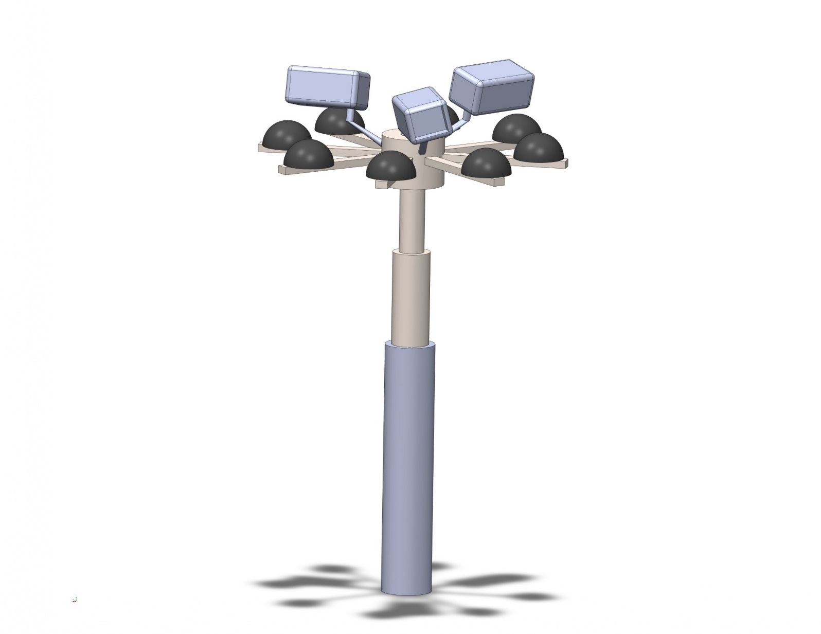 CAD MODEL OF DEVICE